Digital Signal Processing and Communications
Assignment
HND Electrical & Electronic Engineering Course
UWTSD
By Krzysztof Matela
Student ID: 1804424

Page Index:
- Introduction Page 3
- Background Information …
  - Signal Modulation Techniques …
    - Amplitude Shift Keying Page 4
    - Phase Shift Keying …
    - Quadrature Phase Shift Keying Page 5
  - Math on Sinusoids …
    - 2 Sine Waves …
    - Phases …
    - Product on QPSK Signal Page 6
  - Digital Signal Processing Page 7
    - Aliasing Page 9
    - Minimal Requirements Model Page 10
- Simulation Models …
  - ASK Page 12
  - PSK Page 13
  - QPSK Page 15
- Results Page 17
- Discussion …
- Conclusion …
- References …

- Introduction
The goal of this paper is to critically compare variants of signal modulation techniques used to send data from one place to another. This is being widely used by communication systems such as radio, or television and their principle of operations starts with a binary message encoded behind a carrier wave and transmitted via antenna using radio waves.
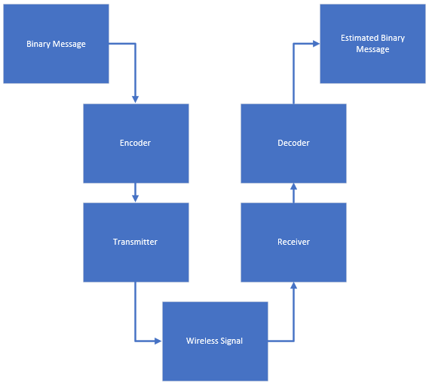
On the receiver end, there is another antenna that will capture the radio waves from which decoder will estimate the message. Naturally, this signal is contaminated with noise coming from natural sources such as lightning, or other wireless signals.
Next stages involve breaking it down into small manageable pieces involving: Mathematics on sinusoids, Sampling Theorem, and MATLAB software.
- Background Information
  - Signal Modulation Techniques
The question to answer here is how does one represents the binary message? The process of converting binary message into a sequence of signal is called signal modulation and it mostly revolves around manipulating properties of a sinusoid signals such as amplitude, frequency and phase.
    - Amplitude Shift Keying
ASK signal only encodes binary ‘1’ behind a carrier wave and ‘0’ is represented by the absence of signal. Bellow example in Excel, shows a binary sequence of ‘1 0 1’ with a bit period of 1 second and 5Hz frequency of a carrier wave.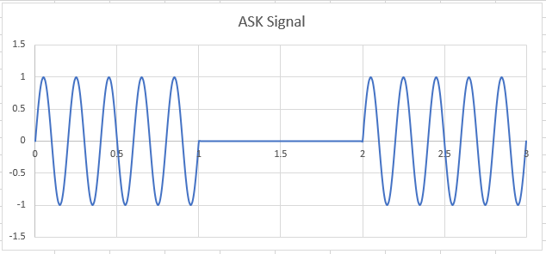
    - Phase Shift Keying
Unlike ASK, PSK has an actual signal to represent ‘0’ which is out of phase from the signal for ‘1’. Another example for the same sequence shows how change in phase appear to take shape of letters ‘W’ and ‘M’.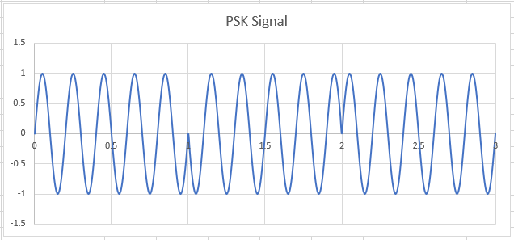

    - Quadrature Phase Shift Keying
This modulation variant uses ranges of phases to code digital bits. For instance, a pair of bits ‘0 0’ has 0° phase shift, ‘0 1’ pair has 90°, ‘1 0’ pair 180°, and ‘1 1’ has 270°.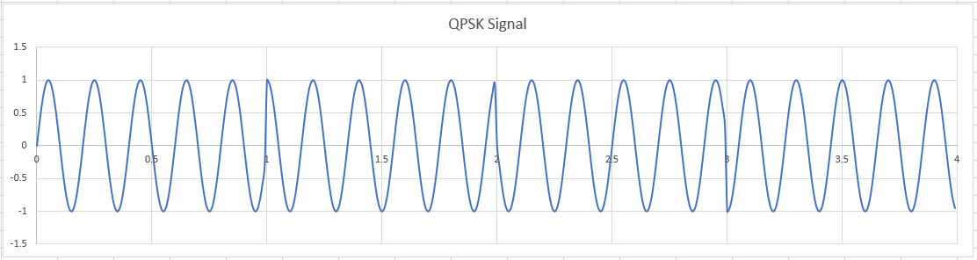
  - Maths on Sinusoids
To better understand signal properties and to aid intuition in further designs, it is good to try and visualize the results of some mathematics on sinusoids.
    - 2 Sine Waves
Formula for sine wave $A sin(2πft+∅)$ for frequency = 5Hz were used to produce this graph which includes results for product and adding.
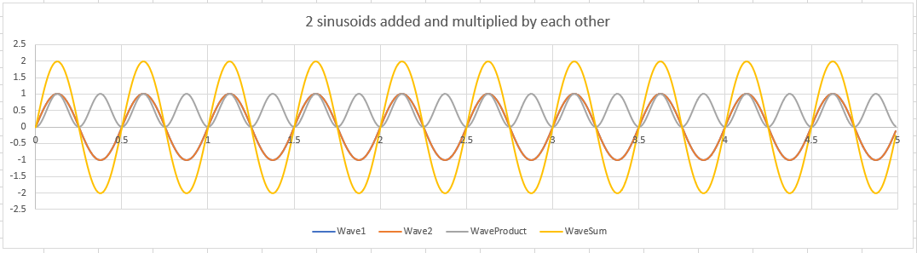
First thing to observe on this graph is the yellow ‘sum’ wave. There were no major changes to the shape of the wave apart from doubling its amplitude.
Multiplying 2 equal sine waves resulted in -ve side move to +ve side which simultaneously doubled its frequency. This could be useful to extract ‘1’ from signal in ASK model because it would only require a filter that would smooth out the AC component for a given bit period for it to work.
    - Phases
Introducing phases into the graph gave more results:
45°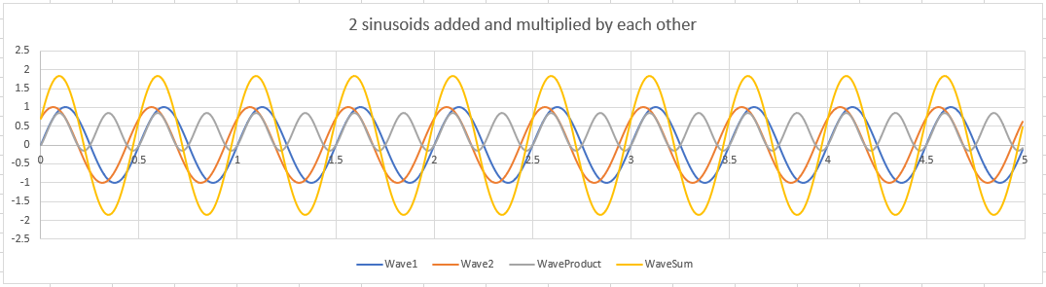90°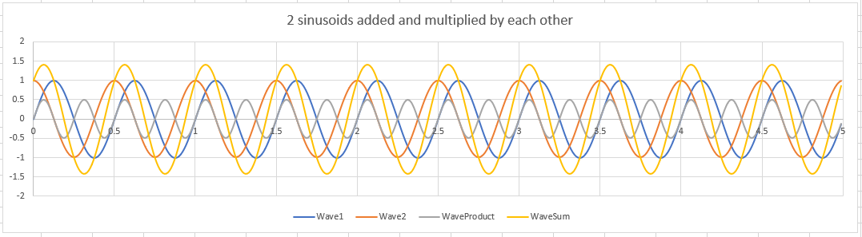135°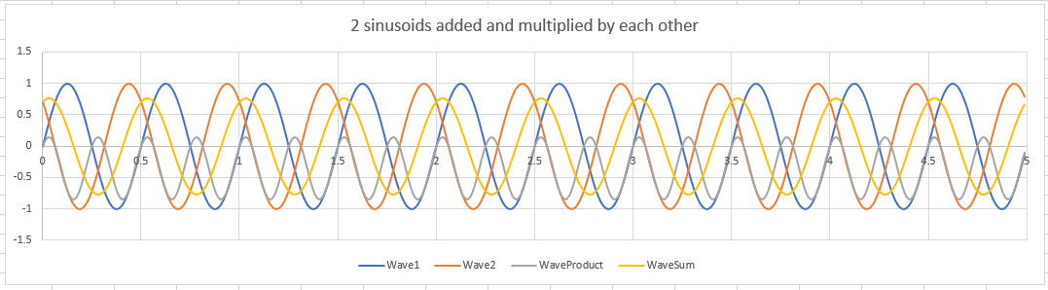180°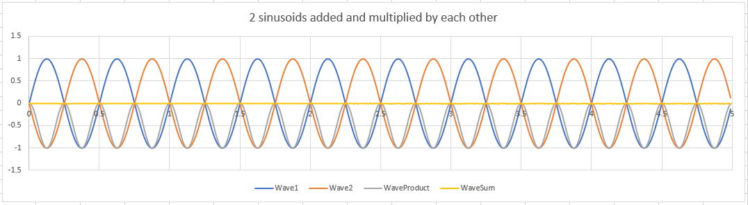
What can be observed from these graphs is that with each next phase angle the product of sine waves moves further down -ve side with the same frequency and addition resulted in two sine waves gradually cancelling each other out.
    - Product on QPSK signal
In an earlier example of QPSK, showing use of various phases, it is tempting to try product on this varying signal. This doesn’t give any interesting results for original phases intill trying inbetween phases such as 45°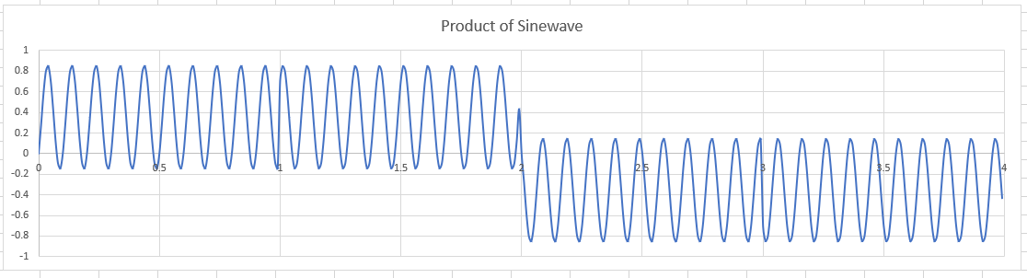135°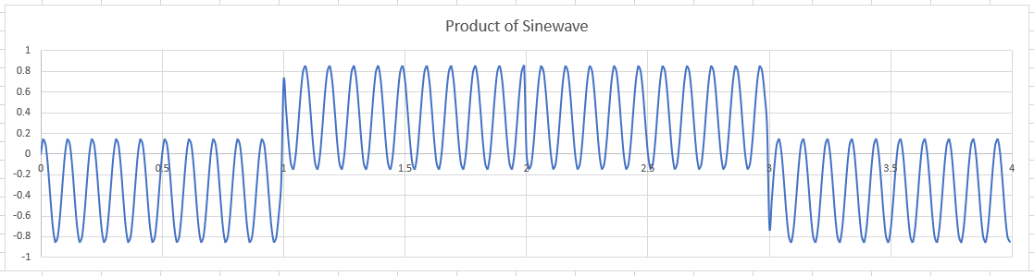
225°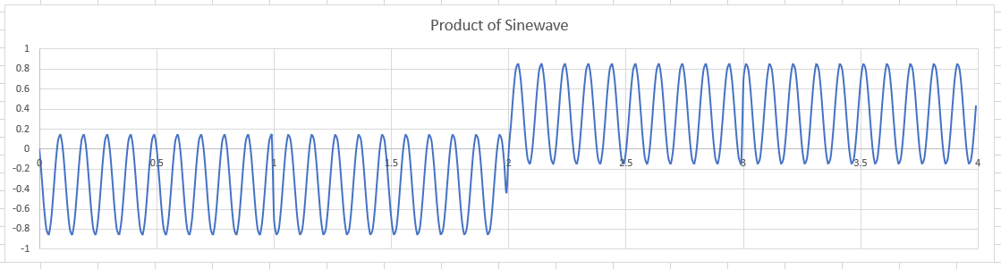
This shows how one can separate two sets of PSK signals by using product with in between phases component.
  - Digital Signal Processing
Above Excel graphs are great introduction into digital processing because it operates in very similar way. Said graphs are not true sinusoids but evenly spaced points on a vector graph connected together:
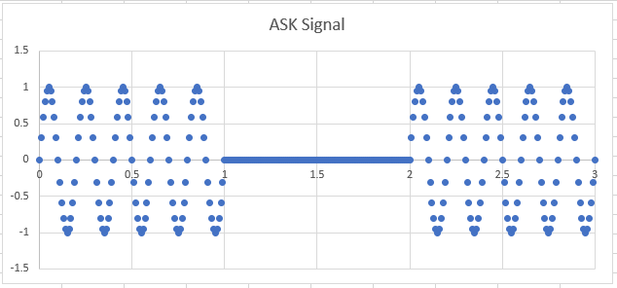
These points were calculated using formula but in real life those would come from analogue source and would be sampled at equal intervals of time ‘t’. This process of acquiring samples would be done by an A/D converter and it is called ‘quantization’[1].
For the same reasons, the digital signal processing can be known as discrete-time signal processing[2] where it does its work single sample at the time along side mathematic formulas. The sampling rate has a minimal requirements and it depends on a system. Typical amplications are shown in the table[3]:
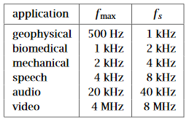

    - Aliasing
Aliasing is the result of undersampling the signal and cause system to fail at reconstructing it:
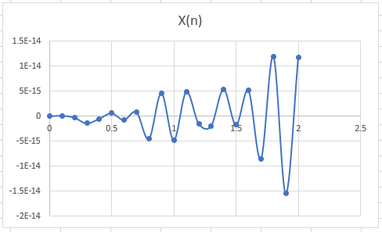
This problem is solved by using Nyquist Interval $[-\frac{f_{s}}{2},\frac{f_{s}}{2}]$[4] which states that minimal requirement for sampling is 2 samples for half cycle per second. For example, a frequency of 5Hz requires:
$$f_{s_{(min⁡)}}=5Hz*2samples*2halfs of cycle={20}/s$$
Therefore, $f_{s}= \frac{1}{20}=0.05$ is the minimum sampling rate for that frequency and tested in excel, solved the aliasing issue:
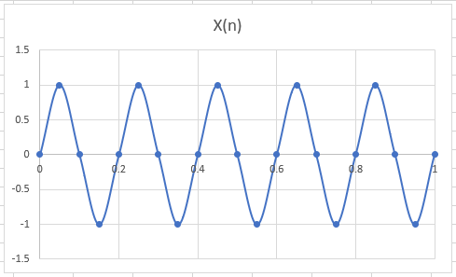
    - Minimal Requirements Model
Testing above theory required a simple model for signal modulation and filtering. Model was made out of repeating sequence stair, switch, sine wave, product, and digital filter design blocks. First binary sequence is generated and fed into a switch. Switch uses binary data as a threshold to output either Sine wave or zero. The sine wave box was set to 5Hz and sample time 1/20. Digital filter had a lowpass response and was set to ‘Hz’ with matching $f_{s}$ of a sine wave with $f_{pass}$ equal to half my data rate and $f_{stop}$ my frequency of carrier wave (just like in ‘Math on Sinusoids’ section, the sine wave will double its frequency regardless of phase when multiplied by itself). Lastly, the magnitude specifications were set to $A_{stop}=40dB$ inspired by a 4th order RC filter.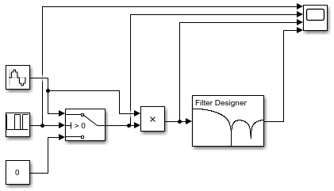
The scope output: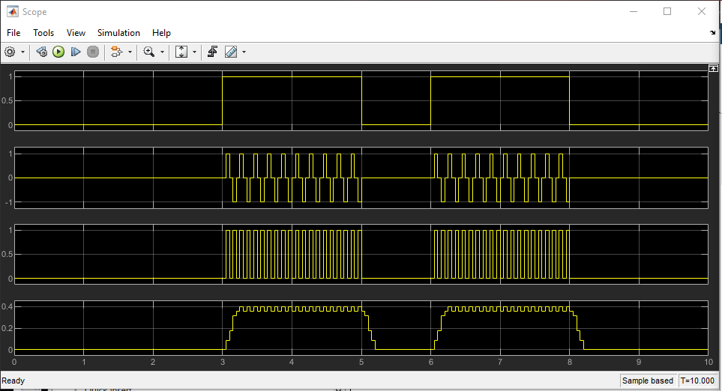
This plain ASK model uses a ‘Finite Impulse Response’ filter which will produce output sample by weighted sum of some number of input samples. This output will run only a finite amount of samples and the set of coefficients is an approximation to the ‘Inverserse Fourier Transform’[5]. This effect is what give signal a trapezium looking shape with each single output sample acquiring more input samples for summation.
- Simulation Models
Simulation models were done in Simulink MATLAB. MATLAB alone is a programming environment for scientists and engineers to apply complex mathematics in a user-friendly interface. Simulink is an extension to MATLAB where designing is carried out with building blocks with parameters instead of coding formulas.
The building blocks used in models were:
- Repeating Sequence Stair – Generates specified signal which in models took place of binary ‘1’ and ‘0’.

- Sine Wave Generator – Computes the sine wave by specified properties for amplitude, frequency, phase and more.
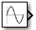 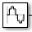
- Constants – Stores specified number.
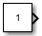
- Switch – Uses a threshold input to determine output coming from either of two remaining inputs.
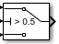
- Product, Add, Subtract – Performs a mathematical operation on two inputs.
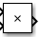 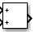 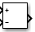
- AWGN – AWGN generates random noise based on Signal-to-Noise Ratio (SNR). It is used to simulate real-life noise that come from external sources.
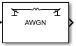
- Digital Filter Design – For all simulation models, specified to be FIR filter with a lowpass response type.
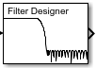
- Deserializer1D and Serializer1D – Moves input from serial data stream to parallel and vice-versa.
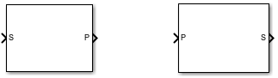
- Demux and Mux – Stands for Demultiplexer and Multiplexer and it takes the input parallel stream and splits into two serial outputs and vice-versa.

- Delay – Delays signal by specified number of samples.
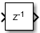
To make models more bias proof, each model sent same binary sequence ‘0 0 0 1 1 0 1 1’ and at the same frequency of a carrier wave.
  - Amplitude Shift Keying
For ASK, choice for carrier wave frequency was 250Hz at 1000 samples per second to satisfy Nyquist Interval. Before filtering, there was noise channel present to simulate real life noise with the ability to increase it using Signal-to-Noise Ratio. The FIR filter was set to ‘Hz’ frequency specification with $f_{s}=1000$ to match carrier wave and $f_{pass}$ and $f_{stop}$ to a range from 0.5 to 5Hz. Because the $f_{stop}$ is far from carrier wave frequency, filter is expected to smooth out AC component of carrier frequency very well.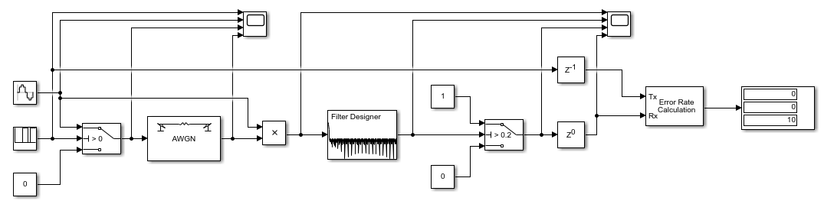The scope outputs:
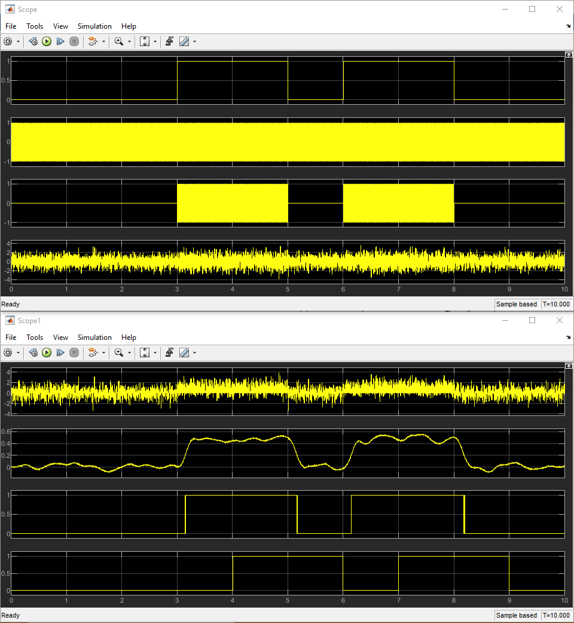
System works very well at SNR = 10 and it showcase use of Delay block to shift data to the next bit period. Notable signal property here is that it is very attenuated, ranging from around 0 to around 0.6 it gives little space to recognize logic ‘1’ and ‘0’ and with increasing noise, this range will be affected even more.
  - Phase Shift Keying
For PSK model, the choice for frequency and filter were the same because they worked well in ASK scenario. The difference here is the carrier wave which is 180° out of phase with the original wave to represent binary ‘0’ and a lower threshold for binary logic decoding.
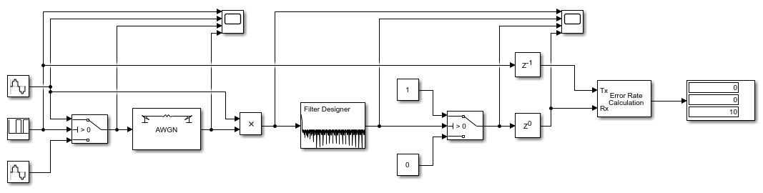
The scope output: 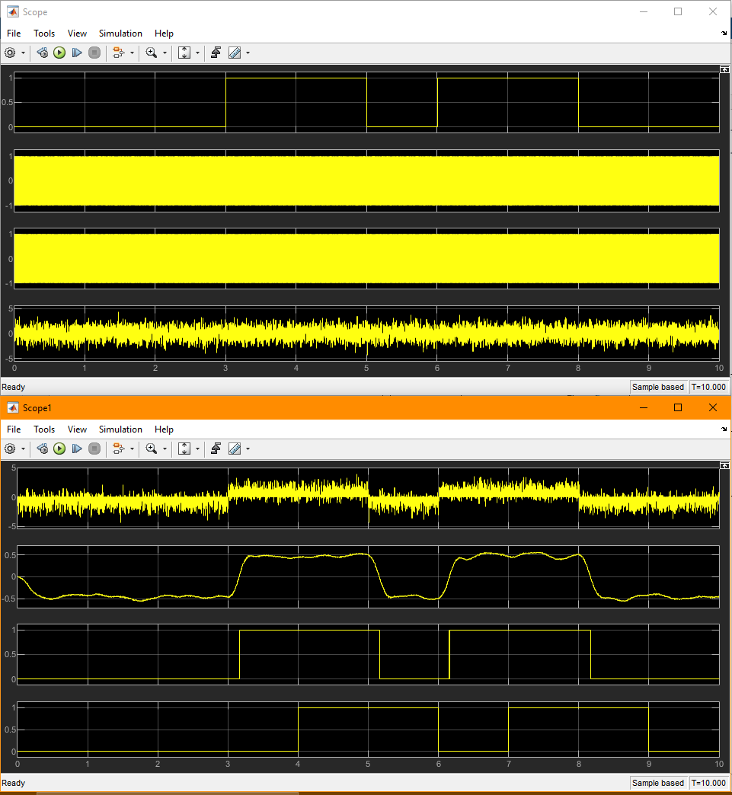
This system showcases the use of out of phase sinusoids described in Math section. Just as ASK system had a very low range, the PSK system has a much greater range to get logic ‘1’ and ‘0’. Because of this, this system is expected to outperform ASK in noise testing as signal would have much more space to get wobbly.
  - Quadrature Phase Shift Keying
This model, takes advantage of two sinusoidal properties of phase and amplitude. Shown in Math section, the summation of two carrier waves with different phases can modulate its amplitude depending on phase angle between two. Bellow model does it by deserializing data into two PSK 90° out of phase channels other called ‘I’ and ‘Q’, each having their carrier waves out of phase from each other.
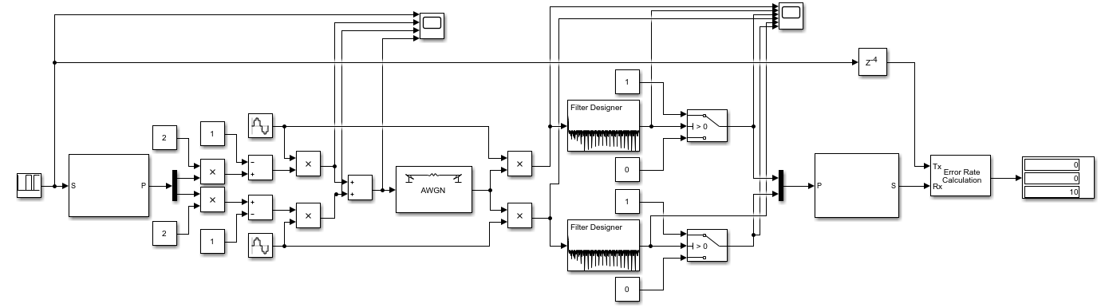
This model is a lot bigger with math blocks to create 2 channels. For ‘I’ channel as an example, after deserializing data, it ranges goes from 0 to +1 so by multiplying by 2, range goes from 0 to +2, lastly by subtracting 1, that range would now go from -1 to +1. That range would now mathematically determine two out of phase carrier waves for that channel of QPSK. Same thing goes for ‘Q’ channel but that channel has a 90° and 270° phase shift to original carrier wave for the two bits.
As an honourable mention to Fourier transform used by the filter, the QPSK signals have both respective delays to the output. Because of that, the systems’ serializer sampled the wrong bit at time interval = 0. Problem was solved by adding extra Computation delay to the Error Rate Calculation.
The scope output:
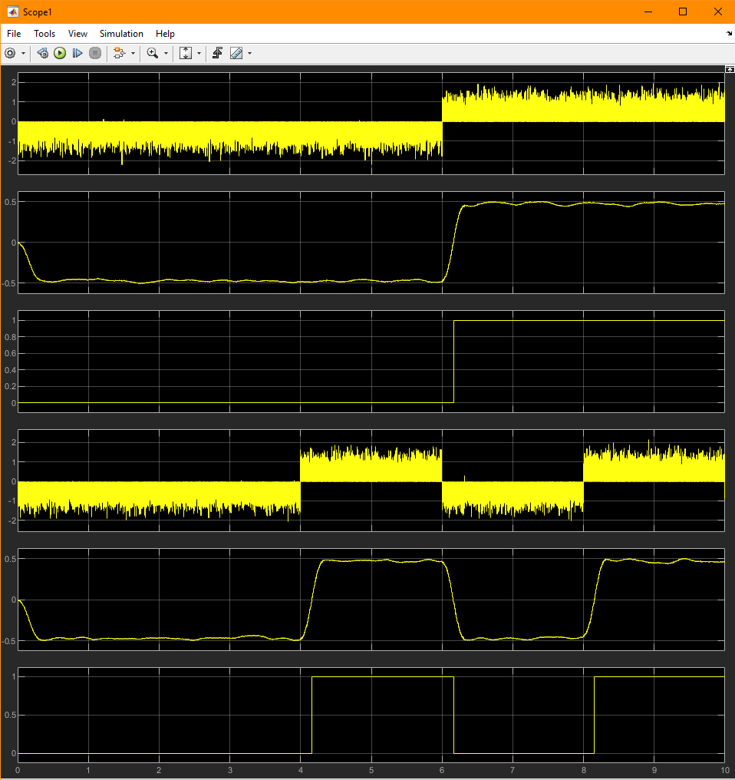
First thing to notice here are the two distinguish channels being decoded simultaneously. Regardless of that, the signals do not appear to be attenuated any more than PSK model. This shows clear advantage over the previous models from a simplicity of transmitting 2 bits at the same time without signal losses.

- Results
Plotting the results of Bit Error Rate on the graph: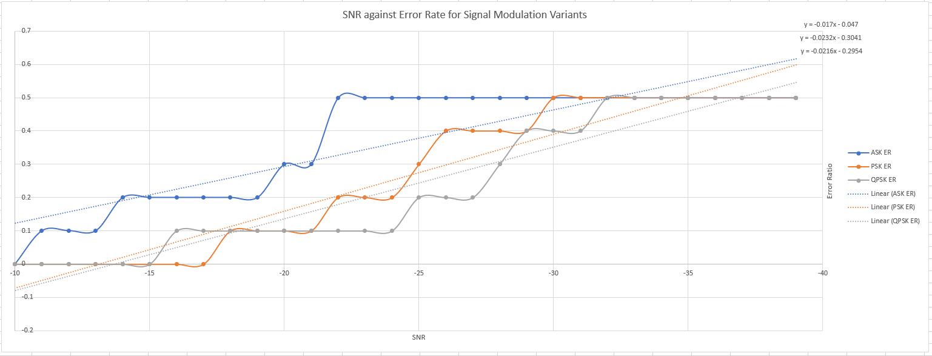
As expected, the ASK model was first to have errors. Most probable cause of that is the techniques’ slim room for error after signal passes the filter.
The PSK model completely upstage ASK one with its noise resistance as the signal has more room.
Regardless of transmitting 2 bits at the same time, the QPSK maintained great noise resistance of a PSK.
- Discussion
This paper explored fundamentals to signal processing in digital environment. The Excel graphs visualizing the effects of mathematical operations aided intuitive approach in designing stage and outline the merits of using sinusoids with different phases. Big find was the ability to encode multiple bits behind a single carrier wave of QPSK and then filter pairs out, as well as amplitude modulation by summing waves with different phase angles.
MATLAB can do everything Excel did here and more, in future designs, it would be best to explore MATLABs capabilities for handling advanced mathematics, graph visualizations, and its block building environment.
- Conclusion
The goal was to critically compare 3 signal modulation variants by looking for their strengths. Visualizing sinusoids was a great way to ensure that simulation will meet expectations. Exploring sampling theorem, shows minimal sampling requirements for any carrier wave. Investigating existing modulation techniques such as ASK, PSK, QPSK, gave an ability to make minimal requirement Modulator-Demodulator and digital filter.
- References
[1] S. J. Orfanidis. (1996-2009). “Introduction to Signal Processing”. Prentice Hall. Page 13.
[2] P. Horowitz, W. H. (2015). ”The Art of Electronics”, Third Edition. Cambridge University Press. Chapter 6.3.7 Digital Signal Processing. Page 418.
[3] S. J. Orfanidis. (1996-2009). “Introduction to Signal Processing”. Prentice Hall. Page 19
[4] S. J. Orfanidis. (1996-2009). “Introduction to Signal Processing”. Prentice Hall. Page 18.
[5] P. Horowitz, W. H. (2015). ”The Art of Electronics”, Third Edition. Cambridge University Press. ISBN: 9780521809269. Chapter 6.3.7, Digital Signal Processing. Page 419.

