

Project Management LCBB5005
~ Assessment 2 ~

Project Management: Google Headquarters Project in London, UK

Lecturer: Dr. Faizu Edu
Student: Vladimir Mihai BARA – 2110942

Table of Contents:

- Introduction……………………………………………………..3
- Analysis of Google Headquarters Project in London a success for future IT sector in the UK……………………………………….4
2.1. Assessment 1 success element from Google Headquarters Project, London………………….………………………………...4
- Successful Project Management and Google Headquarters in London:…………………………………………………………7
- The human role is a crucial factor in successful project management…………………………………………………….9
- Lessons to be learned from Google Headquarters Project in London………………………………………………………….9
- Conclusion …………………………………………………... .10
- References …………………………………………………….11

“Man’s mind, once stretched by a new idea, never regains its original dimensions.”
Oliver Wendell Holmes, Jr.

- Introduction:

This essay is based on the first assessment workout and offers a rationale ground for the success of the mega Project Management from the heart of London: Google Headquarters Project in London, King’s Cross, UK. This Google Headquarters Project is a definite success for the future IT sector of the UK, as has the potential to empower more big IT players to develop their Headquarters in the UK, especially in London. As London is the home of a significant number of IT companies; as of 2024, there are over 1847 IT companies located in the city, according to Tech Behemoths.
As we previously saw, the Project Management Institute (PMBOK, Project Management Institute, 2013, p. 417) defines a “project as a temporary endeavor undertaken to create a unique product, service, or result”. Also, Larson and Gray (2018) state that “Project Management provides people with a powerful set of tools that improve their ability to plan, implement, and manage activities to accomplish specific objectives”.
First, based on the first assignment analysis, we will offer the ground lines for Google Headquarters Project success. Secondly, we will rationalize the lessons that could be learned from the development of a mega project management. Nevertheless, we will evaluate how the leadership factor is crucial in the success of this London Google Headquarters Project.
All in all, our analysis of Google Headquarters Project in London will reveal the necessary path toward successful project management. By explaining the core elements of project management, we will conclude that Google London Headquarters is a successful project.

- Analysis of Google Headquarters Project in London a success for future IT sector in the UK:

Google is working to inaugurate a new Headquarters in the heart of London in King’s Cross; this project is a one-billion-pound project. Google is going to build one new building alongside King’s Cross Station – the first one built outside the USA. Google currently owns the building at 6 Pancras Square, and a third building will represent a campus to house approximately 7,000 Google employees.
Picture 1: Google Headquarters project with roof-top garden King’s Cross London (source: https://betterfutureawards.com/LON17/project.asp?ID=15932)
  - Assessment 1 success element from Google Headquarters Project, London:
In the first assessment, we analysed the life cycle of the project management, as Gray and Larson, (2006) present it under the following figure:
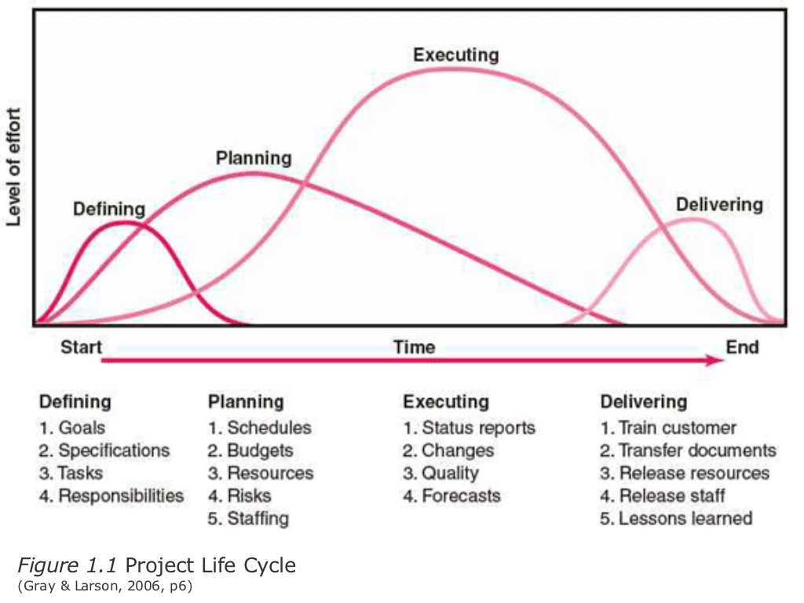
We all use in our daily life Googles products and services. Google LLC is an “American multinational technology company focusing on artificial intelligence, online advertising, search engine technology, cloud computing, computer software, quantum computing, e-commerce, and consumer electronics” (Google LLC, Wikipedia, 2013). One main reason why Google searches to consolidate its physical presence in the heart of London is a declaration of its power and position worldwide and the vision of Google CEO Sundar Pichai who believes in the alchemy of the people working together face-to-face: “We firmly believe that being together, having that sense of community is super important for whenever you need to solve hard problems. So, we don’t think the future is 100% remote. We value our offices; we value the culture” (Sundar Pichai interview in Time Magazine, Sept 2023).
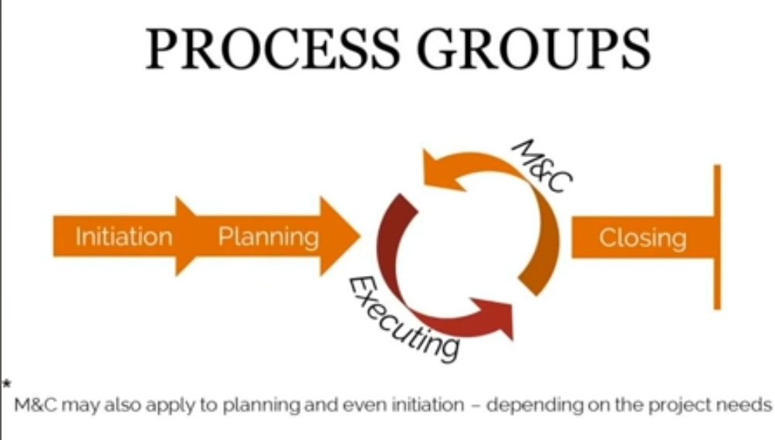
In the first assignment, we also looked to the process groups of Project Management:
Figure2. Project Management 5 Process Groups: Initiation, Planning, Executing, Monitoring and Controlling, Closing. (Deniz Sasal, 2017)
We were looking into details, in the first assessment, of the project Scope as “the work performed to deliver a product, service, or result with the specified features and functions” (PMBOK Guide, 6th edition, 2017, p.175), and also, on the SMART Goals. We gave details and we were deeply looking at the SMART Goals.

    - Project execution:
Following the step of well planning, the project execution it’s a straightforward step that follows the holistic Project Execution Plan (PEP) under the Plan, Do, Check, Act model.
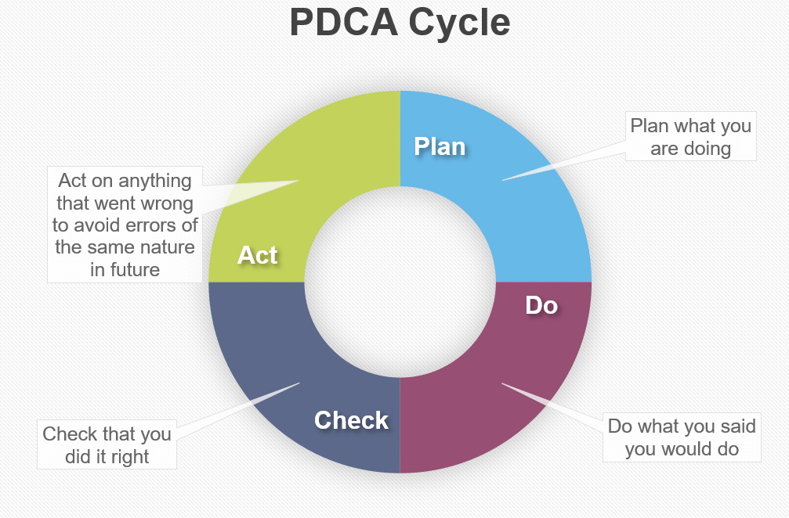
Figure 3: PDCA Cycle Diagram (source: https://www.qmsuk.com/news/what-is-the-plan-do-check-act-cycle)

    - Project monitoring and control:

The PM’s role is vital in the life of the project. In the monitoring and control step, the personality and the personal skills of the PMs are fully used by intensively communicating with the shareholders to motivate the builders to follow the plans and deliver the project according to the scope. PMs have the focus on initial timeframe, budget, and agreed quality.

    - Delivering or project closure:

At the end of the project, the PM will deliver Google London Headquarters to the sponsor of the project. Also, the PM will gather all the information on the process of the project and will do relevant reports on the budget, schedule, quality, risk, shareholders, and the lessons learned.
- Successful Project Management and Google Headquarters in London:
Successful project management typically involves achieving the project goals within the constraints of scope, time, quality, budget, and resources. Key elements of successful project management include:
1. Clear Objectives: Defining clear, realistic, and measurable goals and objectives.
2. Effective Planning: Creating a detailed project plan that outlines the scope, resources, timeline, and milestones.
3. Resource Management: Efficiently utilizing and allocating resources including personnel, time, and budget.
4. Risk Management: Identifying potential risks and developing strategies to mitigate them.
5. Communication: Maintaining open, transparent, and frequent communication with the project team and stakeholders.
6. Team Leadership: Providing strong leadership, direction, and motivation to the project team.
7. Stakeholder Engagement: Involving and keeping stakeholders informed and engaged throughout the project lifecycle.
8. Quality Control: Implementing quality management processes to ensure the deliverables meet the required standards.
9. Adaptability: Being able to respond and adapt to changes and challenges that arise during the project.
10. Successful Closure: Completing the project with a formal closure process, including the delivery of the project deliverables, and post-project evaluation.
The ultimate measure of success is often whether the project met its objectives and delivered value to the stakeholders within the agreed-upon parameters.
Google's new London headquarters, located in King's Cross, can be considered a successful project management endeavour based on several factors:
1. Innovative Design and Facilities: The headquarters, known as the "landscraper," is Google's first wholly owned and designed building outside the US. It features a 3-lane 25-meter swimming pool, a 200-meter rooftop running trail, and a large sports hall with views over London, showcasing Google's commitment to innovation and employee well-being (https://www.inc.com/business-insider/google-headquarters-uk-offices-london-landscraper-pool-basketball-court.html).
2. Community Integration and Retail Space: The headquarters plans to include 250 meters of ground-floor retail space, flexible event space, and various amenities for tourists and the community. This approach indicates a desire to integrate the building into the local environment and contribute to the area's vibrancy (https://9to5google.com/2022/04/14/google-wants-to-turn-its-king-cross-hq-into-a-destination-for-tourists-community-projects-and-more/).
3. Economic Impact and Job Creation: Google's decision to build this new headquarters in London is seen as a vote of confidence in Britain’s prospects post-Brexit. The project is expected to create 3,000 jobs and will be part of a campus that can house up to 7,000 employees, positively impacting the local economy (https://www.excel.london/google-commits-to-massive-new-london-headquarters).
4. Sustainability and Environmental Commitment: The building is designed to be low-energy and sustainable, featuring all-electric systems, solar shading instead of traditional heating methods, and the use of low-carbon local materials. This approach reflects Google's commitment to sustainability and reducing its carbon impact (https://9to5google.com/2022/04/14/google-wants-to-turn-its-king-cross-hq-into-a-destination-for-tourists-community-projects-and-more/).
Despite some delays in the project timeline, with initial completion slated for 2016 but still ongoing, the overall scope and execution of the project demonstrate a strong commitment to innovation, community integration, sustainability, and economic growth, key indicators of successful project management.

- The human role is a crucial factor in successful project management.

This paramount key to the success of project management will analyse now:
4.1. Leadership and Decision-Making: Effective leadership is essential for making key decisions, guiding the project team, setting clear goals, and ensuring that the project remains on track. As Google is one of the most important worldwide IT companies, will search to have the best in Project Management to lead its London headquarters development.
4.2. Expertise and Skills: The collective expertise and skills of the team members contribute significantly to the project's success. This includes technical skills, problem-solving abilities, and specialized knowledge relevant to the project.
4.3. Communication and Collaboration: Good communication is vital for coordinating tasks, sharing information, resolving conflicts, and ensuring that everyone is on the same page. Collaboration fosters a sense of teamwork and helps in pooling diverse ideas and solutions.
4.4. Risk Management: Humans play a key role in identifying potential risks, assessing their impact, and developing strategies to mitigate them. This involves both foresight and experience.
4.5. Motivation and Morale: The motivation and morale of the team can greatly affect the project's outcome. Keeping the team motivated and managing morale through challenges is a critical human aspect of project management.
4.6. Adaptability and Problem-Solving: Projects often face unexpected challenges. The ability of the team to adapt to changing conditions and solve problems creatively is a crucial human element.
4.7. Stakeholder Engagement: Engaging with stakeholders, understanding their needs and expectations, and managing their input and feedback is a vital human aspect that contributes to the project's success.
4.8. Quality Control: The attention to detail and commitment to quality by the human team ensures that the project's outputs meet the required standards.
In summary, while tools and processes are important, it's the human elements - leadership, expertise, communication, and adaptability, among others - that often make the difference between a project's success and failure.

- Lessons to be learned from Google Headquarters Project in London:

The Google London headquarters project, often referred to as the "landscraper," has faced significant challenges in its development. Initially announced in January 2013 with an intended move-in date of 2016, the project encountered delays and a lack of building activity, leading to multiple changes in deadlines. Original plans were eventually scrapped, and new plans were drawn up by Heatherwick Studios and Bjarke Ingels Group. Despite these setbacks, Google remains committed to the project, which is set to be one of its largest bases worldwide, capable of accommodating 7,000 employees. The building is designed with eco-friendly features and will include amenities like a swimming pool and running track. However, as of the last update, there was little to no activity on the construction site, and Google had taken up residency in a nearby existing building, as well as secured another smaller property at King’s Cross (https://thebossmagazine.com/google-london-hq/). And this situation is attributed to the Covid-19 pandemic times.
The Google London headquarters project has faced significant delays, which could be interpreted as challenges in its project management. The project experienced a delay of at least three years. The building's design was scrapped and reworked, leading to further postponements. This situation indicates difficulties in project execution and could be seen as a failure in terms of adhering to the planned schedule and design objectives (https://www.building.co.uk/news/google-hq-faces-at-least-three-year-delay/5068479.article) (https://www.dezeen.com/2015/06/15/thomas-heatherwick-rework-allford-hall-monaghan-morris-boring-google-london-headquarter-hq-plans/).

- Conclusion:
A mega project management like Google Headquarters in London is not an easy task for any professional Project Manager, especially since it’s developed in the heart of London’s transport at King’s Cross. An experimented Project Manager leading this mega project by engaging different teams and stakeholders is a paramount condition. At the same time, PM will apply all the project tools that he has for the success of the project.
The Google London Headquarters Project’s SCOPE is a must to be obsessively followed by the Project Manager, and his presence in the middle of the people during the project lifetime motivates the execution teams. As we have observed until now, even if the budget is generous, the timeframe represents the real nemesis especially since the COVID-19 restriction already impacted the project.
We evaluate that the Government restrictions imposed by the COVID-19 pandemic raised new issues for the Google Headquarters London Project. However, the aspects that are imposed by the UK Government cannot be avoided by any actor involved in this kind of mega project.
The personality of the PM and his communication skills would influence the teams to progress in this project and to deliver it as prevue. Nevertheless PM’s leadership is the key to ensuring a large success of this Google Headquarters London Project, as we observed the difficulties that has to encounter. Leadership and good communication skills would make the difference in the success of Google Headquarters in the London Project and its potential failure. In this case, there are several lessons to be learned and accepted in order to move forward with the development of the project.
As Google CEO Sundar Pichai believes in the alchemy of the people working together face-to-face – “We firmly believe that being together, having that sense of community is super important for whenever you need to solve hard problems. So, we don’t think the future is 100% remote. We value our offices; we value the culture.” – this is how the Project Manager has to believe that he could lead to the realization of this mega Project.
The importance of this project is paramount for Google and this represents an important step forward for the all IT London Industry. This new Google Headquarters will magnetize the IT engineers and also will state an important message for all big IT companies: Google is one of the biggest presence in the UK and worldwide.
- References:
  - Larson, E. and Gray, C. (2018) Project Management: The Managerial Process 7th Edition, McGraw Hill, p.6.
  - PMI (2017) The Guide to the Project Management Body of Knowledge (PMBoK), 6th Edition: PMI, p. 175; p. 417.
  - Meredith, J. and Mantel, S. (2009) Project Management: A Managerial Approach, Asia: John Wiley and Sons.
  - Sundar Pichai interview in Time Magazine, Sept 2023: https://time.com/5891624/sundar-pichai-time100-talks/
  - Silicone roundabout - How successful was Britain’s plan for its own Silicon Valley? | Torsten Bell | The Guardian Oct 2019.
  - Google Headquarters project with roof-top garden King’s Cross London, Source: https://betterfutureawards.com/LON17/project.a
  - PDCA Cycle Diagram, Source: https://www.qmsuk.com/news/what-is-the-plan-do-check-act-cycle.
  - https://www.inc.com/business-insider/google-headquarters-uk-offices-london-landscraper-pool-basketball-court.html access on December 2023
  - https://google-wants-to-turn-its-king-cross-hq-into-a-destination-for-tourists-community-projects-and-more/ access on December 2023
  - https://www.excel.london/google-commits-to-massive-new-london-headquarters access on December 2023
  - The Boss Magazine: https://thebossmagazine.com/google-london-hq/ access on December 2023

