

Filming the Force: The Influence of Police Auditing Videos on Social-Media and the Impact this has on Public Perceptions of British Policing

Jessica Jones
BSC36 Professional Policing Practice
Student Number: 2134526
January 2026
Word Count: 8800

Declaration
This work has not previously been accepted in substance for any degree and is not being concurrently submitted in candidature for any degree.
Signed: Jessica Jones
Date: 04/01/2026
Statement 1:
This dissertation is being submitted in partial fulfilment of the requirements for the degree of BSc36 Professional Policing Practice
Signed: Jessica Jones
Date: 04/01/2026
Statement 2:
This dissertation is the result of my own independent work/investigation, except where otherwise stated.
Other sources are acknowledged by footnotes giving explicit references. A bibliography is appended.
Signed: Jessica Jones
Date: 04/01/2026
Statement 3:
I hereby give consent for my dissertation, if accepted, to be available for photocopying and for interlibrary loan, and for the title and summary to be made available to outside organisations.
Signed: Jessica Jones
Date: 04/01/2026
Statement 4:
I hereby give consent for my dissertation, if accepted, to be available on the university’s IT system to those who have consent to use the system.
Signed: Jessica Jones
Date: 04/01/2026

Abstract
The visibility of police auditing videos on social media platforms raises significant questions related to how this content impacts the public’s perceptions of British policing. Often published to YouTube, self-proclaimed auditors and citizen journalists aim to hold policing professionals accountable, raising concerns surrounding legitimacy and demanding transparency. This study examines how police auditing content shared to YouTube influences their audience’s attitudes towards British policing, by using mixed-methods to combine research and qualitative content analysis of five UK-based police auditing videos. This study will also provide a thematic analysis of 500 accompanying viewer comments to scope the underlying stance of the viewer, whilst aiming to identify key themes and perspectives in relation to whether the videos enhance or diminish faith towards British police forces. Comments have been selected, analysed and categorised according to their primary stance, in order to highlight dominant patterns of public sentiment. In addition, an anonymous survey was distributed to current and former frontline police officers to explore a professional perspective on the growing practice of police auditing.
By focusing on UK based police auditing content, this study aims to address gaps in existing literature and contribute to ongoing debates around police legitimacy and the relationship between police forces and the digital age.

Table of Contents
Chapter 1 – Introduction | 6
1.1 Background and Context | 6
1.2 Research Discrepancies | 7
1.3 Research Aims | 7
1.4 Research Questions | 7
1.5 Rationale and Significance of This Study | 8
1.6 Structure of the Dissertation | 8
Chapter 2 – Literature Review | 9
2.1 Introduction | 9
2.2 Media Framing and the Construction of Police Representation | 9
2.3 Sousveillance, Public Auditing and Power Dynamics | 11
2.4 Police Legitimacy, Public Trust and Perceptions of Authority | 12
2.5 Digital Visibility, Social Media and Guidance for Organisations | 13
2.6 Police Auditing and Absence in UK Based Academic Research | 14
2.7 Summary and Identified Challenges | 15
Chapter 3 – Methodology | 15
3.1 Introduction | 15
3.2 Research Design | 16
3.3 Data Sources | 16
3.3.1 Police Auditing Videos | 16
3.3.2 YouTube Comment Sections | 16
3.3.3 Policing Professionals Survey | 16
3.4 Sampling Strategy | 17
3.4.1 Video Sampling | 17
3.4.2 Comment Sampling | 17
3.4.3 Survey Sampling | 18
3.5 Data Collection Methods | 18
3.5.1 Video Data Collection | 18
3.5.2 Comment Collection | 18
3.5.3 Survey Data Collection | 18
3.6 Data Analysis | 19
3.6.1 Content Analysis (Video Data) | 19
3.6.2 Thematic Analysis (Comments & Survey Data) | 19
3.7 Ethical Considerations | 20
3.7.1 Use of Publicly Available Data | 20
3.7.2 Survey Ethics | 20
3.7.3 Data Storage | 20
3.7.4 Researcher Positionality | 20
3.8 Limitations to Methodology | 21
Chapter 4 – Findings | 21
4.1 Introduction | 21
4.2 Theme Set 1: Police Portrayal in Auditing Videos | 21
4.2.1 Theme 1: Professionalism vs Confrontation | 22
4.2.2 Theme 2: Misunderstanding or Misapplication of Legal Powers | 22
4.2.3 Theme 3: Authority, Power Dynamics and Control of the Situation | 23
4.2.4 Theme 4: Escalation and Emotional Responses | 23
4.3 Theme Set 2: Audience Interpretation in YouTube Comments | 24
4.3.1 Theme 1: Support for Auditors and Distrust in Police | 25
4.3.2 Theme 2: Criticism of Auditor Behaviour | 25
4.3.3 Theme 3: Debates About Legal Rights | 26
4.3.4 Theme 4: Perceptions of Professionalism and Legitimacy | 26
4.4 Theme Set 3: Police Officer Perspectives and Survey Findings | 26
4.4.1 Theme 1: Auditors as Provocative or Hostile | 27
4.4.2 Theme 2: Anxiety Around Being Filmed | 27
4.4.3 Theme 3: Concerns around Public Misinterpretation | 27
4.4.4 Theme 4: Values of Transparency | 27
4.5 Comparative Summary: Conclusion of all Data Findings | 27
Chapter 5 – Discussion | 28
5.1 Introduction | 28
5.2 Interpreting Video Portrayals Through Media Framing Theory | 28
5.2.1 Selective Narratives and Auditor Control | 28
5.2.2 Highlighting Police Uncertainty or Mistakes | 28
5.2.3 Emotional Escalation and Performance | 29
5.3 Audiences as Co-Producers of Digital Content | 29
5.3.1 Polarisation of Interpretations | 29
5.3.2 Public Legal Reasoning | 29
5.4 Police Officer Perspectives: Feelings, Misrepresentation and Vulnerabilities | 30
5.4.1 Recognition of Transparency | 30
5.5 Linking Findings to Police Legitimacy and Public Confidence | 31
5.6 Case Example: Inspector Vs Auditor | 31
5.7 Interpreting Auditing through Sousveillance Theory | 31
5.8 Implications for Policing and Chapter Summary | 32
Chapter 6 – Conclusion | 32
6.1 Introduction | 32
6.2 Summary of Key Findings | 32
6.3 Addressing the Research Questions | 33
6.4 Contribution to Knowledge | 34
6.5 Limitations of Study | 34
6.6 Recommendations for Policing Practice | 34
6.7 Future Research | 35
6.8 Final Remarks | 35
Bibliography | 36
Appendices
Appendix A – Survey Questionnaire | 39
Appendix B – Comment Analysis Data Overview | 46
Appendix C – Referenced YouTube Videos Dataset | 64

Chapter 1: Introduction
1.1 Background and Context
Throughout the past decade, police forces across England and Wales have become under heightened scrutiny for their conduct and professionalism. Owen-Evans et al (2024) discusses the findings of a survey conducted in 2024, whereby 52% of adults in the UK stated that they have little to no confidence in the police’s ability to tackle crime locally. Owen-Evans et al highlights how this view has seen an increase of 13%, compared to a previous survey distributed in 2019.
The College of Policing (2025) reiterates this sentiment when focusing on the levels of public trust in the fairness of the police. The college explains that annual Crime Surveys conducted in England and Wales documents a decline in the public’s levels of trust in police fairness from 2019 onwards, despite remaining unchanged for the previous 15 years. The college highlights this decline using the below figure.
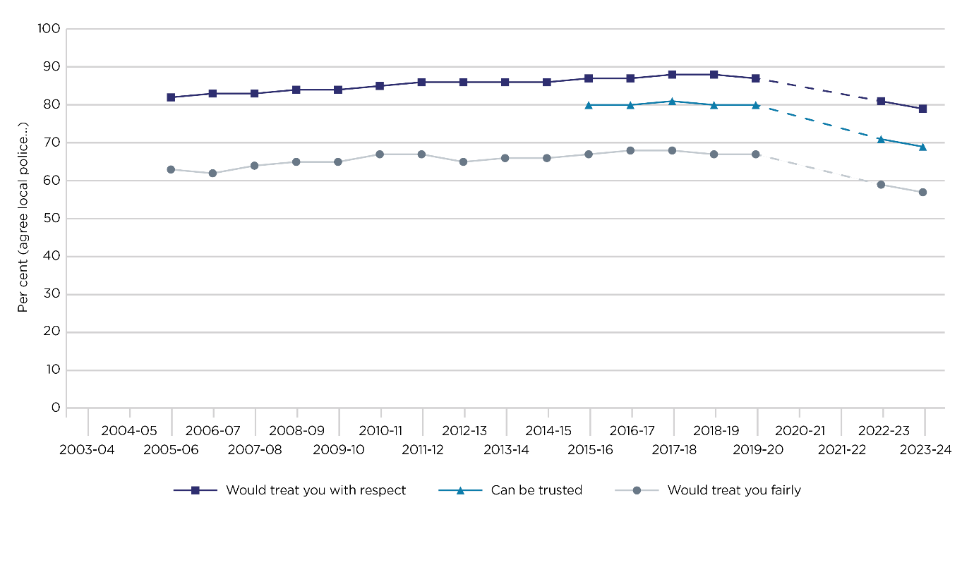
Figure 1.1 – Trust in Police Fairness (Source: College of Policing, 2025)

The rise of digital culture has created an opportunity for members of the public to conduct their own documentation of their interactions with policing professionals, assessing and discussing their abilities, knowledge and dispositions. This trending practice has formulated a term known as Police Auditing, which typically involves members of the public filming interactions with police officers in public spaces, often with the intention to test the officer’s knowledge and conduct by challenging what is perceived as misuse of power with the aims of promoting accountability.
Online platforms such as YouTube and TikTok have accelerated the visibility of these interactions and enable an opportunity for substantial public discussions. Edgerly et.al (2009) argues that social media platforms, such as YouTube provides individuals with the opportunity to create and widely disseminate their own opinions and political views. Social media platforms also create a space in which ideologies and opinions can be broadcasted to influence the opinions of the creator on to its general audience.

1.2 Research Discrepancies
Despite its increasing popularity, there is limited academic research into the phenomenon of police auditors in the UK. Existing studies relating to policing and digital media focus on official police communication strategies, the implementation of body worn video cameras and institutional techniques in to managing online public engagement. Few studies have been conducted in which consider how public-created content influences public perception of police forces across the UK, and the opportunities for debates surrounding organisational legitimacy remains unexplored. Whilst police auditing videos attract a significant number of views and provoke intense online debates, little is known about how these videos contribute to public understanding of policing and its role in the UK.
Existing literature does not discuss or focus on how police officers are typically portrayed or framed within the auditing content, nor does it expand on how the audience interprets the portrayals along with the perspectives of policing professionals in relation to citizen-led auditing. This gap presents challenges for both academic research and policing practices, questioning whether the phenomenon contributes towards a greater degree of public trust or reinforces negative perceptions of police officers. This must be explored in order to understand the broader implications that social media auditing has on British Policing.

1.3 Research Aims
The aim of this dissertation is to examine how UK police auditing videos influence public perceptions of British policing by analysing the portrayal of police officers within online content, whilst examining the response from audiences alongside the perspective of policing professionals.

1.4 Research Questions
This study will focus on the following questions.

- How are police officers portrayed in UK based police auditing videos on YouTube?

- How does the audience interpret and respond to these portrayals through YouTube’s comment section feature?

- How do serving or former UK police officers perceive the rise of police auditing videos and civilian led documentation?

- To what extent might police auditing videos influence public confidence in British police forces?

1.5 Rationale and Significance of this Study
The study is important to address what has become a rapidly developing area where academic research is limited. Police auditing videos are now a significant part of online content, yet their impact remains unexplored. Concerns surrounding police legitimacy has prompted a demand for more transparency and accountability by organisations, with social media offering a platform for expression. Police auditing videos often depict confrontational encounters or disputes between the auditor and officers over knowledge and legal powers, enabling members of the public to evaluate officers conduct, attitude and behaviours. Understanding how content of this nature influences the public is crucial for police forces across the UK to identify areas of improvement, particularly when seeking to maintain or re-build public trust at a time where informal digital-surveillance or sousveillance allows for more scrutiny than ever before.

1.6 Structure of the Dissertation
To achieve the above objectives, this dissertation will be structured as follows:
Chapter 2 – Literature Review
This chapter will examine existing research on media framing theories, sousveillance theories, digital visibility, recent incidents of police interactions and the public’s perception of policing within the UK. This chapter will identify the academic gap in research and situates the study within relevant and theoretical contexts.
Chapter 3 – Methodology
This chapter outlines the research design, sampling methods and data collection techniques alongside ethical considerations and content analysis. This chapter will begin a thematic analysis and interpretation of survey data dispersed to serving and retired policing professionals in South Wales.
Chapter 4 – Findings
This chapter will present the results from social media video analysis, comment section analysis and completed surveys from serving and retired policing professionals in South Wales. This chapter will be structured by key themes that address the research questions directly.
Chapter 5 – Discussion
This chapter interprets the findings in relation to existing literature and examines the implications for police legitimacy and public confidence, alongside an exploration of the role in which social media influences the perception of modern-day policing.
Chapter 6 – Conclusion
This chapter summarises the key findings and outlines the study’s contributions, whilst discussing limitations and offering recommendations for future research and policing practices.

Chapter 2: Literature Review
2.1 Introduction
This chapter reviews the key bodies of literature relevant to the study. Due to the limited availability of academic research surrounding this topic, the review will draw upon related fields including media framing theory, sousveillance and citizen-led accountability. This chapter also focuses on police legitimacy, digital visibility and public interpretations of British policing. Together, these themes provide a foundation to analyse how police officers are portrayed within online auditing videos and how audiences react and interpret such portrayals alongside the influence and broader implications on the perception of policing in the UK.

2.2 Media Framing and the Construction of Police Representation
The media framing theory offers a crucial foundation for understanding how police auditing videos contribute to the audience’s interpretation of the encounter. Entman (1993) proposes that the way in which the media depicts an event, or issue significantly contributes and influences the public’s understanding. The term framing refers to the way in which the information is selected, emphasised and portrayed, influencing the audience’s perception of the event. This theory suggests that mainstream media outlets make selective choices in relation to the use of keywords, image usage, metaphors, sources and narratives, in turn directing the audience’s attention towards an intended narrative and away from others. This suggestion was also reinforced by McGovern & Phillips (2017) who describes the relationship between police forces and mainstream media as multidimensional and complex. They explain that for police forces, the media provides an opportunity to create a public awareness of crime threats and events along with promoting recent organisational successes. McGovern & Phillips highlight the shifting relationship between the police and the media, where police organisations may supply information in a way for the media to frame events in ways that support police legitimacy. Alternatively, the media framing theory suggests that there is an opportunity for mainstream media outlets to shape a narrative that highlights misconduct, structural discrimination or accountability failures, which can explain why certain events dominate public scrutiny whilst others do not. Entman’s theory explains how the method of framing typically focuses on defining a problem, assigning the blame and proposing solutions which corresponds with McGovern & Phillips description of a complex relationship between the organisation and the media. Not only does this apply to non-fictional dissemination of information, but rather McGovern & Phillips suggest that fictional representations of policing such as crime dramas and pop-culture can have in influence on the public’s expectations of policing, particularly around a representation of authority, investigative procedures and uses of force.
When combined, both theories suggests that the media and popular culture play a central role in shaping public understanding of crime and policing through the practice of media framing. Police auditing videos typically place the auditor’s perspective at the forefront of the event, as the auditor has ownership of choosing when to begin recording, editing the content to a preferred style or narrating the events. This opportunity provides the auditor with a considerable amount of power in shaping the audience’s perception. Selective editing can amplify moments of tension, uncertainty or confrontation, potentially enabling a frame that portrays the officer as uninformed or unprofessional. This also proposes the possibility that the auditor may adopt a confrontational approach in an attempt to provoke a response from the officer, further influencing the framing of the interaction itself. These frames differ significantly from that of media produced by police organisations, that often aim to emphasise professionalism, transparency and legitimacy.
Studies conducted on social media policing suggests that online content tends to intensify emotional responses from users. Bullock (2025) examined the public sentiment towards policing in England by analysing reactions to a viral social-media post involving Metropolitan Police Officers in Kingston upon Thames from November 2023. This study collated over 5000 interactions from the social media platform X, formally known as Twitter, and identified that the dominant narrative in relation to the response from the public was negative. The key findings from the study suggest that the most common responses by the public contained themes of anger and disgust, accompanied by the use of symbols and emoji’s that were associated with themes of ridicule and frustration.
Bullock writes that the overall response from the public to the viral incident depicted a significant theme of scepticism surrounding the effectiveness and capabilities of the Metropolitan Police officers. The study highlights how social media platforms can rapidly generate and amplify public criticism of British policing, receiving emotionally charged responses from the audience which contribute to broader narratives of police effectiveness and public confidence. This finding appears to align with Entman’s argument that framing is not simply created by the content but is also shaped by the audience’s interactions, which corresponds with the suggestion that police auditors may construct visual narratives of police interactions to achieve an amplified response from the audience.

2.3 Sousveillance, Public Auditing and Power Dynamics
Sousveillance is a term which is used to describe the recording of a hierarchy. The phrase was created using the French word ‘Sous’ meaning ‘Below’ and refers to the concept of ‘Watching from Below’. Sousveillance typically refers to a practice where members of the public record, monitor or scrutinise figures of authority, including government officials and policing professionals. Fernback (2013) discusses Sousveillance and its concept and explores how everyday social media users utilise platforms such as Facebook in a way to form networks of resistance through sousveillance practices which holds authorities accountable or disrupt traditional power hierarchies. In contrast to traditional method of surveillance which typically stem from institutions downwards, Sousveillance challenges authorities by exposing those in a position of power to public scrutiny.
Police auditing sits firmly within this framework. Auditors film police officers not merely as observers but with active resistance, intending to challenge those with authority and asserting their legal obligations to record in public spaces. This creates tensions surrounding power, control and legitimacy between the police and the public. Goldsmith (2010) examines how recent technological developments such as the widespread use of mobile phones have transformed the visibility of policing. Goldsmith argues that the ability for any person to record, upload and create images of police actions and behaviours has shone a light on a new visibility that affects the image of policing organisations. Mobile phones and online platforms now allow a larger audience to witness police interactions and behaviours that would have previously remained hidden, and in some cases evidence of police misconduct can rapidly be shared. Goldsmith proposes that the increased visibility of recording police interactions with members of the public now contributes as significantly to the shaping of public perception as that of traditional news sources.
A significant incident which highlights tensions between the power dynamics of police auditing and police authority occurred in Merthyr Tydfil in August 2021. The Independent Office for Police Conduct (IOPC) (2022) reports that a serving Police Inspector confronted a 16-year-old boy who was filming outside of Merthyr Tydfil Police Station as part of a YouTube police audit video. The Inspector – who we will refer to as G - approached and confronted the male, who the court found was calmly recording the front of the building. It is reported that G demanded the name of the teenager and challenged his right to record in a public space. The teenager refused to provide G with his personal details, which resulted in the inspector arresting him on suspicion of terrorism offences, an arrest which was later deemed unlawful. Video footage was later recovered from the teenagers own recording, which displayed a use of force carried out by the Inspector almost immediately following both parties’ initial interaction. The teenager alleged that the officer placed him into an arm-lock, forcing him to his knees and pulling his hood in a way in which restricted the teenagers breathing. The report concludes that G used an unnecessary amount of force, particularly as the teenager displayed no physical resistance, which subsequently was deemed disproportionate and unlawful. The IOPC explains how G’s behaviour failed to meet the standards of professional conduct and his actions undermined public confidence in policing.
This case amplifies how the act of recording police officers can escalate into a confrontational encounter, particularly when officers misinterpret or are uneducated on the practice itself, perceiving recording of the interaction as threatening or intrusive. Furthermore, this case illustrates the role of sousveillance, whereby a member of the public is filming a person in a position of authority, ultimately holding that person accountable for their conduct. It can be argued that the conviction of G was possible due to the incident having been recorded from multiple angles, demonstrating how public recording can challenge official narratives. The case of G also reflects themes from Entman’s media framing theory. Following the incident and arrest of the teenager, the footage was widely circulated on social media and generated a considerable response and discussion, with many viewers expressing belief that the footage captured evidence of an excessive use of force and abuse of power.

2.4 Police Legitimacy, Public Trust and Perceptions of Authority
Bradford et.al (2021) defines police legitimacy as a degree in which members of the public believe that the police are entitled to exercise their authority. This is described as a strong psychological and societal belief that members of the public believe that the police are ‘correct’ and ‘proper’ authorities, as opposed to just powerful organisations. Bradford et.al explains that legitimacy within the context of policing is often assessed from the public’s perceptions, and how every-day people view, trust and accept police authority. They continue to explain the importance of legitimacy as successful policing techniques rely heavily on public co-operation, consent and compliance by the communities’ forces serve. In the UK, concerns surrounding police legitimacy have increased in recent years due to a number of high-profile cases involving allegations of police corruption, discrimination, abuse of power and failings of internal accountability proceedings.
Police auditing videos circulated on social media make real-life interactions more visible than ever. Depending on their framing, such videos may reinforce or undermine existing perceptions of legitimacy. In contrast, recordings of officers portrayed as respectful and knowledgeable may contribute to an enhancement of public confidence. Unlike footage which is governed by policies and guidelines such as the use of police body-worn cameras, police auditing videos are unregulated and influenced heavily by the creator’s objectives. This leads to concerns about representations that documented negative interactions with the police may be framed as evidence of misconduct.
Dowler et al (2007) investigates how various types of media consumption influence the public’s perception of police misconduct and overall faith in policing. Whilst they recognise that the media’s portrayals of the police can be both positive and negative, they examine how such portrayals can shape attitudes amongst viewers. The study found that media exposure significantly affects public perceptions of police behaviour, focusing on how heavy consumption of fictional crime-drama television tends to produce more favourable views of the police, whilst exposure to news stories which highlight incidents of misconduct tends to produce a more critical opinion. This study highlights the importance of understanding how media narratives contribute to public opinions and proposes that repeated exposure to negative portrayals can significantly affect the public’s level of trust, despite an incident or situation being isolated or uncommon.

2.5 Digital Visibility, Social Media and Guidance for Organisations.
The digital transformation of policing has generated increasing attention, with police forces utilising social media as an engagement tool to provide real-time updates and manage their own image. A study conducted by Meijer & Thaens (2013) proposed that digital engagement can improve transparency and foster trust between organisations and the public, however, also highlights the challenges that policing faces surrounding social media usage. Jones et al (2025) describes how police visibility online is challenged by existing narratives, institutional communications, news and media headlines alongside publicly generated police content. This suggests that police auditing videos can counteract a narrative in which the organisation aims to represent, often gaining attention as they appear to be more authentic, unfiltered and confrontational appealing to sceptics of police forces.
The online platform YouTube displays a growing number of police and public video interactions. The comment sections of these videos provide a space in which viewers can debate and critique an officer’s behaviour and abilities. Research conducted by Graham & Wright (2015) proposes that comment sections within online media platforms can contribute to a reinforcement of existing biases, generate collective narratives surrounding legitimacy and trust along with displaying a polarisation of opinions. They studied how these sections may influence the opinion of those consuming the content and found that comments left by individuals can shape and reinforce how others interpret certain events.
Guidance for professionals engaging with self-proclaimed YouTube auditors has been issued by the UK’s National Protective Security Authority (NPSA) (2023), which addresses the growing trend of individuals who visit public and semi-private sites to record and film staff, property or premises. The NPSA also explains that the aims of such individuals are often to create video content for online purposes which is frequently controversial in nature rather than purely informational filming. The guidance states that whilst filming from a publicly accessible location is generally considered legal, including the use of drones subject to particular airspace regulations, such activities can pose a security or reputational risk especially when interactions with staff escalate. The NPSA suggests that individuals should chat politely to eliminate tension, limit the interaction, and avoid making incorrect legal claims surrounding photography in a public setting.

2.6 Police Auditing and Absence in UK Based Academic Research
Despite its growing popularity, police auditing remains under-researched in the UK. Much of the existing literature is informal, appearing on social media, online forums or news articles as opposed to peer-reviewed research. In the UK, police auditors familiarise themselves with specific legislation, including the Police and Criminal Evidence Act (1984), various terrorism laws and public order legislation, in preparation to be questioned or confronted by police officers on and off duty. Therefore, it is imperative that the officers confronting individuals recording should also be equipped with the knowledge of recent legislation to avoid incorrectly accusing the individual of committing a criminal offence.
The lack of UK specific academic research means little is known about how auditing videos may represent police forces, and how viewers interpret these portrayals. Adding to this complication is the underrepresentation of how policing professionals themselves understand and experience the auditors. Given the scale of online engagement with many auditing channels attracting hundreds of thousands of viewers, the gap in research is significant. This dissertation will directly address the absence of academic literature surrounding the topic of online police auditing by combining three elements that have not yet been studied together, including:
Representation – Discussing video framing techniques and the intention of those capturing the encounters.
Interpretation – Responses from audiences and viewers on social media platforms.
Professional Perception – The perspectives of serving and retired policing professionals including their experiences in engaging with police and social media auditors.

2.7 Summary and Identified Challenges
The literature reviewed highlights several key insights into the topic of social media police auditing video content. The media framing theory demonstrates that the portrayal of police officers during interactions with the public, influences the audience’s interpretation or perception of the event. Sousveillance theory explains the rise in resistance from members of the public, and the growing demand for the public to hold those in positions of authority accountable for their actions. Furthermore, the dynamic of control and authority is recognised when reflecting upon the incident of a former police officer and a teenage YouTube auditor in the case of G, again reiterating the necessity for further academic research and awareness for serving and former policing professionals.
Existing literature has not examined UK police auditing videos in depth, nor has it considered how viewers and policing professionals interpret such content. Likewise, the broader implications of such content has not yet been explored, therefore this study aims to make a contribution towards academic research.

Chapter 3: Methodology
3.1 Introduction
This chapter outlines the methodological approach adopted to investigate how UK police auditing videos influence public perceptions of British policing. This chapter explains the research design, data sources, sampling strategy, data collection procedures, analytic methods and ethical considerations. This chapter concludes by identifying methodological limitations.

3.2 Research Design
Due to the limited academic research on police auditing, a qualitive, exploratory research design was developed. Cresswell (2013) proposes that a design of this nature is suitable for investigating complex, social phenomena where meanings, interpretations and experiences are central. A qualitive approach allows for an in-depth examination of how police officers are portrayed within online auditing videos, how the viewer perceives and interprets those portrayals and the perspective of policing professionals.
The research utilises a multi-method strategy, combining content analysis of police auditing videos, thematic analysis of YouTube comment sections and a qualitative survey of current and former UK based police officers.

3.3 Data Sources
3.3.1 Police Auditing Videos
The first data source consists of UK-based police auditing videos uploaded to YouTube by popular auditing channels. The selected video and analysis notes can be located in Appendix C. This content typically involves individuals recording police stations, police vehicles and police officers from a publicly accessible space. Often, the intention of the individual recording the footage is to provoke a response or record engagement from policing professionals, testing an officer’s knowledge and professionalism, and generally to gage how the professional reacts to a member of the public recording them. Videos were chosen as a data source as they are the primary form of content produced and consumed in relation to this topic.

3.3.2 YouTube Comment Sections
The second data set is the comment sections in which accompany the video recordings published to YouTube. The sampled comments and detailed analysis can be located in Appendix B. Comments provide access to the viewers interpretation of the events portrayed, along with any emotional or societal reactions. Comment sections provide an insight into how the viewer develops an understanding of the event, along with their stance on the situation.

3.3.3 Policing Professionals Survey
The third data source is an anonymous survey which was distributed to current and former policing professionals. Details of this survey can be located in Appendix A. The survey includes a combination of closed questions, requiring the participant to answer such questions with ratings or yes and no answers. The survey also includes open-ended questions in which the participant has the opportunity to discuss personal experiences or opinions relevant to the topic. This provides insight into how officers themselves perceive auditors, how they have experienced being at the forefront of an auditing encounter, or whether they believe auditing contributes or contradicts public confidence in British policing.

3.4 Sampling Strategy
3.4.1 Video Sampling
A sampling strategy was used to select five videos that met the following criteria:
- The video must have been recorded in the United Kingdom depicting British police forces.
- Uploaded by established auditing channels with significant follower bases
- Videos showing clear interactions between auditors and policing professionals.
- Videos with substantial audience engagement. More than 10,000 views and a utilised comment section.
- Uploaded within the past 5 years to ensure contemporary relevance and correspond with statistics from 2019 onwards.
Selecting videos with high engagement would suggest that the published content has a meaningful impact on the public’s perceptions. Selecting multiple videos for sampling allows for comparison across different interactions, therefore reducing the risk that findings are based on a single extreme example or one particular style of production. Details of the sampled videos can be located in Appendix C.

3.4.2 Comment Sampling
From each YouTube video, 100 comments were sampled. A purposive approach was used to ensure representation of the following:
- Comments supportive of the content.
- Comments critical of the content.
- Neutral or observational comments.
- Replies and discussion threads.
- Highly rated or up-voted comments.
This method of sampling allowed for a reduction of any biases associated with selecting comments only from a single perspective. Details of the selected comments can be located in Appendix B.

3.4.3 Survey Sampling
Recruitment of participants took place by distributing 100 surveys through professional networks within South Wales Police, of which received 28 responses. Participation was voluntary and anonymous. This sampling method is appropriate given the sensitivity of the topic and the relevance of the data collection in relation to the opinions and viewpoints of serving and retired police officers and staff. Whilst all participants were employed by South Wales Police, steps were taken to minimise bias by inviting participants from various police stations and force areas where possible. Details of this survey can be located in Appendix A.

3.5 Data Collection Methods
3.5.1 Video Data Collection
Videos were directly accessed using YouTube. No downloads or re-uploads of the content were made. Analysis was conducted using publicly accessible, published content with notes taken on the following areas:
- Officer behaviour – communication styles, professionalism, body language.
- Auditor behaviour – communication styles, body language, compliance.
- Legal references – references made by auditors and officers to UK legislation.
- The nature and escalation of the encounter.
- Power dynamics and verbal framing.

3.5.2 Comment Collection
Comments were accessed using the social media platform ‘YouTube’ and manually copied into a secure document. Each comment was assigned an anonymised ID username, and replies were grouped where relevant to preserve conversational patterns and context.

3.5.3 Survey Data Collection
The survey was created using a Microsoft Word document which was printed and distributed to various policing professionals. It consisted of the following:
- Demographic questions – questions surrounding the participants role and length of service.
- Closed questions on perceptions of social media police auditing videos.
- Open questions inviting a narrative response or personal opinion.
Examples of questions included in the surveys are:
“How do you feel about members of the public filming police activities?”
“Have you encountered police auditors? If so, please describe your experience”
“Do you think auditing videos influence public trust in policing? If so, how?”

3.6 Data Analysis
3.6.1 Content Analysis (Video Data)
Videos were analysed focusing on identifying patterns in:
- Police and auditor interactions.
- Use of legal language.
- Emotional tone
- Instances of escalation or de-escalation
- How authority is determined, established or challenged.

3.6.2 Thematic Analysis (Comments & Survey Data)
Comment data and survey responses were analysed using Bruan and Clarke’s (2006) six stage thematic analysis framework:
- Familiarisation with the data
- Generating initial codes
- Searching for themes
- Reviewing themes
- Defining and naming themes
- Producing the report
Identified themes included:
- Support for the auditors
- Criticism of police behaviour and actions
- Distrust in policing institutions
- Defence of police officers
- Debate over legal rights
- Concerns around provocation
- Professionalism and public expectations
- Officers’ awareness of auditors
- Concerns surrounding being recorded
- Beliefs about public misinterpretation
Using the same analytic approach for the comment section data and the survey data allowed for comparison between public and police perspectives.

3.7 Ethical Considerations
Ethical approval was obtained in line with the university’s guidelines. Key ethical issues included.

3.7.1 Use of Publicly Available Data
YouTube videos and comment sections are publicly accessible. In order to comply with an ethical best course of practice, the following steps were taken:
- Avoiding direct usernames and anonymising published comments.
- Avoiding quoting identifiable information.
- Sensitivity to any videos depicting active police incidents or persons reporting offences.

3.7.2 Survey Ethics
For police officers and staff participation, the following measures were implemented:
- Participation was voluntary
- No identifiable information was collected
- Participants could withdraw at any time
- Responses were stored securely

3.7.3 Data Storage
All data was stored in password protected files which were only accessible by the researcher, in accordance with GDPR and institutional data management policies.

3.7.4 Researcher Positionality
Notes were kept to ensure a balanced and critical review of the data to minimise any potential interpretation of the researcher’s perspective or opinion.

3.8 Limitations of Methodology
The study used samples of published online videos of auditor and officer engagements. Findings reflect interpretations rather than absolute truths. Auditors likely upload content that is dramatic or confrontational for entertainment purposes, which may not represent everyday police and public interactions. YouTube comment sections often reflect the views of highly engaged or regular consumers of content of that nature as opposed to members of the public with neutral opinions. Policing professionals who choose to participate in the survey may hold stronger views about auditing, either positive or negative.
Despite these limitations, the methodology is appropriate for the study and provides valuable insights into the perceptions and representations of policing in a social media context.

Chapter 4: Findings
  - Introduction
This chapter presents the findings from three data sources:
- Police Auditing Videos on YouTube
- YouTube Comment Sections
- A survey completed by current or former South Wales Police officers.
This chapter is organised thematically and addresses the research questions. First, the chapter analyses how police officers are portrayed in the videos. This chapter examines audience interpretations of the events portrayed, expressed through comments left underneath the YouTube content. Finally, this chapter will discuss the findings of the perspectives of former and serving policing professionals in South Wales Police, followed by a comparative summary of the findings across all three data sources.

  - Theme Set 1: Police Portrayal in Auditing Videos
This section will directly address research question 1: “How are police officers portrayed in UK police auditing videos?”. Analysis of the selected auditing videos referenced in Appendix A, revealed several recurring themes in the portrayal of police officers. These portrayals were shaped by not only the officer behaviour, but also by the auditor’s style of filming, narration, editing and commentary.

    - Theme 1: Professionalism verses Confrontation
Across the selected videos, officers were portrayed in contrasting ways. Some officers displayed clear professionalism – maintaining a calm attitude, using measured communication styles and explaining a knowledge of legal powers and rights. These officers were framed favourably, with the auditor sometimes acknowledging their conduct and professionalism.
In contrast, other encounters showed visible tension or conflict. Officers appeared uneducated, defensive or frustrated when challenged about legislation and use of legal powers, particularly whilst being recorded in a public setting. These moments were often emphasised by the auditor through close-up filming, repeated questioning and assertive narration.

Example Transcript evidence:
Video 2 (Appendix C) – “You’re Being Detained” - AUDITING BRITAIN (2023)
03:26 – After hearing the grounds for his detention, the auditor challenges both officers reasoning and asks if this is reasonable to “infringe on my freedom”. Officer 2 answers “Yes it does”. The auditor asks again why his behaviour has grounds for him being detained, and officer 2 says “I’ve just explained twice, I don’t need to go through it again”.

    - Theme 2: Misunderstanding or Misapplication of Legal Powers
A common theme was officers demonstrating uncertainty regarding the legality of photography or their grounds for engagement. This has been displayed in the following ways:
- Officers referencing terrorism legislation incorrectly.
- Requests for personal details without a legal obligation or justification.
- Confusion surrounding the officer expressing “reasonable suspicion”
- Incorrect statements about the auditor’s rights to photograph or record police stations in public spaces.
These instances were often highlighted by the auditor, reinforcing a narrative that the police have a misunderstanding of legislation and UK laws, or that the auditor had a better knowledge of legislation than the serving officer. Most interactions displayed the auditor correcting the officer and educating them on UK legislation. This theme aligns with existing literature suggesting that the public filming interactions with police can expose gaps in legislation awareness or a misuse of power.

Example Transcript evidence:
Video 4 (Appendix C) – “Police Put in Their Place by DJ & PJ Audits” – PJ AUDITS (2023)
01:50 – Officer 1 tells the auditors that her job is to find out what the purpose of the recording is for and makes reference to “you could be terrorists for all I know”. Both auditors laugh. Auditor 2 questions the officer and asks, “do you suspect us of terrorism?”.
02:55 – Officer 1 has explained that the police have received a report of males flying drones above buildings in the area and her purpose is to find out what the reason for the drones is. Auditor 2 responds with “do you understand that it would be lawful to fly a drone in this area?”.

    - Theme 3: Authority, Power Dynamics and Control of the Situation
Power dynamics were central to the portrayal of officers. Several videos showed officers attempting to exert control over the situation by ordering the auditor to stop filming, requesting identification, demanding movement away from police premises and attempting to restrict access to publicly accessible areas.
The auditor’s refusal often shifted the power balance, presenting officers as authoritative but vulnerable to being challenged by an individual failing to comply with their orders. This supports the relevance of sousveillance, as auditor-filmed material reframes the traditional power dynamic between figures of authority and members of the general public.

    - Theme 4: Escalation and Emotional Responses
In some videos, interactions escalated quickly, sometimes due to tone, misunderstandings or auditor provocation. Emotional responses included elements of frustration, irritation, raised voices and defensive body language such as posture and stances.

Example Transcript evidence:
Video 2 (Appendix C) – “You’re Being Detained” - AUDITING BRITAIN (2023)

13:09 – 13:50 – The auditor states that he wants a copy of the search record at that instant. The officers request his details. The auditor is aggressive, shouting at the officers and demanding that they provide him with a copy of the search record. Officer 3 insists that he requires the auditors’ details for a copy of the record, to which Officer 1 interjects and tells officer 3 that he does not require his details. Officer 1 previously identified himself as a Detective Inspector, and the auditor states to the others “Do as the inspector says”.

4.3 Theme Set 2: Audience Interpretation in YouTube Comments
This section will directly address Research Question 2: “How do viewers interpret and respond to these portrayals?”.
Comment analysis showed that audience reactions often form strong, polarised narratives about policing. These comments were analysed and categorised by their primary stance, according to whether they primarily expressed support for, or criticism of police, auditors, both, or neither, whilst recognising that negative comments towards police does not necessarily imply support for the auditor and vies-versa. The primary stance approach was selected in order to determine the general orientation of the comment itself.

Figure 2 – Comment Analysis Data (Appendix B)

Comment analysis of the combined primary stance data across all five sampled videos reveals a dominant trend of criticism directed towards the police. As illustrated in Figure 2, the majority of comments, 58%, were categorised as Critical of Police. This highlights a prevailing scepticism or dissatisfaction with police conduct and engagement during the sample videos. A further 17% of comments expressed support for the auditor, suggesting that a notable proportion of viewers agreed with the practice. Neutral or unclear comments accounted for 14% of the data, reflecting either lack of alignment with either party or ambiguity. In contrast, comparatively few comments were supportive of the police, contributing to only 4% of the collected data. Furthermore, 6% of comments displayed criticism towards the auditor, and comments critical of both parties represented by only 1%. These findings combined suggests that audience engagement with police auditing content on YouTube is predominantly shaped by critical evaluations of police behaviour with a limited display of defence or critique of both parties.

4.3.1 Theme 1: Support for Auditors and Distrust in Police
Out of the 500 comments reviewed, 17% of comments expressed a primary stance of support for the auditor. These comments included praise for the auditor on aspects such as protecting public rights, revealing misuse of power and refusing to comply with the officers’ orders.

Example Comments (Appendix B)
- “My God!!!! That male 'non police officer' was a total disgrace to his profession. Well done to you for putting him in his place. Excellent!!!!”

- “Well done, DJ! As usual, not only do you educate the staff, you also educate the officers.”

4.3.2 Theme 2: Criticism of Auditor Behaviour
In contrast to the above theme, 6% of comments did not support the auditor’s behaviour and questioned their motivations. Commenters criticised auditors for provoking police officers, seeking confrontation, creating content purely for financial gain and undermining legitimate policing efforts.

Example Comments (Appendix B)
- “Don't put yourself in this situation then.... oh wait, he needs a video to make money from YouTube”
- “This guy has zero respect for the police. He's unbelievably rude and engineers these situations for views. This is not auditing and all he's achieved is wasting people's time.”

4.3.3 Theme 3: Debates About Legal Rights
Many comments centred on legal interpretation, indicating that viewers were actively engaged in discussing topics surrounding an individual’s right to record in public. Comments engaged in disputes around definitions of public and private spaces, the correct use of stop and search powers and appropriate grounds for police engagement.

Example Comments (Appendix B)

- “Section 3.5.5 of police policy states they are contractually obliged to inform you they are recording under police policy and GDPR rules and regulations.”

- “Under Section 1 of Pace they're also supposed to tell the suspect what prohibited objects they are searching for. Didn't happen here, it was just a fishing exercise (probably to find some id). I was shouting at the screen "AB, ask them what they're searching for and why"

4.3.4 Theme 4: Perceptions of Professionalism and Legitimacy
Comments often evaluated the officer’s tone, body language and manner, linking these to perceptions of professionalism and legitimacy.

Example Comments (Appendix B)
- “That male copper was a disgrace. He looked like something the cat dragged in, chewing like an old cow. No pride and no respect.........FOR HIMSELF, how is anybody supposed to respect him?”

- “Well standards in our police service are definitely falling. What a sorry excuse for an officer he was both in attitude and dress. Scruffy, arrogant and ignorant.”

  - Theme Set 3: Police Officer Perspectives and Survey Findings
This section directly responds to Research Question 3: “How do police officers perceive the rise of citizen-led auditing?”
Survey responses highlighted mixed perspectives on social media auditors. Several themes were identified based on participants responses.

4.4.1 Theme 1: Auditors as Provocative or Hostile
Many officers described auditors as intentionally confrontational. Officers reported feeling provoked, set up, filmed without context and legally challenged in a way designed to elicit mistakes.
Officers expressed concerns that the auditors’ objectives were not surrounding police accountability, but rather to gain online publicity and monetisation.

4.4.2 Theme 2: Anxiety Around Being Filmed
Officers acknowledged that being filmed affects their performance and behaviour, with several reporting fear of being misrepresented, concerns around the videos going viral on social media, worry around disciplinary consequences and stress related to online reactions or abuse.

4.4.3 Theme 3: Concerns around Public Misinterpretation
Participants expressed concerns that the public may misunderstand footage which lacks situational context, interpret lawful actions as an abuse of power or misconduct, overgeneralise single or isolated incidents in policing as a regular occurrence.

4.4.4 Theme 4: Values of Transparency
Many participants acknowledged that public recording of police officers allows for a potential to promote officers professionalism, provide independent evidence, hold officers accountable for misconduct and aligns with modern expectations of transparency.

4.5 Comparative Summary: Conclusion of all Data Findings
Several patterns emerged across all three data sources.
Convergence
Both auditors and viewers scrutinise officer behaviour intensely. Officers recognise that power dynamics are shifted almost immediately when the realisation that they are being video recorded is apparent.
Divergence
Auditors portray police officers through critical and sometimes hostile framing. Viewer perspectives differ, with some supporting the auditors and others alleging antagonistic behaviour. Officers displayed vulnerability and fear over being misrepresented by selective editing techniques.

Chapter 5: Discussion
5.1 Introduction
This chapter discusses the findings presented in Chapter 4, in relation to existing literature and the research objectives.

  - Interpreting Video Portrayals Through Media Framing Theory
The analysis of auditing videos demonstrates that police officers are framed in ways that significantly shapes how viewers interpret their behaviour. This mirrors the central argument of Entman (1993) media framing theory, which proposes that the way information is presented can influence the audience’s perspective or interpretation.

    - Selective Narratives and Auditor Control
Auditors exercise control over various aspects of the published content. Auditors decide when to begin recording, what is recorded, how conversations and interactions are edited, voiceovers inserted into the footage during editing periods to direct a desired narrative, and which legal arguments are emphasised or removed.
Selective framing enables auditors to position themselves as defenders of public rights and entitlements, whilst presenting police officers as uneducated, defensive or corrupt. These findings support Goldsmith’s (2010) view of social media as a site where alternative narratives of policing challenge representations made by police organisations.

5.2.2 Highlighting Police Uncertainty or Mistakes
Misunderstandings of legislative knowledge particularly around photography, terrorism legislation and what is considered “suspicious” behaviour, often appear prominently in the selected videos. As Dowler (2007) argues, repeated exposure to negative policing portrayals cements public perceptions despite when such incidents are isolated or uncommon.

5.2.3 Emotional Escalation and Performance
The selected videos displayed many auditors adopting a confrontational style of communication, subsequently promoting tension and creating compelling dramatic content for viewers to consume. The presence of visible frustration or verbal escalation from police officers’ feeds into this framing, presenting the encounter as evidence of aggression.

  - Audiences as Co-Producers of Digital Content
YouTube comment analysis showed that audience interpretations are far from passive. Viewers actively construct narratives and express interpretations which reinforce or reject the auditors framing, supporting Graham and Wright’s (2015) proposition that online comment sections act as arenas whereby opinions are debated and formed.

    - Polarisation of Interpretations
Two primary interpretative positions were noticeable within the comment sections.
Position A: Pro-auditor and Anti-Police
Viewers adopting this stance frequently viewed officers as incompetent, aggressive, or unprofessional. Many expressed praises towards the auditor for holding police officers accountable and exposing what was described as unacceptable behaviour. Opinions were present surrounding the perception that should these interactions not have been recorded, then episodes of misconduct may otherwise have gone unnoticed.

Position B: Pro-Police and Anti-Auditor
Other comments expressed criticism towards auditors, alleging that their behaviour was antagonistic and provocative. Viewers appeared to criticise the auditor’s behaviour, describing their actions as harassment, or opportunistic rather than legitimate accountability work.
The polarisation demonstrates how audiences draw on their existing attitudes towards policing, supporting arguments that trust is shaped by pre-existing beliefs surrounding accountability and fairness in authority.

5.3.2 Public Legal Reasoning
Viewers frequently debated the legality of elements surrounding filming in public settings, what is considered as reasonable suspicion, legitimate grounds for stop and search powers to be utilised along with misuse of legislations relating to terrorism offences. This supports the idea that online policing content contributes to informal public education on legal issues and legislation, recognising that some comments provided misunderstandings and spreads misinformation.

  - Police Officer Perspectives: Feelings, Misrepresentation and Vulnerabilities
Survey findings showed that many officers perceive auditors as negative overall, displaying perceptions of auditors being intentionally provocative and antagonistic.
Many participants perceived that auditors aims and objectives are primarily focused around “setting traps”, deliberately provoking confrontational situations and testing the officer’s knowledge for entertainment purposes. It can be argued that this perception contributes to occupational stresses which can influence the officers’ abilities and professionalism when dealing with real encounters.
Participants also recognised that these videos remove the context of the situation, highlighting moments of tension and present lawful decisions as misconduct. Officers also recognised that the auditor has the power to edit the footage to remove moments of compliance or explanations, again leading to a misconception that the officer is uneducated.
This reinforces Goldsmith’s (2010) argument that digital visibility can make policing more vulnerable to “context collapses”, where nuance is lost in the favour of viral simplicity.

5.4.1 Recognition of Transparency
Despite the above mentioned concerns, participants also noted that filming interactions between police and the public can improve the requirement for professionalism, along with protecting officers from false allegations. Participants recognised the importance of embodying accountability and supported the possibility for positive encounters to support themes of public trust and confidence in frontline policing professionals.
This contrast is significant and identifies that officers are not entirely opposed to members of the public recording interactions thereof but expresses concerns surrounding fairness and accuracy of the published content.

  - Linking Findings to Police Legitimacy and Public Confidence
The aim of this study was to explore whether police auditing content online has any influence on public perceptions of UK policing. The findings suggest that the content does have an impact, however the impact is not uniformly displayed across audiences.
Viewers with pre-existing perceptions of police officers may interpret police auditing videos as confirmation of their belief. The possibility for selective framing to occur, combined with emotionally charged comment sections can create areas where distrust becomes enhanced and projected. Isolated incidents of mistakes, errors and lawful decisions framed in a negative way can contribute to broader negative perceptions of policing. This supports Dowler’s (2003) thesis that media can amplify rare events as the norm.
Conversely, police auditing videos which depict the officer engaging in a calm, lawful and respectful manner will likely improve perceptions particularly when auditors fail at their objective, that many participants suggest is to provoke or arouse conflict. This demonstrates that auditing videos can serve as evidence of positive policing incidents and supports an increase in confidence and legitimacy.

  - Case Example: Inspector Vs Auditor
The case provides a powerful illustration of the tensions identified in the findings. The incident whereby a South Wales Police Inspector was found to have assaulted a teenage auditor reflects several key themes. These include the following:
- Misapplication of legal powers
- Rapid Escalation
- Forced accountability
- Public Reaction
This case is one that strengthens the argument that police auditing contributes to enforcing accountability, legal rights and entitlements and legitimacy issues between policing and professionalism.

  - Interpreting Auditing through Sousveillance Theory
Mann’s concept of sousveillance is highly relevant to the findings of this study. Police auditing represents the “watching from below” concept, that disrupts traditional power structures and forms of surveillance.
Auditors use accessible technology to scrutinise police behaviour during real-life encounters, shifting control over visibility levels and influencing others to challenge those in positions of authority.
Findings support the argument that increased visibility exposes policing professionals to misrepresentation, misinformation, emotional public reactions and a greater pressure to adopt accountability. This is reinstated by participants who expressed feelings of vulnerability within their concerns of being recorded on duty.

  - Implications for Policing and Chapter Summary
The findings of the study suggest several implications exist for traditional policing practice within the UK.
A common theme is the requirement for improved officer training, particularly a clearer guidance on the public’s rights surrounding filming and photography. Also highlighted is the need for additional training in areas of communication, particularly whilst being recorded, along with a consistent and uniformed understanding of relevant legislation. Policing organisations can recognise that officers who are captured displaying calm, respectful methods of communication within the videos often receive more positive public responses.

Chapter 6: Conclusion
  - Introduction
This concluding chapter will summarise the key findings, reflect on the contribution of this study whilst acknowledging limitations and outlines recommendations for policing organisations to improve practice and future research.

  - Summary of Key Findings
The findings demonstrate that police auditing videos play a role in shaping how policing is perceived on digital platforms. Analysis of the videos uncovered that police officers may be portrayed through selected narratives which emphasise moments of uncertainty, conflict or legislative disputes. Whilst some videos portrayed officers acting with professionalism, others highlighted misunderstandings of legislation and the escalation of behaviour between both parties.
Audience analysis revealed that YouTube comment sections functioned as spaces for debate, where users expressed supportive and opposing views for both auditors and police officers. Survey responses from policing professionals revealed opposing perspectives, with participants perceiving that auditors as confrontational, motivated by entertainment and financial gain. The officers also expressed anxiety towards being recorded by social media auditors, raising concerns related to public misinterpretation or the risk of selective editing. Contrastingly, participants also acknowledged that public recording of policing interactions can enforce professionalism and accountability, having a positive impact on the perception of policing as a whole.

  - Addressing the Research Questions

- How are police officers portrayed in UK police auditing videos?
Officers are portrayed through frames which often emphasise authority, legality and emotional responses, which has the potential to be shaped by the auditor’s control over filming styles and narration.
- How do viewers interpret and respond to these portrayals?
Viewers interpret auditing videos in polarised ways. This includes supporting auditors as accountability enforcers or criticising the auditors as provocateurs intending to incite conflict. These interpretations are underlined by existing attitudes towards policing and contribute to pre-determined beliefs or experiences.
- How do Police Officers perceive the rise of citizen-led auditing?
Officers perceive auditing as challenging and stressful, though some recognise its potential benefits for transparency and professionalism. Officers acknowledge that online content creators maintain a level of control in how the portrayals are displayed through editing and framing opportunities. Survey participants acknowledge feelings of anxiety surrounding how such portrayals can influence public perceptions.
- To what extent might Police Auditing Videos influence public trust in British Policing?
Auditing videos can both undermine and enhance trust, depending on existing opinions, perceptions and beliefs surrounding policing as a whole. This is determined by contributing factors relating to officer behaviours, audience interpretation of situational circumstances and opportunities for selective editing and framing techniques.

  - Contribution to Knowledge
This study targets a specific gap by focusing on UK police auditing content only, an area which has received little academic attention. Secondly, the study integrates three perspectives, representation, audience interpretation and police officer perceptions, which are rarely combined for examination. Furthermore, by applying framing theories, sousveillance theory and concepts of procedural justice, the study contributes to the understanding of how digital accountability practices shape police legitimacy in modern day society. This also reinstates how the recordings are not primarily utilised for social media or entertainment purposes but may become evidentially valuable when contributing to real life convictions.

  - Limitations of the Study
Despite its contributions, the study has displayed limitations. The qualitative sample size limits generalisability and the selection of highly engaged auditing videos may overrepresent confrontational encounters due to entertainment value. YouTube comments reflect the views of active users rather than overall members of the public. This study recognises that those viewers are likely to frequently engage with content of the same nature and themes. It also recognises that YouTube algorithms may promote specific videos, increasing levels of engagement and activity, therefore understanding that the popularity of such videos is not due to audience choice alone. Survey participation may be subject to self-selection bias and additionally the study relies upon publicly available content, those of which are self-reported encounters which may have underlying agendas.

  - Recommendations for Policing Practice
Based on the findings of this study, several recommendations are presented which may contribute to mitigating conflict and strengthening public confidence.
- Improved Training
Improving training practices for officers surrounding the public’s legal and perceived rights to film or photograph in publicly accessible settings. This should include de-escalation and communication techniques whilst being recorded.

- Improved Officer Awareness
Further to the advancement of practical training exercises, policing institutions may benefit from educating officers and staff on the practice of social media auditing in general. As this phenomenon is relatively modern in nature, many officers may be unaware of the concept due to individual factors such as age, technological capabilities and understandings of social media.

- Clearer National Guidance
Clearer National Guidance on engaging with auditors would be beneficial to those who are engaging with auditors to ensure consistent and lawful responses. This would strengthen a uniformed approach to handling such interactions and reduce the frequency of misuse of legislative powers.

- Wellbeing Support
Wellbeing support for frontline officers who experience stress relating to high levels of digital scrutiny or traumatic interactions. Recognising the identification that many frontline officers feel anxiety when being recorded or presented online in a particular way primarily if that individual does not frequently engage with social media outside of their employment.

  - Future Research
Future research could expand this study by including larger datasets, comparative analysis across police forces or quantitative public surveys. Research that examines how repeated exposure to auditing content influences trust over time would be valuable in understanding long-term implications that content of this nature possesses. Further research could also explore the experiences of auditors themselves or examining the impact with relation to alternative social media platforms.

  - Final Remarks
Police auditing represents a significant shift in how policing is scrutinised in a modern day society. This study has shown that auditing videos are not neutral recordings, but portrayals that can shape public perceptions, influence police legitimacy and re-enforce the demand for police accountability. Understanding these dynamics is essential for policing practice as society continues to navigate the complexities of digital visibility and faith in modern day policing.

BIBLIOGRAPHY

- Bradford, B., Jackson, J., Milani, J. and Hohl, K. (2021) Identity, legitimacy and cooperation with police: Comparing General Population and a London street population. Available at: https://eprints.lse.ac.uk/108997/2/Manuscript_PPPL_revised.pdf (Accessed: 3rd November 2025)

- Bruan, V. and Clarke, V. (2006) ‘Using thematic analysis in psychology’, Qualitative Research in Psychology, 3(2), pp. 77-101. doi:10.1191/1478088706qp063oa. (Accessed 2nd November 2025)

- Bullock, J., & Dodsworth, F. (2025). Law, order, and social media: Perceptions of police effectiveness on X/Twitter. Crime, Media, Culture: An International Journal, 0(0). https://doi.org/10.1177/17416590251394705 (Accessed 26th November 2025)

- College of Policing (2025) Trends in satisfaction, trust and confidence over the past 20 years. Available at: https://www.college.police.uk/guidance/improving-public-confidence-police/trends (Accessed 19th December 2025)

- Cresswell, J.W. (2013) Research design: Qualitative, quantitative, and mixed methods approaches. 4th edn. London: SAGE Publications. (Accessed 2nd November 2025)

- Dowler, K. (2007) ‘Measuring general and specific community confidence in the Police: A multi-dimensional approach’, Policing: An International Journal of Police Strategies & Management, 30(1), pp. 130-145.

- Entman, R.M. (1993) ‘Framing: Toward clarification of a fractured paradigm’, Journal of Communication, 43(4), pp. 51-58. doi:10.1111/j.1460-2466.1993.tb01304.x (Accessed: 27th November 2025)
- Fernback, J. (2013) ‘Sousveillance: Communities of resistance to the surveillance environment’, Telematics and Informatics, 30(1), pp. 11-21. doi:10.1016/j.tele.2012.03.003 (Accessed: 23rd November 2025)

- Goldsmith, A. (2010),’ Policing's New Visibility’, The British Journal of Criminology, Volume 50, Issue 5, September 2010, Pages 914–934, https://doi.org/10.1093/bjc/azq033 (Accessed: 26th November 2025)

- Wright, S., Jackson, D. and Graham, T. (2020) ‘When Journalists Go “Below the Line”: Comment Spaces at The Guardian (2006–2017)’, Journalism Studies, 21(1), pp. 107–126. doi: 10.1080/1461670X.2019.1632733. (Accessed: 28th November 2025)

- Independent Office for Police Conduct (IOPC) (2022) South Wales Police Officer found guilty of common assault. Available at: https://www.policeconduct.gov.uk/news/south-wales-police-officer-found-guilty-common-assault (Accessed: 28th November 2025)

- Jones, M., Ralph, L., Millie, A., & Rowe, M. (2025). Policing and social media: Exploring police digital visibility. Criminology & Criminal Justice, 0(0). https://doi.org/10.1177/17488958251338572 (Accessed: 28th November 2025)

- Meijer, A. and Thaens, M. (2013) ‘Networked coproduction of public services in virtual communities: From a government-centric to a community co-creation perspective’, Government Information Quarterly, 30(4), pp. 446-456. doi:10.1016/j.giq.2013.05.011 (Accessed: 25th November 2025)

- National Protective Security Authority (NPSA) (2023) Social Media Auditors: Guidance. London: National Protective Security Authority. Available at: https://www.npsa.gov.uk/system/files/documents/npsa-social-media-auditor-guidance.pdf (Accessed: 28th November 2025)

- Owen-Evans, R. and Low, N. (2024) Public trust and confidence in the police. POST Horizon Scanning. London: UK Parliament. DOI: https://doi.org/10.58248/HS80. Available at: https://post.parliament.uk/public-trust-and-confidence-in-the-police/ (Accessed: 18th December 2025)

- Police and Criminal Evidence Act (PACE) (1984). London: HMSO

- McGovern, A. and Phillips, N (2017) ‘Policing and media: Public relations, simulations and communications’, in Liebling, A., McAra, L. and Maruna, S. (eds.) The Oxford Handbook of Criminology. 6th edn. Oxford: Oxford University Press, pp. 642-666. (Accessed: 25th November 2025)

APPENDIX
APPENDIX A
Survey Questionnaire

This appendix contains the full text of the survey questionnaire distributed to serving and former police officers within South Wales Police. The questionnaire was used to gather data on the individuals’ perceptions of social media auditing practices. The questionnaire consisted of the following questions. Copies of the collected data set can be provided upon request.

Policing Personnel Perceptions of Public Filming and Social Media Auditing

You are invited to take part in an anonymous survey exploring the perceptions of serving and former police officer’s and staff’s perceptions of public filming of police activity and the rise of Social Media Auditors.
This survey contains no identifiable information, and you may skip any question. You may withdraw from the survey at any time. Responses are confidential and will be used for academic research only. Some questions relate to experiences with challenging encounters, and all findings shall be your own opinion or perceptions.
By completing this survey, you confirm that you understand the purpose of this study and consent to participate.

Please mark your answers with a ☑

Section 1
Demographic & Professional Background

- How many years of police service do you have?
☐ 0-2 Years
☐ 1-2 Years
☐ 6-10 Years
☐ 11-20 Years
☐ 20+ Years
☐ Prefer not to say

- What is / was your role within policing?

☐ Police Constable
☐ Sergeant
☐ Inspector or Above
☐ PCSO
☐ Special Constable
☐ Retired Officer
☐ Other (Please Specify) _______________________________________________
☐ Prefer not to say

- Have you ever been filmed by a member of the public whilst on duty?

☐ Yes
☐ No
☐ Unsure

- Have you ever encountered a Police Auditor?

☐ Yes
☐ No
☐ Unsure

Section 2
Please answer the following questions by circling the most applicable
1 (Strongly Agree) → 5 (Strongly Disagree)

- I feel comfortable being filmed by members of the public

1 2 3 4 5

- I believe members of the public have a right to film police officers in public places.

1 2 3 4 5

- I feel that Police Auditors often try to provoke a reaction from Police Officers / Staff

1 2 3 4 5

- Being filmed makes me more cautious in how I communicate.

1 2 3 4 5

- I am confident in my knowledge of the law relating to public filming.

1 2 3 4 5

- I feel that public filming increases transparency in policing.

1 2 3 4 5

- Public filming can undermine my ability to effectively do my job.

1 2 3 4 5

- Police auditing videos often present officers unfairly.

1 2 3 4 5

- Police auditing videos can damage public trust in policing.

1 2 3 4 5

- Police auditing videos can also highlight good practice by officers.

1 2 3 4 5

- I believe Police Forces should provide more training on how to handle being filmed by members of the public.

1 2 3 4 5

- The rise of police auditing videos on social media affects officer morale.

1 2 3 4 5

Section 3
Please answer the following questions and tick all that apply.

- In your view, what are the main motivations of police auditors?
☐ Accountability and Transparency
☐ Testing Police Knowledge
☐ Provocation
☐ Entertainment / Financial Gain
☐ Public Education
☐ Anti-Police Sentiment
☐ Other (Please Specify) ____________________________________________________

- What concerns do you have (if any) about being filmed on duty?
☐ Footage taken out of context
☐ Selective editing
☐ Safety Concerns
☐ Harassment or Provocation
☐ Fear of Disciplinary Actions
☐ No Concerns
☐ Other (Please Specify) ____________________________________________________
- Which legal powers are you most unsure about when members of the public film?
☐ PACE
☐ Terrorism Act Powers
☐ Public Order Legislation
☐ None – I feel confident
☐ Prefer not to say
☐ Other (Please Specify) ____________________________________________________

Section 4
Personal Experiences
- Please describe any experiences you have had with members of the public filming you whilst on duty.

___________________________________________________________________________
___________________________________________________________________________

- If you have encountered police auditors, how would you describe those interactions?

___________________________________________________________________________
___________________________________________________________________________

- What challenges do you feel police auditors create for front-line policing, if any?
___________________________________________________________________________
___________________________________________________________________________

- In your opinion, how do police auditing videos influence public perceptions of policing?
___________________________________________________________________________
___________________________________________________________________________
- How have you personally felt whilst being recorded by a social media auditor?
___________________________________________________________________________
___________________________________________________________________________

- What training, guidance or support (if any) do you think officers need when dealing with social media auditors?
___________________________________________________________________________
___________________________________________________________________________

- Is there anything else you would like to share about public filming or social media police auditing?

___________________________________________________________________________
___________________________________________________________________________

End of Survey
Thank you for your participation.

APPENDIX
APPENDIX B
Comment Analysis Data Overview
This appendix provides an overview of the comment analysis data collected from the selected YouTube videos. The full dataset, including all coded comments and categories is available as a supplementary Excel file. This file can be reviewed for a detailed breakdown of the coding process and comment classification analysis.

VIDEO SAMPLE 1 – COMMENT ANALYSIS
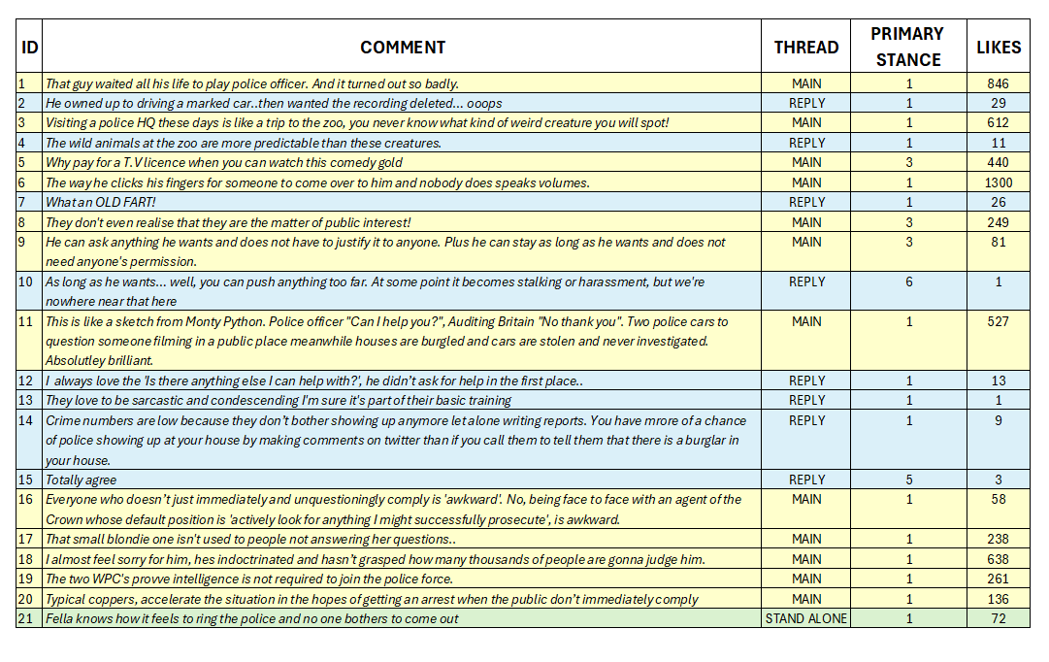
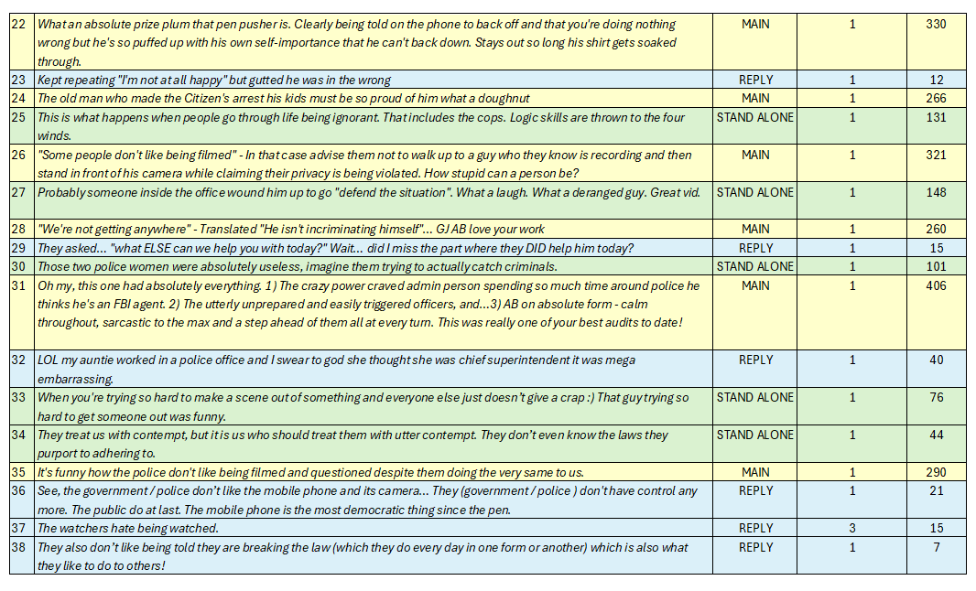
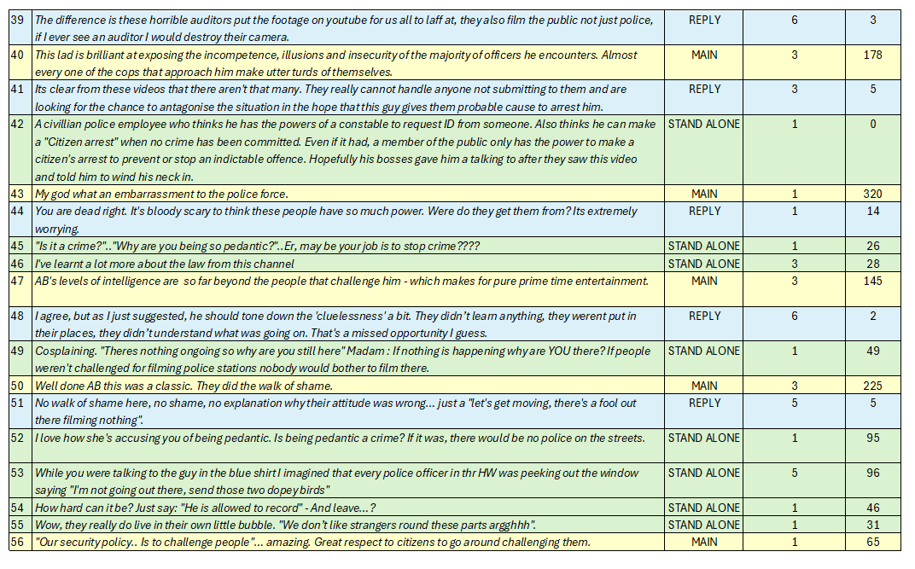
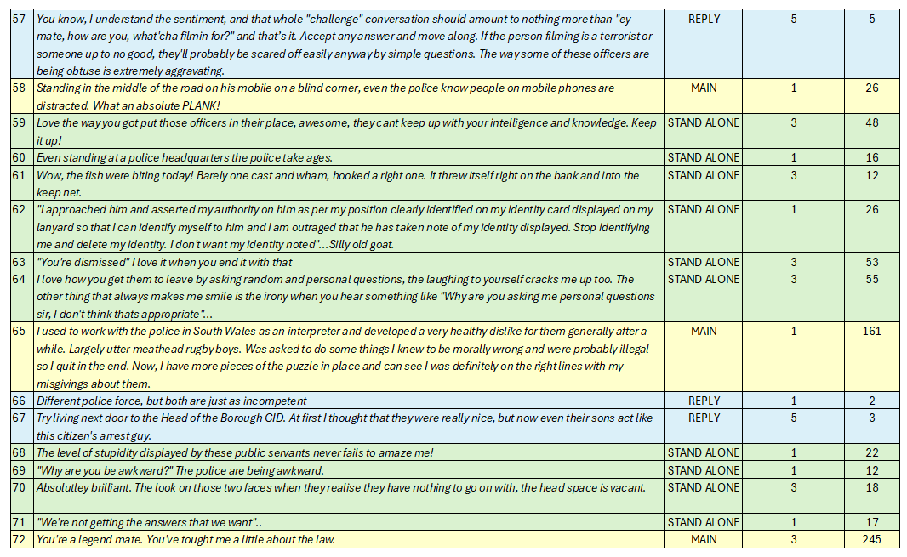
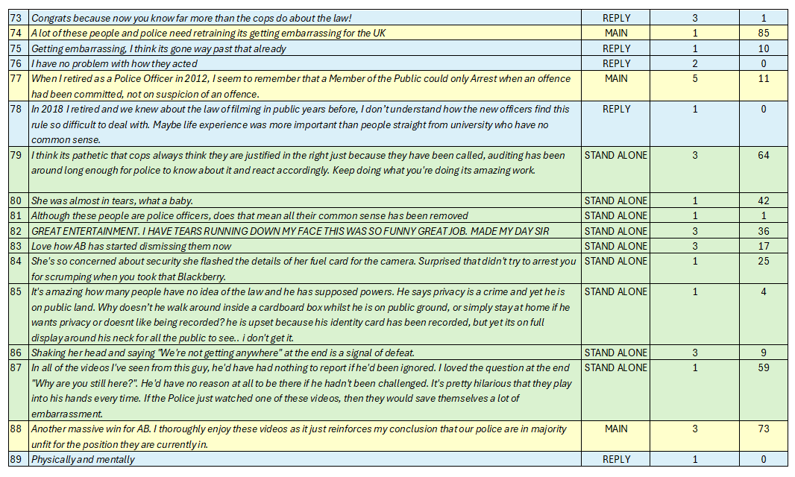
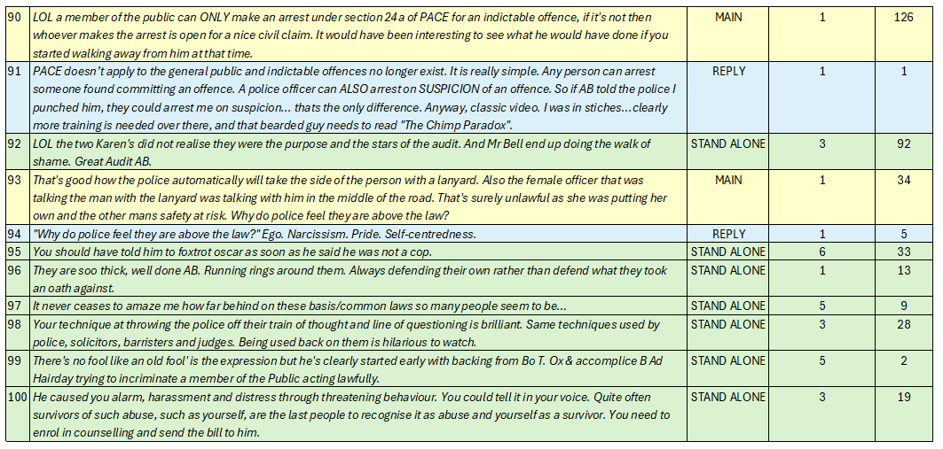

VIDEO SAMPLE 2 – COMMENT ANALYSIS
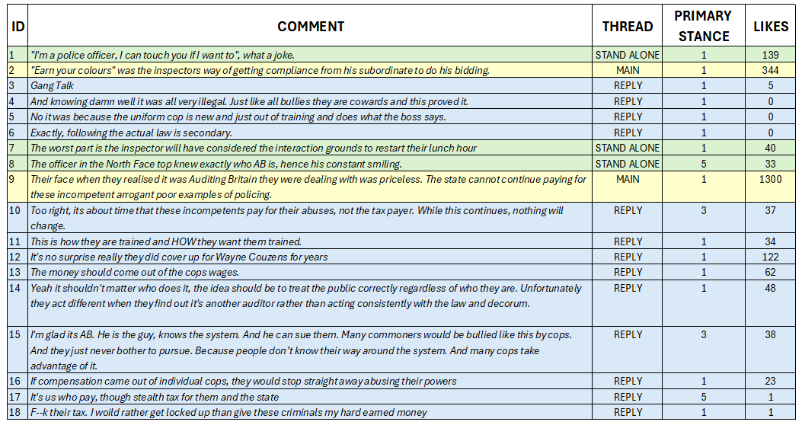
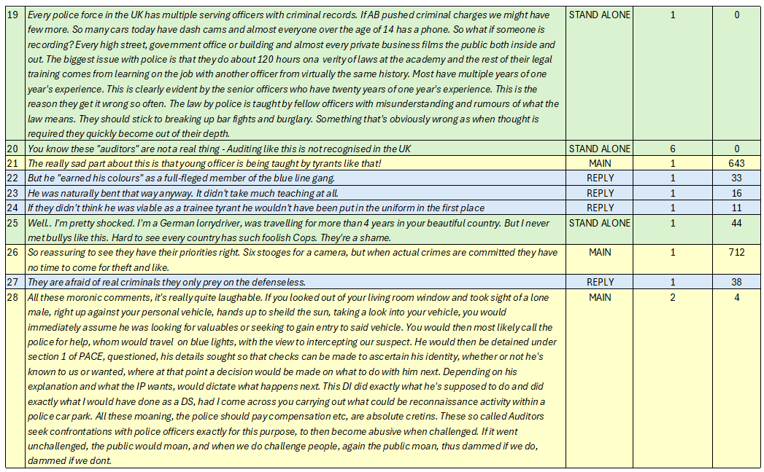
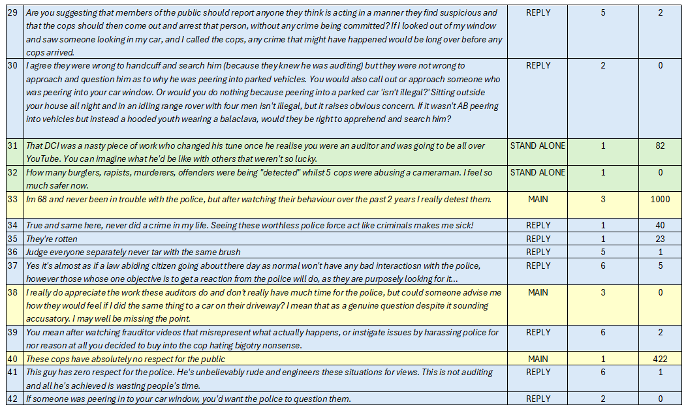
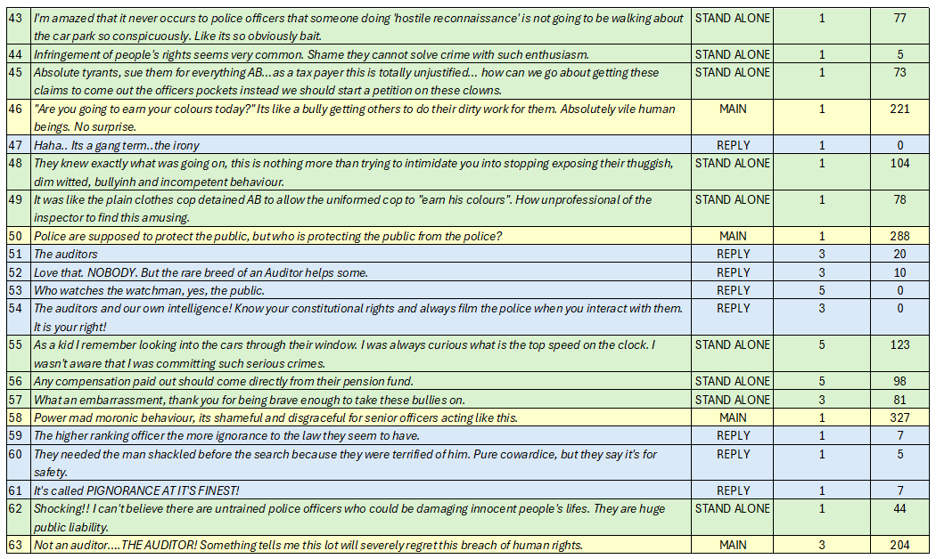
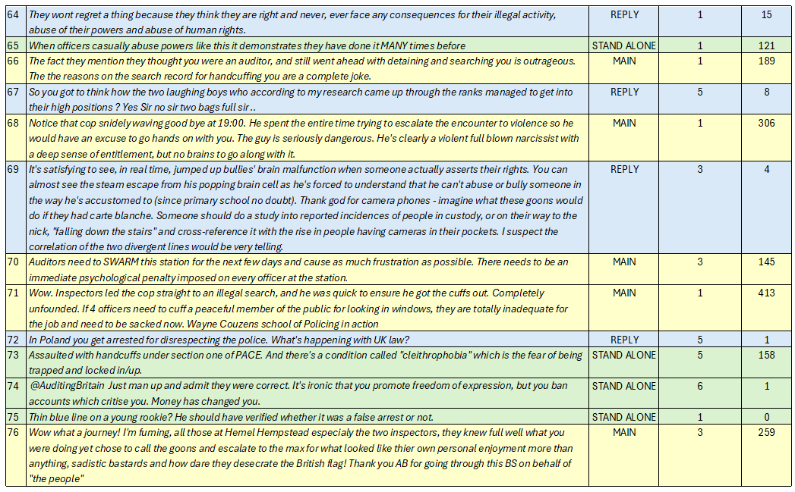
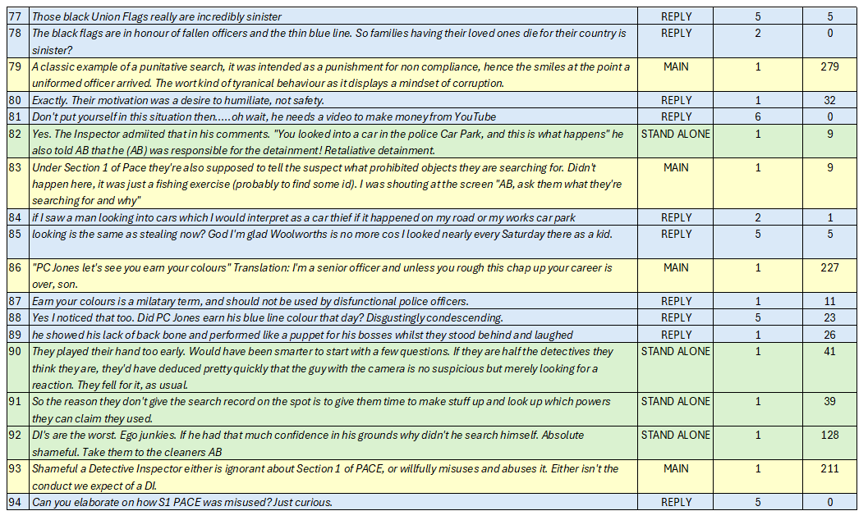
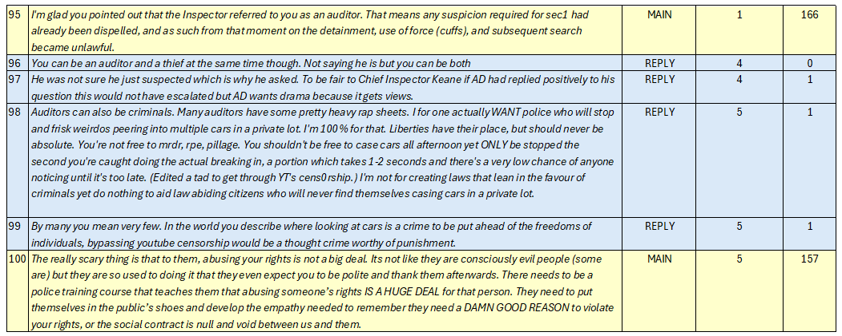

VIDEO 3 – COMMENT ANALYSIS

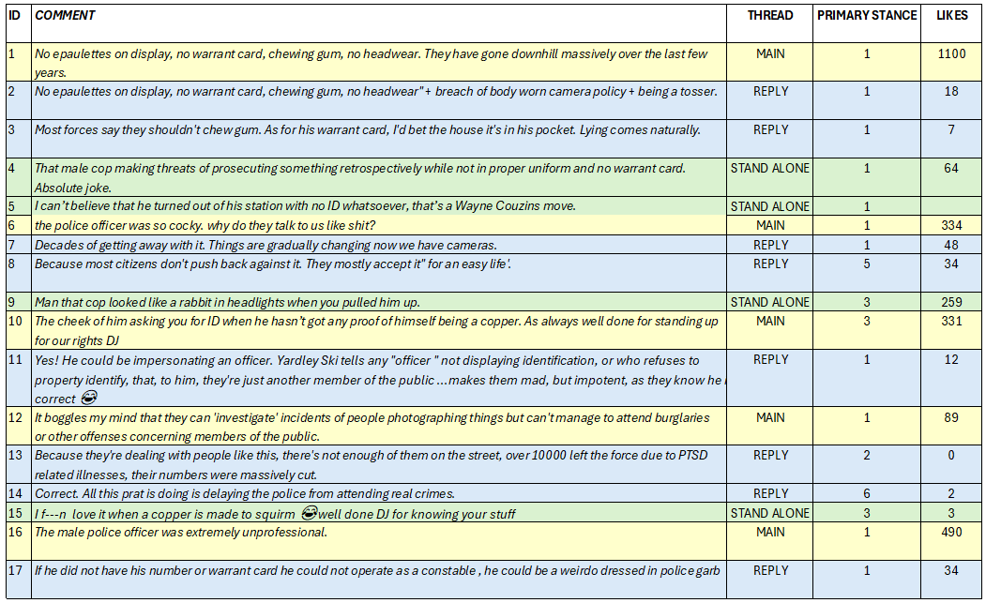
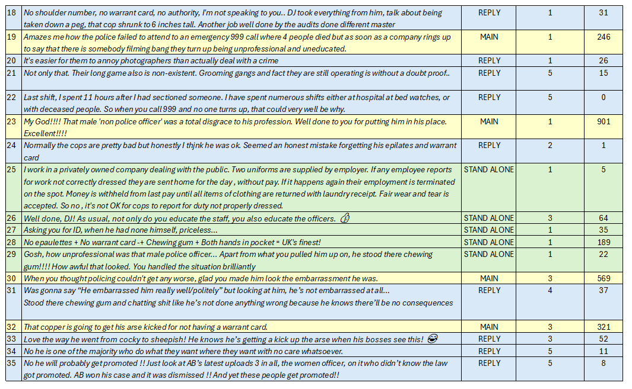
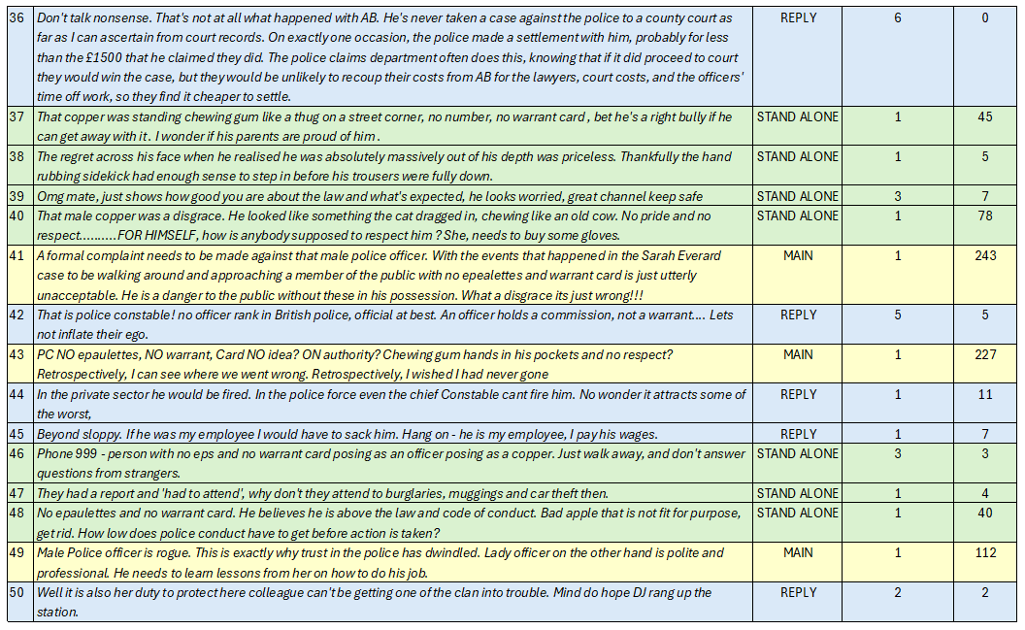
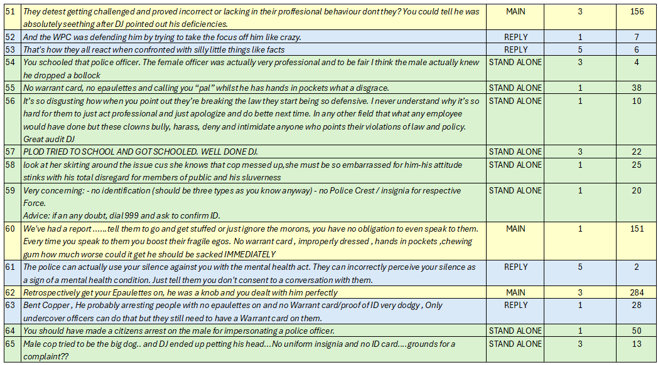
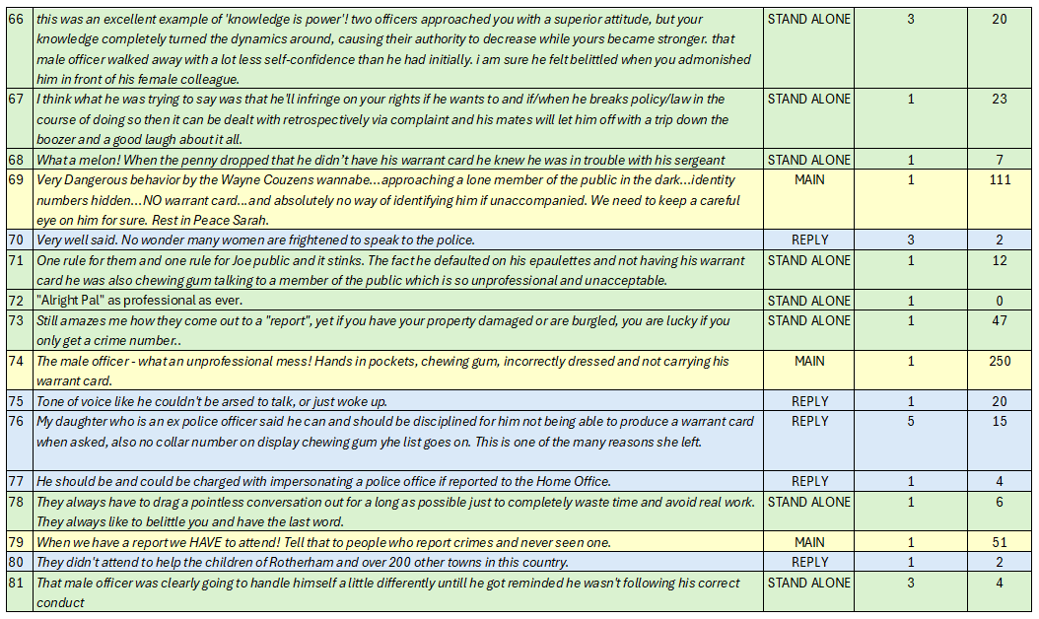
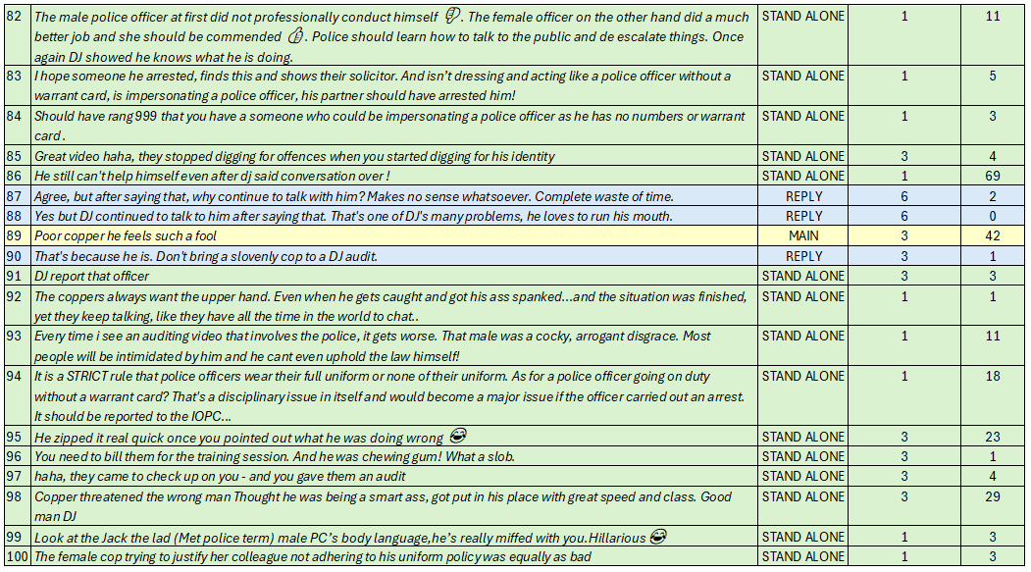

VIDEO 4 – COMMENT ANALYSIS
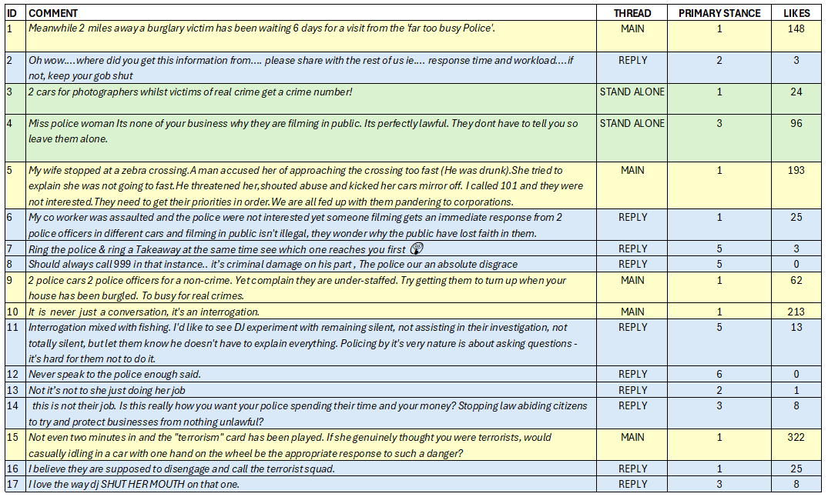
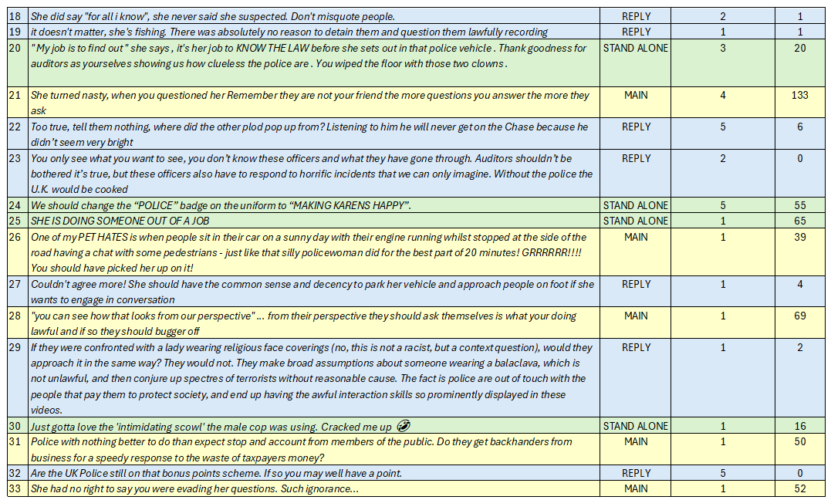
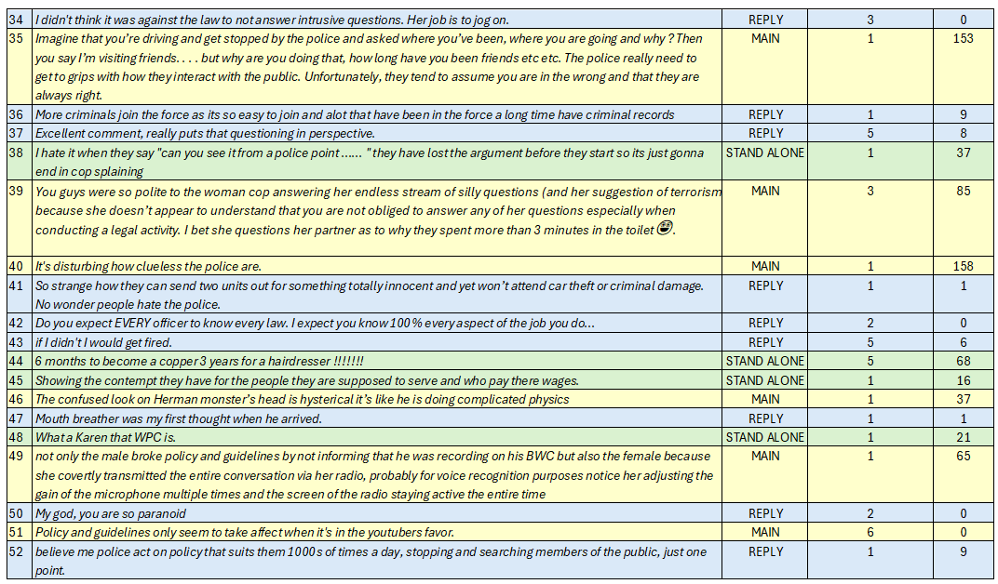
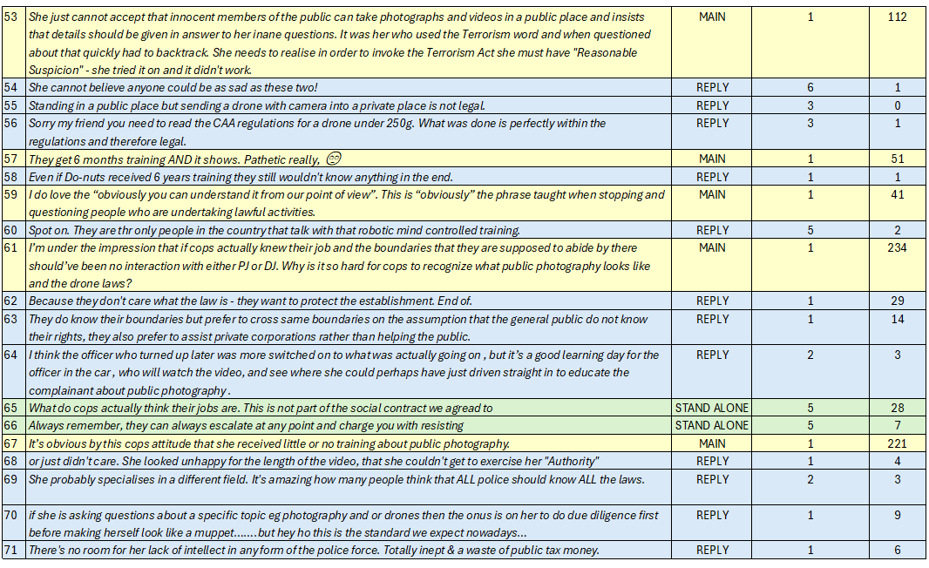
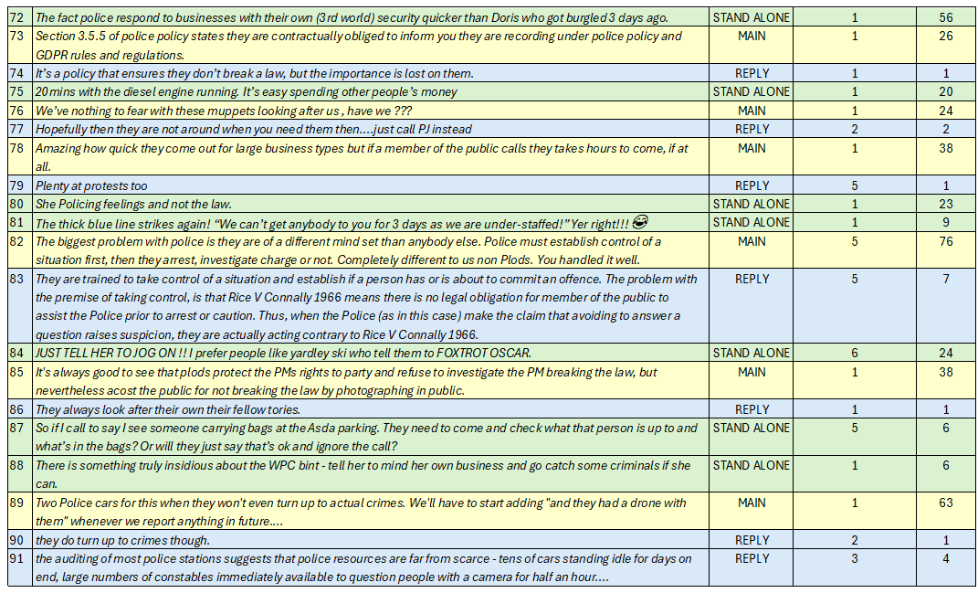
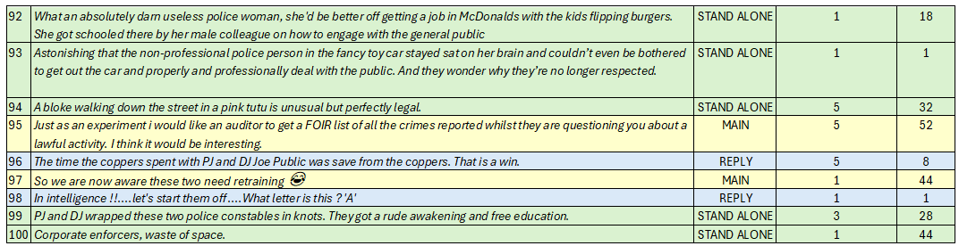

VIDEO 5 – COMMENT ANALYSIS
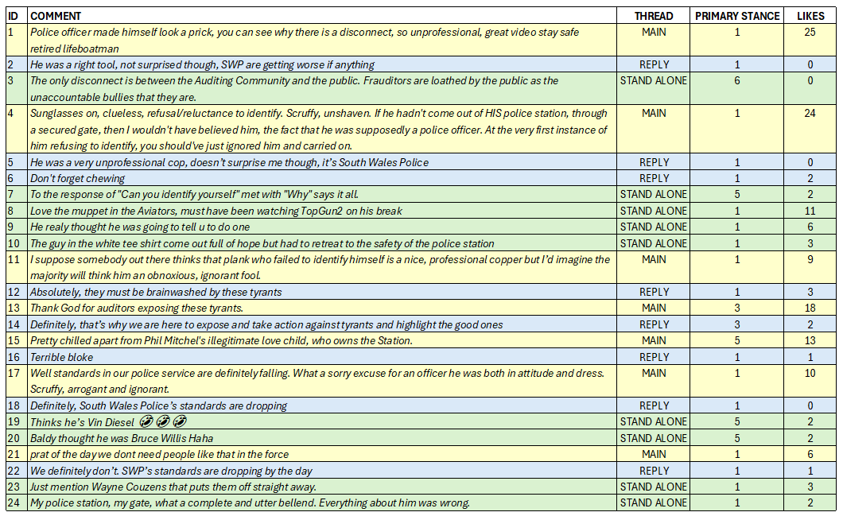
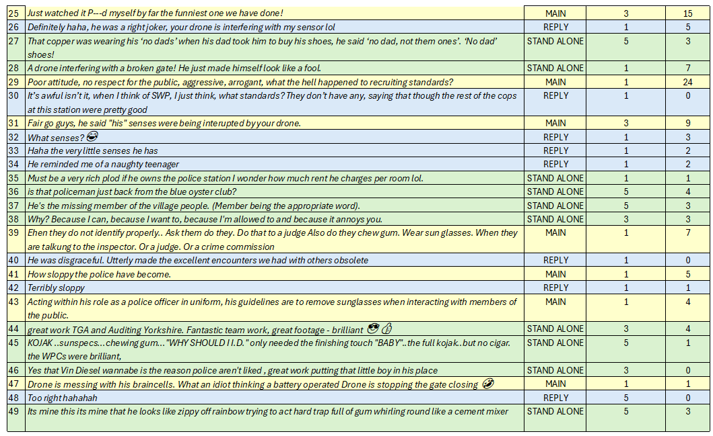
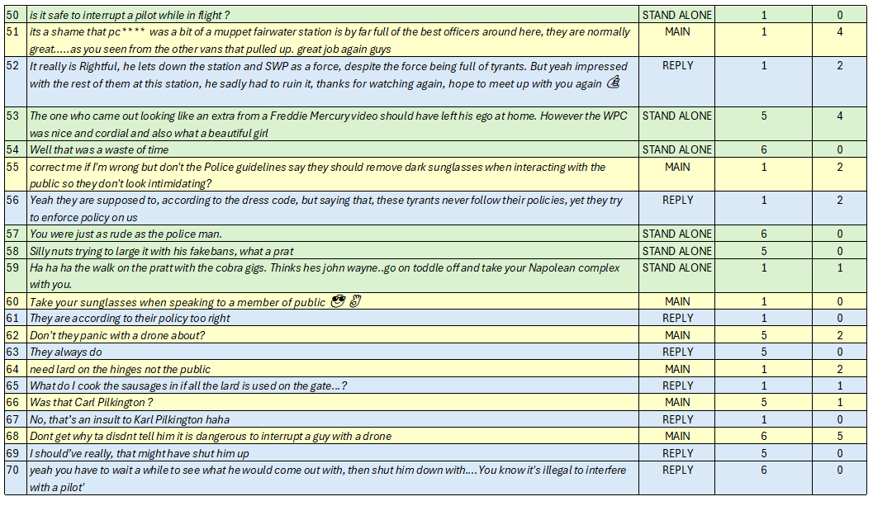
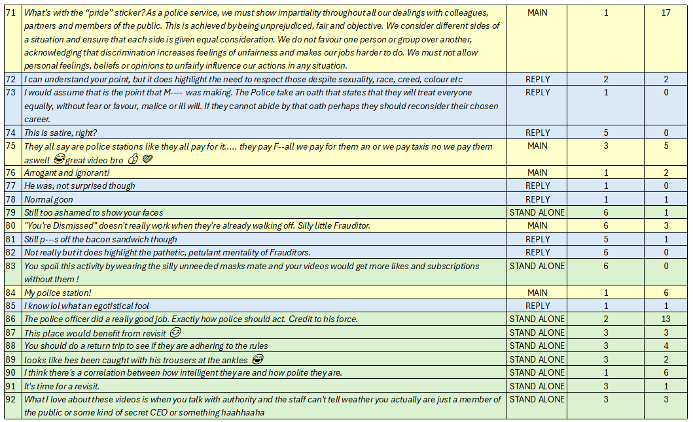
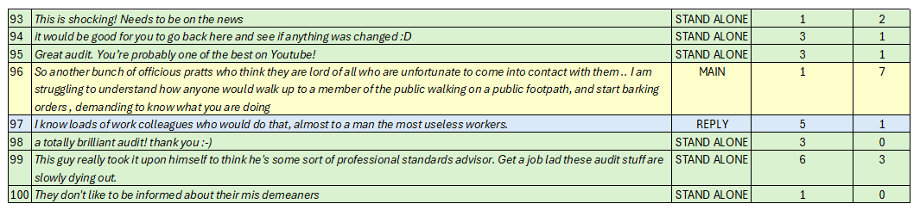

COMBINED PRIMARY STANCE PERCENTAGE – COMMENT ANALYSIS – VIDEOS 1-5

APPENDIX
APPENDIX C
Referenced YouTube Videos
This section contains the supplementary materials relating to the video content analysis undertaken for this study. This appendix provides methodological details to support the findings presented in Chapters 4 and 5 of the dissertation. Included in this section is links to the selected YouTube videos sampled for analysis, along with contextual information such as the location, duration and number of officers involved. Also included are analysis notes for each sampled video, including key moments within the footage, interactional dynamics, communication styles and framing techniques.

- “Citizen’s Arrest” - Auditing Britain (2021)
URL : https://www.youtube.com/watch?v=8hMgvLKhqK0
Context
Location: CAMARTHEN, Wales
Who initiates interaction: POLICE OFFICER
Number of Police Officers recorded: 2 Officers, 1 Police Staff
Length of Video: 22:06
Views : 774,840

Police Behaviour
Communication Styles | First officer to approach male: Polite / Direct – Asks how the male is doing. Answers the auditors’ questions and leaves the area.  Male member of Staff: Argumentative immediately. Frustrated, condescending.  Officer 1: Polite initially. Turns argumentative.  Officer 2: Polite, Calm throughout.
Challenges Auditors Behaviour / Actions | Male member of Police staff.  Officer 1 and Officer 2.
Uses Authoritative Language | Male member of staff makes references to seizing the auditor’s device and making a citizen’s arrest. Uses phrases such as I’m suspicious of you.
Attempts / Requests to Stop Recording | Male member of staff asks to stop recording.
Threatens Arrest | No officers threaten arrest.  Male member of staff threatens citizen’s arrest.

Auditor Behaviour
Communication Styles | Equally polite and argumentative. Mirrors tone and communication of those engaging with him. The auditor is vague in his replies when questioned and does not provide clarity on his purpose for recording.
Quotes Legislation | The auditor uses leading questions to allow opportunity for all challenging him to begin quoting legislation. The auditor does not reference legislation directly but makes comments such as “Challenged for being on public land?”.
Challenges Officers Knowledge | Does not challenge officers, challenges the male member of staff.
Attempts Escalation | Makes multiple provocative/ insulting comments. Comments on the male’s “Big Belly”, asks Officer 2 why she is wearing sunglasses when it is raining. Asks Officer 1 if she has had lip fillers. As both officers are leaving the area, the auditor shouts, “You’re dismissed” and laughs.
Repeats Questions | Yes. Repeats questions numerous times.

Power and Framing
Who controls the interaction? | The auditor arguably controls the interaction.
Who speaks the most? | Equal parties.
Is the officer framed positively or negatively? | The male member of police staff is framed negatively. The officers are framed neutrally as they do not challenge the auditors’ actions or request that he stops.
Any visible escalation? | No
Other | It appears that the male member of staff is older in age and does not understand the practice of police auditing for social media. He is initially suspicious and concerned for the male’s presence at the headquarters. Both officers who attend appear to be aware that the male is recording and may have an understanding that this footage will likely end up on social media. Both officers are polite and attempt to de-escalate the situation, when realising that the auditor is seeking confrontation the encounter ends and they leave before the auditor does.

Key Moments – Include Timestamps
0:30 – Police officer approaches auditor at front gates. Politely engages with the auditor. Auditor asks if the police station is open to the public, police officer informs the auditor it is not. Police officer then leaves the area.
01:10 – Auditor enters car park area outside of police station. Auditor states they believed this station was initially the headquarters.
01:40 - Auditor says “Theres not much to see here to be honest. The police officer was polite enough”.
03:00 – Auditor arrives at Dyfed Powys Police Headquarters. Auditor announces to his audience that he has arrived and walks towards a car park.
03:40 – Auditor approaches a marked police vehicle in the carpark where an officer is exiting the vehicle whilst speaking on a phone. Officer appears to notice the auditor and returns inside of the vehicle promptly. Auditor continues to film the officer but has no interaction.
04:09 – Auditor says, “Oh look at that is that a camera” and points their camera towards a CCTV camera on the outside of the building. Auditor says, “That is a camera” and proceeds to walk around the carpark pointing their camera at personal / private vehicles.
05:35 – Officer continues to walk around the outside of the police station but has no engagement from any staff or officers. Auditor says, “There’s not much to see really”. The footage appears to be cut here.
05:38 – Following the cut in footage, a male in plain clothing approaches the auditor and says, “Excuse me, can I just ask what you are doing?”. The auditor responds with “Just filming in general” The male says abruptly “No, what are you doing?” and holds his hand out, in what appears to be an attempt at blocking the view of the auditor’s camera. The male then proceeds to position himself away from the camera, however the auditor continues to record. The male says in an aggressive tone “What are you doing and who are you?” whilst frowning at the auditor. The auditor engages in the same way and replies, “I just told you”.
05:55 – The male who appears to be wearing a lanyard with Dyfed Powys Police written on it, shouts to another colleague for assistance and begins to make a phone call, the male says “Just wait here” to the auditor. Meanwhile the auditor asks, “Am I being detained?”. The male then says, “You aren’t going anywhere, you need to explain your presence here and what you are filming”.
06:15 – The Auditor again asks the male “Am I being detained sir?” The male responds with “Have you got permission?”, the auditor again asks, “Am I being detained?”, the male replies with “Have you got permission to do what you are doing?”
The Auditor then asks, “Did you detain me?” the male replies, “Yes”. Then the auditor asks, “Are you a police officer?” and the male replies “No I am not a police officer”. The male then makes a comment in reference to “Making a citizen’s arrest”.
06:57- The male identifies himself as a police employee at the headquarters. The auditor challenges the male on his politeness and manner of engagement.
07:25 – The male comments “I know you are filming me now”, to which the auditor replies “Yes for my safety”. The auditor then makes a comment towards the male, saying that he has a “Big Belly”. The employee does not respond and continues to contact an officer for assistance.
07:58 – The auditor begins raising his voice at the male and challenging his decisions to make a citizen’s arrest. The male continues to say that he is suspicious of the auditor’s behaviour.
08:20 – The auditor gives the male an opportunity to start the conversation again and tells him to be polite this time saying, “How about you ask me what is it that you are doing here?”. The male follows the auditors’ instructions and says the words verbatim. The male is significantly redder in complexion than he was at the beginning of this interaction, displaying stress and frustration.
08:38 – The male begins to challenge the auditors’ rights to record the police station, asking whether the auditor has obtained permission to record the police station. The auditor avoids a direct answer and alleges that they don’t need permission to film here. The male then begins challenging that the auditor does not have the male’s permission to record him. The auditor then asks the male why he approached him if he did not want to be recorded.
09:20 – The male answers a phone call and continues to explain to the person on the line what is going on, making reference to “What is the FIM doing?” and “The guy is filming me though”. This appears that he is being made aware of police auditors and their purpose. The male then informs the auditor “The inspector might send a police officer over”. His demeanour at this point is significantly less confident than when he first approached the auditor.
11:07 – The male attempts to explain to the male the role of civilian staff and stops himself. The auditor tells the male to “explain” and the male states “No because you are recording me”.
11:21 – The male informs the auditor that someone would be coming down to speak with him shortly. The auditor informs the male that “I don’t have to wait; I can leave at any time”. The male tells the auditor “I would like that recording to be deleted, and if you don’t agree to delete it then I will ask an officer to take the phone away from you”.
11:55 – The auditor asks the male for his name and he refuses. The auditor says that he can see the male’s name as it is visible on his badge which is worn on the neck lanyard. The male then attempts to question the auditor surrounding breaching his personal information within the recording. The auditor informs the male that the police have no powers to stop him recording, nor to remove his phone or delete the footage.
12:15 – The auditor begins to walk away from the male, saying “I’m going to go and pick some blackberries”. The male remains with the auditor awaiting police assistance. The male slowly follows behind the auditor as he walks outside of the police headquarters back towards the main road. The male continues to make phone calls and requests an ETA for police officers to attend.
13:43 – Two uniformed female police officers arrive at the area in a marked police vehicle. Officer 1 approaches the male first, she asks “Can I help you in any way?” in a polite manner. Officer 2 speaks with the male staff member who reported the incident. The auditor approaches Officer 2 and the male to hear what he is reporting. Officer 1 attempts to stop the auditor by saying “Can I ask the reason for the filming?” The auditor says, “One Second”. Officer 2 does not acknowledge the auditor whilst receiving an account from the reporting male.
14:28 – 15:40: Officer 2 asks the auditor to have a chat with her on a nearby pavement. The auditor asks if he is being detained, the officers say no, and the auditor agrees. Officer 2 asks why the auditor is there. She asks him if he needs to speak to anyone, the auditor declines and says that he “likes to film police buildings for matters of the public interest”. Both officer 1 and officer 2 appear to look confused. Officer 2 activates her body worn video camera.
15:52 – Officer 1 attempts to appeal to the auditor and explains that not everyone is comfortable with being recorded. The auditor gets argumentative and begins to point out cameras on the police vehicle, and the officers body worn cameras, explaining that he does not like being recorded by the police. Officer 1 says “yeah ok” and walks away from the auditor. As officer 1 walks away, the auditor states “I think you get it now”.
17:45 – As the interaction is about to end, the auditor begins to make provocative comments in front of the male member of staff with requests to get him a coffee, as he is a member of the public and they should look after him because it is raining. The male does not respond to these remarks but looks frustrated.
17:57 – The male informs the officers that he is not happy that the auditor has recorded him and his personal information. He explains that the force’s security policy is to challenge people who they are suspicious of and that is what he has done. Officer 1 asks about the recording of the male’s badge details, and the auditor states “A badge is to be on display”. Officer 1 explains that whilst the badge may be visible, the auditor does not need to record it. The auditor responds with “Is it a crime to film it?” and Officer 1 states “I don’t understand why you are being so pedantic”.
19:07 – Officer 1 continues to attempt to engage with the auditor and asks why he is there filming. The auditor ignores her questions and says, “Did you get lip filler?”. Officer 1 responds with “Again what is my personal look to do with you?”. Officer 1 states “I think you’re questioning is way beyond what you should be asking me, you are asking me personal questions about the way I look”. Officer 1 appears to be more argumentative and frustrated with the auditor’s behaviour. Officer 1 ends the conversation.
20:10 – Officer 2 attempts to diffuse the situation and asks the auditor if he is leaving. Officer 2 asks the auditor what his plans are when he leaves the headquarters. The auditor is vague and says that as soon as the officers leave, he will leave. Officer 2 informs the male that if he remains at headquarters then he will be challenged. The auditor replies “Challenged for being on public land?”
20:55 – Officer 2 explains they have been polite with the auditor and just wanted to know what his purpose for recording the headquarters is. The auditor explains “I record matters of the public interest”.
21:16 – Officer 1 says to Officer 2 “We’re not getting anywhere” and both officers return to the police vehicle and leave. As they enter the vehicle, the auditor shouts, “You’re dismissed” and laughs.

- “You’re Being Detained” - AUDITING BRITAIN (2023)
URL: https://www.youtube.com/watch?v=6ojZxTGEvoI
Context
Location: HEMEL HEMPSTEAD, England
Who initiates interaction: Officer – Detective Inspector (Non Uniformed)
Number of Police Officers recorded: 6 Officers
Length of Video: 36:45
Views: 758,781

Police Behaviour
Communication Styles | Officer 1 – Direct, authoritative argumentative, sarcastic.  Officer 2 – Polite initially, appealing, direct, argumentative, calm.  Officer 3 – Nervous, direct, argumentative.  Officer 4 – Calm, authoritative, clear.  Officer 5 – Calm, appealing, polite.  Officer 6 – Does not engage.
Challenges Auditors Behaviour / Actions | Officers 1 – 5 engage with the auditor and challenge his actions and body language.
Uses Authoritative Language | All officers use authoritative language.
Attempts / Requests to Stop Recording | Officers 1 and 2 requests the auditor stop recording.
Threatens Arrest | Officer 4 warns the auditor that he may be subject to arrest for public order should he continue to be argumentative.

Auditor Behaviour
Communication Styles | Auditor matches the communication styles portrayed by the involved officers.  Following a stop search, the auditor’s communication style becomes irater and more aggressive. Auditor makes insulting comments to officers and shouts demands at them, referring to himself as their superior.
Quotes Legislation | The auditor does not directly quote legislation but questions the officer’s knowledge of legislative procedures.
Challenges Officers Knowledge | Yes, the officer frequently challenges the officers’ explanations and justifications for use of force and powers.
Attempts Escalation | The auditor attempts escalation by raising his tone of voice and shouting insults towards officers, referring to himself as their superior.
Repeats Questions | Yes, the auditor frequently repeats questions.

Power and Framing
Who controls the interaction? | Initially it appears the officers control the interaction, however following the stop search, the narrative shifts and the auditor control the encounter by making demands.
Who speaks the most? | Equal interaction by officers and auditor.
Is the officer framed positively or negatively? | All officers are framed negatively during the interaction.
Any visible escalation? | There is a visible escalation following the stop search.
Other | The auditor proceeds to attend other police stations and inform other officers of this interaction following the end of the encounter.

Key Moments – Include Timestamps
00:29 – Auditor arrives at Hemel Hempstead police station, approaches a sign which states “Private Parking Police Vehicles Only”. Auditor enters the private parking area and begins filming inside of unmarked vehicles. States that he is looking for GDPR breaches. Video cuts here at 01:08.
01:09 – Following the cut, auditor is approached by two males in plain clothing. Male 1 tells the auditor that he is a police officer and shows his warrant card. Male 2 says nothing. Officer 1 asks the auditor to stay there. Immediately the auditor is resistant and tells him “Don’t touch me”.
01:49 – Officer 1 tells the auditor that he is detaining him as he has been seen filming police vehicles. Male 2 now identifies himself as a police officer and proceeds to ask the auditor what he is doing at the station.
02:01 – Officer 1 states that he will be searching the auditor, whilst looking at his mobile phone. Officer 2 tells the auditor that he has seen him looking into cars and he finds this suspicious as it is private property. The auditor points out that a female member of the public across the road has also looked into vehicles as she walked by, Officer 2 states that she wasn’t “encroaching” on private property in the manner that the auditor was doing so.
02:39 – Officer 1 informs the auditor that he is being detained under Section 1 of PACE, does not explain what the reason is for this. Both officers continue to tell the auditor the reason for him being detained is due to him being on private property and looking inside of police vehicles.
03:26 – After hearing the grounds for his detention, the auditor challenges both officers reasoning and asks if this is reasonable to “infringe on my freedom”. Officer 2 answers “Yes it does”. The auditor asks again why his behaviour has grounds for him being detained, and officer 2 says “I’ve just explained twice, I don’t need to go through it again”.
04:20 – Officer 2 asks the auditor “Are you an auditor?” The auditor responds with “All I know is that I’m detained”, avoiding answering the question. Officer 1 explains that he has requested uniformed police officers to attend.
05:40 – A uniformed officer attends. Officer 1 explains the circumstances to the uniformed officer (officer 3).
06:03 – Officer 3 handcuffs the auditor and explains that he is being detained under Section 1 of PACE for the purpose of a search. Officer 3 identifies himself and explains the grounds for the search, which cannot be heard clearly as the camera is taken away from the auditor and placed into an evidence bag whilst still recording.
07:08 – An image presents on the screen, which the auditor has captioned “A fourth officer shows up”. The image is of a uniformed police officer (Officer 4) who has not been seen until this point.
07:35 – The camera is still recording whilst inside of an evidence bag. Raised voices can be heard in the background. The auditor can be heard saying “This is unnecessary”, “There’s four of you here, you don’t need to handcuff me”. Officer 1 can be heard saying “Just bear with these officers and let them do their job”.
10:35 – Officer 1 begins to accuse the auditor of creating the situation. He states that the auditor knew exactly what was going to happen by looking into the vehicles. He states, “you’ve got exactly what you wanted”.
10:57 – An image presents on the screen which the auditor has captioned “Five officers now”. The image is of a female uniformed police officer (Officer 5) who has not been seen until this point.
12:52 – The camera is removed from the evidence bag and the scene portrays five police officers surrounding auditor. The auditor is aggressive in tone and tells all officers to “back off”.
13:09 – 13:50 – The auditor states that he wants a copy of the search record at that instant. The officers request his details. The auditor is aggressive, shouting at the officers and demanding that he provides him a copy of the search record. Officer 3 insists that he requires the auditors’ details for a copy of the record, to which Officer 1 interjects and tells officer 3 that he does not require his details. Officer 1 previously identified himself as a Detective Inspector, and the auditor states to the others “Do as the inspector says”.
13:55 – Officer 4 attempts to de-escalate the situation and explains that the record can be collected within 3 weeks. The situation is hostile, and the auditor is demanding a search record. Officer 3 appears visibly stressed and red in the face, continues to request personal details from the auditor.
14:45 – 15:30 - Officer 4 calmy advises the auditor to lower his voice and threatens public order offences. The auditor challenges officer 4 and uses insulting language. Officer 4 tells the auditor “Don’t talk to me like that”, to which the auditor replies with “I can talk to you however I want, you put me in cuffs, I asked you not to put me in cuffs”. Officer 4 continues to threaten public order offences.
16:44 – Officer 1 explains that officer 5 has gone to collect a paper copy of the search record for him. The auditor questions why officer 3 did not suggest that and officer 1 states “perhaps he did not know”. The auditor proceeds to call officer 3 an “idiot” and “why would you allow this man to search me in the first place; he looks like an idiot”.
17:15 – The auditor tells officer 4 to go away and officer 4 refuses. Officer 4 states that he can “do what he wants” and the auditor argues “you can’t do what you want, you’re on the clock”. The auditor continues to shout at the officer saying comments such as “you’re on the public’s money”, and “you’ll do as your superior tells you”, “start moving”.
17:46 – Officer 4 remains calm and asks the auditor “do you have a job to go to?” to which the auditor aggressively responds, “this is my job and it pays really well”. The auditor says, “this is the job I use to pay your wages, so right now I’m your superior and I’m telling you to get lost”. The auditor continues to say, “Get lost”.
18:12 – The auditor makes reference to the paper copy of the search stating “That’s the paper I’m going to use to make a claim against all of you”. Officer 1 does not react to this comment and says, “I will be looking forward to that”.
18:28 – The auditor states, “at one point you knew I was an auditor, he said it” and points to Officer 2. The auditor alleges that the officers knew all along what was happening.
18:52 – Officer 5 returns with a paper copy of the search record. She is writing on the paper. At this point the auditor has inserted an image over the screen, which is an edited photograph of officer 5 with a moustache and sunglasses.
19:50 – The auditor asks officer 1 and officer 2 if they would like to know why he was looking inside of vehicles. He proceeds to explain that “sometimes when you walk past police stations, police officers tend to leave documents on display. I am here to see if they are breaking GDPR basically. If I tell you, then you will ruin the whole thing”. The auditor proceeds to say “Inspector, I could have a million reasons to be looking into cars, but you can’t just do this to people”. The inspector states that he understands and thanks the auditor for explaining.
22:40 – All officers leave the area. The auditor narrates “I did not expect them to do this. I did not have my spy glasses on. Never mind”.
23:10 – The footage cuts, the auditor continues to record around the police station. The auditor approaches the rear of the station and records the marked police vehicle. The auditor narrates “full of idiots”.
24:05 – A marked police vehicle approaches the gates and a further officer (officer 6) enters the frame. Officer 6 greets the auditor politely, and the auditor tells the officer “I’ve just been detained by your colleagues”. Officer 6 does not respond and continues to drive into the station car park.
24:46 – The video footage ends, and the screen displays the auditor’s channel logo. The auditor provides a voiceover where he explains that following the interaction he attended the Job Centre and The Council Offices before meeting some of his subscribers.
The auditor continues to explain that he then attended Watford Police Station to obtain a copy of the search record.
26:55 – The auditor attends the front desk at the police station. A female member of staff is at the front desk who greets the auditor. The auditor states “I had the pleasure of meeting your chief inspector today. He was a tosser really”. The auditor explains that he was searched and told to attend this station to obtain a copy. The female requests the auditor to take a seat in the waiting area.
28:56 – The auditor walks passed a reflective surface, and the footage is cropped to avoid displaying his reflection.
30:57 – Whilst awaiting the females return. The auditor continues to record the police station and makes comments on the “state” of it, commenting that the station is “outdated”.

- Constable You Have Got No Epaulettes and No Warrant Card! – DJ AUDITS (2024)
URL: https://www.youtube.com/watch?v=JhLbKoX-hM
Context
Location: DEESIDE, UK
Who initiates interaction: Police
Number of Police Officers recorded: 2
Length of Video: 13:45
Views: 361,917

Police Behaviour
Communication Styles | Calm, polite, respectful, relaxed.  Officer 1 – at times appeared confused and could not respond.  Officer 2 – attempted to de-escalate the situation and defend her colleague.
Challenges Auditors Behaviour / Actions | Neither officer challenged the auditors’ actions or behaviour.
Uses Authoritative Language | No authoritative language used.
Attempts / Requests to Stop Recording | No.
Threatens Arrest | No.

Auditor Behaviour
Communication Styles | Confident, challenging, defensive, condescending.
Quotes Legislation | Did not quote legislation. Made reference to understanding drone piloting laws.
Challenges Officers Knowledge | Yes – auditor challenged Officer 1 in relation to drone policies and uniform compliance.
Attempts Escalation | Yes – auditor challenged Officer 1 when informed that officer 1 could deal with any offences retrospectively due to recording on body worn camera. Auditor also refused to engage with officer 1 when discovering that they did not have a warrant card or visible epaulettes.
Repeats Questions | The auditor did not repeat questioning.

Power and Framing
Who controls the interaction? | The auditor controls the interaction.
Who speaks the most? | The auditor speaks the most.
Is the officer framed positively or negatively? | Officer 1 is framed negatively when the auditor repeatedly points out that he is non-compliant with uniform policies. At the end of the video, the auditor asks officer 1 what the first thing he will do when he returns to the station. Officer 1 states that he will have a coffee, and the auditor corrects him by saying “No you’re going to get you’re warrant card and wear epaulettes”. This is condescending.
Any visible escalation? | No visible escalation.
Other

Key Moments – Include Timestamps
00:17 – The auditor is seen cycling at the start of the video. The auditor cuts across an oncoming lane of traffic where a police car is approaching. The auditor states “We have the police here, are they for us? I think they are”.
00:52 – The auditor stands recording the police vehicle which is now stopped in a junction. The auditor says, “we will let them come to us if they want to talk to us”. Video is cut here.
02:07 – The auditor continues to record an industrial premises. The auditor comments “filming from a public place, everyone is entitled to do it”. Meanwhile the police vehicle is still parked nearby.
02:53 – Two uniformed police officers approach the auditor. Officer 1 is a male, officer 2 is a female. Officer 1 addresses the auditor first by saying, “Hi, Pal”. Officer 1 explains that police have received a report from the industrial premises that someone is flying a drone over the site. Officer 1 states, “I take it you’re aware of all of the regulations”.
03:08 – The auditor replies to officer 1 by stating, “Are you?”. Officer 1 responds with “I’m asking you”. The auditor replies, “Of course I am”.
03:22 – Officer 1 questions the auditor whether there is a camera within his drone. The auditor confirms there is and officer 1 requests to see the auditors drone identification. The auditor complies. At 03:29, the auditor says, “Although I am not operating the drone at the moment, I don’t need to show you anything, but I am a nice guy” and proceeds to show the officers the drone specifications.
03:40 – Officer 1 asks the auditor questions surrounding the drone’s weight. The auditor replies “249”. The officer does not respond. The auditor then questions the officer and says, “What does that mean to you when I say 249?” The officer states “doesn’t mean much to me” in an unbothered tone of voice.
03:52 – Officer 2 interjects the interaction and explains that the officer’s purpose is to check the weight of the drone. Officer 1 then informs the auditor that he is recording on his body worn video camera. Officer 1 also states that should there be any offences committed then “we can deal with them retrospectively”. The auditor then laughs at this comment.
04:12 – Officer 1 asks the auditor if they are satisfied that the area is not a restricted zone for flying drones. The auditor avoids answering this question and asks officer 1 if he has any epaulettes on display. Officer 1 responds with his collar number. The auditor is not satisfied and asks officer 1 why he is not wearing any epaulettes. Officer 2 again intervenes and states that her colleague has provided his collar number.
04:25 – The auditor responds to officer 2 by informing her that it is “uniform policy” to wear epaulettes. The auditor then states, “That’s not good enough, how do I know that you are telling the truth?”. The auditor requests that officer 1 show them his warrant card. Officer 1 informs the auditor that he does not have his warrant card with him.
04:36 – The auditor informs officer 1 that he is required to carry his warrant card with him at all times. The auditor then says to officer 1, “Conversation over, I’ll talk to you” and looks to officer 2. Officer 2 engages in a polite manner and provides her collar number to the auditor.
05:45 – Officer 2 has explained to the auditor the reason that they are in attendance. Officer 2 states that the police are satisfied with the information the auditor has provided, and the auditor responds with “I’m not satisfied that you’re doing things correctly”. Officer 2 asks why this is the case, and the auditor challenges the officers stating that they are not following policies.
06:35 – Officer 2 engages with the male in a calm and polite conversation. The auditor informs officer 2 that he has a social media platform where he posts his content, and viewers engage. The auditor informs the officers that this is his job, and he earns good money from doing this. The auditor states “It’s content creation, this type of thing pays quite well on YouTube”.
07:40 – Officer 2 again attempts to appeal to the auditor, explaining that some people feel uncomfortable or panic when a person is seen to be filming the premises. She explains that people may suspect that person is attempting to commit an offence. The auditor responds to this statement by suggesting that his footage would then be beneficial for evidential purposes.
08:15 – The auditor then informs officer 2 that at no point has he been on private property. The officer attempts to educate the officers informing them that the airspace above a premises is not considered private property. The officers do not challenge this remark and agree with the auditor.
09:00 – Officer 1 attempts to engage with the male again in a calm manner. He explains the police’s reasoning for approaching the auditor. The auditor comments that “You will actually regret this” and “uniform policy is quite important you know, and if you were not with your colleague, you’d have no way of identifying yourself”. Officer 1 does not challenge this remark and states “I appreciate that”.
10:44 – Whilst engaging in conversation, the auditor makes a comment to the effect of “It’s great, the more people that get educated by these videos, that’s also the entertainment part of the video”. He also states, “You know when people come to police stations, and some of your colleagues say you’re not allowed to do this, and now its all stopped because they’ve been educated as well”.
11:30 – The officers leave the area. The auditor continues to record the officers leaving and comments “he’s gone to get his warrant card and his epaulettes” and laughs.

- Police Put in Their Place by DJ & PJ Audits – PJ AUDITS (2023)
URL : https://youtube.com/watch?v=vmC0ML2MguU
Location: PETERBOROUGH, England
Who initiates interaction: Police officer.
Number of Police Officers recorded: 2 Officers
Length of Video: 19:12
Views : 227, 685

Police Behaviour
Communication Styles | Officer 1 was initially polite, but became defensive, suspicious, questioning and argumentative.  Officer 2 was polite and attempting to de-escalate the situation in a calm and direct manner.
Challenges Auditors Behaviour / Actions | Officer 1 challenged auditors’ actions and behaviours.
Uses Authoritative Language | Yes – officer 1 used authoritative language, officer 2 was more conversational and relaxed.
Attempts / Requests to Stop Recording | No.
Threatens Arrest | No threats of arrest. Officer 1 made reference to suspicion of terrorism offences but did not threaten any actions.

Auditor Behaviour
Communication Styles | Auditor 1 was conversational, calm and jovial, repeatedly made jokes towards the officer but maintained a level of respect.  Auditor 2 was defensive, argumentative and confrontational. Challenged officers’ knowledge several times.
Quotes Legislation | Auditor 2 did not quote legislation directly but made reference to knowledge of specific powers and policies.
Challenges Officers Knowledge | Auditor 2 made suggestions towards officer 1, suggesting that she enquire about drone weight when approaching pilots in the future.
Attempts Escalation | No.
Repeats Questions | No.

Power and Framing
Who controls the interaction? | Equal balance of control during interaction. Dynamics switched frequently between auditors and officers controlling the situation.
Who speaks the most? | Equally balanced.
Is the officer framed positively or negatively? | Neutrally framed. The auditors commented that officer 2 ‘saved the day’ during the encounter whilst raising concerns to officer 1 quoting terrorism legislation.
Any visible escalation? | No.
Other

Key Moments – Include Timestamps

00:25 – Auditor 1 is in company with auditor 2. They are approached by a female officer, (Officer 1), in a marked police vehicle. The officer is polite and asks if the auditor has a drone and where it is. The interaction is friendly and both parties are joking with each other. The officer asks the auditors what the purpose of their drone is.
01:30 – Auditor 2 has explained to the officer that they are photographers, and the drone is part of their equipment. Officer 1 asks what their photography is going to be used for. Auditor 2 becomes defensive and asks the officer why she is asking “intrusive” questions.
01:50 – Officer 1 tells the auditors that her job is to find out what the purpose of the recording is for and makes reference to “you could be terrorists for all I know”. Both auditors laugh. Auditor 2 questions the officer and asks, “do you suspect us of terrorism?”.
02:15 – Auditor 2 challenges the officer and asks whether the police have received a report surrounding the auditors photography. Officer 1 states “you don’t need to get so.” before stopping herself. The auditor explains “we have a right to reply”. The officer states that she is simply asking question surrounding the purpose of recording public buildings.
02:55 – Officer 1 has explained that the police have received a report of males flying drones above buildings in the area and her purpose is to find out what the reason for the drones is. Auditor 2 responds with “do you understand that it would be lawful to fly a drone in this area?”.
05:45 – A second officer attends. (Officer 2).
07:00 – Officer 1 has become more direct in communication. She explains that the auditors have been evasive in their explanation which arouses suspicion. The auditor requests the officers name, station and collar number. The auditor proceeds to explain that they are conducting social experiments by recording public buildings to see how individuals at that location reacts to being recorded.
07:40 – Auditor 2 tells the officers that they have been recording a business who is involved in a controversy online at the time. The auditor states that they intend to continue reporting outside of the building, stating that “they may come out and object, but we are in a public place performing a lawful activity”, the auditor also states that he is flying a “249 gram drone, which is one of the questions you should have asked”.
08:05 – Auditor 2 continues to tell the officers that he is creating educational content which stands up for the rights of the public, photographers and drone flyers.
08:38 – Auditor 2 tells Officer 1, “next time you see a drone flyer, ask them the weight”. Officer 1 states that she “doesn’t need to know the weight” and the auditor responds with “its educational for you”. Officer 2 attempts to interject and appeal to the auditors to de-escalate the video.
09:05 – The auditor asks officer 2 if he is recording them using his body worn video camera. Officer 2 confirms that his camera is recording. The auditor states that the officer should have made the auditors aware that they are being recorded. The officer shrugs his shoulders. Both auditors tell the officer that it is their policy to inform the public that they are recording on their body worn video camera. Officer 2 accepts that he should have informed the auditors of this.
17:17 – Officers leave the area.
18:07 – Both auditors engage in discussions and summarise the interaction with officers. Auditor 2 mentions that officer 1 made reference to terrorism legislation. Auditor 2 states “I think the male PC saved the day there”, referring to officer 2.

- BAD ATTITUDE PC5*** “Why are you Flying a Drone over MY Police Station?” Fairwater Police Station – THE GWENT AUDITOR / TGA (2022)
URL : https://www.youtube.com/watch?v=GjCgSsKUXdU
Location: CARDIFF, South Wales
Who initiates interaction: Auditors
Number of Police Officers recorded: 6 Officers
Length of Video: 19:57
Views: 16,755

Police Behaviour
Communication Styles | Officer 1 – Polite, calm, little communication.  Officer 2 – Polite, calm, limited interaction.  Officer 3 – Direct, authoritative, argumentative, sarcastic, challenging.  Officer 4 – Polite, limited interaction.  Officer 5 – No interaction.  Officer 6 – Polite, calm, little communication.
Challenges Auditors Behaviour / Actions | Officer 1 asked what the auditors were doing but did not question their actions.  Officer 3 challenged the auditors when flying drones over the police station and alleged that they were interfering with the secure gates.
Uses Authoritative Language | Officer 3 was authoritative in his communication style, but no officers referred to any legislation nor did they make any demands towards the auditors.
Attempts / Requests to Stop Recording | No requests to stop recording were made.
Threatens Arrest | No arrests were threatened.

Auditor Behaviour
Communication Styles | Auditor 1 was polite during every interaction until becoming argumentative when challenged by officer 3. Auditor 1 then made insults towards officer 3.  Auditor 2 was more vocal in his resistance and argumentative with communication towards officer 3. Auditor 2 repeatedly insulted officer 3. Auditor 2 attempted to question other officers on their opinions of officer 3.
Quotes Legislation | Did not quote legislation
Challenges Officers Knowledge | After interacting with officer 3, Auditor 2 questioned officers 4, 5, and 6, about the possibility that his drone could interfere with the security gates. Did not challenge any officer’s knowledge of legislation directly.
Attempts Escalation | Both auditors appear to attempt escalation when officer 3 is walking away from the interaction. Both auditors repeatedly state, “you’re dismissed”, attempting to provoke a reaction. Both auditors spoke verbal insults to officer 3. Auditor 2 spoke with officer 4 and told her to tell officer 3 that he is a “muppet”.
Repeats Questions | When engaging with officer 3, both auditors repeatedly demanded that officer 3 verbally identify his collar number.

Power and Framing
Who controls the interaction? | Equally balanced interaction.
Who speaks the most? | The auditors speak the most.
Is the officer framed positively or negatively? | Officer 1 –positively.  Officer 2 – positively.  Officer 3 – Negatively.  Officer 4 – positively.  Officer 5 – Neutral.  Officer 6 – Neutral.
Any visible escalation? | No visible escalation but tension could be seen during the interaction with officer 3.
Other

Key Moments – Include Timestamps
00:20 – Auditor 1 introduces the video and states that he is at FAIRWATER police station in the company of Auditor 2. Auditor 1 makes reference to another YouTuber who had previously attended the station, Auditor 1 states “He got nothing out of these guys, he got one brief encounter”.
01:01 – Both auditors are standing behind secure gates to a private car park at the police station. Auditor 2 can be seen to be wearing a face covering, with a brightly coloured T-Shirt with the text “AUDITING YORKSHIRE” clearly displayed. Auditor 2 appears to be wearing a body camera and is holding a handheld camera pointing this through the secure gates.
01:05 – Auditor 1 turns towards a road and notices a police vehicle. He states, “Oh there’s a cop car now, he’s coming in”. Both auditors approach the police vehicle as the officer is entering the secure gated area. Inside of the vehicle appears to be two officers.
01:20 – Auditor 1 approaches the female officer (Officer 1) who is the driver of the vehicle. Auditor 1 greets the officer politely. Officer 1 responds “Hello how are you?”. Officer 1 then asks, “What are you up to?” and Auditor 1 replies, “just making videos”. The officer does not respond. Auditor 1 says, “Do you have a collar number?” and officer 1 replies with her collar number.
01:37 – Auditor 2 asks officer 1 if they are “allowed in to have a walk around?”, to which officer 1 states “no, absolutely not, sorry guys”. Auditor 1 then enquires about arranging a tour of the building, and officer 1 tells him to contact “head office” to enquire. The vehicle then drives into the car park, and the auditors thank the officer for her time.
02:16 – A male officer (officer 2) then exits the police vehicle inside of the secure car park. He appears to be waiting for the gate to close. Both auditors approach officer 2 and ask him a few questions surrounding how the gates are operated. Officer 2 briefly engages in conversation before walking inside of the building.
03:20 – Both auditors walk around the publicly accessible car park at the front of the station and photograph the marked police vehicles.
03:34 – Auditor 1 states “They seemed alright here so far at Fairwater”. Both auditors continue to walk around the perimeter of the building.
04:15 – Auditor 2 can be seen opening a cover to a wall mounted defibrillator. Auditor 2 states “Are these meant to be open?”, Auditor 1 replies, “I’m not sure”. Auditor 2 states “I’m pretty sure these are supposed to have a passcode on them so they can’t be stolen, definitely a flaw in security there”.
04:44 – Auditor 1 can be seen pressing his camera against a window of the building to record the inside. Auditor 1’s reflection can be seen here and he appears to be wearing a face covering also.
05:09 – Auditor 1 makes reference to a PRIDE sticker which is displayed on the doors of the building. He states that “you see them a lot on the vans, I’ve seen the pride vans coming out of Cardiff Bay”.
05:23 – Video cuts here.
05:25 – Video resumes and both auditors return to the secure gates near to the private car parking area. Both auditors state they intend to fly drones over the building.
06:00 – Officer 2 is seen inside of the secure car park again. Auditor 1 initiates conversation and asks Officer 2, “is there any chance of seeing the blue lights today?” and Officer 2 politely replies, “I can’t predict the calls that come out of today sorry mate”. During this interaction, multiple signs can be seen on the exterior of the secure gates which display “NO PUBLIC ACCESS”.
06:40 – Auditor 1 states he is going to fly a drone and discusses where he should take off. Auditor 1 walks towards a pavement. Auditor 2 also sets up a drone.
07:17 – Footage cuts to drone footage instead of handheld camera footage. As the drone takes off, an unmarked vehicle can be seen entering the secure gates to the private car park.
08:20 – The video displays areal views of the police station, and the auditor can be heard making comments how the officers are waiting for the gates to close before leaving the area. Auditor 1 states “They’re doing it properly”.
08:48 – Auditor 1 can be heard saying, “The gate is having issues”, “It keeps opening all of the time”.
10:00 – Still displaying the drone footage. A male officer can be seen walking towards the auditors. Auditor 1 says “They’re coming out to us”.
10:10 – Footage cuts back to handheld camera. A male officer (officer 3) can be seen asking the auditors about the drone. Officer 3 is wearing a tactical vest over plain clothing with sunglasses.
10:27 – Footage cuts again. Auditor 1 says to Officer 3, “Must be an issue with the gate mate”. Officer 3 says, “What’s the deal with the drone boys?”. Auditor 1 says, “Just making some videos”, officer 3 replies “what for?”. Auditor 1 responds, “Could you identify yourself please?”. Officer 3 abruptly asks “Why?”, and Auditor 1 responds “Because you’re speaking to us, you’re asking us questions”. Officer 3 then states, “Yeah because you are flying a drone over my police station”. Auditor 1 says, “Your police station? Actually, it’s more our police station than it is yours, we’re the taxpayers”.
10:55 – Both auditors repeatedly ask Officer 3 to identify himself. Officer 3 says, “collar number’s there mate”. Auditor 1 states “verbally say it please”, to which Officer 3 replies “What is your camera not working?”, before saying his collar number. Auditor 2 interjects and asks, “Is your voice not working?”.
11:05 – Officer 3 says “What I’m wondering gents is whether that (points to sky) is stopping the sensors working”, referring to the gate not closing properly. Auditor questions why officer 3 would believe this. Officer 3 says, “I drove through and they started closing and as soon as that’s gone over, it’s messing up my sensors”. Auditor 1 responds, “I don’t know why you’re saying your sensors and your police station”, before auditor 2 interjects and states, “you’re quite arrogant you aren’t you”.
11:17 – Officer 3 says, “Boys, I’m not really interested”. Auditor 1 says, “You’re being a bit of a pratt to be honest mate”. Officer 3 shakes his head and walks away from the auditors.
11:20 – As officer 3 is walking away, Auditor 2 says, “Yeah well I tell you what, you’re dismissed go away”, and Auditor 1 responds, “Yeah off you go you pratt I’ll see you later”. Officer 3 does not react to these comments. Auditor 2 continues to state, “You’re dismissed” and “Your egos to big, muppet”.
11:48 – Both auditors continue to stand outside of the gate and state “Blaming us for the gate, absolute pratt”, “Think’s he’s a bad man, look at his shoes”, “What a pratt ey?”, “Idiot”. At no point does officer 3 react. Footage cuts at 12:10.
12:11 – Footage resumes, Auditor 1 approaches the now closed gate where no officers are in sight. Auditor 1 states “So yeah we’ve just had the drones up guys, we had that egotistical cop coming over, now we’ve got a guy over there across the road and he was just on the phone”.
12:30 – Auditor 1 approaches the male on the phone and says “Alright mate?”, who is standing outside of the main entrance to the police station. Auditor 1 engages in a conversation with this male but realises that he is not a police officer. Auditor 1 then asks Auditor 2 if he wants to return to the gated area where they engaged with officer 3.
13:22 – Auditor 1 says, “There’s another van coming in”. A marked police van can be seen approaching the gated area. Both Auditors approach the driver’s side of the vehicle whilst the driver is awaiting the gates to open. The driver is a female police officer in uniform (Officer 4) who greets both of the auditors.
13:39 – Officer 4 engages in a polite conversation with the auditors about the weather.
13:56 – Auditor 2 approaches officer 4’s window and says “Who’s that officer with the bald head?”, officer 4 seems confused by this question and states that she does not know. Auditor 2 states “Bald head, bit of a muppet”.
14:12 – Officer 4 states that she does not know who Auditor 2 is referring to, and asks “Do you need to speak do him?” , Auditor 2 replies “No just tell him I said he’s a muppet”. Auditor 1 then explains to officer 4 that the auditors were flying a drone over the police station and Officer 3 was alleging they were interfering with the gates. Officer 4 laughs and says, “I’m not sure technology is not my forte unfortunately”, both auditors laugh politely.
14:30 – Auditor 2 suggests to Officer 4, that Officer 3 ‘reads up’ on drone laws. Officer 4 does not respond and says goodbye before driving into the car park.
15:20 – Footage is cut again. Resumes to a further marked police vehicle entering the gated area. Two officers can be seen inside of the vehicle, but they do not engage with the auditors. One officer gives the auditors a thumbs up. As the vehicle drives into the carpark, auditor 1 states “He is supposed to wait for the gate to shut”.
16:10 – Auditor 2 then states “Big massive fail”. Auditor 2 states that this police station has failed the audit due to officer 3’s behaviour. Auditor 2 says, “As soon as I started getting shirty with him, he chipped”.
17:00 – Both auditors remain near to the secure gates and record two further approaching police officers, officer 5 and officer 6.
17:20 – Auditor 2 calls out to officer 5 and officer 6 and asks “Can I ask you a quick question, it’s to do with a drone”. Officer 5 does not reply and walks inside of the building. Officer 6 says “I wouldn’t have a clue with drones sorry”. Auditor 1 asks whether there is any drone officers at the station, and officer 6 says there is not.
18:00 – Auditor 1 explains the encounter they had with officer 3. Officer 6 continues to explain that he does not have any understanding of drones or drone policies. Officer 6 walks inside of the building.
18:35 – Auditor 2 says to auditor 1, that when he asked officers 5 and 6 to answer a question, they shook their head. Auditor 2 states “Why don’t police want to speak with members of the public or interact with them, they should be saying yeah no problem, sir how can I help you”. Auditor 1 continues to express how the officers should be proud to be public servants.
19:13 – Auditor 2 is referring to the interaction with officer 3 and states “I don’t think he would dare introduce himself to a judge in that way”. Both auditors conclude their videos and say that it’s been an interesting audit.

