Lauren Emily Price Student Number: 1807244
distinctive & regeneration bmsp4005
learning log report

CONTENTS

EXECUTIVE SUMMARY 2
INTRODUCTION 2
WHAT WAS THE INDUSTRIAL REVOLUTION? 2
HOW DID THE INDUSTRIAL REVOLUTION AFFECT LLANELLI? 2
COAL - END OF AN ERA 3
TATA STEEL 3
LLANELLI WETLAND CENTRE 3
CONCLUSION 4
REFERENCES 5
APPENDIX 6
APPENDIX 1 – LLANELLI WETLANDS CENTRE MAP 6
APPENDIX 2 – LLANELLI WETLANDS CENTRE FIELD TRIP PHOTOS 6

EXECUTIVE SUMMARY
From attending lectures with two guest speakers and the visit to the Llanelli Wetland Centre, this report will focus on the distinctiveness of Llanelli. Using information and observations gathered, the report will highlight how Llanelli has changed in terms of the regeneration of the area and what makes the town distinctive.

INTRODUCTION
Llanelli is a town rich in history and has changed drastically over the years. Llanelli comprised mostly of small farms and where the majority of land was owned and controlled by major landowners of large estates with tenants in situ. The town consisted of rural communities where most people were employed within farming and agriculture (Hannam. J; 2019).
Llanelli had a number of coal mines but these were relatively small operations at this time and only provided income for associated families involved in the business. The mines lacked capital investment and owners lacked the relevant knowledge of how to develop them further. (Ibid).
With the introduction of the Industrial Revolution, Llanelli saw significant changes, not only to the landscape of the area but also in social changes. During the course if the Industrial Revolution Llanelli saw huge technological developments and became almost unrecognizable to what it once was.

WHAT WAS THE INDUSTRIAL REVOLUTION?
The Industrial Revolution was an era where rural communities, which revolved mainly around farming and agriculture, became more industrial and urban, (History.com; 2019).
The Industrial Revolution took place from the 18th to 19th Centuries and areas such as Llanelli, saw major industrialisation with the introduction of powered machines, steam ships and railroads.
The Industrial Revolution had a huge impact on the social, cultural; and economic conditions of many rural areas in Europe and America. (History.com; 2019).

HOW DID THE INDUSTRIAL REVOLUTION AFFECT LLANELLI?
It was noted that the first significant development happened when coal seems below the large estates were leased out. Due to the technological changes including the development of steam engines and machinery, Llanelli began to see an increase in the demand for coal. The town of Llanelli is conveniently sat on the coast so with the introduction of steam ships, the demand for ‘sea coal’ increased greatly. The transportation of coal was again made faster and more efficient by the creation of the first tram-road and this had great benefits for the exportation of coal from the area.
Llanelli was beginning to see more opportunities and people who wanted to take advantage, were attracted to the area. Investors started to invest large sums of money into Llanelli and current landowners began to invest their land holdings and so began Llanelli’s industrial development.
Llanelli fully embraced the Industrial Revolution and the introduction and creation of the steam train network provided endless opportunities for businesses to develop.

COAL - END OF AN ERA
During the 20th Century, Llanelli saw a decline in the coal industry and it eventual ceased altogether in the 1990’s. With the disappearance of the coal industry came the production of tin plate. By now, Llanelli had become a dynamic and diverse industrial area and entered the 20th Century with new opportunities.

TATA STEEL
The guest lecturer, Nicola Jones from Tata Steel gave a great insight into what Tata Steel is and what goes on there.
Tata Steel is one of Europe’s main steel producers and has manufacturing plants all over Europe. Tata Steel supplies strip steel products to a variety of different markets including construction, packaging, white goods, automotive and engineering. (Tata Steel; 2019).
Llanelli has the benefit of its own Steelworks located on the outskirts of Llanelli in Trostre. The main focus at the steelworks is on the production of tinplated steel which is used in the canning industry including food and drinks cans, paint tins and aerosols. Some of the plant’s main most well-known customers comprise Heinz, Farrow and Ball and Crown. (Jones, N; 2019).
Raw materials including coal, iron ore and limestone arrive by ship directly into Port Talbot’s Steelworks where they are used to create steel coils to be transported to the steelworks in Llanelli. The steel is transported via Tata Steel’s own private railway, running twice a week directly from Port Talbot into the Llanelli Steelworks. The railway makes the movement of the steel coils more convenient and efficient.
The Llanelli Steelworks have circa 600 directly employed workers and circa 600 contractors.

LLANELLI WETLAND CENTRE
Sarah Rees, the Tour Guide of the Llanelli Wetland Centre explained that the development of The Llanelli Wetland Centre began in 1984. Sir Peter Scott the Founder of the Wildlife Wetland Trust believed in his vision to allow the general public to be able get closer to nature and in particular birds. The site in Trostre was picked as the chosen area to create the Wetland Centre because it would be less likely to suffer from pollution issues. (Rees, S; 2019).
The site was opened in 1991. (Wildfowl & Wetlands Trust Limited; 2019).
The Llanelli Wetland Centre is a perfect example of an area that has been regenerated. The land originally comprised unused farmland and now is a habitat to a multitude of birds and animals that live in the salt marshes. The area is being extended and redeveloped to provide different habitats for the differing types of birds that live there.
The Centre is extremely popular with families, bird watchers, locals and tourists and its visitor numbers increase every year. (Rees; S; 2019).

CONCLUSION
Llanelli has seen significant changes over the years. It is an area rich in history. It is diverse and unique in that is it forever changing and regenerating.
Llanelli Steelworks alone generate employment in the area with many people moving from smaller towns and villages to seek employment here.
Looking at the decline in the coal industry for example, Llanelli has proved it is open and willing to change and develop in order to help keep employment levels steady and generate income into the area. It is a versatile area which has embraced change positively.
It would seem that there is still more to do in this town but the positive changes that have already been made, including that of the development of the Llanelli Wetlands Centre, shows a willingness for change.
The Industrial Revolution had a profound effect on Llanelli and has shaped what it has become today.

REFERENCES
- Hannam, J. (2019). Guest Lecturer – Llanelli & The Industrial Revolution. February 19th 2019.
- History.com Editors. (2019). Industrial Revolution. Available at: https://www.history.com/topics/industrial-revolution/industrial-revolution
- Jones, N. (2019). Guest Lecturer – Tata Steel. February 26th 2019.
- Rees, S. (2019). Tour Guide – Llanelli WWT. February 26th 2019.

- Tata Steel. (2019). At A Glance. Available at: https://www.tatasteeleurope.com/en/about–us/at-a-glance

- Wildfowl & Wetlands Trust Limited. (2019). Llanelli Wetland Centre. Available at: https://www.wwt.org.uk/wetland-centres/llanelli/

- Wildfowl & Wetlands Trust Limited. (2019). Our History. Available at: https://www.wwt.org.uk/who-we-are/our-history/

APPENDIX

APPENDIX 1 – LLANELLI WETLANDS CENTRE MAP

APPENDIX 2 – LLANELLI WETLANDS CENTRE FIELD TRIP PHOTOS

APPENDIX 1

APPENDIX 2
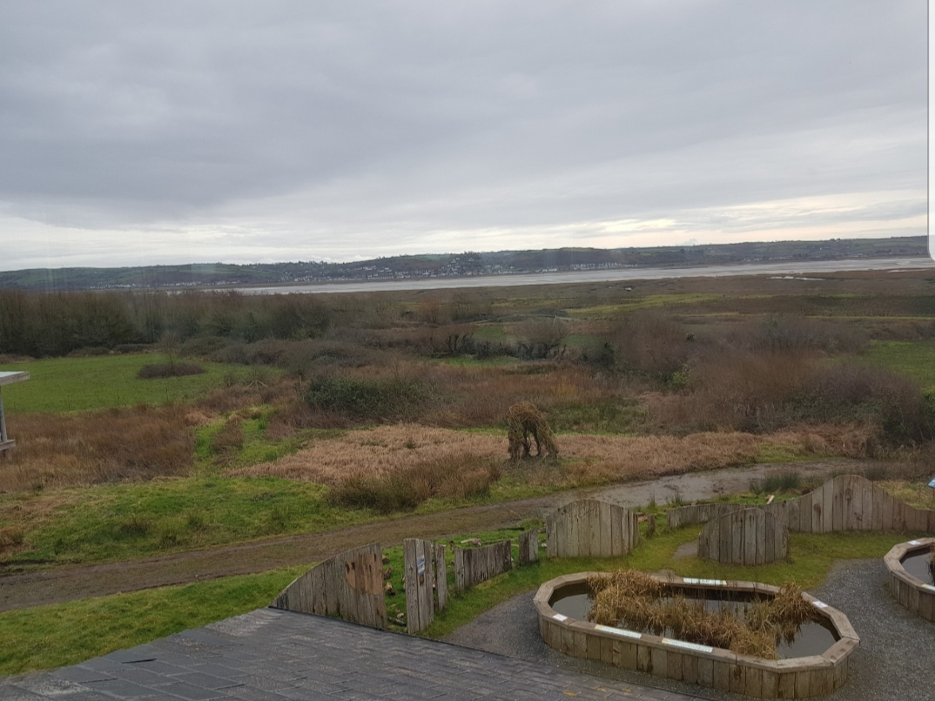
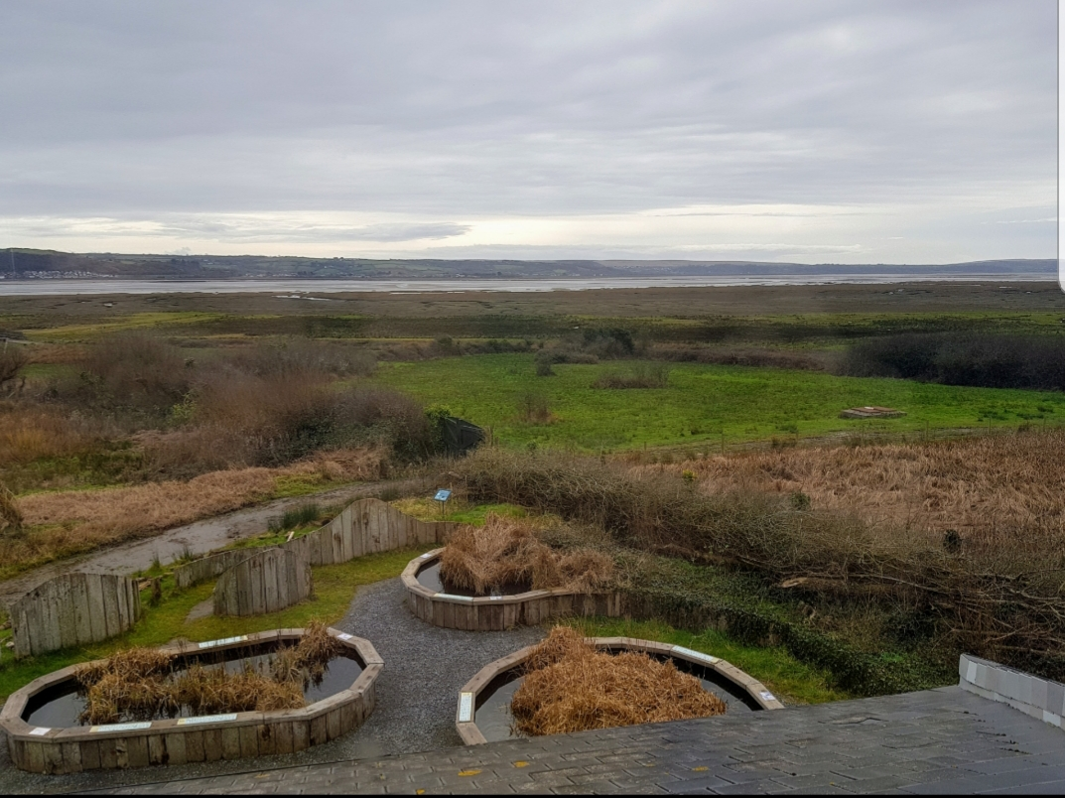
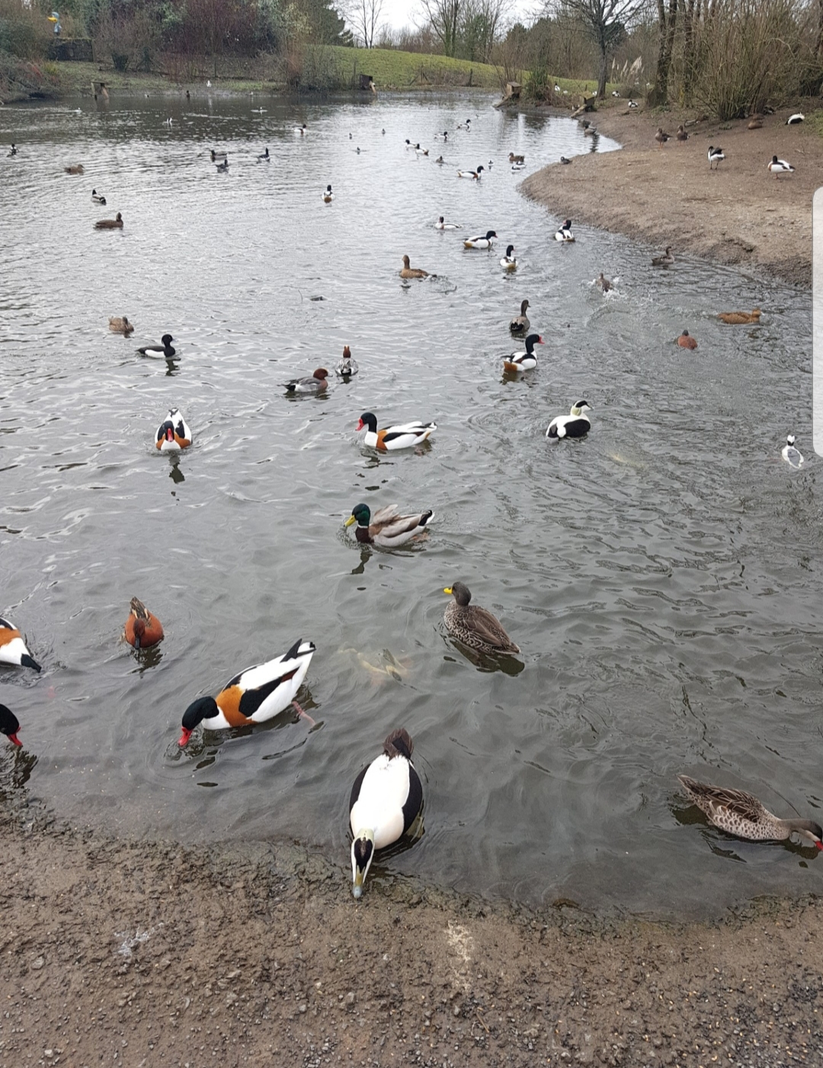

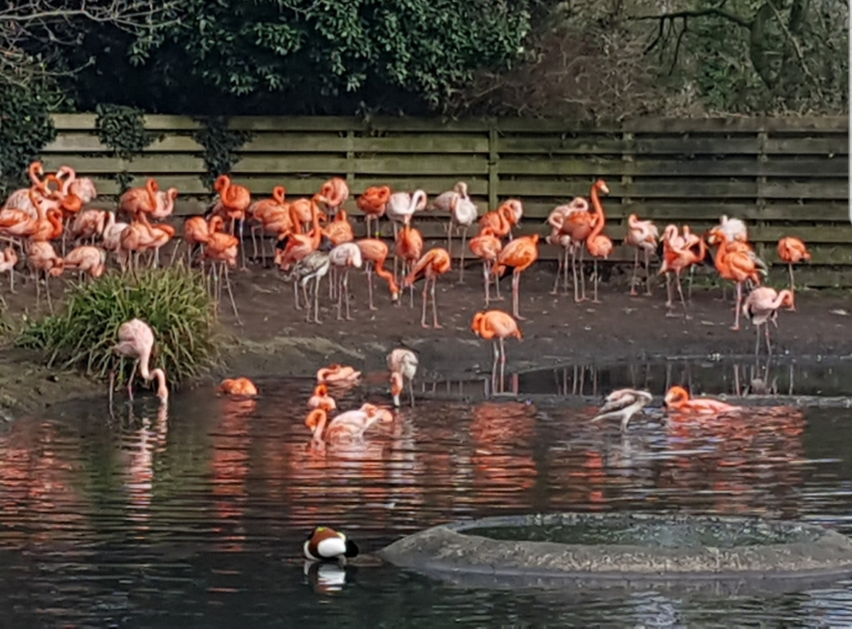
View of Tata Steel.


