

University Of Wales Trinity of Saint Divid

Student Name: Aminata Mbye
Student Number: 2412820
Programme: BA (Hons) Leadership and Management Skills for the Workplace
Module: Organisational Culture
Module Number: LCLM 5005
Lecturer: Dr Christopher Osborne
Assignment Title: Organisational Culture: Individual Report



Table of Contents
1: Introduction
2: Organisational Culture of Tesco
3: How organisational culture helps shape the company’s structure and decision making
4: Relevant frameworks, models or theories to the selected organisational
5: Organisational culture and adaptation to the external environment of the selected organisational
6: Organisational culture and effective functioning of the selected organisation
7: Evaluation of the impact of organisational culture on organisational performance of the selected organisation
8: Conclusion
9: References


- Introduction
In 1919 Jack Cohen returns from war and started a market stall in the East End of London selling surplus groceries. He used his demob money to buy first day’s stock, he believed in putting affordable food in the reach of everyone. At the end of the day of his first day, he made a profit of £1 on the sales of £4.
In 1924 the name Tesco was born, the first own brand product was Tesco Tea. The first store was opened in Burnt Oak, Edgware, north London, in 1934 he built a new headquarters and warehouse at Edmonton, north London. It was the first modern food warehouse in the country. In 1937 he expanded across London and neighbouring counties. Tesco employed more than 330,000 staffs.
Tesco is a British leading multinational grocery retailer, with thousands of stores across the UK, Republic of Ireland, Hungary, Czech Republic and Slovakia. From the year 2000 Tesco have expanded across a range of formats, including online, Hypermarkets, Convenience stores, they offer great values and quality on food and groceries as well as F and F Home and clothing, Banks, Insurance, Mobile phones and Petrol stations. (Lasky,2017).

2. Organisational Culture of Tesco
Tesco’s organisational culture is anchored in its “Every Little Helps” ethos, focusing on customer-centricity, teamwork and continuous improvement. Tesco’s corporate culture offers five lessons: recognize and reward staffs, take social responsibility, build a feedback habit, prioritise diversity and inclusion, and protect employee wellbeing.
Across 5000 stores and 350,000 employees, Tesco treats people how they wanted to be treated, putting customers and shared values at the centre. Eg: A store manager sends a short survey to her team every month and read the responses. Tesco’s corporate culture focuses heavily on growth and challenge, diversity, and employee-focused values making it a corporate culture we can all learn from. (Schosser,2022)
A company’s corporate culture is the collection of beliefs, values, and behaviours that characterize an organization and influence its practices. It is the emotional environment of the workplace that reflects the way the company is manage and handle. Tesco’s values and beliefs are clear-cut. To be successfully customer-oriented, Tesco’s corporate culture guarantees: Teamwork- having trust and respect for one another, being able to listen and support each other and saying, “Thank You”, sharing information and experience.
Recognition and Reward: Making sure that employees are feeling their best in the workplace. After all, happy workers = happy customers. Tesco understands that looking after their employees build trust and respect which is essential to long term success. Showing recognition and giving rewards can be expressed every single day through praise and motivation. Giving training and personal development, staff housing and Christmas benefits to ensure that Tesco is a great place to work and shop.
Social Responsibility: Tesco cares about the people and the community in a variety of ways, including healthy living lifestyle and education, projects, charitable assistance, excellent working conditions, promoting inclusivity in the workplace and improving human rights in the supply chain. Tesco is fully committed to developing their people to care for the environment and plans that allow them to nurture the right skills to do their job successfully.
3: How the organisational culture helps shape the company’s structure and decision making.
Tesco’s organisational structure has hierarchical and decentralized structure. Tesco organisational structure diagram consists of three groups of employees: the top, the middle, and base level of management. Decision-Making at Tesco, Tesco employs a variety of methods to make decisions, focusing on data-driven strategies and customer insights
- Top-Level and Mediate level: At the highest level, Tesco is governed by a board of directors, led by Chief Executive Officer (CEO) Ken Murphy. Below this, the second tier has five principal committee: audit committee, corporate responsibility committee, nominations committee, remuneration committee, and disclosure committee. (Assignmentdesk,2026)
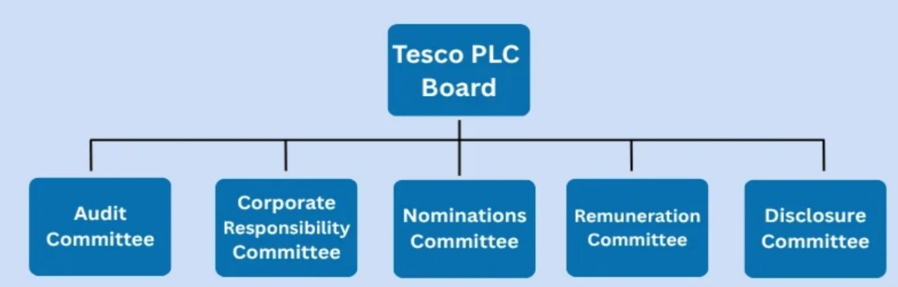
- Base Level: After the top-level and the middle-level, there is a base level of management. Here, employees are divided into specific regions. At the top of the chart is a regional manager, below them are food trading managers, non-food trading managers and personal managers. Each of the three managers has team members such as fresh food section managers, ambient food section managers, electrical section managers, clothing section managers, and personal assistant.
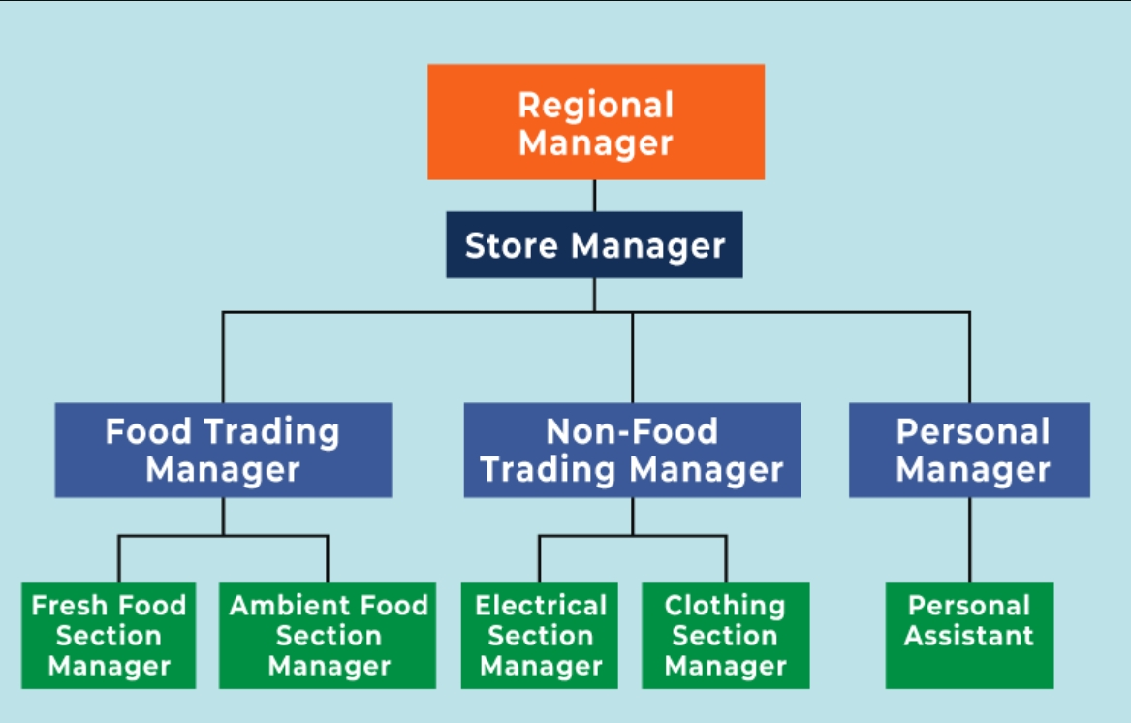
This is Tesco’s organisation structure and how it supports its daily operations.

Key Characteristics of Tesco’s organisational structure
- Hierarchical: is a tall and pyramidal structure with several layers of management. This creates a clear chain of command
- Decentralized: this gives freedom to the store manager to make operational decisions in a way that best meets local needs
- Empowerment: this structure empowers employees and encourages them at all levels to take responsibility and make decisions. It gives them a sense of involvement in the business
Advantages
- Career Progression: the tall hierarchy structure provides a chance for employees to advance their careers, as it creates many management layers.
- Specialisation: a functional structure enables departments to specialise in specific areas like marketing and finance.
- Local Decision-Making: the tall structure allows local and regional managers to make decisions that suit their local areas, which can improve customer satisfaction.
Disadvantages
- Slow Decision-making: the long chain of command means that decision-making can take a long time
- Reduce Employee Motivation: plus, employees can feel less encouraged if they are given fewer responsibilities
- Poor Inter-Departmental Communication: the division of departments can lead to poor coordination and communication between them
Here are some key aspects of Tesco’s decision-making process
- Data Analysis: Tesco utilizes extensive data analytics to understand customer behaviour and preferences, the data from its Clubcard loyalty program, which has over 19 million active users. This program provides a wealth of data that informs product placement and promotions, allowing Tesco to personalise marketing efforts and product replacement in store
- Market Research: Tesco conducts regular market research to stay updated on industry trends and consumer needs. This includes surveys, focus groups and competitors’ analysis to inform strategic decision
- Customer Feedback: Tesco actively seeks customer feedback through various channels; this is crucial for improving services and product offerings
- Technology Integration: the use of technology, such as artificial intelligence and machine learning helps to optimize inventory management and supply chain logistics
- Sustainability Initiative: decisions are also influenced by sustainability goals; this includes sourcing products and reducing food waste
Evidence of Decision-Making
- Customer Satisfaction Surveys: Regular surveys indicate that customer satisfaction has improved due to changes made based on feedback
- Sustainability Report: Tesco publishes annual sustainability reports that outline their goals and progress, demonstrating how this initiative influence business decision. (Studocu,2026)

4: Relevant frameworks, models or theories to the selected organisation
Tesco operates under a steering wheel framework to balance operational, sustainability and financial goals. The major operational and strategic framework include:
- Strategic Business Unit Model and Distributed Innovation: instead of centralised innovation, Tesco empowered store managers to experiment with localised solutions. This enables the company to act with agility during shifting market demand.
- Operational Efficiency and Financial Drivers: The framework targeted a £1.5bn cost reduction by simplifying in-store backroom operations, logistics and goods-not-for-sale. It also focused heavily on cash generation to strengthen their balance sheet
- Corporate Governance and Risk Management: This framework ensured tight controls over sustainability commitments, financial reporting, and human rights in the global chain.
- Agility in Challenging Conditions: 2020 required Tesco to rapidly pivot its framework to expand Grocery Home Shopping capacity (+20%) and introduce priority slots for vulnerable customers during the COVID-19 pandemic. (Fu,2024)
Tesco Business Model: Tesco PESTLE Analysis
The PESTLE Analysis of Tesco for 2026 highlights key external factors influencing its operations, including political stability, economic conditions, social trends, technological advancements, legal regulations and Environmental concerns.
This PESTLE analysis provides a comprehensive overview of the external factors that Tesco must navigate to maintain its competitive edge and ensure sustainable growth in 2026.
- Government Stability: Political stability in the countries where Tesco operates is crucial. Instability can disrupt supply chain and affect operation.
- Economic Factors: Economic fluctuation such as inflation or changes in consumer spending can impact Tesco’s sales and profit. Tesco needs to adapt its pricing strategies accordingly.
- Social Factors: Shifts in consumer behaviour, such as increased demand for online shopping and sustainable products, influence Tesco’s product offerings and marketing strategies.
- Technological Factors: Tesco is investing heavily in technology to improve operational efficiency and customer experience.
- Legal Factors: Tesco must comply with various regulations across different countries, including labour laws, health and safety standards and consumer protection laws.
- Environmental Factors: Environmental concerns are increasingly influencing Tesco’s operation. The company is focusing on reducing its carbon footprint and implementing sustainable practices in its supply chain to meet consumer expectations and regulatory requirement.

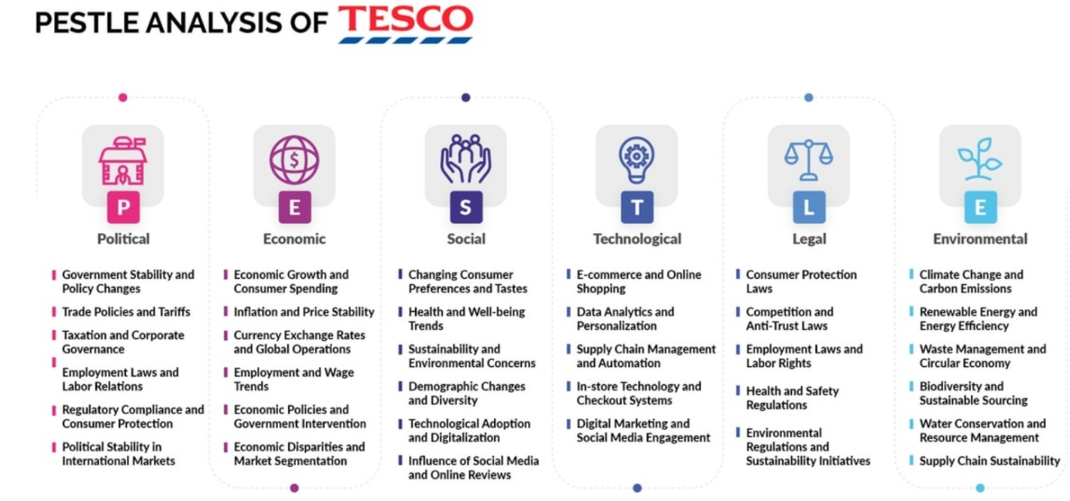
5: Organisational culture and adaptation to the external environment of Tesco.
Impact of changes in the external environment of Tesco over the last three years (2020-2023): Operating in a highly competitive and dynamic sector, Tesco has faced significant challenges and opportunities arising from macro-environmental factors such as economic shifts, technological advancement and socio-political developments. By employing a PESTLE framework (Political, Economic, Social, Technological, and Legal).
External Environment Changes Affecting Tesco PLC
Over the past three years, Tesco has navigated a complex external environment shaped by multiple intersecting factors. One of the most significant influences has been the COVID-19 pandemic, which began impacting global markets in early 2020.
Politically the UK economy experienced severe disruptions with a recession in 2020 followed by a slow recovery, this reduced consumer spending power. Tesco as a grocery retailer, this resulted in increased demand. Customers shifted towards value products and placing pressure on the profit margins. Post-Brexit trade agreements and border controls introduced in 2021 increased supply chain costs and delays in the importation of goods. (House of Commons Library,2022)
Technological advancement has played a role, the acceleration of e-commerce by the pandemic saw a dramatic rise in the online grocery shopping. According to industry reports, online sales in the UK retail sector grew by over 50% between 2020 to2021(Mintel, 2022).
Tesco’s Strategic Adaptation to External Changes
In response to these external challenges, Tesco has implemented several strategies to maintain its market position and ensure long-term sustainability. Economically, to address the pressures of inflation and cost-conscious consumers, Tesco has focused on its Clubcard Price scheme, offering loyalty-based discounts to retain customers.
Additionally, Tesco expanded its range of budget-friendly, owned brand products to compete with discounters like Aldi and Lidl. To mitigate the impact of Brexit-related supply chain disruptions, Tesco has invested in domestic sourcing partnerships. For instance, the company increased its collaboration with UK farmers and suppliers to reduce reliance on EU imports.
Technologically, Tesco has significantly enhanced its online presence to capitalise on the e-commerce boom. The company expanded its online delivery capacity by recruiting thousands of additional staffs and investing in automated warehousing systems. In terms of social and environmental pressures, Tesco has taken proactive steps to align with consumer values and regulatory demands. (Tesco PLC,2023)
Tesco’s benchmarking
Tesco benchmarks its business performance against competitors like Asda, Lidl, Morrisons and Waitrose. With each of its benchmarks, the company publishes a company scorecard presenting its ranking position, score and findings of how well the company is performing.
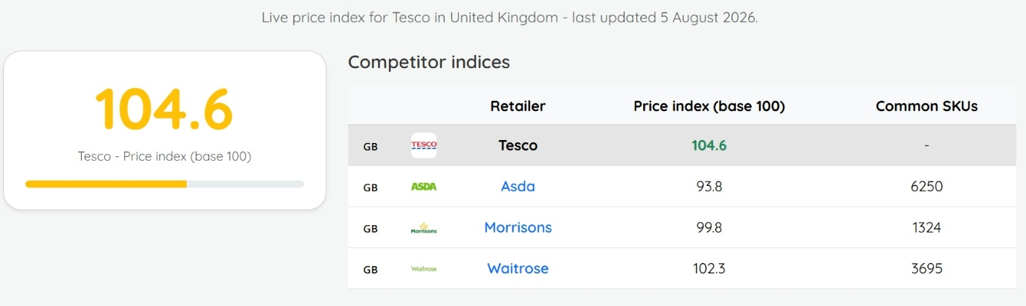

6: Organisational Culture and Effective Functioning of Tesco
Tesco’s core purpose is to serve their customers, communities and planet better every day, it means they always keep customers at the heart of what they do, while also reflecting their responsibilities to the community and to society more broadly.
Customers: Everything they do begins and ends with their customers. By understanding their customers, they can anticipate and respond to their needs and expectations. As a group they serve a wide range of different customers, from retail to banking, and mobile.
Communities: The role Tesco play in the thousands of communities they serve is vital- whether creating good jobs, supporting local suppliers and producers or helping local causes through their community programmes.
Planet: Tesco’s commitment to sustainability is core to their business. It drives their work across their operations and supply chain to reduce their environmental impact and support a healthier way of living.
At Tesco, everyone is welcome, there is an opportunity for all:
- We listen carefully and make sure everyone is heard, value, supported and empowered to be their best.
- We build trust, by being honest, and fair. Respecting each other and working together
- We value different perspectives and make each of us unique, we can make Tesco great for our customers and colleagues.
- We work as one team, care for each other and thank each other.
Every little help makes a big difference
- Helping to reduce food waste globally and ensuring surplus food goes to those who need it
- Making it easier to live more healthily
- Sourcing great quality, affordable and sustainable products
- Making a positive contribution to the communities where we operate.
Every little help makes a big difference – it's the value they live by to ensure they serve their customers, colleagues and their communities better every day. It really captures how, when they add up the small things they do.
Since they first introduced their Tesco Values more than a decade ago, they have become a vital part of their culture and an essential underpinning of their growth and success. They ensure that every person at Tesco understands what is important – about how they work together as a team and how customers are at the centre of what they do. They are universal values, which have helped guide their people as Tesco has grown into new markets and new countries. (Tescoplc.com, 2026)
7: Evaluation of the impact of organisational culture on organisational performance of Tesco
Tesco supports its people and communities in several ways: Healthy-living education, community projects, charitable assistance, safe working conditions, inclusive hiring and human rights standards across its supply chain. (Schosser,2022)
Tesco states its core purpose is “serving our customers, communities and planet a little better every day. Tesco’s culture is anchored in three core values that define how it operates:
- No one tries harder for customers – customer-centricity as the priority
- We treat people how they want to be treated – inclusive respectful workplace
- Every little help makes a big difference – responsibility to communities and the planet
Positive Impacts on Employees
- High engagement and inclusion: 84% of colleagues would recommend Tesco as a great place to work; 86% feel the culture of inclusive
- DEI and wellbeing: Everyone’s welcome framework flexible working from day one, virtual GP service, and Employee Assistant programme
- Development and training: Serve, Pick and Fill upskilling taken by 176,000 colleagues: continuous learning boost confidence and retention
Positive Impacts on Customers
- Customer service standard: No one tries harder for customers drives helpful, polite, responsive service across all channels
- Customer-led innovation: Culture of listening and acting on feedback-Clubcard, online delivery, range personalisation
Positive Impact on Business Performance
- Competitive advantage: Customer-first culture + innovation = market leadership in UK grocery; strong loyalty and market share
- Reputation and ESG: Embedding sustainability into values builds investor confidence and regulatory compliance
Challenges and Negative Impacts
Internal Tensions
- Scales vs consistency: With 300 thousand plus colleagues across markets, cultural dilution can occur-headquarters values may not match local store reality
- High-pressure environment: Outcome/achievement orientation can lead to stress burnout and work-life balance complaints in some locations
- Cultural alignment and internationally: Adapting UK values to different markets creates friction-some initiatives don’t translate well
External and Ethical Risk
- Past scandals: 2017 accounting irregularities and bribery allegations damaged trust; raised questions about cultural gaps between stated values and practices
- Supplier relationships: Perceived aggressive negotiation tactics contradict “act responsibly” values; strain partner trust
- Pay and conditions debates: Despite DEI progress, living wages and contract hours criticism persist-perceived gap between rhetoric and experience
Structural Limitations
- Bureaucracy: Large matrix structure slows decision-making; can stifle the innovation culture it claims to support
- Resistance to change: Deeply embedded routines makes cultural shifts slow; inconsistent leadership commitment undermines new initiatives
Overall Assessment Table
DIMENSION | IMPACT
Employee Engagement | Strong positive
Customer Satisfaction | Strong positive
Innovation and Agility | Moderate-strong
Ethical and Reputation | Mixed
International Transfer | Variable

Bottom line: Tesco’s culture is its greatest competitive strength – but its full potential will only be realised when the values colleagues see from leadership match the values, they are expected to live with customers and each other.
8: Conclusions
We know how challenging it is for many households across the country, as they continue to grapple with the ongoing cost of living pressure. We are committed to doing everything we can to drive down food bills and Tesco is now consistently the cheapest full-line grocer.
Our investment in value, and in improving more than 1,100 own brand products from pasta to fresh fish are helping us to offer outstanding quality at great prices. Customers are responding well, contributing to market share gains in store and online.
Strong financial performance
- UK and ROI LFL sales up 8.4%, including UK up 8.7%, ROI up 6.9% and Brooker up 7.5%
- Retail adjusted operating profit £1,417m, up 13.5% at constant rate, including save to invest delivery of c. £290m
- Net debt improved by £605m since year-end due to strong cash flow and Bank special dividend: net debt/EBITDA ratio 2.3x
Creating long-term sustainable value for all Tesco stakeholders
- Continued strong focus on customer satisfaction, market share and cash, ensuring we balance all stakeholders’ need
- Biggest investment in pay and new wellbeing services for colleagues
- Launched stronger starts grants programme to help 5,300 schools gives children a healthier, stronger start in live
Outlook:
Looking forward, we will continue to prioritise investment in our customer offer, working with our supplier partners to reduce prices wherever we can whilst delivering the outstanding quality our customers expect.
Our save to invest programme, resulted in a strong performance in the first half of the year which means we can expect to deliver between £2.6bn and £2.7bn retail adjusted operating profit for the 2023/24 financial year. We continue to expect Bank adjusted operating profit of between£130m and £160m. (Tesco PLC, 2023)
References:
1: Lasky J, 2017, Tesco PLC. London, UK
2: Schosser A, 2022, 5 Lessons from Tesco’s Corporate Culture. London, UK
3: Assignment desk, 2026, Tesco Organisational Structure. London, UK
4: Studocu, 2026, How Tesco Make Decisions Provide Evidence. Amsterdam, Holland
5: Fu R, 2024, Analysis of Business Operation Mode and Marketing Strategy of British Mainstream Supermarket. London, UK
6: House of Commons Library, 2022, Brexit: Impact on UK Trade and Supply Chains. UK
7: Mintel Group LTD, 2022, UK Online Grocery Retailing Report. UK
8: Tesco PLC, 2023, Sustainability Report 2022. UK
9: Tescoplc.com, 2026, Core Purpose and Values. London, UK
10: Schosser A, 2022, What Are Tesco’s 5 Lessons for a Strong Corporated Culture? EU
11: Tesco PLC, 2023, Interim Results Trading Statement 2023/2024. London, UK

