Personal Reflection Photo Essay – Strata Florida:
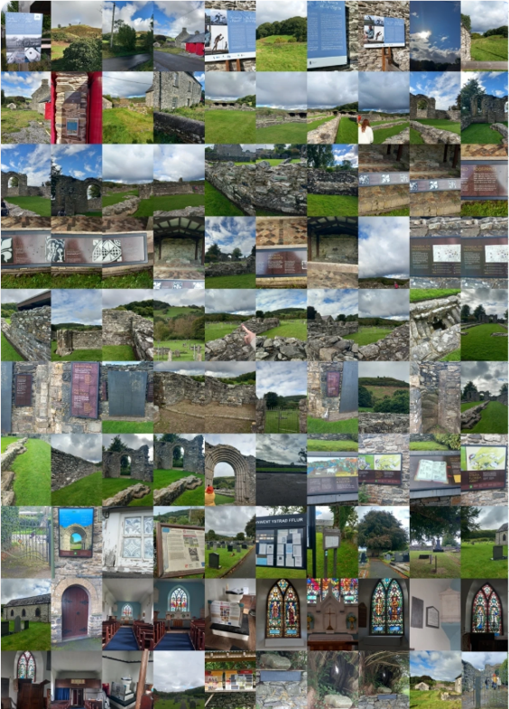
Strata Florida or Ystrad Fflur is a key historical heritage site, as there are the remains of a former Cistercian abbey, as well as many gravestones and a church, it is also the resting place for many generations of medieval Welsh Princes. ‘Strata Florida, situated at the geographical centre of Wales, is a special place, the land around it is rich in history through the centuries’ (About, no date). I found this field trip interesting as I had previously heard through word of mouth about the legend of Strata Florida and the important and interesting history of the place and I was curious to learn more and to view the site for myself, I also found out lots of information while on the trip from noticeboards that I had not found on the website. On the field trip, I observed many things that were interesting to me from the perspective of a History and English Literature student. For example, I found the placement of the abbey’s remains and how they are not necessarily in line with the structures that pre-date the abbey fascinating. I was also interested in the placard placed to honour Welsh poet Dafydd ap Gwilym and his supposed burial site. Overall, this trip enabled me to think about the importance of the history of a place.
1 - Collage of pictures taken by me at Strata Florida
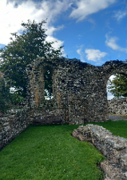
I found the remains of the walls of the abbey interesting as it is useful to see how large and grand the abbey would have been but also to see the importance of how the abbey was placed and how it was set up inside and how this links to the Cistercians who built the abbey. From the main archway of the West doorway, you can see where the altar would have stood before the abbey was a ruin. Although it is just the remains, this is still a spectacular site, especially as a student of history, for example I was impressed by the arches of the abbey due to the grandeur of them.
2 - Photo taken by me of wall remains
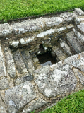
I found this remain of a font that predates the abbey fascinating as although it remained a part of the abbey, it does not seem to fit with the rest of the abbey due to the placement. The Cistercians would have placed their font at the entrance of the church rather than where this one is placed, therefore the abbey was built on top of this remain, which is interesting from the perspective of a history student as it shows there are multiple histories to this site as well as the Abbey which was built in 1164. This also made it clear to me as to why information from archaeologists is important to historical sites to enable them to understand more about why the structures are the way they are.
3 - Photo taken by me of the remains of a font
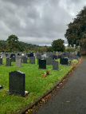
At Strata Florida, outside of the church, there is a large cemetery, the graves in which date all the way from recent years to centuries ago. This was interesting as the graves range from average people to Welsh royalty and a famous Welsh poet. The graves were also all in different states of disrepair, some appeared brand new, but others were decayed and damaged. This suggests that although this is a renowned historical site, it also has current, modern use.
4 - Photo taken by me of Cemetery
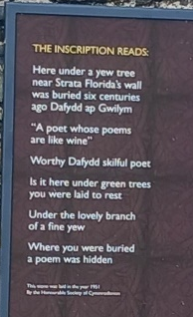
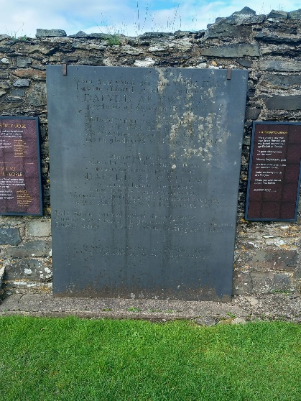
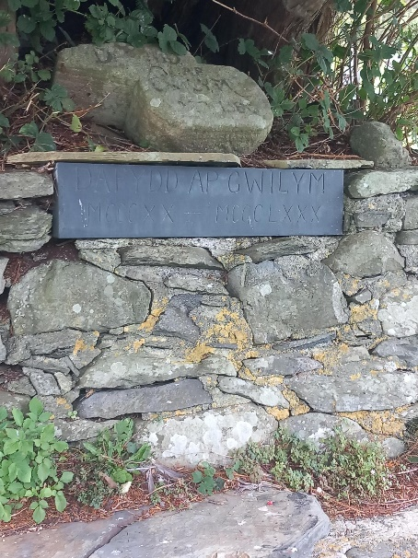
Also located within the graveyard is the supposed grave of famous Welsh poet Dafydd ap Gwilym. This is located at the base of a large and grandiose Yew tree and includes a placard and memorial stones. Dafydd ap Gwilym (c1315-c1350), ‘was a poet generally considered one of the greatest figures in Welsh literature’ (The Editors of Encyclopaedia Britannica, 1998). He wrote a large number of poems about love and nature; he is viewed as remarkable as compared to his contemporaries he wrote far more poems even though he died at a younger age. As well as the placard there are also memorial stones at the base of this tree which have been placed by members of the public to honour the poet. Dafydd ap Gwilym is famous for having inspired generations of poets after him due to his unique perspectives. He also was well known for being influenced by popular poets from all over the world rather than just poets within Wales. After his death, there have been multiple poems dedicated to him, including one about the Yew Tree that sits above his supposed grave. As well as a placard on the Yew Tree, there is also a large engraved placard attached to one of the walls from the ruins of the abbey dedicated to Dafydd ap Gwilym. This placard reads ‘Here under a yew tree near Strata Florida’s wall was buried six centuries ago Dafydd ap Gwilym “A poet whose poems are like wine”, worth Dafydd skilful poet is it here under green trees you were laid to rest under the lovely branch of a fine yew where you were buried a poem was hidden’ (From translation placed next to placard). This placard shows the importance of Dafydd ap Gwilym as a poet and the impact of his work. This is also a key part of the history of the site of Strata Florida. This is particularly interesting to me as a History and English Literature student as I have previously studied the work of Dafydd ap Gwilym and I am interested of the history of things and people.
7 - Photo taken by me of translation.
5 - Photo taken by me of engraved placard honouring Dafydd ap Gwilym.
6 - Photo taken by me of supposed grave of Dafydd ap Gwilym.
Overall, the trip to Strata Florida was fascinating to me as a student of English Literature and History due to the artefacts and ruins I was able to see while on the trip, and the information I was able to learn from the signage and placards that are placed at this key heritage site.
Heritage sites like Strata Florida and St Fagans are important as they allow the continuation of education about History as they provide an interactive learning experience, this is key to maintaining the study of the Humanities throughout the future, therefore they should be maintained and supported, and this trip furthered my idea of this.

References:
Picture 1 – Collage of Photos taken by me (Megan Dabell) during trip to Strata Florida
About (no date). https://www.strataflorida.org.uk/about.html.
Picture 2 – Photo taken by me (Megan Dabell) during trip to Strata Florida
Picture 3 - Photo taken by me (Megan Dabell) during trip to Strata Florida
Picture 4 – Photo taken by me (Megan Dabell) during trip to Strata Florida
Picture 5 - Photo taken by me (Megan Dabell) during trip to Strata Florida
The Editors of Encyclopaedia Britannica (1998) Dafydd ap Gwilym | Medieval Welsh, Poet Laureate, Nature Poetry. https://www.britannica.com/biography/Dafydd-ap-Gwilym.
Picture 6 – Photo taken by me (Megan Dabell) during trip to Strata Florida
Picture 7 - Photo taken by me ( Megan Dabell) during trip to Strata Florida

Bibliography:
About (no date). https://www.strataflorida.org.uk/about.html.
Strata Florida Abbey | Cadw (no date). https://cadw.gov.wales/visit/places-to-visit/strata-florida-abbey.
Strata Florida Abbey (CADW) - Pontrhydfendigaid - Visit Mid Wales (no date). https://www.visitmidwales.co.uk/things-to-do/strata-florida-abbey-cadw-p1723891.
Strata Florida St Mary (no date). https://www.nationalchurchestrust.org/church/st-mary-strata-florida.
The Editors of Encyclopaedia Britannica (1998) Dafydd ap Gwilym | Medieval Welsh, Poet Laureate, Nature Poetry. https://www.britannica.com/biography/Dafydd-ap-Gwilym.
Strata Florida Abbey (no date). https://castlewales.com/strata.html.
DAFYDD ap GWILYM (fl. 1340-1370), poet | Dictionary of Welsh Biography (no date). https://biography.wales/article/arc_s-DAFY-APG-1340.

