CarerCircle
Confidential Digital Wellbeing Support for the UK's Unpaid Carers

Student Name: Anita Johnson
Student Number: 2422551
Module Code and Title: Changemakers: Creativity and Value Creation
Lecturer's Name: Laila Surani
Assignment Title: Component 2 — Poster and Pitch

Date of Submission: 24/ 07/26

Table of contents

Contents
CarerCircle 3
poster 4
Background 5
Innovation Description 5
Impact on Health and Social Care 6
Public and Stakeholder Involvement 6
Policies, Services and Professional Links 7
Conclusion 7

CarerCircle

Confidential Digital Wellbeing Support for the UK's Unpaid Carers

poster and pitch
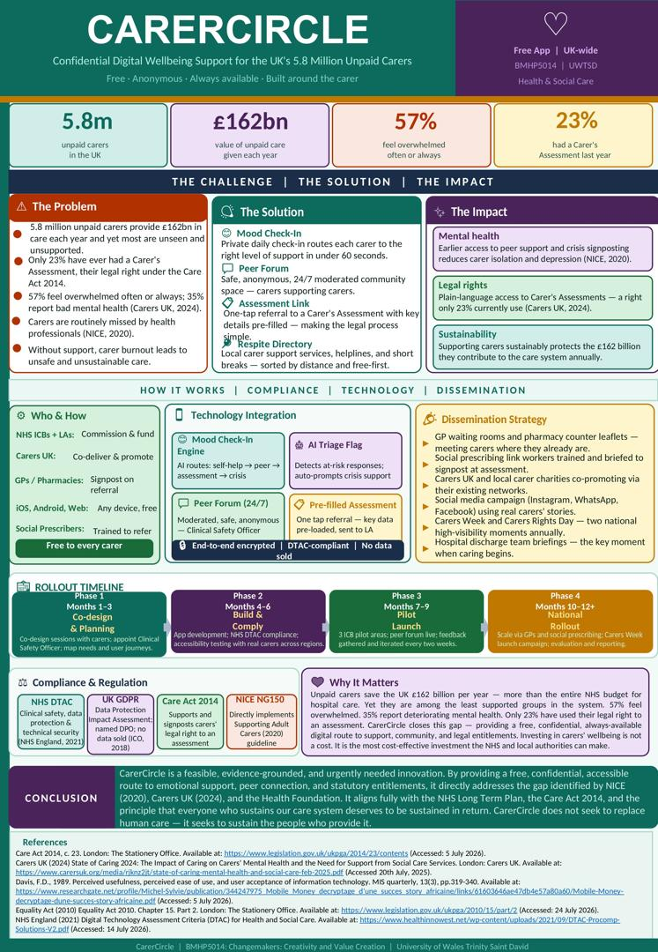
The unpaid carer wellbeing gap (Carers UK, 2024)

poster

The Pitch
Introduction
CarerCircle is a proposed digital wellbeing platform, specifically for the UK's 5.8 million unpaid carers (Carers UK, 2024). While the role of unpaid carers is now a key component of health and social care policy, there has been comparatively little investment in carers' mental health. This pitch therefore outlines the rationale for CarerCircle, a confidential app that includes well-being check-ins, peer support, signposting to respite and a direct link to a statutory Carer's Assessment. It is particularly focused on the gap between what is legally required of carers under the Care Act 2014 and what carers experience, as evidenced by isolation, exhaustion and unmet need. Undoubtedly, the primary beneficiaries are unpaid carers themselves, as well as the wider health and social care system and the people they care for, who stand to benefit from a healthier, better-supported carer workforce (Peytrignet, Grimm and Tallack, 2023).

Background
Unpaid carers are the backbone of the UK care system. Specifically, census and subsequent research place the number of unpaid carers at 5.8 million, with the economic value of their unpaid support estimated at £162 billion a year (Carers UK, 2024). Importantly, Carers UK's (2024) State of Caring survey, which received responses from more than 12,500 carers, revealed that 57% of carers reported feeling overwhelmed often or always, and 35% reported their mental health as bad or very bad, compared to 27% the year before. In addition, the same survey revealed that two-thirds of carers require more support for their own health and wellbeing, yet only 23% have received a Carer's Assessment in the last 12 months, despite this being a legal right under Section 10 of the Care Act 2014 (Carers UK, 2024). Similarly, NICE's (2020) guideline on supporting adult carers highlights that carers are often 'hidden from view', with health and social care professionals missing opportunities to identify them and signpost appropriate support. In fact, the evidence from the real world is that carers often do not know that a Carer's Assessment is available or feel able to request assistance when they are also working, dealing with finances, and caring for others. This is a clear and pressing gap that CarerCircle aims to address, given the high emotional need and low awareness of entitlement.

Innovation Description
CarerCircle is a free mobile application, with a light web version, designed around the carer's wellbeing, not the logistics of caring. Specifically, when the app opens, carers complete a short, private daily or weekly mood check-in. Depending on their responses, the app provides one of three options: self-help resources and breathing or grounding exercises; a moderated peer-support forum where carers can connect with others in similar situations; or a guided referral to request a statutory Carer's Assessment from their local authority, with key information pre-filled to reduce the barrier of a lengthy form. In addition, an integrated directory signposts local respite services, carer support groups and helplines. Importantly, what makes CarerCircle new is not the individual features, which build on existing digital health approaches (Rogers, 2003), but rather the combination and framing: existing tools such as Carers UK's Jointly app focus primarily on coordinating the practical tasks of caregiving between family members, whereas CarerCircle is deliberately designed around the carer's own mental health and legal entitlements. Moreover, the Technology Acceptance Model suggests that carers, many of whom are time-poor and unfamiliar with health apps, will be more likely to engage if the tool is genuinely easy to use and clearly useful to them (Davis, 1989); consequently, CarerCircle is designed with a minimal number of steps between opening the app and receiving meaningful support.

Impact on Health and Social Care
The main beneficiaries of CarerCircle are unpaid carers, including a diverse group of people, such as working-age adults balancing work and care, older spousal carers and parent carers of disabled children, many of whom report reducing their social contact and hobbies because of caring pressures (Carers UK, 2024). The app also makes it easier to request a Carer's Assessment, helping ensure this entitlement is used more equitably, especially by carers who are less confident in navigating local authority systems, including some older, disabled, and non-English-speaking carers. Better carer wellbeing has a positive impact on the person being cared for, as NICE (2020) has found that carer burnout is associated with a decrease in the capacity to care safely; it also has a positive impact on the wider system, as unsupported carers are more likely to reach crisis point and require more expensive statutory intervention. Likewise, for health and social care staff, an app that helps identify and signpost carers proactively also supports the identification duties set out in NICE's (2020) guideline, reducing the burden on GPs and social workers to remember to ask. Finally, CarerCircle serves the common good by safeguarding the well-being of the people whose unpaid work makes the care system possible, and ensuring that support is available fairly, irrespective of a carer's background, location or working hours.

Public and Stakeholder Involvement
CarerCircle would be co-produced from the beginning, in accordance with the Care Act's focus on carer involvement in decisions that impact on them (Care Act 2014). Specifically, a steering group of carers, representing a range of ages, caring relationships and backgrounds, would shape the app's design, language and features before launch. In addition, continued engagement would involve a feedback loop within the app, regular focus groups and working with Carers UK and local carer forums. In addition, public engagement would not be limited to carers but would also involve friends, neighbours and employers, who would be made aware of carers' needs and support the aims of the campaign, helping to normalise conversations about caring and reduce the isolation many carers report.

Policies, Services and Professional Links
CarerCircle is directly underpinned by the Care Act 2014, which gives carers a legal right to an assessment of their own needs (Care Act 2014), as well as by NICE's (2020) NG150 guideline on supporting adult carers. Similarly, the Equality Act 2010 provides information on the app's commitment to equality of access, including reasonable adjustments for carers with disabilities. Importantly, the app would not duplicate services, but would connect carers with existing services, including GPs, social workers and voluntary sector organisations like Carers UK and local carer centres, and would be designed to meet the NHS Digital Technology Assessment Criteria before being adopted by any NHS or local authority partner (NHS England, 2021). In practice, the app would be used as a signposting tool by professionals in nursing, social work and primary care during their normal interactions with carers.

Conclusion
The UK is estimated to save over £162 billion a year through unpaid carers, but over half feel overwhelmed and only a small proportion receive statutory support to which they are entitled (Carers UK, 2024). However, CarerCircle provides a low-cost, scalable, and evidence-based solution to this gap, offering carers a confidential space to be heard and a clear pathway to the support they are entitled to. Investing in carers' wellbeing is not a luxury; it is a necessity for the sustainability of the care system.

Reference list
Care Act 2014, c. 23. London: The Stationery Office. Available at: https://www.legislation.gov.uk/ukpga/2014/23/contents (Accessed: 5 July 2026).
Carers UK (2024) Facts About Carers, December 2024. London: Carers UK. Available at: https://www.carersuk.org/media/ocxheq2c/facts-about-carers-dec-2024-final.pdf (Accessed: 15 July 2026).
Carers UK (2024) State of Caring 2024: The Impact of Caring on Carers' Mental Health and the Need for Support from Social Care Services. London: Carers UK. Available at: https://www.carersuk.org/media/rjknz2jt/state-of-caring-mental-health-and-social-care-feb-2025.pdf (Accessed: 20 July 2025).
Davis, F.D. (1989) ‘Perceived usefulness, perceived ease of use, and user acceptance of information technology’, MIS Quarterly, 13(3), pp. 319–340. Available at: https://www.researchgate.net/profile/Michel-Sylvie/publication/344247975_Mobile_Money_decryptage_d'une_succes_story_africaine/links/61603646ae47db4e57a80a60/Mobile-Money-decryptage-dune-succes-story-africaine.pdf (Accessed: 5 July 2026).
Equality Act 2010, c. 15, Part 2. London: The Stationery Office. Available at: https://www.legislation.gov.uk/ukpga/2010/15/part/2 (Accessed: 24 July 2026).
Information Commissioner's Office (ICO) (2018) Guide to the UK General Data Protection Regulation (UK GDPR). Available at: https://ico.org.uk/for-organisations/uk-gdpr-guidance-and-resources/data-sharing/ (Accessed: 5 July 2026).
National Institute for Health and Care Excellence (NICE) (2020) Supporting Adult Carers. NICE guideline NG150. London: NICE. Available at: https://www.nice.org.uk/guidance/ng150 (Accessed: 5 July 2026).
NHS England (2021) Digital Technology Assessment Criteria (DTAC) for Health and Social Care. Available at: https://www.healthinnowest.net/wp-content/uploads/2021/09/DTAC-Procomp-Solutions-V2.pdf (Accessed: 14 July 2026).
Peytrignet, S., Grimm, F. and Tallack, C. (2023) Understanding unpaid carers and their access to support. London: The Health Foundation. Available at: https://www.health.org.uk/reports-and-analysis/analysis/understanding-unpaid-carers-and-their-access-to-support (Accessed: 24 July 2026).
Rogers, E.M. (2003) Diffusion of Innovations. 5th edn. New York: Free Press.

