

LEADERSHIP AND MANAGEMENT, THEORY AND PRACTICE

Programme: BA Business Management
Module name: Leadership and Management, Theory and Practice
Module code: LCBB6003
Lecturer name: Mr Afzal Munna
Student name: Cerasela Lavinia Stoica
Student ID: 2125057
Table of Contents
Task 1: Presentation 3
Introduction 3
Business leaders of the 20th century 3
Similarities and differences in leadership characteristics 5
Conclusion 6
Task 2: GROUP REPORT 7
Introduction 7
Learning outcome 7
Conclusion 8
Reference list 9

Task 1: Presentation

Introduction
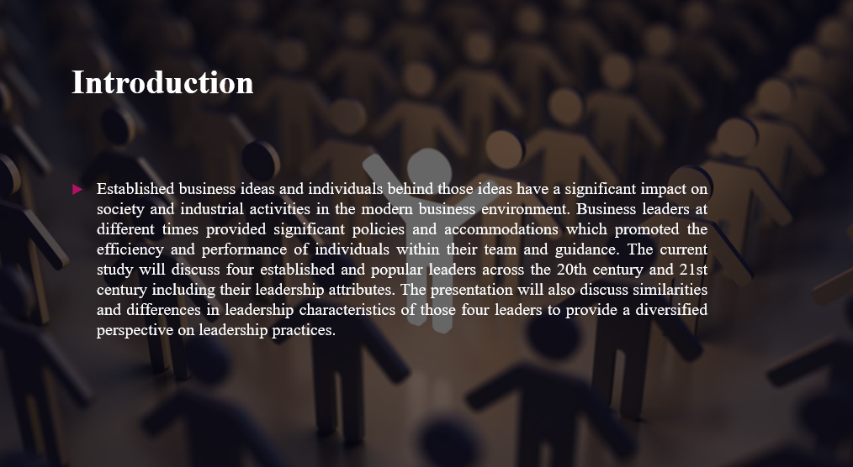
Established business ideas and individuals behind those ideas have a significant impact on society and industrial activities in the modern business environment. Business leaders at different times provided significant policies and accommodations which promoted the efficiency and performance of individuals within their team and guidance. The current study will discuss four established and popular leaders across the 20th century and 21st century including their leadership attributes. The presentation will also discuss similarities and differences in leadership characteristics of those four leaders to provide a diversified perspective on leadership practices.

Business leaders of the 20th century
Leadership Attributes of Steve Jobs
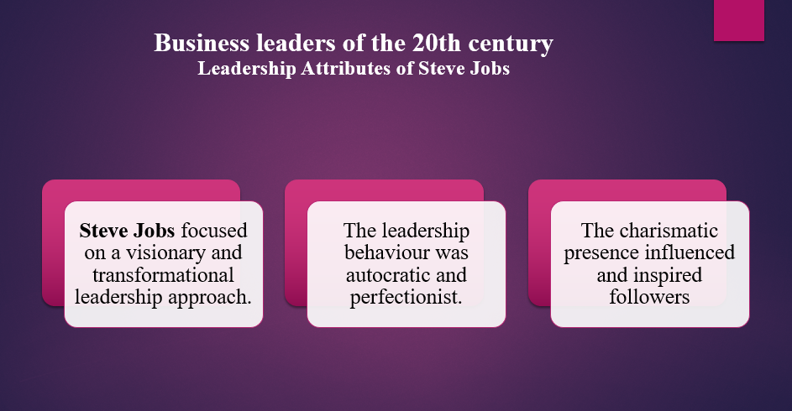
- Steve Jobs focused on a visionary and transformational leadership approach.
- The leadership behaviour was autocratic and perfectionist.
- The charismatic presence influenced and inspired followers.
Steve Jobs encouraged comprehensive leadership styles which promoted transformational leadership style and a visionary approach in Apple to inspire the team. The leadership behaviour of Steve Jobs was more autocratic which included an abrasive management style. As an individual, I focused on excellence and perfection along with achieving the best possible results. Despite a tough leadership approach, team members and followers inspired loyalty and comprehensive dedication to the working principles and values of their leader. Liability to articulate Steve Jobs's vision in team performance also played a significant role in motivation and engaging the team (Adigwe, 2024).

Leadership attributes Jack Welch
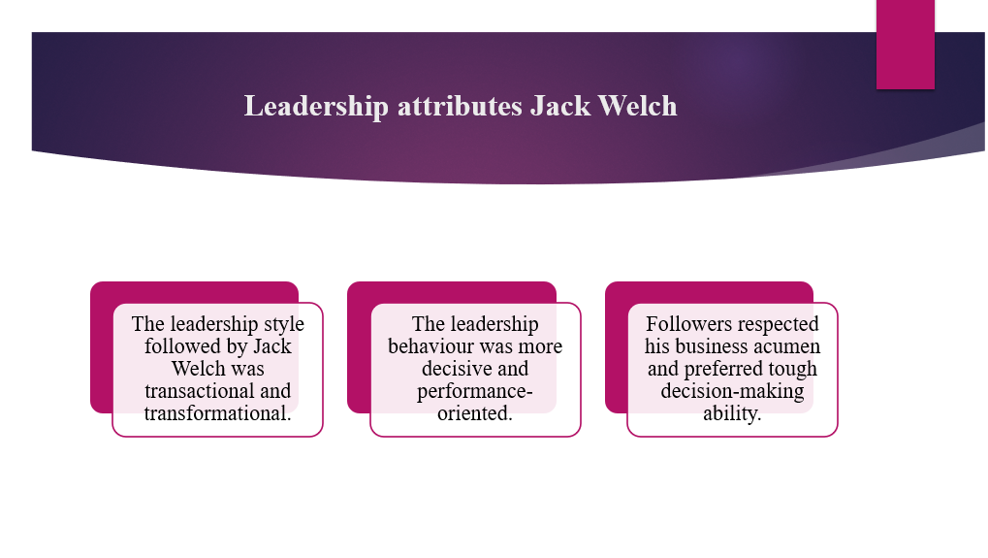
- The leadership style followed by Jack Welch was transactional and transformational.
- The leadership behaviour was more decisive and performance-oriented.
- Followers respected his business acumen and preferred tough decision-making ability.
Jack Welch focused on transactional and transformational leadership styles in general electronics for implementing strict management processes along with promoting efficiency and cultural innovation. Considering the leadership behaviour, Jack Welch was more concerned with performance and promoted high high-performing working culture which fosters a competitive working environment (Rice et al., 2023). Followers respected the leadership practices of Jack Welch due to extensive efficiency in profitability and growth results. Unbiased, clear and efficient decision-making practices are also promoted by the followers.

Business leaders of the 21st century
Leadership attributes Jeff Bezos
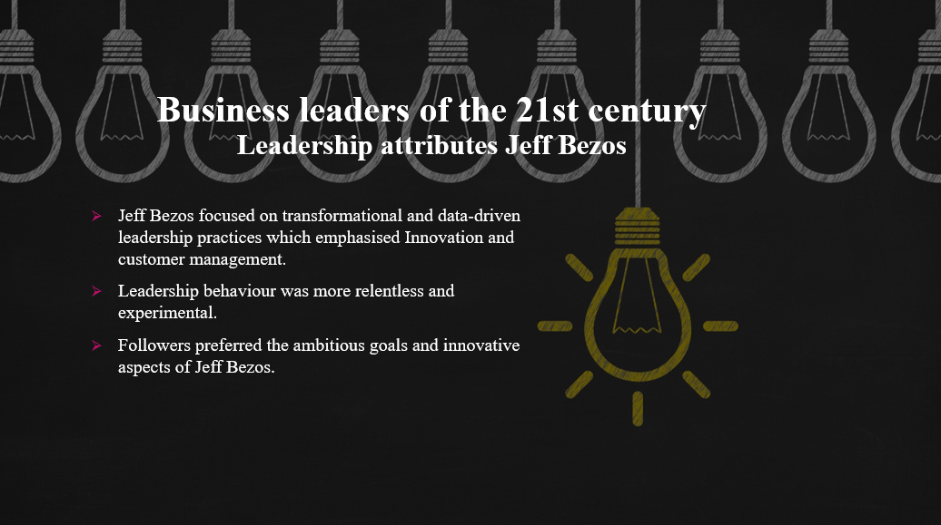
- Jeff Bezos focused on transformational and data-driven leadership practices which emphasised Innovation and customer management.
- Leadership behaviour was more relentless and experimental.
- Followers preferred the ambitious goals and innovative aspects of Jeff Bezos.
Jeff Bezos followed a data-driven leadership practice which maintains the infrastructure of a transformational leadership style. He promoted relentless and experimental leadership practices to encourage a culture of experimentation at Amazon. Followers also preferred and identified the innovative and customer-centric approach of Jeff Bezos. Jeff Bezos also used comprehensive accommodation of customer-centric changes which evolved the circumstances of employees' experience and skill requirements (Choi and Phan, 2021). Providing a diversified working environment and accommodating experimentation at Amazon significantly helped the leader to establish a new range of organisational effectiveness.

Leadership attributes Satya Nadella
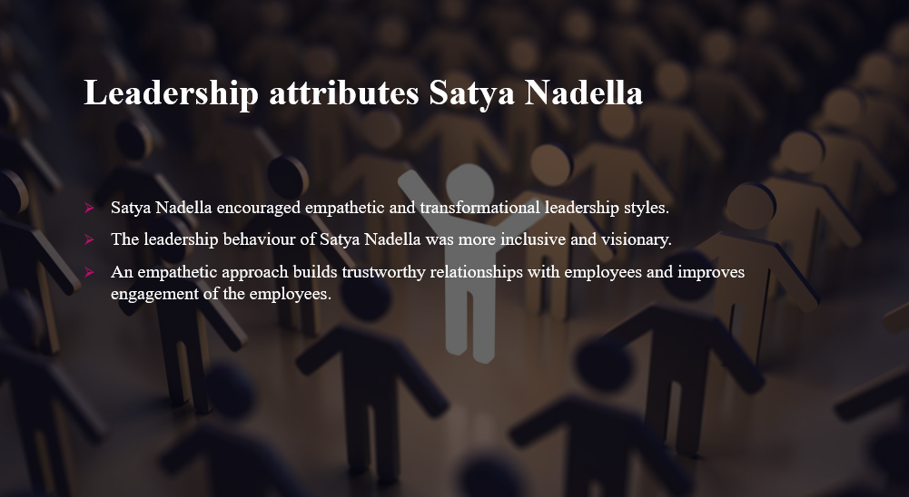
- Satya Nadella encouraged empathetic and transformational leadership styles.
- The leadership behaviour of Satya Nadella was more inclusive and visionary.
- An empathetic approach builds trustworthy relationships with employees and improves engagement of the employees.
The empathetic and transformational leadership style of Satya Nadella in Microsoft promoted a growth mindset and collaborative working culture. Nadella also promoted inclusive working culture and effective communication to establish collaboration within the working environment. Followers preferred the leadership practices of Nadella due to his trusted and respectful decisions focused on empowering and continuous development of the employees (Dewar et al., 2022). The leadership practices in the 21st century are more concerned with developing employees' efficiency with different tools and devices. The establishment of collaboration and building relationships with employees promoted more of a democratic approach in the working environment.

Similarities and differences in leadership characteristics
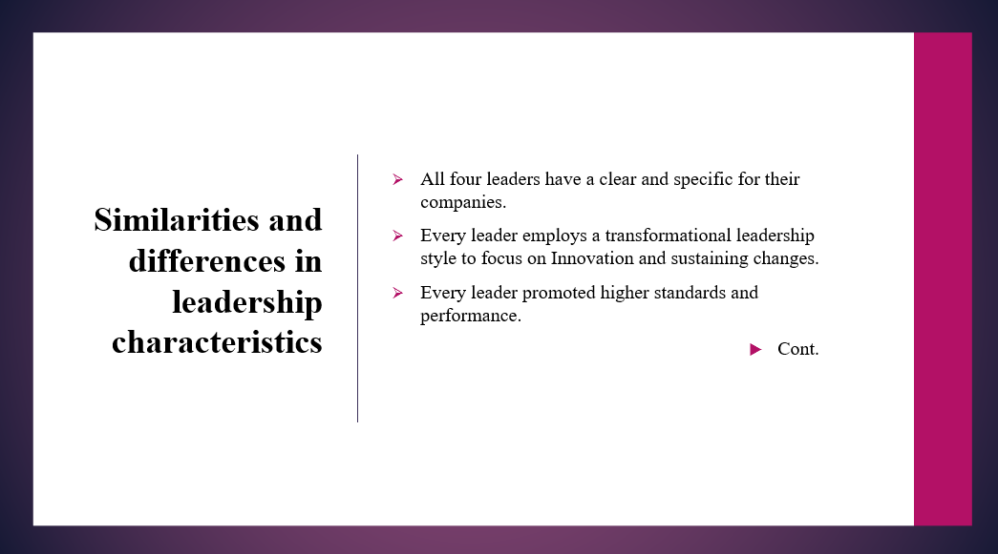
- All four leaders have a clear and specific for their companies.
- Every leader employs a transformational leadership style to focus on Innovation and sustaining changes.
- Every leader promoted higher standards and performance.
Cont.
The similarities of all four leaders include a clear and specific approach to the development of their company. All the leaders encouraged effective communication and inspiration in the working environment which significantly enhanced engagement and efficiency of the employees. Comprehensive uses of the transformational leadership style by each leader also develop significant changes in the organisation regarding innovation and change management (Martínez-Martínez et al., 2021). Moreover, the accommodation of high standard and performance development practices employed by individual leaders in their respective areas also helps companies to encourage high productivity and individual performance. The establishment and effective accommodation of appropriate leadership approaches with understanding the circumstances are also similar in the case of every individual leader.
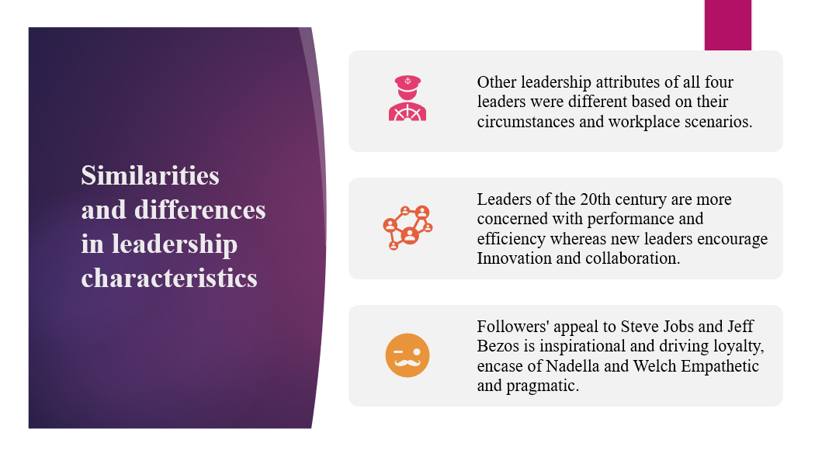
- Other leadership attributes of all four leaders were different based on their circumstances and workplace scenarios.
- Leaders of the 20th century are more concerned with performance and efficiency whereas new leaders encourage Innovation and collaboration.
- Followers' appeal to Steve Jobs and Jeff Bezos is inspirational and driving loyalty which incase of Nadella and Welch Empathetic and pragmatic.
Apart from all the similarities, all four leaders have their specific values and practices concerned with their working circumstances. Steve Jobs was autocratic and demanding which introduced a strong and rough leadership practice whereas Jack Welch focused on performance-specific changes and strict policies to gain better outcomes. The leadership behaviour of Jeff Bezos combined data-driven decision-making practices with innovative experimentation where Satya Nadella is extensively known for inclusivity and fostering a collaborative culture. The differences are also visible in the approach of leaders between the 20th century and the 21st century (Kadiyono et al., 2020). Followers are concerned with Steve Jobs and Jeff Bezos as their missionary and inspirational leader whereas Jack Welch and Satya Nadella were more inclined toward issues and improvement of employees concerned as well as their working circumstances.

Conclusion
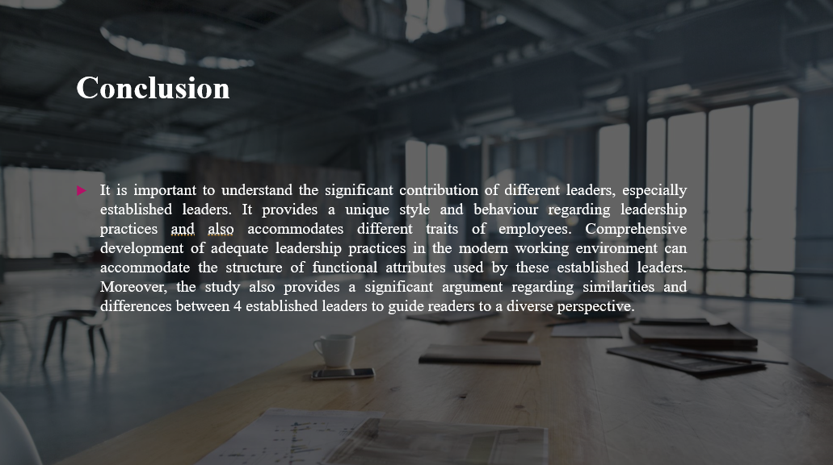
It is important to understand the significant contribution of different leaders, especially established leaders. It provides a unique style and behaviour regarding leadership practices and also accommodates different traits of employees. Comprehensive development of adequate leadership practices in the modern working environment can accommodate the structure of functional attributes used by these established leaders. Moreover, the study also provides a significant argument regarding similarities and differences between 4 established leaders to guide readers to a diverse perspective.

Task 2: GROUP REPORT

Introduction
Effective leadership practices are responsible for successful business operation and comprehensive management of employees in a diversified working environment. Specific leadership approaches include comprehensive uses of inclusive working environment and improvement of working culture. The study provides a brief discussion of different outcomes based on leadership practices gained while analysing the leadership practices of 4 established and popular leaders (Steve Jobs, Jack Welch, Jeff Bezos, Satya Nadella).

Learning outcome
The leadership practices include a comprehensive focus on specific working environments and appropriate decisions which can encourage individual participation and growth. Established leaders like Steve Jobs, and Jack Welch focused on developing standard business practices which would allow them to manage employees in a very strict manner. It significantly promoted their engagement with maintaining and promoting the participation of the employees through strict guidelines and policies (Megheirkouni and Mejheirkouni, 2020). In the 20th century, most of the leadership practices followed the transformational leadership style but it was more concerned with managing and focusing on standardising practices. The leadership practices also change according to the circumstances and requirements in the business environment. In the 21st century, most leadership practices are more focused on the development of effective working culture and appropriate working principles which can promote the engagement and efficiency of the employees (Fries et al., 2021). Popular and successful leaders like Jeff Bezos and Satya Nadella encouraged collaboration in the working environment to promote performance and creativity. These leaders also focused on the comparative development of innovation in the working environment which can subsequently promote the organisational capability to utilise resources and manage the overall working environment (Abdullahi et al., 2020).
Appropriate decision-making practices and focusing on problem problem-solving skills of leaders are essential to choose an appropriate leader. Most business organisations prefer leaders skilled and experienced to manage employees as well as utilise performance regarding organisational needs and objectives. The prime responsibility of the leader can also be demonstrated as the ability to align the organisational objectives and goals of the employees. Subsequent integration and development of various policies in the working environment promote the efficiency of the leaders to encourage and engage employees. On a short note, leaders are responsible for the sophisticated development and management of employees in the working environment along with utilising available information and data from external sources to influence the flexibility and adaptability of the employees. Appropriate application of different leadership theories such as transformational leadership style, autocratic leadership style, democratic leadership style, transactional leadership style and other leadership approaches can be used based on the circumstances and requirements. The situational leadership model provides a convenient approach for leaders to choose different leadership styles and combine their aspects for the management of the working environment (Day et al., 2021).

Conclusion
Effective leadership practices provide significant benefits to organisations in terms of managing employees and also promoting organisational efficiency and performance. The study provides a comprehensive discussion on learning outcomes focusing on leadership practices and efficiency of the 4 most popular and established leaders in the 20th and 21st centuries. Accommodation of different theories and an appropriate focus on information management is a critical task in leadership practices. The study also justifies the utility of employee engagement and continuous changes in leadership approaches to accommodate variability in employee engagement and performance attributes.

Reference list
Task 1
Adigwe, C. S. (2024). Transformational Leadership: A Comparative Exploration of the Leadership Prowess of Jeff Bezos and Steve Jobs. Asian Journal of Economics, Business and Accounting, 24(3), 68-89.
Choi, Y., and Phan, W. M. J. (2021). Narcissistic leaders: The good, the bad, and recommendations. Organ. Dyn, 100868.
Dewar, C., Keller, S., and Malhotra, V. (2022). CEO excellence: The six mindsets that distinguish the best leaders from the rest. Simon and Schuster.
Kadiyono, A. L., Sulistiobudi, R. A., Haris, I., Wahab, M. K. A., Ramdani, I., Purwanto, A., ... and Sumartiningsih, S. (2020). Develop leadership style model for indonesian teachers performance in Education 4.0 era. Systematic Reviews in Pharmacy, 11(9), 363-373.
Martínez-Martínez, M., Molina-López, M. M., Mateos de Cabo, R., Gabaldón, P., González-Pérez, S., and Izquierdo, G. (2021). Awakenings: an authentic leadership development program to break the glass ceiling. Sustainability, 13(13), 7476.
Rice, J., Martin, N., Raziq, M. M., and Fieger, P. (2023). A reconsideration of Jack Welch's managerial legacy. EuroMed Journal of Business.
Task 2
Abdullahi, A. Z., Anarfo, E. B., and Anyigba, H. (2020). The impact of leadership style on organizational citizenship behavior: does leaders' emotional intelligence play a moderating role?. Journal of management development, 39(9/10), 963-987.
Day, D. V., Riggio, R. E., Tan, S. J., and Conger, J. A. (2021). Advancing the science of 21st-century leadership development: Theory, research, and practice. The Leadership Quarterly, 32(5), 101557.
Fries, A., Kammerlander, N., and Leitterstorf, M. (2021). Leadership styles and leadership behaviors in family firms: A systematic literature review. Journal of Family Business Strategy, 12(1), 100374.
Megheirkouni, M., and Mejheirkouni, A. (2020). Leadership development trends and challenges in the twenty-first century: rethinking the priorities. Journal of Management Development, 39(1), 97-124.

