
Harry Foxton (1702199)
27/03/2019
Group Project – Hydro Scheme Feasibility
Team sustained ability

Contents
1 Introduction 3
2 Site Details 4
2.1 Site Choices 4
2.1.1 Site Specification 5
3 Theoretical Calculation and data collection (Harry Foxton) 6
3.1 Basic principles 6
3.2 Turbine classification 6
3.3 Preliminary data collection 7
3.3.1 Safety: 7
3.3.2 Methodology 8
3.4 Turbine selection and Theory 9
3.4.1 Turbine choice 10
3.5 The Pelton Turbine 10
3.5.1 Theoretical consideration for manufacturing: 11
3.6 Grid Connection 12
3.7 Section 4 Appendices 13
4 Legislation (Sion Evans) 14
4.1 General Information 14
4.2 WRA – Proposal Outline & Applications Details 14
4.3 WRB – Hydropower Schemes 17
4.3.1 Flow Duration curve 17
4.4 WRD – Abstraction License Application 19
4.5 WRE – Impoundment License Application 20
5 Manufacturing and Installations (Joseph Blackmore) 22
5.1 Overview 22
5.1.1 Component specifications and overall design layout 22
5.1.2 Installation 22
5.2 Specification of Fundamental Scheme components 23
5.3 Preventative Maintenance 25
5.3.1 Shut-down Mechanisms 26
5.4 Installation 26
5.4.1 Penstock Path 27
5.4.2 Powerhouse Location & Accessibility 28
5.4.3 Intake Weir & Penstock Inlet Location 29
5.5 Logistical Obstacles 30
6 Cost analysis (Timothy Jones) 31
6.1 Introduction 31
6.2 Initial Capital 31
6.2.1 Powerhouse Equipment 32
6.2.2 Installation 32
6.2.3 Additional costs 34
6.3 Ongoing Costs 34
6.3.1 Maintenance 35
6.4 Tariff 35
6.4.1 Competition 35
6.4.2 Calculated 36
6.5 Cost viability 37
7 Time Management (Timothy Jones) 39
8 Figures, Tables and Equations 41
9 Bibliography 42

Introduction

As the demand for energy continues to rise with population and increasing technological advancements, the environment is becoming deteriorated and Earths finite resources have begun to deplete. Due to this there are massive global efforts towards finding new innovative and sustainable ways for producing electrical energy. Hydropower is one of the various sustainable energy sources used in today’s world.
This report includes the full design process of a run of the river small-hydropower scheme, for a small village in the Neath valley, where the energy demand is expected to raise from 5-50MW. The purpose of this scheme is to provide a clean sustainable energy supply to the village that will contribute to the energy demand and last for years to come without negatively effecting the environment of the area.
Hydropower is one of the oldest power sources used by mankind. Originally used by farmers for mechanical tasks it has long since been adapted to produce a usable energy source in the form of electricity. The kinetic energy of flowing water is harnessed by mechanically rotating a turbine which is connected to a hydroelectric generator, which then converts rotational mechanical energy into electricity (USGS, 2016). Hydropower turbines are much more efficient than steam turbines with efficiencies rarely below 80%. Hydropower schemes offer long term generation with an 80-year life span, more than double the 25-year life span given to solar PV and wind. It provides 90% of the world’s renewable power with 30-40% of the UK’s renewable power generation supplied by hydro. (British Hydro, 2018). Additionally, hydropower costs less than almost all other energy sources, due to its direct method of energy transfer and easily maintainable design. According to (British Hydro, 2018) recent studies suggest there is a potential 2GW increase of hydro capacity in the UK.

Site Details

Site Choices
During initial Discovery for a site, Ordnance Survey mapping service was used to identify potential areas of interest in the surrounding area. It was observed that in the Neath Valley region there were many small streams of water running down into the valley basin which had the potential for hydropower due to the steep terrain indicated by the contours. The first trip involved an exploration phase where we inspected 3 potential sites chosen by either the head of the site or the width displayed on the map which indicated a high volumetric flow (Figure 1).
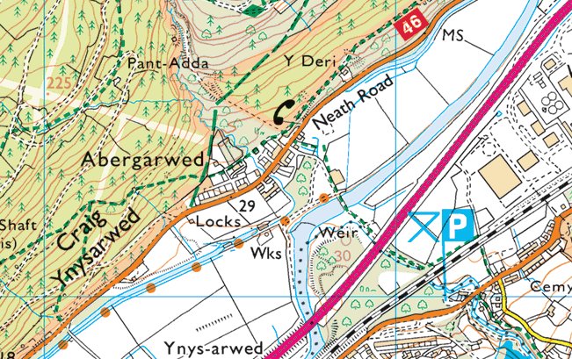
Site 1
Site 2
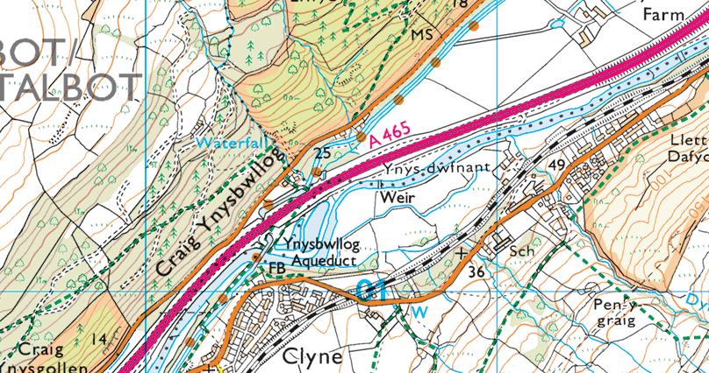
Figure 1 - Ordnance Survey
Site 3

Figure 1 – Ordnance Survey Maps (Ordnance Survey, 2019)
Site 3 was the first to be visited; however, upon arrival it was discovered that the stream was already being used for water treatment due to the high iron content found in the water from this region due to its mining past.
Site 1 and 2 are in very close proximity as displayed on the map above. Site 1 uses an existing natural weir which is on the main river; the weir that is proposed only has a head height of 1.5m therefore to be viable must have a very high volumetric flow rate and if the scheme was to be put forward, it would be suggested to increase the head height of the weir by means of an additional constructed weir. Site 2 is proposed as a high head, low volumetric flow rate usage. The marked position of site 2 in the above diagram indicates the exit point of the potential scheme as it would run down the hillside through a penstock.

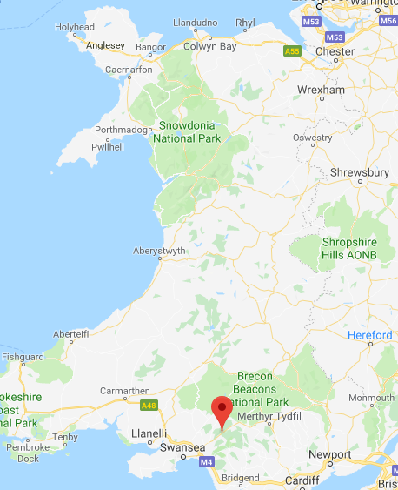
Site Specification
Our site is located in the Neath valley, South Wales, just south of the Brecon beacons (Fig 1). Our site will be using the Garwed Brook stream that originates in an old disused mine and flows 970m down the mountain side to join the Neath river as shown in the map below. The catchment description of the upland area Neath is a mixture of livestock farming some forest cover and urban development. There is mixed geology in a mainly upland catchment area containing; Carboniferous Limestone, Old Red Sandstone, Milestone grit and coal measures. In the mid catchment there is extensive boulder clay cover (National River Flow Archive, 2019).

The intake of water will take place at SN81360297. (MagicMap.gov, 2019)

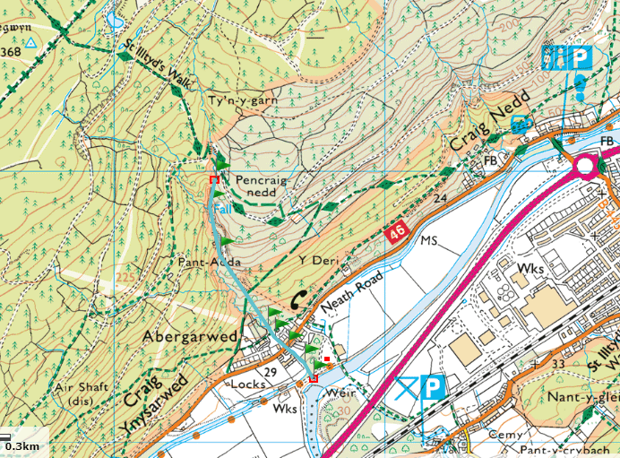

The power house and discharge will be constructed at SN81730228 (MagicMap.gov, 2019)

Theoretical Calculation and data collection (Harry Foxton)

Basic principles
To justify the implementation of a hydro scheme in this scenario, we must use theoretical calculations to ensure it is a feasible and cost-effective design. We can use these calculations to directly influence the outcome of the final design.
The basic principle of gaining electrical energy from a source of water involves 3 major conversions of energy; for hydro power to work there must be a source of water that has a moderate to large height difference over a relatively small distance, this vertical height difference is known as head height. When water is stored at a higher point than another point, the mass of water has potential energy. As the water falls down through the head height, the potential energy in the water is converted into kinetic energy. The second conversion of energy is the conversion of kinetic energy in the water to rotational kinetic energy in a turbine blade. The final form of energy conversion is rotational kinetic energy to electrical energy from the turbine to the generator.

Turbine classification
Turbines are classified by the means in which they collect the mechanical energy in the water and convert it into rotational mechanical energy and are usually dependent on 2 aspects; as previously mentioned the head height of a site changes the velocity at which the water can travel, the second aspect of energy conversion is the volumetric flow rate of the site measured in m^3/s. There are 3 main ways in which a turbine can collect energy from the force of the water: A turbine can use the mass and volumetric flow of the water to provide a consistent force and pressure, this is collected by means of a reaction force against the surface of the blade which is at an angle relative to the direction in which the water approaching the blades therefore making a component of that force act in a lateral direction, thus producing a rotational force. This kind of set up is usually found at a site with low head but high flow rate. Another method to collect the kinetic energy from a water supply is by means of an impulse action; this impulse action is cause by the water traveling at a high velocity, therefore must have a high head. In this set up the kinetic energy in the water transfers to the turbine over a very short period of time and the site usually has a higher head but a lower flow rate. The final way in which a turbine can convert GPE into rotational kinetic energy is by means of a gravity fed system; this principle does not use the velocity of the water, but the force generated purely by the mass of the water which uses a component of the force generated by the mass and gravity to rotate a central axis (Green Bug Energy Inc., 2016)

Preliminary data collection
To inform the decision of scheme viability for each site there must be some preliminary data collection to estimate potential power outputs.

Safety
One of the most important things to consider when performing any potentially dangerous activity is safety. Prior to the first site visit a risk assessment was assembled as shown below which explains any potential hazards and how they would be minimised during the visit. In addition to this, during the visit, an active risk assessment was performed if any of the circumstances may have changed from the preliminary risk assessment. Upon first inspection it appeared safe to access site 1 however after closer inspection it was determined that it was too dangerous to gain full access across the width of the river due to its depth, therefore data collection for the site only accounted for a small weir like section of the river that was shallow enough to access. Below shows the risk assessment used for the field work data collection.
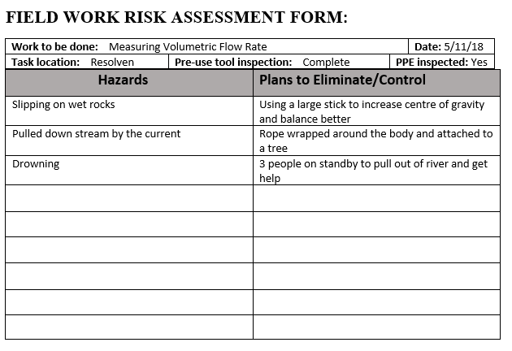
Figure 2 - Risk Assessment

To calculate estimations of power output for the site, the following equation shown in Equation 1 is to be used. This equation is a variation of the standard equation for Gravitational Potential Energy however, as Power is energy per unit of time, rather than mass being used in the equation, mass flow rate of the stream is used to account for a change in time. The below equation also accounts for efficiency losses that are expected to be found in the system.
$$P=\dot{m}gh_{net}η_{Total}$$
Where:
$$\dot{m}=mass flow rate$$
$$g=gravitational constant \left(9.81\right)$$
$$h_{net}=h_{gross}-10\% head loss$$
$$η_{total}=Total efficency loss$$
Equation 1 - Hydropower Generation Equation

Methodology
To determine the mass flow rate of the water source the volumetric flow rate first needs to be determined, the first step is to determine the cross-sectional area of the stream which can be found using the trapezium rule:
$Area=\frac{Interval}{2}(D_{0}+2\left(D_{1}+D_{2}+D_{3}+…+D_{n-1}\right)+D_{n}$
Equation 2 - Area under a curve with a straight surface
Where D is the depth at given intervals. The next piece of information needed is the velocity of the water; this was obtained by timing the period in which it takes an object to travel on the surface of the water over a given distance; 10 readings were taken to obtain an average velocity. This information can then be used in the following equation to calculate the mass flow rate of the stream.
$$\dot{m}=ρAv$$
Equation 3 - Mass Flow rate of stream
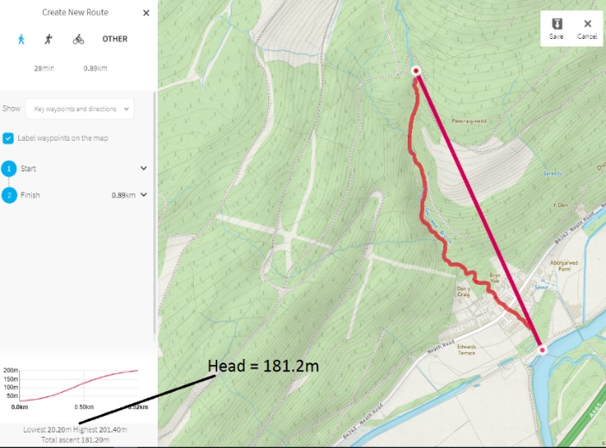
It is important when estimating power outputs to account for potential efficiency losses in the system. The following efficiency losses will be assumed (Renewables First, 2015):
Figure 3 - OS mapping (Ordnance Survey, 2019)

$$η_{turbine}=0.85$$
$$η_{drive}=0.95$$
$$η_{generator}=0.93$$
$$η_{total}=0.751$$

Head heights for site 1 were measured simply using a tape measure however site 2 is to run down the side of the slope for several hundred meters, therefore a tool provided by Ordnance Survey has been used to determine an estimated height gain over the distance planned for the project.

A final feature to account for, is the velocity correction factor which is an efficiency loss caused by friction against the piping; these power estimations will use a velocity correction factor of 0.97 (Thake, 2000).
Using the above methodology data readings and calculation estimates were made for sites 1 and 2. The full data set can be found in Table 3 in the appendices.
Site 1 estimation:
$$P=891.813×9.81×0.95×0.751=6241.75W=6.24175kW$$
Site 2 estimation:
$$P=113.92×9.81×163.08×0.751=136872.45W=136.87kW$$
These estimations clearly indicate that Site 2, despite having a volumetric flow rate 10 times less than site 1, has far more potential to be an effective scheme with some considerable potential for electrical generation. It is for this reason that Site 2 will be pursued as the primary site, therefore disregarding Site 1 from hereafter.
Multiple visits have been made to the site by the team to gather multiple readings for the decided site to observe variations to flow over a period of time. If this proposed scheme was approved, more data collection would be made over a series of years if possible, however due to the timescale given for the project, data collection was limited however it still clearly illustrates fluctuation in estimated power output. Below shows the calculated data from the visits made (Table 1), raw collected data can be found in the appendices (Table 4). This data can be used to decide the manufacturing choices.
Date collected | Cross sectional area (m^2) | Mass flow rate (kg/s) | Estimated power output (kWh/day) | Power output (kW)
05/11/2018 | 0.096875 | 113.921681 | 3284.938731 | 136.8724471
20/11/2018 | 0.079355 | 98.43957138 | 2838.511139 | 118.2712975
30/01/2019 | 0.12466875 | 214.2134014 | 6176.856701 | 257.3690292
11/02/2019 | 0.1388 | 255.7396715 | 7374.269273 | 307.2612197
18/02/2019 | 0.154171875 | 254.1487623 | 7328.395307 | 305.3498045

Table 1 - Table showing Summary of Calculated data from site visit

Data Analysis
This data shows an average estimated power of 225kW of energy. With a deviation of 64kW in the estimation of flow. Most hydro turbines operate at a specified power therefore, with a variation this high it would be predicted that a reasonable amount of water will overspill the system and run directly into the discharge point.

Turbine selection and Theory
Turbines used in hydro power have defined operating ranges of head height and volumetric flow rate at which they best function which is dependent on the design of turbine. The most prominent designs for turbine form are; Kaplan, Francis, Pelton, Turgo and Archimedes.
A Kaplan turbine heavily resembles a propeller you may see on a boat, however there are some fundamental differences; the blades of a Kaplan turbine are able to vary the pitch similar to a wind turbine to either maximize or minimize power generation. Kaplan turbines are classified as reaction turbines however the turbine does use elements of impulsive force to generate rotation (Andrews & Jelley, 2007). This turbine functions most effectively at sites that have lower head heights and high volumetric flow rates.
The Francis turbine uses guide vanes to project the water in a rotational direction which is then led into the turbine which uses many curved blades to force the lateral energy of the water into rotational energy. This turbine type in considered a hybrid model as it functions most effectively at medium head and medium flow rates, making it a cross between an impulse and reaction type turbine.
Pelton turbines are next potential option for power generation; A Pelton wheel uses a series of buckets which are used to deflect an incoming jet of water, the resulting force generates rotational kinetic energy. A Pelton turbine wheel functions best at low flow rate and high heads, therefore, operate with high velocity water streams. Pelton turbines are classified as Impulse turbines.
Turgo turbines are another type of impulse turbine. The turbine blades in a Turgo turbine are shaped helicoidally with the jet facing at an angle with relation to the central axis of the turbine. As the jet of water hits the blade the component of force acting tangentially to the turbine is increased as the water passes through the turbine maximising rotational output to the generator shaft (Renewables First, 2015).
The final option of turbine is the use of an Archimedes screw; this screw type turbine operates at low heads with medium flow rates. As the water flows into the turbine the mass of the water in the screw leads to rotation as it slowly passes down the large screw shaped turbine (Western Renewable Energy, 2019).

Turbine choice
Our site chosen has a gross head height of 181.2m which is considered very high and an average flow rate of approx. 0.1m^3/s which is considered relatively low; thus, the chosen turbine should be an impulse based turbine, narrowing down the options to either a Turgo or a Pelton turbine. Turgo turbines are better suited to handle higher flow rates than the Pelton turbine however, at lower flow rates the Pelton turbine has a higher efficiency. Therefore, the chosen turbine for this scheme is the Pelton wheel as the flow rate is considered low for this scheme therefore a Pelton wheel will be able to maximise efficiency (Hanania, et al., 2015).

The Pelton Turbine
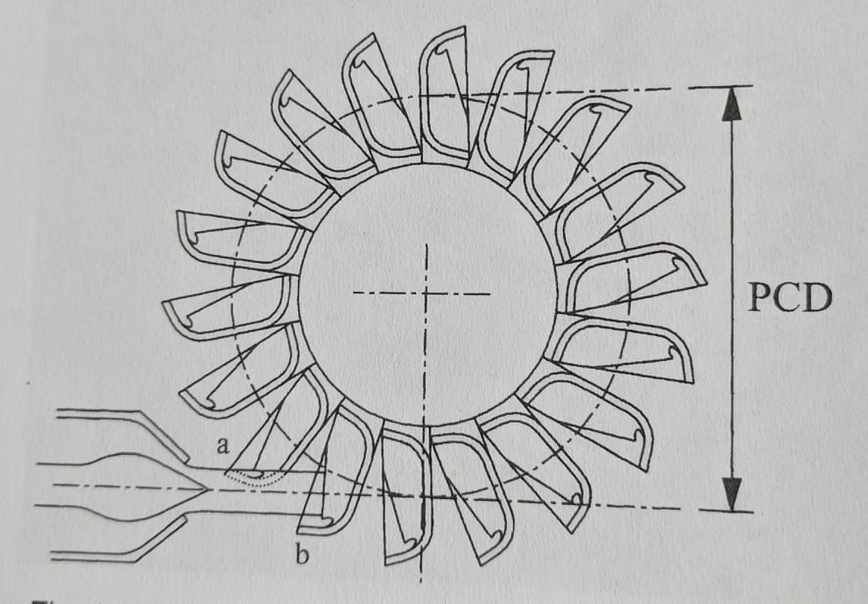
Some of the main characteristics of a Pelton turbine include the nozzle; the nozzle is where the jet of water leaves the piping to contact the wheels, the shape of the nozzle has evolved over time to minimize diffraction of liquid at the exit point which can result in a loss of energy. The spear valve, which protrudes through the jet and can vary the flow of the jet very precisely without affecting the strength or linearity of the stream. After the jet exits the nozzle, it collides with the buckets of the Pelton wheel, buckets are designed to turn the jet almost 180 degrees with a split ridge in the middle, this 180-degree rotation of the water maximises the collection of kinetic energy from the water. The buckets are attached periodically to a disc. The defining features when considering the manufacture of a Pelton turbine are the PCD (Pitch Circle Diameter) and the number of Jets used.
Figure 4 - PCD of a Pelton wheel (Thake, 2000)

Theoretical consideration for manufacturing
When the manufacture of a hydro scheme is being considered, it is important to consider theoretical calculations to ensure the parts used fit the specifications of the site, such as the flow rate and head height found in the collected data.
The equation shown in Equation 4 gives a means to calculate the theoretical diameter of the Jet of a turbine when assuming 1,2,3 or 4 Jets are being used. Shown in Table 2 is the application of this equation for a varying number of Jets.
$$d_{jet}=\frac{17.2}{H_{net}^{\frac{1}{4}}}∙\sqrt{\frac{Q}{n_{jet}}}$$
Where:
$$Q=flow\left(litres /s\right)$$
$$H_{net}=net Head\left(m\right)$$
$$n_{jet}=number of Jets$$
$$d_{jet}=diameter of jet (mm)$$
Equation 4 - Equation showing diameter of jet (Thake, 2000)
For a Pelton turbine to operate most efficiently it is recommended that the Diameter of the Jet is 12% of the PCD of the turbine when the head height is 50 meters or less. Above 50 meters the efficiency drops off heavily at a 12% ratio therefore, the ratio between PCD and Jet Diameter should be reduced to 11%, however turbine runners are usually available in increments of 25mm (Thake, 2000). The PCD’s for each number of Jets is shown in Table 2 along with the available PCD’s for manufacturing.
Another piece of information that needs to be gathered is the rpm of the turbine and therefore the gear ratio to connect the turbine to a given generator, due to the fact that most generators operate at fixed RPMs. Using the following equation, the rpm can be found for a given flow rate (Thake, 2000).
$$\frac{πN∙D}{60}=x∙v_{jet}$$
Where:
$$N=speed of runner (rpm)$$
$$D=PCD (m)$$
$$v_{jet}=Jet Velocity (m/s)$$
$$x=ratio of speed of PCD compared to Jet (Typically 0.46)$$
Equation 5 - equation to find RPM of Runner (Thake, 2000)
Table 2 uses the following information based off collected and calculated data:
$$Q_{avg}=187.3 litres s^{-1}$$
$$H_{net}=H_{Gross}×0.9=163.08m$$
$$v_{jet}=54.96m/s$$
$$x=0.46$$

Number of Jets | Diameter of Jet (mm) | PCD (m) | Available PCD (m) | RPM of runner | Gear ratio with 1500rpm generator
1 | 65.87 | 0.599 | 0.600 | 804.7 | 1.86
2 | 46.58 | 0.423 | 0.425 | 1136 | 1.32
3 | 38.03 | 0.346 | 0.350 | 1380 | 1.09
4 | 32.94 | 0.299 | 0.300 | 1609 | 0.93
Table 2 - Graph showing Characteristics of turbine with varying number of Jets
These calculations should be considered when making design choices for the system. Given the calculations it would be recommended to use 2 jets, as with 2 jets the PCD is reduced heavily compared to 1 jet therefore, reducing material costs, with 2 jets there is also a higher level of control as, at low flow rates the turbine can use only 1 jet.

Grid Connection
There are 2 main options for connecting the turbine to the national grid electrical supply. Fixed speed induction and Grid-tied Inversion. Fixed speed induction uses an induction motor where the stator is excited by the grid supply, this means the outputted energy from generator is synchronised with the grid supply by default however it does mean it is less controllable. The other option is Grid-tied inversion which takes the AC supply from the generator, which due to slight variations in flow and yield is not a high enough standard to be applied to the grid, therefore a 3 phase rectifier turns the ‘dirty’ AC into clean DC current which is then inverted back into grid standard AC (Renewables First, 2015)

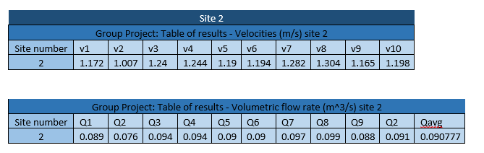
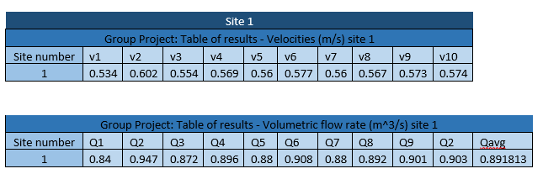
Section 4 Appendices
Table 3 - Preliminary Data collection for site 1 and 2

Date collected | Width (m) | Length sample space (m) | D1 | D2 | D3 | D4 | D5 | D6 | D7 | D8 | D9 | D10
05/11/2018 | 2.5 | 7.5 | 0 | 0.05 | 0.05 | 0.04 | 0.04 | 0.04 | 0.03 | 0.03 | 0.03 | 0
20/11/2018 | 2.36 | 8.3 | 0 | 0.025 | 0.026 | 0.034 | 0.036 | 0.038 | 0.04 | 0.028 | 0.027 | 0.03
30/01/2019 | 3.27 | 11 | 0 | 0.04 | 0.035 | 0.035 | 0.037 | 0.034 | 0.033 | 0.041 | 0.05 | 0
11/02/2019 | 3.2 | 11 | 0.02 | 0.04 | 0.045 | 0.025 | 0.047 | 0.05 | 0.04 | 0.045 | 0.045 | 0
18/02/2019 | 3.25 | 11 | 0.025 | 0.04 | 0.055 | 0.045 | 0.03 | 0.038 | 0.045 | 0.054 | 0.05 | 0.02

Date collected | T1 | T2 | T3 | T4 | T5 | T6 | T7 | T8 | T9 | T10
05/11/2018 | 6.4 | 7.45 | 6.05 | 6.03 | 6.28 | 6.28 | 5.85 | 5.75 | 6.44 | 6.26
20/11/2018 | 6.88 | 6.39 | 6.52 | 6.33 | 6.7 | 6.5 | 6.5 | 6.46 | 6.4 | 6.95
30/01/2019 | 6.02 | 6.057 | 6.92 | 5.33 | 7 | 6.3 | 7.4 | 5.4 | 6.4 | 6.56
11/02/2019 | 6.09 | 6.19 | 6 | 6.16 | 5.99 | 6.83 | 5.49 | 5.42 | 5.21 | 5.48
18/02/2019 | 6.12 | 6.54 | 6 | 6.89 | 6.54 | 6.2 | 7.2 | 6.85 | 7.2 | 6.13

Table 4 - Full data collection for Primary site

Legislation (Sion Evans)

General Information
Due to the complexity and potential impacts on communities and river wildlife, hydropower schemes need to be designed and managed carefully. Plans to mitigate potential flood risks and significant impacts of aquatic wildlife must be considered in the scheme design to obtain several licenses, consents and approvals required by National Resources Wales (NRW). The development of the proposed scheme can only progress once these licenses have been obtained. Under the Water Resource Act-1991, an abstraction license is needed if you want to extract more than 20$m^{3}$(cubic metres) of water per day from either surface water or groundwater in Wales. Additionally, to protect the environment and manage the country’s water resources, an impoundment license and fish pass are needed if you want to impede the flow of inland waters (National Resources Wales, 2019). The required forms set by NRW are:
- WRA – Proposal outline & application details
- WRB – Hydropower schemes
- WRD – Abstraction license application
- WRE – Impoundment license application
- FP 003 – Fish pass application

WRA – Proposal Outline & Applications Details
Pre-applications come highly recommended before a formal application for an abstraction and/or impoundment license due to the vast complex variations of existing licences. A WRA and WRB form must be completed along with a consultation of how successful the application is likely to be. The application sections that apply to our project are:
- Application type and fee – Specification of application type and details of how to pay for them.

- Applicant type – The details of the legal entity of which the licenses are being issued to, a list of various types of licence holder and signature needed is shown in table 4.

- Agent/Nominated individual details – The detail of an individual or agent assigned as a point of contact.

- Entitlement to apply – Evidence of land ownership or right to access the location of abstraction must be provided as stated by the Water Resources Act 1991 section 35 (Legislation.gov.uk, 2006). - “satisfy [NRW] that they have, or at the time when the proposed licence is to take effect, will have a right of access to land contiguous to the inland waters at that place for the purposes of water abstraction and that they will continue to have such a right for a period of at least one year beginning with the date on which the proposed licence is to take effect.”

- Remediation work – Specify if any remediation

- Source of supply – The source where surface water abstraction is intended to take place must be stated along with geomorphology photosurveys. Details of geomorphology requirements are stated in table 6.

- Proposal summary – This section includes a summary of the project along with the instantaneous/peak abstraction rate in litres per second $\left(\frac{L}{s}\right)$ and the hourly ($\frac{m^{3}}{hour}$), daily $(\frac{m^{3}}{day})$ and annual quantities $(\frac{m^{3}}{year})$ required. Additionally, the period and total quantity $(m^{3})$ of extraction must be stated.
Type of Licence Holder | Signature Needed
Individual/sole trader | The licence holder
Partnership | One or more of the partners
trust | All trustees or the chairman, treasurer or secretary
Charity | A person authorised by the charity body
Organisation of individuals (other than partnership, trust or charity) | The chairman, treasurer, secretary or other authorised personnel
Public body (i.e. the local authority) | Authorised personnel set by the organisation
Table 5 - Details of types of licence holder and signature needed (National Resources Wales, 2019)
Basic Site information | Length & gradient of depleted reach??
 | Location of site
 | River name if known (or nearest)
 | Grid reference and elevations (mAOD) of intake
 | Grid reference and elevations (mAOD) of Turbine house
 | Grid reference and elevations (mAOD) of discharge
Annotated map | The location of intake weir, penstock route, turbine house and discharge
 | The point at which the photographs were taken
Photographs: Structure siting | Photo of the intake structure location
 | Included an object to illustrate levels & extent of the intake weir
 | Photo of pipeline route where it is in or near the watercourse
 | A photo of the turbine house location
 | A photo of the discharge location
 | Photo of the bankside access track (if applicable)
Photographs: Upstream/Downstream | Photo of the river reaches upstream of the point of abstraction
 | Photos of the river reaches downstream of the discharge
 | Photos taken evenly spaced along the depleted reach no >250m intervals
Photographs: other channel features | Bridges & culverts
 | Areas of erosion & deposition
Photograph composition | Show sediment type?
 | Riverbed Material
 | Left & right banks
 | Floodplain/surrounding land use?
Scale | Have you used ranging pole or tape to show scale?
Reference | Are the photographs referenced
Table 6 - Checklist for geomorphology photo surveys (Natural Resources Wales, 2019)

WRB – Hydropower Schemes
Before licenses can be applied for, the flow data of the watercourse must be accumulated including a full detailed flow duration curve. A flow duration curve is one of the most important pieces of information that feeds into the design of the hydropower scheme and determines whether the project location is feasible.

Flow Duration curve
A flow duration curve is calculated by recording thousands of river flow rate ($m^{3}$/s) values over several years so that full seasonal changes are accounted for. The flow data is organised from the highest values to the lowest (on the Y-axis) and plotted against a percentage exceedance scale (on the X-axis). A percentage exceedance scale is calculated by dividing 100% by the number of data points with the highest flow rate datum corresponding to the first percentage exceedance point. The result will look something similar Figure 6.


Figure 5 - A typical steady flow duration curve (Renewables First, 2015)
The curve of a flow duration curve determines the type of river flow that occurs. A smooth gradual curve describes a steady flow river, but a steep sharp curve describes a turbulent river that is susceptible to flashy characteristics. Where the point on the graph meets the percentage exceedance it shows the flow rate of the river is equal to or higher than the value on the Y-axis. For example, at 100% exceedance, the flow rate is 0.25 ($m^{3}$/s) thus, the flow rate of the watercourse is equal to or greater than 0.25 ($m^{3}$/s) 100% of the time. Flow rate is annotated by the letter ‘Q’ and is combined with the exceedance value number do describe the flow rate, for example, Q60 means the flow rate is equal or exceeded for 60% of the time. This is used to describe the relationship between the curve at the flow rate and various points on the flow duration curve.
Typically, flow rates between Q0 and Q1 are extreme storm and flood events, andQ1-Q10 are times of high flow rates. These conditions influence the flood defence scheme designed to cope with extreme flows. The hydropower scheme will work most efficiently across the medium ranges of flow rates from Q10-Q70. Beyond these ranges Q70-Q95 is known as periods of ‘low flow’ where the hydropower system will be operating at low power output efficiency, and Q95-Q100 hydropower systems will be shut down due to low-flow draught flows. Maintenance will take place during these operation shut-down times.

Additional to the flow duration curve, a description of the following information is necessary to determine the management zone: (Natural Resources Wales, 2019)
- Topographic data including the length and gradient of the depleted reach
- Size of the catchment area at the point of abstraction
- Whether the project is within the hydrological catchment of a designated area and how likely the features of this site will be affecting the presence of supporting habitat or the sensitivity of the hydrological regime of the catchment site.
- Whether there are any flow sensitive species in the proposed area and how likely the proposition will affect these species.
The specific mitigation requirements are determined by these site-specific conditions, affected water bodies and other uses of the site. This information determines the volume of abstraction that is determined by NRW for the hydropower scheme. Due to the watercourse of our site being a discharge from an old mine with no aquatic life we are requesting a 100% abstraction license.

WRD – Abstraction License Application
- Application type – Specify the capacity of the hydropower scheme using options provided to determine the cost and license type.

- Abstraction details – A 12-digit National grid Reference (NGR) for the point of abstraction that corresponds with drawings submitted and maps must be displayed.

- Means of abstraction – the design enclosing drawings, plans and cross sections of any fixed intake structure must be included in this section, along with the equipment that will be used to abstract the quantities of waster that are being applied for.

- Abstraction quantities & calculations – The details of water abstraction must be stated in this section including the purpose, period and total quantity $(m^{3})$ of water abstraction (determined using table 3). Additionally, the instantaneous/peak abstraction rate in litres per second $\left(\frac{L}{s}\right)$ and the hourly ($\frac{m^{3}}{hour}$), daily $(\frac{m^{3}}{day})$ and annual quantities $(\frac{m^{3}}{year})$ must be declared for hydropower abstraction. Details of the equations used to derive the quantity of water abstraction must also be submitted to verify that the correct values have been calculated.

- Hydropower – All of the hydropower flow data must be submitted here including the length of the depleted reach (m) and the full flow duration curve of the site including the method used to derive the flow curve. Additionally, a copy of the catchment map, graph, data and annual average rainfall must be submitted to determine the catchment size and flow values.

- Means of measurement – The methods of measuring the abstraction rate must be stated. A calculation checklist is supplied by NRW to calculate a Hydro Abstraction factor that can be used with the values of power generated to calculate the abstracted quantities allowing for electrical output conversions.

- Water efficiency – Details of plans to implement efficient use of water during the electrical power production.

- Fish & eel considerations – As stated in section 14 of the eels (England and Wales) Regulations 2009 (legislation.gov.uk, 2009) “where the Agency determines that the passage of eels is likely to be impeded the agency may require a responsible person, at their own cost, to construct an eel pass”. Upon completing a fish survey plans to mitigate fish ladders into the design of the scheme must be displayed to safeguard fish and eels as they migrate up and down stream. If it is shown that the intake is inaccessible to fish no measure are required to be proposed.

- Discharge details – The discharge of water back into the environment must be measured and controlled in order to understand the effect it will have and how the negative impacts can be prevented. Therefore, the location, NGR and the quantity of water being discharged must be stated along with a description of the equipment and structure involved in the discharge process.

- Other water users’ considerations – Any other water users must be considered and made aware in this section. The Local Authority’s Environmental Health department will hold details of other abstractors and recreational users under the Private Water Supplies Regulations (legislation.gov.uk, 2018)

WRE – Impoundment License Application
- Impoundment details – The name and reference of all impoundment points must be provided along with a 12-digit NGR that corresponds with any maps. Additionally, details of how the impoundment will be constructed and a description of how this construct will affect the flow of inland water.

- Description of impoundment – The name of the watercourse that will undertake impoundment must be declared along with a detail of whether the proposal will change downstream flow or new submerged areas behind the impoundment works. Details of the liner that is to be used in the impoundment catchment area must be provided with the height of the structure that being proposed. Once the above has been declared the level of the overflow in metres above ordnance datum. Due to the Flood and Water Management Act 2010 (legislation.gov.uk, 2019) the full planned capacity of the construct when it’s full to spillway level must be stated and impoundment constructs with a capacity exceeding 25,000 cubic metres must be registered with NRW. Details of the controlled release of water such as reservoir compensation flows, flood attenuation flows, or residual flow must be stated along with the equipment and method used to measure the water level. Additionally, method of filling the impoundment area must be included with details of how much will be abstracted and how the abstracted water will be replaced i.e. by rainwater or pumped.

- Fish and eel considerations – This is a repeat of process 8 in section 4.4 of this report.

- Construction, maintenance & operation – this section must include a description of any sediment management plan to be put in place along with details of maintenance and frequency of activities e.g fish pass maintenance and the operation of scour valves to determine how this affects the watercourse.

- Planning application – confirmation from the local planning authority must be provided

- Drawings & design statement – full details of all protection of any residual flow plans and plans of any fish passage should be included in full scale detailed drawings. The requirements set by NRW are as follows: (National Resources Wales, 2019)
• Location Plan at 1:5,000, 1:10,000 or larger scale, subject to the extent of the development with the land boundary clearly marked.
• Site plans of the intake and discharge structures at 1:1,250 or 1:2,500.
• Plan, profile and cross-section drawing that details intake and residual flow structure crest heights or invert levels with reference to an appropriate ordnance Datum point.
• A design statement clearly explaining how the structure will operate in accordance with the abstraction regime, including details of how any residual flow will act.

Manufacturing and Installations (Joseph Blackmore)

Overview
In order to install a cost effective and energy efficient hydroelectric scheme, as a group of engineers we need to use the most suitable component specification and installation method in order to match the scale and location of the project. The construction of a hydroelectric scheme can be a complex procedure that requires a specific order of installation. It is imperative that our team understands how our scheme is constructed and how we can make the best use of current technological developments to install the most efficient hydroelectric power generator possible. Factors such as the time taken for construction and the varying cost and efficacy of the available components on the market will greatly affect the sustainability of our project.
Firstly, I am going to use my previously carried out research into how similarly scaled hydroelectric schemes have been constructed in order to inform myself about the engineering challenges that will need to be overcome in the installation of this scheme. The order in which different aspects of the project installation are undertaken is vitally important for an engineering team to understand, as certain phases of development may rely on other aspects of the installation being completed prior to others.

After finding and measuring a suitable site where a hydroelectric scheme could be utilised in Resolven, we needed to decide as a group what type of hydroelectric scheme would be most suitable at the site. At our chosen site we figured that a run-of-river style set up using the existing weir could be applicable. We also found that a high flow rate stream was channelled into the river from the surrounding hillside, this water source has potential to generate power using a Pelton style turbine. The manufacturing and installation challenges involved in either style of hydroelectric scheme vary due to their differences in design and implementation into the natural environment. As a group we decided that using the high flow rate tributary would be the best option as the estimated power output calculations for the main river channel was deemed too low for the investment that would be required in order to implement a scheme of such scale. Another significant issue with manipulating the flow of the main channel was the high risk of flooding due to low lying fields and a private car repairs business following the course of the river. A significant positive of using the tributary stream is that the risk of flooding these areas is negated as water source originates from the hills surrounding the area.
The manufacturing challenges faced by this scheme can be split into 2 main sections;

Component specifications and overall design layout
This section involves the following issues;
- Specification of power house
- Size and material choice for penstock pipes
- Overall scheme layout
- Evaluation of potential risks for improper component specification
- Preventative measures regarding damage and wear

Installation
Navigating challenges involving logistics such as;
- Suitable construction methods
- Potential issues with working with contractors
- How to navigate around geographical obstacles in the construction phase
- Maintenance requirements

Specification of Fundamental Scheme components

Our proposed scheme is of small scale with a high head water supply. As this system will be operating with a high flow rate we have decided that a Pelton wheel turbine would be the most effective method of utilising this water supply as this design utilises high impulse water jets to rotate the turbine. This type of hydro turbine is highly suited to high water head schemes due to the low volume but fast rate of flow of the water supply. The power house needs to be of appropriate scale for the estimated power outputs that are possible. The overall system design will be inefficient if the water supply is not sufficient enough to generate power using a turbine that is too large. The risk of damaging or having to stop the running of a turbine generator that has too low of a power rating during very high flow rates such as after torrential downpours also needs to be considered.

Using the estimated power output values calculated in section 3, the scheme can be planned to an appropriate scale, this will determine the potential manufacturing and installation based obstacles that must be considered for this type of hydroelectric scheme. The rating of turbine generator and size of penstock pipes will be determined by the flow rate of water into the system.
The values collected from our readings taken at the proposed site varied from 2838.51 kWh/day to 7374.27 kWh/day. This gives a range from 118.27kW to 307.26kW, therefore the Pelton turbine generator must have an output rating of at least 200kW to be able to comfortably meet the demands of this particular water supply. The turbine generator should use a twin jet design as this will reduce the size of the PCD, allowing for a more compact powerhouse design. Using the readings collected with the highest volume of water flowing past the reference point, I can get an estimation for the size of penstock pipe that will be required for this scheme, if the pipe is too small this will be a limiting factor for the power output of the overall system. The calculations in section 3 show that the highest mass flow rate recorded at the site was 255.74 kg/s, the cross sectional area of the body of water at this flow rate was 0.1388m^2.

Taking the density of water (ρ) to be 1000kg/m^3, the volumetric flow rate of this body of water is
Q = 255.74/1000 = 0.25574m^3/s

Taking the cross-sectional area of the body of water and using the equation for the cross- sectional area of the end of a pipe (pi x r^2) the required internal pipe radius to hold the water can be calculated;
Pi x r^2 = A radius = √0.1388/pi = 0.2101 metres, = 21cm radius,

Recorded velocity of this body of water taking an average from the 10 readings;
11 metres/ 5.886 seconds = 1.87 m/s

Using the continuity flow equation Q= A x velocity
A = Q/velocity
A= 0.256/1.87, A= 0.137m^2
Equation 6 - (Azenkot, 2004)

This suggests that for the body of water recorded at the highest rate of flow during our measurements at the site, a pipe with a diameter of 42cm would allow a flow of water at a velocity of 1.87 m/s if friction inside the pipe is negligible. A larger diameter pipe will allow for a higher net head value due to reduced friction, but will also increase the cost of installation. The penstock must be steel as this is a high head flow of water, lower strength materials would be unsuitable due to the pressures involved with this flow of water. For this particular site it would not be feasible to bury the penstock pipe due to the nature of the terrain. The penstock should follow the existing path of the stream and have welded joints, this will reduce costs in comparison to mechanical joints and will be a viable option for this site as the hard ground terrain will be suitable for the foundations of the concrete anchor blocks required at the joints. (Gordon & D.G, 1985). Unsuitable material choice or poor construction quality for a high head penstock arrangement can lead to failures at the welded joints due to the high pressure flow of water that they contain. High corrosion resistance is required as the pipes will be constantly exposed to the elements, A high quality steel of substantial thickness will reduce long term maintenance costs as the likelihood of pipe failures are very small in well-designed penstock arrangements.

As for a representation of the overall scheme layout, our design principle will follow that of most other run of the river high head hydro schemes;

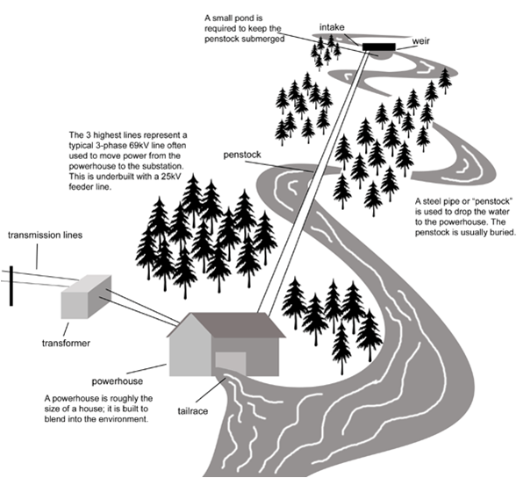
Our scheme will need to follow the basic design principles of other high head run of river schemes, however each specific project has its own unique engineering challenges that must be overcome.
Figure 6 - (ClimateTechWiki, 2006)

Preventative Maintenance

In conjunction with using high quality components from reputable manufacturers, installing a Coanda screen at the intake of the system will prevent the ingress of debris into the penstock and subsequently into the turbine generator itself. Debris entering the high pressure Pelton turbine system risks damaging the water jets and Pelton wheel itself. Blocked jets can lead to severe water hammer, this risks rupturing the penstock, leading to expensive repairs and prevention of electricity generation until repairs are completed. There are no moving parts or power requirements for a Coanda screen, they offer a low maintenance method of preventing the ingress of potentially damaging debris from entering the turbine generator. Wedge wires prevent the ingress of particles above 1.5mm in size, whilst water is directed over the screen in a fast moving sheet, and the bars deflect it into a tank below whilst debris continues straight on and is washed off by the surplus flow. Such a device also has the benefit of preventing the ingress of aquatic life into the turbine. Fine silt particles are not prevented from entering the turbine system however, this is why it is imperative that the turbine and high pressure jets are manufactured from high quality steel to prevent corrosion over time. Another advantage of this technology is the lack of required maintenance, the screens are self-cleaning as the excess water run-off clears the screens.
(Powerspout , n.d.)
Below is an image of a Coanda screen set up for a high head micro hydro scheme that also uses a Pelton turbine;

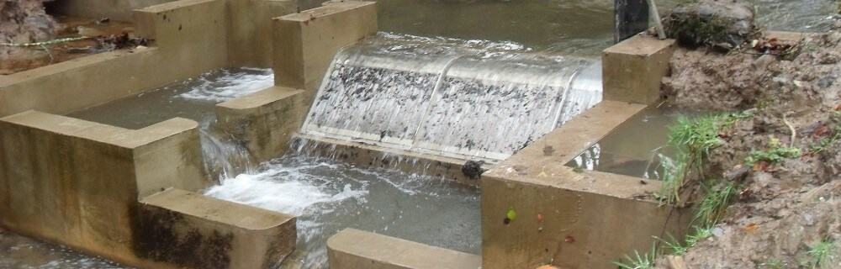
Figure 7 - (Renewables First, 2012)

Shut-down Mechanisms
A remote monitoring system that can give continuous system performance updates to a website is an effective method of highlighting potential system issues as early as possible. Providing an early indication of faults can reduce the risk of expensive component damage. Monitoring systems can use a wide variety of sensors to remotely monitor a variety of variables that can give early indications of failure such as;

- Shaft vibration (proximity probes)
- Pressure pulsations
- Mechanical stresses (strain gages)
- Natural frequencies
- Electric- current and voltage
- Noise (Norconsult , n.d.)
- Bearing Housing Vibration (accelerometers)

If the load from a Pelton turbine is removed, it will speed up very quickly leading to potential generator damage. The most common way of stopping a Pelton turbine in an emergency is through the use of deflectors. This mechanism employs the use of shaped metal plates to deflect water away from the runner, this principle works much in the same way as a spoon deflects water running out of a tap. This type of mechanism protects the Pelton itself but are not sufficient on their own in preventing water hammer as they have no effect on the water jets themselves, thus they cannot prevent pressure build up in the Penstock. A surge tank should be used as a fail-safe to prevent water hammer and penstock damage in the event of high water pressure. This can be implemented in the form of a small reservoir tank situated above the penstock pipe somewhere near the middle of its length. Over speed sensing in the form of mechanical switches operated using centrifugal force that triggers when the speed reaches a pre-set limit. Generator manufacturers often build these systems into the overall system design.
(Thake, 2000)

Installation
Typically a hydro scheme will be installed by a contractor, this will usually be a civil engineering specialist or the turbine manufacturer itself. Due to the high capital investment involved in such a scheme the most prolific method of implementing a scheme is through a ‘turnkey contract’, this is where the entire installation process is planned and overseen from start to finish by a single contractor. The contractor will be responsible for planning and sourcing appropriate components along with using competent and financially viable labour to carry out the installation of the project
The typical lead time for a turbine from commissioning to delivery at the proposed site in the UK is typically between 6-10 months, this must be considered in the timescale planning of a development (British Hydropower Association, 2012). There are many logistical challenges that must be tackled in the installation of a high head hydropower scheme, each individual project will provide different challenges that depend on the location. The cost and time needed to complete the construction of a hydro power scheme is heavily reliant on the accessibility of the site, large machinery such as delivery trucks for components require main road access to the site, luckily this is not an issue for the location of our proposed hydro scheme. Figure 8 shows an ordnance survey site map for the location of the proposed scheme;
The pink line represents the path of the penstock pipe, the most feasible method of installing this scheme would be to follow the existing path carved out by the river itself. By following the path of the river it will eliminate the need to fell the surrounding trees, this path also has hard ground, allowing for easier installation for the concrete foundations at the penstock joints. The projected penstock path represented by the pink line suggests that the gross head height is around 180 metres and the length of steel pipe needed is around 1 kilometre.
(Ordnance Survey, 2019)

Penstock Path

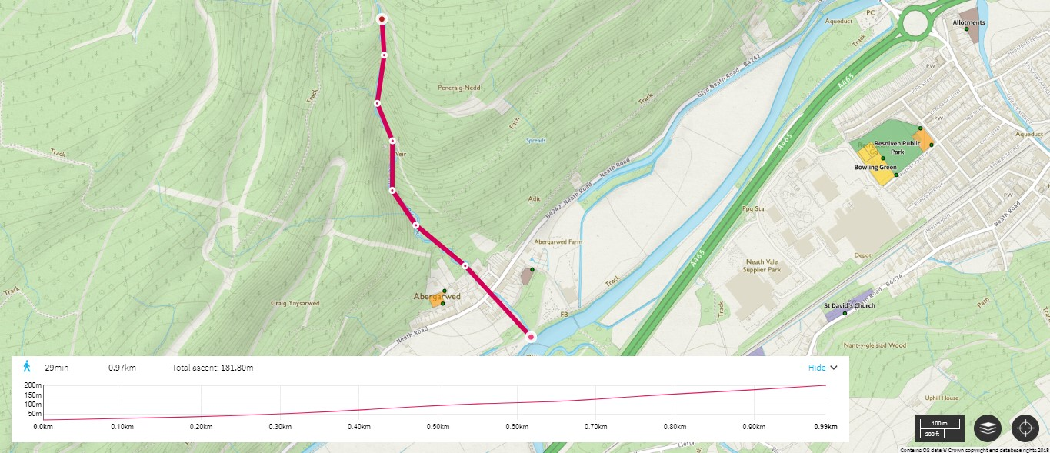
Figure 8 - Ordnance Survey

Powerhouse Location & Accessibility

Figure 9 - (Ordnance Survey, 2019)
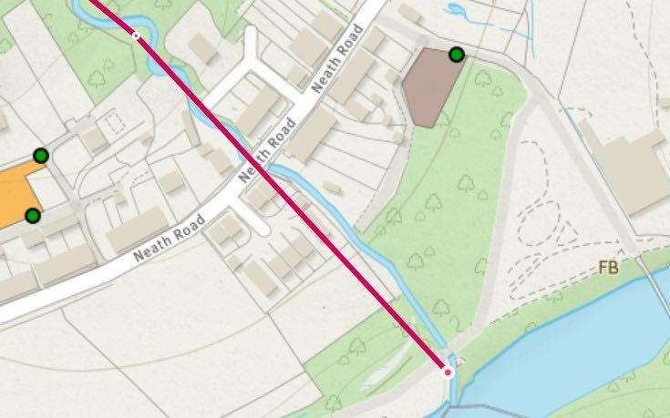

Neath Road is a main road that allows ease of access for any transportation vehicles to the site. The penstock pipe will be constructed to follow the existing path of the water underneath the main road. This is the most viable option as constructing the penstock to be vertically supported above the road will increase costs and prove difficult to gain council permission. Following the existing path laid out by the river also allows the penstock to be constructed in a path that does not obstruct the surrounding residential housing.
This is the access road to the power station and water outlet where the water can be discharged back into the main river channel (tail race). The electromechanical equipment will require annual servicing. The equipment supplier or installing can use this access path to carry out the necessary servicing required at the powerhouse.

Intake Weir & Penstock Inlet Location

Figure 10 - (Ordnance Survey, 2019)
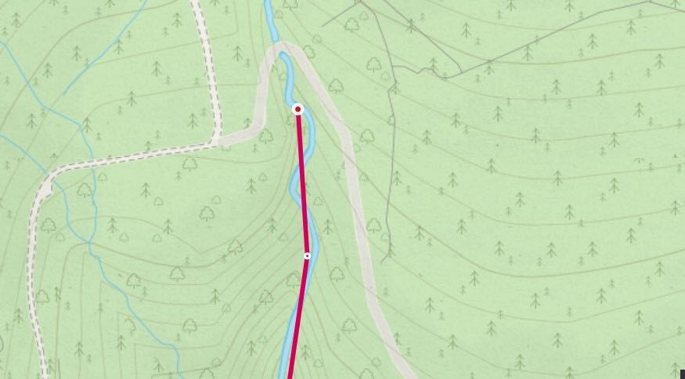

There are two forest roads that can facilitate ease of access to the reservoir and Coanda screen location. This road can be used in the construction phase of the project and will also allow for access to the inlet section of the project for any potential maintenance requirements.

Logistical Obstacles

Access to the intake and powerhouse sections of the overall scheme development as previously highlighted are convenient, the greatest logistical challenge offered by the site location is accessibility for the construction of the penstock. As the penstock is going to follow the existing river channel, access in the form of heavy machinery for the construction phase could be difficult. Contractors will need to assess the difficulty of the overall construction process in order to gain a more specific estimation for cost and time required to complete the construction process. It may be necessary to fell some of the pine trees surrounding the construction site in order to gain better access. For this particular site public access restrictions for the pathways leading up to the intake are not an issue as these are forestry commission roads and are not widely used by the general public. Disruption during the delivery of components on the main road will be minimal, as the scale of this project would allow for the use of delivery trucks that are already widely driven on this road. Disruption to the local residents during the construction of the penstock section that passes behind residential housing will need to be considered and discussed with locals prior to construction. (Scottish Environment Protection Agency, 2015). As the penstock diameter required for this scheme is relatively small, the need for large cranes during the construction process can be eliminated.

Cost analysis (Timothy Jones)

Introduction
One of the fundamental aspects of any project or business is the associated costs behind them that would decide the viability of the project and calculate profits. A cost analysis weights up all the costs inwards and outwards to determine if it would be profitable to go ahead. These costs include the initial and ongoing costs (Business Jargons, n.d.).
If the costs of a project are not totalled up correctly or things are missed out the project could be abandoned due to insufficient funds or not be profitable. Without estimating the costs of the project, the budget could be met before completion which could cause quality issues trying to finish the project quickly or cheaper components. These combined could cause problems and ultimately cost more and go over budget. The time needed to recalculate and change projects plans also would cause it to go over budget (Ganesan, 2018).
It is important to use a cost benefit analysis with a project concept such as this, to look at the project logically as to not get distracted by the alternative motivations for the project to succeed (Thompson, 2019). An idea such as this, is moving renewable energy forward and produces another source of producing clean energy to an increasing demand. The drive to push for more environmentally friendly energy generation could influence the decision of whether this scheme is to proceed, but as an investment could have no benefit or potentially a loss.

Initial Capital
The initial capital costs of any project are those during the planning up to construction of the project (Transportation Economics, n.d.). Capital costs include;
- Legal documents
- Acquiring land
- Design/planning
- Materials
- Hardware
- Civil Engineering / Equipment hire
- Electrical connection

A Capital cost is the initial investment or a project but has no additional working costs which must made in the future.
Hydropower plants typically have high capital costs due to the size and nature of the equipment needed, as well and the amount of construction and the work needing to be done to the land to store water, divert it and connect back to water source.

Powerhouse Equipment

Turbine
Lancaster University conducted an investigation to calculate the costs of hydroelectric turbines from manufacturers. They did so by researching manufactures and analysing all the data (Lancaster University North West Hydro Resource Model, n.d.). From this they derived equations for Pelton, Francis and Kaplan turbines. The equation uses the individual sites volumetric flow rate and head height. For a Pelton turbine they produced the following equation;
C = Cost of the Pelton turbine
Q = mass flow rate ($m^{3}/s$) = 0.187 m³/s
H= head height (m) = 181.2m
$$C=8300 x {(QxH)}^{0.54}$$
$$C=8300 x {(0.187 x 181.2)}^{0.54}$$
$$=£55,626.02$$
Equation 7 – (Lancaster University North West Hydro Resource Model, n.d.)
This price includes the combination of a turbine and generator. This the exact price for our flow and net head, the actual price would round up to £60,000.

Electrical Connection
The cost of an inverter system that is suited to our 225kw output generator is the Parker SSD690PH. It can produce the output we need and can handle up to 250kw. This system would cost £17,421.36 (ACDC Drives, 2019).

Installation
No two hydroelectric schemes are the same and are built to suit the environment, demand and are restricted by the water supply. Therefore, the cost for installing our hydroelectric scheme will have to suit our location in Resolven, Neath. We must consider the access to our site which is some distance off a main road as well as clearing out the land of shrubbery and levelling it out to prepare the site for construction. The access to the initial source of the stream and the length of piping from the source to housing station. The housing station will need to be designed specifically to accommodate the size of the generator and turbine.
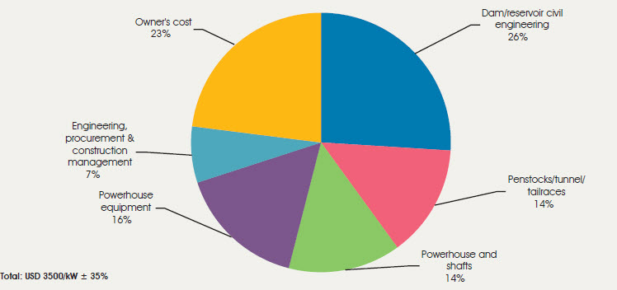
Figure 11 (Global CCS Institute, n.d.)
As it is difficult to obtain quotes for civil engineering costs and construction of the project it can be calculated relative to the other costs of the project. This figure shows the distributed costs of an existing hydroelectric plant. Using this information from figure 12 with 16% of the costs from the powerhouse equipment and construction of a small reservoir and power house adds up to 40%.
Powerhouse equipment = Turbine/Generator + electrical connection
$$=£60,000+£17,421.36$$
$$=£77,421.36$$
$$1\%=\frac{Powerhouse Equipment Cost}{\%}$$
$$1\%=\frac{£77,421.36}{16}$$
$$=£4,838.84$$
$$40\%=cost for 1\% x 40$$
$$=£4,838.84 x 40$$
$$Civil Engineering=£193,553.6$$
The installation costs vary as the head high is different per scheme. The head difference between our sites is 181.2m and using surveying maps it covers a distance or around 1km. This length will increase the capital cost due to constructing the pipe together, from reservoir source to the turbine. The pipes carrying the water will need to be placed underground or on top of the land. The pipes we will be using will be made from mild steel with a diameter of 400mm. There is no given price for this diameter but would request a quote from a company to produce the required size and quantity the project needs. Using other values of existing mild steel tubes an approximate value of the 400mm diameter pipe can be calculated. The price for a 50.8mm diameter tube is £32.64 and for a tube double the diameter of 101.60mm the price is £74.44. The Values are for a tube of 3.05m in length (Steeltubedirect.co.uk, 2019). As the diameter doubles, the price approximately doubles the cost. Using this as a guide to produce and estimate for the price of a 400mm diameter pipe;
$$\frac{400}{101.6}=3.937$$
$$Price of 400mm diameter tube=£74.44 x 3.937$$
$$=£293.07$$
£293.07 is equal to the price of the pipe at 3.05m in length. This need be calculated to find the price across the 1km path.
$$\frac{1000m}{3.05m}=327.87$$
328 sections of pipe needed.
$$Total Price=Price per pipe x number of pipes$$
=$£293.07 x 328$
$$=£96126.96$$

Additional costs
Owners costs and engineering procurement combine to cover the remaining costs. Owners costs cover the costs of licences, land, design and permit costs (Theprojectdefinition, 2015). Engineering procurement costs cover the salaries of the engineers undertaking the project (Job Hero, 2019). Using figure 1 again to accommodate for these costs;
$$1\%=£4838.84$$
$$30\%=Owners costs and Engineering Procurement$$
$$=£4838.84 x 30$$
$$=£145,165.2$$

Ongoing Costs

Ongoing costs or the continuous payments that must be paid throughout the life span of a product or system. The ongoing costs consists of operational and maintenance costs. Operational costs are the costs in which it takes to run the project or system on a day to day basis (Up counsel, 2019). A hydropower plant has very little in terms of operational costs as it has a high capital in which all the equipment needed to function is purchased. Hydropower only requires the flow of water to operate, which does not come at a cost and has no additional costs to function daily.

Maintenance
Using other examples of small hydroelectric power plants as a guide there is an average amount of regular costs that occur per site to determine estimations of maintenance costs of a particular site. The maintenance costs are proportional to the initial capital cost of the project. A study into hydropower plants across the world deducted that the costs of maintenance associated with larger hydropower plants were 2.2 to 2.3% of the capital per year and 2.5% per year for small hydropower schemes (International Renewable Energy Agency, 2018).

$$Initial Capital=Powerhouse+Civil Engineering+Steel pipes+other costs$$
$$=£77,421.36+£193,553.6+ £96,126.96+£145,165.2$$
$$=£512,267.12$$
$$Maintenance cost per year=2.5\% of capital$$
$$=0.025 x £512,267.12$$
$$=£12,806.68$$

Tariff

Competition
In order for the project to be a success it is necessary to understand the competition already existing. The main competition for renewable energy has always been energy generation via Fossil fuels. As the hydroelectric plant would feed into the national grid they must equal or provide a cheaper alternative to fossil fuels for the project to be viable.
Researchers at Yale and Harvard carried out a survey across America to determine whether or not they would be willing to pay more for renewable energy. The survey found that just over half of the population were willing to do so if it increased by 10 or 30 percent. 82% of the Americans were supporting of the idea of renewable energy but if it came at no additional cost to themselves, otherwise the percentage of people dropped dramatically to 39% as soon as a small increase was mentioned (Becker, 2018). This survey shows how it could be possible to introduce more renewable energy techniques which came at an increased cost for the customers. This would only be the case if the decision is unanimous across the whole area. If the renewable energy couldn’t beat the fossil fuel alternative but match its price, most of the population would support this to produce more clean energy.
Currently the cheapest provider that is available in the Neath area next to where the hydroelectric scheme will be implemented is 12.376p per KWH (Ukpower, 2018). If this price is fixed 12.376p or 10 years;
Average power output = 225 kwh/h
$$Units of electricity=225x24x365x10$$
$$=19,710,000$$
Cost = 0.12376 x 19,710,000
$$=£2,439,309.6$$
This price here is the total price that it would cost if the electricity was bought currently from the national grid with the equal units of electricity that the hydroelectric turbine would generate. To payback the project within 10 years it must produce each unit of electricity at 12.376p or lower.

Calculated

The total combination of all the capital costs equal;
$$Initial Capital=Powerhouse+Civil Engineering+Steel pipes+other costs$$
$$=£77,421.36+£193,553.6+ £96,126.96+£145,165.2$$
$$=£512,267.12$$
If the pay back of this project was considered over a 10-year period maintenance would amount to;
$$Maintenace over 10 years=Maintenance per year x 10 years$$
$$=£12,806.68 x 10$$
$$=£128,066.8$$
$$Total cost over 10 years=capital+Maintenance$$
$$=£512,267.12+128,066.8$$
$$=£640,333.92$$
If the projects aim was to payback the full cost of the installing the hydropower plant for a 10-year period, the cost per kwh would be;
$$Price per kwh=\frac{Total cost }{Units of electricity over 10 years}$$
$$=\frac{£640,333.92}{19,710,000}$$
$$=£0.0325$$

This is the minimum price per kwh that in which the costs would be covered and be able to generate a profit. At this price it is extremely competitive to the £0.12376 alternative that is currently availability.
Revenue per year after 10-year period.
$$=Price per kwh x units of electricity per year$$
$$=£0.0325 x 1,971,000$$
$$=£64,057.5$$

After the 10 years only the £12,806.68 would occur yearly for maintenance and compared to the production of £64,057.5 it produces £51,250.82 in profits.
If the electricity was sold at the same rate currently available by the national grid the project could be paid off much sooner than the 10 years previously calculated.
$=$ 0.12376 x 1,971,000
$$=£243,930.96$$
years | Revenue | Accumulation
0 | £243,930.96 | £243,930.96
1 | £243,930.96 | £487,861.92
2 | £243,930.96 | £731,792.88
3 | £243,930.96 | £975,723.84
Table 7 Accumulation of revenue
Using a payback method and our initial capital costs £512,267.12. The capital cost lies in between 2-3 years. To determine for that year the duration of month the revenue is then divided 12 months to find the average cost per month. Using these calculations, it would take 2 years 2 months to by back the initial capital not including the yearly maintenance costs.
A more competitive figure of around £0.09 could meet the middle between the minimum price for a 10-year payback and competing with the price already provided by the national grid. A more competitive price would aid the feasibility of the project and an incentive for people to support renewable energy generation.
$$Generated per year=Cost per kwh x units of elecricity$$
$$£0.09 x 1,971,000$$
$$=£177,390$$

Cost viability

Throughout these cost estimates, assumptions have been made such as constant power output from the turbine remaining at 225 kwh 24 hours per day. A rough estimate of civil engineering as well as other costs such as land cost. Not including larger unpredictable maintenance issues that could arise that cost more than 2.5% accounted for. All of these could affect the overall price for the project as well as the kwh price and payback duration. In reality it would not produce power at this constant rate and would have additional costs unaccounted for so the price is likely to increase or have lower output than calculated.
As these prices stand this project is economically viable. To payback the project by 10 years is a realistic time scale and this site could do so providing a very competitive price of £0.0325. Alternatively, if the price was kept in the region of current prices it could pay off the capital in 2-3 years and produce a significant amount of profit. The most effective price would be to sell each unit of electricity of at slightly lower rate compared to the current market at around £0.08-£0.10 to be able to have a competitive edge as well as producing a profitable amount and payback within a 10-year period.

Time Management (Timothy Jones)

Time management is the planning of a project effectively and efficiently. Time management ensures that a project is always working at its maximum productivity by setting target and completion dates (Tran, 2015). To carry out good time management a schedule should be created to construct a time frame for each or the tasks and whole project. It is best to overestimate and include buffer times for tasks as the schedule is under perfect conditions assuming everything will go right and according to plan where are realistically it won’t (Tremel, 2019). A correct schedule with buffer times is important as within a business if a task longer than expected, it would cost the company for not delivering the project as signed for within a contract. Creating a schedule can also help identify tasks of priority that need to be completed. Producing this schedule graphically is helpful, especially to seem what is dependent on another tasks and helps the overall running of the project smoother. Continuous time management ensures completion and a good reputation to remain competitive against other companies and chosen over then for future projects.
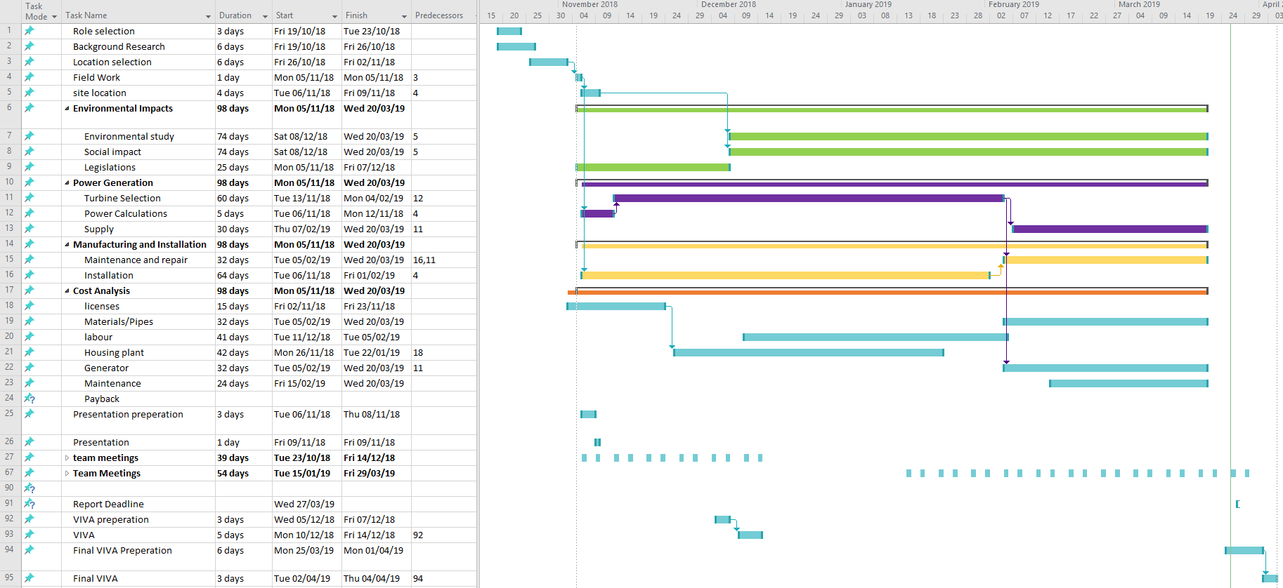
Figure 12 - Created using Microsoft project)
At the start of our group project a Gantt chart was assembled shown in figure 12, to plan the structure and time scale of the project from start to finish. At the beginning of the project, time was allocated to select roles and begin general research into the project. Group project lectures and additional team meeting were planned weekly to ensure that the project would move forward as planned and communicated well between one another. Each member of the team had their own roles and sections to complete and a Gantt chart enabled a visual aid to see the dependant variables between tasks. During the project not all things were able to go as planned due to unforeseen circumstances and tasks taking longer than estimated. There were also additional dependencies that were not accounted for and delayed the start times of following sections. The planning of the project with buffer times helped to allow additional time to complete individual tasks before the deadline was met. In an industry a corrective Gantt chart would be created to show where the project has overrun or completed early to aid in future projects.

Figures, Tables and Equations

Figure 1 - Ordnance Survey 4
Figure 2 - Risk Assessment 8
Figure 3 - OS mapping (Ordnance Survey, 2019) 9
Figure 4 - PCD of a Pelton wheel (Thake, 2000) 12
Figure 5 - A typical steady flow duration curve (Renewables First, 2015) 18
Figure 6 - (ClimateTechWiki, 2006) 25
Figure 7 - (Renewables First, 2012) 26
Figure 8 - Ordnance Survey 28
Figure 9 - (Ordnance Survey, 2019) 29
Figure 10 - (Ordnance Survey, 2019) 30
Figure 11 (Global CCS Institute, n.d.) 34
Figure 12 - Created using Microsoft project) 40

Table 1 - Table showing Summary of Calculated data from site visit 10
Table 2 - Graph showing Characteristics of turbine with varying number of Jets 13
Table 3 - Preliminary Data collection for site 1 and 2 14
Table 4 - Full data collection for Primary site 14
Table 5 - Details of types of licence holder and signature needed (National Resources Wales, 2019) 16
Table 6 - Checklist for geomorphology photo surveys (Natural Resources Wales, 2019) 17
Table 7 Accumulation of revenue 38

Equation 1 - Hydropower Generation Equation 9
Equation 2 - Area under a curve with a straight surface 9
Equation 3 - Mass Flow rate of stream 9
Equation 4 - Equation showing diameter of jet (Thake, 2000) 12
Equation 5 - equation to find RPM of Runner (Thake, 2000) 13
Equation 6 - (Azenkot, 2004) 24
Equation 7 – (Lancaster University North West Hydro Resource Model, n.d.) 33

Bibliography
ACDC Drives, 2019. Parker SSD 690PH. [Online]
Available at: https://acdcdrives.co.uk/parker-690plus-690-433375H1-B00P00-A400?language=en&currency=GBP&gclid=EAIaIQobChMItZL3kKig4QIVmK3tCh3d0w_SEAQYASABEgIZv_D_BwE
Andrews, J. & Jelley, N., 2007. Hydropower, Tidal Power and Wave Power. In: Principals, Technologies and Impacts Energy Science. Oxford: Oxford University Press, p. 105.
Azenkot, A., 2004. Irrigation Systems Design, s.l.: Ministry Of Agriculture Extension Field Service .
Becker, S., 2018. Are People Willing To Pay More For Clean Energy?. [Online]
Available at: https://solstice.us/solstice-blog/will-people-pay-more-clean-energy/
British Hydro, 2018. Hydro Facts. [Online]
Available at: http://www.british-hydro.org/hydro-facts/
British Hydropower Association, 2012. A Guide To UK Mini-Hydro Developments. [Online]
Available at: http://www.british-hydro.org/wp-content/uploads/2018/03/A-Guide-to-UK-mini-hydro-development-v3.pdf
[Accessed 21 March 2019].
Business Jargons, n.d. Cost Analysis. [Online]
Available at: https://businessjargons.com/cost-analysis.html
ClimateTechWiki, 2006. Run of River Hydro For Large Scale Electricity Supply. [Online]
Available at: https://www.climatetechwiki.org/technology/ror
[Accessed 28 March 2019].
Ganesan, Y., 2018. Project Cost: Why is it important for Project Managers?. [Online]
Available at: https://www.greycampus.com/blog/project-management/project-cost-why-is-it-important-for-project-managers
Global CCS Institute, n.d. Hydropower capital costs. [Online]
Available at: https://hub.globalccsinstitute.com/publications/renewable-power-generation-costs-2012-overview/51-hydropower-capital-costs
Gordon, J. & D.G, M., 1985. Material Selection For Penstocks. Hydro Review , pp. 80-85.
Green Bug Energy Inc., 2016. Types of Turbines. [Online]
Available at: http://greenbugenergy.com/get-educated-knowledge/types-of-turbines
[Accessed 19th March 2019].
Hanania, J., Stenhouse, K. & Donev, J., 2015. Turgo turbine. [Online]
Available at: https://energyeducation.ca/encyclopedia/Turgo_turbine
[Accessed 26th March 2019].
International Renewable Energy Agency, 2018. Renewable Power Generation Costs in 2017. [Online]
Available at: https://www.irena.org/-/media/Files/IRENA/Agency/Publication/2018/Jan/IRENA_2017_Power_Costs_2018.pdf
Job Hero, 2019. Procurement Engineer Job Description. [Online]
Available at: https://www.jobhero.com/procurement-engineer-job-description/
Lancaster University North West Hydro Resource Model, n.d. Hydro Resource Evaluation Tool. [Online]
Available at: http://www.engineering.lancs.ac.uk/lureg/nwhrm/engineering/turbine_costs.php?#tab
Legislation.gov.uk, 2006. Water Resources Act 1991 - 35. Restrictions on persons who may make applications for abstraction licences. [Online]
Available at: https://www.legislation.gov.uk/ukpga/1991/57/section/35
legislation.gov.uk, 2009. The Eels (England and Wales) Regulations 2009. [Online]
Available at: http://www.legislation.gov.uk/uksi/2009/3344/regulation/14/made
legislation.gov.uk, 2018. The Private Water Supplies (England) (Amendment) Regulations 2018. [Online]
Available at: http://www.legislation.gov.uk/uksi/2018/707/contents/made
legislation.gov.uk, 2019. Flood and Water Management Act 2010. [Online]
Available at: https://www.legislation.gov.uk/ukpga/2010/29/contents
MagicMap.gov, 2019. [Online]
Available at: https://magic.defra.gov.uk/MagicMap.aspx
National Resources Wales, 2019. WRX Guidance Note. [Online]
Available at: https://cdn.naturalresources.wales/media/680372/guidance-note-wrx.pdf
Natural Resources Wales, 2019. Before You Apply. [Online]
Available at: https://naturalresources.wales/permits-and-permissions/water-abstraction-and-impoundment/hydropower/before-you-apply/?lang=en
Norconsult , n.d. Hydroelectric Power Plants; Construction Operation & Failures , s.l.: s.n.
Ordnance Survey, 2019. Lesuire Maps. [Online]
Available at: https://osmaps.ordnancesurvey.co.uk/51.70831,-3.71718,17
[Accessed 19th March 2019].
Ordnance Survey, 2019. OS maps Online. [Online]
Available at: https://osmaps.ordnancesurvey.co.uk/53.67284,-1.96727,11
[Accessed 27 March 2019].
Powerspout , n.d. Coanda Intake Full Screen Cube. [Online]
Available at: https://www.powerspout.com/products/coanda-intake?variant=12634278658103
[Accessed 26 March 2019].
Renewables First , 2012. Case Study: High head hydro pelton turbine. [Online]
Available at: https://www.renewablesfirst.co.uk/project-blog/high-head-hydro-pelton-turbine/
[Accessed 26 March 2019].
Renewables First, 2015. How do you connect hydro to the grid?. [Online]
Available at: https://www.renewablesfirst.co.uk/hydropower/hydropower-learning-centre/how-do-you-connect-hydro-to-the-grid/
[Accessed 27th March 2019].
Renewables First, 2015. How do you connect hydro to the grid?. [Online]
Available at: https://www.renewablesfirst.co.uk/hydropower/hydropower-learning-centre/how-do-you-connect-hydro-to-the-grid/
Renewables First, 2015. Hwo much power could I geneerate from a hydro turbine. [Online]
Available at: https://www.renewablesfirst.co.uk/hydropower/hydropower-learning-centre/how-much-power-could-i-generate-from-a-hydro-turbine/
[Accessed 21st March 2019].
Renewables First, 2015. Pelton and Turgo Turbines. [Online]
Available at: https://www.renewablesfirst.co.uk/hydropower/hydropower-learning-centre/pelton-and-turgo-turbines/
[Accessed 22nd March 2019].
Renewables First, 2015. what is a flow duration curve. [Online]
Available at: https://www.renewablesfirst.co.uk/hydropower/hydropower-learning-centre/what-is-a-flow-duration-curve/
Scottish Environment Protection Agency, 2015. Guide to Hydropower Construction Best Practice. [Online]
Available at: https://www.sepa.org.uk/media/34332/guide-to-hydropower-construction-phase-good-practice-guidance.pdf
[Accessed 27 March 2019].
Steeltubedirect.co.uk, 2019. ERW Round Steel Tube and Pipe Round Tubes. [Online]
Available at: https://www.steeltubedirect.co.uk/productselector#?shape=150
Thake, J., 2000. Basic Theory. In: The Micro-Hydro Pelton Turbine Manual. Bourton-on-Dunsmore: Practical Action Publishing, p. 11.
Thake, J., 2000. The Micro-Hydro Pelton Turbine Manual. In: Bourton-On-Dunsmore: Practical Action Publishing, pp. 51-53.
Thake, J., 2000. Turbine Selection. In: The Micro-hydro Pelton Turbine Manual. Bourton-on-Dunsmore: Practical Action Publishing, pp. 26-27.
Theprojectdefinition, 2015. Owner’s Cost. [Online]
Available at: https://www.theprojectdefinition.com/owners-cost/
Thompson, J., 2019. What Makes Cost Benefit Analysis Important?. [Online]
Available at: https://smallbusiness.chron.com/cost-benefit-analysis-important-75211.html
Tran, L., 2015. The Importance of Time Management. [Online]
Available at: https://www.inloox.com/company/blog/articles/the-importance-of-time-management-aspects-of-project-management-part-1/
Transportation Economics, n.d. Transportation Benefit-Cost Analysis. [Online]
Available at: http://bca.transportationeconomics.org/costs/initial-costs
Tremel, A., 2019. Effective Time Management for Project Success. [Online]
Available at: https://project-management.com/effective-time-management-for-project-success/
Ukpower, 2018. Gas & Electricity Tariff Prices per kWh. [Online]
Available at: https://www.ukpower.co.uk/home_energy/tariffs-per-unit-kwh
Up counsel, 2019. Ongoing Costs of a Business. [Online]
Available at: https://www.upcounsel.com/ongoing-costs-of-a-business
USGS, 2016. Hydroelectric power: How it works. [Online]
Available at: https://water.usgs.gov/edu/hyhowworks.html
Western Renewable Energy, 2019. Archimedes Screw Turbine. [Online]
Available at: http://www.westernrenew.co.uk/wre/hydro_basics/machines/archimedes_screw_turbines
[Accessed 22nd March 2019].

