———————————————————————————————————-
Community Mental Health Services (CMHS)
———————————————————————————————————
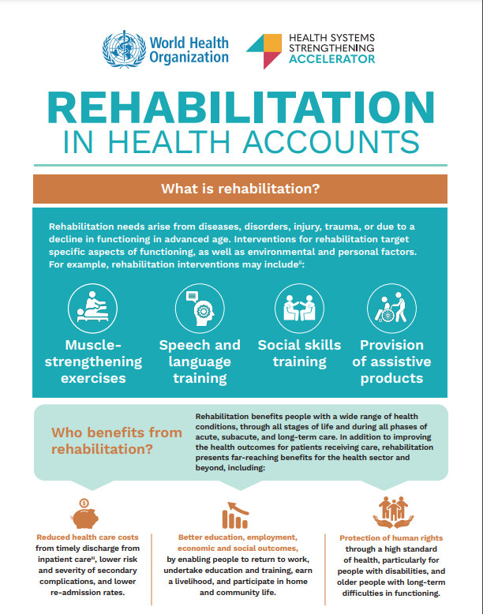
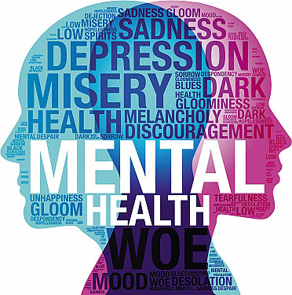
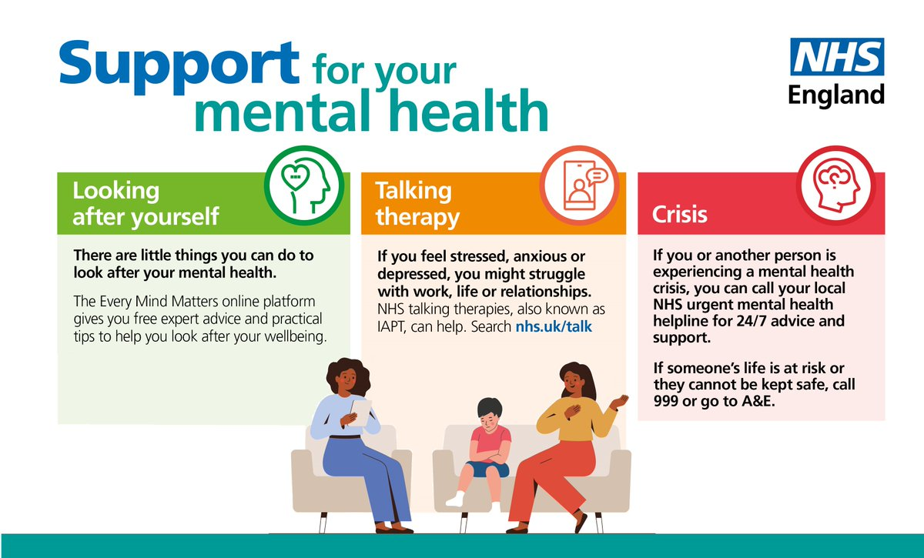
— Supporting Mental Wellbeing in the Community —
- Mental health assessments
- Medication management
- Therapy and counselling
- Crisis support
- Rehabilitation and recovery support
- Social support and assistance in everyday life.
Brief history of community mental services.
Prior to the established of community mental health services, mentally ill individuals were usually to be sent to huge psychiatric hospitals referred to asylum. These establishment were widespread in the 18th and 19th centuries. However, a lot of asylums were overcrowded, and in most case, patients were not properly treated, neglected, and isolated (Shorter,1997).
- Mental health nurses
- Psychiatrists
- Psychiatrists
- Social workers
- Occupational therapists
- Support workers
The role of each professional is different in helping the service user with his mental, emotional, and social needs.
A community mental health service is provided by a multidisciplinary team that consist of:
Introduction
Community Mental Health Services (CMHS) refer to health care services which offer mental health care and support to community members as opposed to being in a hospital. These services help individuals to deal with mental health illness including depression, anxiety, schizophrenia, bipolar disorder, and other psychological illness whilst still living a normal life (NHS, 2023).
These services are a variety of support, which includes:
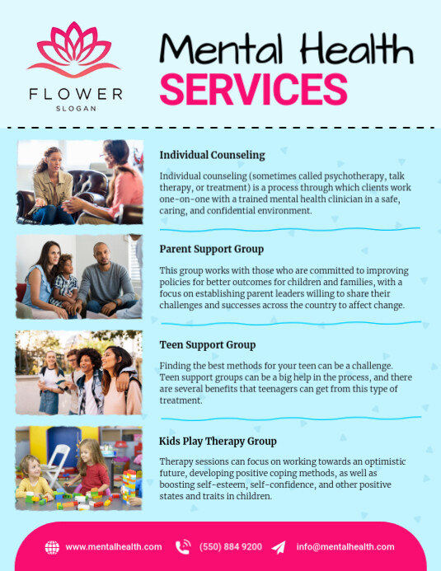

An individual care plan is developed together with the service users. This strategy involves treatment, therapy, medication, and recovery goals.
Care planning
Challenge 1: staff shortage
GPs, hospitals, or other medical workers refer people. Psychological evaluation is conducted to understand the condition and needs.
Assessment
The attitude to mental health started to shift in the middle of the 20th century. It was increasing becoming perceived that institutional care was not necessarily good and that it could hinder recovery. The development of psychiatric drugs also ensured that individuals could cope with illness even without being in hospitals.
The trend towards community care in the uk dates to 1950s and 1960s. One of the turning points was care in the community policy of 1980s and 1990s. The aim of this policy was shut down big psychiatric hospitals and. Deliver care in the local communities instead (Department of Health, 1990).

Treatment and support
The lack of qualified mental health workers is one key obstacles. Nurses, psychiatrists and support workers are not adequately supplied to address the increasing demand of mental health services
This can lead to:
- Long waiting times
- Reduced quality of care
- Increased stress for staff.
NHS England (2023) notes that the need to receive mental health services has grown rapidly, particularly following the COVID-19 pandemic. Staffing issue may influence the speed at which service users are assisted and supported.
Therapies like cognitive services offer Behavioural Therapy (CBT), medication administration and emotional support may be used in treatment.

Community Mental Health Services offer crisis teams which assist person with serious mental crisis. This would help in avoiding hospitalisations.
Crisis intervention
Stress, financial issues, social isolation, and the pressures of life are some of the factors that are leading to increased prevalence of mental health issues.
There is an increase seeking assistance, which demands the Community Mental Health Services.
Challenge 2: More mental health services are in demand.

Promoting independence
This can result in:
- Delays in treatment
- Overworked staff
- Limited resources
In case of overstretching of services, it may influence the recovery and wellbeing.
Despite that, Community Mental Health Services still becomes a crucial tool that contributes to the support of the people and enhances mental health outcomes.

The service helps them to get skills to live independently, work and socialise.
These services are based on such principles as:
- Person-centred care
- Respect and dignity
- Confidentiality
- Promoting recovery

References
Department of health (1990). Care in community. London: HMSO
Department of Health and Social Care (2018). The NHS Long Term Plan. London: DHSC
NHS (2023). Mental health services. Available at: www.nhs.uk
NHS England (2023). Mental health workforce statistic: NHS England.
NHS England (2019) community Mental Health Framework. London NHS England.
Shorter, E. (1997). A History of Psychiatry. New York: Johns Wiley & Sons.

Community Antenatal Midwifery services
Community Antenatal midwifery service plays an influential role in supporting pregnant women and enhancing maternal and infant health outcomes. The services they provide are care, education, and emotional support during the process of pregnancy in the community, and not in the hospital environment only. Understanding the history of community antenatal midwifery, how it works currently, and its significance that displays the required contribution to present-day healthcare.

The beginning of Antenatal midwifery services can back to the early twentieth century when rates of maternal and infant mortality rates were extremely high compared to the current rates. Owing to the lack of trained medical care, until the midwifery services were developed, many women delivered at home and exposed them to more complications and even death (Borsay and Hunter, 2012). The midwives act 1902 was the most important turning point in the United Kingdom, as it brought formal training, regulation, and registration of midwives. This Act was to enhance the quality of care to decrease the number of deaths of mothers and infants. With the establishment of the National Health Service (NHS) in 1948, the accessibility to antenatal healthcare improved drastically, and it free of charge, so the health outcomes of mothers were improved (NHS England, 2019). However, with time, the service were moved to a more holistic and preventative community-based care model where the midwives were able to assist the women both at home and the local clinics.

The community antenatal midwifery services of today work under a multidisciplinary healthcare system. Midwives also give regular prenatal check up in order to check the health of the mother and the infant. This check up involves measuring blood pressure, getting fatal development, testing medical diseases like gestational diabetes, offering health education on healthy eating, exercises, and birth preparations (National Institute Health Care Excellence [NICE], 2021). Midwives can also detect the emotional wellbeing and recognise risk factors, which includes mental health issues, domestic abuse, or social vulnerability. This proves that the contemporary antenatal care is focused on the psychological as well as the social and physical needs. Despite that, even though it is essential, community midwifery services are challenged. The quality and continuation of care may be influenced by staff shortages, workloads, and limited resources (Royal College Midwives, 2022). Progression of care is particularly important, as women visiting the same midwife during pregnancy report to have greater satisfaction and improved outcomes. Consequently, the service is effective and requires better staffing and financial support t remain high quality.

The service of community antenatal midwifery plays an outstanding role in improving the quality of life of service users. Such services help in observing and preventing complications in their early stage, which reduces risks to both the mother and the baby. As an illustration, pre-eclampsia, which is a potentially serious and potentially deadly disease, can be recognised by measuring blood pressure (NICE, 2021). Timely intervention is achieved through early detection, which is beneficial to safety. Also, midwives can offer education that will enable women to make informed choices related to pregnancy and childbirth process. Emotional support is also necessary, because during pregnancy, it may be a stressful period. Midwives build a trustful relationship with women, that is why it reduces anxiety and encourages positive mental health (NHS England, 2019). There is also the advantage of increased accessibility given that community-based care is more accessible to vulnerable populations that might be affected by barriers to hospital. This aids in minimising inconsistencies in health and all women are provided with necessary assistance.
Ultimately, the development of community antenatal midwifery services as a response to an exceedingly high maternal and infant mortality rates in the past and its reinforcement by the legislation and the establishment of the NHS. Currently, these services can offer crucial physical emotional, and emotional help, but such problems as staff shortages still exist. Overall, community based antenatal midwifery services play a prominent role in better birth outcomes and their infants. Their all-inclusive, supportive, and holistic practice has positioned them as pillars of contemporary maternity care.

