UNIVERSITY OF WALES TRINITY SAINT DAVID
LONDON CAMPUS
Assignment 2
Learning in the Digital Era
Video Link: Present your Video Link here (Upload your video presentation on You Tube or OneDrive/any other platform of your choice and then share that link here).
Please be sure to give unrestricted access to your video presentation so that your work can be marked by the examiner.
Module Name: Learning in the Digital Era
Module Code: ACCA 4025

Student Name: PAUL YCOSSIE
Student ID: 2518100
Group: 4

Lecturer’s Name: Dr. Dipo

Table of Contents
Introduction 2
Main Body 2
Conclusion 12
References 13

Introduction
Self-evaluation and professional development planning are foundational practices in education and many professions, serving as catalysts for continuous improvement and growth. Self-evaluation involves individuals critically reflecting on their own skills, performance, and areas for growth, while professional development plans translate these insights into actionable goals and strategies for advancement.

Main Body
elf-evaluation and professional development planning are central to effective professional growth, especially in education.
Video Link:
Slide 1 COVER PAGE
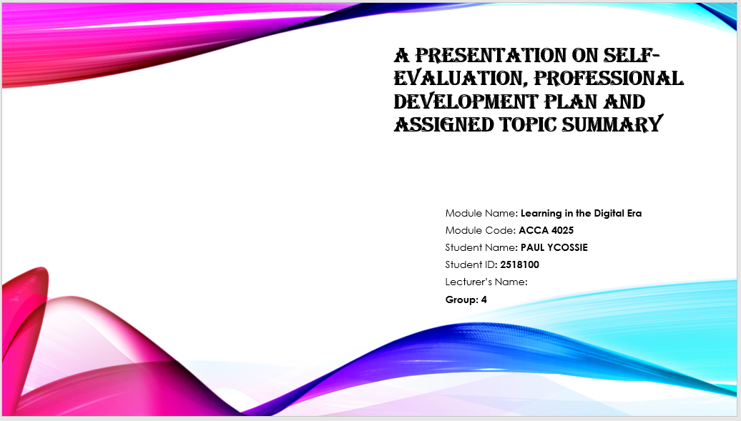

Slide 2 CONTENTS
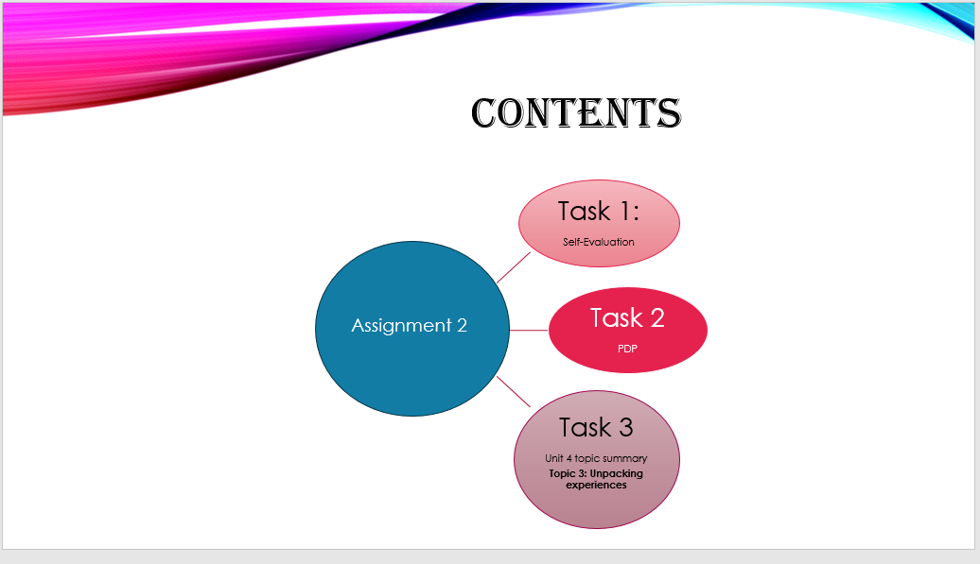

Slide 3 INTRODUCTION

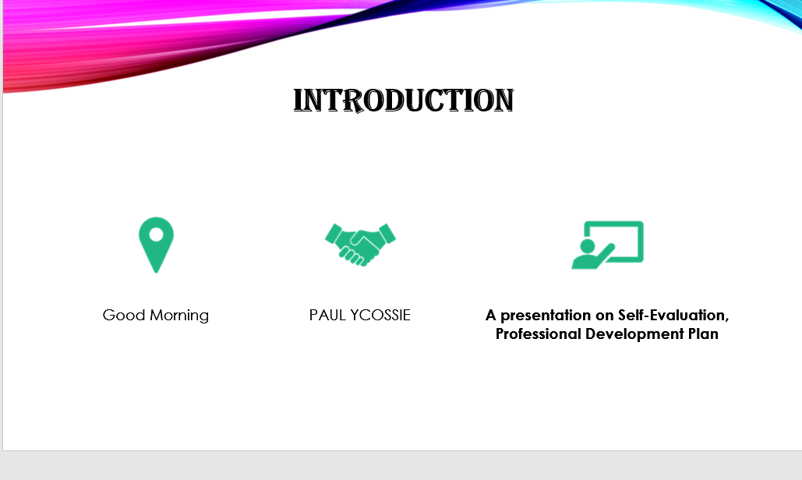

Slide 4 MAIN BODY
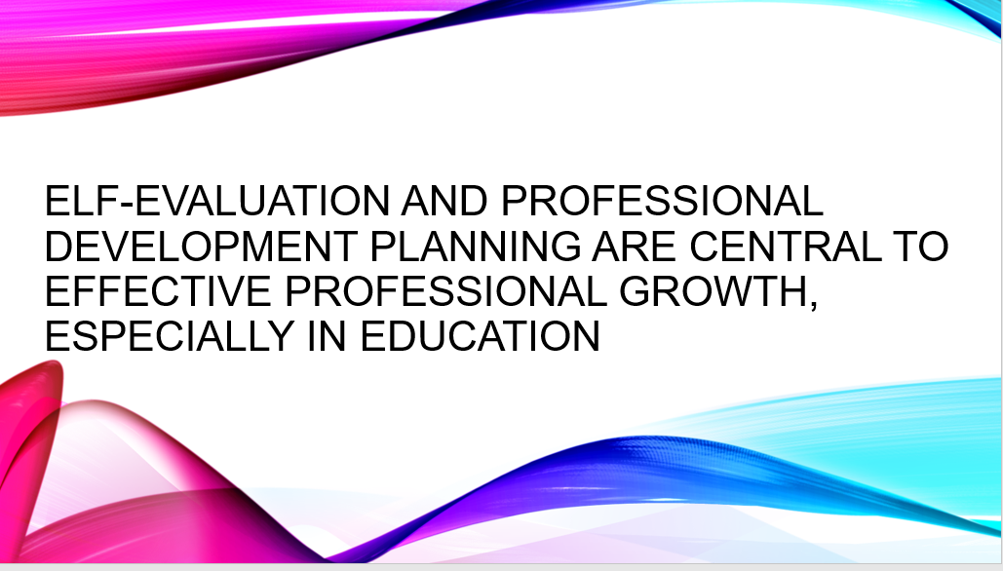

Slide 5 GIBB’s REFLECTIVE MODEL

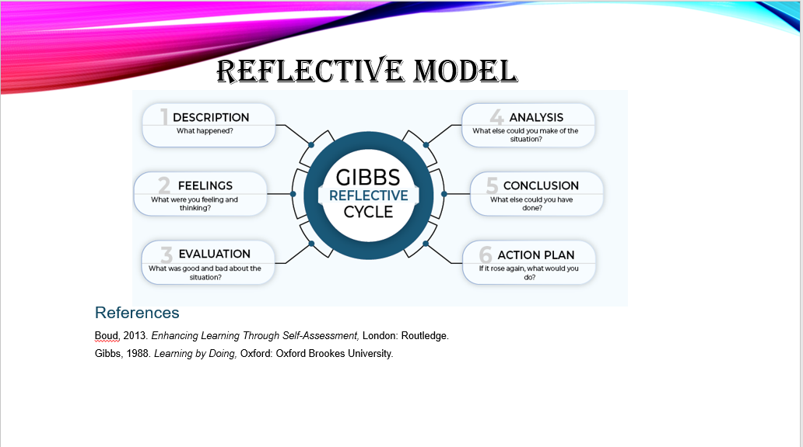
Gibbs’ Reflective Cycle is a six-stage model Description, Feelings, Evaluation, Analysis, Conclusion, and Action Plan designed to help learners reflect systematically on their experiences [1]. It encourages individuals to think deeply about what happened, how they felt, what went well, and what they need to improve. The model is widely used in education because it supports reflective learning and helps students understand their strengths, weaknesses, and learning needs [2]
I will use Gibbs’ Model to structure my reflection in Assignment 2. I will begin by describing the task, then express my feelings and evaluate what worked or did not work. I will analyse the reasons behind my performance and conclude with what I learned. Finally, I will create an action plan outlining the steps I will take to improve in future assignments.

Slide 6 TASK 1: SELF EVALUATION
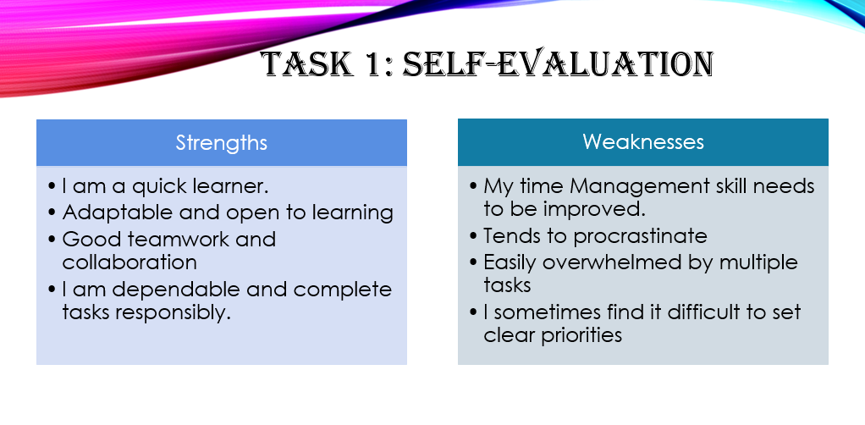
From my SWOT analysis, one key strength I identified is that I am dependable and complete tasks responsibly, which helps me stay committed to my work and ensures that I meet expectations. However, a weakness I recognised is that I sometimes find it difficult to set clear priorities, which can affect how efficiently I manage my time and complete important tasks. Understanding these areas helps me improve my planning and organise my workload more effectively [3].

Slide 7 TRAITS GAINED FROM THE SELF EVALUATION
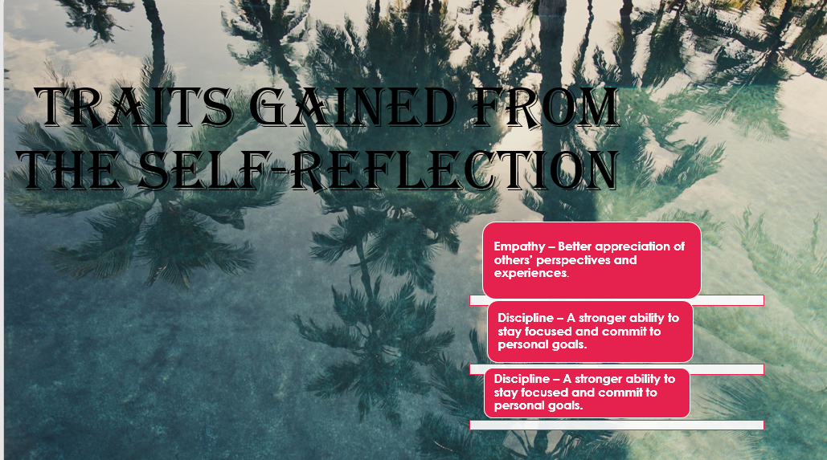

Self-evaluation plays a key role in developing important personal traits such as empathy and discipline. Through self-evaluation, individuals reflect on their actions, attitudes, and interactions with others. This process helps build empathy by enabling individuals to better understand and appreciate the perspectives and experiences of those around them, which improves relationships and promotes respectful and effective communication. Self-evaluation also strengthens discipline by helping individuals identify areas where greater focus and commitment are needed. By recognizing habits that hinder progress, individuals can set clear goals and work consistently toward achieving them. Discipline developed through self-evaluation encourages responsibility, effective time management, and perseverance. Overall, self-evaluation supports both emotional growth and personal development, allowing individuals to relate better with others while remaining focused and committed to achieving their personal and professional goals [4]

Slide 8 PROFESSIONAL DEVELOPMENT PLAN

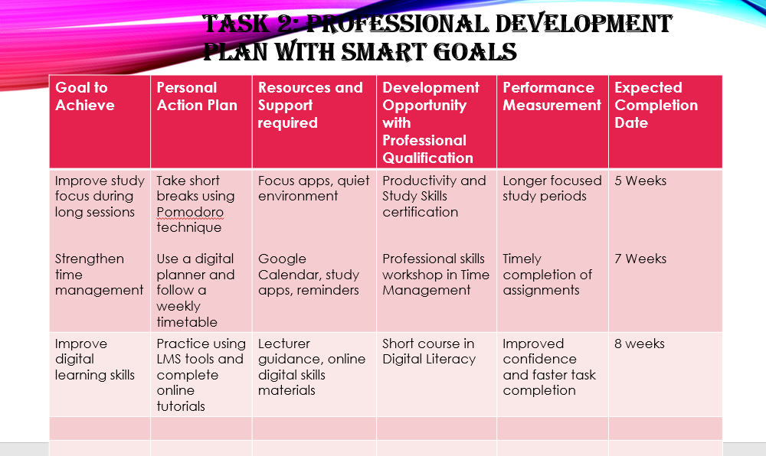

Professional development plans that use SMART goals are effective for enhancing learning, performance, and career progression, especially when supported by training, templates, and regular review. High-quality SMART goals require clear structure and ongoing evaluation to ensure they drive meaningful professional growth. For best results, organizations and individuals should provide training, use standardized templates, and regularly review progress to maximize the impact of PDPs with SMART goals.

Slide 9 UNIT 4 TOPIC SUMMARY
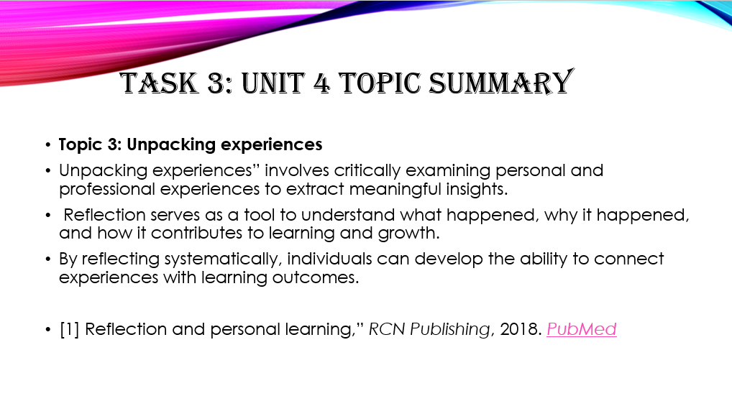
Summary of Topic 3: Unpacking Experiences
Reflection plays a vital role in both personal and professional learning because it helps individuals understand their experiences, identify learning gaps, and develop deeper insight. Research shows that reflective practices such as journaling, guided prompts, and structured models like Gibbs and Kolb improve critical thinking, self-awareness, and professional growth. Although challenges such as limited time, unclear expectations, and insufficient feedback can reduce its effectiveness, reflection remains a powerful tool for connecting theory to practice and supporting continuous improvement throughout one’s learning journey. [5]

Slide 10 CONCLUSION

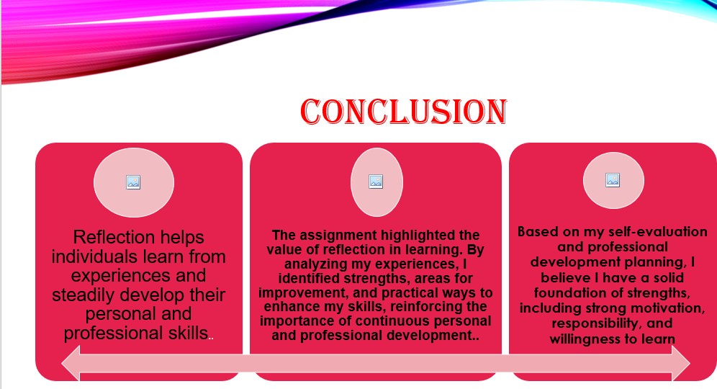In my conclusion, taking time to reflect and unpack experiences helps turn everyday activities into real learning moments. By thinking about what happened, how it felt, and what could be done better next time, learning becomes more meaningful and personal. Using a structured reflection model like Gibbs’ Reflective Cycle makes this process easier and more focused. Overall, reflection supports personal growth, builds self-awareness, and helps improve future academic and life experiences.

Slide 11
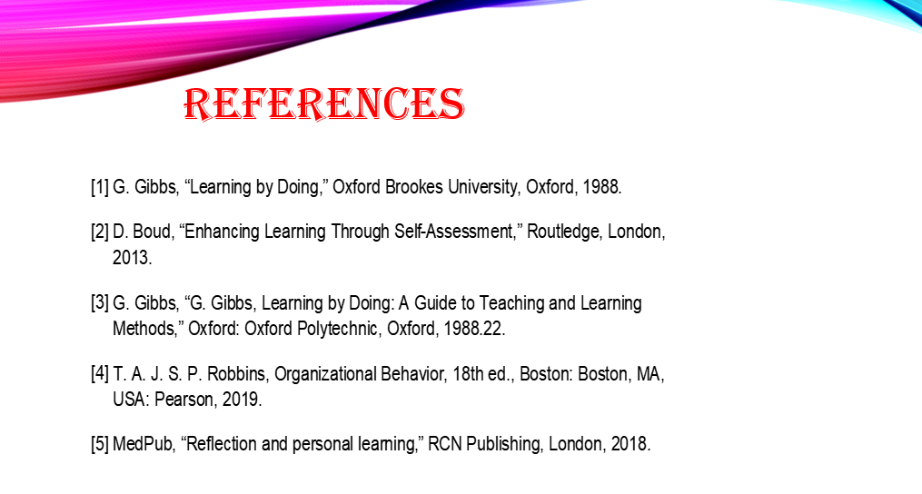

Conclusion
In conclusion, the self-evaluation helped me identify my strengths, such as communication, adaptability, and problem-solving, while also highlighting areas that need improvement, including time management, confidence, and prioritisation. The professional development plan offers clear steps that will support my progress and help me become more effective in my academic and professional roles. Overall, the traits gained from this reflection will help me move forward with greater self-awareness and resilience.

References

[1] | G. Gibbs, “Learning by Doing,” Oxford Brookes University, Oxford, 1988.
[2] | D. Boud, “Enhancing Learning Through Self-Assessment,” Routledge, London, 2013.
[3] | G. Gibbs, “G. Gibbs, Learning by Doing: A Guide to Teaching and Learning Methods,” Oxford: Oxford Polytechnic, Oxford, 1988.22.
[4] | T. A. J. S. P. Robbins, Organizational Behavior, 18th ed., Boston: Boston, MA, USA: Pearson, 2019.
[5] | MedPub, “Reflection and personal learning,” RCN Publishing, London, 2018.

