Student’s name : Diana Vukov
Student’s ID : 2234549
Personnel Resourcing & Development (BMIH5005)
Tutor : Helen Lee
Word Count : 2638

ESSAY: DISCUSS HOW THE EVOLUTION OF HRM FACILITATES THE STRATEGIC DEVELOPMENT OF AN INTERNATIONAL HOTEL BRAND THROUGH WORKFORCE PLANNING, RECRUITMENT AND SELECTION

Table of Contents
Introduction 3
Main Body 3
Conclusion 9
References 11

Introduction
The revolutionary path of human resource management is explored in this article through which the crucial role played by it into practical designing and procedures that involved workforce planning, recruiting and selection procedures, eventually leading towards global success of ‘Stellar Haven.’ Adaptability, innovation and human resource management in the strategic position of worldwide hotel brands affect their success level a lot in the modern dynamic hospitality industry. Stellar Haven, a global brand in the hotel industry, best represents the anticipated increase of HRM participation to reach strategic success.
The modern HR management has been transformed over the years by a profound transformation from ordinary administrative duties into an enabler and integral part of business development initiatives. Viewed as a department responsible mainly for routine duties, HRM is now a proactive procreative element in headlong operations between an organization’s tactics and strategic goals One of the many drivers to this development is linked to one of the notable sources of worthwhile trading such as human capital, which has been identified a critical part in achieving competitive advantage, especially for service-oriented and people-intensive manufacturing responsibility industry. The development of HRM in ‘Stellar Haven’ on the other hand is an intriguing topic. The role of HRM strategy in the brand’s global development is also important, as it goes together with extraordinary facilities and services to conclude.

Main Body
Strategic role of HR functions
The operations are deemed conventional for the brand ‘Stellar Haven’ and it is critical that contemporary HRM functions align with this industry’s dynamic global business setting, particularly because immediate staffing needs generate success and long-run growth of worldwide hotel brands. The alteration from a traditionally administrative functionality to a strategic partner has altered the fate of the two positions (Hamouche, 2023).
Strategic Workforce Planning:
Strategic workforce planning is integral to HRM’s purview and forms a vital responsibility of the organisation, which regards building for tomorrow. The performance of Stellar Haven has heavily depended on its capability to forecast, in advance and keep pace with the workforce that processes common objectives and corporate goals. Through workforce planning, HRM does a feasible and extensive analysis that enables them to review existing and upcoming human resource needs by identifying skills gaps as well as predicting future events in the hospitality industry. Based on ‘Stellar Haven,’ this involves the understanding of the subtle nuances that govern global marketplaces, as well as cultural factors and evolving customer needs of heterogeneous markets (Tiwary, 2024).
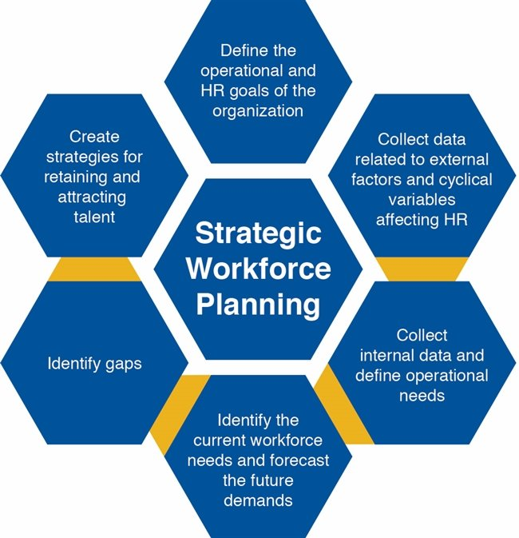
Figure: Strategic Workforce Planning
(Source: Tiwary, 2024)
HRM in ‘Stellar Haven’ means making sure a great guest touch, which uses efficient employee on-boarding using smart workforce administered in the strategic direction. This includes placement of spoken and written communications; integration skills needed in the workplace today to allow them some adaptation or even alterations when entering the workforce. If one is linked to the operational workforce that creates responsiveness and effectiveness in a dynamic industry like Stellar Haven, then it contributes to sustainable performance.
Strategic Recruitment:
Organizations also need to pay special attention in terms of recruitment which is a key HR activity determining a level and pattern of skills among the workforce. According to the opinion of ‘Stellar Haven,’ strategic recruiting is a practice also called discovery and hiring people whose talents, beliefs and cultural ties meet with the company’s larger purpose. HRM plays an important role in ensuring s to get the opportunity of access which means that recruiting strategies that will observe different talent pools are directed so as to obtain a workforce with various perspectives geared towards enhancing creativity and adaptability. The global strategic recruiting process in a worldwide hotel brand framework, pertaining to ‘Stellar Haven’ extends on a worldwide size but it also accounts for the unique and cultural nuances of various locations (Oginni et al., 2023). The employee image is to be established by the HR department together with other stakeholders as they use the values and repute of the organization in order to attract good men. This strategic recruitment meets the current staffing needs as well as ensures the long-term financial health of the brand due to cultivating a workforce that is diverse and has high levels of competence to determine what times change requires new people on its feet.

Strategic Selection:
One of the most significant stages is the selection process, during which HRM ensures that a candidate does not only have required capabilities but he or she corresponds with business values and long-term vision. One is the strategic selection method that applied at “Stellar Haven” designed to find people not only with proper qualification for appropriate positions but also have potentials for future promotion in the organization.
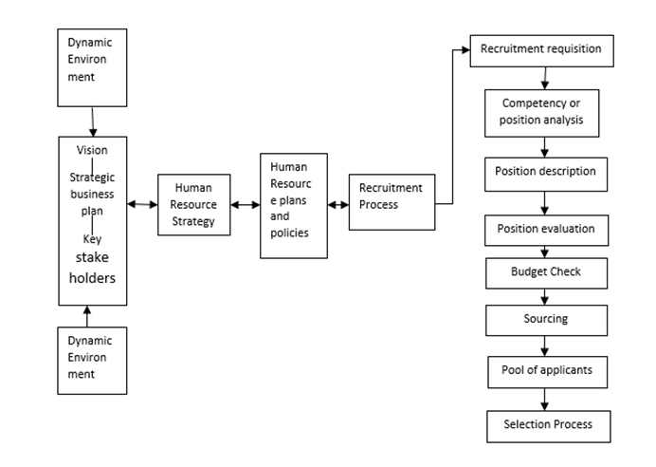
Figure: Strategic Selection Planning
(Source: Gandhi, 2021)
This process includes conducting rigorous evaluations, interviews and assessments in order to ensure full understanding as opposed to superficial knowledge that is suitable for a candidate’s fitment in a specific brand environment (Gandhi, 2021). In addition, in the global context of ‘Stellar Haven’s HRM is confronted with cultural and language barriers at each stage during recruitment. Strategic selection moves further than technical skills and features cultural conformity, the global attitude that embraces both factors as part of its brand image to offer a consistent guest paradigm all over the world.
The HRM procedures such as planning in the workforce, recruitment, and hiring are very important strategic processes that go hand in hand with the growth of global hotel chains like ‘Stellar Haven’. By thinking strategically, it ensures that HRM is no longer viewed simply as a workforce but an active partner in organizational goal attainment and therefore human capital. That said this would be a dynamic factor causing the brand to perform well on the world stage sustainably (Koc, 2020). ‘Stellar Haven’ lets us see how a more sophisticated view of the role HRM plays in developing challenge resilience results in sustainable innovation, which is an important condition for surviving and thriving among contemporary world international hospitality companies.

Strategic HR planning process
The world of Hospitality around the globe is very competitive in its nature, and most if not poses steep competition. HRM plays an important role when it comes to the strategic development of renowned brands like ‘Stellar Haven’. This article describes HR planning processes that would assist this organisation in expanding its workforce via human labour planning, hiring and selection respectively. Strategic HR planning, borne out of the new HRM model which has become a proactive partner in achieving organisational goals.
Forecasting Labour Demand and Supply:
The basis of strategic HR planning for the ‘Stellar Haven’ lies in the future projection of labour demand and supply. Provision of the necessary information about future trends in customer needs helps HRM to collect relevant data coming from human lifestyles that apply data-drive methods that predict changes in personnel requirements specific to the changing hospitality market (Anubala, 2023). This involves studying previous records, performing market research and using the value of capital in predicting how many workers with the specific skills will be needed through various corners in the organization.
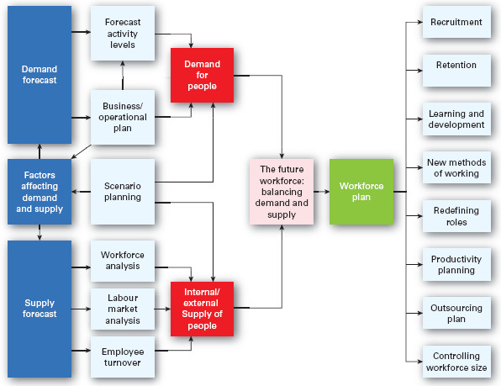
Figure: Forecasting Labour Demand and Supply
(Source: Supriadi, Rahardjo, and Suprihandari, 2020)
The scope of predicting forgiveness ‘Stellar Haven’ can be observed, however, is complicated with its transnational reach. HRM must take into account cultural, legal and economic factors that differentiate the very locations where people's brand is based (Supriadi, Rahardjo, and Suprihandari, 2020). ‘Stellar Haven’ ensures to accurately estimate the demand for labor, leaving it with commonly adequately trained professionals at most convenient times of their arrival and preventing overstaffing or not staffing scenarios negatively affecting guest satisfaction and cost-efficiency through time.
Goal Setting and Strategic Planning:
Strategic HR planning of ‘Stellar Haven’ is more than forecasting as it involves aligning the HR strategy with the overall organizational goals and vision. Given the fact that goal formulation is an important aspect of strategization, in this case it will entail pinpointing some specific goals for talent acquisition and development as well as maintaining the workforce to focus on brand’s strategic growth (Tsiona, 2023). In the global scenario, ‘Stellar Haven’ might seek worldwide expansion, cultural convergence and uniformity in brand issues under highly diversified markets.
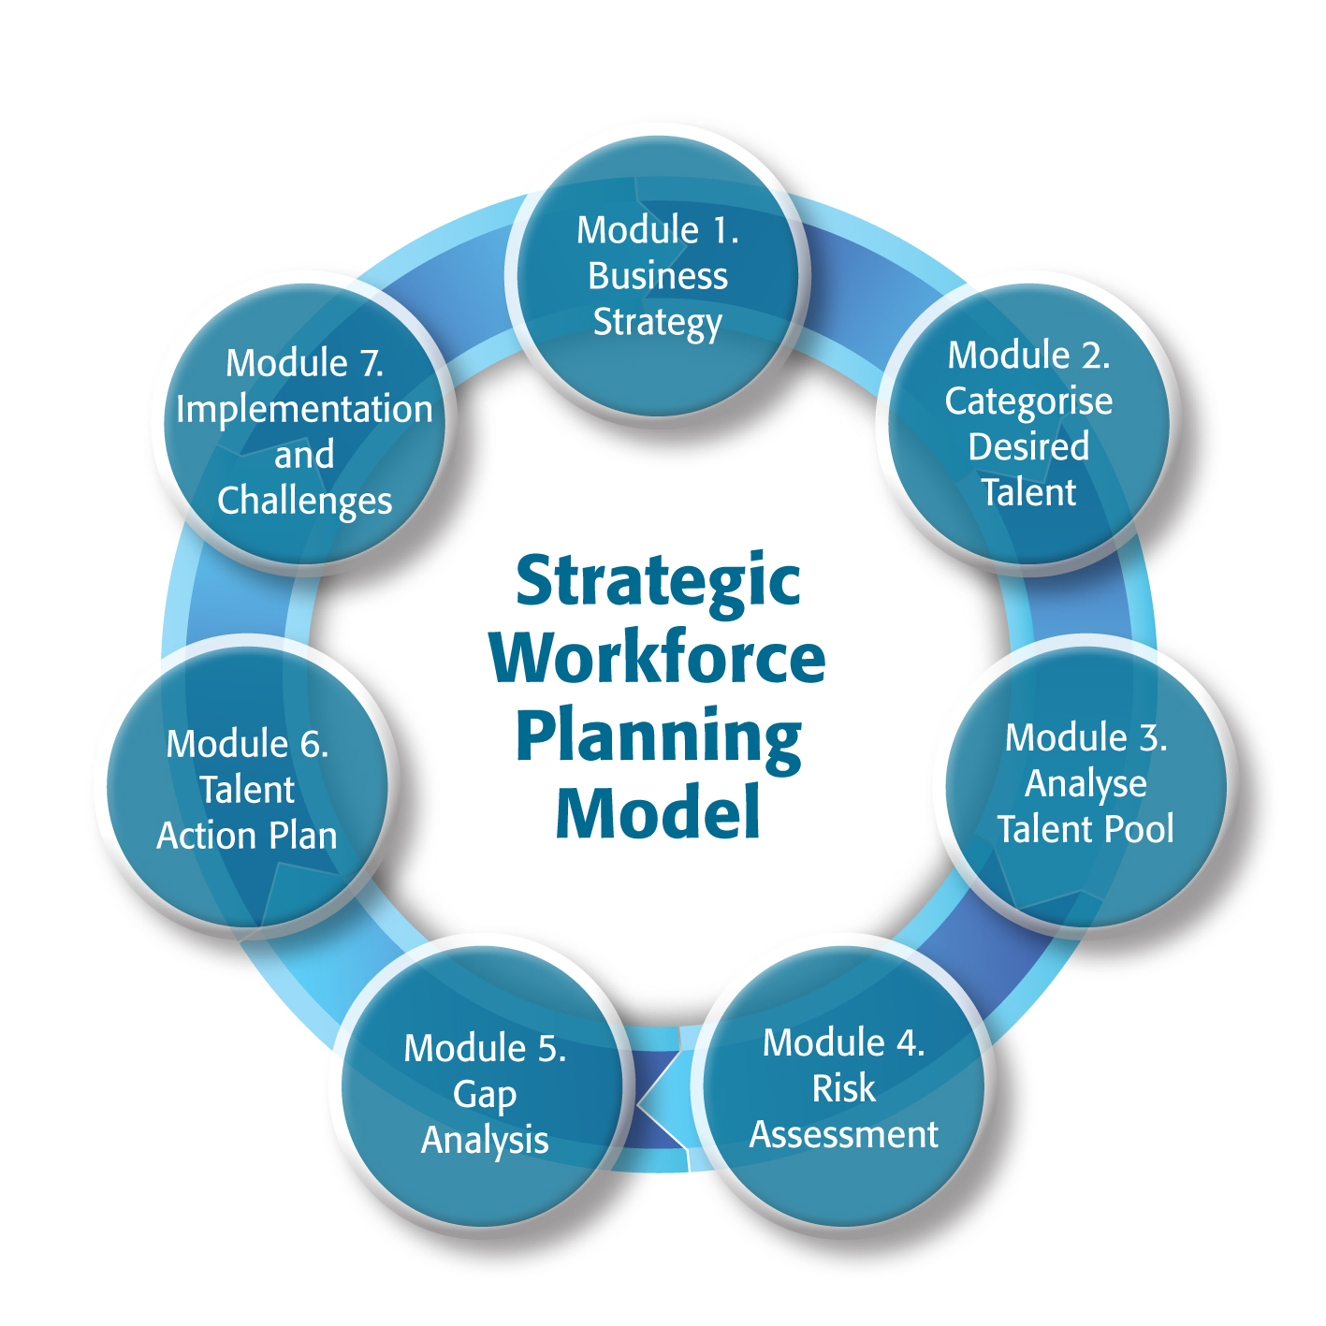
Figure: Goal Setting and Strategic Planning
(Source: Tsiona, 2023)
Strategic planning involves some HR activities even like cross-cultural training, international recruiting, and talent development for a better brand competition worldwide. The activity of alignment between the HR goals and those in ‘Stellar Haven’ with regards to their strategic visions is what makes HR planning lead organizations to achieving success. It assures that human capital is adequate for operational needs and ensures the development of brands and sustainability.
Program Implementation and Evaluation:
Effective HR program implementation is critical to strategic planning. 'Stellar Haven' HRM provides agile workforce planning, recruiting, and selection efforts. Recruitment methods, talent development programmes, and performance management systems help achieve HR objectives during programme execution. Programs must adapt to different cultures in the worldwide hotel sector, as consumer expectations vary. 'Stellar Haven' HRM trains its staff to deliver a consistent and excellent visitor experience across all sites. HR program effectiveness must be measured during the assessment. HRM measures strategic planning achievement using staff turnover, visitor satisfaction, and worker productivity (Bailey and Suddaby, 2023).

Recruitment stages and selection process
In the extensive variety of strategic growth for multinational hotel brands like 'Stellar Haven,' the recruiting phases and selection process managed by Human Resources Management (HRM) are key parts. The primary objective of this article is to dive into the halfway capabilities and present a few vital strategies in human resource management, including labor force arranging enrolment, and choice procedures that have helped 'Stellar Haven' in its essential turn of events.
Workforce planning and talent needs assessment:
Prior to embarking on the recruiting process, 'Stellar Haven' initiates a thorough evaluation of its talent requirements. The HR office cooperates with business chiefs to grasp the essential targets and exact aptitude required for every business division inside the association (Doz, 2020). After distinguishing ability needs, labour force arranging fills in as an essential technique for satisfying these necessities. 'Stellar Haven' utilises estimating to determine the exact sum and type of ability important to work with the extension of the business.
Recruitment Stages:
Recruitment at 'Stellar Haven' consists of many steps aimed at attracting, appraising, and choosing people who share the brand's values and strategic objectives (Lunguleac Bardasuc, 2022). The cycle begins with work profiling, in which HRM works with enrolling supervisors to recognize jobs and obligations. For instance, to support its sustainability programs, HRM could foster profiles for positions like Environmental Sustainability Manager and Eco-Friendly Practices Coordinator. Following position profiling, 'Stellar Haven' involves various roads for candidate obtaining, including web stages, industry organizations, and associations with hospitality colleges.
Selection Process:
This evaluation considers technical skills, cultural fit, and brand strategy. For instance, if 'Stellar Haven' is entering a maintainable tourist industry, the selection process might include surveying people's experience taking on and managing sustainable practices (Marwan, 2020).
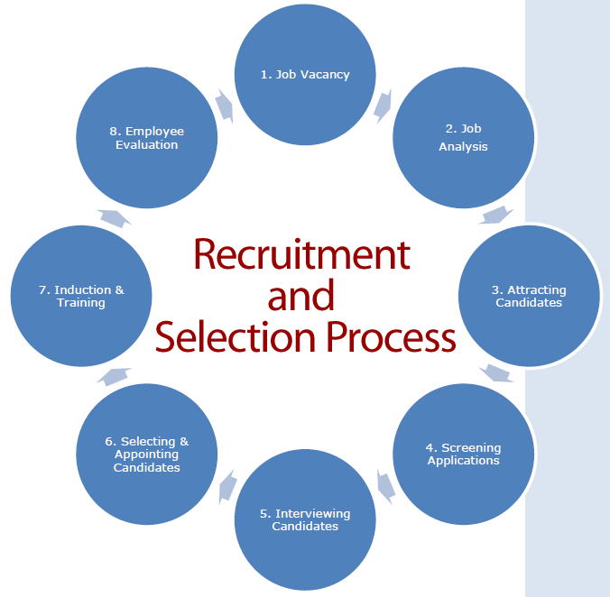
Figure: Recruitment stages and selection process
(Source: Harmsen, 2023)
The enlistment and decision cycles at 'Stellar Haven' display the fundamental progression of HRM in helping the brand's development. By consolidating capacity with specialty unit targets, using worldwide enrolling strategies, and completing a complex decision interaction, 'Stellar Haven' guarantees that its workforce drives the brand's fundamental goals (Harmsen, 2023). The models offered show the process of HR organizing, enlisting, and determination strategies add to the effective and explicit approach that describes 'Stellar Haven' in the effective worldwide cordiality industry.

Conclusion
In conclusion, the development trajectory of ‘Stellar Haven’, a powerful international brand lodging house, carves an example to be followed to show how important is HRM in driving strategic evolution. Theo's concept of HRM evolving from an administrative function to corporate strategy in the role of a value-driven and business-focused strategic collaborator has been central towards Stellar Haven’s continued success. One of the mechanisms that is used by the brand to prove how HRM adapts to changes in hospitality is manifested when it utilizes strategic workforce planning, recruitment and selection processes to complete an intellectual assessment model. The subsections within this essay on strategic functions of HRM highlight the imperative nature of forecasting and addressing emergent world trends, cultural variance, and customer preferences. The strategic workforce planning allowed in ‘Stellar Haven’ makes all the other staff members work effectively as a single team and remain flexible to various trends within which it operates. The strategic functions of HRM that include recruitment and selection show how ‘Stellar Haven’ attracts the high performing people who are not only operational on a short-term basis, but also fit into values and vision of brand long-term. The evolution of HRM at ‘Stellar Haven’ can be likened to the journey that has been embarked upon in efforts to build a lasting future, one that is characterised by plausible economic innovation and competitiveness as part of the qualifying standards for inclusion into the global market.

References
Anubala, R., 2023. The Future of Hospitality: Predictive Analytics in Hotel Management. International Journal for Multidimensional Research Perspectives, 1(3), pp.38-58.
Bailey, C. and Suddaby, R., 2023. When Time Falls Apart: Re-centring human time in organisations through the lived experience of waiting. Organization Studies, p.01708406231166807.
Cannon, C.M., Herbert, P. and Sangris, F., 2022. Yellowknives Dene and Gwich’in Stellar Wayfinding in Large-Scale Subarctic Landscapes. Arctic, 75(2).
Doz, Y., 2020. Fostering strategic agility: How individual executives and human resource practices contribute. Human Resource Management Review, 30(1), p.100693.
Farooq, R., Zhang, Z., Talwar, S. and Dhir, A., 2022. Do green human resource management and self-efficacy facilitate green creativity? A study of luxury hotels and resorts. Journal of Sustainable Tourism, 30(4), pp.824-845.
Francois Koukpaki, A.S., Adams, K. and Oyedijo, A., 2020. The contribution of human resource development managers to organisational branding in the hotel industry in India and South East Asia (ISEA): a dynamic capabilities perspective. Employee Relations: The International Journal, 43(1), pp.131-153.
Gandhi, D., 2021. The Leadership Landscape: South Asian Women in Higher Education. Drexel University.
Gupta, A.D., 2020. Strategic human resource management: Formulating and implementing HR strategies for a competitive advantage. CRC Press.
Hamouche, S., 2023. Human resource management and the COVID-19 crisis: Implications, challenges, opportunities, and future organizational directions. Journal of Management & Organization, 29(5), pp.799-814.
Harmsen, E.L., 2023. Inclusive, Accessible, Sustainable–Designing A Different Future.
Hassanein, F. and Özgit, H., 2022. Sustaining human resources through talent management strategies and employee engagement in the Middle East hotel industry. Sustainability, 14(22), p.15365.
Koc, E., 2020. Cross-cultural aspects of tourism and hospitality: A services marketing and management perspective. Routledge.
Liu, Y. and Ruiz Pardos, M., The Effects of Film-Induced Tourism Culture on Hong Kong’s destination branding.
Lunguleac Bardasuc, L., 2022. Managing marketing strategies and public relations in public universities. Study of the new communication techniques.
Marwan, A., 2020. Impact of artificial intelligence on education for employment:(learning and employability Framework).
Oginni, B.O., Ayantunji, I.O., Olaniyan, T.S., Ajibola, K.S. and Ajakaye, T.B., 2023. The Nexus Between Recruitment and Selection Practices and Business Performance of Nigerian Small and Medium-Sized Manufacturing Enterprises. International Journal of Management Studies (IJMS), 30(2), pp.469-500.
Supriadi, I., Rahardjo, K.A. and Suprihandari, M.D., 2020. Expectations and standards for accounting professions and implications in the learning pattern in Industrial 4.0. Ilomata International Journal of Tax and Accounting, 1(2), pp.66-73.
Suwanto, S., Sunarsi, D. and Achmad, W., 2022. Effect of Transformational Leadership, Servant Leadershi, and Digital Transformation on MSMEs Performance and Work Innovation Capabilities. CEMJP, 30(4), pp.751-762.
Tanova, C. and Bayighomog, S.W., 2022. Green human resource management in service industries: the construct, antecedents, consequences, and outlook. The Service Industries Journal, 42(5-6), pp.412-452.
Tiwary, I., 2024. Streaming and India's film-centred video culture: Linguistic and formal diversity. International Journal of Cultural Studies, 27(1), pp.65-81.

