A report into the effectiveness of additive manufacturing techniques as a mass manufacture process in the extreme sport industry

Contents
1. INTRODUCTION 2
2. Manufacturing methods 4
2.1 Additive manufacturing 4
2.1.1 FDM 4
2.1.2 Selective laser sintering 4
2.1.3 Stereolithography 5
2.1.4 Chosen process 5
3. Materials 6
3.1 Redesign materials 6
3.1.1 ANMA 6
3.1.2 PARA 6
3.1.3 PEKK 6
3.1.4 Chosen Material 6
4. Design 7
4.1 current design 7
4.2 Redesign 8
5. Conclusions 8
6. Appendices 9

ABSTRACT
This is a report into the effectiveness of additive manufacturing techniques as a mass manufacture process. Traditionally Additive manufacturing has been hampered by slow production speeds and high capital cost, however with the falling cost of additive manufacturing systems and the progress in the associated technologies it may have more of a standing as a mass production process.

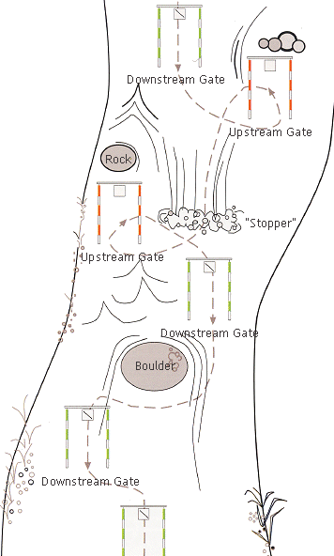
INTRODUCTION
Figure 1 (Penfold, 2019)
Canoe slalom is a sport in which an athlete navigates their canoe down a river through a number of coloured gates, in the correct order, in the fastest time possible, touching or missing any of the gates incurs a two or a fifty second time penalty respectively. Therefore this requires fitness skill and control over their canoe. There are two main disciplines in canoe slalom there is kayak (K1) or there is Canoe (C1/C2) in Canoe the athlete kneels in the boat and use a single bladed paddle. In order to have greater control over their canoes the athletes strapped themselves in to the boats and later began to fit foam blocks in to the boat to press their knees into to gain more contact points with the boat. Other components have since been developed to perform this function whilst reducing the added weight. (Penfold, 2019)
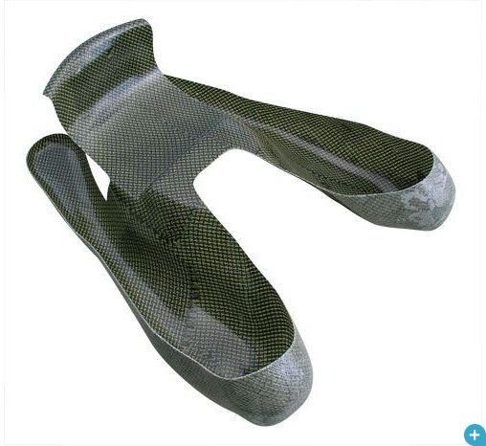
The component chosen for this report is a monocoque composite knee cups designed to be fixed into canoe slalom canoes. They are used for the purpose of increasing the number of contact points between the athlete and the boat. This enables the athlete to apply more force allowing greater control over the canoe, whilst negotiating the whitewater slalom course. The monocoque Knee cups are much stiffer than the more traditional minicell foam resulting in more of the force being transferred from the athlete into the movement of the boat. This means that less energy and more crucially time is wasted in the compression of the foam. The knee cups are manufactured using either carbon Kevlar (as seen above) or carbon fibre in a matrix with epoxy resin to save weight giving the athlete an edge over other competitors. This part is then fixed in to the canoe usually with Kevlar cloth and epoxy resin (Chappell, 2019).
Figure 2 Galasport knee cups (Galasport, 2018)
Other options include hand cut foam. This type of outfitting allows for more adaptability, in that it can be cut to shape to fit the user, however, this takes a long time to set up. In most cases this method does not provide as many contact points, is easily compressible and is much heavier than the composite knee cups. (Chappell, 2019)
Additive manufacturing would improve the product. Additive manufacturing would allow ultimate adaptability between consumers. It does not require mould or tool changes between each components production or extensive hours spent fine tuning foam outfitting. Manufacturing is proceeded by scanning individual body parts to provide a bespoke fitting part. This means that the part is fully personalised in terms of shape and size of the component to perfectly fit the individual’s body shape and requirements. This is a huge improvement currently all knee cups are moulded from the legs of top Olympic and World championship level athletes and therefore does not allow for users with wider, longer, shorter legs than the athlete that the Knee cups were moulded from. It also allows easier adaptability in strengthening specific areas of the part in specific directions than can be completed using composites. Additive manufacturing would also benefit the manufacturer as they would be no need to store the moulds since an AM part would be produced from a 3D scan of the athletes legs. (Chappell, 2019)

Manufacturing methods
Currently the component is manufactured by taking a physical mould of the athletes’ legs by getting them to kneel as they would in the canoe, a casting material is then poured into the box and allowed to harden, and the athlete can then remove themselves from the cast. The cast is used to make a composite mould. Once hardened the mould is then prepped and layered with composite material, this is vacuum infused with epoxy resin and left to cure. Once cured the final component can be removed from the mould and fixed into position in the canoe. These components are expensive and time consuming to manufacture. They are manufactured at a very low rate. This product lends itself to additive manufacturing as the speed and cost of manufacture will not be an issue. (VAJDA group, 2018)

Additive manufacturing
Additive manufacturing more widely known as 3D printing or rapid prototyping allows for the production of completely unique parts designed specifically for individual customers. Additive manufacturing (AM) involves the computer controlled layer by layer manufacture of parts. AM also benefits from the ability to add strength in different directions, as required in different areas of the part, without largely increasing the thickness and therefore the weight of the part is kept to a minimum. Additive manufacturing also allows for more complex support structures that may increase the performance or life expectancy of the product which is not possible with current manufacturing techniques. Additive manufacturing also has its disadvantages for example it is much slower than most traditional forms of manufacture due to the layer by layer process in which it constructs parts. AM is more cost effective for producing one off models or prototypes, however, it is much more expensive to use in mass production due to higher labour intensity, long production time and limiting size of the machine. (Achillas, 2016) (Gardan, 2015) (Morgan, 2018-19) (Owen, 2017-18)

FDM
Fused deposition modelling (FDM) is a process by which a heated material filament is deposited layer by layer to form the body of the part. This type of manufacturing can reduce lead times on parts by 30-50% even with more complex part geometries compared to traditional manufacturing methods. FDM benefits from wide range of potential materials for production, also the ability to have part material and support structure material that can be easily removed, limiting the time spent of finishing the product. FDM has become much more mainstream in recent years with the falling cost of 3D printers. However, has its limitations, one of which is the feed rate if the feed rate is too slow airgaps can form in between the layers or the lower layer maybe cooled too much for the next layer to fully bind to it, this causes weaknesses in the z-axis (as manufactured). FDM has the second highest capital cost ranging for between £71,500.00 to £304,000.00 (CES Edupack, 2018).

Selective laser sintering
Selective laser sintering (SLS) is another additive manufacturing process. SLS works by taking a CAD model splitting the z-axis (as manufactured) into many thin sketches 100-150µm deep. This is then fed into the SLS machine which deposits a fine layer of the chosen material powder onto the machine bed, the machine then uses a laser to melt the powder where the sketch geometries specify. This material cools to a specified temperature whilst the next layer of powder is deposited on top. This process is repeated until the part is complete. The advantages of SLS include a relatively high tensile and impact strength and due to the excess powder remaining on the bed there are no support structures necessary for the manufacturing process (to support the body of the part whilst it hardens). The disadvantages of SLS include a rough surface finish likened to a medium grit sandpaper and a need for a lot of post manufacture finishing. SLS has the highest capital cost ranging from £137000 - £645000 (CES Edupack, 2018)

Stereolithography
Stereolithography (SLA) is similar to SLS it uses a laser to heat and bond thin layers (25-150µm) of the part material together. The material used for SLA manufacture is a photo sensitive resin. The part is lowered into the resin between each layers solidification. Allowing a thin layer of the unbonded liquid to flow over the part ready to be heated by the laser. In order to produce more complex structures manufacturing support structures are needed to support the part until it fully solidifies. The part also requires cleaning and needs to undergo a UV post cure to completely solidify. SLA has the cheapest possible capital cost of the three processes, ranging from £1520 - £789000 however, has the second highest unit price between £21.60 and £3380 (CES Edupack, 2018)

Chosen process
SLS was chosen as the manufacturing process for the new part because of its isotropic properties, it does not need support structures to hold the part in shape while under construction and the fact that it does not need a post cure. FDM was rejected, even though it is faster, and produces smoother parts than selective laser sintering (SLS), the part produced would have much weaker inter layer bonds that would be unfit for use in this part

Materials
The current material chosen for this part is carbon Kevlar or carbon fibre in a matrix with epoxy resin. This material is used to provide a stiff yet lightweight part. (VAJDA group, 2018)

Redesign materials
The material chosen for the redesign must be applicable to both the part and the chosen method of manufacture. Therefore it must have a high tensile strength and flexural modulus. Because of the nature of the part and the forces applied through it was decided that an isotropic material would be most applicable. Therefore filled materials were discounted. From the remaining materials the three with the highest tensile strength and flexural modulus were shortlisted.

3.1.1 ANMA
Acrylonitrile methyl acrylate copolymer (ANMA) is an amorphous thermoplastic that is used in the medical, cosmetic and food industry. It has excellent durability in both fresh and salt water and a fair resistance to UV degradation. It has a relatively high tensile strength of 78-86Mpa and a flexural modulus of 3.29-3.45Gpa this would help to prevent cracking or fractures under the forces applied by the athlete. ANMA is also relatively inexpensive at £7.43-£9.46 per kilogram. ANMA is the lightest of the three materials with a density of 1140-1160 kilograms per meter cubed. (CES Edupack, 2018)

3.1.2 PARA
Polyarylamide is a semi-crystalline thermoplastic used in the automotive, food and piping industries it has an excellent durability in fresh water, however, is not as durable in salt water, PARA also has a good resistance to UV degradation. Polyarylamide also has a high tensile strength of 83-99Mpa, and a flexural modulus of 4.4-4.5GPa this will prevent the part from bending under the loads applied to it by the athlete. PARA is the cheapest of the three materials shown at £5.50-£5.60 per kilogram. PARA could be the lightest material with a density of 1120-1220 kilograms per meter cubed. (CES Edupack, 2018)

3.1.3 PEKK
Polyetherketoneketone is an amorphous thermoplastic used in the aerospace industry it has an excellent durability in both fresh and salt water, PEKK also has an excellent resistance to UV degradation. It is said to be as strong as aluminium at 40 Percent of the weight (Varholak, 2017). PEKK also has a high tensile strength of 85.1-94.1Mpa and a flexural modulus of 3.29-3.46 GPa. PEKK is by far the most expensive of the three materials shown at £66-£73.60 per kilogram, it is also the heaviest with a density of 1270-1290 kilograms per meter cubed. (CES Edupack, 2018)

3.1.4 Chosen Material
PARA was the chosen material, because it is the strongest and the cheapest of the three materials.

Design
Other than the orientation of the plies there is not a lot of design process in the current part as it is molded and then manufactured. However, because the new part uses a different material other aspects need to be taken in to consideration, for example if the new material is not as stiff as the previous one then can the design stiffen it.

4.1 current design
The moulds are shaped from the athletes legs to give the maximum contact points between the athlete and the boat. One of the disadvantages the current product is designed and manufactured is that it is not possible to create more complex support structures that would strengthen the product allowing a thinner wall geometry.
The current part, also, requires slightly outward drafted walls to be able to remove the part from the mould, however, with additive manufacturing the walls could be drafted slightly inwards this would give the end user a better connection with the boat. The current part also needs to have specific areas to attach it to the boat whereas the support ribs for the redesigned part would also provide the attachment points for the part.
In order to find key areas where the components could be improved a Failure Modes Effects Analysis (FMEA) and Quality Function Deployment (QFD) was run on the current part (see appendix 4.1.1 (FMEA) and 4.1.2 (QFD)).
The results of the FMEA showed that the potential failures with the highest severity were those that could cause entrapment, cuts or otherwise physically harm the user. The re design and change in manufacturing method would greatly reduce the likelihood that they would occur by producing rounded edges and being produced from a material not susceptible to splintering. Other potential failures included cracking or fractures in the part due to the forces applied by the end user. The re design will prevent this occurring by employing support structures designed to reduce stress concentrations within the part. The QFD showed that the most important requirements from the user are that the part is fitted to the individual and that the part is lightweight. It also shows that the current products whilst being lightweight are very badly fitted to the individual (unless It is the individual the part was moulded for) there is potential for a better part to be slightly heavier design as long as it is well fitted to the individual. It also showed the athletes value the part being comfortable and having no sharp edges, the redesign will be able to accomplish this by using the CAD model and manufacturing it a set amount larger which would allow for a foam layer to be adhered to the inside of the part for comfort and thermal insulation. The AM process will ensure all the edges are rounded off so that there is no possibility of it cutting the athlete.

4.2 Redesign
Additive manufacturing allows for more complex supports structures that are not possible with the current method of manufacture.
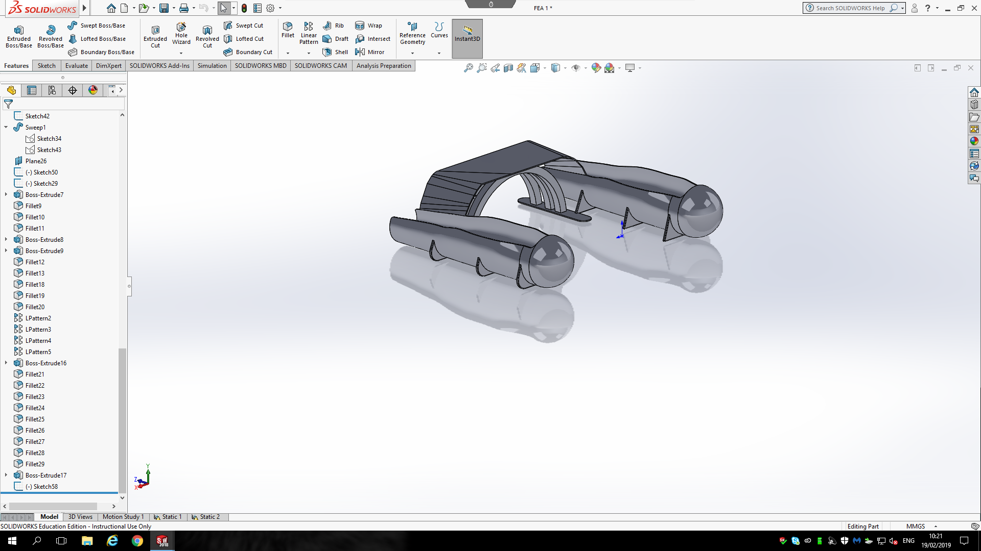
The redesigned part uses support ribs along the lower sections of the part, this give it support against the lateral forces applied through it by increasing the surface area of the base of the part, therefore reducing the stress caused by the same forces exerted by the athlete. It also incorporates a support arch underneath the seat to prevent potential cracking in the seat when in use, it does this by spreading the load both through the dropped edges of the seat that contact the knee cups and through the support arch that transfers the load into the boat. The support ribs and arches also provide better attachment points than those available on the original part
The redesign is not a fixed part as additive manufacturing allows for adaptability between each athlete, the process of creating a separate CAD file for each athlete is very time consuming. 3d scanning equipment is a rapidly developing sector, scanning time could potentially be decreased greatly. This technology is already being implemented by orthopaedic doctors in America in the design and construction of prosthetic limbs for amputees, a product which used to be/is produced in a similar method to the knee cups. 3D scanning also eliminates the possibility for human error in measuring the leg to produce the model from. (Vakulenko, 2014) (Dickinson, 2016)

Conclusions
In conclusion additive manufacturing has the potential to revolutionise industries with highly specific one-off parts, for example in the medical prosthetics industry, however, in the extreme sports industry, even though the part could be produced more cheaply (discounting capital cost) the end part would be too heavy and therefore not applicable to the situation. For that reason this report has shown that additive manufacturing is not necessarily the best way of producing low number production runs of intricate parts. However, this is a rapidly expanding area as new technology becomes available it has the potential to become a viable alternative.

Appendices

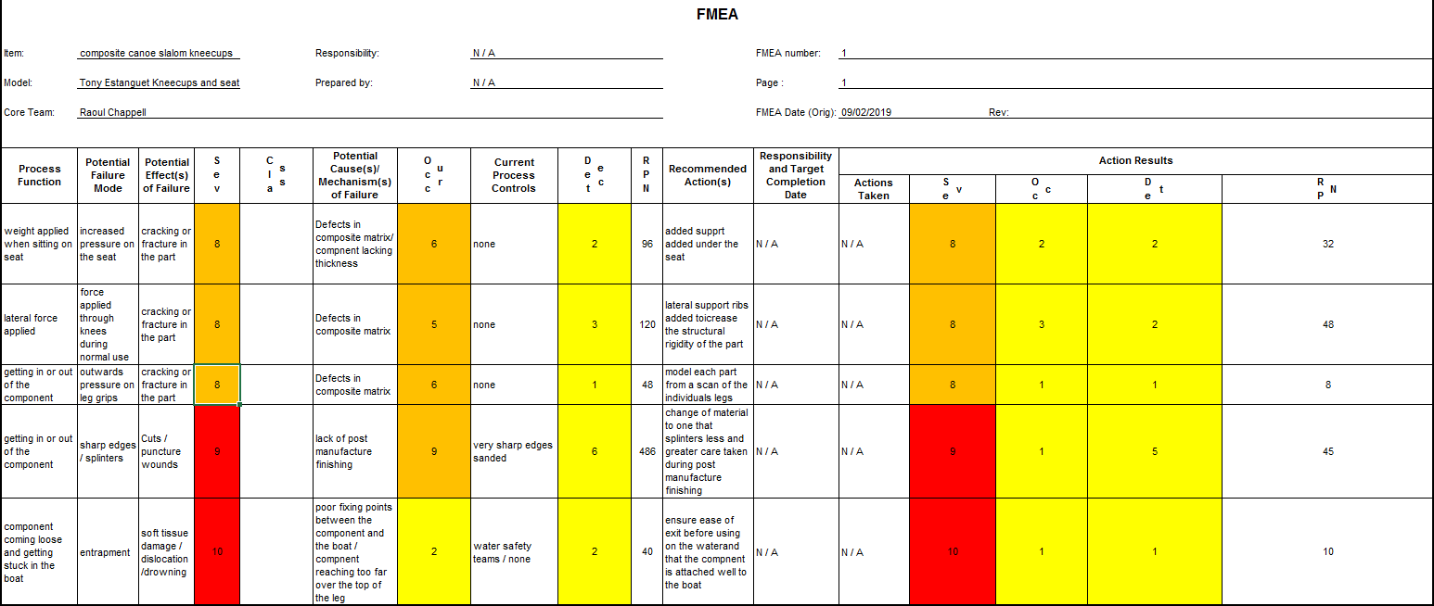
4.1.1 FMEA
Figure 3 FMEA (Morgan, 2018-19)

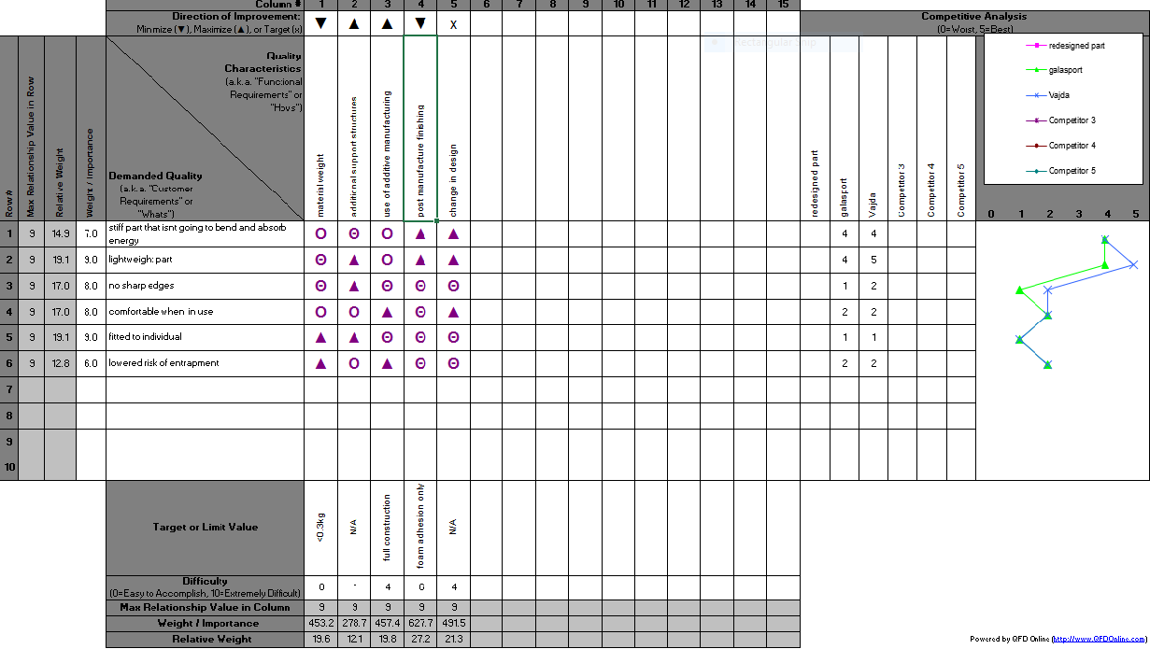
3.1.2 QFD
Figure 4 QFD (Morgan, 2018-19)

References
Achillas, C., 2016. Alternative production strategies based on the comparison of additive and traditional, Volos, Greece: International Journal of Production Research.
CES Edupack, 2018. ANMA (extrusion), s.l.: GRANTA design.
CES Edupack, 2018. Fused deposition modelling, s.l.: Granta Design.
CES Edupack, 2018. PARA (unfilled), s.l.: GRANTA design.
CES Edupack, 2018. PEKK (unfilled, amorphous), s.l.: Granta design.
CES Edupack, 2018. Selective Laser Sintering, s.l.: Granta design.
CES Edupack, 2018. Stereolithography, s.l.: Granta design.
Chappell, R., 2019. Prior expierience of fourteen years in canoe slalom [Interview] (21 February 2019).
Dickinson, A. S., 2016. Registering a methodology for imaging and analysis of residual-limb, Southhampton: Universituy of Southhampton.
Gardan, J., 2015. Additive manufacturing technologies: state of the art and trends, Troyes, France: International Journal of Production Research.
Morgan, R., 2018-19. Design for manufacture lectures. Swansea: UWTSD.
Owen, G., 2017-18. Materials and manufacturing lectures. Swansea: UWTSD.
Penfold, N., 2019. Canoe Slalom UK. [Online]
Available at: http://www.canoeslalom.co.uk/info/FAQs.htm#what_is_it
[Accessed 21 February 2019].
VAJDA group, 2018. Instagram story, Bratislava: VAJDA group.
Vakulenko, A., 2014. 3D Scanning Improves Prosthetic Design, Rockaway: Advantage Business Media.
Varholak, L., 2017. Boeing's space taxis to use more than 600 3D-printed parts [Interview] (3 February 2017).

