

Student Name: Naima Nadimahmed Arab

Student ID:2503320

Module Name: HUMAN CAPITAL MANAGEMENT

Module Code: LCMB7023

Lecturer’s Name: DR. GLADIUS KULOTHUNGAN

Work Count:2619

Term 1

Executive summary
This study critically investigates how global and technical factors are influencing national and international labour markets and HRM and IHRM strategies. Automation, AI, and digital platforms are displacing and creating employment, forcing HR to prioritise up-skilling, talent forecasting, and flexible workforce planning. HR professionals struggle with compliance, mobility, and cultural integration due to ageing populations, migration trends, workforce diversity, geopolitical instability, and pandemics. Strategic HRM strategies like “build,” “buy,” “borrow,” and “bind” are being used to create, attract, and retain talent in global sectors including technology, healthcare, and hospitality to fill skills gaps. The reflective part states that MBA graduates require global and adaptive skills—digital proficiency, communication, leadership, and self-directed learning—to succeed in technology-driven environments. The paper stresses the importance of future-ready HR policies and human agility in the shifting global labour market.

Table of Contents
_Toc213580191Introduction 4
Question 1: Technology & Labour Markets 5
The Reshaping of Labour Markets 5
Implications for HRM/IHRM Strategies 6
Question 2: Demographic & Geopolitical Factors 9
Key Demographic Factors 9
Key Geopolitical Factors 9
Challenges for HR Professionals 11
Question 3: Skills Gaps & Strategic HRM 12
Understanding the Causes 12
Strategic HRM Approaches 12
Sector-Specific Examples 13
Question 4: Reflective Report on Capabilities 15
Introduction 15
Self-Assessment 15
SWOT Analysis 16
Development Plan 17
Conclusion 18
References 19

Introduction
Context of the report: The assessment examines how global and technical influences are changing labour markets and HRM and IHRM practices.
Impact of Global Forces on Labour Markets and HRM: Globalisation has increased skilled worker mobility and competition. Geopolitics, demographics, and international migration affect where and how organisations hire and manage workers. HRM must incorporate global but local cultural diversity, distant work management, and international labour laws. Rethinking IHRM for equitable employment, global workforce integration, and cross-border disruption resilience.
Impact of Technological Forces on Labour Markets and HRM: AI, automation, and digital platforms are rapidly changing jobs and skills. Automation replaces monotonous jobs, requiring digital and analytical abilities. Data-driven decision-making and AI have changed HRM recruitment, learning, and performance management. Technology helps IHRM manage remote teams, but data privacy, cybersecurity, and digital resource access are issues.

Question 1: Technology & Labour Markets

The Reshaping of Labour Markets
Automation & AI: HRM must proactively address robotics and AI job loss and creation. AI ethicists, data analysts, and automation experts must be tech-savvy and reduce monotonous chores. HR strategies must shift from workforce planning to continual reskilling and upskilling to prepare employees for changing job profiles. To maximise labour potential through automation, HR must combine technical efficiency and human flexibility.
The Gig Economy & Digital Platforms: The gig economy and online platforms have changed HR procedures by replacing long-term employment with contract work. Uber, Fiverr, and Upwork boost global talent and scale. Job stability, classification, and benefits are complicated by gig workers' lack of labour protections (Brynjolfsson and McAfee, 2014). HRM and IHRM must rethink workforce strategies to manage permanent, freelance, and remote workers while complying with legal frameworks and retaining engagement and performance in a digital, distributed workforce.
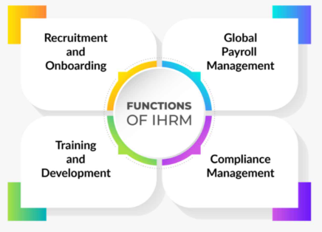
Fig 1: IHRM Functions
Source: (ALP Consulting, 2024)
Skills Churn: Skills churn has lowered the half-life of skills, rendering competencies useful for a decade obsolete in a few years due to rapid technological innovation. This has increased STEM and advanced digital literacy demand in most businesses. For lifelong learning and flexibility, HR must anticipate skill needs and provide agile learning frameworks.

Implications for HRM/IHRM Strategies
Talent Acquisition
AI-automated applicant sourcing, screening, and matching has improved talent acquisition efficiency and reduced bias. 67% of enterprises recruit with AI, up 189% from 2022. In these companies, 36% claim AI decreases recruitment expenses or interview load and 89% say it speeds sourcing (CIPD, 2025). HRM and IHRM must value adaptability and learning agility over qualifications in dynamic, tech-driven contexts. AI-based recruitment systems must respect cultural variances and foreign data-privacy laws.
Learning & Development (L&D)
L&D is crucial in 2025 due to rapid technology change and a short skill half-life. Upskilling and reskilling are essential to keep workers competitive as digital skill shortages affect productivity for 76% of worldwide organisations. Micro-learning modules and digital badges provide career-aligned education on demand in modern HR. Performance data and bespoke courses from AI-driven platforms increase engagement by 45% above traditional training.
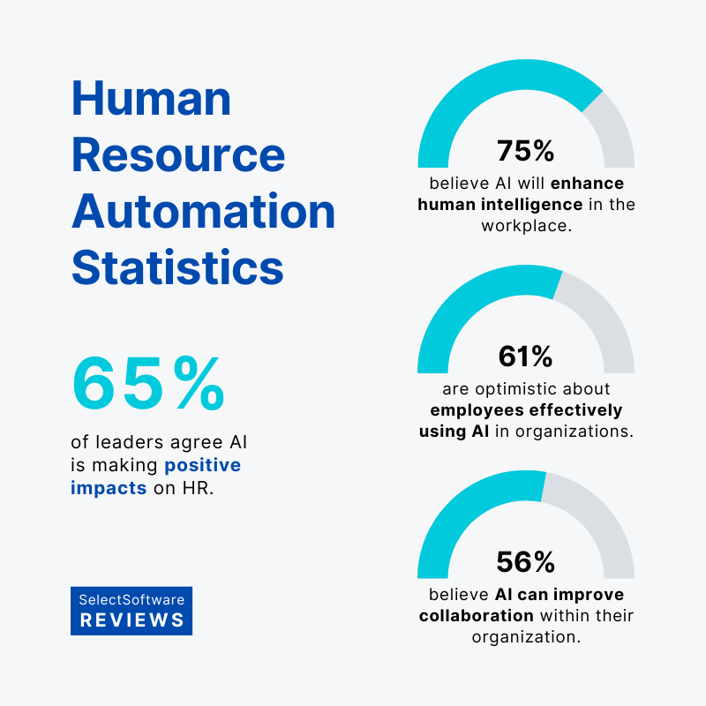
Fig 2: AI Automation
Source: (Nguyen, 2025)
Strategic HR Planning
In 2025, strategic HR planning identifies skill gaps and manages full-time, part-time, and gig workers with data and technology. 58% of worldwide organisations use gig and freelance labour, indicating flexibility and scalability. HR departments use predictive analytics and AI-based workforce modelling to detect skill gaps and align people with business goals. Companies may avoid workforce shortages and enhance productivity across all job types with this proactive approach. Strategic IHRM workforce planning must include regional labour laws, cross-border compliance, and cultural integration for consistency and inclusivity. Company growth in volatile global labour markets depends on strategy and staff flexibility.
IHRM Specifics
Digital platforms provide a worldwide, remote workforce, making IHRM difficult in 2025. Digital cooperation has changed global job patterns, with 41% of workers working remotely. Global digitisation improves governance and compliance. HR directors must oversee GDPR, India's Digital Personal Data Protection Act (2023), and changing U.S. and Singapore gig economy laws. Differences effect data security, workforce categorisation, and monitoring (World Economic Forum, 2025). To achieve regulatory compliance and employee confidence, IHRM initiatives must safeguard cross-border data, use ethical AI, and have equitable digital standards. By combining global homogeneity and local flexibility, successful organisations create globally suitable HR frameworks.

Question 2: Demographic & Geopolitical Factors (500 words)

Key Demographic Factors
Ageing Populations
Ageing populations in Europe and Japan are straining labour markets, lowering workforces and increasing dependency. Japan's working-age population has dropped 1.5 million in five years, whereas 22% of the EU is 65+ (Deloitte, 2025). HR must convey knowledge from experienced workers to younger generations and maintain productivity with less staff due to this generational transition. In a rapidly ageing global workforce, HR strategies must focus on multi-generational workforce planning, flexible retirement options, and lifetime learning to retain knowledge and maintain organisational success.
Changing Migration Patterns
Migration is transforming global labour markets, offering HR possibilities and problems. A “brain drain” is causing many developing nations to lose qualified workers to industrialised economies while host countries fill talent shortfalls. In 2020–2024, healthcare, technology, and engineering increased OECD skilled migration demand by 18%. Visa and immigration restrictions hamper international talent mobility. HR and IHRM must follow immigration regulations, recruit internationally and locally, and promote inclusive migrant worker onboarding.
Increasing Workforce Diversity
International diversity is changing company culture and necessitating inclusive HR. Companies with varied workforces value social responsibility and innovation. Elite ethnic and gender diverse companies gain 39% from inclusiveness (Dowling et al., 2017). HR must improve DEI policies, cross-cultural communication training, and inclusive leadership to manage team values and expectations.

Key Geopolitical Factors
Trade Wars & Protectionism
Trade wars and protectionism affecting global supply chains need companies to reconsider HR and employment strategy. Since 2023, trade barriers between large economies including the U.S., China, and the EU have climbed 12%. Companies have opted to “nearshoring” and “friendshoring” to politically stable or allied nations because to these concerns. China shipped 27% less to the US in September 2025 than to the EU and ASEAN, which rose 14.2% and 15.6%.
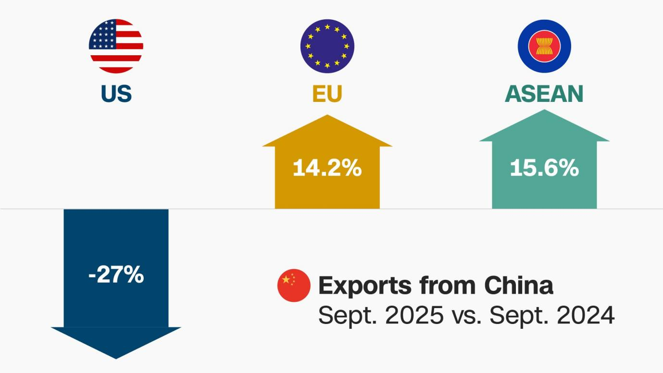
Fig 3: Trade War Relations
Source: (BBC News, 2025)
Political Instability & Sanctions
Political instability and international sanctions threaten multinationals' operations and human capital. Over 40% of offshore companies experienced geopolitical tensions or sanctions last year. Unstable conditions threaten expatriate safety, payroll, and cross-border financial compliance. HR and IHRM need crisis response plans, flexible relocation policies, and secure digital payroll systems to maintain business continuity.
Pandemics & Global Health Crises
Pandemics and global health crises have propelled remote and hybrid work models, transforming workplace relations forever. A long-term structural shift is evident in 38% of global workers working remotely at least part-time (PwC, 2025). These calamities have also led firms to tighten OHS rules, invest in mental health, and improve remote team digital infrastructure.

Challenges for HR Professionals
Talent Mobility: Frequent visa and work permit modifications limit global employee mobility. HR needs digital tracking and flexible mobility to comply and reduce relocation delays.
Risk Management: Emerging geopolitical and health dangers require reliable crisis strategies. HR provides duty-of-care and rapid replies to overseas staff.
Compliance: Country-specific labour and data regulations cause problems. By monitoring rules, HR must assure global compliance and avoid costly penalties.
Cultural Integration: Distributed team management requires inclusion. Communication and cultural awareness training in HR foster teamwork.

Question 3: Skills Gaps & Strategic HRM

Understanding the Causes
Rapid technology change outpaces human capacity, causing industrial skills gaps. Even though 44% of workers' essential skills will change by 2030, many school and corporate training programs are obsolete and unresponsive to business needs. Global L&D spending averages 2.6% of payroll, restricting upskilling (Jooss et al., 2024). This gap between education, technology, and workplace needs requires HRM to innovate and prepare to fill talent shortages.

Strategic HRM Approaches
"Build" Strategies: The “build” technique builds internal talent through systematic learning and skill upgrading. Corporations teach future workers through apprenticeships, business academies, and university-ed-tech alliances. Internal upskilling boosted retention and productivity in 72% of companies. These strategies restrict external hiring and align employee performance with company goals. This approach improves HRM learning and adapts core competencies to market and technology developments.
"Buy" Strategies: In “buy” tactics, targeted recruitment and employer branding attract outside talent. Companies can identify untapped talent and predict key skills with talent analytics. With predictive analytics, 59% of companies hire more accurately and 30% faster. Competitive pay, hybrid work options, and employer branding help firms stand out in talent-scarce situations (Marques and Oliveira, 2024). HRM can connect recruitment with strategic company goals and respond to quickly changing labour realities using this method.
"Borrow" Strategies: Businesses can “borrow” expertise from consultants, freelancers, and outsourcing for short-term skills. Most organisations use contingent or gig labour to fill capacity gaps without long-term financial obligations (ManpowerGroup, 2025). HR can quickly respond to project needs, reduce costs, and maintain operational agility with this adaptive model. Contracts, data security, and integration must be addressed to guarantee external contributors meet business culture and performance.
"Bind" Strategies: “Bind” strategies retain skilled personnel by encouraging engagement, progress, and loyalty. The Gallup State of the Global Workplace Report 2025 found that companies with effective retention and development programs earn 21% more and cut turnover by 59%. Work rotation, mentoring, and professional development boost employee happiness in HRM (Ndraha, 2024). Continuous learning and appreciation make employees feel valued and perceive long-term potential, reducing turnover and improving organisational stability in competitive labour markets.
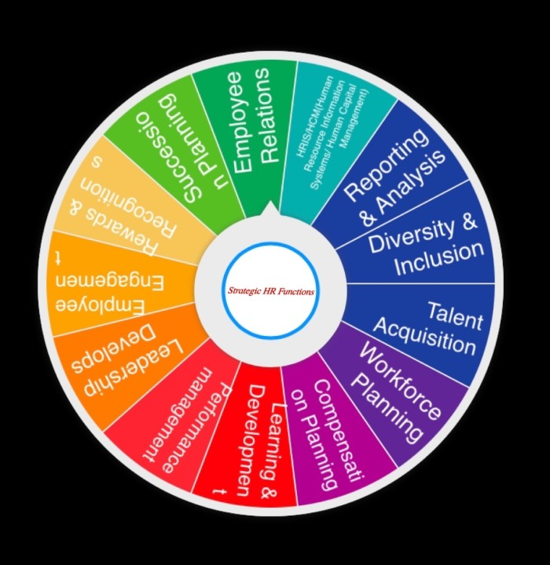
Fig 4: Binding Factors for HRM
Source: (Mehrotra, 2025)

Sector-Specific Examples
Tech: Tech companies are utilising “build” and “borrow” to fill skills gaps. Companies are creating internal coding bootcamps and learning routes to upskill personnel in high-demand fields like AI, machine learning, and cloud architecture to meet a benchmark finding that 44% of IT directors predict AI/ML/data science capabilities are toughest to obtain in 2025 Companies are recruiting freelancing AI consultants to fill gaps (Cappelli, 2008). The global supply-demand ratio for AI talent is 1:3.2, meaning more than three roles per skilled individual. This dual model lets HR invest in long-term personnel pipelines and respond to rapid technology change.
Healthcare: International recruitment is being used to "buy" nursing staff. Over 7 million nurses are needed worldwide, encouraging UK, Canada, and Australia recruitment (Zhang and Wang, 2025). To reduce burnout, a major cause of sector exit, “bind” methods including better working conditions, mental health support, and planned career ladders are being implemented.
Hospitality: Internal management training 'builds' hospitality executives and improves service. Employer branding helps companies "buy" talent in a competitive labour market. 68% of hospitality organisations recruit talent with brand awareness and flexible, career-advancing employee value packages.

Question 4: Reflective Report on Capabilities

Introduction
MBA graduates need global and flexible skills to flourish in today's tech-driven business world. Intercultural, adaptable, and technology-driven decision-makers are valued. 78 percent of MBA recruiters stress cross-cultural collaboration and adaptation. Graduates can lead diverse teams, traverse complex international markets, and innovate in an unpredictable global economy with these skills.

Self-Assessment
Description
My MBA taught me technology, communication, teamwork, leadership, and self-directed learning, which boosted my career. After studying MS Teams, Excel analytics, and LMS, I examined data with ChatGPT. Writing and group presentations helped me reach ethnic peers. I assigned work and included many perspectives in collaborative initiatives. As informal leadership, I helped peers with sophisticated analysis, digital tasks, and morale (Gibbs, 1988). Finally, I self-directed learning by completing deadlines, researching outside the course, and learning Python for analysis.
Feelings
AI-driven research and cross-cultural collaboration originally frightened me. These trials helped me grow as I gathered experience. Leading peers, managing group dynamics, and working independently increased my confidence and global career.
Evaluation
These experiences improved both my technical and interpersonal capabilities. Proficiency in digital tools enhanced my productivity, while strong communication and teamwork contributed to successful group outcomes. Leadership experiences revealed my potential to motivate others, and self-directed learning instilled resilience and adaptability (OECD, 2019). Nevertheless, I recognised areas for development, particularly in advanced data analytics and cross-cultural leadership.
Analysis
Gibbs says reflective practice links skills. Technology skills improve digital collaboration. Leadership and teamwork in global HR demand emotional intelligence and adaptation. Self-directed learning helps MBA grads study for life and support all capacities. Global organisations require multiculturalism, digital skills, and strategy.
Conclusion
Though leadership and analytics are still developing, my reflective process displays strong technical and communication skills. Experiences have strengthened my employability and ability to work in dynamic, multinational contexts.
Action Plan
Through CIPD cross-cultural leadership seminars and Power BI and Tableau HR Analytics certifications, I hope to build these skills by mid-2025. I will document my lessons and seek international HRM advice. These efforts aim to make me a more adaptable, data-driven, and culturally sensitive global company executive.

SWOT Analysis
Strengths | Weaknesses
• Strong proficiency in digital tools (MS Teams, Excel, LMS, AI-assisted research). | • Limited experience with advanced HR analytics and data visualisation tools.
• Effective communicator and collaborator in multicultural teams. | • Moderate confidence in leading large, cross-cultural virtual teams.
Opportunities | Threats
• Growing global demand for digitally skilled and adaptive MBA graduates. | • Rapid technological changes could outpace current skills.
• Access to online certifications and leadership workshops for continuous up-skilling. | • Increasing competition for international HR roles requiring global mobility.

Development Plan
Leveraging Strengths: Digital skills and intercultural team communication provide me an edge in the global employment market. MS Teams, Excel, and AI-assisted research tools help me adapt to digital transformation. Communication across cultures improves my collaboration in many circumstances. These skills make me a versatile, future-ready MBA worker who can confidently operate in data-driven, global firms.
Addressing Weaknesses Insufficient cross-cultural team leadership experience is a weakness. To rehearse managing multiple perspectives and communication approaches, I will supervise my MBA program's next multicultural group project. I will also take Coursera's “Leading Global Teams” online course by March 2026 to learn about global leadership and virtual cooperation. After the project, I'll ask team members and mentors for leadership and international team management input.

Conclusion
Finally, this research shows how global and technical factors affect HRM and IHRM strategies and labour markets. HR must prioritise upskilling and workforce planning as automation, AI, and digital platforms change employment structures and increase skill obsolescence. Geopolitical instability, demographic changes, and global health challenges necessitate flexible, inclusive, and compliant HR. Strategic HRM strategies like build-buy-borrow-bind can address talent shortages. This suggests that HR professionals and MBA graduates must obtain global awareness, technical fluency, and continual learning to succeed in a complex global labour market.

References
Brynjolfsson, E. and McAfee, A. (2014). The Second Machine Age: Work, Progress, and Prosperity in a Time of Brilliant Technologies. New York: W. W. Norton & Company.
Cappelli, P. H. (2008). Talent on Demand: Managing Talent in an Age of Uncertainty. Harvard Business Press. (The classic “Make vs. Buy” framework for talent management).
Chartered Institute of Personnel and Development (CIPD). (2025). ‘AI use in the workplace: Practical advice for HR professionals’, CIPD Knowledge Guide, 23 January. Available at: https://www.cipd.org/en/knowledge/guides/preparing-organisation-ai-use/
Deloitte (2025). 2025 Global Human Capital Trends. USA: Deloitte. Available at: https://www.deloitte.com/us/en/insights/topics/talent/human-capital-trends.html
Dowling, P. J., Festing, M. and Engle, A. D. (2017). International Human Resource Management. 7th edn. Andover: Cengage Learning. Available at: https://books.google.com/books/about/International_Human_Resource_Management.html?id=OyPRzwEACAAJ
Gibbs, G. (1988) Learning by doing: A guide to teaching and learning methods. Oxford: Oxford Further Education Unit. Available at: https://reflection.ed.ac.uk/reflectors-toolkit/reflecting-on-experience/gibbs-reflective-cycle
Jooss, S., Collings, D.G., McMackin, J. and Dickmann, M., 2024. A skills‐matching perspective on talent management: Developing strategic agility. Human Resource Management, 63(1), pp.141-157.
ManpowerGroup. (2025) 2025 Talent Shortage Survey. Milwaukee: ManpowerGroup. Available at: https://go.manpowergroup.com/talent-shortage
Marques, P. and Oliveira, P., 2024. Charting Excellence in Healthcare: An In-Depth Exploration of Strategic Performance Metrics via Balanced Scorecard Implementation.
Ndraha, A.B., 2024. Digital Workforce Planning and Management in the Public Sector. In Digital Transformation in Public Sector Human Resource Management (pp. 21-38). IGI Global.
Organisation for Economic Co-operation and Development (OECD) (2019) Future of Education and Skills 2030/2040: OECD Learning Compass 2030. Paris: OECD. Available at: https://www.oecd.org/en/about/projects/future-of-education-and-skills-2030.html
PwC (2025). 28th Annual Global CEO Survey: India Perspective. India: PwC. Available at: https://www.pwc.in/assets/pdfs/publications/ceo-survey/2025/28th-annual-global-ceo-survey-india-perspective.pdf
World Economic Forum. (2025). The Future of Jobs Report 2025: Insight Report. Geneva: World Economic Forum. Available at: https://reports.weforum.org/docs/WEF_Future_of_Jobs_Report_2025.pdf
Zhang, Y. and Wang, J., 2025. Current Status, Challenges, and Breakthrough Paths in the Construction of Dual-Qualified Teacher Teams in Guang dong Private Higher Vocational Colleges Driven by the Digital Economy. Nexus Series of Social Sciences, Humanities and Education, 1, pp.29-36.
Image References
Mehrotra, S. S. (2025) ‘Strategic HR – a binding factor for any organisation’, LinkedIn Pulse. Available at: https://www.linkedin.com/pulse/strategic-hr-binding-factor-any-organization-silky-s-mehrotra
BBC News (2025) ‘US–China trade war impact: [News article]’, CNN Business, 1 November. Available at: https://www.cnn.com/2025/11/01/business/us-china-trade-war-impact-intl-hnk-vis
Nguyen, A. (2025) ‘100+ Critical HR Statistics and Trends for 2025’, SelectSoftware Reviews Blog, 2 July. Available at: https://www.selectsoftwarereviews.com/blog/hr-statistics
ALP Consulting (2024) What is International Human Resource Management? Available at: https://alp.consulting/what-is-international-human-resource-management/

