A Critical Analysis of the Relationship Between Teacher Subject Knowledge and Effective Learning and Teaching in the Primary School
In this essay, I will firstly be discussing, analysing and evaluating the literature related to the topic of teacher subject knowledge for primary teaching. Following on from this, I will be evaluating my own knowledge base for teaching at primary school level. The evaluation will take place based on my own experience throughout Professional Teaching Experience (PTE) at a placement school. In order to comply with BERA guidelines, I will be keeping the school, along with its staff and students, anonymous. Therefore, the primary school in question will be referred to as School X throughout the essay, and any teachers or students discussed will be referred to as Teacher A, Pupil A, Pupil B and so on.
School X is a community primary school situated within the county of Rhondda Cynon Taf. At the time of inspection, around 10% of pupils were eligible for free school meals and 11% of pupils had additional learning needs. Both of these statistics were much lower than that of the all-Wales averages, these being 19% and 21% respectively (information taken from Estyn report, Appendix 1). The classroom that I was placed in was a Year 3 class with twenty-seven pupils, made up of thirteen boys and fourteen girls. Two pupils were placed on School Action plans, and six pupils received interventions for maths and literacy. All pupils spoke English as a first language, and apart from the children receiving intervention, the class received no additional support in the form of staffing (e.g. volunteers, teaching assistants).

In 2009, The Cambridge Primary Review, an independent enquiry into the conditions and future of primary education was published. The objective of the enquiry was to
“identify the purposes which the primary phase of education should serve, the values which it should espouse, the curriculum and learning environment which it should provide, and the conditions which are necessary in order to ensure both that these are of the highest and most consistent quality possible, and that they address the needs of children and society over the coming decades”
(Hofkins and Northen, 2009, p4)
As part of the review, children were asked what they thought constituted a good teacher, with responses including “really know their stuff” (Hofkins and Northen, 2009, p29) and “be able to explain things clearly so that you understand” (Alexander, cited by Richards, 2014). This leads us to question what it is exactly a teacher needs to know in order to be a good teacher that can explain things clearly for pupils to be able to understand what they’re learning.
Lee S. Shulman, a former Professor at Stanford University’s School of Education, carried out research on teaching and teaching education during his tenure, which included the notion that teachers needed “not only know how to teach, but also what to teach and why” (Shulman, 1994, p84). In his 1987 article Knowledge and Teaching: Foundations of the New Reform, he argues that teacher knowledge can be classified into seven different categories; content knowledge; general pedagogical knowledge, covering the knowledge classroom management and organisation strategies that appear to rise above subject knowledge; curriculum knowledge, relating to the “tools of the trade” for teachers; pedagogical content knowledge, “the special amalgam of content and pedagogy” (Shulman, 1987, p8) that forms a teacher’s professional understanding; knowledge of learners and their characteristics; knowledge of learners and their characteristics; knowledge of educational contexts, referring to a range of topics including groupings within the classroom to communities and cultures linked to the school; and knowledge of educational purposes, ends and values. Following on from that, Shulman explains that pedagogical content knowledge (PCK) stands out amongst the other types of knowledge as it “identifies the distinctive bodies of knowledge for teaching” (Shulman, 1987, p8). He argues that the possession of PCK enables teachers to understand how to organise, represent and adapt topics or problems to present them for instruction for all learners.
In his chapter in Teaching and Learning in the Primary School (1994), Shulman condenses the seven categories of knowledge into three new categories; the aforementioned pedagogical content knowledge; subject matter content knowledge; and curricular knowledge. Content knowledge refers to the amount teachers know and how they organise it in their minds. According to Shulman, a teacher’s knowledge must be structured in a way to enable them to explain why something is necessary and worth knowing, as well as how it relates to other things that they learn. PCK “goes beyond knowledge of subject matter… to the dimension of subject knowledge for teaching” (Shulman, 1994, p85). He states that teachers must be able to represent the topics that they are teaching in a variety of ways that ensures that learners of different abilities, backgrounds and cultures can access what is being taught. Curricular knowledge is the amount of knowledge a teacher has to a curriculum and the tools it can provide, such as how to make the learning of a particular subject better, and rearrange a curriculum so that it can be taught and accessed in a more efficient way. In addition to this, under the umbrella of curricular knowledge, Shulman states in his 1986 article Those Who Understand: Knowledge Growth in Teaching that he would expect teachers “to be familiar with the curriculum materials under study by his or her students in other subjects they are studying at the same time”. This requirement of knowledge is particularly relevant to teachers in the Welsh education system at the moment, with the curriculum changing under the instruction of Successful Futures, an independent review carried out by Professor Graham Donaldson in 2015. As part of the review, Donaldson states that the new curriculum for Wales should “encourage depth of learning and provide appropriate challenge in ways that will raise overall standards of achievement” (Donaldson, 2015, p37) and in order for this to happen, he “recommends that literacy, numeracy and digital competence should be cross-curriculum responsibilities” (p42). By incorporating these three cross-curricular responsibilities, Welsh children should “develop high levels of competence in these aspects and have frequent opportunities to develop, extend and apply them across the curriculum” (Donaldson, 2015, p42).
Judging it on date alone, Shulman’s work could be considered out of date. However, the references to Donaldson’s curriculum overhaul in Wales and the Cambridge Primary Review show that it still has relevance to twenty-first century education. His work also went on to inspire further research into the relationship between teacher subject knowledge and effective learning and teaching in schools. Rowland, Huckstep and Thwaites used Shulman’s PCK and subject matter knowledge (SMK) to research how trainee primary school teachers content knowledge of mathematics came across in their teaching, as written in their 2003 article for Proceedings of the British Society of Research into Learning Mathematics. As a result, they coined the phrase ‘the Knowledge Quartet’ to describe “four broad superordinate ‘units’” (Rowland, Huckstep and Thwaites, p97) that teachers use to think about how subject knowledge can come across in the classroom. The units that make up the quarter are foundation, transformation, connection, and energy. The foundation unit focuses on the knowledge, beliefs and understanding a trainee teacher acquires whilst they’re actually at university, before they even step foot in the classroom. It involves understanding how children learn and how they can be taught, as well as using correct terminology and identifying pupil errors. The second unit, transformation, has Shulman’s (1987) idea that “the capacity of a teacher to transform the content knowledge he or she possesses into forms that are pedagogically powerful” as its main focus. Transformation involves teachers being able to use their knowledge to create examples, demonstrations and explanations that not only highlight their knowledge but make it accessible to their learners. Following on from this is the connection unit of the quartet, which hones in on the coherence of a teacher’s planning or actual teaching displayed, either across a lesson or a series of lessons. This coherence could include “the sequencing of topics of instruction” and “the ordering of tasks and exercises” (both taken from Rowland, Huckstep and Thwaites, 2003, p98) to display a knowledge of structural connections within a subject and an awareness of the demands that come from different topics. The final unit is contingency, and consists of knowing how to manage situations in a classroom that are “almost impossible to plan for” (Rowland, Huckstep and Thwaites, 2003, p98). The example that Rowland, Huckstep and Thwaites give is a teacher’s ability to be able to respond to children’s ideas – and believe that if they were to ignore a child’s contribution to a lesson, it implies that there may be a feeling of anxiety over their lack of SMK. The authors then go on to show how the knowledge quartet is used in the assessment of a student teacher’s SMK in a maths lesson. This piece of writing is extremely useful in explaining how Shulman’s ideas about knowledge can be condensed into a way that can be easily understood, and is an introduction into the relationship between teacher subject knowledge and effective learning in the classroom using the example of a student teacher following a PGCE primary course. Whilst the literature refers to mathematical subject knowledge and uses a maths lesson as an example, the Knowledge Quartet can be applied to any lesson. However, there are further pieces of writing that firmly argue the necessity of subject knowledge to create effective learning and teaching opportunities.
Kleickmann et. al (2013) argue that SMK plays a “crucial role” with regards to student progression, and that a teacher’s subject matter knowledge affects their instructional practice and their students’ achievement gains (rewrite). They relate back to Shulman’s research and use the phrases ‘content knowledge (CK)’ and the previously discussed ‘pedagogical content knowledge’ to discuss the vast amount of research that has been carried out into a teacher’s subject knowledge, including their own research on teachers’ knowledge of subject matter and its importance for the quality in schools for student progress. Quoting Shulman, Kleickmann et al. state that content knowledge is a teacher’s understanding of subject matter, and they refer to the fact that “teachers not only need not only understand that something is so, the teacher must understand why it is so” (2013, p91). They go on to talk about how SMK can be derived from three sources; teachers’ own K-12 learning experiences (K-12 refers to kindergarten to twelfth grade in America, its British equivalent would be nursery to sixth form); teacher education and professional development programs; and teaching experiences – all of which provide opportunities to develop both CK and PCK skills. However, Kleickmann et al. also argue that as well as the sources of knowledge, teachers need to carry out “thoughtful reflection” on their educational practice in order to ensure that effective learning and teaching is happening in their classrooms.
Whilst Kleickmann et al.’s theory agrees with the point that’s trying to be made, their investigation used American terminology and focused on the German education system where children are split into different schools based on ability – a system not too dissimilar to the tripartite education system used across England, Wales and Northern Ireland until the 1970s. Their study found that pupils taught by teachers in non-academic schools suffered as a result of teachers not requiring such an in-depth subject knowledge. As this essay is focusing on the Welsh primary education system, you have to consider the audience to which Kleickmann et al.’s article is aimed at.
However, not everybody holds subject knowledge in the same regard as the authors above. John Hattie, in his book Visible Learning for Teachers, firmly believed that teachers’ subject matter knowledge didn’t have a great effect on students’ academic outcomes. Instead, he believed that “teachers’ beliefs and commitments are the greatest influence on student achievement over which we have some control” (Hattie, 2012, p25). Hattie highlighted that teachers who are “doing some things with a certain belief system that truly makes the difference” (2012, p26), and that students taught by a high-impact teacher had “almost a year’s advantage over his or her peers in a lower-effect teacher’s classroom” (2012, p26). Hattie then turned his attention to focus on two types of teacher - the experienced teacher and the expert teacher - and found that whilst there was no difference between the two in terms of the amount of knowledge that they had, it was how they used and organised their content knowledge that made a difference between them. An expert teacher was deemed more able to provide more challenge for their students and provide instruction that Is “more integrated, more coherent, and at a higher level of abstraction” (Hattie, 2012, p34).
Whilst Hattie believes subject matter knowledge isn’t the all-important element of effective learning and teaching, it could be argued that he shares the same view as Shulman in terms of a teacher knowing how to use and organise their knowledge is a vital component of effective teaching. From the review of this literature, it could be claimed that knowledge in its various forms is essential for effective teaching and learning, alongside teacher attitudes, efforts and beliefs.

In this next part of the essay I will be analysing my own subject knowledge in relation to effective learning and teaching in the classroom during my Professional Teaching Experience (PTE), using the knowledge quartet designed by Rowland, Huckstep and Thwaites.
Foundation
Mathematics is a subject that I have struggled with all of my life, and it wasn’t until I started to work as a learning support assistant in primary and secondary schools that I began to feel confident in my own ability. At School X, one maths lesson per week is dedicated to ‘problem-solving’, with the aim to equip pupils ready for their national tests towards the end of the academic year. During these lessons, pupils work in Kagan groups – a mixed ability grouping that encourages “engagement and, on the tail of that, achievement” (Wright, 2016). Observing these lessons and the Kagan groups at work began to make me lose confidence as I would struggle to reach the answer alongside the pupils, and thought how would I ever be able to teach them as a mixed ability group to find the answer. However, I didn’t want to let my own anxiety get the better of me and I would throw myself in at the deep end and have a go at teaching problem solving (rewrite this).
For this lesson (Appendix 2), I decided to use a context – going to the ice cream shop - to keep children engaged. Griffin (2015) states that the first step to helping students move from surface learning to deep learning is to create a willingness and excitement to learn by front-loading context, and as part of the new curriculum, Donaldson (2015) says that “Children and young people need regular opportunities to deepen their understanding of number… to reinforce and use their numeracy skills in different contexts” (p40). The aim of the lesson was for pupils to find out how many different combinations of three ice cream flavours – chocolate (C), mint (M) and vanilla (V) could be made. However, after setting the pupils off to do their tasks I was made aware of my own downfalls of foundation content knowledge – I knew how I wanted the children to complete the task, but had not shown them a method for them to do this. By not giving them the foundation knowledge and showing them how to complete the task in a systematic way e.g. CCC, CCM, CCV, and assuming that they would know to do this after seeing them complete a task systematically the week before, the pupils struggled to complete the task effectively.
After receiving feedback on how I could have improved that lesson, I was determined to give systematic approaches another go so that I could improve both my own subject knowledge and that of the pupils. For this lesson (Appendix 3), I asked pupils to work in partners on the carpet using a whiteboard to share out coins between two characters and show me the different ways they could do this in a table. By doing this, I could see which pupils – if any – were taking a systematic approach and use them as an example to show other pupils how to record their answers. The pupils were amazed by this approach and commented on how much it easier was to complete the task now that they knew what to do.
Transformation
As mentioned previously, the transformation unit of the quartet concerns the examples, explanations and demonstrations a teacher uses to “transform the content knowledge he or she possesses” (Shulman, cited by Rowland, Huckstep and Thwaites, 2003).
As mentioned previously, my weaker subject knowledge of maths and lack of confidence towards teaching the subject hindered the way in which I taught the first problem-solving lesson. This resulted in the lesson’s concept, procedures required and success criteria - the basic premise is that the students have the same idea as their teacher what is going on in the classroom, and what they should be learning as a result of doing (Hattie, cited by Stem Learning, 2010) – was missed completely. This caused the pupils’ examples of possible different combinations of ice cream not reflecting how I wanted them to look as a result of systematic processing.
Welsh, on the other hand, I feel a lot more confident to teach. I have a degree in Welsh therefore my subject knowledge is (or would be expected to be) of a considerably high standard, and I feel really passionate about Welsh language acquisition amongst English speaking children. From the previous statement, it could be assumed that I dedicated myself more to making sure I had good explanations, resources and activities for the Welsh lesson in question (Appendix 4).
From my own experience of being in Welsh lessons as a pupil and as a learning support assistant, I’ve found that attitudes towards learning Welsh can be quite poor so keeping children engaged and willing to learn can be a task in itself. My placement class at School X had a really positive attitude towards Welsh but I still wanted to create a really engaging lesson to capitalise on their mindset. This links back to Hattie’s thoughts on being a high-impact teacher and increasing the potential attainment of a class in comparison to a low-impact teacher.
The objective of the lesson was to learn about the rooms in the house, and I decided that the best way to do this was to use visual resources such as word mats and online tours of a house (Appendix 5) so that the pupils could make the connection between the images and the new vocabulary being used. My confidence with regards to speaking Welsh enabled me to confidently model the new vocabulary to the pupils and use techniques such as ‘My Turn Your Turn’ and repeating the vocabulary in various different ways (whispering, shouting, etc.) to assess the pupils’ pronunciation. As a result, the success criteria could be understood and met by the pupils and they built a solid knowledge and understanding of how to talk about their house in Welsh.

Connection
Connection involves knowing how to make a topic flow coherently, including knowing what to teach at each point of a term, and what to actually teach and do during a certain lesson or series of lessons. As this segment of PTE occurred during the Christmas period, a lot of lessons got replaced with Christmas concert practices, the concerts themselves and Christmas visits, which obviously cannot be helped but did have an effect of the flow of lessons. Working in classrooms for a period of time means that I have seen a full sequence of work completed, but in terms of my own teaching Maths, Literacy and Topic – the name School X have given to the part of the timetable dedicated to Humanities Area of Learning and Experience set out in Donaldson’s new curriculum, covering Geography, History and RE – were the main victims of the Christmas timetable overhaul, therefore it became difficult to create a full week’s sequence of work on one topic in particular. As School X dedicate twenty minutes every morning to practicing Welsh, with each week focussing on a new sentence pattern, it was much easier to create a sequential lesson from that. When I was timetabled to teach Welsh, the question of the week was “Ble wyt ti’n byw?” with the children responding with the type of house that they lived. The children already knew how to answer what place they lived in, so with my subject knowledge of Welsh, I was able to create a structural connection to the next appropriate step, which I believed to be to learn about the rooms in the houses they lived in. By recapping the knowledge, the children already had in relation to where they lived, they were able to acknowledge that they were moving onto something new but related to what they already knew about houses. Some pupils I was able to move on further – they were able to tell me orally who they lived with (I was unaware that they knew this) so when it came to writing about it I was able to give them correct sentence structures so that they could write it into their books – something I would have struggled to do if my subject knowledge was poor on this subject.
Contingency
The final category is defined by Rowland, Huckstep and Thwaites (2003) as “the ability to think on one’s feet” and concerns one’s ability to plan for events that are “almost impossible to plan for”. They also state that it’s about having the knowledge to respond to pupils’ ideas and to be able to move away from what you’d originally planned to teach in order to try and accomplish something else. Hattie (2012, p30) wrote that “a typical lesson never goes as planned”, and whilst that appears to be a blasé comment, it can cause stress to the knowledgeable teacher, let alone a student teacher who doesn’t have the complete subject knowledge to prepare for when the lesson deviates from what has been planned. This situation occurred during a Maths lesson (Appendix 6) I taught about temperature. The previous lesson I had taught the pupils about negative numbers in preparation for this lesson about recognising positive and negative numbers in regard to reading temperatures on a thermometer. I had spent time with the children on the carpet recapping positive and negative numbers, watching weather reports that showed positive and negative numbers and how to work out differences between temperatures for the higher ability learners. However, within seconds of handing out the worksheet the middle ability group approached me to all say that they didn’t understand what they had to do – I hadn’t realised that I had given them thermometers with interval scales (a continuous scale where numerical difference between values is meaningful (Six Sigma, n.d). Whereas I had planned to assist my lower ability pupils with their work, I had to deviate from this completely to bring my middle ability groups to the carpet and explain how to work out the value of the unnumbered lines on the scale. As this was unexpected, I didn’t have a prepared explanation for this but attempted to explain how to read the scales, but some of the pupils still didn’t understand what to do and I didn’t have the subject knowledge to explain further, and resorted to giving those pupils work aimed at the lower ability pupils that was far too easy for them. As this was a lesson observed my school mentor, I was made aware that I had pitched the lesson too high – at year 3, pupils are required take temperature readings using thermometers and interpret readings above and below 0°C (Department for Education and Skills, Welsh Assembly Government, 2015, p7). One of the lesson objectives I had created, equivalent to “read and interpret scales or divisions on a range of measuring instruments” (Department for Education and Skills, Welsh Assembly Government, 2015, p6), was a skill expected to be achieved by pupils in Year 6. If I had had appropriate curriculum knowledge, the contingency situation could have been completely avoided, highlighting the importance of knowledge in effective learning and teaching.

In this essay, I have discussed points Shulman has made about the type of knowledge needed by teachers in order for teachers to be successful and effective in their classrooms, citing pedagogical content knowledge as a “special interest because it identifies the distinctive bodies of knowledge and teaching” (p8). Rowland, Huckstep and Thwaites went on to use Shulman’s research to create the Knowledge Quartet to identify how knowledge types play out throughout teaching. Kleickmann et al. used pedagogical content knowledge to conduct studies to prove its importance in student achievement, whereas Hattie argued against this by saying it wasn’t about how good a teacher’s knowledge was but more about how teachers organised that knowledge that had an impact on students.
As a result of analysing my PTE so far, and reading relevant literature to accompany it, I believe there to be a strong relationship between teacher subject knowledge and effective learning and teaching in the primary school. Creating links between the work of both Shulman and the Knowledge Quartet and my experiences of teaching so far has enabled me to see strengths in my ability to plan and teach effective lessons and parts where I need to vastly improve. Going forward, I will be using the Knowledge Quartet as an essential tool for planning lessons and finding and fulfilling gaps in my subject and pedagogical knowledge. After analysing my strongest subject knowledge against my weakest, it has made me realise I need to work harder to create a stronger subject knowledge across the board in preparation for Donaldson’s recommendation that that literacy, numeracy and digital competence should be Cross-curriculum Responsibilities for all teachers (p40) in the new Welsh curriculum. As well as this, I need to take on board the message Hattie portrayed across his work about having a certain attitude or belief system (ref, p26) and have a more positive attitude towards subjects that I am not so confident about to ensure any future pupils have a well-rounded education to lead them towards a bright future.

References
Department for Education and Skills, Welsh Assembly Government (2015). Programme of Study for Mathematics Key Stages 2–4. Cardiff: Welsh Assembly Government, pp.6, 7.
Donaldson, G. (2015). Successful Futures: Independent review of curriculum and assessment arrangements in Wales. Cardiff: Welsh Assembly Government, pp. 37, 42
Estyn.gov.wales. (2019). Estyn. [online] Available at: https://www.estyn.gov.wales/ [Accessed 5 Jan. 2019].
Griffin, T. (2015). Using Context to Deepen and Lengthen Learning. [online] Faculty Focus | Higher Ed Teaching & Learning. Available at: https://www.facultyfocus.com/articles/course-design-ideas/using-context-deepen-lengthen-learning/ [Accessed 3 Jan. 2019].
Hattie, J. (2012). Visible learning for teachers. London: Routledge, pp. 25, 26
Hofkins, D. and Northen, S. (2009). Introducing the Cambridge Primary Review. Cambridge: University of Cambridge, Faculty of Education, pp.4, 29.
Hwb. (2019). Tai - De. [online] Available at: http://resources.hwb.wales.gov.uk/VTC/ngfl/wsl/bdag/tai-de/apps/simple-projector/index.html [Accessed 7 Jan. 2019].
Kleickmann, T., Richter, D., Kunter, M., Elsner, J., Besser, M., Krauss, S. and Baumert, J. (2013). Teachers’ Content Knowledge and Pedagogical Content Knowledge. Journal of Teacher Education, 64(1), pp.90-106.
Richards, C. (2014). Becoming a Teacher. In: T. Cremin and J. Arthur, ed., Learning to Teach in the Primary School, 3rd ed. Oxon: Routledge, p.14.
Rowland, T., Huckstep, P. and Thwaites, A. (2003). The Knowledge Quartet. Proceedings of the British Society for Research into Learning Mathematics, 23(3), pp. 97, 98.
Shulman, L. (1986). Those Who Understand: Knowledge Growth in Teaching. Educational Researcher, 15(2), p.8.
Shulman, L. (1987). Knowledge and Teaching: Foundations of the New Reform. Harvard Educational Review, 57(1), p.8.
Shulman, L. (1994). Knowledge and Teaching: Foundations of the New Reform. In: Pollard, A., Bourne, J., NetLibrary, Inc, & Open University. (1994). Teaching and learning in the primary school (Open University. Postgraduate Certificate of Education). London ; New York: Routledge in association with the Open University, pp. 84, 85.
Six Sigma (n.d.). Purpose and Nature of Scales. [image] Available at: https://www.whatissixsigma.net/types-of-scales/ [Accessed 5 Jan. 2019].
Stem Learning. (2010). John Hattie: Learning intentions and success criteria | STEM. [online] Available at: https://www.stem.org.uk/resources/elibrary/resource/273227/john-hattie-learning-intentions-and-success-criteria [Accessed 3 Jan. 2019].
Wright, S. (2016). The 30-second briefing: What are Kagan structures?. [online] TES. Available at: https://www.tes.com/news/30-second-briefing-what-are-kagan-structures [Accessed 2 Jan. 2019].

Appendices
Appendix 1 – School X’s Estyn report (Estyn, 2019)
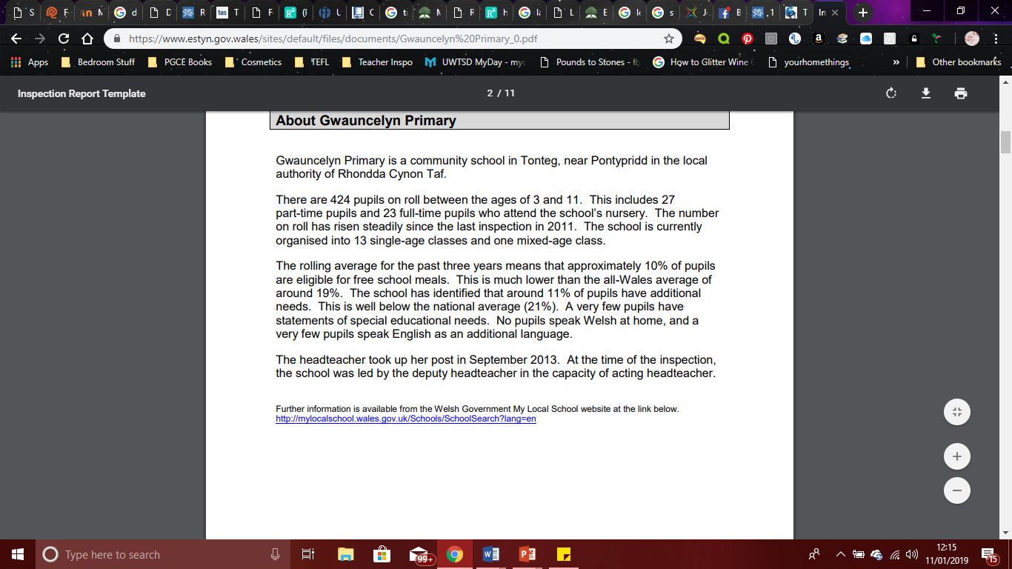

 |  |  |  |  |  |  |  |  |  |  | 1B

Session Plan – Key Stage 2
Name of trainee: |  | Rachel Davies |  |  |  | Session ref: |  |  | 261118_1
Personal target(s) in relation to QTS:
Year group: | 3 |  | No. of learners: |  | 27 |  | ALN: | JS, WL – working in Kagan groups so will be supported by peers  Additional resources will be provided  so they can perform tasks practically if necessary
Additional Adults:
Learning objective(s):  To use problem solving skills to create combinations |  |  |  |  |  |  | Success criteria:  Can you create different combinations of ice cream?  Can you follow the steps to create the different combinations?  Can you use equipment to help you?  Can you explain how you completed your tasks?
Links to previous learning: problem solving
Curriculum coverage (range, skills)
identify the appropriate steps and information needed to complete the task or reach a solution
transfer mathematical skills to a variety of contexts and everyday situations
explain results and procedures clearly using mathematical language

Literacy(LNF)  explain information and ideas using relevant vocabulary  and discussion  contribute to group discussion, sharing ideas and information use talk purposefully to complete a task in a group  review and improve sections of their work |  |  |  |  |  | Numeracy (LNF)
DCF  change instructions to achieve a different outcome.  break down a problem into separate parts to make it easier to understand |  |  | Thinking  Productive Thinking:  - Using information and understanding  - Creating, deciding, analysing, evaluating |  |  | ESDGC |  |  |  | YCC
Key vocabulary(English/Welsh):
Choose, Decide, Combination(s), altogether, different, initials, abbreviations

Appendix 2 – Problem Solving Lesson Plan 1

Time | Session activities, organisation and management | Key questions & Assessment for Learning opportunities
15 mins | Introduction
15 mins | Sit in Kagan groups to answer question  Introductory questions:  On Friday 6 friends go to the ice cream shop. Half of them order 3 scoops of ice cream, and there are 13 scoops of ice cream altogether. Can you show me each friend’s ice cream bowl?  On Saturday, 6 friends go into an ice cream shop and each order two scoops of ice cream. They had three flavours to choose from, vanilla (V), cherry [c] or mint (M). Each friend had a different combination of ice cream. What were the different combinations that they ordered? Give two examples (VC, VV) on the board to show them what to do  (VM/MV, CM/MC, CC, MM)
15 mins |  |  | How did you arrange your scoops of ice cream?  How many of the friends ordered 3 scoops of ice cream?
15 mins |  |  | Why am I using V, C, M instead of vanilla, cherry or mint?
15 mins |  |  | Why are VM and MV the same?
15 mins |  |  | Use thumbs (up/middle/down) to assess learning
35 mins | Main activities
35 mins | Sat in Kagan groups, working in pairs, pupils need to work out how many possible combinations of flavours there are using three flavours of ice cream. Pupils must remember that each bowl must be different.  (10 – VVV, CCC, MMM, VVC, VVM, CCV, CCM, MMV, MMC, VCM)  Pairs can use play dough to create the different combinations. (?)  When they have arrived at their answer, ask them to compare their solution with the other shoulder partner on their table, and agree between them how many combinations there should be. Once everyone has agreed there are 10 combinations, move the class on to the next part of the task.  Explain that the ice cream shop now sells chocolate flakes, so now we need to know how many combinations of ice cream there could be if we include the chocolate flakes.  Extension: Ask pairs to work out how many different combinations there could be if we include a fourth flavour (lemon [l]),
35 mins |  |  | How did you work as a group to discover how many combinations there are altogether?  Did you agree on how many combinations there are? If you didn’t, what did you do?  Is there a way of finding the answer 20 for the combinations without having to make all the bowls?
10 mins | Plenary
10 mins | Top Tips:  Work as pairs.  - List 3-5 top tips for completing the mathematics/success criteria you have covered during the lesson.  - Compare your lists.  - Are there any different approaches you might try?
10 mins |  |  | Assesses their ability to work in pairs, organise their work. Encourages peer learning and listen to strategies that could help them improve for their next task.

Appendix 3 – Problem Solving Lesson Plan 2
 |  |  |  |  |  |  |  |  |  |  | 1B

Session Plan – Key Stage 2
Name of trainee: |  | Rachel Davies |  |  |  | Session ref: |  |  | 101218_1
Personal target(s) in relation to QTS:
Year group: | 3 |  | No. of learners: |  | 27 |  | ALN: | JS, WL – working in Kagan groups so will receive support from peers
Additional Adults: |  |  | Teacher - GB
Learning objective(s):  To use a systematic approach when solving problems |  |  |  |  |  |  | Success criteria:  Can they produce an organised list of ways to share the coins?  Can they explain the method they used to create their lists?
Links to previous learning: Recap systematic approaches
Curriculum coverage (range, skills)
use mental strategies to recall number facts within 20
recall 2, 3, 4, 5 and 10 multiplication tables and use to solve multiplication and division problems
record data Present and analyse data Interpret results
represent data using: – lists, tally charts, tables and diagrams
Literacy(LNF)  use visual information if relevant, e.g. labelled diagrams |  |  |  |  |  | Numeracy (LNF)
DCF |  |  | Thinking |  |  | ESDGC |  |  |  | YCC
Key vocabulary(English/Welsh):

Organise, share, system

Time | Session activities, organisation and management | Key questions & Assessment for Learning opportunities
 | Introduction
Children sat in carpet partners
Explain that if my answer is 12, what could my sum be?
Change the number to give children a few attempts at creating different calculations
 |  |  | Recapping number bonds and practicing different types of sums (encourage division as that was last week’s lesson)
 | Main activities
 | Explain that on the weekend you were playing a game where you would win coins, that you then had to share between 2 giants, Zig and Zag. How many different ways could I have shared the coins out?  Ask pupils to work in carpet partners to work out how many ways they could share it out on their whiteboards.  When pupils give feedback model layout ready for when they complete task in books.  E.g. 4 coins  Once completed, send pupils to Kagan groups to complete tasks from the board  a. The next level of the game is to share out 4 gold coins. How many different ways can this be done?  b. The final level to the game is to share out 10 coins. How many different ways can this be done? |  | If Zig has one/two/three coins, how many would Zag have? (Encouraging a systematic approach to organising work)
  Zig | Zag
   | OOOO
  O | OOO
  OO | OO
  OOO | O
  OOOO
 |  |  | By watching pupils in their pairs complete the task, I can see which pupils are completing it correctly to show to other pupils
 | Plenary
 | Bring pupils together to share examples of sharing the coins out and discuss how they made their lists |  | Bring children to the board to create ways to share the coins – assess if they can do it systematically

Appendix 4 – Welsh Lesson Plan
 |  |  |  |  |  |  |  |  |  |  |  |  |  |  | 1B
 | Session Plan – Key Stage 2
 | Name of trainee: |  |  | Rachel Davies |  |  |  | Session ref: |  |  | 071218_3
 | Personal target(s) in relation to QTS:
 | Year group: |  | 3 |  | No. of learners: |  | 27 |  | ALN: | JS, WL – in Kagan groups so will have support from peers  Word mats will be given out  Further support given
 | Additional Adults: |  |  |  | Teacher - GB
 | Learning objective(s):  To identify the rooms of the house in Welsh  WALT for book: “Y Ty” |  |  |  |  |  |  |  | Success criteria:  Can they identify what type of house they live in? (initially with visuals, then without)  Can they identify different rooms in a house?  Can they write information about their house and the rooms inside it?
 | Links to previous learning: previous learning from Helpwr Heddiw
Curriculum coverage (range, skills)
view and listen carefully responding orally, in writing and non-verbally
experience a variety of audio, audio-visual, electronic, visual and written stimuli, ideas and texts, e.g. DVDs, tapes, interactive white board material, a theatrical performance
work independently, in pairs, in groups and as a member of a class
write in response to a variety of audio, visual and audio-visual stimuli, e.g. stories, poems, their interests, activities and experiences in the classroom and elsewhere, a television programme, a statue

 | Literacy(LNF)  explain information and ideas using relevant vocabulary  contribute to group discussion, sharing ideas and information  include relevant details, information or observations in their writing |  |  |  |  |  |  | Numeracy (LNF)  identify the appropriate steps and information needed to complete the task or reach a solution
 | DCF |  |  |  | Thinking |  |  | ESDGC |  |  |  |  |  | YCC  Opportunity to use Welsh to communicate naturally
Key vocabulary(English/Welsh):
Dw I’n byw, ty, lolfa, cegin, ystafell wely, ystafell ymolchi, garej, atig, gardd

Time |  | Session activities, organisation and management |  |  |  |  |  |  |  |  |  | Key questions & Assessment for Learning opportunities
25 mins |  | Introduction
Recap “Ble wyt ti’n byw?” “Dw I’n byw yn…” practicing in shoulder partners
Recap types of houses by playing Splat
ty ar wahan, ty semi, ty teras, fflat, carafan, byngalo, bwthyn

Introduce rooms in the house using Hwb game
http://resources.hwb.wales.gov.uk/VTC/ngfl/wsl/bdag/tai-de/apps/simple-projector/index.html
Gwaithgaredd 1 No. 2 – tour around the house
complete the interactive tour of the house, asking children to repeat the words

Move on to No. 3 to hear words again, then move on to No. 4 where pupils can come to the board and label the rooms of the house
If there is time, move on to No. 5 (game – listen to the sounds to guess what room of the house it is) (if you run out of time, do this for the plenary)
Introduce new sentence pattern, “yn y ty mae…”. Explain that this is “In the house there is a…”. Build sentences together as a class.
Explain to the class that you want the children to write a paragraph explaining where they live, what house they live in and what rooms there are.
“Dw i’n byw yn Pentref Eglwys/Tonteg/Efail Isaf. Dw I’n byw mewn ty ar wahan/ty semi/ty teras etc. Yn y ty mae…”

Revision of previous questions asked during Helpwr Heddiw
Question children to identify features of houses
“What is the difference between a house and a cottage?”
 |  |  |  |  |  |  |  |  |  |  |  |  | “What is a bungalow?”
 |  |  |  |  |  |  |  |  |  |  |  |  | Go over differences between ty teras, ty semi, ty ar wahan
Building sentences together allows for whole class participation and opportunity to revise words that had just been learned
Building on previous learning of oral task, now becoming a writing task
25 mins |  | Main activities
Pupils are to write their paragraphs in their book, following the template on the whiteboard and using word mats if necessary.
Once they have completed this, they can fill in the house picture with what rooms they have in the upstairs and downstairs of the map
 |  |  |  |  |  |  |  |  |  |  |  |  | Questioning leading to extension: Can you tell me how many bedrooms are in your house e.g. yn y ty mae dau ystafell ymolchi
10 mins |  | Plenary
If not done already, complete No. 5 (see introduction)
Randomiser:
https://www.classtools.net/random-name-picker/19_acad2Z

Ask pupils to translate the Welsh rooms into English
 |  |  |  |  |  |  |  |  |  |  |  |  | Revision of words learned during plenary

Appendix 5 – Resources used for Welsh lesson
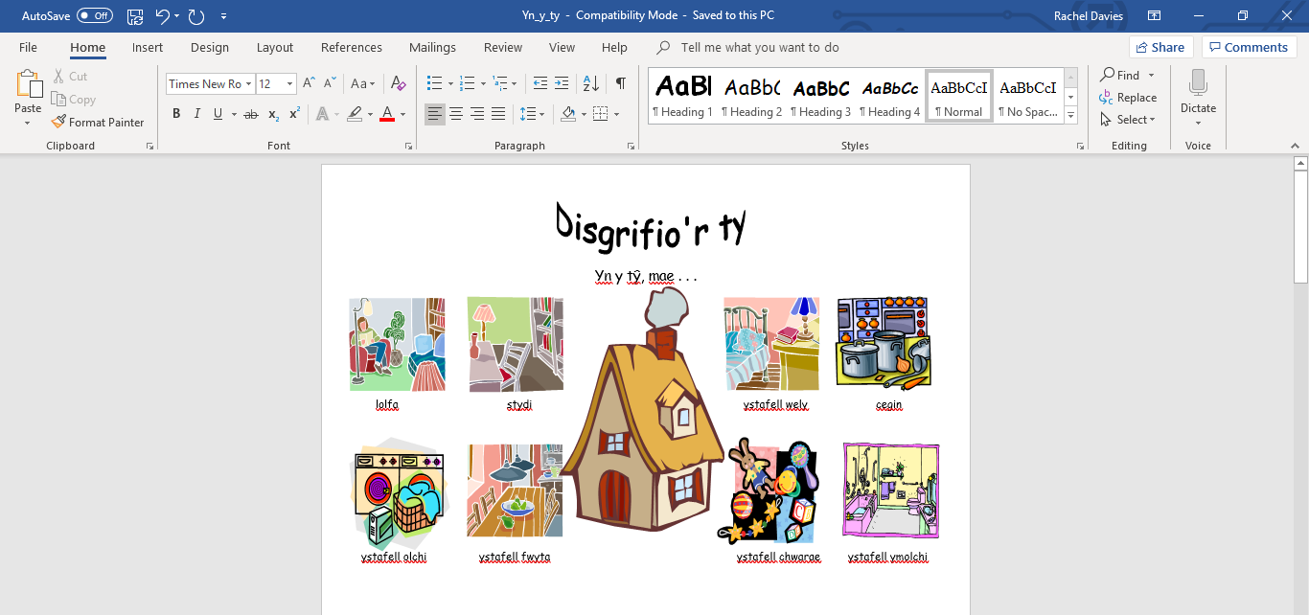
Word mat

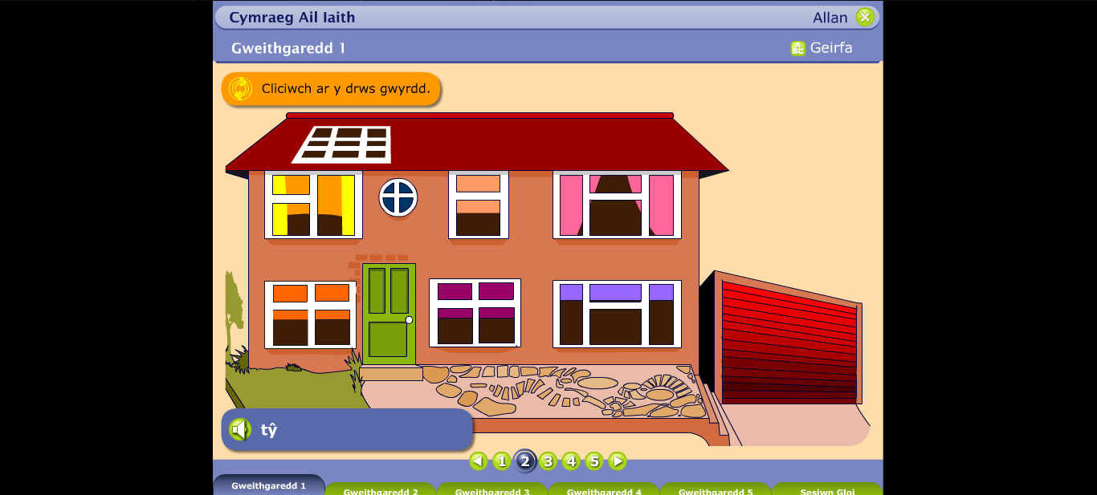
Online House Tour (taken from Hwb, 2018)

Appendix 6 = Temperature Lesson Plan
 |  |  |  |  |  |  |  |  |  |  |  |  |  | 1B
 | Session Plan – Key Stage 2
 | Name of trainee: |  |  | Rachel Davies |  |  |  | Session ref: |  |  | 121218_1
 | Personal target(s) in relation to QTS:
 | Year group: |  | 3 |  | No. of learners: |  | 27 |  | ALN: | JS, WL – provide further support within a group
 | Additional Adults: |  |  |  | Teacher – GB
 | Learning objective(s):  We are learning to read temperatures using positive and negative numbers |  |  |  |  |  |  |  | Success criteria:  All would: Accurately read temperatures from a thermometer  Some should: Accurately read positive and negative temperatures from a thermometer  Be able to work out the differences between temperatures  Put the temperatures in order from coldest to hottest  Some could: Work out the new temperature of a place
 | Links to previous learning: Negative numbers
Curriculum coverage (range, skills)
take temperature readings using thermometers and interpret readings above and below 0°C

 | Literacy(LNF)  use visual clues, e.g. illustration, photographs, diagrams and charts, to enhance understanding |  |  |  |  |  |  | Numeracy (LNF)
 | DCF |  |  |  | Thinking |  |  | ESDGC |  |  |  |  | YCC
Key vocabulary(English/Welsh):

Temperature, degrees, minus, difference, hotter, warmer, colder
Time |  | Session activities, organisation and management |  |  |  |  |  |  |  |  |  | Key questions & Assessment for Learning opportunities
 |  | Introduction
 |  | Talk about negative numbers from yesterday’s lesson and complete subtractions in whiteboard partners using number lines to help them.  (Write sums on the board and keep answers for ordering activity)  Ask children if they know when we use/see negative numbers the most – weather.  Watch yesterday’s weather forecast, pausing to show the weather where the highest temperature is 7 degrees and the lowest temperature is -1  https://www.itv.com/news/2018-12-11/uk-weather-forecast-another-chilly-night/  Ask children how we can work out the difference in temperature  Use Top Marks Temperature game to work out what is the difference between the two temperatures  https://www.topmarks.co.uk/Flash.aspx?f=Temperaturev2  Use answers from sums to ask pupils to put in order from lowest to highest  Use example thermometer on whiteboard to introduce scales to pupils |  |  |  |  |  |  |  |  |  |  | Recapping yesterday’s lesson – some pupils struggled to correctly calculate sums using negative numbers
 |  |  |  |  |  |  |  |  |  |  |  |  | What symbols do we use to show that we are talking about temperatures?
 |  |  |  |  |  |  |  |  |  |  |  |  | Assess whether children know the difference between taking numbers away to reach a minus number and working out the difference between the new temperatures
 |  | Main activities
LA = Colour in the thermometer to match the temperature written underneath
MA = Read the temperatures on the thermometers and work out the differences between them
HA = Read the temperatures in London, Glasgow and Inverness and answer the corresponding questions

Extension: MA = move on to HA worksheet
HA = Negative numbers and temperature Twinkl sheet

LA = assesses ability to read and respond accurately
MA = assess ability to accuarately read scales and create a subtraction sum
 |  |  |  |  |  |  |  |  |  |  |  |  | HA = assesses ability to read a scale, create subtraction sums and order numbers
 |  | Plenary
Country temperature comparisons game – click on the countries across Europe to reveal their average temperature and work out the difference between them
http://www.teacherled.com/resources/eurotemps/eurotempsload.html

