Introduction
The brief I have received is to re-engineer and redesign a dual suspension mountain bike frame as a light endurance motorbike frame. Minor design changes have to be made and different materials and manufacturing processes could be used to redesign the light endurance motorbike frame.
Part analysis
The bike’s frame is the key component in the bike’s construction. All the components of the bike are fitted to this frame. Frames have to be strong, stiff, light and rigid and they are designed to do so using different materials, structures and shapes. For a good performance of the bicycle various conditions have to be met such as stability, ride quality, ergonomics to rider etc. The bike frame consists of several tubes made out of different materials welded to each other to create the rigid structure of the frame. The different length of the tubes, and the angles at which they are attached define the frame geometry. The classic shape of the frame is two triangles. Frame geometry depends on the type of discipline the particular bike is made for. As an example- mountain bikes have different frame geometry than track bicycles. Each frame is designed to accommodate each bike’s different components. There are various frame sizes and shapes. The most commonly used material to make the bike frames has been steel. The frame can be also made from lighter and stronger materials such as titanium, aluminum and carbon fiber. An 'aluminum' frame is mostly made of aluminum but is actually an alloy of aluminum and other stuff that might include small amounts of zinc, magnesium, silica, titanium, scandium or zirconium.
Typical use and work environment
The mountain bike is a bicycle designed for off-road cycling. Mountain bikes share similarities with other bicycles, but incorporate features designed to enhance durability and performance in rough terrain. These typically include a full suspension, large knobby tires, more durable wheels, more powerful brakes, straight handlebars, and lower gear ratios for climbing steep grades. Mountain bikes are generally specialized for use on mountain trails, single track, fire roads, and other unpaved surfaces, although perhaps the majority of them are never used off pavement, and it is common to find hybrid road bikes based on "mountain bike" frames for sale. This type of terrain commonly has rocks, roots, loose dirt, and steep grades. Many trails have additional TTFs (Technical Trail Features) such as log piles, log rides, rock gardens, skinnies, gap jumps, and wall-rides. Mountain bikes are built to handle these types of terrain and features. The heavy-duty construction combined with stronger rims and wider tires has also made this style of bicycle popular with urban riders and couriers who must navigate through potholes and over curbs. Since the development of the sport in the 1970s, many new subtypes of mountain biking have developed, such as cross-country (XC), all-day endurance, freeride, downhill, and a variety of track and slalom types. Each of these place different demands on the bike, requiring different designs for optimal performance. MTB development has led to an increase in suspension travel, now often up to 8 inches (200 mm), and gearing up to 27 speeds, to facilitate both climbing and rapid descents. The expressions "all terrain bicycle", "all terrain bike", and the acronym "ATB" are used as synonyms for "mountain bike". (Wikipedia) The mountain bike frame is the main component of the bike. The frame could be made from several different materials – carbon fiber, steel, aluminum, titanium and alloy. The frame size depends on the wheel size of the bike.
Materials & Production Methods
• Frame – Metal tubes(Softened by heating, and Hollowed out to form and then welded together)
• Tyres – Compound Rubber (Milled, Compressed & Vulcanised)
• Derailleurs and gear shift levers – Plastic/Metal (Injection Molded)
• Seat – Padding covered with nylon or plastic materials (Injection Molded)
• Handlebars – Rubber (Injection Molded)
• Rims – Metal (Machine cut)
• Brakes – Ceramic Disc (Machine cut)
• Cranksets – Steel or aluminum alloy (Machine cut)
New work conditions
Endurance motorbikes are made to tackle rough terrain and survive long distances. The endurance motorbikes are suitable for long distance riders, those that ride on rough roads and the vast majority of riders. Enduro motorcycles closely resemble motocross bikes. They may have special features such as oversized gas tanks, engines tuned for reliability and longevity, sump protectors, and more durable (and heavier) components. Enduro bikes combine the long-travel suspension of an off-road motocross bike with engines that are reliable and durable over long distances, and may be fitted with oversize gas tanks for adequate range. (Wikipedia) The robustness of an off-road motorcycle is mainly due to the frame, a tubular construction of steel or aluminum. Many off-road and enduro motorcycles are equipped with a separate subframe which is then bolted to the main frame, these subframes are usually made of aluminum tubing to save weight and make the bike lighter. (Offroadcentrum)
Design considerations
The frame design is based on several fundamental elements: durability, versatility in the selection of components for assembly, maximum space for the accommodation of the petrol or the electric powertrain. The best material for the frame would be aluminum as it’s the lightest possible material after carbon fiber, but as carbon fiber frames tend to snap , the aluminum is the better choice for the occasion of an endurance motorbike because of its rigidity. Several subtle changes to the geometry and dynamic parameters have to be made, all of which will give considerable benefits to both moto-cross and enduro riders. The rear shock has to be mounted lower and on the center-line of the machine for optimal mass centralization and high-speed stability. The center of gravity height should be much lower and the bike frame itself should have much more space in the front part of the frame the regular mountain bike frame.
New part design
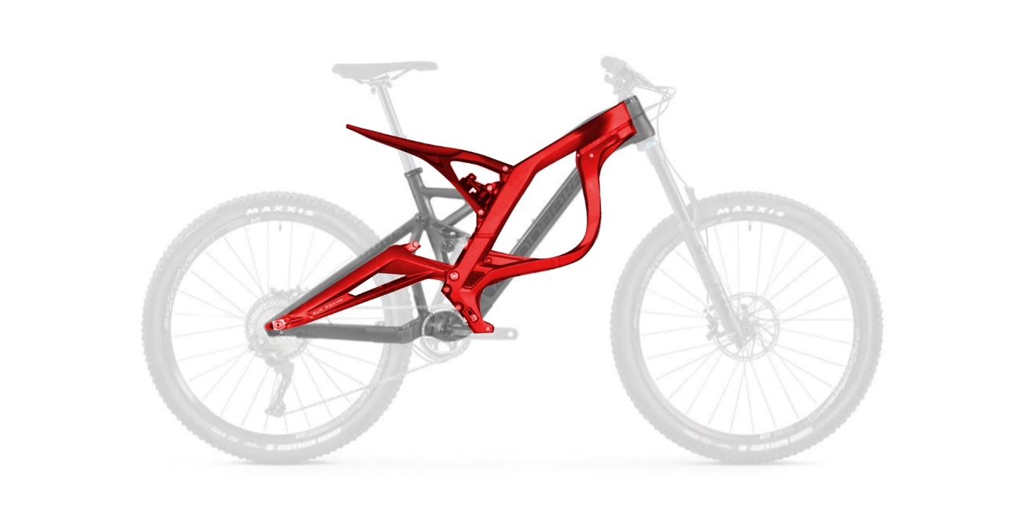
The new part has a different geometry than the standard mountain bike frame. The frame body is bigger to fit the power plant and pushed forward for better weight distribution. The seat post is extended so a motorbike seat could be mounted. One of the holding tubes for the rear suspension has to be removed so a larger spring shock can be installed. The frame positions the rear shock’s mounting point low, opening up the airbox area and contributing to a lower center of gravity. The frame geometry also helps give you more traction, and that means more holeshots. The rear swingarm uses forged aluminum to make it as light as possible, while still being strong enough to do the job of taking significant jumps. The shape and placement of the rear shock provides a very long stroke, the geometry of all the frame components take inspiration from dirt motorcycle designs that are common.
New manufacturing method employed for production of this new part
The main frame itself would be made from the highest-grade aluminum alloy. Aluminum-lithium alloys have the lowest densities of all aluminum alloys. An example is AA8090. They also have higher than typical elastic moduli and high strengths. The high strength to weight and stiffness to weight ratios has made them of interest to aircraft manufacture. Unfortunately, their poor machinability, difficult in manufacturing and inconsistent short-transverse fracture toughness have prevented their widespread use. The frame is completely forged with lightweight aluminum alloy with top exquisite technology of the industry.
Suitability and advantages of new part
This “dirt bike” geometry and progressive suspension will make the motorbike much more rigid but at the same time, with the usage of the new types of aluminum, the frame itself will stay light. The new frame will be bigger in size to accommodate the powertrain and the new suspension but it would stay lighter than a regular steel mountain bike frame. The new frame can accommodate a much larger rear shock suspension which is important for ride comfort for both on and off-road users. The new frame has enough space for an electric or a petrol power plant to be installed.
Manufacturing process
The new frame would be made from forged aluminum and not casted because when treated with heat, aluminum forgings show certain mechanical properties that make their strength to weight ratio far superior than that of castings. Also forging the aluminum frame would cost much less than casting it as die forging tools are generally much cheaper than die cast tooling. The production rate of forging is also much higher than that of casting. In highly stressed applications, there are many forgings used as against castings as they are more affordable. Also forged parts are much easier and more flexible to design.
Cost justification
A forged aluminum frame would cost much less than the standard casted aluminum frame of a regular mountain bike. Overall the cost of manufacturing the new motorbike frame would not dramatically exceed the cost of a regular mountain bike frame as the type of aluminum I have chosen is not as far off from the aluminum used in regular bikes. Also the manufacturing cost would be cheaper because as I mentioned earlier, the actual manufacturing process of the forged aluminum frame would be cheaper.

