PSYCHOLOGY FOR HEALTH AND SOCIAL CARE: COMPONENT 2: REPORT

STUDENT NAME: SANDRA OMOJOLA
STUDENT NUMBER: 2008192
LECTURE NAME: BIANCA SANFILIPPO
MOUDLE NUMBER: BMHP4003_LON

Executive summary
The eight psychosocial developmental stages as identified by Ericsson have been crucial towards the development of understanding of the changes taking place over a person's life span. The contrasting forces further allow us to understand the consequences of not being able to achieve the best out of each developmental stage. Among these developmental stages, the adolescent stage is the most crucial as it is a bridging stage between childhood and adulthood therefore is naturally very challenging. Identity and role confusion are the two contrasting forces in this age period. The constant search for self-identity can be assisted by healthcare professionals allowing them to understand the physical changes taking place within their bodies allowing them to make personal decisions with informed knowledge. Following the development of sexuality, there are several confusions regarding that aspect, ability to assist individuals in the right direction without any prejudice leads to professional success later in life.

Table of Contents
Introduction 4
Discussion over Ericson’s’ theory 4
Role of a healthcare practitioner 7
Reflection 10
Conclusion 11
Reference 12
Appendix 13
Appendix 1: Stages of psychosocial development 13
Appendix 2: developmental stages and events 14
Appendix 3: Classification of Adulthood 14

Introduction
Individuals undergo eight psychosocial developmental stages as discussed by Ericson. The present report has been focused on these developmental stages along with the changes IN each stage. The role of the practitioner and a reflective account over future development ages has also been executed.

Discussion over Ericson’s’ theory
Eric Ericson was primarily a stage theorist who had adopted the controversial psychosexual theory of Freud and further modified it to transform it into eight stages of psychosocial development. Erickson believed that every individual had awareness regarding the factors which motivate an individual throughout life, making ego gain greater importance over actions in comparison to id (Orenstein and Lewis, 2020, p.76).
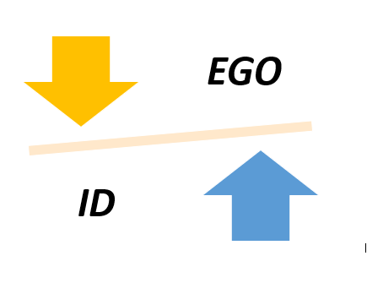
Figure 1: Superiority of ego over id According to Ericson
(Source: Self-Created)
The stages which had been developed by him had been completely based upon the epigenetic principles. These epigenetic principles hold the notion that every individual unfolds their personality in each predetermined stage with the influence of surrounding culture. During each of these psychological stages there is a conflict, overcoming these conflicts allows the child to develop into a well-adjusted healthy adult (Gressick and Langston, 2017, p.109).

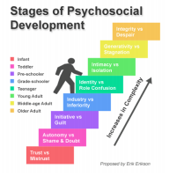
Figure 2: 8 stages of development according to Ericson
(Source: Gressick and Langston, 2017, p.109)
Stage 1: Trust vs mistrust
Ranging from birth to 12 months, infants learn to trust adults. This situation of trust arises when these adults can fulfil their basic survival needs (Kormyshev et al. 2020, p.5). Dependency upon the caregivers is undeniable in this stage, therefore sensitive and responsible caregivers allow the infant to develop a feeling of trust allowing them to see the world as a safe and predictable place. In contrast, when the caregivers do not meet the baby's needs, they gradually develop a sense of mistrust.
Stage 2: Autonomy vs shame and doubt
Toddlers aged 1 to 3 begin to explore and control individual actions. The primary task is to resolve the issue of autonomy versus shame through the development of independence. Definitive preference towards certain elements in the environment starts to develop. Denial to work upon their environment and abilities develops the instance of shame and lowered self-esteem.
Stage 3: Initiative vs guilt
Reaching the age of 3 to 6, individuals gain the capability of initiating activities that asserts control over the world through their actions. Sense of responsibility facilitated with ambition is developed when they are allowed to explore, contrastingly, over-controlling parents might allow the development of feelings of guilt.
Stage 4: Industry vs inferiority
During the age of 6 to 12 children are faced with the task of comparing themselves with their peers. A sense of pride develops when they have been successful in matching up to the capabilities of their peers (Maree, 2021, p.1107). On the contrary, a sense of inferiority can also develop when they find themselves to be inadequate to their peer group. Inability to eliminate this inferiority complex gets extended into adolescence as well.
Stage 5: Identity vs role confusion
In the words of Ericson, the primary task of an individual in their adolescent phase is the task of developing a sense of self. Several questions like “who am I?”,“what do I want in life?” allows adolescents to explore various roles, set goals, and overall explore the self. Successful individuals at this stage have a strong sense of self-identity through which they can withhold their beliefs and face problems (Knight,2017, p.1047). Apathetic adolescents are in constant search for their identity or pressured to conform to the ideas of their parents leading to role confusion and a weakened sense of self.
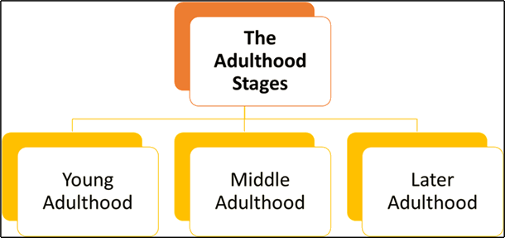
Figure 3: Stage of adulthood
(Source: Knight, 2017, p.1047)

Stage 6: Intimacy vs isolation
Individuals in their adulthood ranging from 20 to 40 have crossed the adolescent stage and developed self-identity making them ready to share their lives with others. A strong sense of self is required before the development of intimate relationships.
Stage 7: Generativity vs stagnation
This stage includes the age group extending from 40 to mid-60s. Generativity is developed through active involvement in activities like volunteering, raising children, mentoring thereby contributing towards the next generation. The ability to be involved in meaningful and productive work allows the development of positivity towards society. In contrast, individuals unable to make a positive contribution face stagnation and fear as they can’t leave a mark in society.
Stage 8: Integrity vs despair
Reflections upon past life and its success allowed the development of a sense of success, satisfaction, whereas the inability to achieve fruitful results throughout life results in despair.

Role of a healthcare practitioner
During the adolescent phase as described by Ericson, there is a contrasting force between identity development and role confusion. Adolescence can be broadly categorised into four developmental stages of physical, intellectual, emotional, and social development (Kaiser, 2020, p.45). During The stage of physical development, puberty takes the limelight as the body undergoes several biological changes. As a healthcare practitioner, it becomes the responsibility to make young adolescent individuals be aware of these changes and not get involved in activities based on unhygienic activities. Furthermore, as the genitals develop, the tendency to explore sexuality consecutively develops, requiring proper guidance from the practitioner to adopt safety measures. As adolescents are still in the process of understanding the world, they need to be supported in making adequate emotional adjustments to understand the Gray area in every concert.
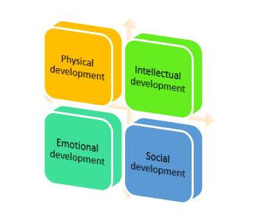
Figure 4: developmental stages of adolescence
(Source: Kaiser, 2020, p.45)
Reiterating Erikson's views, Stanley Hall had stated that adolescence is a period of storm and stress, therefore in terms of emotional and social development, there are several aspects like physical appearance, vocational chives, career aspirations, education, sexuality, political and social views, personality and interests which are developed during this period (Samsanovich, 2021, p.46), therefore a healthcare practitioner needs to assert the developmental in all these aspects allowing them to develop clarity in perspective through assistance in understanding and allowing them to make their own decisions.
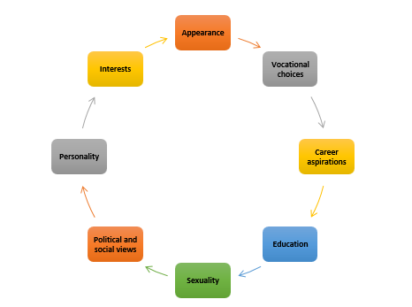
Figure 5: areas of assistance to be provided to the adolescent individual by healthcareprofessional
(Source: Samsanovich, 2021, p.46)
Consecutive to the development of sexuality in adolescents it leads to the development of several issues like sexually transmitted diseases, sexual abuse, unplanned pregnancy, emotional confusion, parental and societal concerns over certain sexual behaviour. In this regard the healthcare practitioner needs to make the teenagers aware of the hormonal and developmental changes which are about to take place, indicating instances and anomalies which should be brought under medical attention (Cross and Cross, 2017, p.43). Several diseases can be spread having lifelong health and emotional consequences. Therefore, the individuals can be made aware by the healthcare professionals so that preventive measures can be adopted towards these diseases. Furthermore, adolescence is in the initial phase of discovering their sexuality are more prone to sexual abuse (Arnob, 2020, p.457). In this regard, the healthcare professional needs to spread awareness regarding the identification of abuse and the process to be followed in reporting it.
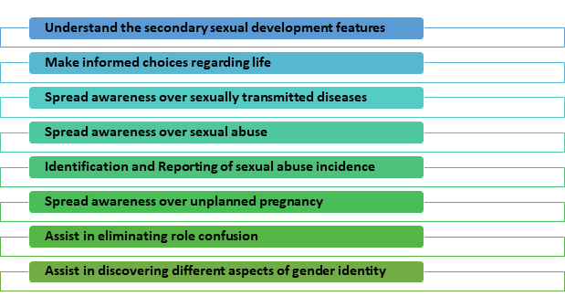
Figure 6: Different Roles of healthcare practitioner
(Source: Self-Created)

Reflection
The stage of adolescence is a crucial building block of an individual. Personally, having crossed this stage I understand the relevance and its importance for a person as well. Ericson’s developmental stages have allowed me to explore the different psychological and social development of human beings in an amalgamated manner. The initial confusion which is created during this stage of life is owing to secondary sexual development through hormonal changes. Therefore, I would use this understanding to make young adolescents identify and make peace with the developmental stages. Furthermore, according to the study conducted by (Dimitrova et al. 2018, p.15), it has been seen that several instances of body image issues develop during this stage as the influence of society and peer-group enhances. I would make them understand the importance of healthy living over the issue of body image allowing them to avoid the role confusion which conflicts with the development of identity. Sexual abuse is very difficult to identify as is generally assisted with the notion of self-involvement and concerns over society disapproving the situation (Gross, 2020, p.179). I would therefore allow these adolescent individuals in identifying these instances of forcefulness and providing help care numbers for efficient reporting of situations. Society has been shaped to conform towards male and female gender identity, therefore, disregarding the others. This further aggravates the conflict between role confusion making them shy away from society or mask their identity paving the path towards depression. Allowing them to explore their individuality according to Erikson's theory will allow professional success in a social care setting.

Conclusion
In conclusion, it can be said that an individual undergoes different developmental stages throughout life. Eric Ericson had explored these developmental courses and found out the conflicting developmental stages associated with growing up and ageing that assist in the development of an individual. Ego takes a crucial position in our lives steering all the actions and decisions taken. Stage five of the psychosocial developmental stage consists of the adolescent stage which holds prime importance in the present study. A healthcare professional can assist adolescents with the changing hormonal and social preferences allowing them to become well-adjusted. Furthermore, adhering to the finding of Ericson allows professional growth and development.

Reference
Arnob, J.M., 2020. Impact of Sexual Harassment on Psychosocial Development of Girls.
Cross, T.L. and Cross, J.R., 2017. Maximizing potential: A school-based conception of psychosocial development. High Ability Studies, 28(1), pp.43-58.
Dimitrova, R., Hatano, K., Sugimura, K. and Ferrer-Wreder, L., 2018. The Erikson psychosocial stage inventory in adolescent samples. European Journal of Psychological Assessment.
Gressick, J. and Langston, J.B., 2017. The Guilded Classroom: Using Gamification to Engage and Motivate Undergraduates. Journal of the Scholarship of Teaching and Learning, 17(3), pp.109-123.
Gross, Y., 2020. Erikson's Stages of Psychosocial Development. The Wiley Encyclopedia of Personality and Individual Differences: Models and Theories, pp.179-184.
Kaiser, E., 2020. Violence on street children: Looking through Erikson’s psychosocial development theory. Journal of Health and Social Sciences, 5(1), pp.45-52.
Knight, Z.G., 2017. A proposed model of psychodynamic psychotherapy linked to Erik Erikson's eight stages of psychosocial development. Clinical psychology & psychotherapy, 24(5), pp.1047-1058.
Kormyshev, V.M., Sachkov, I.N. and Shurmanov, E.G., 2020. Synergetic features of sports career development. Theory and Practice of Physical Culture, (1), pp.5-5.
Maree, J.G., 2021. The psychosocial development theory of Erik Erikson: critical overview. Early Child Development and Care, 191(7-8), pp.1107-1121.
Orenstein, G.A. and Lewis, L., 2020. Eriksons stages of psychosocial development. StatPearls [Internet].
Samsanovich, A., 2021. THEORY AND DIVERSITY: A DESCRIPTIVE STUDY OF ERIKSON’S PSYCHOSOCIAL DEVELOPMENT STAGES.

Appendix

Appendix 1: Stages of psychosocial development
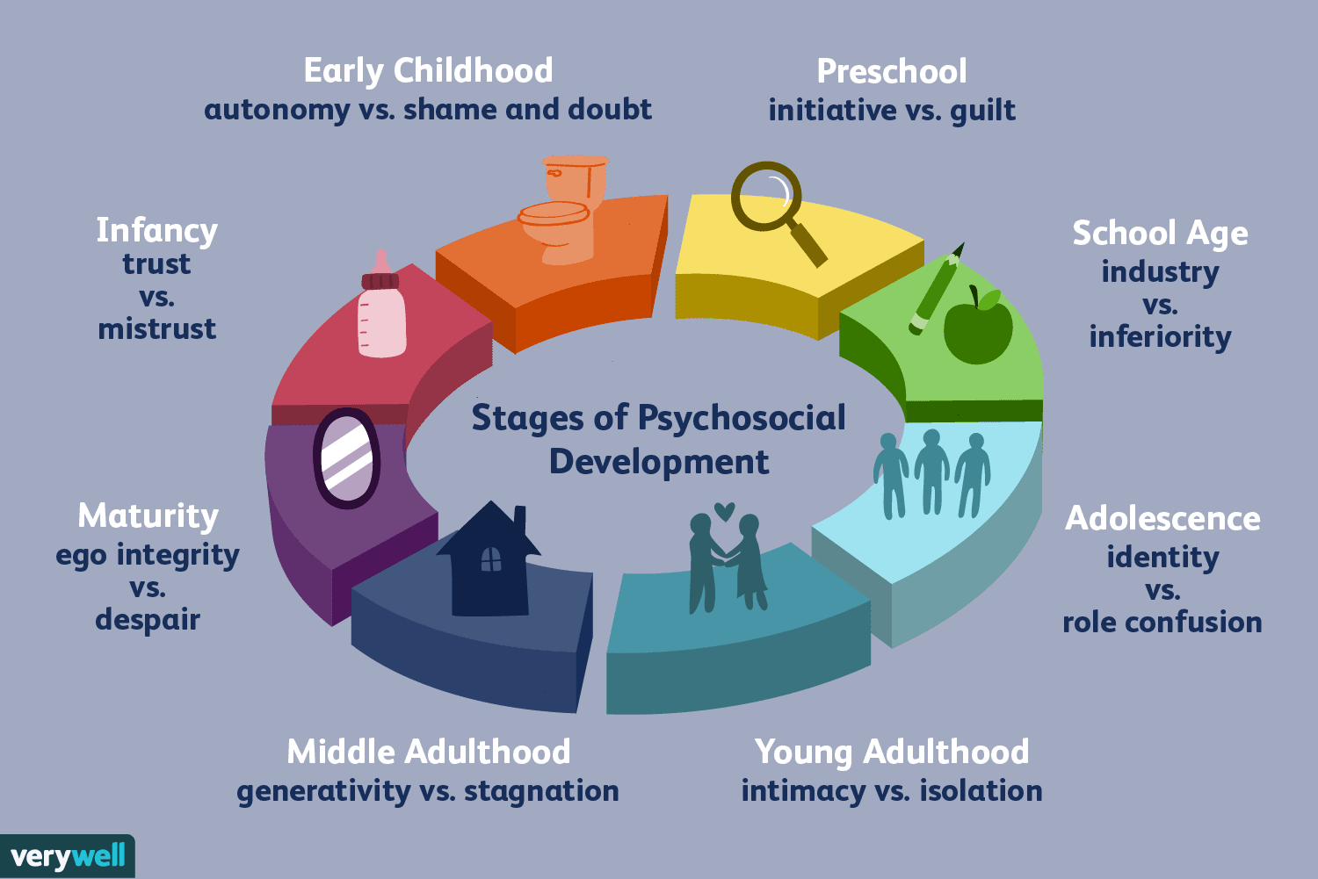
(Source: Kormyshev et al. 2020, p.5)

Appendix 2: developmental stages and events
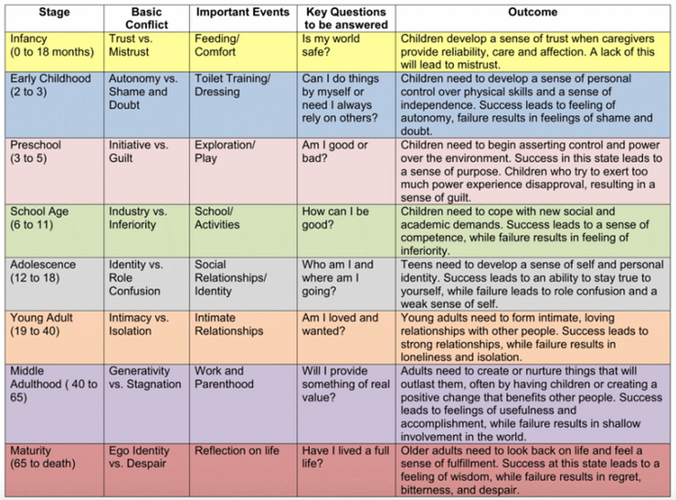
(Source: Samsanovich, 2021, p.12)

Appendix 3: Classification of Adulthood
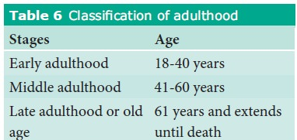
(Source: Maree, 2021, p.1107)

