FINANCIAL MANAGEMENT BMIH 5007
Lecturer: Mr. Dale Clarke
Assignment Number 2: Continental Hotel Budget Planner
Submitted by: Christopher Dwane Rodriguez (2016805)

Content
- Executive summary
- Introduction
- Objectives
- Analysis
- Evaluation
- Contradiction
- Conclusions
- Recommendations

Summary
A illustration calculated figures which are important to constructing of financial budgets. Evaluation and analysis of data used in carefully planning the budgets emphasize the importance of looking through and calculations of the past years data on income and outgoings.
Show the difference of revenues and overheads and product costs and running costs of bills as well as assets and future bonds through comparison of past recorded financial data available.
Introduce and illustrate how the zero base budgeting technique can be useful and how companies benefit from doing this or in what occasion shall ZBB must be done.

Introduction
Looking at the continental Hotel’s past data and given the figures the aim is to come out with a figure acceptable for the following year. In this representation, the following subjects are analyzed and evaluated.
- IHG budget for 2023
- Budget planning
- Zero based budgeting
- Financial audits
- Financial reporting

Objectives
To illustrate properly the calculation of each boxes using the data from the past which are also given. Demonstrate the importance of budgeting in every businesses or organization in their own development or expansion plans as well as the evaluation of their own company.

IHG 2023 Budget plan
The figures below are given and predicted by the Continental budget hotel and the bottom figures are the calculated prediction of the Hotel’s cash flow for every month of 2023 using a traditional budgeting system.
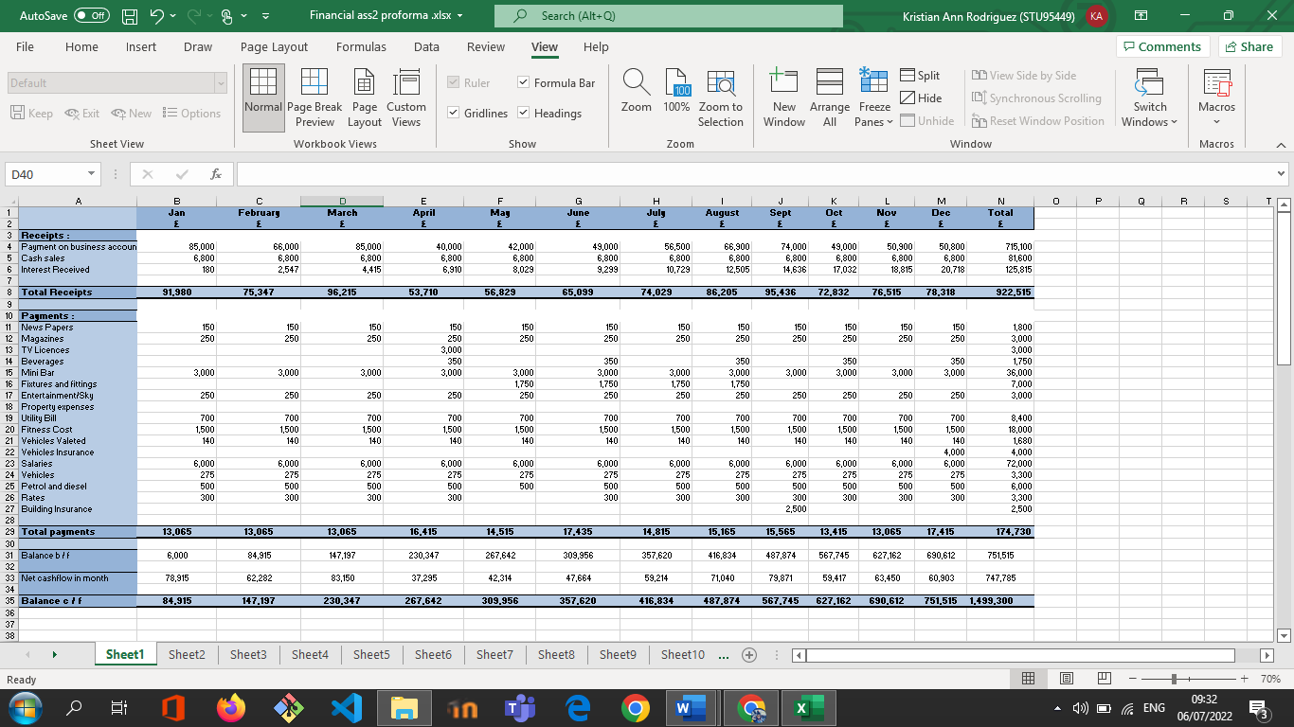

Traditional budgeting
The above is a good example of a corporate traditional budgeting
What is budgeting?
Warren buffet said “ companies collapse because of not doing their budgets”
In a hotel business , for the manager and owner the importance of a budget is enormous, it outlines how management intends to operate the property, translates operating standards into action and shows how the manager can generate profit. The budget also provides owners the opportunity to check that the operator is making proper allowance for their expectations and intentions. For larger independent management companies budgets frequently involved little discussion, and decisions based purely on data are often made by people who have never visited the property. But without a wealth of operating experience the asset managers and owners are at a severe disadvantage.
Creating an annual budget highlighting one of the biggest cost which is labour will impact mainly the opportunity to identify potential savings. What the budget should look like will consider providing the operator with a standard that will be acceptable in advance.
As part of preparing and implementing a business plan is a vital process at the heart of any company in the hospitality industry taking the time to create an actionable budget and prepare accurate forecasts and make all the difference in achieving success for your company. A budget is a plan. A financial plan prepared by persons and by families even a non governmental not for profit organization will have to make a budget. A hotel company would also need to prepare a budget but the challenge for them is that they don’t have a regular fixed income even though it does have fixed regular expenses.
In a more complicated level such as stocks exchange, a corporate budget should also highlight the value of companies for a country as the sources of employment and wealth creation this will illustrate their value as an enterprise or corporation. This is because many people need to know about the financial status of business. The bankers and mortgage lenders investors and stockholders partners and board of directors regulators and internal tax authority employees and clients family members. As the budget acts as a ready reference against which the performances are compared and companies use the term revenue in place of income, the term expense may also be replaced by cost.

Hotel traditional budgeting
In a single hotel property, A budget for a company begins with predicting for the
Revenue = gross Income - the fix regular expenses including VAT = Net profit
Net profit – (Cost of products sold+employees salary) = Operating income
Operating income – is where the dividend and returns are taken to be given to the investors or use to expand the business.

Income statement
To understand the use of budget we also need to learn about the income statement an income statement consists of three heads already discussed before income or revenue, expenses or cost, profit or loss. An income statement is prepared after one business cycle is complete. And the business cycle could be of
- one year,
- one quarter,
- one month or
- one week
Consider the income statement as the financial result of operating the business which is then compared with the budget to examine whether the company was able to achieve its planned financial goals or not.

what is a zero based budget?
Way to make a budget on a blank paper is zero based budgeting that means preparing a budget without having any past data or records as reference. Zero based budgets are made when a company begins its operations for the first time or when a new product is launched however it is interesting to note here that even a company with a long business history must do zero based budgeting sometimes.
The zero based budgets in hotels are not guesswork it is based on data from other hotels in the chain industry wide, standard operating ratios, benchmarks and operating data from a comparable property supplied by experienced expert managers working as independent consultants.
The requirements for creating a zero based budget
The year on year on your budget is sometimes known as the markup method budget a certain percentage is added to the figures of last year to decide on the budget for the coming financial year for example the manager may decide to increase income by 10% over last year. So this markup has to be justified before the budget approval committee. The markup method also has to account for the national inflation rate that causes the rates of everything to go up.
The revenue cost trend analysis and predictions. This process requires the manager to analyse the past business data for at least two to three years to observe a trend or a pattern and the pattern or trend could be of the five following types the data shows.
- no change
- If the data shows a continuous increase
- the data shows a continuous decrease
- the data is cyclic in nature
- the data shows a haphazard pattern with many ups and downs but no repeating pattern
in the case the data shows no change over the last few years we can predict it to continue in same fashion in future. But similar predictions can be made for all types of trends or patterns this is how we can prepare a budget with the help of trend analysis budget strategies.
Hotels makes a master annual budget for the whole organisation and also prepare daily budgets for a strict control over the operations. The sales budget is the part of the operating budget and consists of sales or revenue forecasts and related direct expenses. The master budget is a combined budget of the different departments but not without discussion, arguments, analysis, justification and approval of the important shareholders in business

These budgets often requires managers to work according to the expectations of the Investors and earning a handsome return on investment is a main responsibility this is how business targets keep increasing every year that is why costs are not allowed to constantly increase along with sales a rule of thumb is that if a business is not growing then it is dying increasing revenue decreasing expenses and maximizing profit is at the heart of every business capital. These budget is about keeping a certain amount of money for future major purchases like land machine etc. Commonly a budget also keeps aside a certain amount of money for replacing the existing facilities equipment and furniture called depreciation but often controversial expense category is the discretionary expenses like legal fees travel costs entertainment account HR hiring set, and this expense is often misused by managers for personal gains and hence this category gets closely examined by the investors as well as government auditors in the income statement. The budget helps in three ways planning a future goals, assessing or examining actual results, control of operations and timely managerial decisions planning tool. “A budget is like the Global Positioning System of a car before you start the journey you set your destination the GPS keeps telling you where you are at any point in time with regard to the destination it also keeps you on track”.

Investors ROI | 1499300 | 0

On the ZBB the final number always ends in zero because every penny is accounted for.

Understanding zero based budgeting system
This budget decides how much you want to allocate for each specific category once you’ve written everything down subtract the expenses from the income if you have money left over you need to assign it to a category if you don’t you’re more likely to spend it on something nonessential instead of putting it toward a long term goal, this is the essence of zero based budgeting.
how to implement a zero based budget?
After predicting the revenue creating a zero based budget you have to start tracking and categorizing your expenses you can easily do this with apps like mint. Take time each week to make sure your transactions are categorized and find a method that you can stick to.
how does it compare to other budgeting methods?
A zero based budgeting system may require more maintenance and diligence than other types of budgets because you have to give each dollar a job that means you also have to track each dollar that you spent, this also means you’re forced to confront how much money you actually spend.
Also called zbb is the process of creating a budget from nothing, without using the prior year’s budget or spending numbers, no activities are assumed to be untouchable all expenses are judged and must be justified in order to remain in the budget. When under zero based budget managers are required to justify all budgeted expenditures not just changes in the budget from previous year the baseline is zero rather than last year’s budget there are a few different steps in zero based budgeting to keep in mind the process of zero based budgeting follows the same basic steps one identify business goals two develop an analyse new ways to achieve goals three discover new ways to fund business processes for prioritised funds 0 based budgeting has a lot of advantages I will discuss with one year one efficient allocation of resources as it is based on needs and benefits. With this approach drives managers to find cost effective ways to improve activities. This budget is useful for service departments because criteria are not always easy to identify. This approach increases the communication and coordination within the organisation about certain decisions and by this approach it identifies and eliminates wastage and out of date operations.
The disadvantage
But there are also disadvantages to the application of zero based budgeting. Its time consuming sometimes the necessary expenditures are hard to define for managers as a result of which it becomes too time consuming and exhaustive a process to arrive at a solid foundation with respect to the decision-making about the investment. Another disadvantage of zero based budgeting is requires knowledge in order to apply this approach appropriately it is necessary to train managers well. This budgeting to be successfully implemented managers at all levels of the organisation must understand how zero based budgeting works in the organisation as they are ultimately responsible for the management decision-making and the communication of entire process. It requires manpower, this approach forces staff especially managers to justify every detail related to the expenditures for instance because the R&D department cannot completely underpin their intended innovation this could have advantages for the budgeting of another department because they are able to justify their expenditures in great detail zero based budgeting requirements and this financial management approach requires much documentation and justification in addition to the total budget the manager responsible must identify all expected expenditures and rank all of the activities according to their relevant importance and costs. the persons ultimately responsible are high level managers that make decisions about investments and budget cuts that can be justified at all times based on their supporting information an no immediate pre financing as is the case in the traditional manner of budgeting.

Conclusion
The 0 based budgeting application this type of budgeting usually occurs in the government and non profit sectors. The philosophy behind zero based budgeting is good however it should be noted that zero based budgeting requires frequent reviews. In zero based budgeting reviews are carried every year on account of the fact that it is a time consuming and costly process. And interim reviews can be carried out but that is the organization’s choice with respect to time and priority.

