Portfolio
And Reflective piece

Education in Action: Work placement

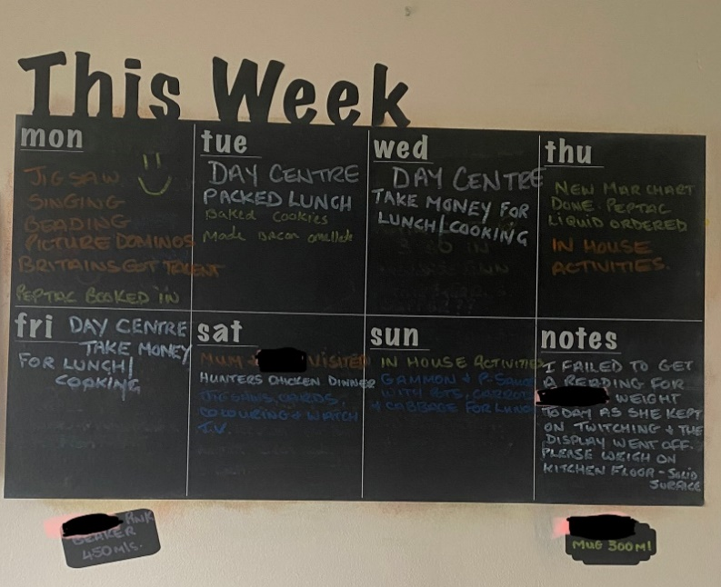
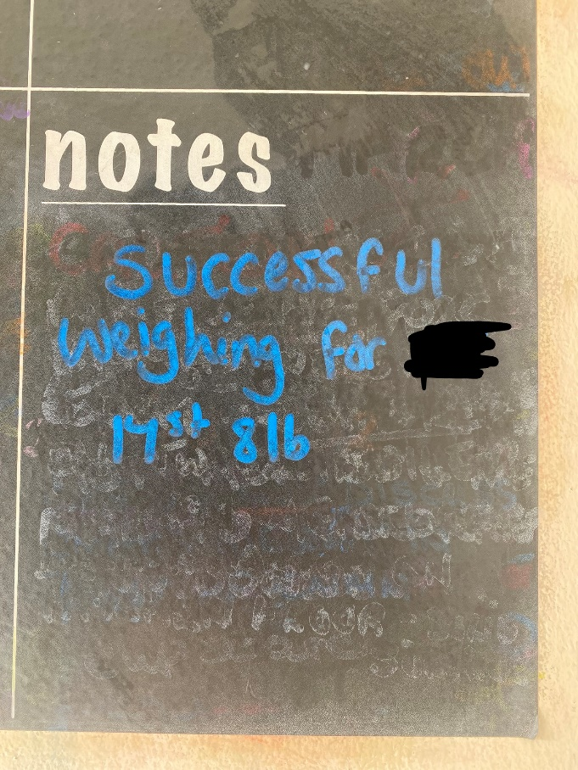
evidence
At the end of the week staff fill out the weekly planner that is in the kitchen; this lets staff know what has been planned for the week commencing. If you are in on that day and do something extra, like baking, you will add it onto the day and mention the activity that took place. For example, we baked cookies on a Tuesday and made bacon omelette, so I have added this onto the planner. This is so that the next person on shift does not repeat the same activity. Extra notes are added for staff to do if other staff were unable to complete a task. As shown in the picture, staff were unable to get a correct reading for the client’s weight, so I then attempted to weigh the individual with success. I then removed the note and replaced it with the successful weighing. So, staff now know she does not need weighing until next month. I also accompanied a client, along with another staff member, to a concert and a theatre activity that was planned. We went to an Elvis tribute concert at the end of March, which was a very good experience for teaching this individual social interaction outside their comfort zone.
  - 1. planning learning activities

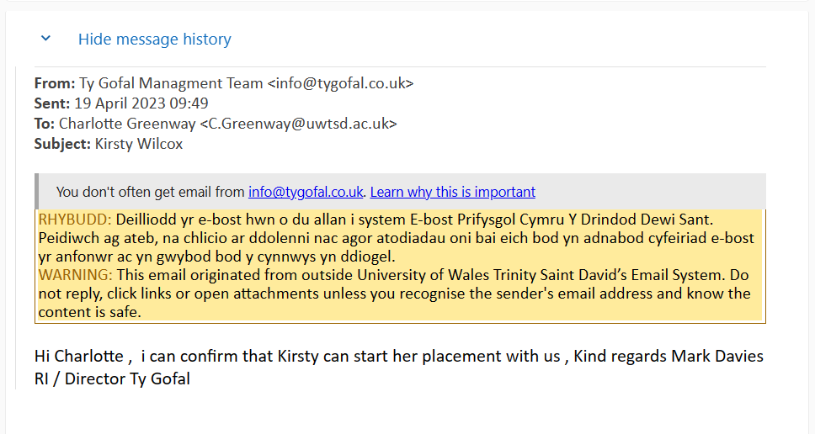
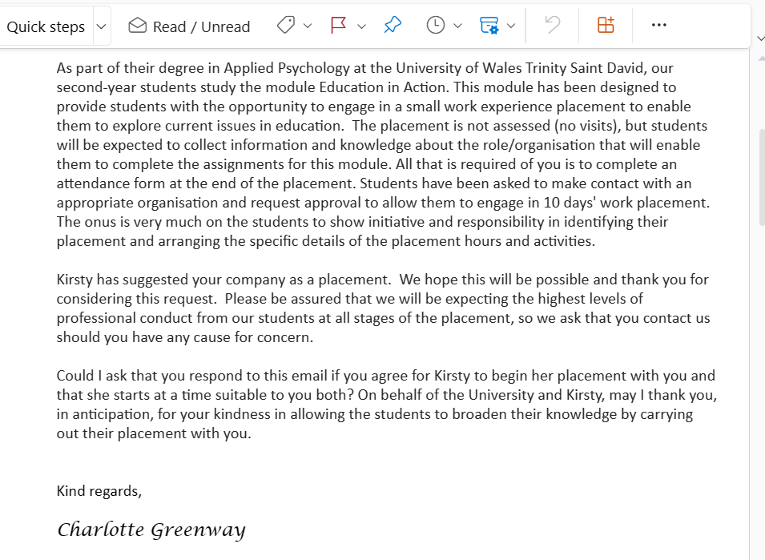
This is the communication between my lecturer and my placement director regarding my starting in Ty Gofal for work experience.
  - 2. Email correspondence regarding placement
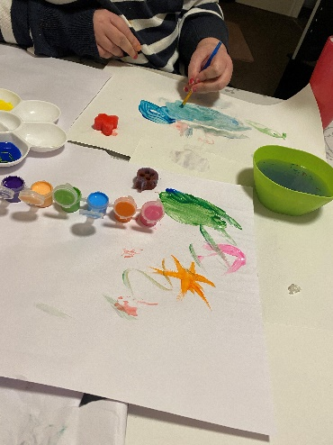
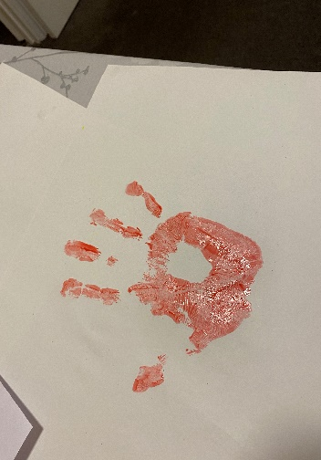
Within my role I would plan activities that would be creative and fun for the individual. I had a duty to organising activities that would suit the individual’s needs, for example, I supported someone who has learning disabilities as well as autism. I had to think if the activity would be easy to understand, fun and interactive, also not confusing for the client. I had to be able to explain to the individual what was needed from them when taking part in the activity. Understanding this individual’s learning abilities helped with planning activities that would be beneficial for them. I planned for us to do baking where the clients would pour the content into bowl and then mix it in. Another time I was teaching the clients to do letters where I would do a dot-to-dot activity on a piece of paper so they would complete the alphabet. Painting was another activity that they enjoyed as they made different colours, shapes and then applied on to the paper.
  - 3. Creative Activities/Learning
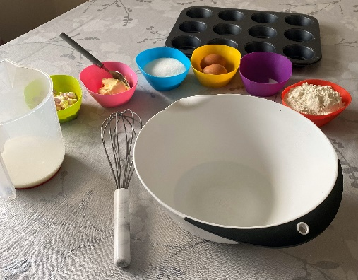

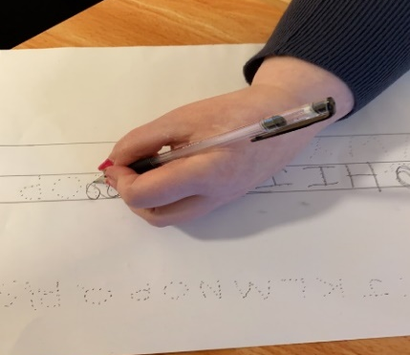
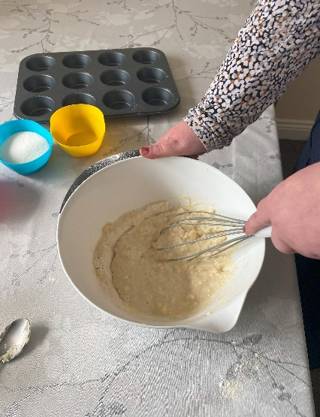

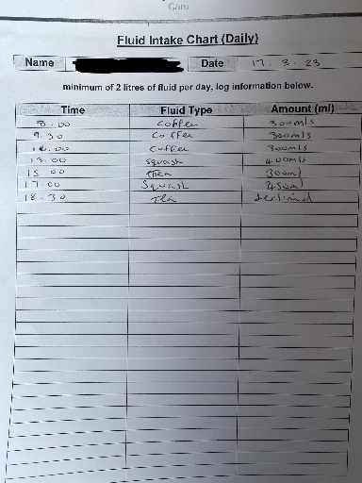
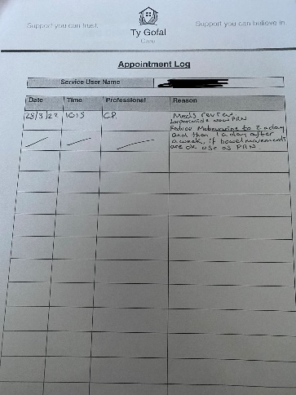
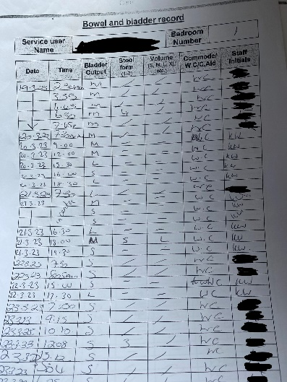
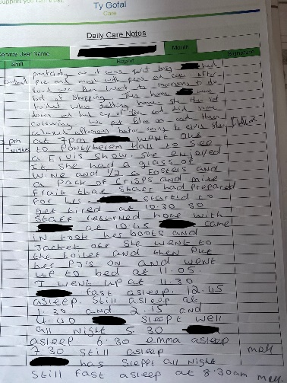
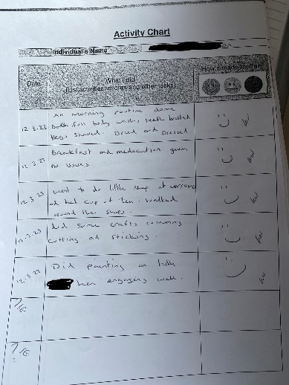
.
  - 4. Reports – drinks intake, stool report, daily activities, Appointment

Throughout the day, when supporting the individual with their day-to-day routine, I would have to document various key things. For example, when they went to the bathroom, the number of fluids they consumed, activities they took part in, and any appointments that had been arranged on that day. All of these would need to be logged and put away in the individual’s file so that other staff can access the client’s file to stay updated during any handover. These will help staff know if clients need more fluids in the day also if they have not had a bowel movement for couple days to then administer laxatives. It can also help staff see if there was anything that triggered a behaviour on that day. For example is the individual constipated or dehydrated.

  - 5. checklists - kitchen appliances, fridge freezer temperatures

At the end of the week, on a Sunday, staff must go around the residential home to check if appliances were working correctly. I would also have to do temperature checks on the water by testing it with a probe; the temperature must be between 41-44 degrees Celsius. If the temperature was too low, or high, then I would report it to the manager who would then adjust it on the boiler. I would also need to check each room and outside in full for any signs of pest and document this on the pest control record. Everyday a hot meal is cooked for the clients by staff, I document what I cooked on the day and then get the temperature of the food this must be tested with a probe and needs to be more than 75 Celsius. Staff would sign their signature next to each part they have done if unable to do the tasks I would need to write in the box with explanation.

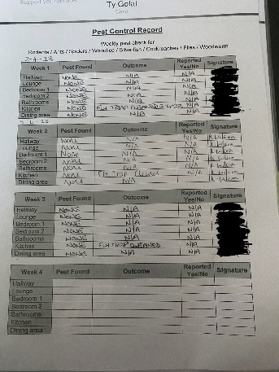
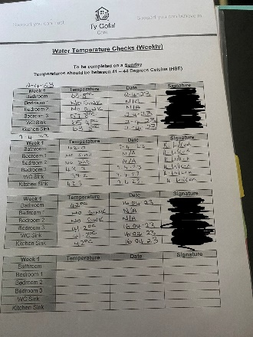
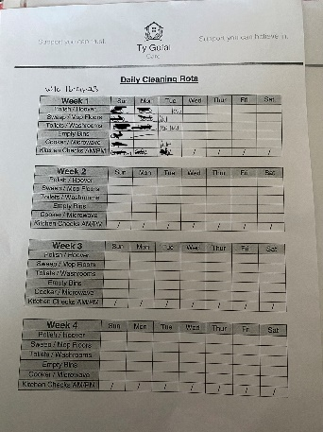
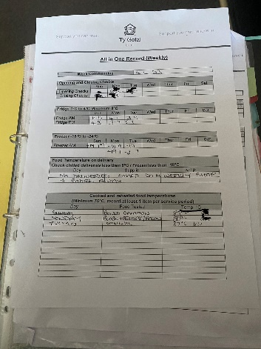

Attendance form

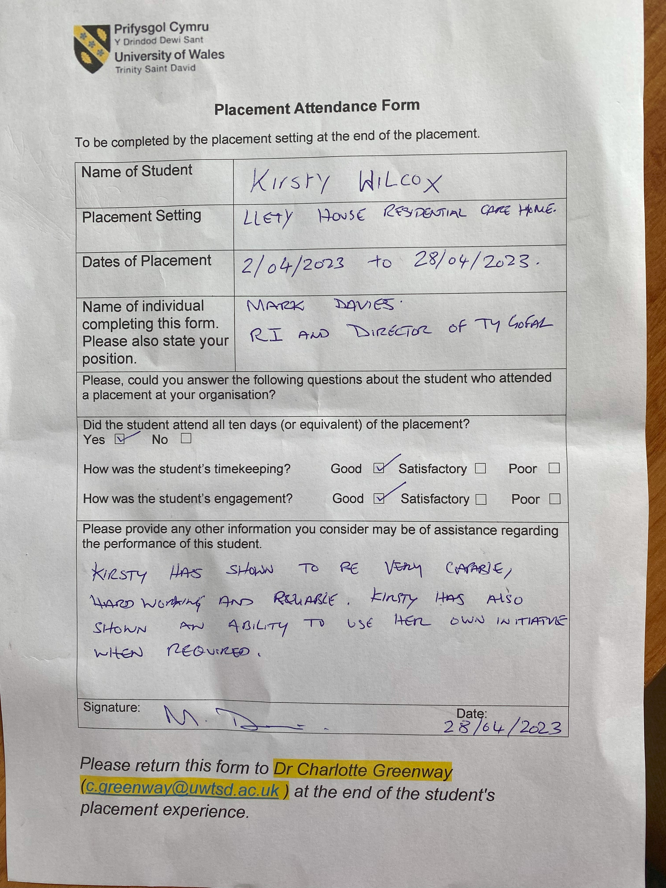

  - Overview

This portfolio is based on my TEN-DAY placement experience at a residential home in camarthenshire area. I was placed in a 4 bed residential home where there resided 2 PEOPLE. the clients have complex needs and my role was to support an guide them to live as independently as they possibly could, and teach them life skills that benefited their needs.

Following Gibbs Reflective Cycle (1988) I will follow the six stages of my experiences I had during my time in placement these stages are
Reflection
Description, Feelings, Evaluation, Analysis, Conclusion, Action plan
Throughout my time in placement, I had experienced some good days and some bad. For instance, when I first started the residents didn’t interact with me well and wouldn’t let me be included in the activities that took place, I believe this was due to not knowing me and not trusting me. I had to take a step back and let them become familiar with my presence and slowly work up the trust between us. One day I tried approaching with an activity that I knew the clients would enjoy, this helped build up the trust between us and they began to let me in and allow me to do more with me each time I was on shift. The more the clients trusted me the more they interacted with me and let me organise activities for them. For example I was supporting one individual with the task of learning to cook her lunch. I decided to start with something small and easy due to this individual having complex needs. The experience was challenging for both of us, due to her communication barrier and slow processing. Also, because I found myself rushing through parts of my explanations which appeared to make it confusing for her, probably due to her not having enough time to process the information. As a result, I experienced some challenging behaviours from her, and I believed this was due to me having a lack of understanding of the individual’s specific needs. After doing some reading on autism and learning disabilities I came to understand more why the individual showed signs of frustration with me. When we cooked again, I knew I had to be patient and let her process the information I gave her for each step that was needed in making her food. This made the experience more relaxing for both of us, and I could see the individual enjoyed the experience. I did find during my time at Placement a lot of paperwork was required to be filled out during the day, I found this to be overwhelming as some days where busy and this gave me little time to fill important information out straight away. This led to me leaving it till the end of my shift and I had to try to remember everything, and this made me feel stressed. I had to find ways to make time when on shift to write out notes when days where busy, this would make my experience less stressful at the end of the day when it came to filling paperwork out, as notes refreshed my memory on events that took place. On another activity I accompanied a member of staff with taking client to a concert to see an Elvis tribute, this was a new experience for me and for the client as she hadn’t been to one since the covid pandemic. Staff was unsure how the individual would react when attending events again, so we arrived early as it was less busy and we found our seats after while the event started to become busier as people arrived. I could see the clients body language change so I began to interact with her to get her focus on me while people began to take their seats, and this seem to help at first, but it didn’t last long, and the client would stand up and leave. However the second member of staff would follow and give her space then she would come back in and sit down. Staff would offer the client a bowl of mixed fruit which and offered a lot of reassurance throughout which would help calm the client. After the event I learnt that giving the client a lot of reassurance and also breathing space when she became overwhelmed made the experience more relaxing and also the client showed to be happier in herself. I enjoyed learning new skills and having a better understanding of learning disabilities and autism, However I also found that the role as a support worker can be stressful and demanding at times and this can affect the work being carried out when on shift as the clients can also sense the tension from staff.

