Table of Content: 
Certificate in Higher Education Skills for the Workplace and Health and Social Care  Evaluation of blended learning and classroom learning on student attainment. | Ionut Modiga  Academic and Employability Skills Module (BMSW 4001)

Introduction: …………………………………………………………………………………………1

Blended learning:……………………………………………………………………………....…...2

Pros of blended learning in the university education:……………………………….….2.1

Cons of blended learning in the university education: …………………………………2.2

Traditional Classroom: …………………………………………………………..……..…………3

Pros of traditional learning in Higher Education…………………………………………3.1

Cons of Traditional learning in Higher Education………………………………………..3.2

Evaluation of Both Forms of teaching in the past and in future…………………….……4

Conclusion: ………………………………………………………………………………………….5

Recommendation: ………………………………………………………………………………….6

Reference: ……………………………………………………………………………………………7

- Introduction

The Dean of the Institute of Inner City Learning (IICL) of UWTSD is wondering if blended learning would be suitable for students studying the Certificate in Higher Education. As a student enrolled on the programme, he has requested you to write an academic report comparing blended learning with traditional classroom learning.

This report is about an academic report associated with the University of Wales Trinity Saint David (UWTSD) of Inner City Learning (IICL). The purpose of this report is to compare blended learning with traditional classroom instruction.

2. Blended Learning:
BLENDED LEARNING
Blended learning is characterized mostly by efficient integration of many methods of communication, learning experience, including cognitive strategies in such an effectively engaging educational process. Blended Learning programs integrate the internet as well as traditional learning tasks and make the most use of tools to enhance students' learning (Kaur, 2013). Blended Learning is the logical combination of well-chosen and compatible face-to-face as well as electronic methodologies and technology.
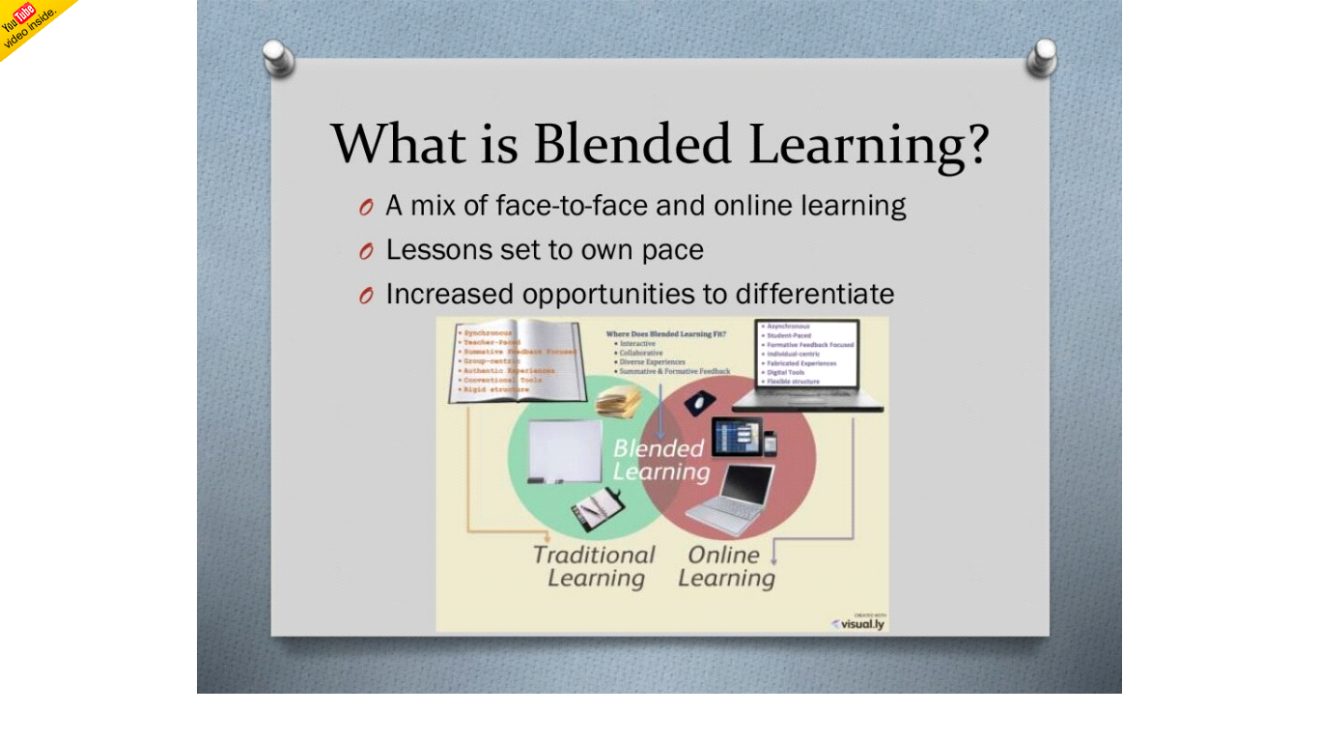
Source:
2.1 Advantages of Blended Learning
- The key benefit of blended learning is that it allows you to reach a broader audience in a shorter amount of time. Because, unlike traditional methods, integrated learning does not require the constant presence of a teacher. At any one moment, traditional classrooms can only hold a certain number of pupils (Castro, 2019).
- Another key advantage of blended learning is that it increases the value of traditional training. Unless they are able to complete tasks independently, people may come to class with the same level of understanding. There is more time for fruitful discussions and application of what they have learned (Boelens et al., 2015).
- A business may save money by using blended learning. It necessitates fewer classrooms or training centers, as well as fewer instructors and reduced travel time. Revenue is being wasted with greater prudence (Dziuban et al., 2018).
2.2 Disadvantages of Blended Learning
- It's hard to dispute that perhaps the initial phases of blended learning, while almost anything is set up, take a lot of time and work. It's tough to convert from a traditional approach to a new one if you've been using one for a long time. One could be thinking about how to establish a balance between in-person and online training (Wikander & Bouchoucha, 2018). It may take some time before the benefits of learning new skills become apparent.
- The additional disadvantage would be that, based on how blended learning is done, appropriate behavior may be reduced. An integrated learning framework is not suitable for everyone, work, subject, or organization. Consider what approach would function effectively for customers in the same kind of way that might evaluate people's reading comprehension when buying books for kids (Dziuban et al., 2018).
- In the field of blending learning, plagiarism is the main issue. While learning on something like a smart device, it may well be tough for blended learners to avoid the impulse to look at things about the world wide web (Criollo-C et al., 2018).
3. TRADITIONAL CLASSROOM LEARNING
Numerous learners should now choose a decidedly modern era's decision in terms of selecting an education system: if to start studying online or in-person (Saglam & Arslan, 2018). Because of the continuous digital revolution, a number of learners are ready to obtain lectures Online rather than in a traditional learning environment.
3.1 Advantages of Traditional Classroom learning
- Learners mostly in a classroom setting have always had the chance to connect with their classmates and teachers make eye contact. It serves as both a cultural and academic advantage. As learners encounter the same classmates during class, they have the opportunity to build connections (Arkorful & Abaidoo, 2015).
- Learners always have the choice of engaging in hands all the time, traditional classroom learning rather than being given teaching resources like textual lessons (Nouri, 2016). Numerous learners depend upon the paradigm to study, therefore transitioning to something like an internet context may create difficulties for them all to retain to see what they have studied.
- All learner dreams of a job in that they will be required to specialize and succeed in certain academic fields. Traditional classroom learning strives to be highly generic within the content and therefore does not concentrate a strong focus on one area than another in terms of quantity and quality while being accommodative(Arkorful & Abaidoo, 2015).
3.2 Disadvantages of Traditional Classroom Learning
- A traditional classroom learning opportunity means that the lecture timetable is set in stone and cannot be altered. learners must plan their individual routines around the education. Whether preparations alter suddenly or perhaps a situation arises, a learner will not be able to rearrange the timetable to submit the assignment at a later time.
- To receive points for overall punctuality in a traditional classroom, learners should personally visit the classes. Some who have driven considerable distances and get to the classroom should allow adequate time to come on schedule, especially if there are adverse conditions (Nouri, 2016).
- Traditional classroom learning should be flexible in every way. Therefore, those in charge of it finish up discrimination towards particular learners. The inclination of professors to show preference against learners becomes a downside of traditional classroom learning (Yan et al., 2018).
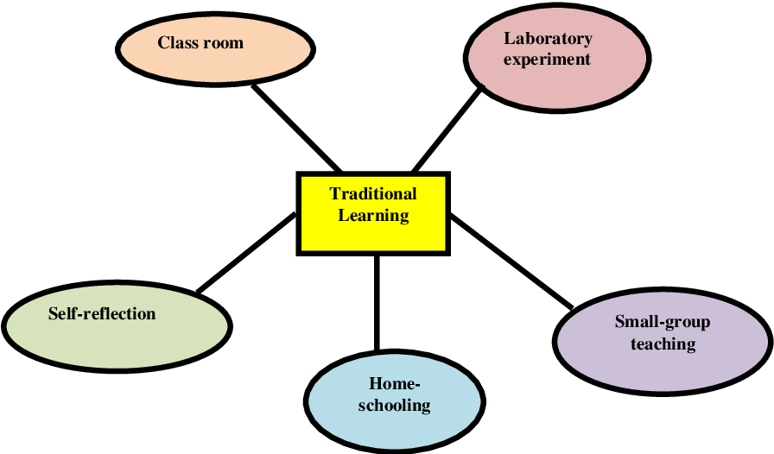

Source: (Singh et al., 2009)

4. EVALUATION OF BOTH FORMS OF TEACHING AND LEARNING IN THE PAST AND PRESENT.
In higher education (HE), learning is a technique of obtaining significant information, skills, and cognitive talents that may be used to address issues satisfactorily. In HE, the use of devices in the classroom is also not a framework. Learners are undoubtedly aware of electronic settings inside the 20th era, therefore teachers and learners are urged to be using digital innovation in the classroom to motivate and employ learners' understanding. Blended learning approaches have now become a standard educational technique to enable learners. As a result, blended learning has evolved to include a variety of educational methodologies as well as is becoming one of the greatest popular things in HE. Furthermore, blended learning improves teaching effectiveness, knowledge transfer, group interactions, self-development as well as cost-effectiveness while also simplifying mistakes and resolving attendance issues. Previous research (Castro, 2019; Wai & Seng, 2015) has shown that mixed learning has advantages and is more effective than standard online learning.
In university learning, blended learning is a popular method of fostering a much more interactive and inviting learning atmosphere in order to reduce learners' stress and worry of making an error. It was first used in campuses inside the mid-1990s (Chopade et al., 2018), and by the year 2000, plenty more degree courses were being provided in a mixed format. Blended learning combines digital and face-to-face education to assist lecturers in achieving instructional objectives such as teaching learners computational but also productive logical abilities, improving teaching quality, including achieving natural cohesion. The research (Bowyer & Chambers, 2017) claim that incorporating technologies into the classroom encourages students to learn through exploration. Interconnectivity, as well as engagement, are increased, resulting in improved reinforcement, interpersonal relationships and usage of curriculum content. Moreover, Individuals have recognized that remote or online education presents challenges, particularly in areas of understanding that demand more advanced study. Furthermore, despite technical advances, some research shows that technology help lower standards of proficiency, such as rote data remembering, and that improving learning capacities is more challenging in an all digital environment.
In traditional learning in the classroom, teaching and learning are usually reliant on the educational strategy, which usually prioritizes the subject over the learners' abilities as well as interests to understand. Youngsters must coordinate their unique tactics and learning abilities at the same time. The educational system, on the other side, does not adequately identify or educate the mind, but instead promotes rote learning. Blended learning is a term that applies to any type of blended learning, although it is most commonly associated with training given through a web browser. Furthermore, by leveraging various digital distribution technologies, knowledge may be enhanced in terms of data transmission and engagement (Yan et al., 2018). As a result, as compared to conventional learning, blended learning has various characteristics, including benefits and downsides. As the trend in university education shifts toward more instructor-led instruction, the internet site has grown more appealing as a supplement to traditional training. Furthermore, pupils will be more involved in the classroom if traditional classroom teaching and learning are used. As a consequence, it's simple to see why one of higher education's primary aims in today's technology classrooms is to increase student involvement in the learning procedure.
Blended learning generally entails a combination of face-to-face and other online learning delivery modalities (as seen in Fig.). Learners often combine traditional classroom lecturers and face-to-face sessions alongside personal internet techniques to develop a blended learning atmosphere that nurtures learners' learning effectiveness and involvement. In addition, it is predicted that blended learning would become the next instructional delivery style that uses a variety of communication channels to improve students’ interaction. Blended learning uses a variety of delayed and simultaneous teaching tactics, including blogs, social media, including chatrooms, to deliver relevant and interactive education.
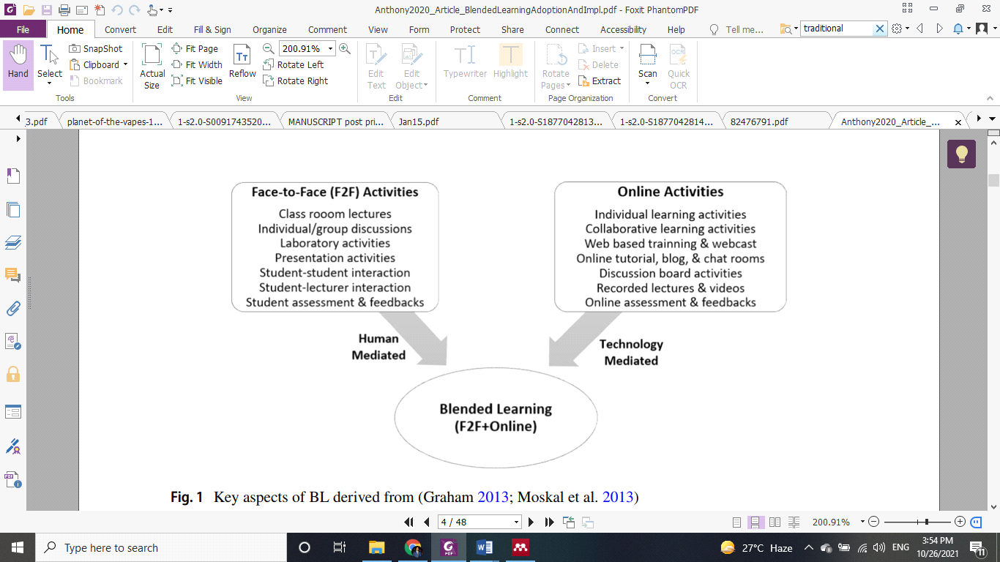

Source: (Anthony et al., 2020)

5. RECOMMENDATIONS
Educational achievement professionals, as well as administration, should examine the essential major elements of a blended learning curriculum when preparing to employ modern media in such an advanced education system. These ideas relate to the higher education learning setting and encompass the implementation of personalized learning programs and also degree programs and curriculum-driven programs. Researchers believe that such ideas will help comprehension groups including young learners providers better implement a blended learning strategy in existing programs, especially that they would be eligible to receive the required career development and financing. Although as compared to traditional classroom learning, blended learning has been successfully adopted in certain higher education programs, teachers and learners have a little platform to interact with and benefit from one another, as well as demonstrate their creativity, as they research, explore as well as assess innovative blended learning reinforcement learning (Boelens et al., 2015). Literacy professionals play a critical part in the creation and implementation of blended learning, and they will be given extra instruction, career learning, including pay as their positions evolve.
Theory of Cognitive may also aid in the development of a traditional classroom learning system. As per cognitivism, certain talents are difficult to acquire before all others, resulting in a competence pyramid. In learning psychology, the ability pyramid has been thoroughly explored as well as being appropriate to practically all learners. Doubling, for instance, is almost never studied well before the student can answer accumulation issues, while the latter is required to master the prior. The characteristic network technique in psychological testing can be used for ability pyramid knowledge to optimize the development of assessment tasks (Chen et al., 2018). Furthermore, Because technology is rapidly evolving, requiring continual assistance for teaching methods, future tech preparation, including innovation skills enhancement will serve to maintain the program's long-term viability. This collaboration between telecom operators and intermediate organizations to organize educational involvement and enhance program competence should be expanded. Assistance must also be provided for the formation of collaborative learning that gathers on just a constant schedule and participates in critical reflection in order to assure the development of learner understanding or even to progress the complicated task of rethinking learning opportunities for blended learning. Additionally, the online pupils seemed to have a hard time getting the teacher face-to-face and approaching him immediately, the student' connections grew stronger as they worked together just to find a solution. This interactive approach persuaded that computational models were the best way to learn.
6. CONCLUSION
To sum up, this report claims that there is little or no diversity of courses available and no human meaningful touch, while blended learning saves money and time. Traditional classroom learning standards emphasize human socialization and aid in character development. Both methods have a lot of promise ahead of them, with various changes and improvements in the works. There were several recommendations for combining both systems at the same time, many of which may enhance the learning atmosphere.
Moreover, enhanced curriculum involvement and commitment in knowledge and tools are recommended; although, it could only be successful if we concentrate on individuals rather than processes and controls. Transformation ought not to be borne solely by learners. It requires a lot of hard in the frame to make substantial reform happen and to keep that difference going. Blended learning in young primary education can only work with a learner-first strategy.

7. REFERENCES
Anthony, B., Kamaludin, A., Romli, A., Raffei, A. F. M., Phon, D. N. A. L. E., Abdullah, A., & Ming, G. L. (2020). Blended learning adoption and implementation in higher education: a theoretical and systematic review. Technology, Knowledge and Learning, 1–48.
Arkorful, V., & Abaidoo, N. (2015). The role of e-learning, advantages and disadvantages of its adoption in higher education. International Journal of Instructional Technology and Distance Learning, 12(1), 29–42.
Boelens, R., Van Laer, S., De Wever, B., & Elen, J. (2015). Blended learning in adult education: towards a definition of blended learning.
Bowyer, J., & Chambers, L. (2017). Evaluating blended learning: Bringing the elements together. Research Matters: A Cambridge Assessment Publication, 23, 17–26.
Castro, R. (2019). Blended learning in higher education: Trends and capabilities. Education and Information Technologies, 24(4), 2523–2546.
Chen, Y., Li, X., Liu, J., & Ying, Z. (2018). Recommendation system for adaptive learning. Applied Psychological Measurement, 42(1), 24–41.
Chopade, P., Khan, S. M., Stoeffler, K., Edward, D., Rosen, Y., & Von Davier, A. (2018). Framework for effective teamwork assessment in collaborative learning and problem solving. In 19th International Conference on Artificial Intelligence in Education (AIED), LAS, The Festival of Learning, ARL Workshop “Assessment and Intervention during Team Tutoring” AIED-2018, 2153, 48–59.
Criollo-C, S., Luján-Mora, S., & Jaramillo-Alcázar, A. (2018). Advantages and disadvantages of M-learning in current education. 2018 IEEE World Engineering Education Conference (EDUNINE), 1–6.
Dziuban, C., Graham, C. R., Moskal, P. D., Norberg, A., & Sicilia, N. (2018). Blended learning: the new normal and emerging technologies. International Journal of Educational Technology in Higher Education, 15(1), 1–16.
Kaur, M. (2013). Blended learning-its challenges and future. Procedia-Social and Behavioral Sciences, 93, 612–617.
Nouri, J. (2016). The flipped classroom: for active, effective and increased learning–especially for low achievers. International Journal of Educational Technology in Higher Education, 13(1), 1–10.
Saglam, D., & Arslan, A. (2018). The Effect of Flipped Classroom on the Academic Achievement and Attitude of Higher Education Students. World Journal of Education, 8(4), 170–176.
Singh, A. K., Yusoff, M. A., & Oo, N. (2009). A comparative study between traditional learning and e-learning. Proceedings of Teaching and Learning Open Forum 2009, 1–7.
Wai, C. C., & Seng, E. L. K. (2015). Measuring the effectiveness of blended learning environment: A case study in Malaysia. Education and Information Technologies, 20(3), 429–443.
Wikander, L., & Bouchoucha, S. L. (2018). Facilitating peer based learning through summative assessment–An adaptation of the Objective Structured Clinical Assessment tool for the blended learning environment. Nurse Education in Practice, 28, 40–45.
Yan, J., Li, L., Yan, J., & Niu, Y. (2018). A comparison of flipped and traditional classroom learning: A case study in mechanical engineering. The International Journal of Engineering Education, 34(6), 1876–1887.

