
MASTER OF BUSINESS ADMINISTRATION
Marketing Management (LCMB7024)

ASSESSMENT COMPONENT 1
Marketing Environment Analysis
Glencore plc: Environmental Pressures, Technological Change and Strategic Growth Towards a Lower-Carbon Business Model

Student name: Abhishek singh jat
Student ID: 2609969
Lecturer: Taonga Kaonga Sobere-Snithers (Birmingham)
Submission date: 22 October 2026
Main text word count: 2656

Table of Contents
1. Introduction 3
2. Task 1: Marketing Environment Analysis 3
2.1 Environmental actor: climate, resource pressure and carbon expectations 3
2.2 Technology actor: electrification, digitalisation and low-carbon processing 5
2.3 Social actors: communities, workers, regulators and stakeholders 6
2.4 Integrated assessment 7
3. Task 2: Strategic Growth and Competitive Positioning 8
3.1 Ansoff Matrix assessment 8
3.2 Competitive positioning 10
4. Task 3: Managerial and Professional Reflection 11
5. Conclusion 12
Reference List 13

1. Introduction
A marketing strategy is influenced by factors operating beyond a firm. In mining, this is particularly the case since companies have to respond to pressures associated with the climate, while continuing to provide materials necessary for energy systems and industrial growth. According to McKinsey (2024), a new era is upon the materials industry whereby the energy transition shapes the demand, investments and competition.
This report will look at Glencore plc, a diversified natural resource company involved in more than 60 commodities in operations and marketing across more than 30 countries with more than 150,000 employees and contractors (Glencore, 2025e). Glencore is an ideal case due to the fact that the firm’s portfolio comprises of both energy commodities and metals facilitating the transition (Glencore, 2024). Three external actors will be analyzed in this report: the natural environment, technology and social actors. Natural environment will be emphasized in the report as per the brief.

2. Task 1: Marketing Environment Analysis

2.1 Environmental actor: climate, resource pressure and carbon expectations
The most important actor is the natural environment due to the fact that mining not only enables but also contributes to the transition. As UNEP (2024) reports, more than 55% of all greenhouse gas emissions emanate from extraction and processing of materials, thereby revealing the existence of the sustainability challenge that faces mining firms. Climate change impacts Glencore in two ways. Firstly, Glencore has to minimize greenhouse gas emissions from the company’s operations. Secondly, the company has to prove to its customers and other stakeholders that the commodities that it sells are consistent with the lower-carbon world.
Climate Action Transition Plan 2024-2026 of Glencore sets targets of minimising combined industrial Scope 1, 2 and 3 emissions to 15% by 2026, 25% by 2030 and 50% by 2035 relative to restated 2019 baseline with net zero industrial emission by 2050 provided that there is a supportive policy environment (Glencore, 2024). In 2024, the scope of market-based emissions 1 and 2 is 27.1 million tones CO2e, that is 21.4% below the restated baseline of 2019 being 34.4 million tones (Glencore, 2025b). The data show progress, but the transition remains unfinished.
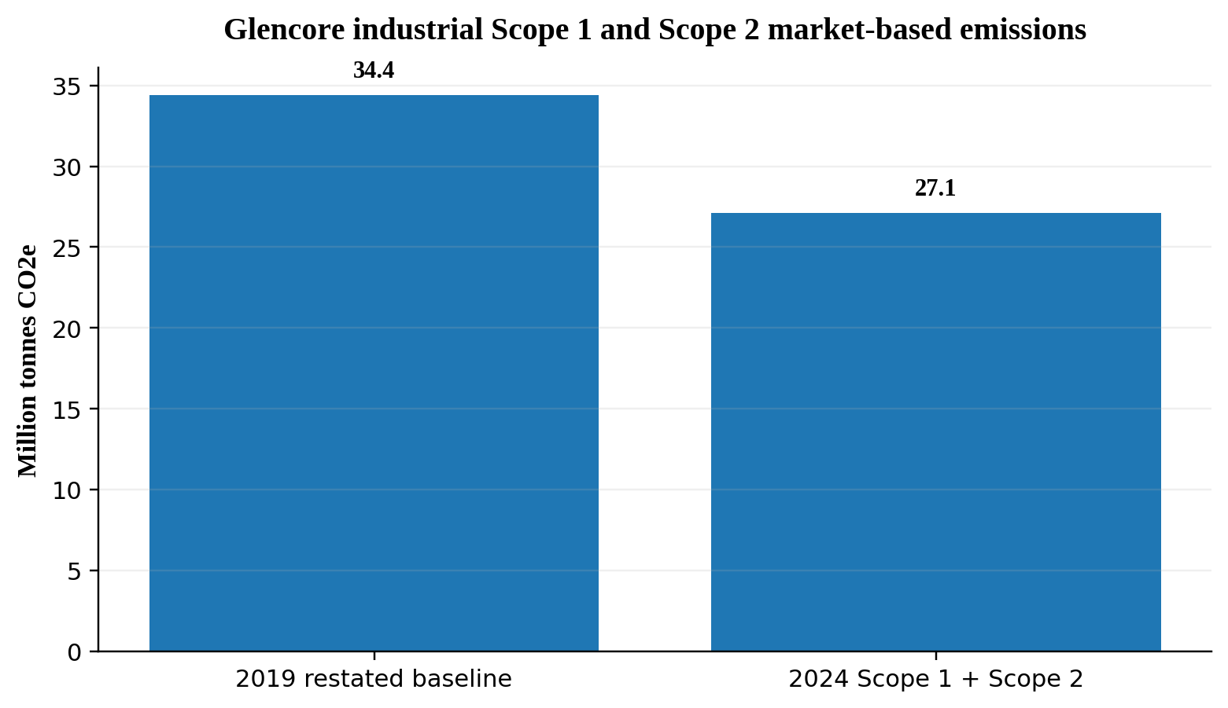
Figure 1. Glencore industrial Scope 1 and Scope 2 market-based emissions, 2019 baseline versus 2024.
Source: Glencore (2025b).
The problem here is the portfolio of Glencore. The climate action plan recognises the need to phase down the coal while investing more in transition-enabling commodities and new business models like recycling and carbon solutions (Glencore, 2024). However, such an approach creates a dilemma. Coal may provide short-term revenue and energy security, but the higher the reliance on coal, the higher is the transition risk and pressure as well as potential climate regulation. On the contrary, copper, nickel, cobalt and zinc may benefit from the demand driven by the electrification and low-carbon technologies (IEA, 2024; Srivastava and Kumar, 2024). The lower-carbon strategy cannot be limited to the operational efficiency. It should gradually enhance the commercial attractiveness of the transition-enabling activities.
The shift is reflected in the capital allocation of the company. As indicated by the 2024 Annual Report, about 65% of industrial capital expenditure was invested in copper and cobalt, zinc and nickel assets and the company expected that the majority of industrial capital expenditure would be directed to transition-enabling commodities in the next three years (Glencore, 2025b). The point is important because it relates environmental pressures to the strategic resource allocation.
However, environmental pressures also present risks that may be covered by the simplistic “green growth” narrative. The higher demand for the transition metals may lead to the larger amount of mining waste, land disturbance and water impact. Organisational, technical and environmental barriers to the adoption of circular economy in the mining sector are described by Osei et al. (2023), and the importance of the reliable and governed critical-minerals supply is emphasised by (Dou et al. 2023). The additional copper is not necessarily sustainable. The company should reduce the environmental footprint per unit of metal produced and maximise the recycling whenever possible.
This is also a marketing problem. As mining products are mostly commodities, the environmental performance is only differentiating in case of the credible and measurable performance. According to Adomako and Tran (2022) – based on the data of 194 mining companies – sustainable environmental strategy can positively affect the competitiveness of the firm, especially in case of the market orientation. However, too ambitious sustainability claims may harm the firm’s credibility. Companies are under the greenwashing risk when the environmental messages are not supported by the performance (Johnson and Greenwell, 2022). Therefore, Glencore should use only credible, measurable carbon improvements in its communications.
In general, the environment actor creates both opportunities and constraints. Climate pressures increase the value of the transition metals and clean production, but also create the penalty for the poor environmental performance. Therefore, the optimal response to the environment actor is the portfolio change coupled with operational decarbonisation and circularity.

2.2 Technology actor: electrification, digitalisation and low-carbon processing
Technology affects the mining costs and the customer value. Glencore’s climate action plan identifies electrification and alternative fuels as operational solutions and recycling and carbon solutions as new business models (Glencore, 2024). This means that technology goes beyond the boundaries of the company. Glencore relies on the developers of technology, equipment providers, energy systems and process innovations that allow translating the climate ambition into low-carbon products.
The research in Mining 4.0 shows that digital and intelligent mine systems can improve safety, efficiency and low-carbon profile of the operations. However, the environmental performance should be an integral part of the design rather than an afterthought (Jiskani et al., 2023). In other words, the digitalisation should be chosen in case when it simultaneously improves the operational performance and environmental control.
The technology is just an enabler, not a guarantee. Glencore should focus on the technologies which reduce the total cost, increase asset reliability and lower emissions. The marketing capabilities of the company are important because they allow to connect producers with customers and translate technical performance into customer value. Digital traceability may increase the strength of this connection. Demessie and Shukla (2024) find the link between sustainable marketing outcomes and competitive advantage and eco-technology capabilities.
The best opportunity for the company is to combine the clean technology with products. The low-carbon electricity, electrified equipment, data-based monitoring, recycled feedstock and credible emissions data may help to Glencore in offering lower-carbon metals. It will be more credible than just announcing the “green” product. Technology is a source of competitive advantage when it allows lowering the emissions, improving traceability and making informed customers.

2.3 Social actors: communities, workers, regulators and stakeholders
Mining impacts individuals living in close proximity to mining operations and processing facilities as well as workers, subcontractors, Indigenous peoples, local businesses and government organizations. Such social actors may impact the legitimacy of Glencore through their beliefs regarding safety, hiring, land usage, access to water, human rights and the sharing of economic gains. The company’s size and international reach call for consistent engagement, but local impacts call for timely and targeted engagement (Glencore, 2025e; Maybee, Lilford and Hitch, 2023).
The social acceptance cannot be achieved through one-sided communication and philanthropic projects only. According to Meesters et al. (2021), the social licence to operate pertains to the legitimacy of resource extraction and overall sustainability, whereas Lindman, Ranängen and Kauppila (2020) emphasize the importance of comparing a corporation’s responsibilities to the needs of stakeholders. Consequently, Glencore should listen to their concerns from an early stage, inform stakeholders about expected impacts, publish comprehensible findings of monitoring activities and demonstrate how feedback influences decision making. Engagement should take place at all stages of a mine’s lifecycle in affected areas.
Potential social risks are related to health and safety, working conditions, land and water access, and quality of grievance procedures. Poor management of such risks may cause delays, intensify conflicts and result in negative reputational impact, but it does not release the company from its duty to ensure protection. Chipangamate et al. (2023) stress the importance of integration of stakeholder engagement practices into modern mining. Glencore should define affected stakeholders, capture their concerns, appoint responsible owners of concerns and provide transparent responses even when they are not able to address a particular concern immediately.
Social actors should be seen as decision-makers, not merely receivers of corporate message. Consistent dialogue, available complaints mechanism and visible follow-up may help in building trust and thus in protecting the social licence of the mine.

2.4 Integrated assessment
There are three actors involved. Environmental pressure leads to technological innovation, and the social actors determine how mining practices will be accepted and regulated. Technology may help in emission reduction and monitoring, although the effectiveness depends on how impacts are managed. This interaction is well articulated in Table 1 and Figure 2.
Table 1. External actor analysis for Glencore.
Actor | Evidence | Main opportunity | Main threat | Strategic implication
Environment | 2024 Scope 1 and 2 emissions: 27.1 Mt CO2e; 21.4% below 2019 baseline (Glencore, 2025b). | Growth in transition-enabling metals and lower-carbon products. | Climate risk, coal exposure and environmental impacts of mining. | Shift capital and capability towards lower-carbon, transition-enabling activities.
Technology | Electrification, alternative fuels, recycling and carbon solutions are in Glencore’s climate plan (Glencore, 2024). | Lower emissions, lower operating cost and traceability. | High capital cost, immature technologies and implementation risk. | Select technologies using carbon, cost and reliability tests.
Social actors | Communities, workers and authorities report concerns over safety, land, water and fair benefits (Meesters et al., 2021). | Stronger trust, legitimacy and relationships with affected communities. | Conflict, safety failures, grievance concerns and reputational scrutiny. | Prioritise dialogue, clear grievance routes and transparent follow-up.
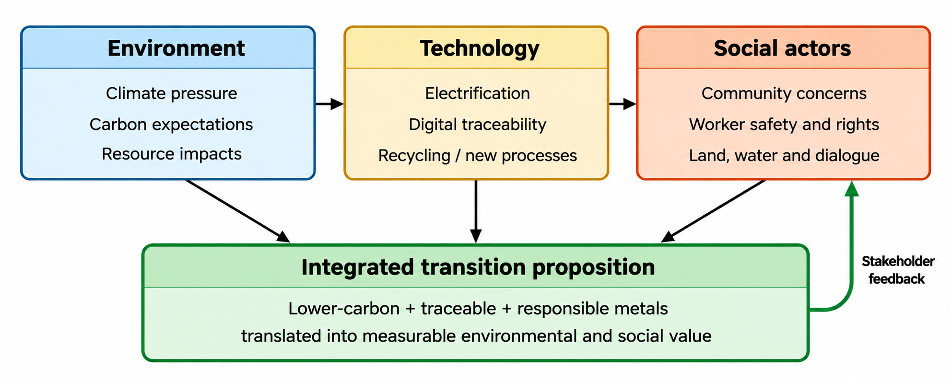
Figure 2. Integrated external-actor pathway for Glencore.
Source: Self-Developed

3. Task 2: Strategic Growth and Competitive Positioning

3.1 Ansoff Matrix assessment
Ansoff’s product and market matrix allows the management to relate the growth strategy to product and market risks. In the case of Glencore, market penetration would involve enhancing carbon efficiency for current products and markets. Market development involves using the current metals for new low carbon chain or markets. Product development involves introducing new low carbon or recycled offerings to the current industrial clients. Diversification involves entering into new products and markets such as broader recycling or carbon solutions.

Source: Self-developed from Kotler, Armstrong and Balasubramanian (2024) and Glencore (2024; 2025d).

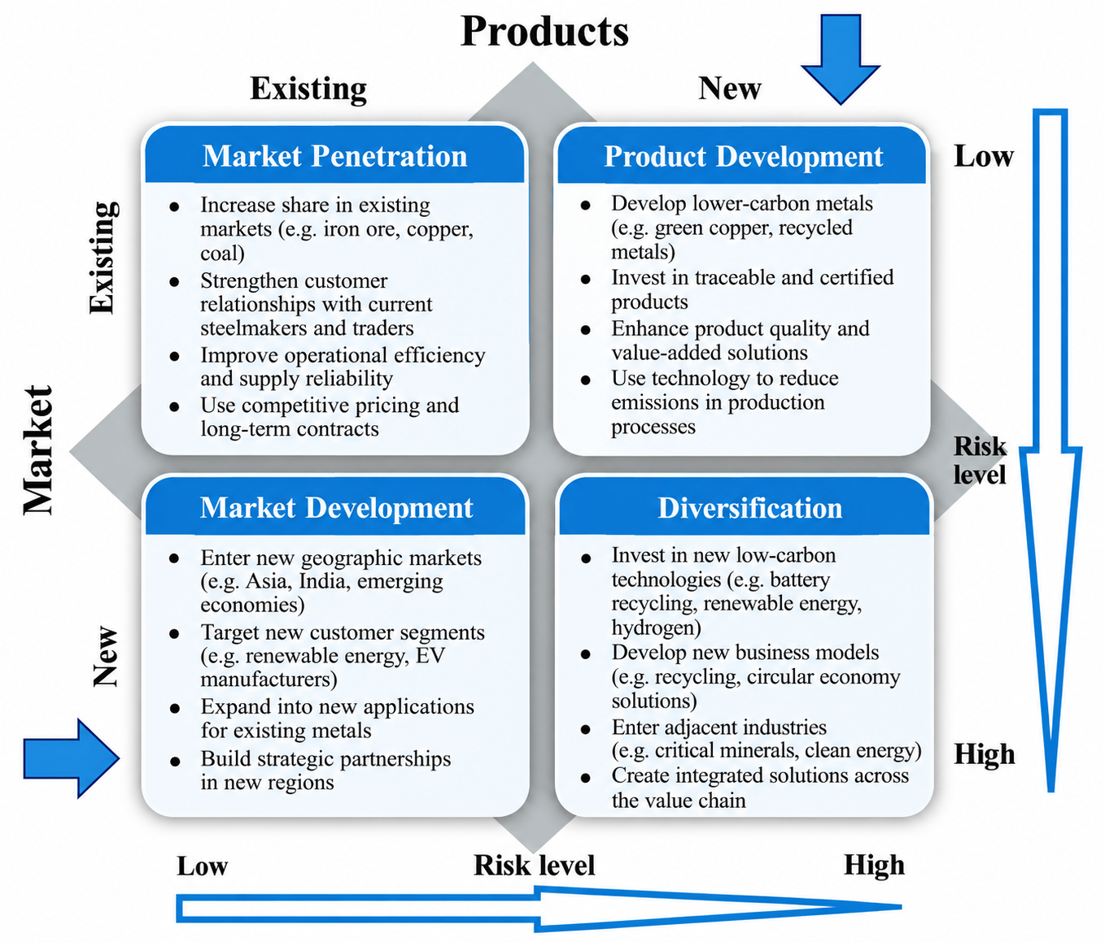
Figure 3. Ansoff Matrix applied to Glencore’s lower-carbon growth options.

The product development approach is the best primary route. Glencore already has mining, processing, marketing and customer connections. It can thus create new value propositions while not compromising its existing competencies. The Capital Markets Day 2025 has laid out the path towards more than 1 million tonnes of copper produced annually by 2028 and about 1.6 million tonnes by 2035 (Glencore, 2025d). Such growth can be associated with low-carbon products, assuming that it is accompanied by credible emissions reductions and improved traceability.
It should not be the pure growth in copper volume. The target should be a unique offer based on low-carbon production, realistically feasible recycled content, credible emissions data and reliable supply. Such an approach is consistent with the findings that the sustainability strategy can support competitiveness if combined with market orientation (Adomako and Tran, 2022), and sustainable marketing results depend on available resources, environmental policies and eco-technologies (Demessie and Shukla, 2024).
The market development should support rather than substitute product development. Glencore can build deeper connections with steel companies, battery manufacturers and other customers under decarbonisation pressure. The long-term contracts, traceability dashboards, lifecycle data and joint pilots can transform commodity supplier-customer relationship into a strategic B2B collaboration.
Recycling can be an attractive diversification route, but it should be gradual. There are technical, organisational and infrastructural barriers to circular mining identified in the literature, which means that recycling should be scaled up via controlled pilots and partnerships, rather than just assumed to be efficient (Osei et al., 2023). Thus, the company should focus on partnerships, pilots and targeted acquisitions, and not attempt a quick and massive diversification.

3.2 Competitive positioning- Porters Generic Strategies
The suggested competitive positioning is focused differentiation with robust cost discipline. Pure price leadership is unfeasible as the prices are set externally. Pure differentiation is risky due to possible unwillingness of customers to pay an additional premium for environmental characteristics. Instead, the better positioning would be “measurable lower-carbon value”: environmental performance credibility with reliability of supply, scale, quality, traceability and marketing competencies.
Such positioning can provide three interrelated advantages. Firstly, the better environmental performance would mitigate regulatory and reputational risks. Secondly, technology and digital traceability would enhance customer switching costs via joint data and long-term relations. Finally, the integrated mining and marketing strategy of the company can link physical supply with the customer-specific offers. Such advantages are consistent with the findings that the sustainability can support the competitiveness of the company, but only if it is embedded in the strategy (Park, 2023; Kim et al., 2024).
Table 2. Strategic option comparison.
Option | Fit with lower-carbon transition | Risk | Recommendation
Market penetration | Moderate | Low | Supporting action
Product development | Very high | Medium | Primary strategy
Market development | High | Medium-high | Secondary growth route
Diversification | High | High | Selective, staged use

4. Task 3: Managerial and Professional Reflection
I have chosen Glencore because it offers a realistic leadership dilemma rather than a sustainability case study. The portfolio of the company consists of coal and copper, zinc, nickel and cobalt, and its management should balance the current income generation and future transition value (Glencore, 2025b). That makes my analysis helpful for senior leaders as the dilemmas are apparent.
I have focused on the natural environment because it is mentioned in the summary, and issues such as climate and resources impact the entire scenario. I have looked into the factors of technology and social actors to connect the environmental issue to action, community, and legitimacy. The major strategic choice that I would make for this business would be product development as opposed to diversification. The basis of my strategic choice stems from the capabilities, customers, and pipeline of Glencore, plus the dangers of establishing new ventures too fast.
The limitation is the reliance on the publicly available secondary information. A consultant would need emissions data for each facility, marginal abatement cost curve, carbon footprints for each product, evidence of willingness to pay, contract structures, technology readiness data and competitor benchmarking before the final approval. This limitation is important because corporate reports provide the strategy from the management point of view. Moreover, the ESG studies prove that environmental risks and opportunities are different at each stage of the mining life cycle (Maybee, Lilford and Hitch, 2023).
Another limitation is uncertainty in the demand and policy in the future. IEA (2024) identifies risks related to the supply, geopolitics and ESG, while the transition plan of Glencore states that the pace of decarbonisation depends on external economic and political factors (Glencore, 2024). Therefore, senior leadership should see the recommendation as a staged strategic direction with certain review points, and not as a forecast.
From the professional standpoint, the most important lesson is that marketing in the mining industry becomes increasingly related to the proof of the value across the whole value chain. Marketing should cooperate closely with operations, sustainability, technology, finance and customers. It would help Glencore to make its environmental performance a credible commercial proposition.

5. Conclusion
Glencore operates in a complex marketing environment wherein environmental pressure, technological change, and social expectations are increasingly connected. While its 2024 emissions performance and increased capital allocation to transition-enabling commodities reflect progress, the company’s reliance on coal and the industry’s environmental and social impacts create unresolved strategic tensions (Glencore, 2024; Glencore, 2025b). Product development is the preferred Ansoff growth opportunity. The company should focus on developing demonstrable lower-carbon and circular metal propositions to its existing industrial customers, supplemented by selective market development and a staged diversification into recycling. This approach is preferable to a “green” positioning because it integrates environmental performance, technology, customer value, and competitive advantage. For senior leadership, the emphasis should be on execution, transparency, and review.

Reference List
Adomako, S. and Tran, M.D. (2022) ‘Sustainable environmental strategy, firm competitiveness, and financial performance: evidence from the mining industry’, Resources Policy, 75, 102515. https://doi.org/10.1016/j.resourpol.2021.102515
Chipangamate, N.S., Nwaila, G.T., Bourdeau, J.E. and Zhang, S.E. (2023) ‘Integration of stakeholder engagement practices in pursuit of social licence to operate in a modernising mining industry’, Resources Policy, 85, 103851. https://doi.org/10.1016/j.resourpol.2023.103851
Demessie, G.T. and Shukla, A. (2024) ‘Drivers and outcomes of sustainable marketing strategy in the African context: the role of competitive advantage and strategic proactivity as mediating and moderating variables’, Cogent Business & Management, 11(1), 2348442. https://doi.org/10.1080/23311975.2024.2348442
Dou, S., Xu, D., Zhu, Y. and Keenan, R.J. (2023) ‘Critical mineral sustainable supply: challenges and governance’, Futures, 146, 103101. https://doi.org/10.1016/j.futures.2023.103101
Glencore (2024) 2024-2026 Climate Action Transition Plan. Glencore plc. https://www.glencore.com/sustainability/esg-a-z/climate-change
Glencore (2025a) Full Year 2024 Production Report. Glencore plc, 30 January. https://www.glencore.com/media-and-insights/news/full-year-2024-production-report
Glencore (2025b) 2024 Annual Report. Glencore plc, 18 March. https://www.glencore.com/.rest/api/v1/documents/static/7a4295e4-3674-45e9-94c4-7d7fb285faff/GLEN-2024-Annual-Report.pdf
Glencore (2025c) Third Quarter 2025 Production Report. Glencore plc, 29 October. https://www.glencore.com/media-and-insights/news/third-quarter-2025-production-report
Glencore (2025d) Glencore Capital Markets Day 2025. Glencore plc, 3 December. https://www.glencore.com/media-and-insights/news/glencore-capital-markets-day-2025
Glencore (2025e) 2025 Half-Year Report. Glencore plc, 6 August. https://www.glencore.com/media-and-insights/news/2025-half-year-report
IEA (2024) Global Critical Minerals Outlook 2024. Paris: International Energy Agency. https://www.iea.org/reports/global-critical-minerals-outlook-2024
Jiskani, I.M., Zhou, W., Hosseini, S. and Wang, Z. (2023) ‘Mining 4.0 and climate neutrality: a unified and reliable decision system for safe, intelligent, and green & climate-smart mining’, Journal of Cleaner Production, 414, 137313. https://doi.org/10.1016/j.jclepro.2023.137313
Johnson, T.F. and Greenwell, M.P. (2022) ‘Are companies using Twitter to greenwash and hide bad environmental performance?’, Energy, Ecology and Environment, 7(3), pp. 213-226. https://doi.org/10.1007/s40974-021-00237-y
Kim, Y.M., Bendle, N., Hulland, J. and Pfarrer, M.D. (2024) ‘Corporate sustainability research in marketing: mapping progress and broadening our perspective’, Journal of the Academy of Marketing Science, 52(5), pp. 1495-1512. https://doi.org/10.1007/s11747-024-01050-9
Kotler, P., Armstrong, G. and Balasubramanian, S. (2024) Principles of marketing. 19th global edn. Harlow: Pearson. https://www.pearson.com/en-gb/subject-catalog/p/principles-of-marketing-global-edition/P200000010013/9781292740836
Lindman, Å., Ranängen, H. and Kauppila, O. (2020) ‘Guiding corporate social responsibility practice for social license to operate: a Nordic mining perspective’, The Extractive Industries and Society, 7(3), pp. 892-907. https://doi.org/10.1016/j.exis.2020.07.013
McKinsey (2024) Global Materials Perspective 2024. McKinsey & Company, 17 September. https://www.mckinsey.com/industries/energy-and-materials/our-insights/global-materials-perspective-2024
Maybee, B., Lilford, E. and Hitch, M. (2023) ‘Environmental, Social and Governance (ESG) risk, uncertainty, and the mining life cycle’, The Extractive Industries and Society, 14, 101244. https://doi.org/10.1016/j.exis.2023.101244
Meesters, M., Wostyn, P., van Leeuwen, J., Behagel, J. and Turnhout, E. (2021) ‘The Social Licence to Operate and the legitimacy of resource extraction’, Current Opinion in Environmental Sustainability, 49, pp. 7-11. https://doi.org/10.1016/j.cosust.2020.11.002
Osei, V., Bai, C., Asante-Darko, D. and Quayson, M. (2023) ‘Evaluating the barriers and drivers of adopting circular economy for improving sustainability in the mining industry’, Resources Policy, 86, 104168. https://doi.org/10.1016/j.resourpol.2023.104168
Park, S.-B. (2023) ‘Bringing strategy back in: corporate sustainability and firm performance’, Journal of Cleaner Production, 388, 136012. https://doi.org/10.1016/j.jclepro.2023.136012
Sander, F., Föhl, U., Walter, N. and Demmer, V. (2021) ‘Green or social? An analysis of environmental and social sustainability advertising and its impact on brand personality, credibility and attitude’, Journal of Brand Management, 28, pp. 429-445. https://doi.org/10.1057/s41262-021-00236-8
Soares, A.F., Spers, R.G. and de Oliveira Santos Jhunior, R. (2025) ‘Projection of global copper demand in the context of energy transition’, Resources Policy, 103, 105567. https://doi.org/10.1016/j.resourpol.2025.105567
Srivastava, N. and Kumar, A. (2024) ‘Critical minerals for energy transition: the emerging regime complex’, The Extractive Industries and Society, 20, 101536. https://doi.org/10.1016/j.exis.2024.101536
UNEP (2024) Global Resources Outlook 2024: Bend the Trend. Nairobi: United Nations Environment Programme / International Resource Panel. https://www.unep.org/resources/Global-Resource-Outlook-2024

