An analysis of the role and importance of social media marketing in the UK beverage sector: A case study of Costa Coffee
Student ID:2028275
Student Name: Mariya Georgieva Malamova
Supervisor name: Riaz Bhatti

Table of Contents
Chapter 1: Introduction 3
Background 3
Significance of the topic 4
Purpose of the research 4
Proposed aim, objectives and research questions 5
Chapter 2: Literature Review 6
Social media channels Costa Coffee use to interact with its audience 6
Influence of social media marketing on the level of brand recognition of Costa Coffee in the United Kingdom 7
Costa Coffee's social media campaigns in the UK 7
Best Practices for enhancement in Costa Coffee's social media marketing strategy inside UK 8
Chapter 3: Research Methods and Methodology (use future tense) 8
Research Philosophy 8
Research Approach 8
Descriptive Research Design 9
Data collection methods 9
Data interpretation 9
Time prospects of the research (Gantt chart) 9
Ethical consideration 10
Chapter 4: Conclusion 10
References 11

Chapter 1: Introduction

Background
In today's digital age, firms can't do without social media marketing to connect with consumers and build brand recognition. More and more people are using social media to communicate with their target demographic, and businesses are capitalising on this trend by establishing robust online profiles. The proliferation of social media has allowed the business to expand its customer base and raise awareness of its products (Filimonau, et al., 2019). Costa Coffee often uses social media to solicit comments, contest entries, and story sharing from its fans. New items, deals, and promotions for Costa Coffee have also been greatly helped by social media marketing. In order to boost sales and attract more customers, the firm often announces the release of new products, deals, and limited-time offers on social media. Sharing user-generated material, customer testimonials, and peeks inside Costa Coffee's operations on social media helps to strengthen the brand's image and credibility. Costa Coffee's sales climbed once again in 2019. For the fiscal year ending February 28, 2019, Costa Limited recorded revenues of 1.34 billion British pounds, up from 1.29 billion the previous year. In January 2019, the firm was bought out by a Coca-Cola firm subsidiary from parent company Whitbread (Statista, 2019).
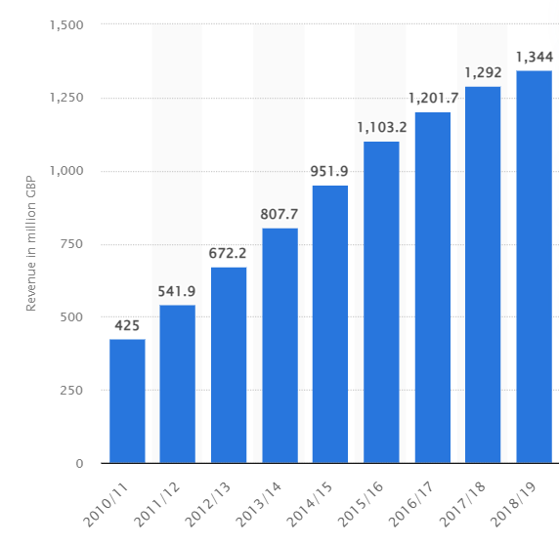
Fig. 1: Revenue of Costa Coffee worldwide from fiscal year 2010/11 to 2018/19
(Source: Statista, 2019)

Significance of the topic
Social media sites like Twitter, Instagram, and Facebook have given businesses fresh opportunities to reach consumers and raise product recognition. Social media is an opportunity for a brand like Costa Coffee to connect with its consumers on a more individual level, and the company has taken notice. Costa Coffee has established a formidable social media presence, enabling them to advertise their wares, interact with consumers, and generate revenue, with more than 1.1 million Instagram followers and 500,000 Twitter followers (Stroud, 2023). The capacity to build consumer loyalty and a feeling of community is a key component of Costa Coffee's social media marketing strategy. Costa Coffee's social media marketing has been crucial in growing the company's client base, promoting its products, and ultimately, boosting revenue.

Purpose of the research
Social media marketing has evolved into an essential component of the marketing strategy for a great number of companies all over the globe, including those in the United Kingdom. As a result of the proliferation of social media platforms like Facebook, Instagram, and Twitter, companies now have the extraordinary potential to communicate with and connect with their target audience in a manner that is both more personal and more dynamic. A beverage business in the United Kingdom, Costa Coffee, will be the subject of this research, which will concentrate on the function and value of social media marketing for the firm, and will include statistics and examples to support the topic.

Proposed aim, objectives and research questions
Aim
The aim of this study is to comprehend the function and significance of social media marketing inside the marketing strategy used by Costa Coffee in the United Kingdom.
Objectives:
- To assess the social media presence of Costa Coffee in the United Kingdom, including an examination of the platforms used, the frequency of posts, and the nature of the material disseminated.
- To evaluate the efficacy of social media marketing in effectively reaching and engaging the intended target audience of the organisation.
- To examine the effects of social media marketing strategies on the levels of brand recognition and consumer perception of Costa Coffee.
- To comprehend the impact of social media on consumer loyalty and its ability to shape purchasing decisions.
- To analyse Costa Coffee's social media marketing strategy in order to find optimal practises and areas that may benefit from enhancement.
Research Question:
RQ 1: What social media channels does Costa Coffee use to interact with its audience in the United Kingdom, and what categories of material are disseminated?
RQ 2: What is the influence of social media marketing on the level of brand recognition and consumer perception of Costa Coffee in the United Kingdom?
RQ 3: How Costa Coffee's social media campaigns in the UK successfully reached and engaged their target demographic?
RQ 4: What is the impact of social media marketing on customer loyalty and purchasing behaviour for Costa Coffee in the United Kingdom?
RQ 4: What are the optimal methodologies and prospective domains for enhancement in Costa Coffee's social media marketing strategy inside the United Kingdom?

Chapter 2: Literature Review

Social media channels Costa Coffee use to interact with its audience
The advent of social media platforms has provided companies with a convenient means to reach their intended consumer base and disseminate information about their goods and services. In addition, social media plays a significant role in enhancing client awareness of a business. Getaruelas (2019) stated that the majority of respondents were active users of social media, particularly Facebook, YouTube, and Instagram; hence, it is crucial for Tim Horton's, Starbucks, and Costa to seize social media and participate creatively to raise target market awareness. As per Costa (2018), Costa Coffee has over 2.8 million Facebook followers and engages them with a range of material. The brand updates, reacts to consumer questions, and chats with around 300k Twitter followers. Costa Coffee has over 1.3 million Instagram followers and provides visually stunning photographs of its drinks and cafés, engaging their audience. Costa Coffee has also used YouTube to make engaging videos.
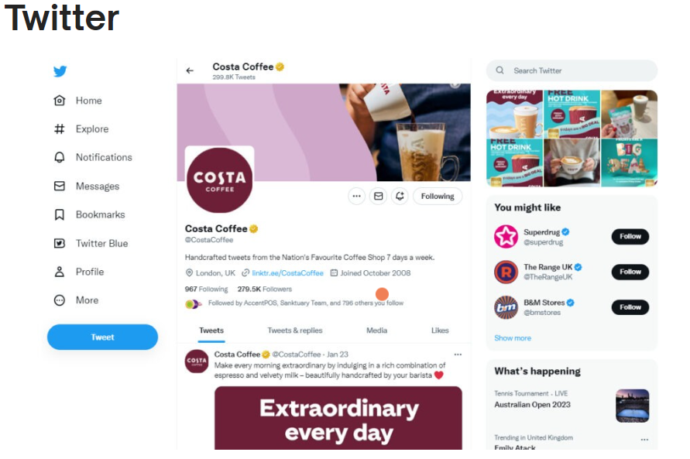
Fig. 2: Costa Coffee Twitter Page
(Source: Stroud, 2023)

Influence of social media marketing on the level of brand recognition of Costa Coffee in the United Kingdom
According to Aljarah et al. (2022), Costa Coffee has increased its UK brand awareness via targeted advertising and clever content sharing. Social media marketing has helped the firm reach more people and spread its brand message. Images and videos of its goods and coffee culture have connected with its audience and strengthened its brand image. Social media also lets Costa Coffee react to consumer questions, comments, and concerns in real time which has helped the organisation create consumer trust and community, enhancing brand awareness. Influencer marketing has also helped Costa Coffee's brand awareness. Costa Coffee has also stayed ahead of its competition by inventing and adapting to the digital world via social media marketing. The firm has used viral ads, social media competitions, and user-generated content to build brand awareness.
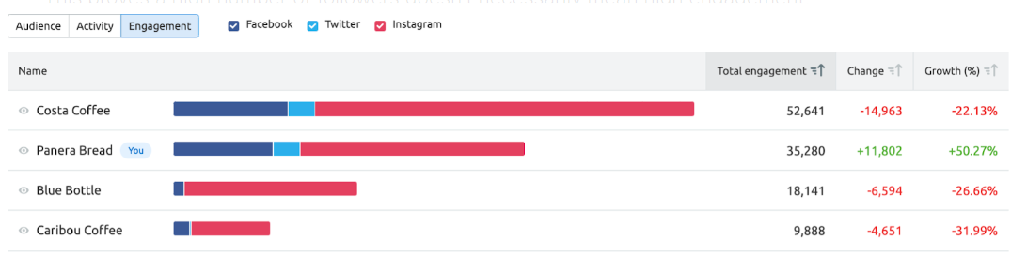
Fig. 3: User Engagement on Costa Coffee social media
(Opryshko, 2022)

Costa Coffee's social media campaigns in the UK
The "Costa Coffee Club." is a popular UK social media promotion for Costa Coffee. This loyalty strategy rewards repeat buyers (Costacoffee.in, 2023). Social media is used to promote programme perks like collecting points for purchases and getting free beverages and other prizes. Costa Coffee promotes consumer loyalty and repeat business by encouraging followers to join the Costa Coffee Club via interesting and interactive postings. Costa Coffee's social media promotions promote seasonal and limited-time products. Innovative beverages and cuisine are the company's speciality, and social media helps promote them. Costa Coffee promotes new items with visually attractive postings. Costa Coffee utilises social media to connect with consumers privately as well as promote its goods and loyalty programme. Responding to consumer concerns, comments, and feedback builds community and engagement with followers (Putri et al., 2020). Costa Coffee uses user-generated content like customer images and anecdotes to build its audience engagement. Social responsibility and sustainability are another highlight of Costa Coffee's UK social media efforts. The firm promotes ethical sourcing, environmental sustainability, and community support. Costa Coffee attracts socially aware customers and stands out in a competitive industry by promoting its ideals on social media.

Best Practices for enhancement in Costa Coffee's social media marketing strategy inside UK
Costa Coffee has to put its energy into creating posts that its target demographic finds interesting and useful. As per Ashbeck (2020), Costa Coffee can establish a solid social media presence and maintain audience engagement by regularly publishing high-quality, aesthetically pleasing content. The firm may target customers with its Facebook and Instagram advertisements, increasing the likelihood that its content would be viewed by those who might be interested in its goods and services. Also, Costa Coffee has to be prompt in replying to messages and comments if it wants to keep its audience engaged. Dufour and Richard (2019) studied that Customers will feel more connected to the brand and be more likely to recommend it to others if the company takes the time to cultivate a strong social media community and encourages two-way contact. A user-generated content strategy that encourages consumers to post about their own experiences with the Costa Coffee brand on social media would also be beneficial to the company. The firm can improve its social media strategy by studying important data like engagement, reach, and click-through rates to determine the content that connects best with its audience.

Chapter 3: Research Methods and Methodology (use future tense)

Research Philosophy
Examining the impact of social media marketing on Costa Coffee is guided by positivism, a research ethic that emphasises the need of testing and confirming hypotheses via empirical means (Alharahsheh and Pius, 2020). To better comprehend and explain social processes, this philosophical framework stresses the need of collecting and analysing data using scientific techniques.

Research Approach
The deductive research approach refers to a methodical procedure that involves the testing of theories and the development of hypotheses. A broad theory serves as the foundation for this research technique, which then evaluates individual hypotheses that are developed from that theory (Pandey, 2019). The deductive research approach is well suited to the investigation of Costa Coffee's social media marketing strategy.

Descriptive Research Design
Descriptive research design has been opted in the scholarly investigation of the effect that social media marketing has on Costa Coffee. Researchers are able to collect and examine data using this form of study methodology, which enables them to give a full picture of the phenomena that is being examined.

Data collection methods
As per Dufour and Richard (2019), the process of doing secondary qualitative research include reviewing and interpreting results from previously conducted research. When studying narrow phenomena or issue, like social media marketing, this method excels because it enables researchers to collect detailed information from many different sources. Researchers conducting secondary qualitative research on the topic of social media marketing's effect on Costa Coffee can draw from a wealth of sources, including comments and reviews left by customers, reports from the industry, and scholarly articles, to draw conclusions about the marketing strategy's efficacy.

Data interpretation
Thematic analysis is a research methodology used to identify, examine, and present recurring themes within qualitative data. This procedure has potential advantages for the examination of social media marketing, since it enables scholars to decipher the intricate and multifaceted narratives that arise from digital conversations and engagements. Thematic analysis may provide useful insights into the influence of social media marketing on customer perceptions and behaviours within the context of Costa Coffee, a renowned global coffeehouse company.

Time prospects of the research (Gantt chart)
ACTIVITIES | Week 1 | Week 2 | Week 3 | Week 4 | Week 5 | Week 6 | Week 7 | Week 8 | Week 9 | Week 10
Topic Selection
Research Aims and Objectives
Literature Review
Methodology
Secondary Data Collection
Findings from Thematic Analysis
Conclusion and Recommendations
Submission

Ethical consideration
Ethical considerations are of paramount importance in any research endeavours, particularly those pertaining to the examination of marketing practises and their effects on both firms and consumers. When examining the impact of social media marketing on Costa Coffee, it is crucial to uphold ethical principles in order to maintain the credibility and reliability of the study. The scholarly journals chosen should be authentic for the purpose of the research.

Chapter 4: Conclusion
To conclude, Costa Coffee would not have been as successful without social media marketing. Costa Coffee has increased its standing in the cutthroat coffeehouse business by using social media to establish and sustain a presence for its brand, interact with consumers, draw in new customers, and collect useful data. Costa Coffee will have to change the way it uses social media to attract and retain consumers if it wants to keep up with the ever-changing landscape of online communication.

References
Alharahsheh, H. and Pius, A. (2020). A Review of Key paradigms: Positivism VS Interpretivism. Global Academic Journal of Humanities and Social Sciences, 2(3), pp.39–43.
Aljarah, A., Ibrahim, B., Lahuerta-Otero, E. and García de los Salmones, M. del M. (2022). Doing good does not always lead to doing well: the corrective, compensating and cultivating goodwill CSR effects on brand defense. Current Issues in Tourism, pp.1–14.
Ashbeck, H. (2020). Coffee Shop Communication: Social Media & Engagement. minds.wisconsin.edu.
Costa, E. (2018). Affordances-in-practice: An ethnographic critique of social media logic and context collapse. New Media & Society, 20(10), pp.3641–3656.
Costacoffee.in (2023). Costa Coffee: Say Hello to Free Coffee. Costacoffee.in.
Dufour, I.F. and Richard, M.-C. (2019). Theorizing from secondary qualitative data: A comparison of two data analysis methods. Cogent Education, 6(1).
Filimonau, V., Krivcova, M. and Pettit, F. (2019). An exploratory study of managerial approaches to food waste mitigation in coffee shops. International Journal of Hospitality Management, 76, pp.48–57.
Getaruelas, R. (2019). IMPACT OF SOCIAL MEDIA ADVERTISEMENT TO THE CUSTOMER PRODUCT BRAND AWARENESS OF SELECTED INTERNATIONAL COFFEE SHOPS IN MUSCAT, OMAN: AN INQUIRY TO THE CUSTOMER. Asian Journal of Management Sciences & Education, 8(1).
Opryshko, V. (2022). A 6-Step Guide to Social Media for Small Businesses. Semrush Blog.
Pandey, J. (2019). Deductive Approach to Content Analysis. Qualitative Techniques for Workplace Data Analysis.
Putri, A.R.A., Nisa, I.K., Yee, L.H., Kee, D.M.H., Min, K.H., Yi, L.S. and Xin, L.J. (2020). J.CO Coffee & Donuts Marketing Strategy. Asia Pacific Journal of Management and Education, 3(1), pp.72–81.
Statista (2019). Costa Coffee: revenue 2010-2018 | Statista. [online] Statista. Available at: https://www.statista.com/statistics/579810/costa-coffee-revenue/.
Stroud, S. (2023). Social Media Case Study: How do Costa Coffee use it? Giraffe Social Media.

