Digital Skills and Research Methods

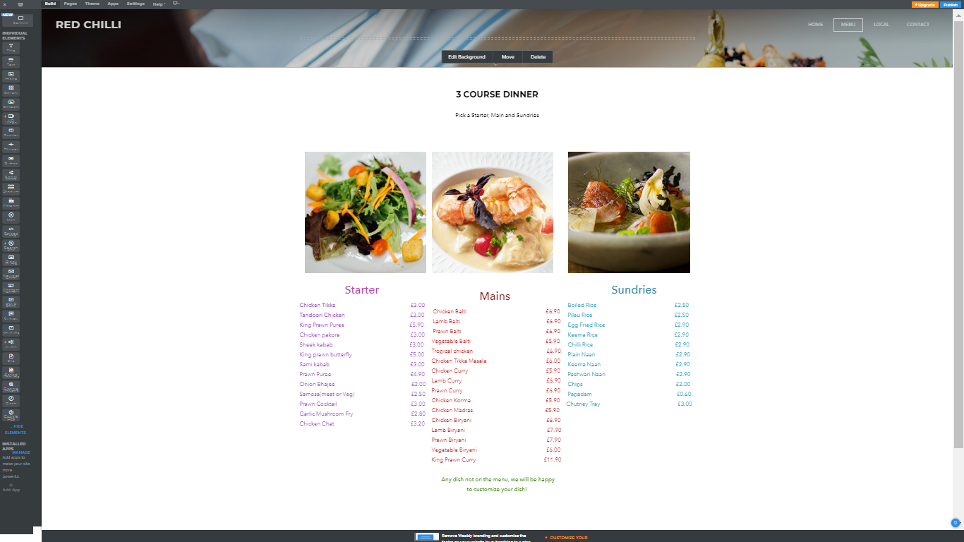
Screenshot of the contribution I have made for the website:
MAKE A RESERVATION

Contribution Audit
My task was to produce a website for the business idea my group has chosen. I done the menu section of the website which is called Red Chilli. I also completed the questionnaire on Google Forms.
Group Name and Participants
Group Name: Red Chilli
Participants in the group: Mohammad Sirajul Hoque, Mujibur Rahman, Mohammed Faruki, Sayed Jalal, Rihana Fariz.

Google Account of the group
Email: redchilli158@gmail.com
Password: redchilli12345

Questionnaire
I have conducted a questionnaire of five questions about the service of Red Chilli after the customer has visited, on Google Forms.


