Assignment Title. Engineering Design (External pipe climber project)

Module code. M4X01160

External Pipe Crawler Design Project: Group C

Challenge Specification:
1. The device can be of any safe design, but it must be self-contained and at all times during the competition fit within the maximum dimensions stated for the particular project.
2. The Device Controller is the only person who is allowed to attend to the device during the preparation and start of each heat. The teams competing in a heat will be required to start their devices simultaneously. Once started there can be no outside interference from the Device Controller who must step away from the apparatus.
3. The device must have a means of satisfactorily attaching any external member if required (such as a chain or line etc.)
4. A full parts list must be produced. Receipts, or verification, must be provided ahead of the competition for inspection by the judges. The total cost of the device (including VAT at 20%) is to be under £25 for the 1st year competition.
5. All parts must be listed with the as-new normal retail purchase price from established suppliers (including VAT, but excluding carriage). Invoices and receipts, or verification, are required to be included with the parts list.
6. Parts with a value of less than £0.20 should be included on the parts list but do not need to be included in the total price (considered free). Components in-kind or provided by the university must be included in the parts list, and costed as appropriate.
7. The cost must include all parts and materials on or over £0.20 used to make the device and any replacement or substitute parts used during the regional events. However spare sets of batteries for example to be changed during the heats need not be counted towards the £25.
8. While the cost of generic tools (drills, saws, files, etc.) need not be included, specialised and unique tools need to be accounted for. For example, a machined wooden former costing £5 used to vacuum form a part during construction must be included as it is bespoke to this item. However the milling cutters used to make the former need not be included. Likewise a battery charger or air compressor can be excluded as they are considered general-use workshop items.
9. Standard sheet/bar materials should be charged as a proportion used per device, within reason. For example if the purchase of a 6m length of steel bar cost £18 and 200 mm were used, the cost recorded would be £0.60 (£18 x 0.2 / 6.0). Purchase of 600 m of bar would be deemed unreasonable.
10. The costed parts list and invoices, or verification, must be clearly displayed by all teams during static judging and scrutineering. Teams may be expected to justify the purchase price of any item of the device, whether on the parts list or not. All devices must be ‘signed off’ by the academic staff member of the individual universities to say that their teams’ device meet all of the scrutineering rules, before the final competition. On the day of the competition and after successfully completing the scrutineering process teams will be given a sticker, this must be attached to the device as proof of scrutineering. Any team which tries to enter a heat without this sticker will not be allowed to compete.
11. Rapid prototyping or additive manufacture is permitted for individual parts but not for the whole assembly (costed at 10p per gram).
12. Teams are encouraged to think very carefully about the safety. All devices must be ‘signed off’ by the academic staff member of the individual universities to say that their student’s devices are deemed safe to operate in a lecture theatre or sports hall environment at the regional competition.
13. The main challenge competitions will consist of several heats for all teams after which the appropriate number of teams will go forward into the regional competition final. All teams must compete in each heat to qualify for the final.
14. There is a time limit for the heats and the final and time will start from the end of the timekeepers starting countdown.
15. It is permissible to replenish the device’s energy source between heats. Competitors should consider this during their design process so as to minimise disruption to the smooth running of the event. Any team not ready to compete within the allocated time will be disqualified from the heat. 16. Lithium batteries are not permitted due to the risk of fire and explosion, but other types of safe rechargeable batteries may be used.
17. All teams must display an A4 sheet detailing the team name and university whilst they are competing, and this must be clearly visible during any run in which the team is taking part, so that the audience knows which teams are competing.

Specific Design Specification:
- Must fit within a cylindrical dimension of 200mm x 300mm
- Must be able to carry at least 1 chain of 2000mm length with ease
- Must be able to climb a copper pipe 15mm diameter and climb 2200mm high.
- Must be able to do it in a competitive time of less than 15 seconds

The members of Group C are:

- Christian Parry: Tasked with researching the Control, Robustness, Payload and Propulsion.

- Raphael England: Tasked with researching Power generation and Storage.

Christian Parry:

I am researching the Control, Robustness, Payload and Propulsion of the device. To start off with I will look at how the device can be controlled for maximum speed/efficiency.

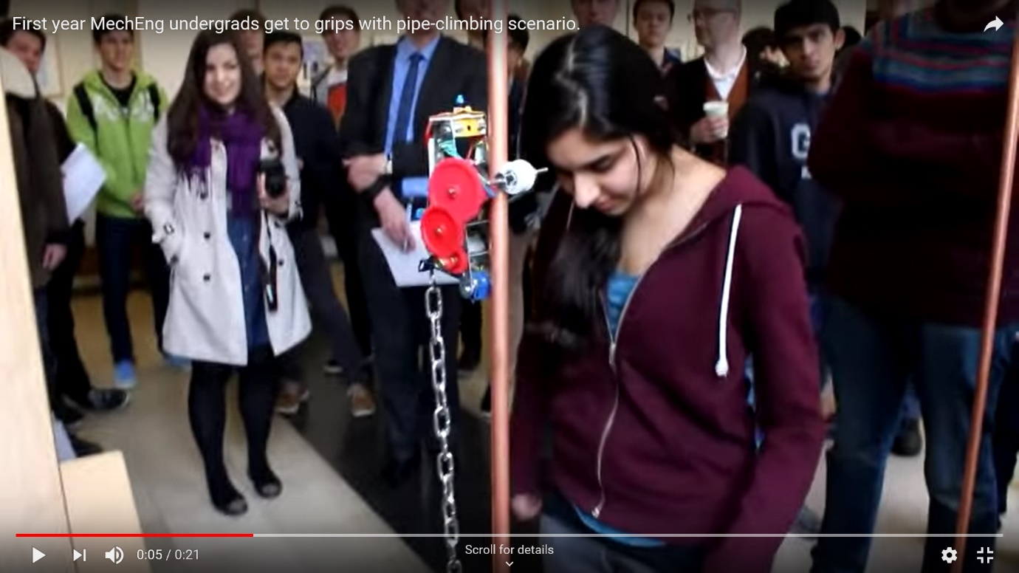
I have come up with an idea for how the device will be controlled after watching some videos on YouTube of past competitions, my idea is that there will be a stop/start button placed on the top of the device which the controller will press to start the device then once it has climbed to the top of the copper pipe it will press the button against the solid stop which will turn the device off meaning it can free fall back to the bottom of the pipe. This I feel will be the quickest way of completing the challenge.

An example of this idea in action can be seen here:

Source: https://www.youtube.com/watch?v=JtUB45wZAQM

As you can see the switch is the illuminated blue part on the top of this device, with this design layout this device managed to complete the challenge in around 18 seconds which is slightly slower than we hope to achieve, however we will still take inspiration from this device.

A switch which could be used for this application would be this:

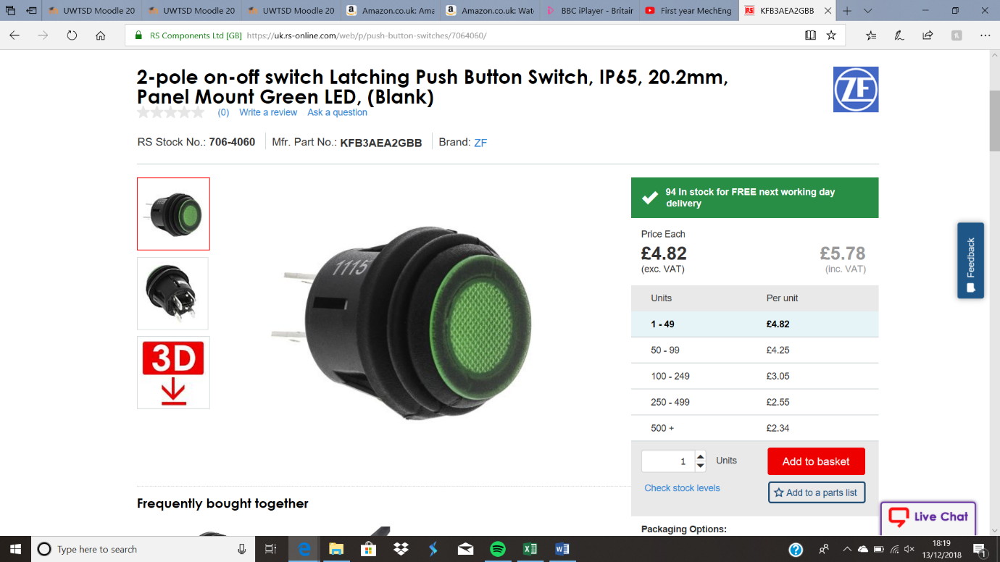

Source: https://uk.rs-online.com/web/p/push-button-switches/7064060/

If we implemented this into the design we would also have to take into account the robustness of the device and also the repeatability as it will be falling 2200mm due to gravity, so we would have to protect our device in some way by either mounting high density foam or potentially springs to the base of the device so that when it falls back down the 2200mm pipe it won’t be damaged.

To mount the chain to the device we will have to consider the weight of the chain and have to decide whether offsetting some of the other weight of the device to balance out with the chain would be a good idea. I have discovered this can be the cause of failure for some of the pipe climbing devices as the device is pulled to one side meaning it doesn’t gain traction correctly on the pipe and therefore can’t climb the pipe. However, one of the fastest devices I’ve seen had offset the weight of the chain with the mounting of the battery on the other side:
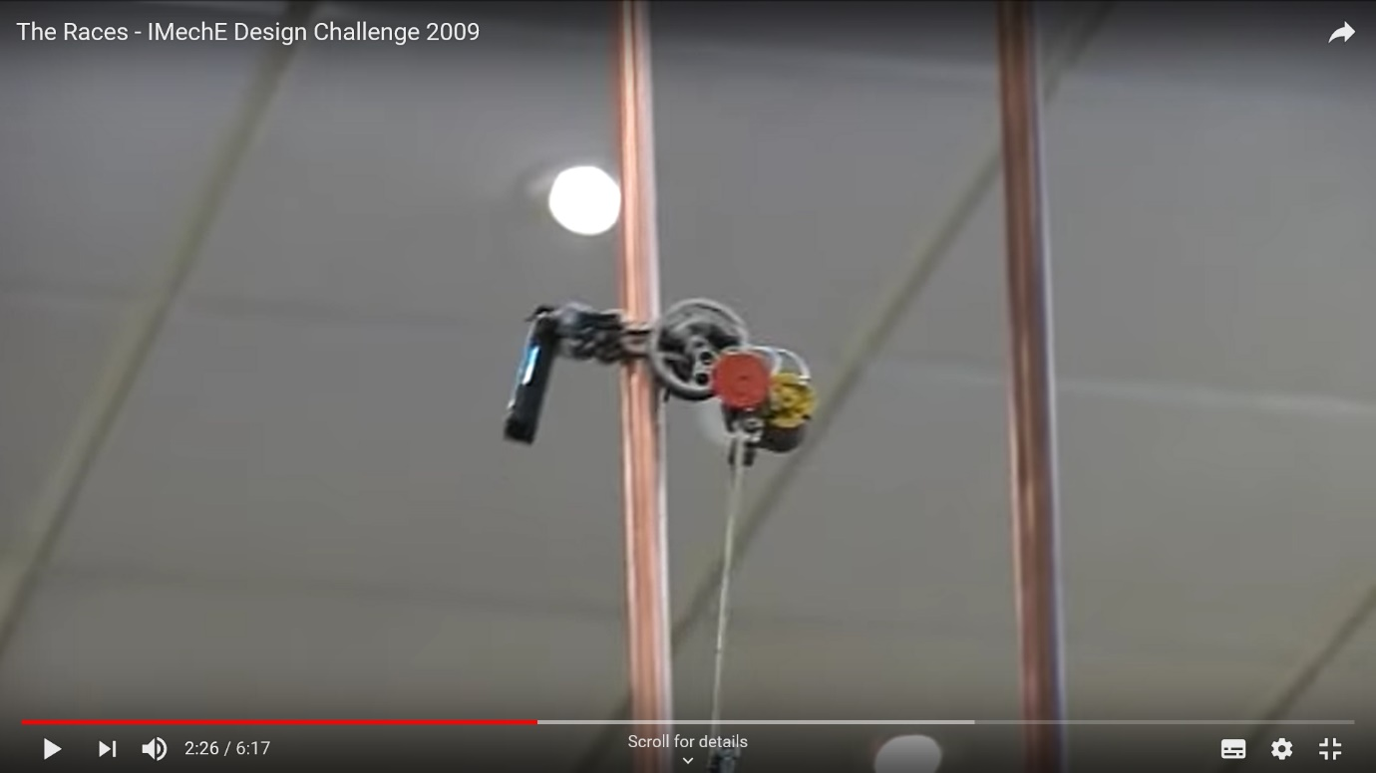

Source: https://www.youtube.com/watch?v=BGuYm0Fos6U

As you can see the device is still not perfectly straight as the weight of the chain hasn’t been completely offset. Despite this it still managed to climb the pipe in around 7 seconds.

Another key design area for the pipe climbing device is the method of propulsion. There are lots of different ways to do this, with some devices having multiple wheels, some making use of a tank track/conveyor belt style, but a majority use a pulley style wheel as it covers the most surface area on the pipe therefore giving it the best grip. An example of this is shown here:

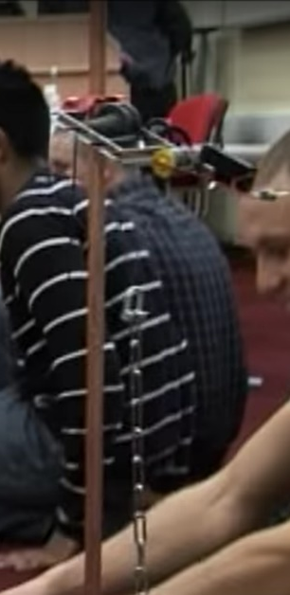
Source: https://www.youtube.com/watch?v=BGuYm0Fos6U

This device managed to climb the pipe in 9 seconds which is a very competitive time. This could be a component that we make to save on costs, or we could use the one listed by Raphael.

Raphael England:

- Through extensive web research of products currently available on the market that would be suitable to this specific model for the project.
Discussion amongst the group members involved different structural designs, methods and tools that would bring this project to life.
These would best be suited in regard to practicality, its ability to function to purpose with maximum affect efficiently, cost effective materials, durability, robustness and stability.
The products for this project were personally managed and researched, of which included different power sources e.g. motors/batteries and switches.
Researching other attempts of the same project from different university teams in previous years provided a much better understanding and overall insight into what design’s/products used in said design might be superior when compared to other models.
BATTERY
I based my decision of what power source to use by considering three main factors.
1.The weight of the battery itself and the negative effect that would have on the acceleration of the model.
2.The voltage of the battery and the positive effect that would also have on the acceleration of the model during the climb up the pipe.
3.The price finding a battery that was going to be suitable for the project that suited the budget for this project
Siemens simatic s7-300 series was chosen because its lighter cheaper and produces more power than the alternatives found throughout my research.
- System requirements: Siemens Battery for use with S5-90U Series, SIMATIC S7-300 Series (RS component, 2018).
- Voltage: 3.6V/min
- Amp hours: 0.8Ah
- Weight: 12g
- Size: A size D
- Service: This is a lithium battery type, so this is rechargeable.
Motor.
After carrying out research to find the attributes of what was required from using the most suitable motor.
As long as the pipe climber mechanism is going up the cylinder in a competitive time frame (under 15s) with an adequate traction on the pipe with the additional and increasing weight as it climbs up the pipe. (given chain measuring 3mm x 2m, 302g)
Brushless motors are typically 85-90% efficient whereas brushed DC motors are around 75-80% efficient. This difference in efficiency means that more of the total power used by the motor is being turned into rotational force and less is being lost as heat. (https://www.quantumdev.com, n.d.)
FC 28-22 Brushless Outrunner 1200kv
Spec.
Weight: 39g (with wire & sticker etc)
Shaft: 3mm
Motor Length: 46mm
Diameter: 28mm
Stator Size: 22x10mm
Suggested prop: 9~10inch
Voltage: 11.1v (3S)
Kv: 1200RPM/V
(Brushless)
Cost £6.46
Data ;
Prop size: 10x5
RPM: 7100
Max Curr: 14.5A
Thrust: 710g (1.51lb)
Mounting
Could use wheel like the Atoplee 20pcs 3x12x4mm High Carbon steel Wire U Groove Pulley, must be 15mm groove to fit over pipe.
Compatibility
Bracket that could be attached to the motor.
Service life
The device needs to last for a total of 4 runs including a test run.
Reliability
Brushless motors are known to be more reliable as they do not produce as much heat, therefore giving them a longer life than its brushed counterpart.
Sources.
https://uk.rs-online.com/web/p/plc-accessories/0628888/
https://www.quantumdev.com/brushless-motors-vs-brush-motors-whats-the-difference/
https://hobbyking.com/en_us/fc-28-22-brushless-outrunner-1200kv.html

