Week 6 Group Work Activity
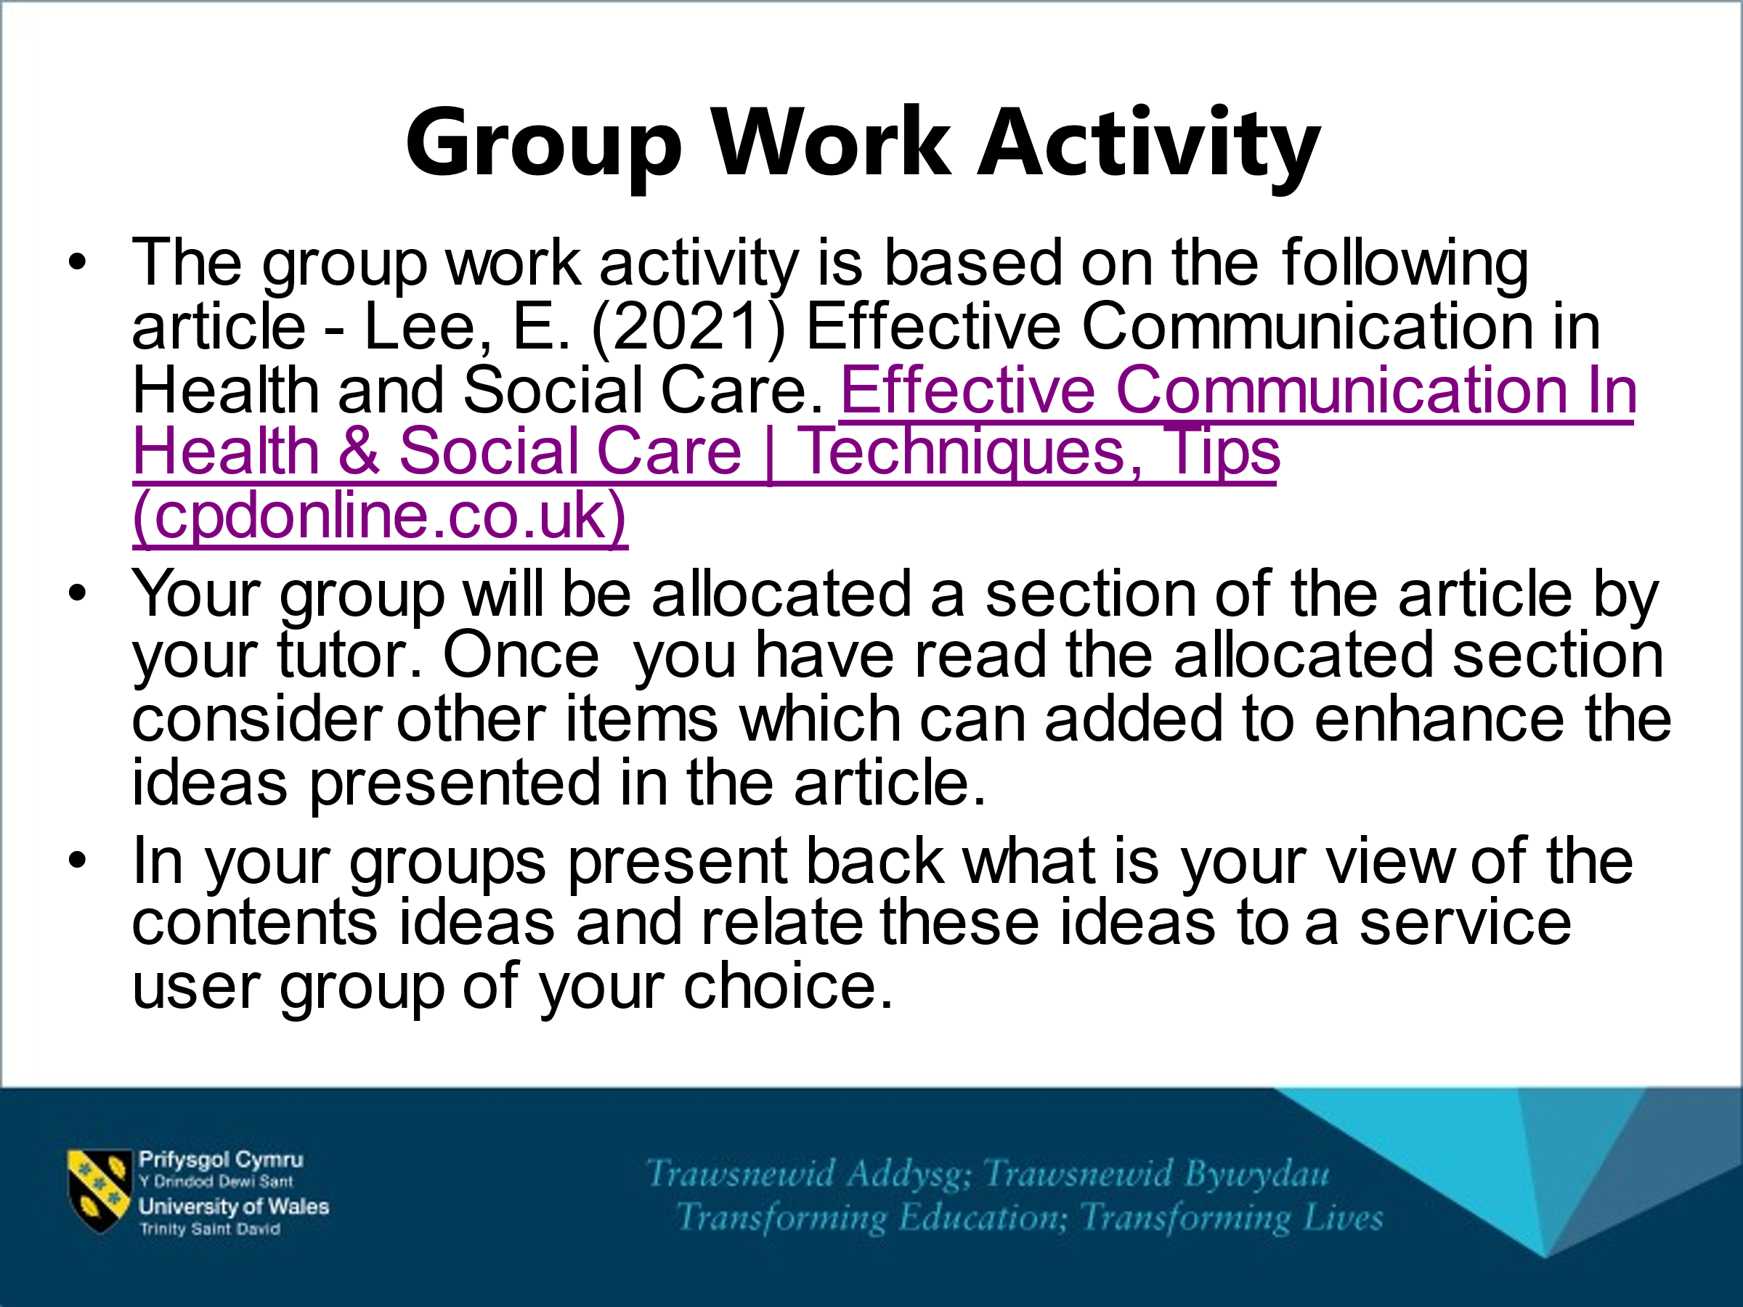
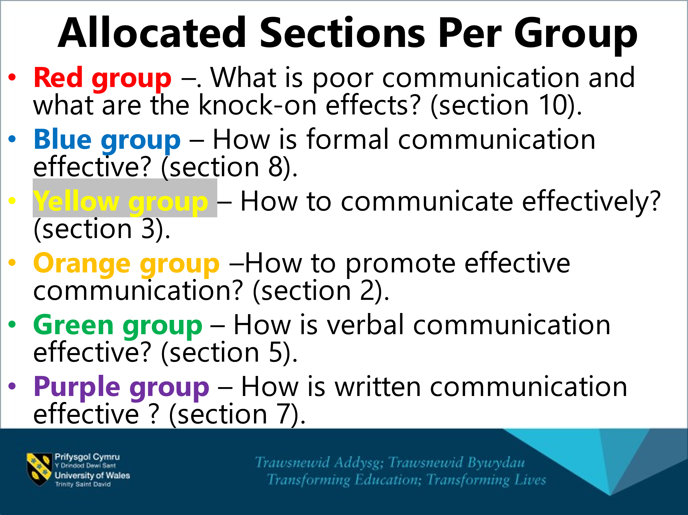
From: Effective Communication In Health & Social Care | Techniques, Tips (cpdonline.co.uk) (September 2022)

Article on
Effective Communication in Health and Social Care
13th October 2021 by Evie Lee

Effective Communication in Health and Social Care

In this article
- Why is effective communication needed in health and social care?
- How to promote effective communication
- How to communicate effectively
- What are the different types of effective communication needed in health and social care?
- How is verbal communication effective?
- How is non-verbal communication (body language) effective?
- How is written communication effective?
- How is formal communication effective?
- How is effective communication used?
- What is poor communication and what are the knock-on effects?
Communication is the process used to exchange information and it is considered effective when both parties, the sender and the receiver, give the same or very similar meaning to the message being conveyed.
Health care is the treatment of ill health and medical conditions.
Social care is the care and support of vulnerable people (with or without ill health and medical conditions) such as elderly people or children.
Communication in health and social care settings can be divided into two types:
- Communication between health and social care workers.
- Communication between the patient (and/or family members) and health and social care workers.
Communication within health and social care settings is considered effective when the receiver, either the patient, family member, or the health and social care worker, understands clearly the message being conveyed by the sender.
For this to happen the message has to be clear, consistent, transparent as well as accessible and inclusive.

- Why is effective communication needed in health and social care?
Effective communication within health and social care settings is very important because it can have a direct, or indirect, impact on the health and social care provided, the overall wellbeing of the patient and on the relationships with patients, family members or colleagues.
Many people may have difficulties in understanding information provided because of language barriers, limited literacy, physical conditions (such as brain damage) or age.
Admission to a nursing home, a foster care home or health facility is a stressful event that involves a noticeable change in lifestyle that requires support. Those affected by a disease are often overwhelmed by fear for their own health and can become irritable, and therefore need reassurance from others.
The World Health Organisation has outlined how the relationship between patients and healthcare workers has evolved over the years with a change in expectations. In the past, patients were used to a healthcare worker being dogmatic and paternalistic. Today, patients usually look to their healthcare worker to help them navigate through a complicated system and expect communication to be based on shared decision-making.
Knowing how to communicate with patients and learning the dynamics of interpersonal relationships is essential for health and social care workers to perform their work at the highest standard.
The Department of Health (now Department of Health and Social Care), together with National Health Service England, published in 2010 Benchmarks for Communication which focuses on the specific needs, wants and preferences of people and carers.
But why are effective communication skills so important in health and social care?
Effective communication enables:
- The exchange of clear information and instructions on care needs.
- The provision of direct (or indirect) emotional support to the patient (or family members) or colleagues.
- The development of positive relationships.

- How to promote effective communication
Communication skills are a top priority for health and social care workers. For this reason, they are usually required to go through some specific training on the subject.
In order to promote effective communication in health and social care settings it is fundamental to consider that this environment can be the source of anxiety and fear for patients.
For different reasons:
- Worries about health and life.
- Distance from family and daily habits.
- Noises.
- Considerable limitation of personal space and privacy.
- Impersonal and cold environment.
Patients usually react to this environment with the same behaviour used in any other situation of anxiety and stress, and for some individuals who are very emotional, they may need more time to decrease their anxiety to acceptable levels.
For these reasons, to ensure efficient communication, health and social care workers must understand the difficulties that patients face in adapting to their new environment and support them using different strategies, such as:
- Listening to the patients and creating some space to let them vent their emotions.
- Reassuring and calming patients in moments of fear.
- Helping patients to stay active and facilitate connection with others, if applicable, to prevent isolation.
Supporting patients in this phase is key to creating a safe environment in which they are ready to pay attention to any form of clear communication related to their care and what is being done in the facility for them.

- How to communicate effectively
Communication in health and social care settings can take different forms and styles depending on:
- The patient status (for example, a patient visiting a dental surgery for a check-up versus a patient being hospitalised to cure cancer, or a child versus an elderly person).
- The message being conveyed (for example, information concerning medicine dosages, delivery timings and changes to the current regime versus information related to the daily menu in the health and social care facility).
Regardless of the form or style, any communication within health and social care settings has to be clear, accurate, consistent, transparent as well as accessible and inclusive in order to be effective.

Clarity
To achieve clarity, it is recommended to:
- Use plain, direct language and avoid idioms or jargon.
- If necessary, repeat phrases, re-phrase the sentences or use simpler words.
- Use pictograms or visuals to explain a difficult concept and get a point across.
- Double-check if the person has understood.
- Observe the body language for clues.
- Encourage people to ask questions or request further information. Ask if they would like anything in writing as a reminder or reference.
- Use an interpreter if a language barrier exists.

Accuracy
Every form of communication within health and social care has to be correct and precise to prevent any error that can potentially have a negative impact on the health and wellbeing of patients.

Consistency
For patients, as well as for health and social care workers, consistency in the means of communication is key to avoid confusion and reduce the risk of missing important details.

Transparency
According to National Health Service England, transparency is key to public and patient participation and is the means by which high-quality and sustainable health services are provided. The same principle applies to social care services.

Accessibility
Many people may have difficulties in understanding information provided because of language barriers, limited literacy, physical conditions (brain damage) or age.
National Health Service England believes it is important that information is presented in an accessible way and, where appropriate, in a range of languages and formats that are easily used and understood by the intended audience.
Providing accessible information helps people to make more informed choices about their healthcare and improves communication and engagement among staff.

Inclusivity
The provision of accessible information can reduce inequalities and barriers to good health. Individuals who have limited or no English, or who use sign language or the deafblind manual alphabet, should have access to a professional interpreter.


- What are the different types of effective communication needed in health and social care?
Communication in health and social care settings can take place in many forms:
- Verbal communication.
- Non-verbal communication (or body language).
- Written communication.
- Formal communication.
- How is verbal communication effective?
In any health and social care setting and circumstances it is good practice to:
- Establish eye contact.
- Create space for questions and double-check if the message has been understood.
- Accompany verbal language with coherent body language.
- Face the receiver at the same height, not from a dominant position.
- Try to take a positive approach.
- Show care, maintaining professionalism and respect at all times.
- Call the receiver by their name.
Depending on the circumstances, to ensure effective communication you may need to:
- Speak clearly and slowly.
- Use very short, simple and concrete words and phrases.
- Give one message at a time.
- Use affirmative sentences.
- Encourage the patient to speak.
- Take time to capture the emotions the patients or family members express and create space if required.
- Empathise.
- Avoid pointing out mistakes unnecessarily.
- Adapt to the patient’s language style if needed to ensure understanding.
- Use an interpreter if there is a language barrier.


- How is non-verbal communication (body language) effective?
According to the World Health Organisation healthcare workers’ body language has been shown to be crucial in the way patients interpret the information they are given.
Health and social care settings can create stress and anxiety for patients and therefore it is key that the workers’ language conveys confidence, credibility, empathy and reassurance.
- How is written communication effective?
Written communication is vital in health and social care settings as it is used for different purposes:
- To record personal details.
- To keep medical/patient records.
- To issue medical prescriptions or referrals.
- To create letters, emails, text messages to inform and remind about appointments at the hospital, doctors, dentist, etc.
- To draw up care plans.
- To issue newsletters and inform notice boards.
- To hand over duties.
Clarity, accuracy and legibility is especially important in written communication, which may contain detailed information concerning, for example, drug dosages, delivery timings and changes to the current regime. Written communication directed to patients and families should avoid jargon to avoid ambiguity and to ensure it is clearly understood.
Written communication should be kept for future reference, stored securely and remain confidential.

- How is formal communication effective?
Formal communication is a style of speaking that is used in professional or official settings using neutral words which are understood by the majority of people and expressed in a way that is considered acceptable and respectful by the majority.
Communications within health and social care settings may include sensitive information such as illness diagnosis, treatments or care needs. It is therefore fundamental that this type of information is clearly understood and respected.
An example of formal communication within health and social care settings is a letter from a doctor including test results.
The degree of formality that health and social care workers are required to keep depends on the circumstances. For example, a doctor discussing a diagnosis with a patient and their family members will require a level of formality higher than that used by the care assistant encouraging a patient to eat some food.
For formal communication to be effective within health and social care settings it is important to avoid jargon or, if it is necessary to use technical language, it may be helpful to add images or pictograms to get the point across and ensure the language used is understood.
- How is effective communication used?
Knowing how to communicate with the patient and learning the dynamics of interpersonal relationships has become essential for health and social care workers.
Effective communication is used to:
- Improve care services.
- Enhance patient experience.
- Create more transparency and openness.
- Reduce complaints.
- Build trust on the health and social care system.
- Reduce stress.
- Create a better working environment for carers.
- Increase self-confidence, professional standing, career prospects and job satisfaction.

- What is poor communication and what are the knock-on effects?
The opposite of effective communication is poor communication.
Poor communication exists when the receiver assigns a different message to that which the sender wanted to convey.
This happens when the message is inaccurate, unclear, lacks transparency and is inaccessible. Inconsistency in the means of communications can also cause confusion and important information can be missed.
According to National Health Service England over 70% of the root cause analysis mentioned communication as a contributing factor in errors in healthcare.
Effective communication is key to patient safety, and it is also crucial to managing an incident once it has occurred.

Verbal communication
Even if the patient and the health and social care worker speak the same language, sometimes, what is clear for the health and social worker is difficult to understand by the patient or the family members. Health and social care workers are often so overwhelmed by the demands of their work that they rush the conversation, they do not create space for questions or do not take time to ensure the message is being understood.

Non-verbal communication (body language)
Health and social care workers’ body language should convey confidence, credibility, empathy and reassurance. However, sometimes, even if this is the intention, when overworked health and social care workers are feeling tired, exhausted and emotionally overwhelmed, they may unintentionally show their state through their body language, frightening already vulnerable patients and adding to their anxiety and stress.

Written communication
Inaccurate written information, incomplete handovers, illegible handwriting and unclear instructions can have a very damaging effect on patients that could be given incorrect diagnoses, treatments or care. According to the World Health Organisation, all too often, medical notes are not kept up to date, and in addition to illegibility, transcription is problematic. These contributing factors have been shown to be at the root cause of many adverse drug reactions.

Formal communication
Whilst medical records and communication need a certain level of formality, at times, the level of formality on which a treatment or diagnosis is discussed is too high and includes technical words that are difficult to understand for individuals not working in the field.
The impact that poor communication in health and social care settings can have goes beyond the health and wellbeing of the patients and includes:
- Diminished trust on the health and social care system.
- Disciplinary action, dismissal and legal proceedings.
The risk of unsafe health and social care is far from patients’ thoughts when they consult a doctor.
The general expectation is for person-centred care where health and social care professionals work collaboratively with the people who use their services to help them make informed decisions about their own health and care. You can learn more about how to promote person-centred care on our knowledge base.

