Data Analysis and Visualisation - ACCB4002

Assessment -1 Analysis and Visualisation of
Data

Stoyan Tsvetanov | Student ID: 1920708

University of Wales Trinity Saint David

BSc Cloud Computing Level 4 Term 2 Group 1

London

Date: 06/08/2021

Table of Contents
DRAW INSIGHTS FROM THE INFOGRAPHIC 3
COLOUR USAGE 4
TEXT PROVIDED IN THE INFOGRAPHIC 4
THE USAGE OF APPROPRIATE GRAPHS AND CHARTS 5
USER-FRIENDLINESS 5
References 5

INTRODUCTION
Infographic:
The infographic is the term that is used to present anything in the form of graphs. We are representing the effect of covid19 on different industries and our results. Impact of the covid19 on various sectors and show the results in the form of graphs and charts and draw the conclusions from the graphs and charts.
We are visualizing the results in the form of the graph and charts and analyzing the results.
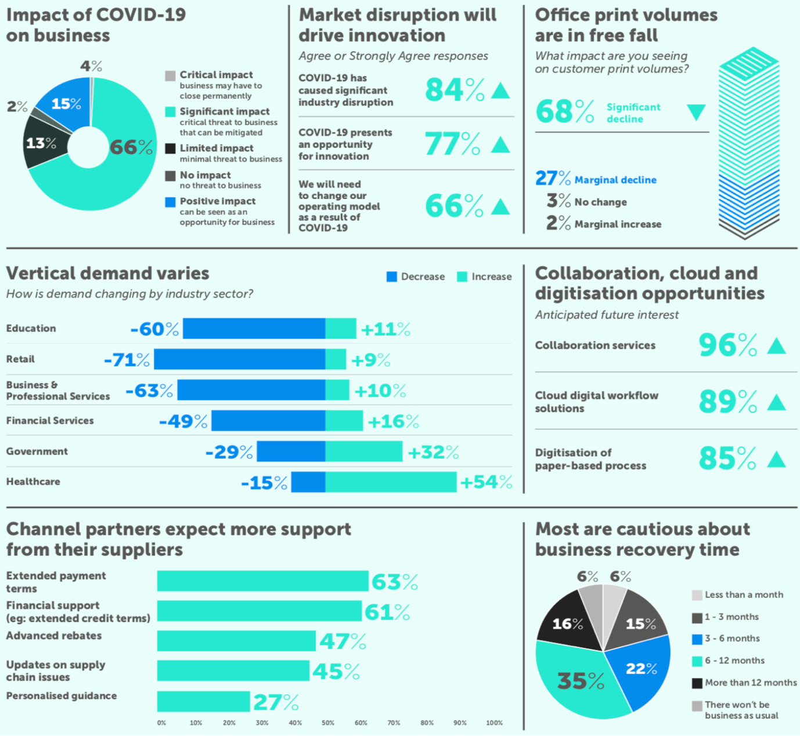
Fig.1 COVID-19 impact on the business infographic

The infographic shows us various graphs and charts from where we can analyze and visualize the data.

DRAW INSIGHTS FROM THE INFOGRAPHIC

The above pie chart shows the impact of the covid19 on the business. We can analyze that the 4% of the pie chart shows the companies are permanently shut down. Many start-up companies and firms shut down their companies due to less number of orders and production and also stop of transportation. Many companies' production is stocked but due to stop of transportation and orders from the client. The companies like IT related also shutdown which is started due to the effect of covid19. (Fernandes, 2020)
The 66% of the pie chart shows the significant impact on the business which tells that critical threat to the business can be mitigated. The 66% of damage to the business or cut off or loss to the business which is a big effect on the business and economy because economies and government taxes will depend on the organizations and other forms if these firms are damaged so badly due to covid19. (Baber, 2020)
13% of minimal impact to the other business due to covid19 because due to lockdown happened the world over wide for that there is less demand because people don’t have money to buy anything for that reason demand is so less than the production and transportation are also stopped people have become jobless because companies are facing a loss so they are removing the employees because they don’t have amount to the pay the salary to the workers. (Gwokyalya, 2020)
Market disruption and will drive innovation:
In this part some of the great innovation and opportunities which will be done in the covid19 we will analyze we can analyze that 84% of the disturbance to the industry happens due to covid19 many of the industries work stopped due to the covid19 because less number of demand and also due to the lockdown happened which will cut off the production. The government announced the lockdown and kept all industries shut down which is a big loss that happened to the industries due to the covid19 so the disruption showed us the rise of disruption to the industries. And at the mean, 77% of the data shows us the rise in new opportunities and innovations. (Boretti, 2020)
Some of the great innovations during covid19 is creating a hand sanitiser by pressing the foot from 2 feet distance and also people have created ventilators within a short period.

Vertical demand varies in different sectors:

66% of education decrease and only 11% of the education sector increases during the covid19. A decrease in education from 66% means that there is a high decrease in the education sector after the lockdown which is not a good thing because education is the most important thing but due to the lockdown education system is shut down the institute and other educational sectors are often closed. (Al-Samarrai, 2020)
- The negative impact of the closure is associated with the accepted length of the pandemic. Business is widely varying about the likelihood of covid19.

COLOUR USAGE

The colour code usage which is used in the infographic is light green, blue, grey, light grey, and medium grey.
The colour used for describing the increase in something or to show a positive increase in some of the sectors light green colour is used.
In the infographic light, green colour is only used for showing positive increase while other colours are used to describe some other things.

TEXT PROVIDED IN THE INFOGRAPHIC

The text provided in the infographic is clean and good in the clean way each and everything is described by the text. The text added in the infographic is storytelling by itself. The text added in all the fields such as the impact of covid19 on business, market disruption and innovation, office print values, vertical demand varies, and collaboration, cloud, and digitisation opportunities.

THE USAGE OF APPROPRIATE GRAPHS AND CHARTS

The presentation of data in the form of graphs and charts is very important to others to analyze in a better way. The graphs have different types such as bar, scatter, pie, area, histogram, and many more.
A good way of presenting something is by adding good graphs to it like we have to describe data of something in the form of years or the form of an increase or decrease. The best way to do that in the graph is a bar plot.
In the above infographic, they are well-used graphs to present the data in a good way.

USER-FRIENDLINESS

The word document present in that is in a good manner and in a correct way because in the graphs and charts there are different types of the plot such as bar, scatter, line, pie, area, and many more. The presentation of data in front of others to analyze the data accurately and to draw insights from the data is an art. Using a plot is also an art of presenting something to others. In the above infographic, they used a bar plot to describe the data and added text to that plot which is a good thing. We can analyze the data and can draw insights from the data.

References

- Kontopantelis, E., Mamas, M.A., Deanfield, J., Asaria, M. and Doran, T., 2021. Excess mortality in England and Wales during the first wave of the COVID-19 pandemic. J Epidemiol Community Health, 75(3), pp.213-223.
- Danon, L., Brooks-Pollock, E., Bailey, M. and Keeling, M.J., 2020. A spatial model of CoVID-19 transmission in England and Wales: early spread and peak timing. MedRx.
- Vandoros, S., 2020. Excess mortality during the Covid-19 pandemic: Early evidence from England and Wales. Social Science & Medicine, 258, p.113101.
- O’Dowd, A., 2020. Covid-19: Care home deaths in England and Wales rise sharply.
- Ayoubkhani, D., Nafilyan, V., White, C., Goldblatt, P., Gaughan, C., Blackwell, L., Rogers, N., Banerjee, A., Khunti, K., Glickman, M. and Humberstone, B., 2020. Ethnic-minority groups in England and Wales—factors associated with the size and timing of elevated COVID-19 mortality: a retrospective cohort study linking census and death records. International Journal of Epidemiology, 49(6), pp.1951-1962.
- Platt, L. and Warwick, R., 2020. COVID‐19 and ethnic inequalities in England and Wales. Fiscal Studies, 41(2), pp.259-289.

TASK 2

