https://sway.cloud.microsoft/Oy3ZoO1rUYzJGfc2?ref=Link.

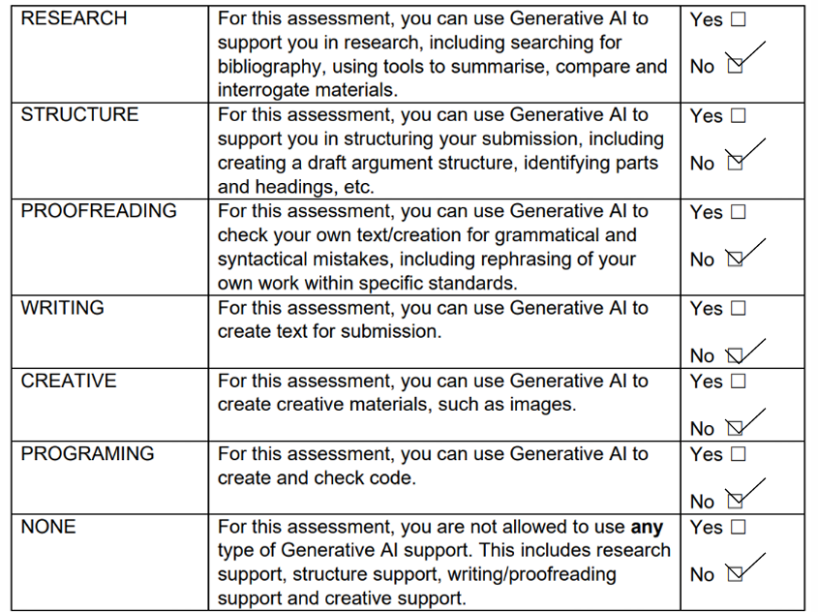

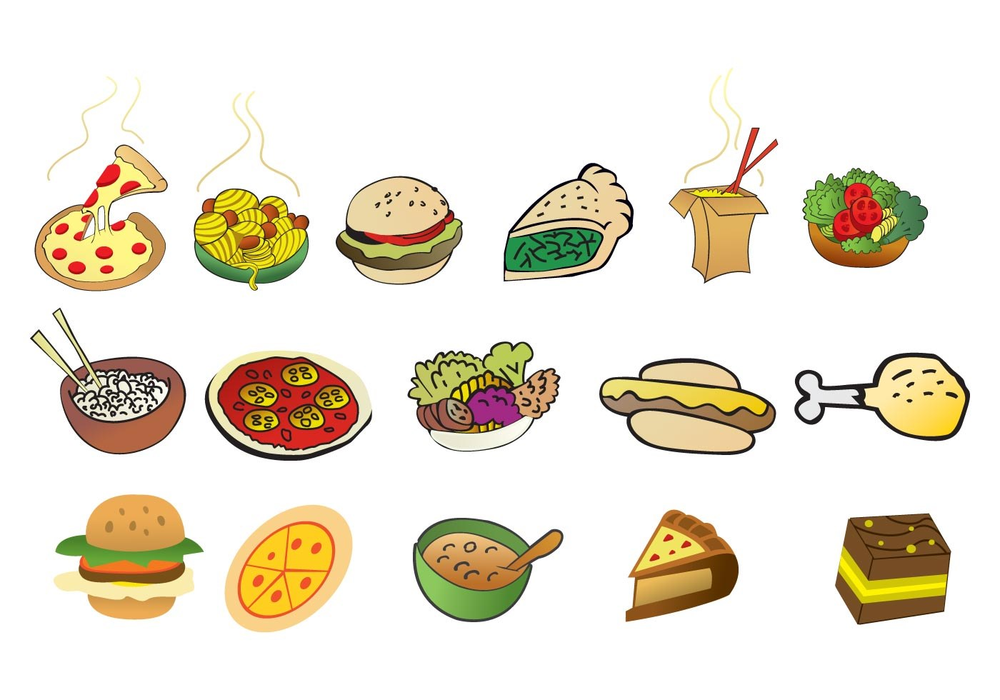

The Effects Of Poor Nutrition On Physical Development
Oh, Hey! It looks like you have stumbled across my blog. I am going to explore the links between poor nutrition, and how this impacts physical development across the lifespan. I will also reflect on some of the common barriers, theories and practitioners which have an impact.
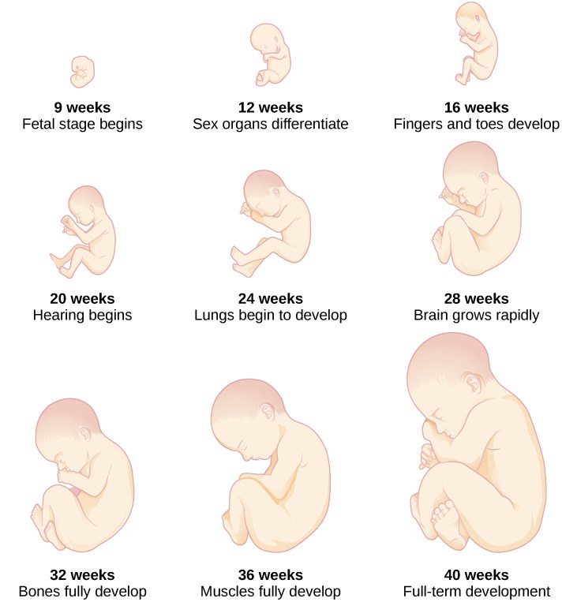
Before Birth... Throughout an individuals lifespan their nutritional needs and requirements will vary. When a child is developing in the womb it requires a range of nutrients provided by the mother to ensure it grows and progresses healthily (Moreno-Fernandez, 2020). These include protein supply, fatty acids and various key micronutrients (Lindsey, 2019). This is achieved by eating a healthy, balance diet, and by taking supplements if or when necessary (Lindsay, 2019). Poor nutrition can result in low birth weight, preterm labour and developmental delay in the future (National Library of Medicine, 2023). It would be reasonable too suggest that this, could effect the child's abilities to reach expected milestones in the future.
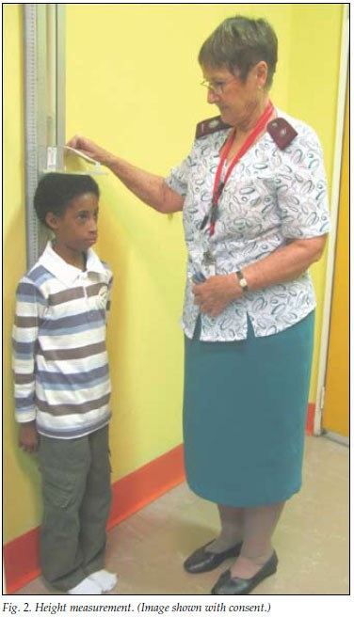
After Birth... Research has shown that approximately 1 in 3 children globally are malnourished, and 2 in 5 are obese (Brian et al, 2019). In order to grow and progress children need to be receiving the correct nutrients through food in order to increase steadily in both height and weight (Doherty and Hughes, 2014). School age is an essential time to educate regarding the importance of a healthy balanced diet(Chaudhary et al, 2020). According to Millward (2017), 25% of children's physical development is stunted as a result of poor diet and nutrition, which could result in internal inflammation. He also suggests poor nutrition can effect a child's pituitary gland (mainly Females), meaning they may experience prolonged puberty. Boyd et al, (2016), also identified risks of bone defects occurring in later childhood. A lack of substantial nutrition from a young age could result in more series issues in future such as obesity and heart disease (Better Health Channel, 2023).
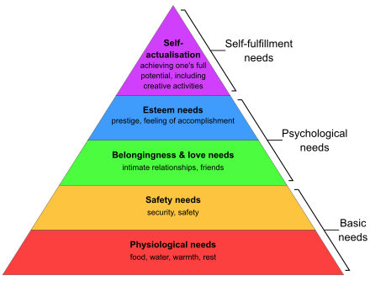
https://www.youtube.com/watch?v=mMHVEFWNLMc.
Who believed in the importance of good nutrition? Maslow's Hierarchy of needs highlights the importance of different aspects of life, which impact on well-being(Dar and Sakthivel, 2022) . It focusses on achieving self-actualisation, suggesting that individuals will pass through a number of stages before achieving this (Rojas, 2023). At the bottom of his pyramid he indicates the importance of food and nutrition, and how poor nutrition can have negative impact on an individuals ability to strive to achieve (Hopper, 2020). Although not linked directly to nutrition, it would be reasonable to believe that Maslow recognised the importance of this. This suggests that good nutrition is critical in regard to meeting the most essential needs, furthermore supporting development (Rojas, 2023). This further supports research by Millward (2017) outlining issues with stunted growth. Maslow's theory believed that food (alongside other physiological needs), was essential from before birth in order to progress and reach expected milestones (Mclain et al, 2024). It would be reasonable to suggest if these milestones were not met, this could negatively impact an individuals quality of life. Unlike Maslow's theory, Vygotsky considers the influence that More Knowledgeable Others (MKO) have on behaviour (Ebril, 2020). An example of this could be regarding a child eating what their parents eat, and considering this as healthy or appropriate. It would be reasonable to suggest that this further outlines the importance of education and awareness of nutrition and healthy eating (Ebril, 2020).

key Milestones and Challenges Faced by the Individuals Fine and Gross motor skills develop in the first couple of years of a child's life and are important in order to achieve a wide range of mobility (Brown Health University, 2022). Without appropriate nutrition, development can be stunted, resulting in a delay in reaching milestones relating to this. An example which I have personally observed is how comfortable a child is with jumping, running and kicking a ball. A child who's fine and motor growth has been stunted may struggle to find balance (Brown Health University, 2022).

Adolescence is another key milestone which a child will face before the age of 18. Ashraf et al (2014) highlighted that nutrition during childhood is approximately 25% responsible for when a child will begin to experience puberty. His research suggested that children who have higher BMI and are Overweight are more likely to experience early puberty, and this is more likely to be prolonged. This applied to females more than males (Ashraf et al, 2014).

Those who live in more deprived areas are more likely to experience poor nutrition and obesity, acting as a barrier, this can directly link to physical development in childhood, potentially effecting health throughout the lifespan (Briazu et al, 2024). A lack of understanding is another barrier to receiving good nutrition (Warburton et al, 2021). If uneducated children, and their parents may not understand the effects and repercussions of a lack of good nutrition, especially from a young age (Murimi et al, 2016). Because of this it could negatively effect their physical development in childhood, and throughout adulthood (Warburton et al, 2021).

How Do Practitioners Support Better Nutrition and why is this important? The British Eatwell Guide attempts to educate children on the importance of good nutrition (Department of Health and Social Care, 2024). Children are usually introduced to this from around 5 years old, within education environments (Murimi et al, 2016). It is partly a teachers responsibility to ensure children are given a good quality of education in order to make healthy informed decisions regarding their well-being (Murimi et al, 2016). This intervention highlights the different food groups and appropriate portion sizes (Department of Health and Social Care, 2024). It also uses visual aids to cater to all ages (NHS, 2022). The Welsh Government also provide free school meals to all primary school children to ensure that all children receive one nutritional meal per day. This further supports healthy eating and nutritional awareness amongst children (Welsh Government, 2022). All healthy eating in Welsh schools is underpinned by the Healthy Eating In Schools (Wales) Measure, which was introduced in 2009 (Law Wales, 2024). Educational support and advice is also available from medical professionals. These professionals aim to educate and answer questions which mothers may have, regarding nutrition and health of their baby (NHS, 2016). The Maternity transformation programme (UK) supports pregnant ladies in ensuring they are receiving adequate nutrition when pregnant (NHS, 2016). This is a government funded scheme which aims to educate and give mothers information regarding the best ways to nourish unborn children (NHS, 2016).
To conclude, nutrition is noted to have an enormous impact on individuals physical development throughout life. Evidence seems to suggest that education and intervention can have tremendous impact on nutritional awareness, and healthy lifestyle (Warburton et al, 2021).
Reference List Ashraf, S., Vincenzo, S. And Rania, E (2014)'Nutrition and Pubertal Development' Indian Journal of Endocrinology and Metabolism. S39-S47. Available at: https://journals.lww.com/indjem/fulltext/2014/18001/nutrition_and_pubertal_development.6.aspx. (Accessed:15/02/2025). Better Health Channel (2023) Diet and Heart Disease Risk. Available at: https://www.betterhealth.vic.gov.au/health/conditionsandtreatments/diet-and-heart-disease-risk. (Accessed: 13/02/2025). Boyd, D., Bee, H (2013) The Developing Child. 13th edn. Edinburgh: Pearson Education Limited. Brian, K., Celine, L., Erik Z (2019). The State of the Worlds Children 2019: Children, Food and Nutrition-Growing Well in a Changing World. New York: UNICEF. Briazu, A., Masood, F., Hunt, L., Pettinger, C., Wagstaff, C. And McCloy, R (2024)'Barriers and Facilitators to Healthy Eating in Disadvantaged Adults Living in the UK: a Scoping Review'. BMC Public Health. Volume 24, 1770. Available at: https://link.springer.com/article/10.1186/s12889-024-19259-2#citeas. (Accessed: 15/02/2025). Brown Health University (2022)Children's Developmental Milestones: Gross and Fine Motor Skills. Available at: https://www.brownhealth.org/be-well/childrens-developmental-milestones-gross-and-fine-motor-skills#:~:text=Six%20to%20eight%20months%20developmental,the%20tummy%2C%20and%20sitting%20independently. (Accessed: 15/02/2025). Chaudhary, A., Sudzina, F. And Mikkelsen (2020) 'Promoting Healthy Eating Amongst Young People- A Review of the Evidence of the Impact of School Based Interventions'. Nutrients. 12, 2894. Available at: https://www.mdpi.com/2072-6643/12/9/2894. (Accessed: 13/02/2024). Dar, A., And Sakthivel, P (2022) 'Maslow's Hierarchy of Needs Is Still Relevant in the 21st Centaury'. Journal of Learning and Education Policy. Vol: 02, No. 05. 1799-1721. Available at: https://www.researchgate.net/profile/Showkat-Dar-13/publication/368327434_Maslow's_Hierarchy_of_Needs_Is_still_Relevant_in_the_21st_Century/links/640887240d98a97717ec841e/Maslows-Hierarchy-of-Needs-Is-still-Relevant-in-the-21st-Century.pdf?origin=journalDetail&_tp=eyJwYWdlIjoiam91cm5hbERldGFpbCJ9. (Accessed: 14/02/2025). Department of Health and Social Care (2024). Eatwell Guide. Available at: Eatwell guide – School Zone | Healthy eating | Campaign Resource Centre. (Accessed: 13/02/2025). Doherty, J. And Hughes, M. (2014) Child Development Theory and Practice 0-11. 2nd edn. Edinburgh: Pearson Education Limited. Ebril, D (2020) A Review of Flipped Classroom and Co-Operative Learning Method Within the Context of Vygotsky's Theory. Available at: https://www.frontiersin.org/journals/psychology/articles/10.3389/fpsyg.2020.01157/full. (Accessed: 22/02/2025). Hopper, E (2020) Maslow's Hierarchy of Needs Explained. Available at: https://www.christianworldmedia.com/client/docs/603_1585079540_17.pdf. (Accessed: 14/02/2025). Law Wales (2024) Healthy Eating in Schools (Wales) Measure 2009. Available at: https://law.gov.wales/healthy-eating-schools-wales-measure-2009#:~:text=The%20Healthy%20Eating%20in%20Schools,local%20education%20authorities%20in%20Wales.. (Accessed: 19/02/2025). Lyndsay, K., Buss, B., Wadhwa, P.D. And Entringer, S. (2019) 'The Interplay Between Nutrition and Stress in Pregnancy: Implications for Fetal Programming of Brain Development. Biological Psychiatry: Celebrating 50 years'. (Version of Record 17 December 2018) Available at: https://www.sciencedirect.com/science/article/pii/S0006322318316354?casa_token=7M3Cb3c9KnAAAAAA:bq7k4C4jTZ_ZdKXf_AvI8qoWmbTZj0pOmt-fNegcB8HztteGa-7-AGvdOPu3m9ZfGEpYJjdQJpk. (Accessed: 07/02/2025). Mclain, K., Leslie, E. And Wade, A. (2024) Foundations for Assisting in Home Care. Available at: https://med.libretexts.org/Bookshelves/Allied_Health/Foundations_for_Assisting_in_Home_Care_(McLain_O'Hara-Leslie_and_Wade)/04%3A_Working_with_Children/4.02%3A_Maslows_Hierarchy_of_Needs_Applied_to_Children. (Accessed: 14/02/2025). Millward, J (2017) Nutrition, Infection and Stunting: The Roles of Deficiencies of Individual Nutrients and Foods, and of Inflammation as Determinants of Reduced Linear Growth of Children. Nutrition Research Reviews. 2017;30(1):50-72. Available at: https://www.cambridge.org/core/journals/nutrition-research-reviews/article/nutrition-infection-and-stunting-the-roles-of-deficiencies-of-individual-nutrients-and-foods-and-of-inflammation-as-determinants-of-reduced-linear-growth-of-children/195A1401085226A8201FEA0EB05BFB02. (Accessed: 13/02/2025). Moreno-Fernandez, J., Ochoa, J., Lopez-Frias, M. And Diaz-Castro, J (2020) 'Impact of Early Nutrition, Physical Activity and Sleep on the Fetal Programming of Disease in Pregnancy: A Narrative Review'. MDPI. (12(12), 3900, 20 December 2020) Available at: https://www.mdpi.com/2072-6643/12/12/3900. (Accessed: 07/02/2025). Murimi, M., Kanyi, M., Mupfudzi, T., Amin, R., Mbogori, T. And Aldubeyan, K (2016) Factors Influencing Efficacy of Nutrition Education Intervention: A systematic Review. College of Human Sciences. Lubbock. Naaz, A and Muneshwar, K. (2023) 'How Maternal Nutrition and Mental Health Affects Child Health During Pregnancy: A Narrative Review'. Cureus. (2023 Nov 13;15(11) Available at: https://pmc.ncbi.nlm.nih.gov/articles/PMC10719542/#:~:text=Contrarily%2C%20malnutrition%20in%20mothers%2C%20such,chronic%20diseases%20in%20later%20life. (Accessed: 07/02/2025). NHS (2022) The Eatwell Guide. Available at: https://www.nhs.uk/live-well/eat-well/food-guidelines-and-food-labels/the-eatwell-guide/. (Accessed: 13/02/2025). NHS England (2016) Maternity Transformation Programme. Available at: https://www.england.nhs.uk/mat-transformation/. (Accessed: 11/02/2025). Rojas, M., Mendez, A. And Watkins-Fassler, K. (2023)'The Hierarchy of Needs Empirical Examination of Maslow's Theory and Lessons for Development'. World Development. (Version of Record 24 January 2023). Available at: https://www.sciencedirect.com/science/article/pii/S0305750X23000037?casa_token=P-J16haHBWwAAAAA:-NhDa6yfdCl6QC9JAQmIiGbuLdCN6fQPgSpyfAl8KjE_d5jDPdxRNBbFKAihuvl6zfh3sckZkuY. (Accessed: 10/02/2025). Warburton, V., Beaumont, L. And Bishop, K (2022) 'Pre-Adolescent Children's Understanding of Health and Being Healthy. A Multidimensional Perspective from the UK'. Health Education. Vol.122 (5), p.519-534. Available at: https://www.proquest.com/docview/2681393336?accountid=130472&parentSessionId=e2PtaKxOoR7drE7%2FIbFgiEZbCvvXHJwc3RKND%2FWgBa8%3D&pq-origsite=primo&sourcetype=Scholarly%20Journals. (Accessed: 16/02/2025). Welsh Government (2022) Universal Primary Free School Meals (UPFSM). Available at: https://www.gov.wales/universal-primary-free-school-meals-upfsm#:~:text=All%20primary%20school%20children%20in,child%20goes%20hungry%20in%20school. (Accessed: 13/02/1015).

The Role of Technology on Social Development


A warm welcome to my blog. Before we start, I was just wondering, what device are you reading this on? Where are you? Technology has become extremely accessible within our society today but have you ever asked yourself whether this has negative effects on our social development? This blog will explore the link between these, will consider barriers, theories and the effect practitioners can have.
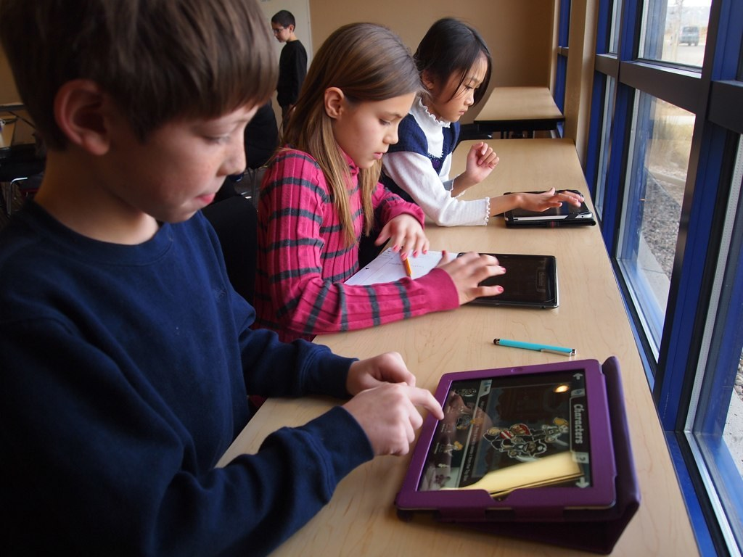
The role of technology in society The use of technology is on the rise (United Nations, 2020). This is as a result of an evolving society, adopting the use of social media as a replacement for in-person, human interaction (Palaiologou, 2014). Whether this is a positive or a negative, it certainly appears to be making an impact of the way we live and complete everyday tasks. As adults, we are able to make informed decisions regarding what resources we want to engage with and use on an everyday basis, however wonder how is this effecting the social skills of the children within our society? Technology is being implemented into children's lives at home, at school and even out in public (Palaiologou, 2014). Ogelman Et al (2016) conducted research exploring the relationship between extensive use of technology and a child's social skills. He found that children who used smartphones on weekdays and weekends struggled significantly more in social situations than those who only watched television (Ogelman Et al, 2016). This suggests that social media may have negative impact on the development of social skills. Contradictory to this, Valencia et al (2019) conducted research around Autism Spectrum Disorder (ASD). She found that introducing people with ASD to technology interventions, can provide them with a safe, engaging and exciting way to practice their social skills. She believed that technology helped them to improve empathy, compassion and self-control (Valencia et al, 2019). It would be reasonable to suggest that the social skills acquired as a child could both positively or negatively impact those used as an adult. Research by George et al (2017) has also shown that technology can have detrimental impact on the mental health of adolescents, potentially further impacting on social skills and abilities, throughout their lifespan.

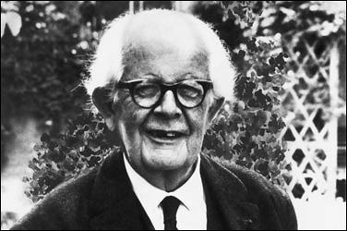
What Theories does this link to? Banduras Social Learning theory states people learn behaviours through observation, imitation, and modelling (Mcloed, 2024). This means that individuals are able to acquire skills, attitudes and beliefs by observing others (Mcloed, 2024). Technology allows people to access a vast range of different content (Devi et al, 2017). Theses views and opinions could then be modelled by the audience, in both positive or negative ways. The use of technology can demonstrate positive social skills, which is then able to be modelled by the user (Valencia et al, 2019). Alternatively social media can be unhelpful in developing social skills and can prevent motivation for the user to have real life, face to face interactions (Hostettler et al, 2018). This could also impact the mental well-being of the individual (George et al, 2017). Piaget's theory links with the role of technology on social development. Similar to Banduras theory, Piaget believed that children were scientists of their own knowledge and learnt from interaction of the world around them (Conkbayir and pascal, 2014). His theory suggested 4 stages of cognitive development which a child moves through as they progressed with age (Barrouillet, 2015). This seems to imply that if a child replaced these real-life experiences with technological ones, then they may not progress at the same rate, or standard. This could effect their ability to interact and socialise with people, and the world around them. Both Piaget's and Banduras theory believe in learning through our surroundings and environment (Mcloed, 2024)(Conkbayir and pascal, 2014). It must be considered that social interaction through technology, as apposed to having and in person conversation or encounters may impact on social development.
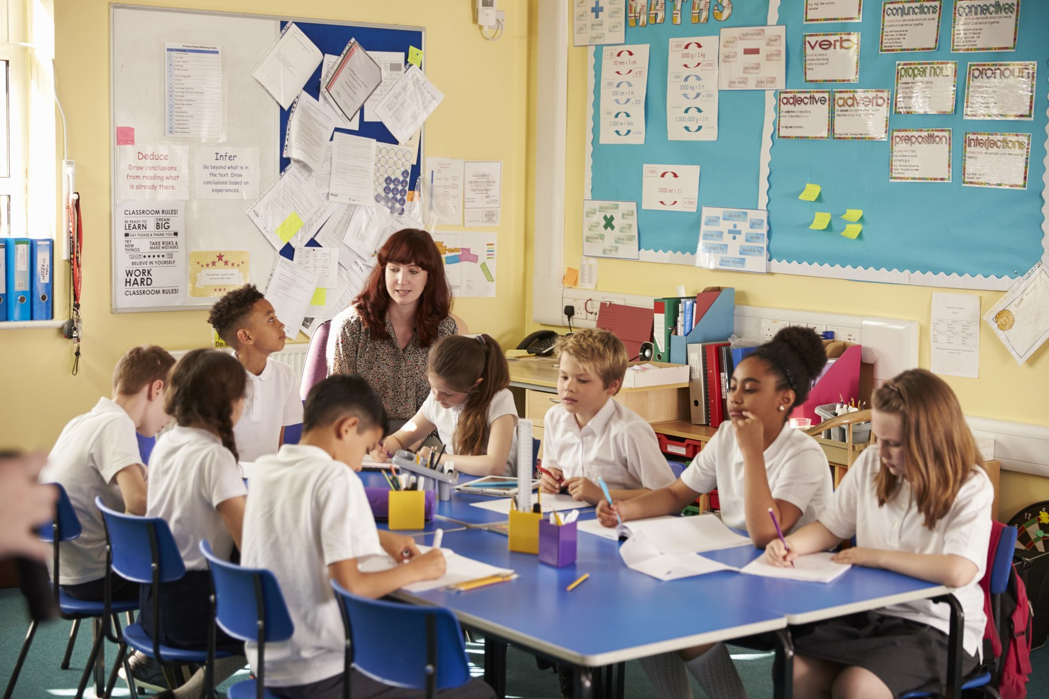
Key milestones and challenges faced by individuals Childhood is a critical time for the development of new social skills (Association of Child Psychotherapists, 2020). This is especially prevalent when a child first begins school at around the age of 4 (Association of Child Psychotherapists, 2020). It is there that they are able to socialise with new children and adults, and where they begin to build personal thoughts, opinions and views (Association of Child Psychotherapists, 2020). This social milestone can be supported by teachers and practitioners within the education environment, and can have a detrimental impact of individuals social development (Deniz et al, 2016). From personal experience I have been able to observe the use of technology in primary schools as a resource to support social skills. Children will often be set work teaching them how to act and speak in different situations, e.g. empathy, communication and reasoning skills. I have also experienced ASD amongst children beginning primary school, and note that this is often where symptoms are noticed, and where additional support is put in place. Technology is often enlisted to support these individuals (Valencia et al, 2019). Mental health can be a barrier to social development (Potenza et al, 2020). According to Potenza et al (2020) the use of technology coincides with increased mental health issues amongst adolescence and university students. Social Anxiety is a growing issue, damaging social development and well-being for these individuals throughout their life (Marijolovic, 2023).

How is this supported by Practitioners? Social development is a detrimental part of a child's school experience (Durlak et al, 2017). Practitioners are trained to support and encourage children within the classroom (Durlak et al, 2017). Alongside this they are attuned to recognise issues, and intervene where necessary (Ofsted, 2024). The Children Act 1989 puts emphasis on the importance of welfare and support of children within education settings, aiming to ensure that if children begin to struggle in certain areas, interventions can be provided (Ofsted, 2024). From personal experience I have observed that when children's social issues have been identified, teachers tend to incorporate more group work and collaborative tasks into lessons which often includes the use of technology. I have witnessed the positive effects of technological programmes such as Minecraft Education. This can help to improve social skills, alongside ability to work collaboratively. From experience, children also tend to engage better when they complete tasks they find enjoyable.
To conclude, Technology is a rapid growing resource used in education which can support and encourage social interaction and development in children. Although this can be useful resource, there can be negative effects and may need to be used in moderation.
Reference List Association of Child Psychotherapies (2020) The child's experience of Primary School. Available at: https://childpsychotherapy.org.uk/resources-families/understanding-childhood/childs-experience-primary-school. (Accessed: 19/02/2025). Barrouillet, P (2015)'Theories of Cognitive Development: From Piaget Today'. Developmental Review. Vol. 38, Pp. 1-12. Available at: https://www.sciencedirect.com/science/article/pii/S0273229715000325?casa_token=BxNbTl18fNUAAAAA:n4HxVWbhMdXGxvjj0Z1ncxcuape7aiNg9uYuCLg4Jhkc2AkNqKiVYEswXodQGpdkjZ756wHGedg. (Accessed: 18/02/2024). Conkbayir, M. And Pascal, C (2014) Early Childhood Theories and Contemporary Issues: An Introduction. London: Bloomsbury Publishing Plc. Deniz, Y., Nuray, B., Birgul, B., Aysun I. And Banu A (2016)'Screening 5 and 6 Year-Old Children Starting Primary School For Development and Language'. The Turkish Journal of Pediatrics. vol.58, Iss 2, Pp 136-144. Available at: https://www.proquest.com/docview/1882372686?accountid=130472&parentSessionId=ruofWP5YnYadjV8aUF5bTuhSUM5Ew1y9a%2BX2YJ6eJiY%3D&pq-origsite=primo&sourcetype=Scholarly%20Journals. (Accessed: 19/02/2025). Devi, B., Khandelwal, B. And Das, M (2017)'Application of Banduras Social Cognitive Theory in the Technology Enhanced, Blended Learning Environment'. International Journal of Applied Research. 3(1): 721-724. Available at: https://d1wqtxts1xzle7.cloudfront.net/103945807/3-1-145-668-libre.pdf?1688294008=&response-content-disposition=inline%3B+filename%3DApplication_of_Banduras_social_cognitive.pdf&Expires=1739874999&Signature=DorUIlCi5uJyVgjujINiHve4WkWhTvoKPS7yTEq89LRRrtqWlYbW-w2joOAt6R3pd8RBF9Wom7MmlRRhzAw9IEwXYZx48uhKWUVuRkHN4JIiK079DnU6pDN3xlUh-O5gnqkCRbAPmAWfDIL252MPAEONAwi2IN9jZE76crvbU4gD6Xu1AdEJGynRae8ffieBMHyAuneImJTSiCS7kAxDtJcxWYBhy80R2JybAms9TsQu5swd5DGLs85~yvQiBeNr9houClYDsaeMWAMaTcLUVFhh2xK67jxGkLwPpk7FsGF70Thxn~qH~qwhPadQEknJaEhA6XUwvWfDjWt1XfxydA__&Key-Pair-Id=APKAJLOHF5GGSLRBV4ZA. (Accessed: 18/02/1025). Durlak, C., Staley, K. And Weissberg, R (2017) 'Social Emotional Competence: An Essential Factor For Promoting Positive Adjustment and Reducing Risk in School Children'. Society of Research in Child Development. Vol. 88, Iss. 2, Pp. 408-416. Available at: https://srcd.onlinelibrary.wiley.com/doi/full/10.1111/cdev.12739?casa_token=yyG_UYkYLucAAAAA%3AjUPs0B4WNiEa6XuWr_tyXuVGb5QiQdwRLHxGa5sLJOnJ40lxO8h7ZOmCy0PF6wXhkRThiQoTvKc6BaY. (Accessed: 19/02/2025). George, M., Russell, M., Piontak, J. And Odgers, C (2017) 'Current and Subsequent Associations Between Daily Digital Technology use and High Risk Adolescents Mental Health Symptoms'. Society of Research in Child Development. Vol. 89, Iss 1, PP. 78-88. Available at: https://srcd.onlinelibrary.wiley.com/doi/full/10.1111/cdev.12819?casa_token=6pK4nV35LOYAAAAA%3AL6eJac2a0N558tGrKd1MoFCk0cBQNIHUuhNPukjf1XB7eZlO3ewJjydgDDIS_J24hzQNyXbcoadwj9Q. (Accessed: 18/02/2025). Hostettler, S., Besson, S. And Bolay, J (2018) Technologies For Development: From Innovation to social Impact. Switzerland: Springer International Publishing. Marijolovic, K (2023) Trauma and Social Anxiety are Growing Mental-Health Concerns for College Students. The Chronicle of Higher Education. Available at: https://www.mtsac.edu/president/cabinet-notes/2022-23/02-feb/1f_Trauma_and_Social_Anxiety_Are_Growing_Mental.pdf. (Accessed: 19/022025). Mcloed, S (2024) Albert Banduras Social Learning Theory. Available at: https://www.simplypsychology.org/bandura.html. (Accessed: 18/02/2025). Ofsted (2024) Links to Legislation, Regulation and Statutory Guidance. Available at: https://www.gov.uk/government/publications/inspecting-local-authority-childrens-services-from-2018/links-to-legislation-regulations-and-statutory-guidance?form=MG0AV3. (Accessed: 19/02/2024). Ogelman, H., Gungor, H., Korukcu. And Sarkaya, H (2016)'Examination of the Relationship Between Technologies use of 5-6 Year-Old Children and their Social Skills And Social Status' Routledge. Vol. 188. NO. 2. 168-182. Available at: https://www.tandfonline.com/doi/epdf/10.1080/03004430.2016.1208190?needAccess=true. (Accessed:17/02/2015). Palaiologou, I (2014)'Children Under 5 and Digital Technologies: Implications for Early Years Pedagogy'. European Early Childhood Education Research Journal. 24(1), 5–24. Available at: https://www.tandfonline.com/doi/epdf/10.1080/1350293X.2014.929876?needAccess=true. (Accessed: 17/02/2025). Potenza, M., Faust, k. And Faust, D (2020). The Oxford Handbook of Digital Technologies and Mental Health. Oxford: Oxford Academic. United Nations (2020) The Impact Of Digital Technologies. Available at: https://www.un.org/en/un75/impact-digital-technologies. (Accessed: 17/02/2025). Valencia, K., Rusu, C., Quinones, D. And Jamet, E (2019)'The Impact of Technology on People with Autism Spectrum Disorder: A Systematic Literature Review' Sensors 2019. 19(20), 4485. Available at: https://www.mdpi.com/1424-8220/19/20/4485. (Accessed: 17/02/2025).

The Effects of Nurture on Emotional Development

It looks like you've found my blog! Hey. I am going to be discussing the effects that nurture has on emotions, and how this can develop throughout the lifespan. I will be considering the key theories that link to this, key milestones and challenges, and how this development is best supported by practitioners in education environments.
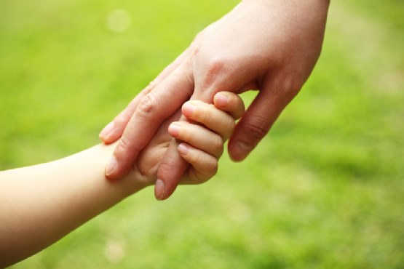
Overview Creating a safe and nurturing environment is an essential factor to achieving positive emotional development, in childhood and throughout the lifespan (Music, 2016). The feeling of security allows children to connect with others, form meaningful relationships, and develop a sense of self confidence and compassion towards others (Nurture UK, 2022). All of these factors support emotional development, and well-being (Nurture UK, 2022). Children of a school age usually undergo psychological changes and emotional development as a result of being treated in many different ways by a wide range of people in a school environment (Immordino-Yang, 2019). Much like primary care givers (Usually parents or guardians), teachers are able to create nurturing, and stable relationships with pupils. Their job to ensure that pupils are protected from harm. Robinson et al (2015), conducted research which concluded that children who experience nurturing relationships are more likely to experience less stress in their lives. It is reasonable to suggest that nurture as a child has a detrimental impact on both emotional development and mental stability throughout life. Un-nurturing and neglectful parenting can result in issues in later life including unhealthy eating habits, abusive and violent behaviours (Khan, 2024). It would also be reasonable to suggest that being brought up in an environment that lacks being nurtured may impact on the type of home environment createed in the future. This is supported by research conducted by Qamar and Majeed(2020).
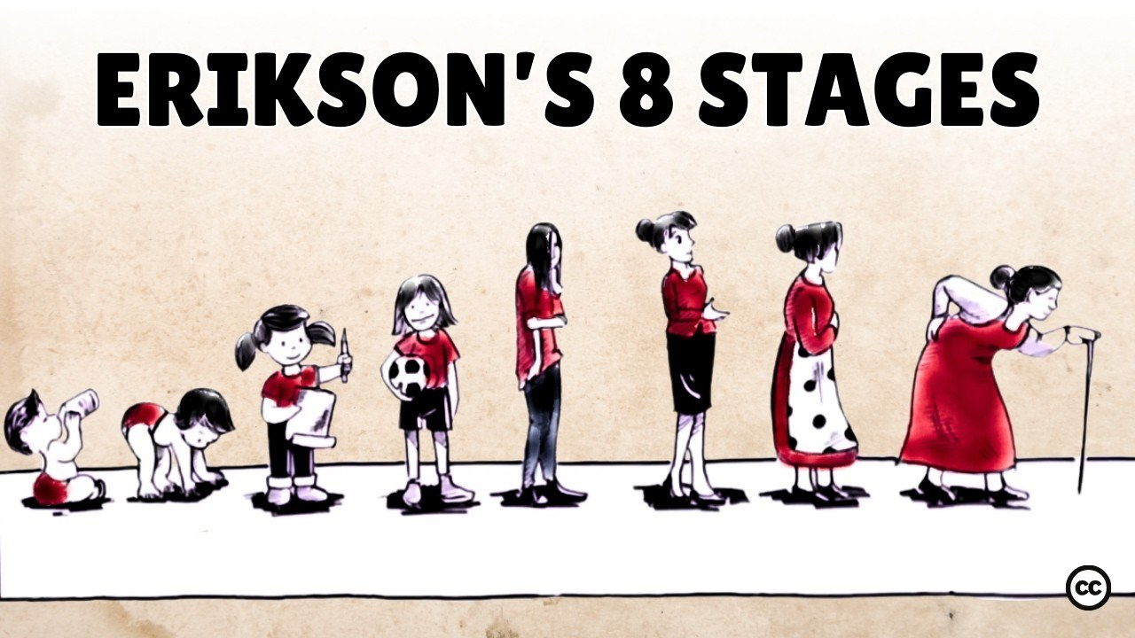
What Theories does this link to? John Bowlby's theory of attachment notes a connection between nurture and emotional development. It suggests if child is unable to form an attachment at a young age, they may never form one (Mcleod, 2024). This theory highlights that not having a secure attachment may result in cognitive, social and emotional difficulties as the child grows up (Mcleod, 2024). It is therefore reasonable to surmise that with a secure attachment comes the feeling of security, love and nurture (NSPCC, 2021). When a caregiver is attentive and nurturing towards a child, Bowlby's believes this creates a feeing of trust and love, and assists meeting emotional milestones (NSPCC, 2021). This can encourage developing emotional resilience, positive self-esteem and enabling the formation of healthy relationships in the future (NSPCC, 2021). According to this theory, children with secure attachments will also be proficient at self regulating their emotions, both as a child and adult (Brumariu, 2015). Bowlby identified 4 stages of a child-carer attachment development: Pre-Attachment (Birth to 6 weeks), Attachment in the making (6 weeks to 7 months), Clear-cut attachment (7 to 24 months), and Formation of reciprocal relationships (24 months plus). With smooth transition through all 4 stages Bowlby theorised that secure attachment should be formed (Mcleod, 2024). Ericksons theory considers 8 stages of development, ranging from birth to death (Syed and Mclean, 2017). These stages focus on nurture and attachment, in regards to well-being. Erikson's first stage looks at trust and mis-trust as an infant (Syed and Mclean, 2017). A secure attachment made between mother and child (birth to 1) helps individuals to accept and understand love, attention and nurture from caregivers (Syed and Mclean, 2017). Its believed that this helped build trust in people throughout the lifespan and expressing emotions. If a child is unable to build secure connection and bond, he theorised that this could result in an individuals doubt and mistrust when older (Kerpelman and Pittman, 2018). It can be surmised that this theory furthermore suggests emphasis on the importance of nurture in childhood, and highlights the detrimental impact that an absence of this could have on individuals lives. Erikson's other stages are: Autonomy vs Shame, Initiative vs Guilt, Industry vs Inferiority, Identity vs Confusion, Intimacy vs Isolation, Generativity vs Stagnation, and Integrity vs despair (Mcleod, 2024). These additional stages of Erikson's theory don't take into consideration nurture (Mcleod, 2024). Both Bowlby and Ericksons theories value the effect that nurturing relationship can have on emotional development and wellbeing, throughout an individuals life (Pittman et al, 2011). Bowlby's theory focusses primarily on childhood stages, whereas Erikson's looks at effects throughout life (Pittman et al, 2011). I consider this a strength of Erikson's theory as it adds emphasis on the outcomes if a secure attachment is not achieved from childhood.

Key Milestones and Challenges Faced by Individuals. A key milestones is the development of the ability to express and share emotions (Early stages, 2024). This skill often develops around school age, and plays a vital role in developing confidence and independence throughout life (Holmboe et al, 2016). From personal experience, I have observed children of school age begin to build confidence in expressing emotions, opinions and their views. I have also observed the development of empathy and compassion towards others. According to Bowlby and Erikson, not having a secure attachment can result in challenges in meeting developmental milestones (Holmboe et al, 2016). Personally I note children who attend school which provides a nurturing, safe and welcoming environment tend to have better communicating skills. However, have also worked closely with children who have additional learning needs (ALN), and have observed challenges in these same areas. Skura and Swiderska (2022) support this view and believe that those with additional learning needs may struggle to empathise and understand other peoples views. They also suggested that with time, they are able to develop these abilities for later life.

How do Practitioners Support This? Creating a safe and inviting classroom is a practice which education staff can encourage emotional development of pupils (Early Intervention Foundation, 2019). It is important that a kind and welcoming attitude is shown, this can promote emotional expression, meaning they are more likely to share concerns (Early Intervention Foundation, 2019). Protecting a child's safety and wall-being should always be the priority within education (UK Parliament, 2024) as supported by the Children Act 1989 (UK Parliament, 2024). Children with ALN within education, should be encouraged to develop emotional awareness and well-being (Murphy et al, 2024). Using engaging activities and tasks can help them to understand and develop their skills (Murphy et al, 2024) . As highlighted by Skura and Swidersha (2022), emotional awareness can be one aspect where they may struggle. This method of delivery can be effective, especially when repeated and built upon. The Additional learning needs and Tribunal (Wales) Act 2018, supports the encourages inclusion and education of those with ALN (Legislation.gov, 2018).
The impact of nurture on emotional development is undeniable. Educational practitioners have a duty to support children, helping them to develop emotionally within schools. Bowlby's and Erikson's theories have supported this outlook.
Reference List Brumariu, L (2015)'Parent-Child Attachment and Emotion Regulation' New Directions for Child and Adolecent Development. Pp. 1-104. Available at: https://onlinelibrary.wiley.com/doi/epdf/10.1002/cad.20098. (Accessed: 21/02/2025). Early Intervention Foundation (2019)'Improving Social and Emotional Learning in Primary Schools' Education Endowment Foundation. Available at: file:///C:/Users/grace/Downloads/improving-social-and-emotional-learning-in-primary-schools.pdf. (Accessed: 22/02/2025). Early Stages (2024) Social-Emotional Milestones. Available at: https://www.earlystagesdc.org/page/social-emotional-milestones#:~:text=Social%2Demotional%20development%20is%20a,with%20others%2C%20and%20build%20confidence. (Accessed: 22/02/2025). Holmboe, E. And Edgar, L (2016)'The Milestones Guidebook' ACGME. Vol. 1. Available at: https://prod2.acgme-i.org/globalassets/acgme-international/MilestonesGuidebook.pdf. (Accessed: 22/02/2025). Immordino- Yang, M (2019)'Nurturing Nature: How Brain Development is Inherently social and emotional, and what this means for education' American Psychological Association. Vol. 54, Iss. 3, Pp. 185-204. Available at: https://www.tandfonline.com/doi/citedby/10.1080/00461520.2019.1633924?scroll=top&needAccess=true. (Accessed: 21/02/2025). Kerpelman, J. And Pittman, J (2018)'Erikson and the Relational Context of Identity: Strengthening Connections with Attachment Theory'. Routledge. Vol. 18, No. 4, Pp. 206-314. Available at: https://www-tandfonline-com.ezproxy.uwtsd.ac.uk/doi/epdf/10.1080/15283488.2018.1523726?needAccess=true.(Accessed: 22/02/2015). Khan, A (2024)'Lack of Attention from Parents Creating Mental Health Issues on Children' International journal of Advances in Engineering and Management. Vol.6, Iss.4. Pp.2395-5252. Available at: https://ijaem.net/issue_dcp/Lack%20of%20Attention%20from%20Parents%20Creating%20Mental%20Health%20Issues%20on%20Children.pdf. (Accessed: 19/02/2025). Legislation.gov (2018) Additional Learning Needs and Educational Tribunal (Wales) Act 2018. Available at: https://www.legislation.gov.uk/anaw/2018/2/contents. (Accessed: 22/02/2024). Mcleod (2024) John Bowlby's attachment theory. Available at: https://www.simplypsychology.org/bowlby.html. (Accessed:21/02/2025). Mcleod (2024) Stages of Attachment Identified by John Bowlby and Schaffer and Emerson (1964). Available at: https://www.simplypsychology.org/stages-of-attachment-identified-by-john-bowlby-and-schaffer-emerson-1964.html. (Accessed: 22/02/2025). Mcleod (2024) Eric Erikson's Stages of Psychological Development. Available at: https://www.simplypsychology.org/erik-erikson.html. (Accessed: 22/02/2025). Murphy, A., Greenway, C. And Conn, C (2024)'Negotiation Additional Learing Needs Reform in Wales: The Voice of the ALENCo'. nasen. Iss. 1467-3383. Available at: https://nasenjournals.onlinelibrary.wiley.com/doi/epdf/10.1111/1467-8578.12568. (Accessed: 22/02/2025). Music, G (2017) Nurturing Natures: Attachment and Children's Emotional, Sociocultural, and Brain Development. New York: Routledge. NSPCC (2021) Attachment and Child Development. Available at: https://learning.nspcc.org.uk/child-health-development/attachment-early-years?form=MG0AV3. (Accessed: 21/02/2025). Nurture UK (2022) The Positive Impact of Nurture on Children's Mental-Health. Available at: https://www.nurtureuk.org/the-positive-impact-of-nurture-on-childrens-mental-health/#:~:text=Nurture%20allows%20children%20to%20connect,and%20parents%20tell%20us%20so. (Accessed: 20/02/2025). Pittman, J., Keiley, M., Kerpelman, J. And Vaughn, B (2011)'Attachment, Identity and Intimacy: Parallels Between Bowlby's and Erikson's Paradigms'. Journal of Family Theory and Review. Iss. 1756-2570, Pp. 32-46. Available at: https://onlinelibrary.wiley.com/doi/epdf/10.1111/j.1756-2589.2010.00079.x. (Accessed: 22/02/2025). Robinson, L., Leeb, R., Merrick, M. And Forbes, L (2015)'Conceptualizing and Measuring Safe, Stable, Nurturing Relationships and Environments in Educational Settings' Springer. Vol. 25, Pp. 1488-1506. Available at: https://link.springer.com/article/10.1007/s10826-015-0332-2. (Accessed: 21/02/2025). Skura, M. And Swiderska, J (2022)'The Role of Teachers Emotional Intelligence and Social Competences with Special Educational Needs students' Routledge. Vol. 37, No. 3, Pp. 401-416. Available at: https://www.tandfonline.com/doi/epdf/10.1080/08856257.2021.1885177?needAccess=true. (Accessed: 22/02/2025). Syed, M. And McLean, K (2017) Erikson's Theory Of Psychological Development. Available at: https://osf.io/preprints/psyarxiv/zf35d. (Accessed: 22/02/2025). UK Parliament (2024) An Overview of Child Protection Legislation in England. Available at: https://commonslibrary.parliament.uk/research-briefings/sn06787/. (Accessed: 22/02/2025). Qamar, T. And Majeed, S (2020)'Neglect Parenting Style and Academic Achievement in Medical Students: Moderating Role of Emotional Intelligence' European Journal of Research in Social Sciences. Vol. 8, No. 1, Iss. 2056-5429. Available at: https://www.idpublications.org/wp-content/uploads/2020/03/Full-Paper-NEGLECT-PARENTING-STYLE-AND-ACADEMIC-ACHIEVEMENT-IN-MEDICAL-STUDENTS.pdf?form=MG0AV3. (Accessed: 21/02/2025).

