Harvard Referencing Activity 1

On the pages that follow there are 20 reputable sources from either books, journals, or websites.

Using your new knowledge of referencing, along with the UWTSD Harvard Referencing Guide (from our Moodle page), please provide the citation for each source, and the full correctly formatted reference for each source in the spaces provided.
The images of the webpages all contain hyperlinks – this means you can click on the link and look around the webpage to search for the information you need.
When referencing journal articles, keep in mind that not all journals will have an issue number.
When you are finished, ensure you save your document and upload it to the correct submission link for Activity 1.

Good luck!

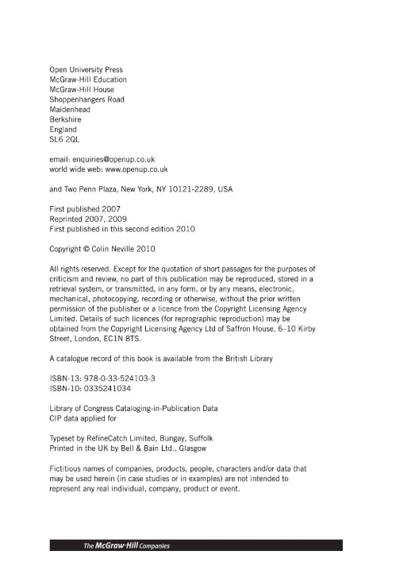

Citation : (Neville, 2010)
Reference : Neville, C. (2010) The Complete Guide to Referencing and Avoiding Plagiarism. 2nd edn. New York: Open University Press.
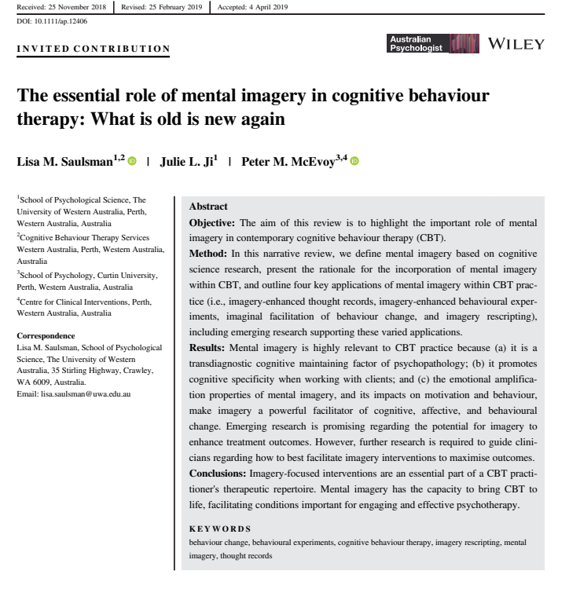
Citation : (Saulsman, Ji and McEvoy, 2019)
Reference : Saulsman, L. M., Ji, J.L. and McEvoy, P.M. (2019) ‘The essential role of mental imagery in cognitive behaviour therapy: What is old is new again’, Wiley.

Citation : Westgate et al (2017)
Reference : Westgate, E.C. et al. (2017) ’Productive procrastination: academic procrastination style predicts academic and alcohol outcomes’, Journal of Applied Social Psychology, 47, pp. 124-135.

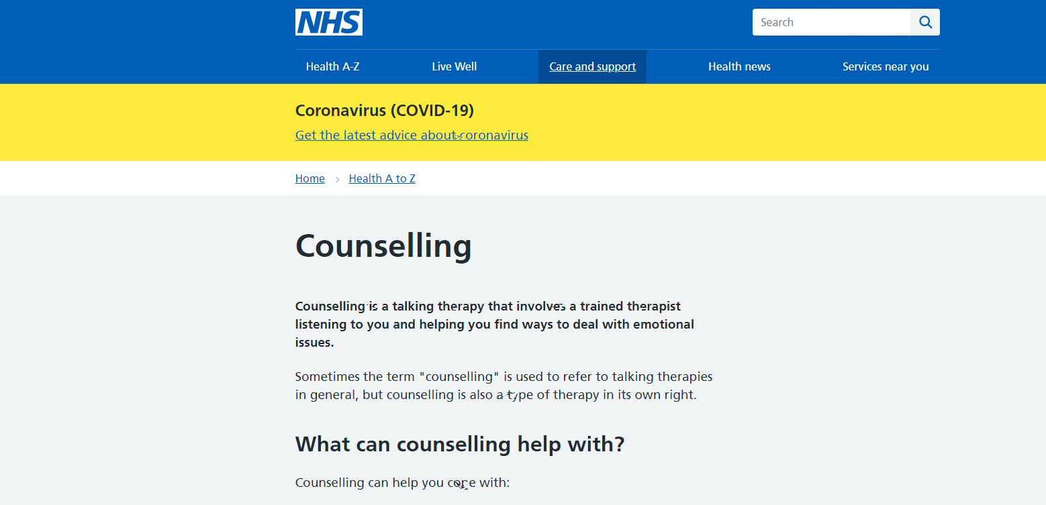

Citation : National health Service (2021)
Reference : National health Service (2021) Counselling. Available at: https://www.nhs.uk (Accessed 9th of February 2021).

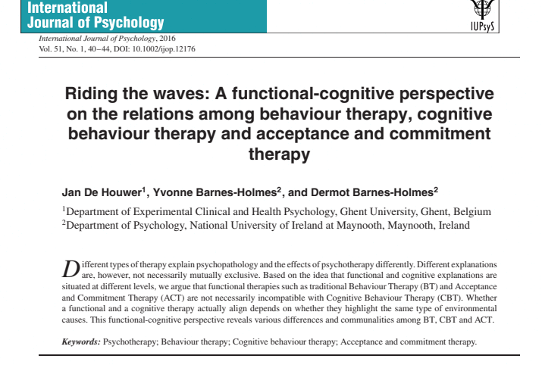

Citation : De Houwer, Barnes Holmes and Barnes-Holmes (2016)
Reference : De Houwer, J.D., Barnes Holmes, Y. and Barnes-Holmes, D. (2016) ‘Riding the Waves: A functional-cognitive perspective on the relations among behaviour therapy, cognitive behaviour therapy and acceptance and commitment therapy’, International Journal of psychology, 51(1), pp 40-44.
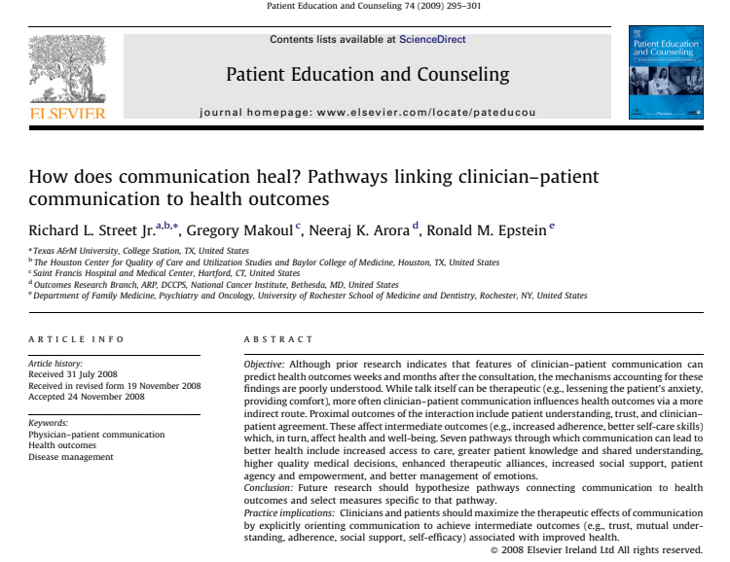

Citation : L. Richard et al (2008)

Reference : L. Richard et al (2008) ’How does communication heal? Pathways linking clinical-patient communication to health outcomes’, Patient education and counselling, 74, pp 295-301.
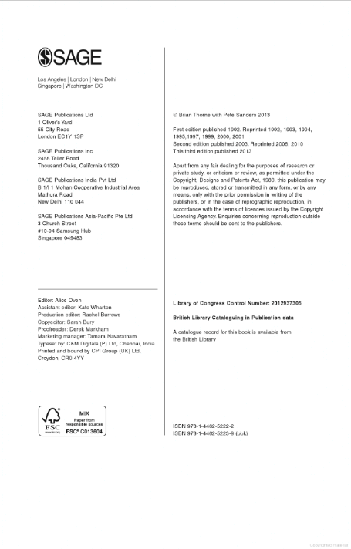

Citation : Thorne and Sanders (2013)
Reference : Thorne, B. and Sanders, P. (2013) Carl Rogers, 3rd edn. Los Angeles-London-New Delhi-Singapore- Washington DC: Sage.

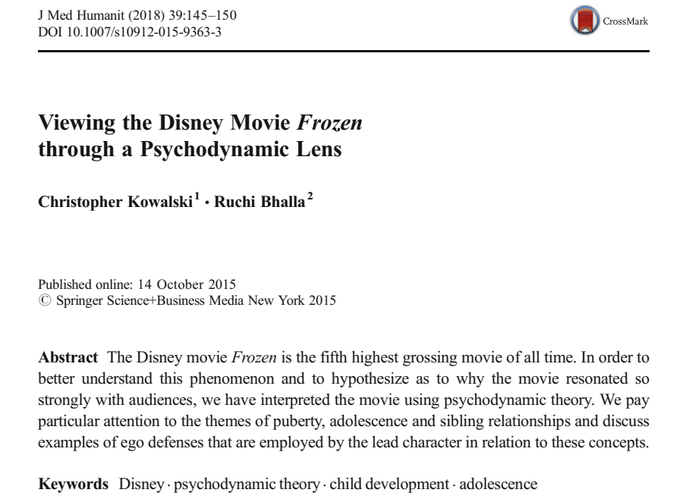

Citation : Kowalski and Bhalla (2015)
Reference : Kowalski, C. and Bhalla, R. (2015) ‘Viewing the Disney Movie Frozen trough a Psychodynamic Lens’, J Med Hummanit, 39,pp 145-150.
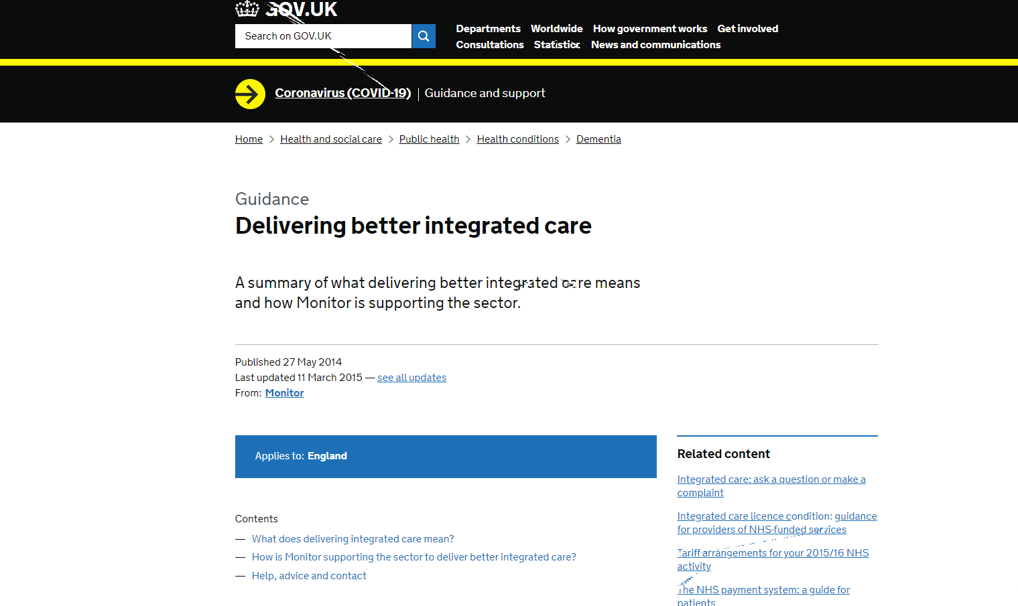

Citation : Gov.UK (2021)
Reference : Gov. UK (2021) Delivering better integrated care. Available at Delivering better integrated care - GOV.UK (www.gov.uk) (Accessed 13 February 2021).
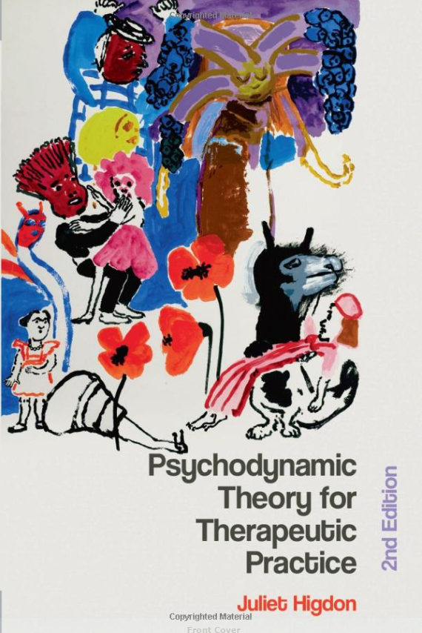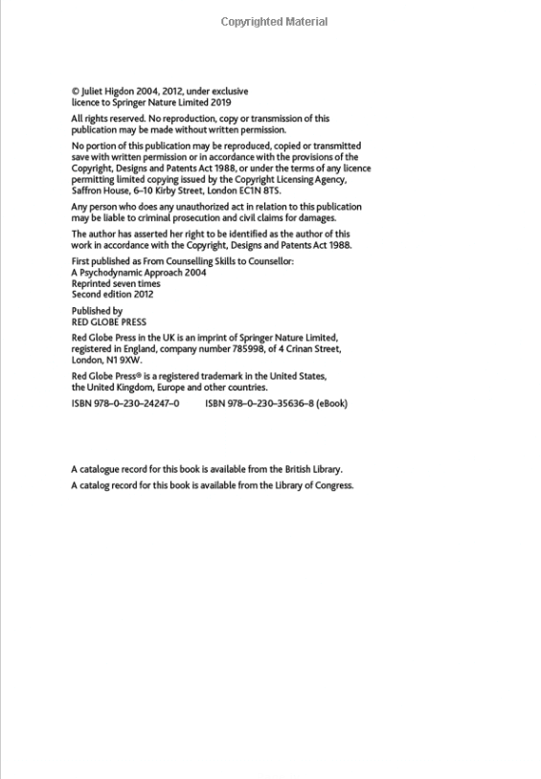

Citation : Higdon(2012)
Reference : Higdon, J. (2012) Psychodynamic Theory for Therapeutic Practice. 2nd edn. London: Red Globe Press.
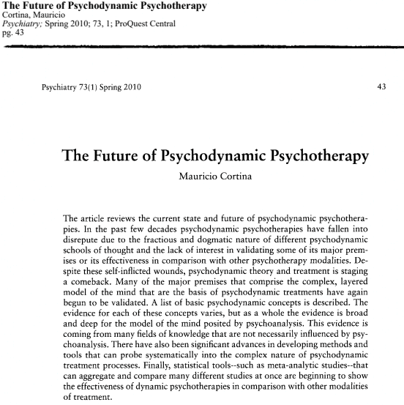
Citation : Cortina(2010)

Reference : Cortina, M. (2010) ‘The future of Psychodynamic Psychotherapy’ Psychiatry 73(1), pp 43.

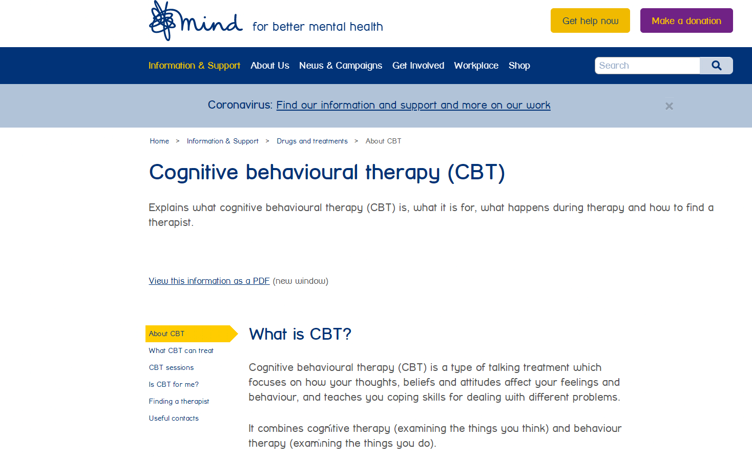
Citation : Mind (2021)
Reference : Mind (2021) Cognitive Behaviour therapy (CBT). Available at: About CBT | Mind (Accessed 13 February 2021).
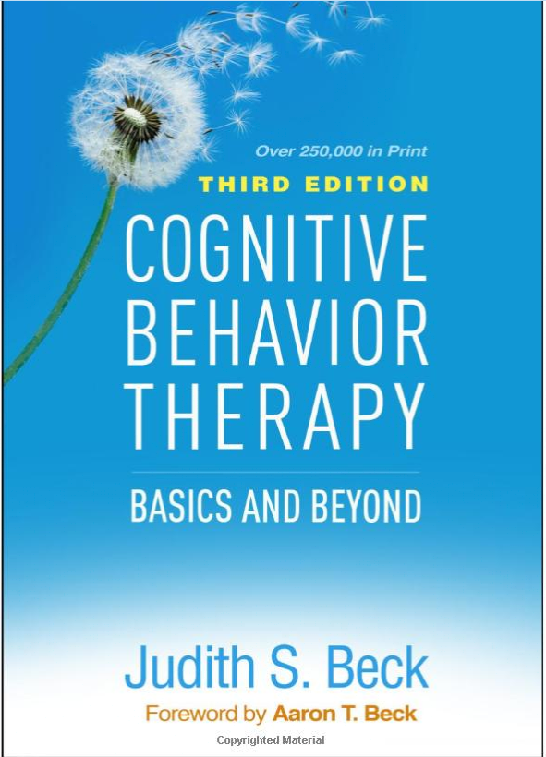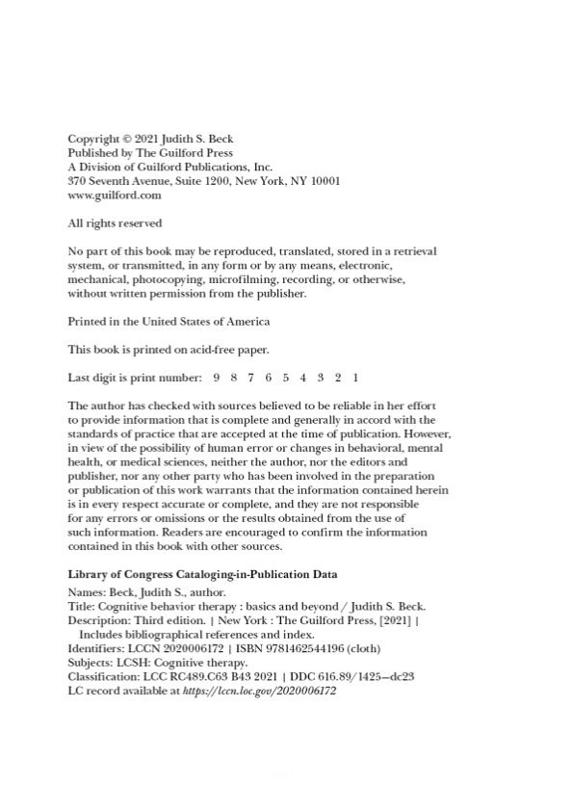
Citation : Beck (2021)
Reference : Beck, J. S. (2021) Cognitive Behaviour Therapy: Basic and Beyond. 3rd edn. New York: The Guilford Press.
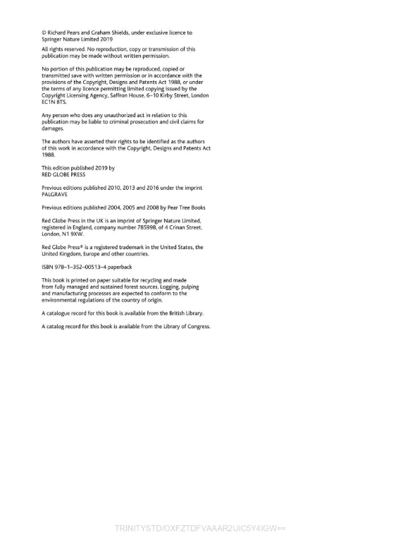
Citation : Pears and Shields (2019)
Reference : Pears, R. and Shields, G. (2019) Cite Them Right the essential referencing guide. 11th edn. London: Red Globe Press.

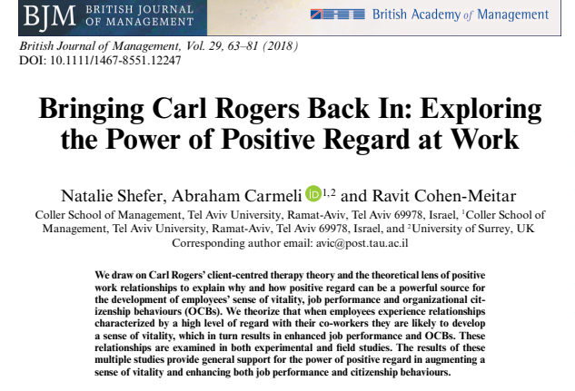

Citation : Shefer, Carmeli and Cohen-Meitar (2018)
Reference : Shefer, N., Carmeli, A. and Cohen-Meitar, R. (2018) ‘ Bringing Carl Rogers Back In: Exploring the Power of Positive Regard at Work’, British Journal of Management, 29, pp 63-81.
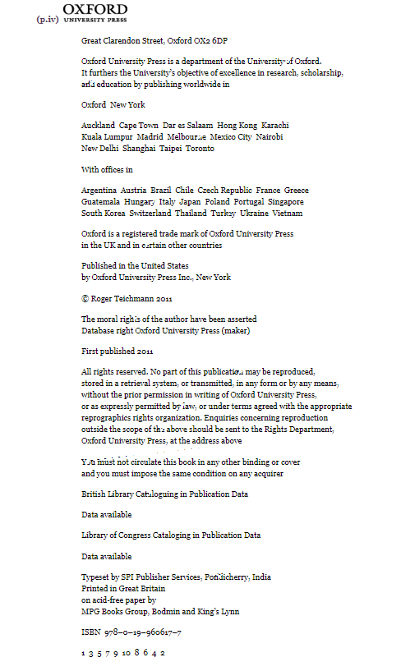
Citation : Teichman (2011)
Reference : Teichman, R. (2011) Nature, Reason & the Good Life Ethics for Human Beings. United States: Oxford University Press.

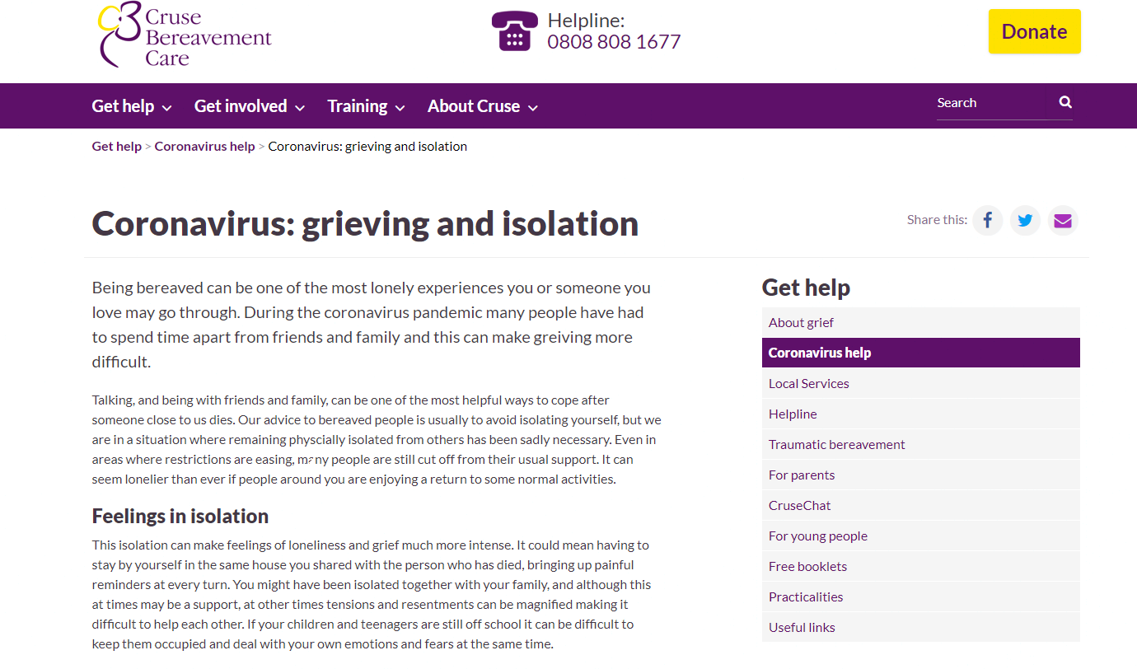

Citation : Cruse Bereavement Care (2021)
Reference : Cruse Bereavement Care (2021) Coronavirus: Grieving and isolation. Available at: Coronavirus: grieving and isolation | Cruse Bereavement Care (Accessed 13 February 2021).
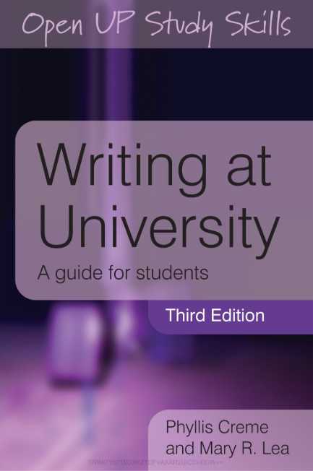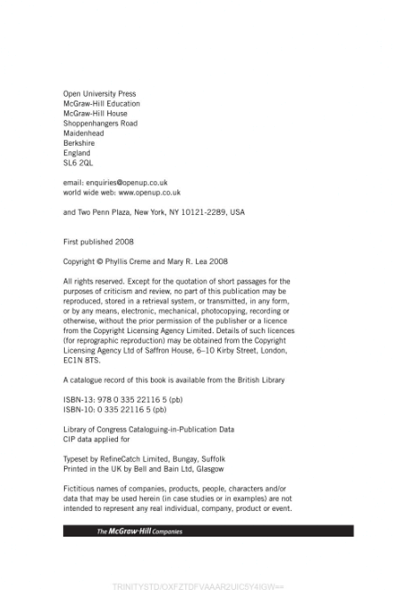

Citation : Creme and Lea (2008)
Reference : Creme, P. and Lea, M.R. (2008) Writing at University. 3rd edn. New York: Open University Press.

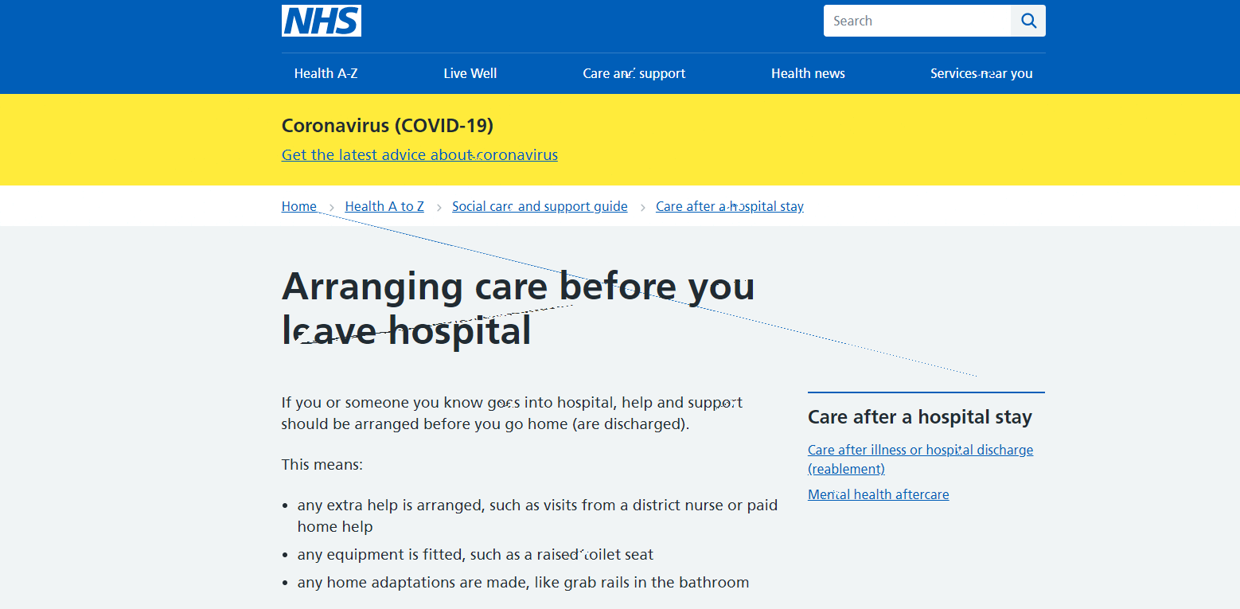

Citation : National health Service (2021)
Reference : National health Service (2021) Arranging care before you leave hospital. Available at: Arranging care before you leave hospital - NHS (www.nhs.uk) (Accessed 9th of February 2021).
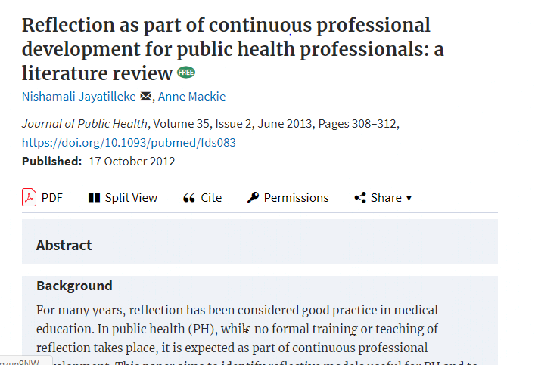

Citation : Jayatilleke and Mackie (2012)
Reference : Jayatilleke, N. and Mackie, A. (2012) ‘Reflection as part of continuous professional development for public health professionals: a literature review’, Journal of Public Health, 35(2), pp 308-312.

