Name: Jack Glascott
Student Number: 1901783

Human Evolution and the Origins of Modern Human Behaviour

Practical exercise 2021

Please indicate your response clearly

Looking at faces 1
Look at the following images and then compare them to the list below. Indicate clearly (circle or highlight) the name of the early hominin skull you believe this to be.
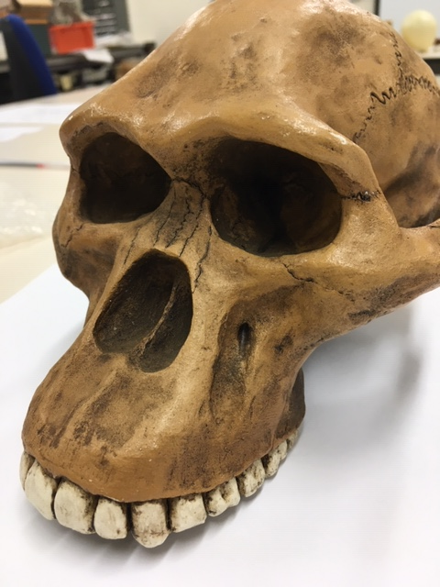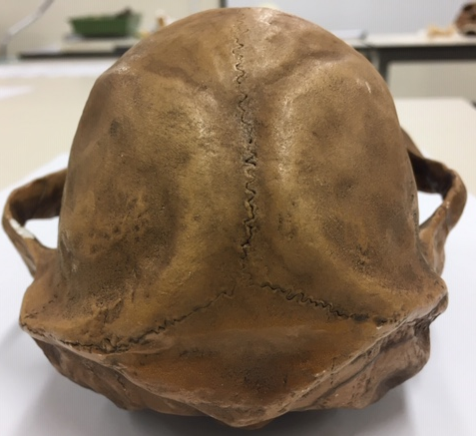

Chimpanzee

Australopithecus afarensis

Australopithecusafricanus

Australopithecus robustus

Homo habilis
Looking at faces 2
Look at the following images and then compare them to the list below. Indicate clearly (circle or highlight) the name of the early hominin skull you believe this to be.
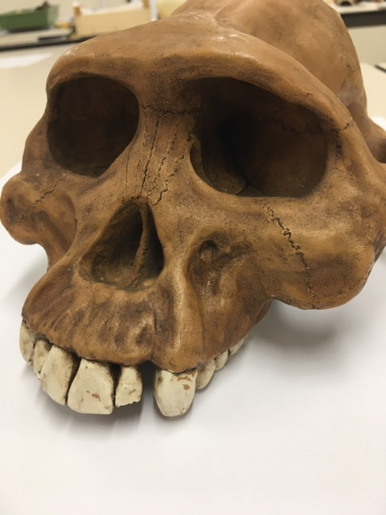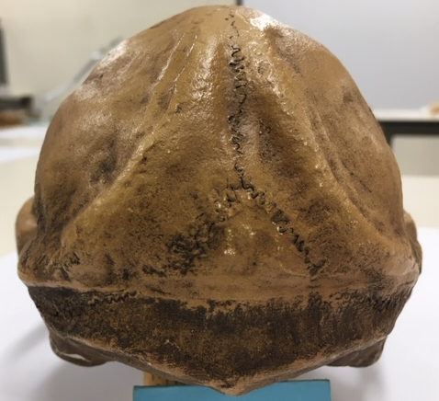

Chimpanzee

Australopithecus afarensis

Australopithecusafricanus

Australopithecus robustus

Homo habilis

Looking at faces 3
Look at the following images and then compare them to the list below. Indicate clearly (circle or highlight) the name of the early hominin skull you believe this to be.
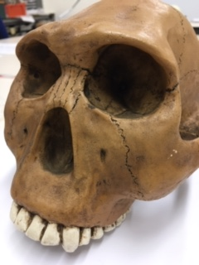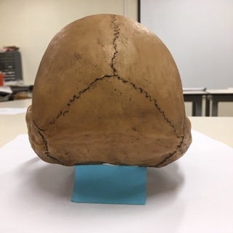

Chimpanzee

Australopithecus afarensis

Australopithecusafricanus

Australopithecus robustus

Homo habilis
Maxilla (upper jaw): Identify the species these belong to
A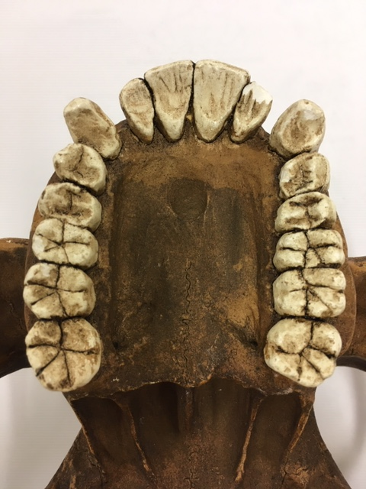B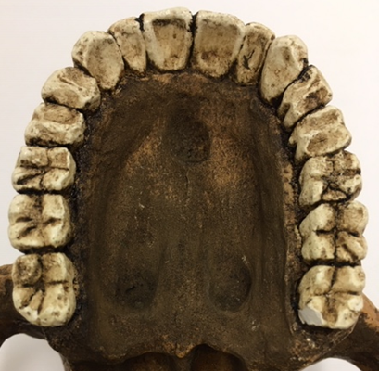
A Australopithecus afarensis B Australopithecus africanus
Top row left Chimpanzee, Middle Australopithecus afarensis, Right modern human
Lower row Left Australopithecus africanus, Right Australopithecus robustus
Indentify the skull to genus and species level
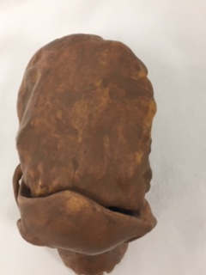
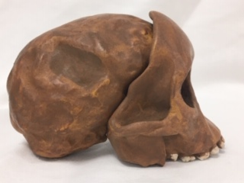
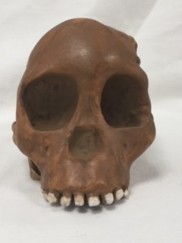
Answer: Australopithecus africanus (Tong child)
Indentify the skull to genus and species level
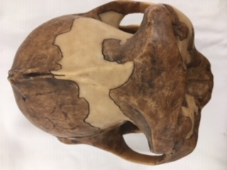
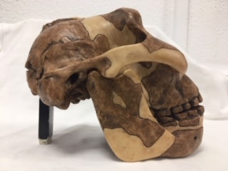
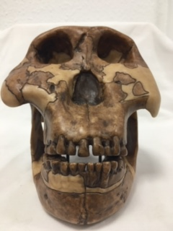
Answer: Australopithicus boisai
Identify the hominin skull to genus and species level
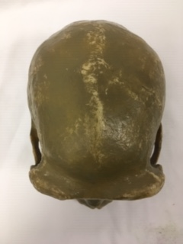

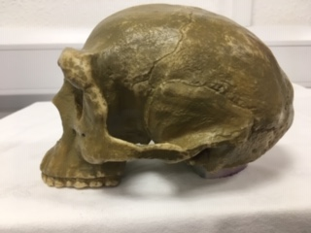

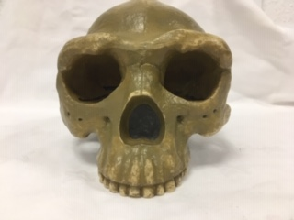
Answer: Homo erectus
Indentify the skull to genus and species level
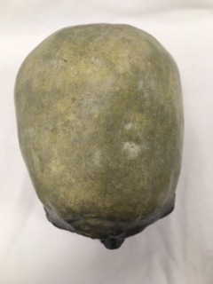
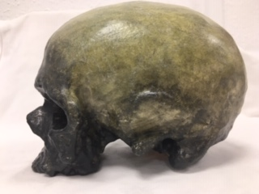
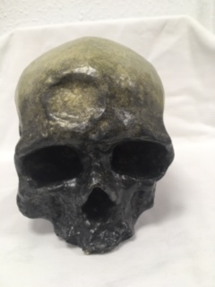
Answer: Homo sapian
Identify, compare and contrast these two mandibles. Use the illustration below to help if you need to.
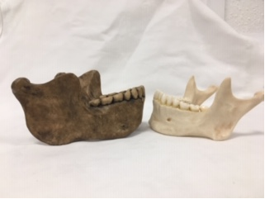
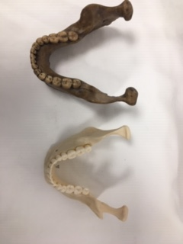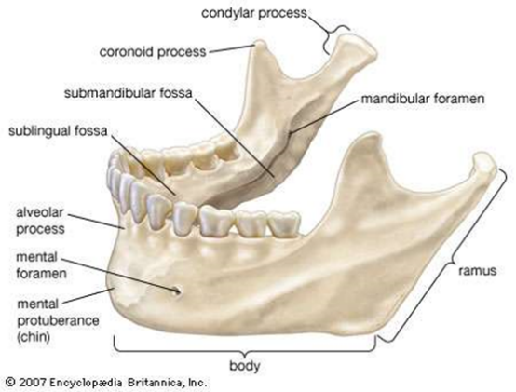

Answer: The similarities of these two mandibles focus on the basic shaping and essential dimensions of the mandible formen, the main body of the jaw and its curvature, and highly similar teeth from molars to incisors from size to spacing. However, the Hindelbergensis jaw (left) presents not only a greater size than the Homo sapiens (right) but also a larger ramus, coronoid process and sublingual fossa, condylar process but lacks mental protuberance, mental foramen and overall seems to have a much more robust and denser bone structure than the Homo sapiens

Stone tools and tool technology: How to tell a stone is worked.
What suggests this has been worked?
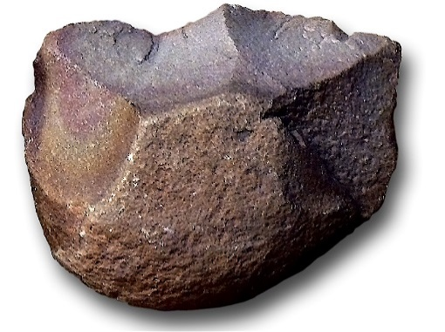
Answer: A clear indication of whether a stone was worked is evidence of apparent modification such as indentations on the stone at the top of the flake pattern indicating the striking of another stone, leftover cortex covering the lower and middle of the flint blade above indicates what the original surface of the stone was and what was worked, apparent flaking and an identifiable edge on the main body of the tool to develop a shape as seen above with the all but one side converted to a blade thus clearly a purposeful construction, lastly is the is evidence of the use with possible edge and wear damage on the blade demonstrating its use as a primary tool and possibly what for, however, this is not identifiable from sight.

Features of stone tool flaking: identify features 1-5
1. platform
2. exterior platform
3. bulb
4. flake
5. edge

Stone tools and tool technology: Stone tools not to scale
Below left: Oldowan Below Right: Acheulean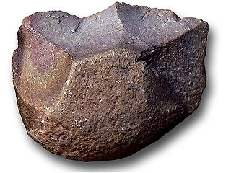 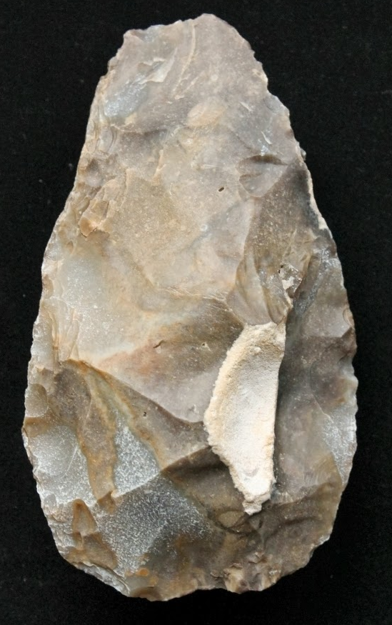
Images taken from https://images.search.yahoo.com

Task: Compare and contrast these two stone tools

The similarities between these two stone tools focus primarily on the formation process and the use of flaking to produce an edge; the Oldowan tool has been worked on with the flaking down into an edge, with similar features on the Acheulean tool with the remaining cortex acting as a striking platform as identified by the bulbs around them; however, the differences of the examples are many one of the critical aspects is the amount of the cortex still on the piece with the left having a large amount of cortex. Significantly more minor flaking indicated less time spent on the piece. In contrast, the Acheulean stone tool presents only a single piece of the cortex and a massive amount of flaking and the active shaping of the stone into the famous and apparent pair shaped hand axe.

