

Student name: FATIMA EZZAHRA ZAHIR
Student ID: 2326547
Module name: Changemakers: Building your Personal Brand for Sustainable Employment
Module code: BMHP5015_LON
Lecturer name: Caroline Salami

Assignment: Reflection on "Changemakers: Building Your Brand for Sustainable Employment"

Introduction
I will consider what I learned from the "Changemakers: Building Your Brand for Sustainable Employment" course in this assignment. This work directly reflects on the four module units, covering major concepts connected to personal and professional development ideas and methods. The study program studied four major subjects: personal branding, boundaryless careers, networking tactics, and emotional intelligence concepts (Gibson et al., 2014). The lessons supplied me with crucial understanding concerning resilience, continual development, and adaptation, which are necessary for navigating the current workplace. I'll show how these components have been essential in helping me develop my own brand, comprehend worldwide connections and flexible career paths, recognize and take advantage of chances, and take into account my general wellbeing in the demanding field of health and social care.

Reflection on Unit 1: Brand You
Unit 1 focuses on ideas crucial to developing a professional identity, including personal branding, self-awareness, and identifying strengths. During lectures and activities, I got an understanding that developing a personal brand is more than simply marketing; it is about real self-expression and consistency across my professional life. I discovered that effective goal planning is intimately tied to motivation, which, according to the lecture material, depends on three factors: autonomy, mastery, and purpose (Duckworth et al., 2007). I discovered that ambition involves a tremendous urge for development that feeds my determination for risk-taking and persistence despite adversities (Duckworth et al., 2007). This ambition operates as a force that directs my decision-making process toward job achievement, while motivation functions as the propeller driving my goal-directed conduct. Increasing my self-awareness was essential to constructing my brand, and it necessitated a thorough examination of my basic work values. When I did the work values assessment in Unit 1, I realised my top intrinsic value wasn't "high salary"—it was 'Making a Visible Difference'. This insight immediately helped me refine my personal brand. Instead of just saying I was "good at time management" on my CV, I started telling a personal story in interviews: "I redesigned our client scheduling board because I found the old system caused confusion and delayed care. Seeing the team’s stress drop and client satisfaction rise proved I was not just managing time, but making a visible, positive change." This small, personal narrative turned a generic skill into a branded strength that clearly aligned with my core purpose in H&SC. The unit redirected me to evaluate my personal health and social care professional aspirations. I discovered that creating a goal entails picturing the desired result and then dividing the target into workable chunks. For example, a professional objective could be set to acquire supervisor position before becoming the administrator of a care centre. Critically, I observed that the development of critical skills and knowledge, plus a clear vision, are requirements for success (Henry, 2021). I understand how personal control (autonomy) and skill acquisition (mastery) are crucial to structuring my journey toward health and social care fulfilment.

Online Activity Screenshots (Unit 1)
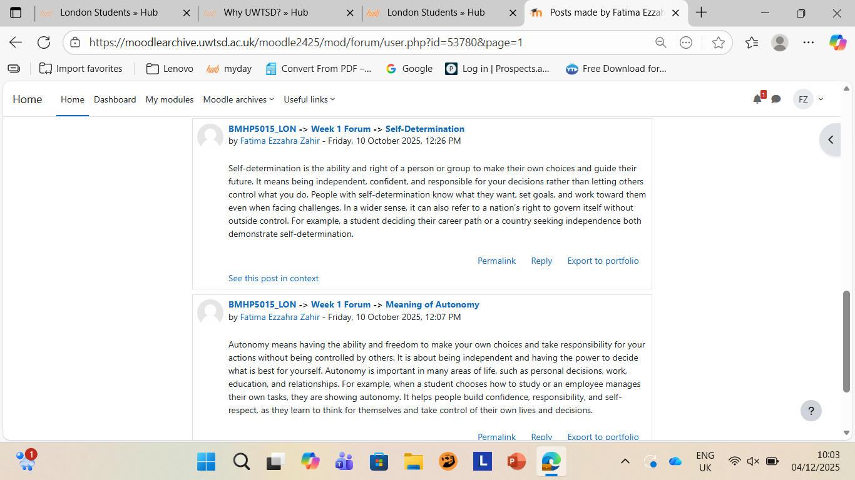
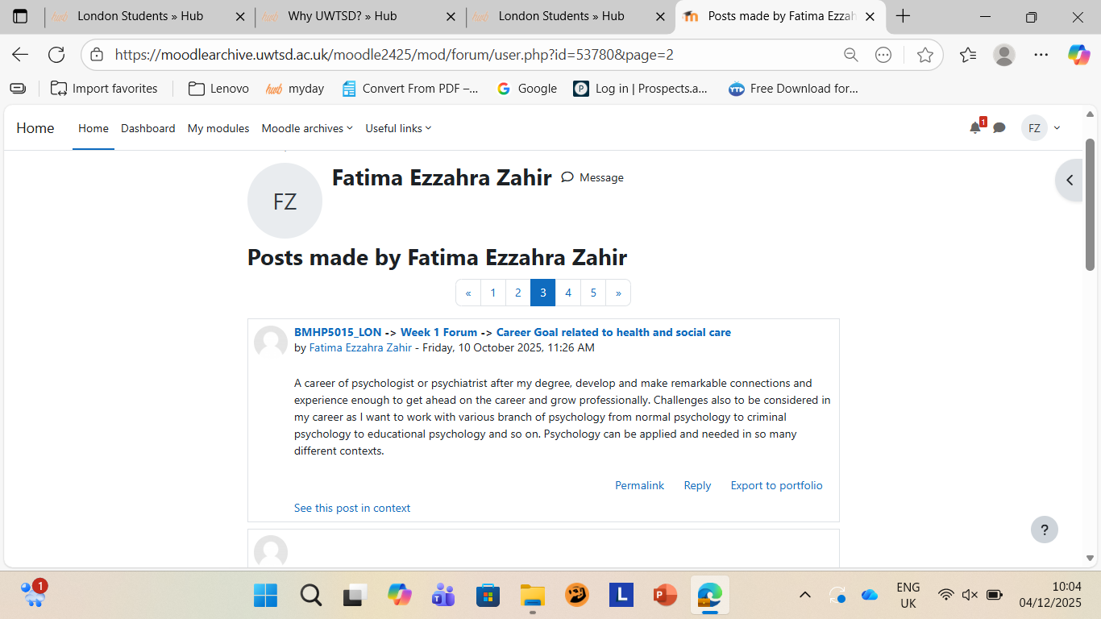

Reflection on Unit 2: It is a Small World
Unit 2 inspired me to focus on the nature of modern employment by presenting the concepts of boundaryless careers and boundaryless talents (Larsson & Tacking, 2023). I discovered that professional jobs today encompass more than just one company or sector, necessitating that workers move between industries and assume various positions and places. This flexible approach, which is especially noticeable in the health and social care sector (where employees may work in clinics, hospitals, or on a freelance basis), permits professional growth but also poses difficulties like job insecurity (Larsson & Tacking, 2023). I used to dread working with one particular colleague who was very abrupt and often seemed annoyed. Unit 2's focus on Emotional Intelligence (EI) made me realise I was focusing only on their behaviour, not the potential emotion behind it. I made a personal effort to apply empathy (a core EI principle). Instead of taking their curtness personally, I started simply asking, "Is everything okay today? You seem stressed." This small shift changed the dynamic entirely. It turned out they were dealing with personal issues. By using EI to address the situation with care rather than frustration, I not only improved our working relationship but demonstrated the very boundaryless skill needed for compassionate, patient-centred teamwork. I discovered that seeking out mentors can dramatically expedite professional development and broaden one's network, which is vital for navigating fluid career trajectories (Klinge, 2015). This form of proactive, aided learning helps professionals to not just survive but actively thrive amid technological and structural change, exhibiting the adaptability necessary in the modern global H&SC business. I learned that adaption abilities and the power to seize opportunities are crucial in today's continuously changing job market. The gig economy, which exemplifies traits of boundaryless careers, was one of the main examples examined. As a healthcare professional, I now have a stronger grasp of the advantages of accepting daily contracts as well as the drawbacks of unstable income and unstable employment (Larsson & Tacking, 2023). Emotional Intelligence (EI) was a key boundaryless skill I researched. I learned that medical professionals need EI to perceive and successfully control emotions in themselves and others (Entwistle et al., 2018). The compassionate, patient-centered care provided in healthcare settings depends heavily on this ability. Furthermore, the literature indicates that EI increases communication and decision-making ability (Gibson et al., 2014), which I can employ to better my professional interactions and performance in difficult emotional situations. Unit 2 also instructed me on the importance of Self-Awareness and Curiosity, which are vital for making better judgments and sustaining up-to-date expertise (Klinge, 2015).

Online Activity Screenshots (Unit 2)
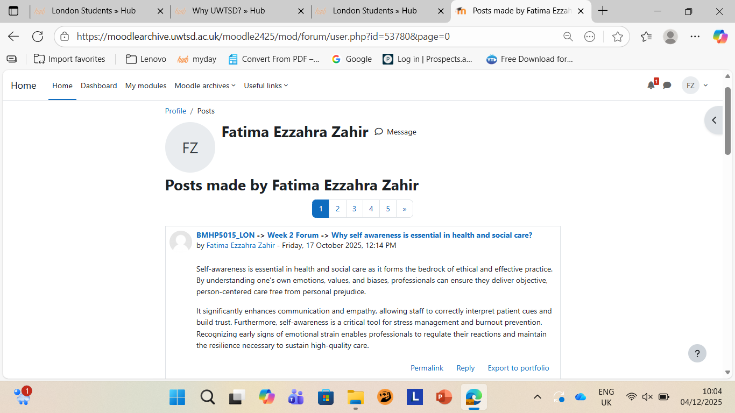
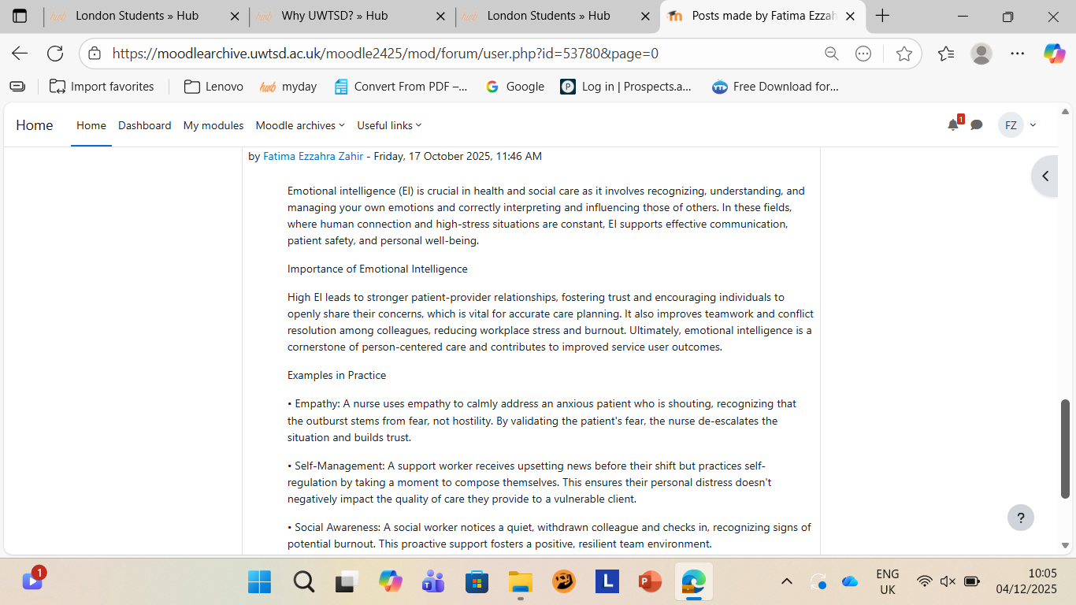
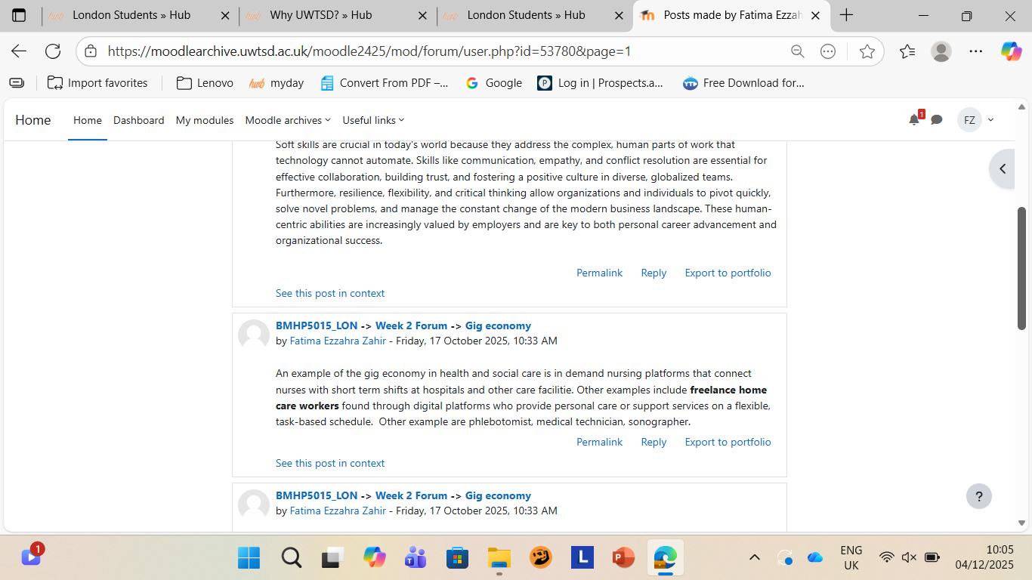

Reflection on Unit 3: Opportunity Knocks
Unit 3 included diverse relationship management and networking evaluation with an emphasis on professional development. I discovered that networking is essential for career progress and that it necessitates meaningful connections in order to exchange knowledge, gain insightful information, and be introduced to new employment opportunities. I discovered that networking is a strategic means of enhancing skills and gaining current field knowledge, which enables me to employ social capital for professional success (Gibson et al., 2014). I spent a few afternoons tidying up my LinkedIn profile after the Unit 3 lectures on online presence. I didn't expect much, but a few weeks later, a former placement supervisor messaged me. They said they saw I had updated my "Interests" to include digital mental health tools and mentioned they needed a temporary assistant with that specific interest for a new pilot project. This was pure serendipity—an accidental, beneficial discovery—triggered by my intentional digital activity. I didn't directly apply for a job; I made myself discoverable. This personal experience taught me that networking isn't just shaking hands at events; it's about making sure your professional curiosity is visible online so opportunities can find you. The unit was crucial in helping me find and use opportunities through the study of network evaluation. I was exposed to three main evaluation categories for analyzing networking success: goal-based, process-based, and outcome-based. I discovered that employing these various methods to regularly evaluate my professional networks will ensure their contribution to my career objectives. Specifically, in healthcare, the examination of networks helps guarantee resources operate efficiently and optimize health outcomes (Sheikh et al., 2021). I can now use network evaluation to track my progress toward a particular, quantifiable goal and connect my learning to a framework such as SMART goals. Furthermore, Unit 3 showed me the necessity of diversity in networking. I came to see that diversified networking fosters creative teamwork, which improves collaborative outcomes. This is a crucial ability for personal growth planning because it allows me to consciously look for relationships that expand my knowledge and expertise in the fields of health and social care.

Online Activity Screenshots (Unit 3)
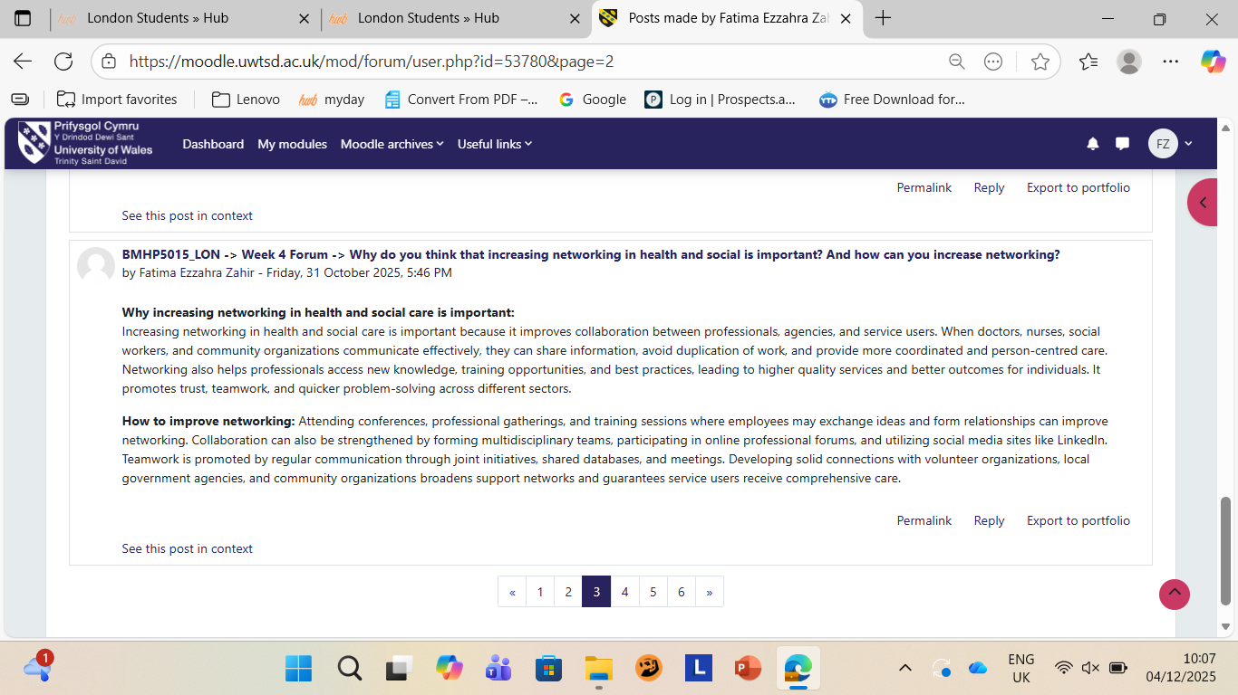
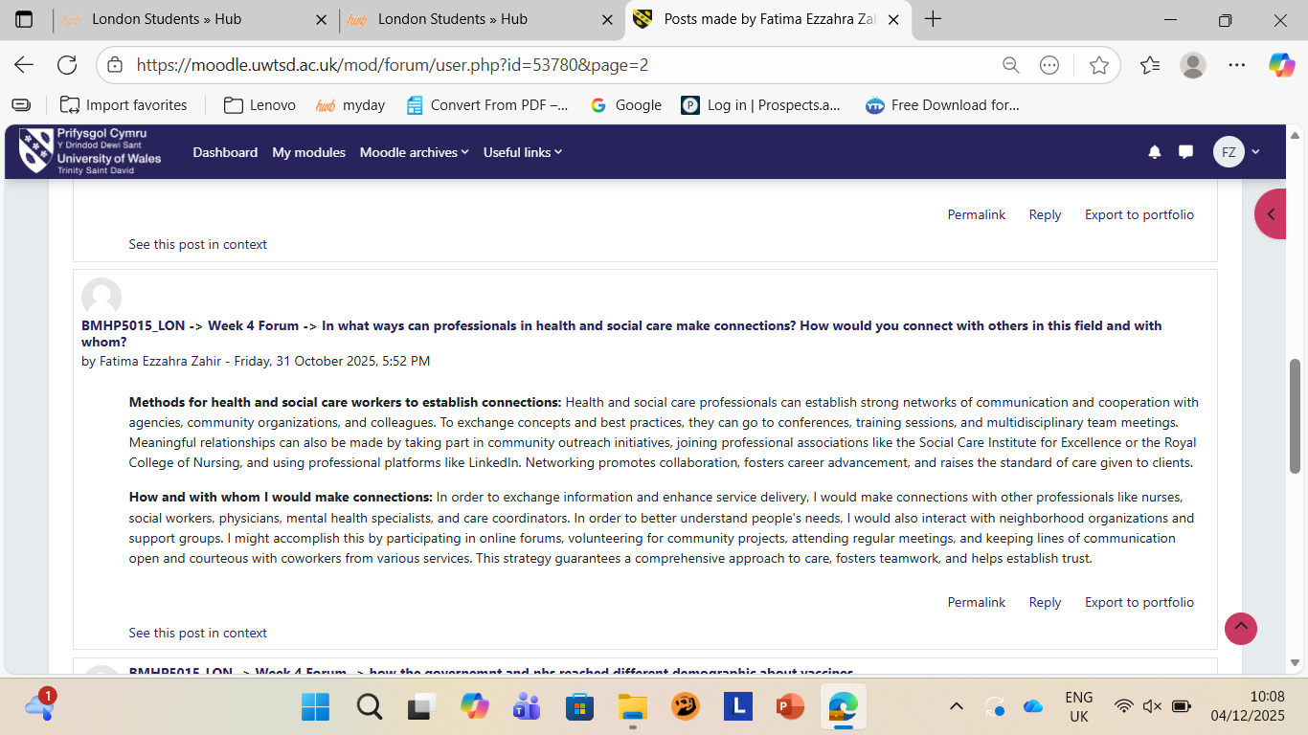

Reflection on Unit 4: The Pursuit of Happiness
Unit 4, "The Pursuit of Happiness," turned my focus to the link between professional performance and life pleasure through meaningful social connections and professional partnerships. The subjects covered, such as wellbeing, resilience, and work-life balance , were explained to be vital for health and social care workers due to the high relevance of teamwork and efficient communication.
Additionally, the unit spent time developing resilience, which is essential for managing the emotional and stressful demands of the health and social care industry. I discovered how crucial it is to recognize and confront limiting beliefs—those unconscious limitations that limit potential (Duckworth et al., 2007). By understanding self-efficacy and adopting a positive mindset, I can better frame setbacks not as personal failures but as learning opportunities. This adjustment in viewpoint, combined deliberately developing supportive professional connections, provides a strong basis for managing stress and preserving long-term psychological wellbeing in a high-pressure environment. This proactive approach to mental health ensures my capacity to continually give high-quality patient treatment. I discovered that networking is more than simply a way to get a job; it's a strategic, ongoing contact that helps me grow personally and maintains the stability of my professional career (Gibson et al., 2014). This new viewpoint has inspired me to actively seek colleagues and mentors in my chosen field. I personally struggled with a huge setback last year when I failed an important professional certification exam. My initial reaction was pure self-criticism; a classic limiting belief identified in Unit 4: "I'm not smart enough for this career." To build resilience, I used the unit's advice: I paused, acknowledged the disappointment, and then shifted my mindset. I reached out to two of my most supportive classmates (strengthening my social connections) and re-framed the failure as a diagnostic tool. We studied together, focusing intensely on the areas I missed. This experience taught me that resilience isn't about avoiding failure but using my support network and positive self-talk to bounce forward stronger. I also investigated the historical evolution of networking with bureaucratic hierarchies. I observed that contemporary service delivery requires a harmonious combination between flexible networks that promote cooperation and the hierarchies that define responsibilities (Gibson et al., 2014). My learning enhanced my personal and professional development by helping me to navigate these formal systems while keeping informal team relationships for maximum efficiency. Crucially, a large portion of the unit examined how professional and social networking improves individual and community health outcomes. I learnt about social prescribing and the Connecting People concept, which highlight how health professionals may aid clients beyond medical treatment systems. Social prescribing connects people to local services, helping them resolve their emotional, practical, and social needs (NHS England, 2025). This supported the notion that our ability to stay connected and supported fosters happiness and wellbeing (Rains & Keating, 2011). By connecting this to a framework such as the PERMA model of wellbeing, I am able to comprehend that flourishing—which is crucial for my long-term resilience in a difficult industry—is mostly dependent on meaningful interactions.

Online Activity Screenshots (Unit 4)
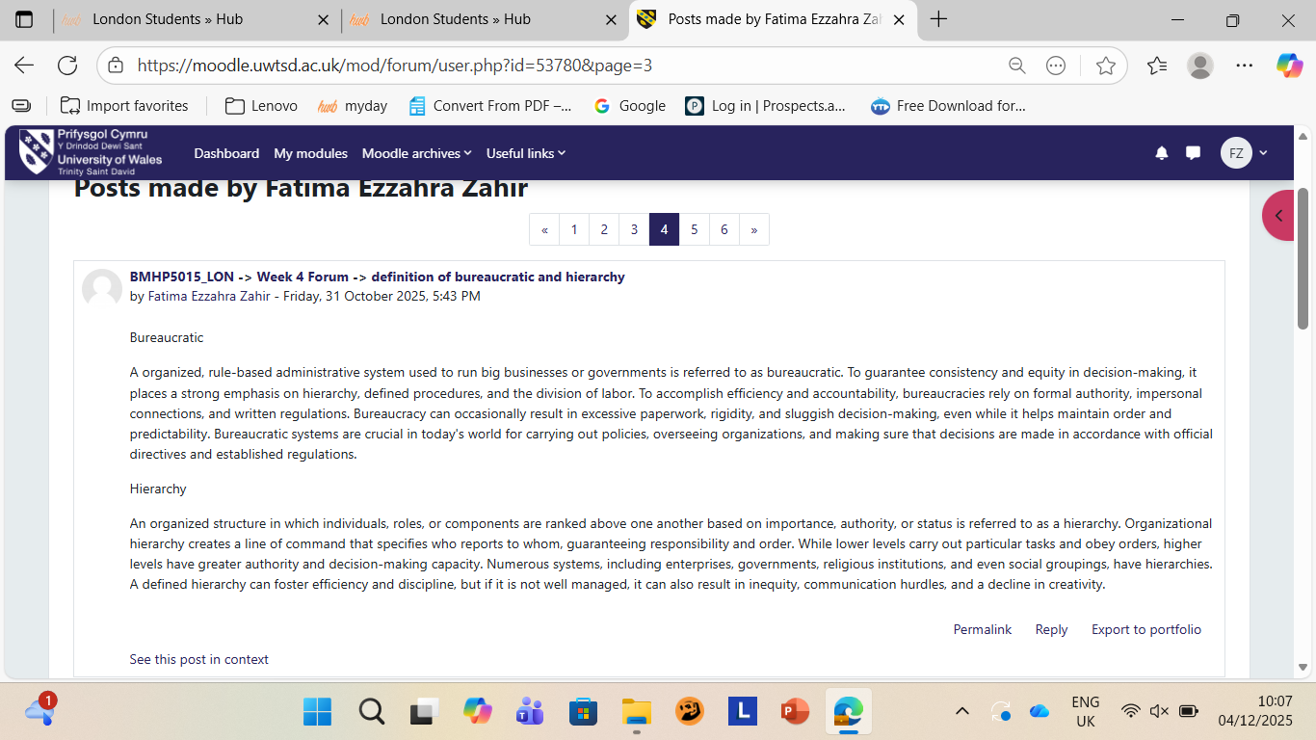

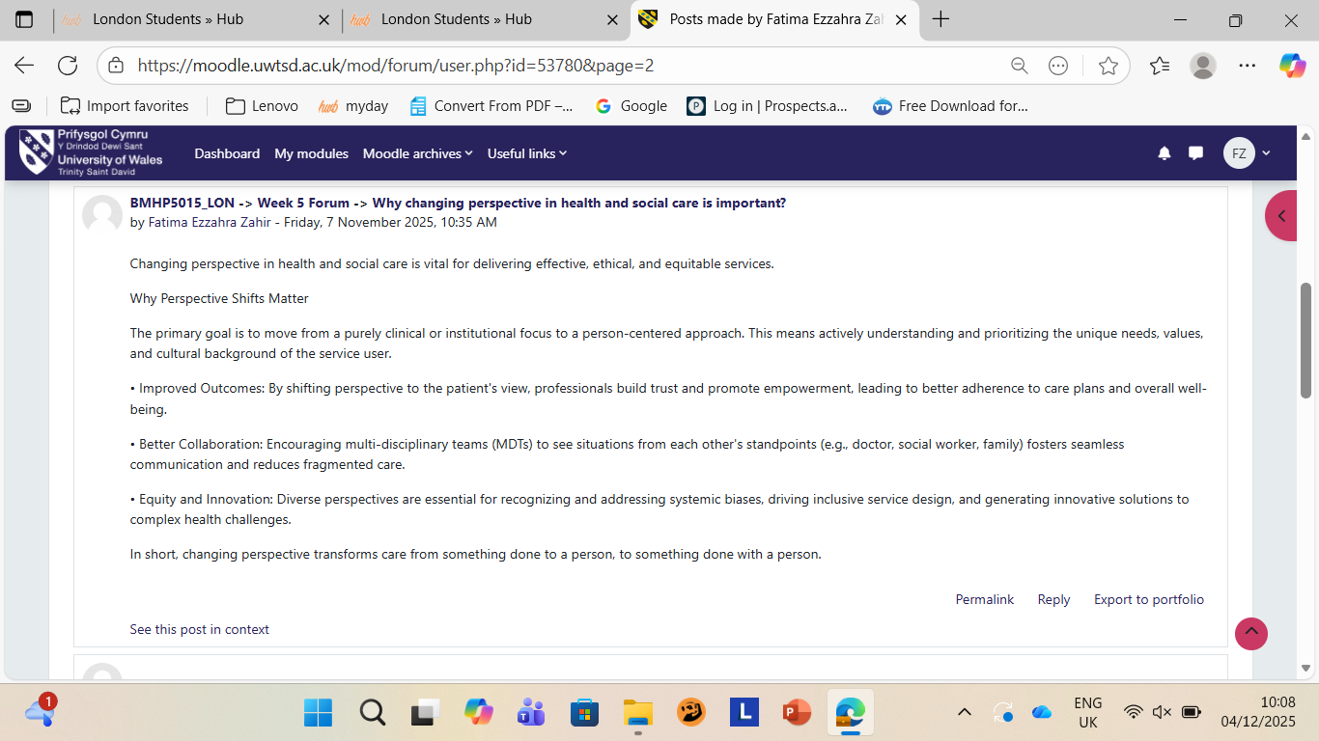
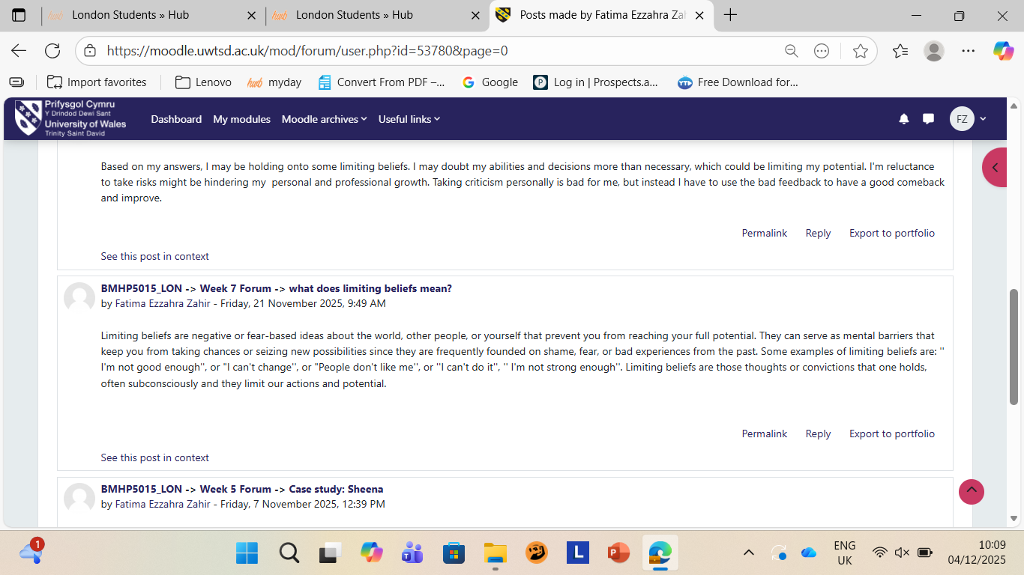
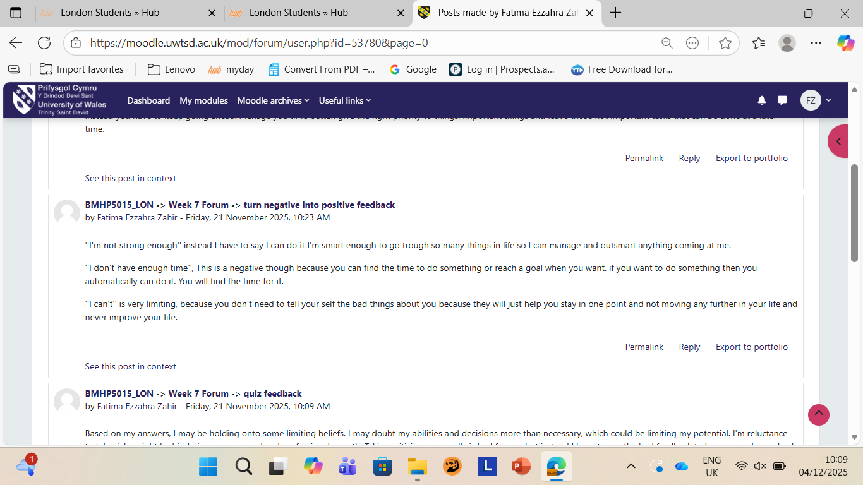

Conclusion
The course modules throughout this course have had a profound impact on how I approach my professional development and work-life balance. The important elements gathered from my observations suggest that having a strong personal brand is essential for professional longevity. Navigating boundaryless careers needs adaptation, emotional intelligence, and a persistent focus on networking. Furthermore, I have realized that building an authentic work identity is vital for developing meaningful partnerships.
The knowledge I have received will greatly assist me build my abilities for jobs in health and social care. I'll confidently use what I've learned to create long-lasting professional connections, establish a solid reputation for my brand, and consistently hone the abilities required to secure new jobs and opportunities in the fast-paced business world. By recognizing the importance of social connections for personal wellbeing and the relevance of frameworks like social prescribing, I am better prepared to thrive and contribute effectively to the industry.

References

Duckworth, A.L., Peterson, C., Matthews, M.D. and Kelly, D.R. (2007). Grit: perseverance and passion for long-term goals. Journal of personality and social psychology, 92(6), pp.1087-1101.
Entwistle, V.A., Cribb, A. and Owens, J. (2018). Why health and social care support for people with long-term conditions should be oriented towards enabling them to live well. Health care analysis, 26(1), pp.48-65.
Gibson, C., Hardy III, J.H. and Buckley, M.R. (2014). Understanding the role of networking in organizations. Career Development International, 19(2), pp.146-161.
Henry, J. (2021). Developing Critical Skills and Knowledge for Success in the Modern Health and Social Care Sector. Available at: https://www.imdb.com/title/tt30840004/ (Accessed: 2 November 2025).
Klinge, C.M. (2015). A conceptual framework for mentoring in a learning organization. Adult learning, 26(4), pp.160-166.
Larsson, J. and Tacking, N. (2023). Antifragility in Small Industry Companies: An Exploration of Resilience and Adaption. Master's Thesis. Jönköping University.
NHS England (2025). Social prescribing. [online] Available at: https://www.england.nhs.uk/primary-care/social-prescribing/ (Accessed: 27 November 2025).
Rains, S.A. and Keating, D.M. (2011). The social dimension of blogging about health: Health blogging, social support, and well-being. Communication Monographs, 78(4), pp.511-534.
Sheikh, A., Anderson, M., Albala, S., Casadei, B., Franklin, B.D., Richards, M., Taylor, D., Tibble, H. and Mossialos, E. (2021). Health information technology and digital innovation for national learning health and care systems. The Lancet Digital Health, 3(6), pp.e312-e325.

