
Full Interface & Testing
Assessment 2
Programme: Applied Computing
Module: Usability Engineering
Module code: ACCB6017
Lecturer: Dr Nassir Ibrahim
Submission deadline: 14th November 2025
14:00 (2 PM)
Natalia Goncearuc
Student number 2228229
Table of Contents

1.0 Introduction 1
2.0 Full-Colour Design Storyboards 2
2.1 The Design Approach 2
2.2 Colour scheme and graphic selection 4
2.3 Main Screen Designs 6
2.4 Game Board and Gameplay Screens Designs 7
2.5 Differences from Wireframe Model 9
2.6 User Journey moves between the screens. 10
3.0 Feedback Collection Process 12
4.0 Data Collection for Working Version 13
5.0 Usability vs. User Experience Discussion 14
6.0 Reflective Summary 15
7.0 References 16
8.0 Appendix 18

Introduction

The user interface (UI) facilitates the interaction between users and the product, while the user experience (UX) refers to the feelings during that interaction[1]. UI design encompasses the visual and interactive elements of a digital product, including layout, typography, colours, icons, and buttons. Its goal is to create an appealing and user-friendly interface that enables easy navigation and interaction[2].
This report presents the 2D Cluedo board game user interface design and the important elements of user interaction with the game. Analysis of the chromatic range in the full-colour wireframe, the composition of elements on the page, interface testing, and feedback. All of this creates an engaging, user-friendly gaming experience that aligns with the themes of the detective mystery, while ensuring accessibility for a diverse audience (user-created characters).
The report discusses the game’s coherent and intuitive interface, integrating screens and interactive elements that guide users seamlessly through its screens, such as settings, menu, campus selection, character selection, customization, and gameplay, followed by a discussion of the refined colour palette, strategically chosen to evoke the desired atmosphere of mystery and intrigue while also taking into account accessibility needs.
To ensure that the game met functional and usability standards, a comprehensive testing strategy was implemented. This involved usability testing, performance assessments, and emotional engagement assessments, providing a complete picture of user interaction [3]. The insights gained guided iterative improvements to the design and functionality, paving the way for future enhancements. This report will detail the methodologies, the testing results, and the implications for the user experience.

2.0 Full-Colour Design Storyboards

2.1 The Design Approach

The mobile version of the Cluedo UWTSD interface design focuses on user experience through attributes such as simplicity, consistency, accuracy, efficiency, accessibility, clarity, feedback, error prevention and recovery. These attributes guide decision-making and simplify design choices[4], [5]. This principle is exemplified in the 2D board game Cluedo UWTSD by incorporating interface icons, such as the clue icon, the detective's card icon, the question icon, and the accusation icon, which enhance user navigation to game objectives, actions, and interactions. While a consistent user interface design is vital, it includes strategically placing buttons in identical locations across all navigation pages. To minimise the risk of errors and facilitate recovery, confirmation messages are thoughtfully integrated into critical actions throughout the interface. These messages serve as a safeguard, ensuring the user can verify their choices before proceeding. Moreover, an interactive hint icon provides tailored guidance as players navigate challenges, helping them effectively address and resolve issues they encounter in the game. This dual approach not only enhances user experience but also promotes confidence in decision-making.
Furthermore, the feedback principle emphasises the need to provide users with feedback immediately after their interactions [6]. In the 2D board game Cluedo UWTSD, feedback is conveyed visually, complemented by auditory cues and vibrational responses. For example, changing the colour of button text, using radio buttons for selection options, and incorporating haptic feedback, which is particularly beneficial for visually impaired users. These improve the overall user experience, helping them feel more in control and better understand the results of their interactions.
Using a specific sound signal for button interaction, which can be enabled or disabled in the settings menu. Another approach is highlighting critical functions in red. An example of this is seen in the game Cluedo, where a wrong guess about the identity of the perpetrator is displayed on the screen in a red-orange hue. Such consistency allows users to quickly gain proficiency in interacting with the system.
Players learn at different speeds, and game masters lead the game in different ways. This difference can create a gap between the game’s difficulty and the players’ skill levels. As a result, players can become frustrated and lose interest in the game [7]. Setting the right level of difficulty in a game is important to maintain player interest [8]. This progression is supported by adjustable difficulty settings in the Cluedo UWTSD game, which can be set to easy, medium, or hard. To improve user interactions, the design should visually and functionally communicate the means of interaction and the outcomes achieved. This concept, known as “affordance” in user interface design, helps users understand how to interact with systems, leading to smoother navigation. For example, on the game rules page, where text density is high, the option to zoom in by simply tapping the zoom icon contributes to smoother navigation.
In addition to the principles mentioned above, the design of the Cluedo UWTSD mobile game also considered Proximity, Continuity, and Symmetry. These elements increase visual cohesion and guide the viewer’s gaze throughout the interface, making the game more accessible. By placing related elements close together, clutter in the game interface is reduced. Continuity encourages natural visual pathways, while symmetry balances the design, creating a visually pleasing appearance.[9] Overall, this thoughtful arrangement enhances both the aesthetic appeal and the user experience, enabling secure navigation and a deeper connection with the Cluedo UWTSD game[10].

2.2 Colour scheme and graphic selection
Colours evoke emotions and influence perceptions in UI/UX design, guiding user actions in apps and websites.[11]. During the design phase, the primary objective was to create an interface that embodied the themes of mystery and investigation characteristic of Cluedo, while simultaneously ensuring both usability and accessibility. The selected colour scheme further enhances the application's immersive experience (Figure 1).

Figure 1 Colour palette used in the interface design of the Cluedo UWTSD version
The chosen colour palette demonstrates a deliberate balance between thematic immersion and accessibility. By incorporating a gradient background that transitions from light blue to pale purple and beige, the design evokes a sense of mystery while maintaining clarity for users with colour vision deficiencies. These soft, understated tones reduce visual distraction, ensuring that text and interactive elements remain the focal point of the interface.
The selection process was guided not only by psychological principles but also by user preferences identified in a prior survey. Ultramarine and blue were chosen for their calming and confidence-inducing qualities, which help lower cognitive load during gameplay. Purple introduces intrigue and sophistication, reinforcing the detective theme, while emerald green conveys clarity and progress, supporting intuitive task navigation. Yellow accents serve as strategic highlights for interactive components, making them easily noticeable and recognisable.
This careful interplay of colours minimises visual fatigue and enhances usability, creating an environment that feels immersive yet functionally efficient. The palette ultimately reflects a thoughtful approach to both aesthetic appeal and user-centred design.
By steering clear of overly saturated colours, the design maintains visual harmony while effectively guiding the user's attention to actionable components [12], [13].
For the graphic elements, a style was chosen that strikes a balance between realism and cartoonish characteristics. This decision, grounded in survey feedback, indicated user preference for a visually engaging interface that does not overwhelm with complexity. Subtle background illustrations depicting campus buildings and detective motifs were incorporated to reinforce the thematic elements while maintaining a focus on the interactive components.
The Cluedo app design uses a modern, mysterious visual and typographic approach that complements the game's detective theme. This is supplemented by background graphics that reinforce the game's investigative mood (Figure 2).

Figure 2 Graphic elements used in the interface design of the Cluedo UWTSD game
Typography plays a crucial role in reinforcing the theme [14]. The “CLUEDO” logo font is bold, all caps, and slightly faded, giving it a dramatic, mysterious character that resonates with the detective concept (Figure 3). In contrast, secondary text, such as menu titles and button labels, uses a clean Arial font to ensure clarity and readability. This contrast between decorative branding and functional text creates a strong visual hierarchy that draws attention and enhances accessibility.

Figure 3 Cluedo UWTSD game logo

2.3 Main Screen Designs
The home page introduces users to the game with a clean design featuring the logo, a loading bar, and two main buttons: “Sign In” and “Play as Guest.” Graphic elements, such as the detective silhouette, highlight the game’s theme, while the loading bar enhances the user experience.
The menu provides access to key functions, such as starting a new game, continuing a session, reviewing achievements, and accessing tutorials. Navigation buttons are strategically placed at the bottom, with options like "Game Rules" and "Settings" for improved usability. The New Game button also changes text colour upon selection, providing clear visual feedback to users (Figure 4).
A text enlargement feature has been added to improve accessibility, allowing users to easily enlarge text, especially on the 'Rules of Game' page that details game regulations.
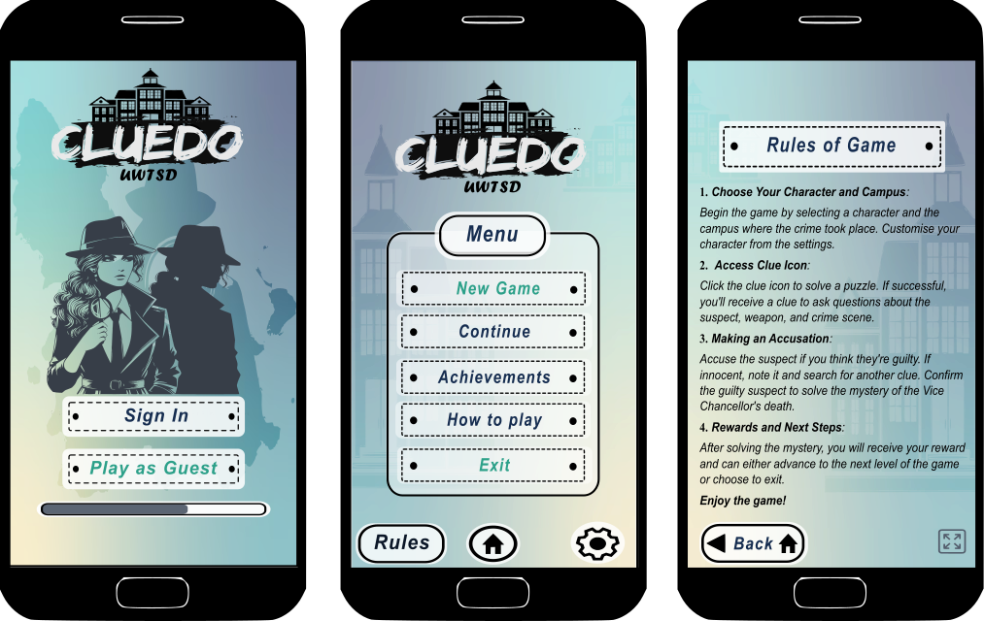
Figure 4 Welcome, Menu and Rules pages of the Cluedo UWTSD

2.4 Game Board and Gameplay Screens Designs

The game board features a two-dimensional layout that accurately represents the floor plans of the rooms. Players engage with various elements, including suspects, weapons, and clues, through the use of clickable icons and radio buttons. The user interface includes essential icons, such as those for clues that initiate puzzle challenges, an "Ask" button to pose inquiries, a "Accuse" button to make accusations, and a detective sheet for tracking progress. Furthermore, icons for pause and hint functions are strategically positioned to enhance the overall player experience. These components are designed to provide clear feedback and mechanisms, including visual highlights and confirmation messages for significant actions (Figure 5), (Figure 6).

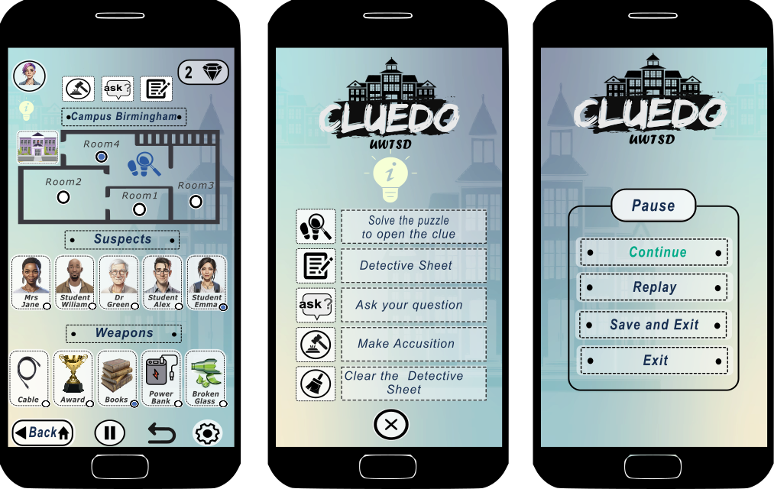
Figure 5 Game board, Hint and Pause pages of the Cluedo UWTSD

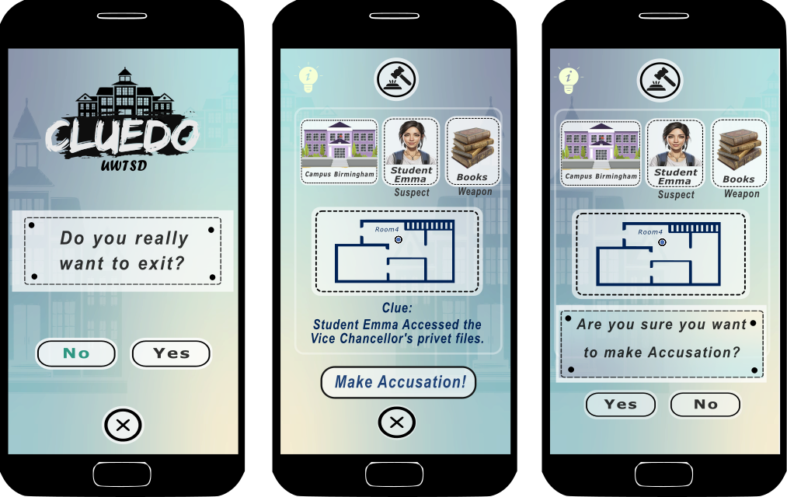
Figure 6 Error prevention message, and the Accusation pages of the Cluedo UWTSD.

2.5 Differences from Wireframe Model
The design has undergone several enhancements compared to the initial wireframe model. In response to feedback received during the testing phase, specific modifications were implemented. For instance, several icon buttons were replaced with more recognisable alternatives for users. Furthermore, hover functionality was introduced for buttons to indicate their interactive nature clearly. The arrangement of certain buttons was also adjusted to enhance accessibility and visibility.
Text size was enlarged, and high-contrast elements were introduced to improve readability. The consistent positioning of navigation buttons across screens was considered to facilitate a more intuitive user experience. Additionally, background graphic elements and character customisation features were integrated to reinforce the application's detective theme. Difficulty levels have been established, categorised as easy, medium, or hard. Moreover, options for sound and music settings, as well as haptic feedback, were included to enhance accessibility.
Content-heavy pages were optimised by dividing them into two separate pages, easily navigable via a button, and additionally implementing a pop-up message to mitigate potential errors. These modifications were substantiated by user feedback and principles of interaction design, ensuring that the final design effectively bolstered both usability and overall user experience.

2.6 User Journey moves between the screens.

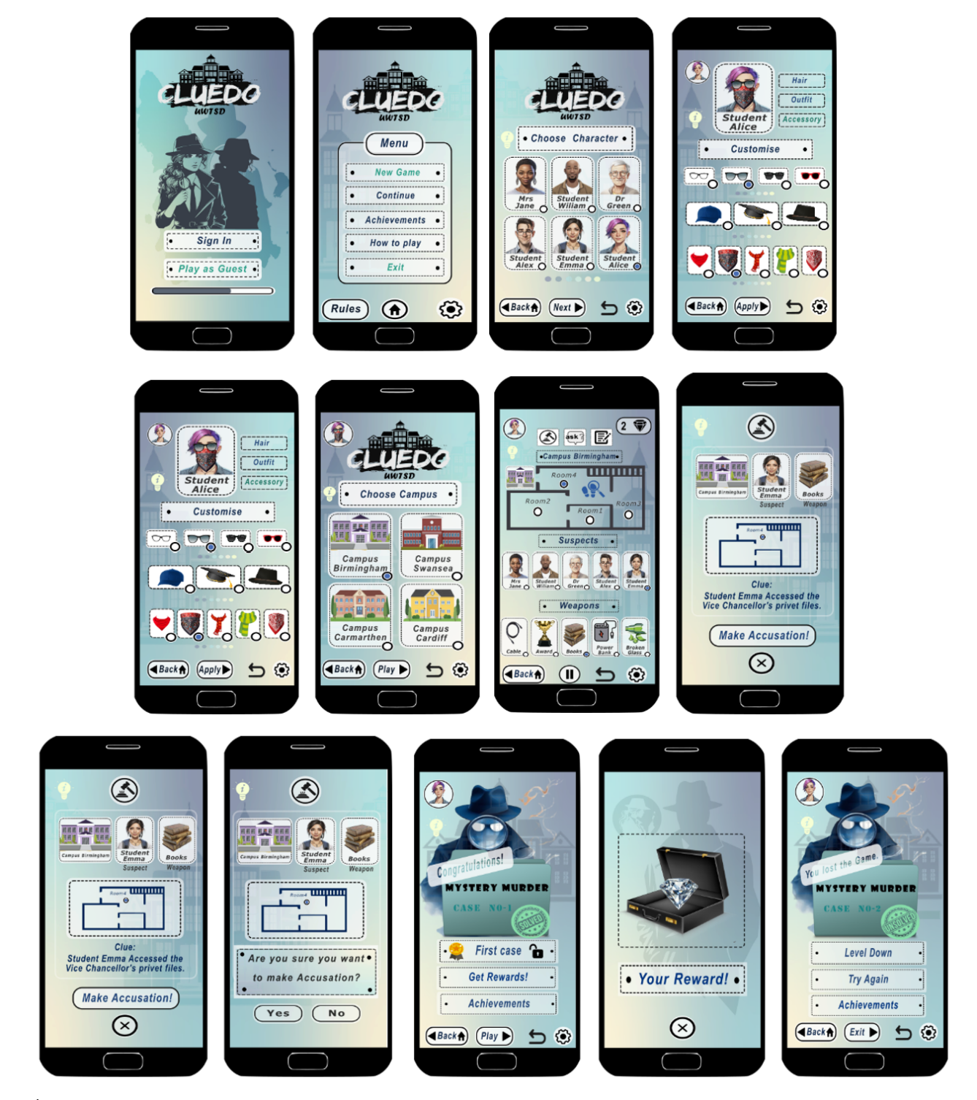
Figure 7 User navigates through pages that display the game scenario stages as the investigation case is solved and unsolved options in the Cluedo UWTSD game.

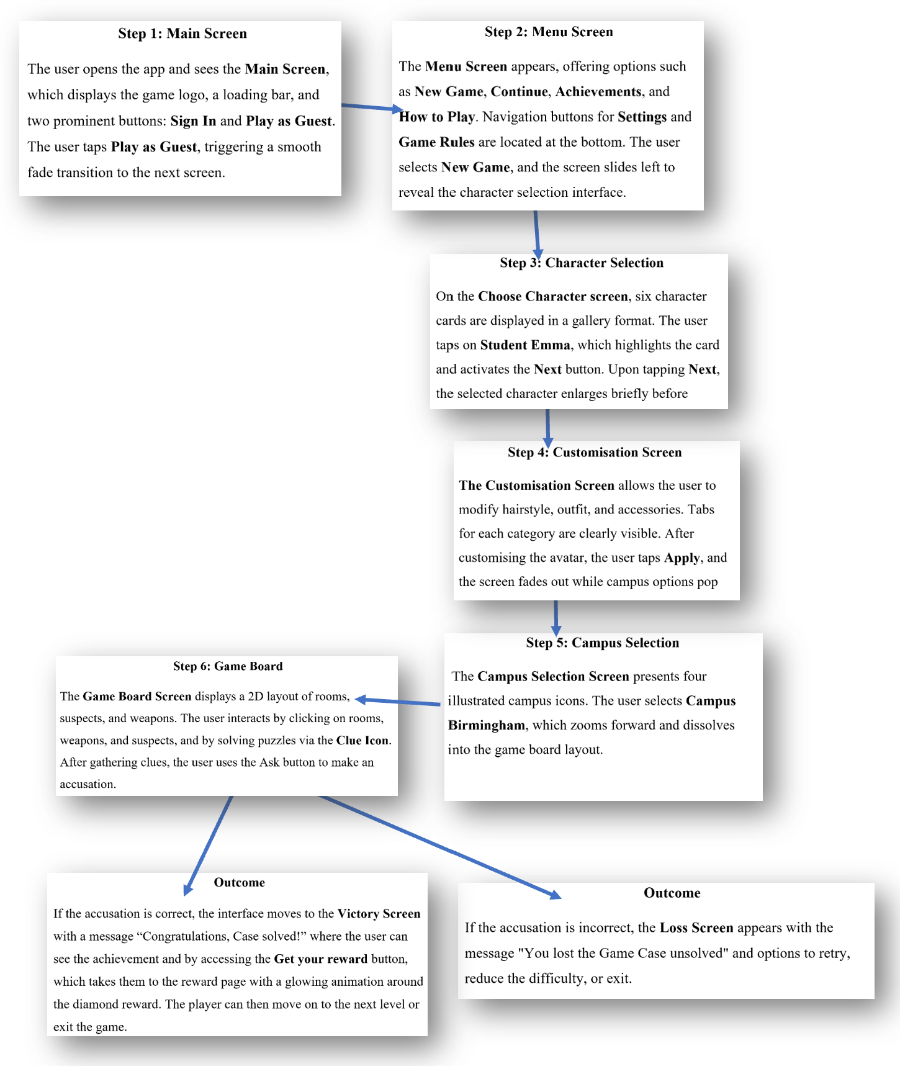
Figure 8 Detailed explanation of user interaction in navigating through pages, showing the stages of a game scenario when the investigation case is solved in the Cluedo UWTSD game

3.0 Feedback Collection Process
The feedback collection process for the Cluedo Online 2D mobile game prototypes was designed to validate both usability and emotional engagement. Using Inkscape, interactive prototypes were created that included all major screens—Main Menu, Character Selection, Customisation, Campus Selection, and the Game Board—with clickable transitions to simulate real gameplay. These prototypes were tested with a mix of real and simulated users to ensure that the graphics and colour scheme achieved the intended effect. Feedback confirmed that the chosen palette created a relaxing yet immersive environment, while the graphics enhanced engagement without distracting from core functionality.
Participants accessed the prototype remotely through a shareable link and were asked to complete predefined tasks such as selecting a character, choosing a campus, customising their avatar, and making an accusation. Observations during these sessions provided insight into navigation patterns and potential usability issues. After completing the tasks, participants filled out a short survey and participated in interviews to rate usability factors, such as ease of navigation and clarity of buttons, as well as emotional aspects, such as engagement and visual appeal.
To ensure the feedback reflected diverse user needs, the recruitment process targeted students from different year groups and lifestyles, aligning with previously defined personas. Creative gamers were represented by younger participants familiar with mobile apps, while senior students with heavy coursework mirrored the persona of users seeking simplicity and reminders. Accessibility-focused participants ensured that visual needs were considered, and competitive gamers were represented by those who valued achievements and leaderboards.
The feedback revealed several important findings. Most users found navigation intuitive, and the detective sheet was praised for its clarity. The colour palette and detective theme were described as engaging and immersive, though some participants noted that animations slowed task completion. An unexpected insight was the popularity of the customisation feature, which users spent significant time exploring, indicating its importance for engagement.
Based on these findings, several adjustments were made. Icon sizes on the campus selection screen were increased to improve clarity, and an option to disable animations was introduced for users who preferred faster navigation. Additionally, customisation options were expanded, acknowledging their role as a key driver of engagement. The methodology combined in-person interviews and online surveys, using tools such as Google Forms and Microsoft Teams to streamline data collection and analysis.

4.0 Data Collection for Working Version
In the working version of the Cluedo Online 2D mobile game, data collection will focus on two primary categories: usage data and emotional response data. These datasets are essential for understanding player behaviour and improving the overall gaming experience[15].
Usage data will include information such as the number of sessions, session duration, navigation paths within the game, and the frequency of feature usage, including customisation and clue interactions[16]. It will also capture game outcomes and whether a player wins or loses, as well as technical details, such as device type and operating system. This data is critical for identifying which features are most popular, where players encounter difficulties, and how they interact with the interface. By analysing these patterns, developers can enhance navigation, optimise performance, and prioritise features that matter most to users.
Emotional response data, on the other hand, will provide insight into user engagement and satisfaction [17]. This will involve collecting ratings after gameplay, feedback on design elements such as colours, animations, and layout, and open-ended comments about the overall experience. Understanding these subjective impressions ensures that the game’s design aligns with its intended detective theme and delivers the desired emotional tone.
The collection process will combine automated tracking and direct user interaction. Usage data will be automatically collected through analytics tools such as Firebase Analytics or Mixpanel, which log events such as button clicks, screen transitions, and time spent on each screen. Emotional response data will be collected through in-app surveys, pop-up feedback prompts after completing a game, and optional rating systems, allowing players to share their thoughts voluntarily.
While both types of data serve complementary purposes, they differ significantly in nature. Usage data is quantitative and objective, requiring no effort from the user, whereas emotional response data is qualitative and subjective, relying on direct user input.
To safeguard user privacy, the game will comply with GDPR and other relevant data protection regulations[18]. Explicit consent will be obtained before collecting any personal or behavioural data, and a clear privacy policy will be provided within the app. Data collection will follow the principle of minimisation, ensuring only essential information is gathered. Usage data will consist of interaction logs and session details, while emotional feedback will remain optional and free of unnecessary personal identifiers.
All collected data will be anonymised to prevent linking it to individual users, and sensitive information such as login credentials will be encrypted both in transit and at rest. Secure servers with role-based access controls will store the data, and regular audits will be conducted to maintain compliance and detect vulnerabilities. Users will retain full control over their data through a privacy dashboard, enabling them to view, download, or delete their information and opt out of analytics or feedback collection at any time.
Finally, the privacy considerations for each data type differ slightly. Usage data, being automatically collected and anonymised, poses minimal risk when properly secured. Emotional response data, however, requires explicit consent and a clear explanation of its purpose, given its subjective and voluntary nature.

5.0 Usability vs. User Experience Discussion
If the Cluedo Online 2D mobile game had been designed purely from a usability perspective, the storyboards would have focused exclusively on functionality and efficiency, rather than aesthetics or emotional engagement. The main screen, for instance, would have featured a plain interface with high-contrast buttons labelled “Register” and “Play as Guest” in large, bold text to ensure maximum clarity. Similarly, the character selection process would have been simplified to a basic list or dropdown menu, eliminating illustrated character cards to reduce cognitive load and speed up decision-making. Customisation options such as hairstyles and accessories would likely have been removed entirely, as they do not directly influence gameplay functionality. Campus selection would have relied on a text-based list rather than illustrated icons, and the game board itself would have been stripped of decorative elements, presenting only clear room labels and clickable suspects and weapons.
During the design process, several conflicts emerged between usability and user experience goals. One notable tension was between visual appeal and navigation speed. Animated transitions and decorative backgrounds enhanced immersion but slowed down user interactions. This was resolved by optimising animations for performance and introducing an option to disable them for players who prioritise efficiency. Another conflict arose between customisation and simplicity. While customisation features increased engagement, they also added complexity. The solution was to retain customisation while streamlining it with clear tabs and preview options, ensuring the process remained intuitive. A third challenge involved balancing theme integration with accessibility. Dark, thematic colors supported the detective mood but risked poor contrast. To address this, the color palette was adjusted to meet WCAG contrast standards while preserving the mystery aesthetic.
An example from the design process illustrates this balance. The initial campus selection screen featured detailed illustrations and subtle animations to create a rich visual experience. However, usability testing revealed that some users struggled to identify campuses quickly. In response, text labels were added beneath each icon, and icon sizes were increased, creating a design that maintained visual engagement while improving clarity and selection speed.

6.0 Reflective Summary
In conclusion, I can say that the design process for UWTSD’s Cluedo Online 2D mobile game was an enjoyable, iterative experience, involving feedback from surveys, observations and interviews. This approach refined ideas and addressed issues early on, engaging users, revealing real-world challenges and guiding improvements to usability and experience.
Usability theory was essential for decisions on layout, navigation, and accessibility, ensuring the interface remained intuitive while incorporating engaging elements. An important insight was the significance of emotional engagement, showing that player enjoyment is as crucial as usability.
The incorporation of diverse characters balanced complexity and simplicity, appealing to both casual and dedicated players.
Finally, exploring usability engineering and the game design process, it was noted that user engagement leads to a functional, engaging product.

7.0 References
[1] W. M. Ayada and M. A. E. E. Hammad, "Design quality criteria for smartphone applications interface and its impact on user experience and usability," International Design Journal, vol. 13, no. 4, pp.339–354, 2023.
[2] N. Hamidli, "Introduction to UI/UX design: key concepts and principles," Preuzeto, vol. 28, no. 3, pp.2024, 2023.
[3] C. M. Barnum, Usability testing essentials: Ready, set... test! Morgan Kaufmann, 2020.
[4] F. Staiano, Designing and Prototyping Interfaces with Figma: Learn essential UX/UI design principles by creating interactive prototypes for mobile, tablet, and desktop, Packt Publishing Ltd, 2022.
[5] L. Buley and J. Natoli,The user experience team of one: A research and design survival guide, Rosenfeld Media, 2024.
[6] K. J. Åström and R. Murray,Feedback systems: an introduction for scientists and engineers, Princeton university press, 2021.
[7] S. N. Harefa, et al., "Analysis on Adaptive Difficulty Adjustment for Player Satisfaction in Game: A Systematic Literature Review," 2024 International Seminar on Application for Technology of Information and Communication (iSemantic), 2024.
[8] F. Mortazavi, H. Moradi and A. Vahabie, "Dynamic difficulty adjustment approaches in video games: a systematic literature review," Multimedia Tools Appl, vol. 83, no. 35, pp.83227–83274, 2024.
[9] J. Beaird, A. Walker and J. George,The principles of beautiful web design, SitePoint Pty Ltd, 2020.
[10] J. Johnson, Designing with the mind in mind: simple guide to understanding user interface design guidelines, Morgan Kaufmann, 2020.
[11] D. J. Walton, "Designing User Experiences For All," Culturally Responsive Computing: An Introduction into Computer Science, Security, and Technology [Updated 12/2024], 2024.
[12] S. Bleicher, Contemporary color: Theory and use, Routledge, 2023.
[13] R. Kimmons, "Color theory in experience design," Learner and User Experience Research; EdTech Books: London, UK, pp.103–125, 2020.
[14] M. Günay, "The impact of typography in graphic design," 2024.
[15] M. Granato, et al., "An empirical study of players’ emotions in VR racing games based on a dataset of physiological data," Multimedia Tools Appl, vol. 79, no. 45, pp.33657–33686, 2020.
[16] T. Li, et al., "Smartphone App Usage Analysis: Datasets, Methods, and Applications," IEEE Communications Surveys & Tutorials, vol. 24, no. 2, pp.937–966, 2022. doi: 10.1109/COMST.2022.3163176.
[17] N. A. Permata, et al., "Design Approach in Educational Game Applications: Enhancing User Satisfaction," 2024 Ninth International Conference on Informatics and Computing (ICIC), 2024.
[18] C. A. González López, "GDPR and Privacy Policies: the case of video games companies and data protection regulations," 2020.

8.0 Appendix

Appendix A: Full-Colour Storyboards
Main Page Design & Menu Screen
Figure 9 Welcome, Menu and Rules pages of the Cluedo UWTSD game
Settings and Sound Configuration & Difficulty Selection (Easy, Medium, Hard)
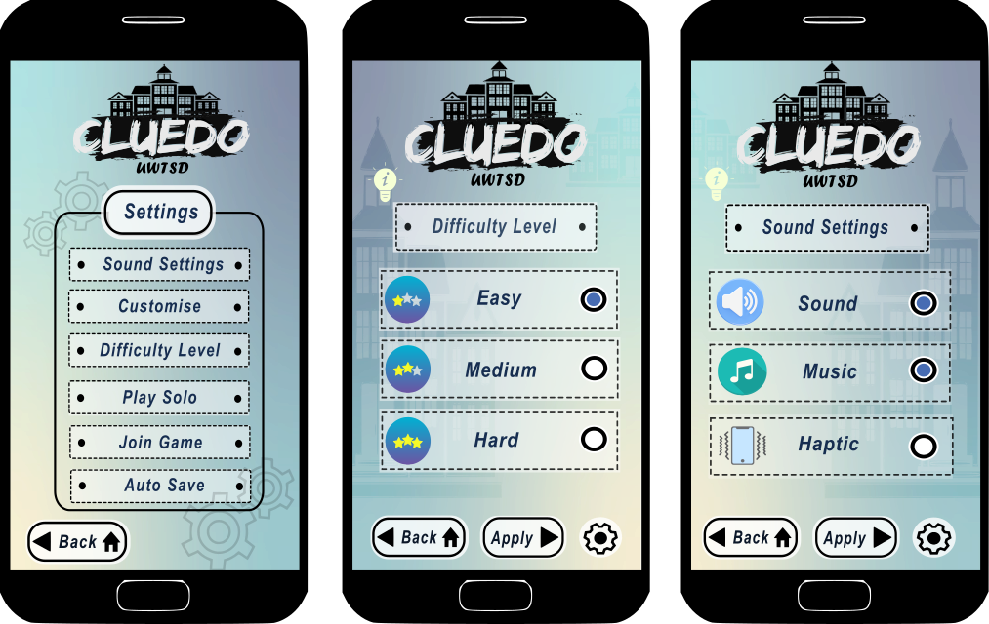
Figure 10 Settings and Settings options of the Cluedo UWTSD game
Character Selection and Customisation & Campus Selection
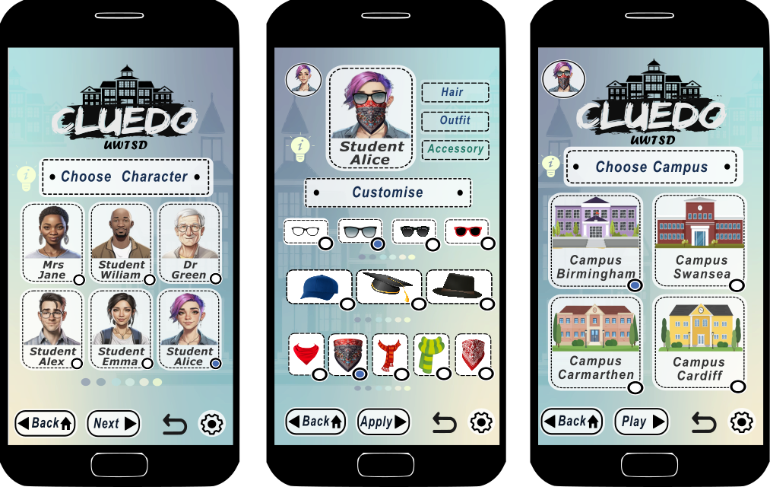
Figure 11 Choose Character, Customisation, and Choose Campus pages of the Cluedo UWTSD game.
Game Board Interface
Figure 12Game board, Hint and Pause pages of the Cluedo UWTSD game
Clue Puzzle and Accusation Flow
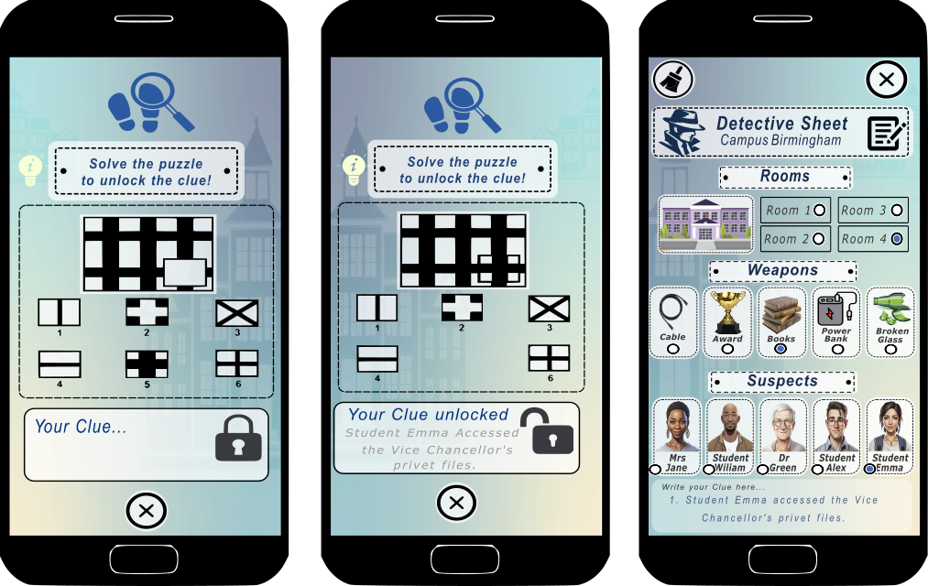
Figure 13 Clue and Detective Sheet pages of the Cluedo UWTSD game.

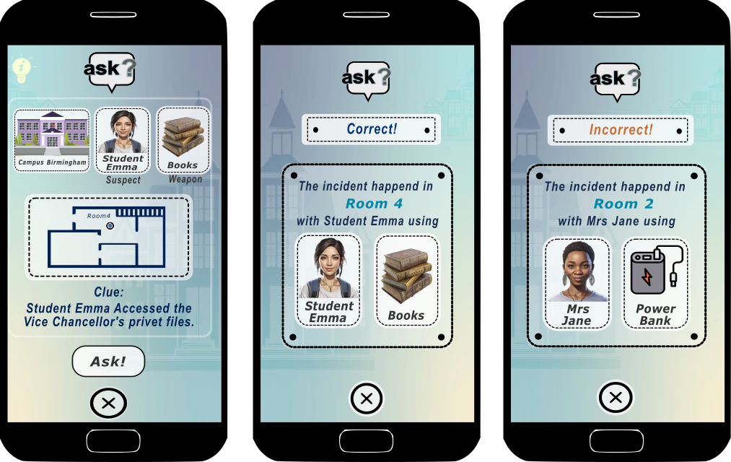
Figure 14 Ask pages with two options for the output of the Cluedo UWTSD game.
Figure 15 Error message prevention and Accusation pages of the Cluedo UWTSD game.

Victory and Loss Screens.
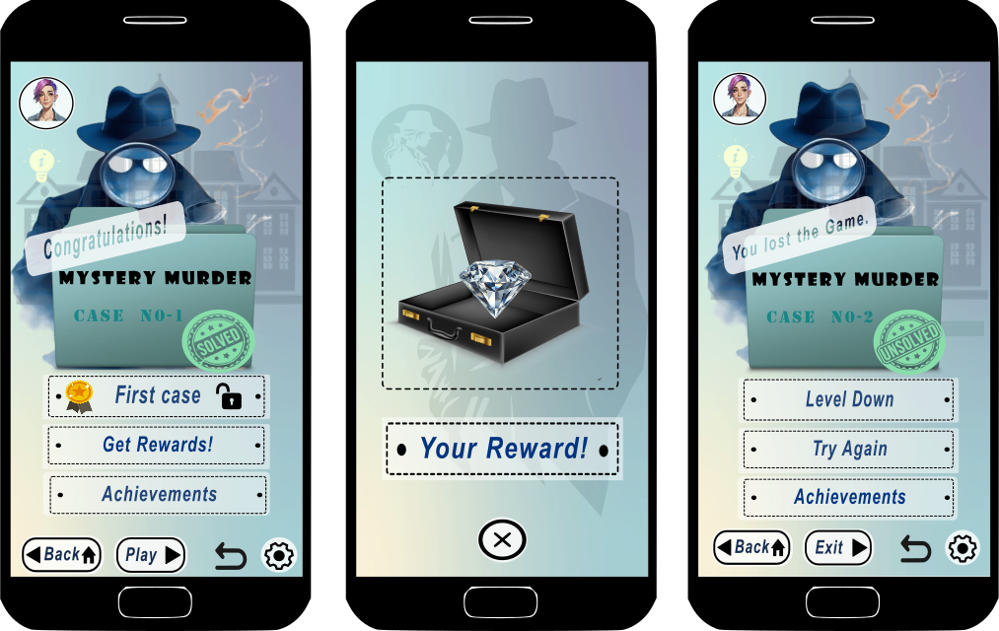
Figure 16 Victory, Rewards and Loss pages of the Cluedo UWTSD game.
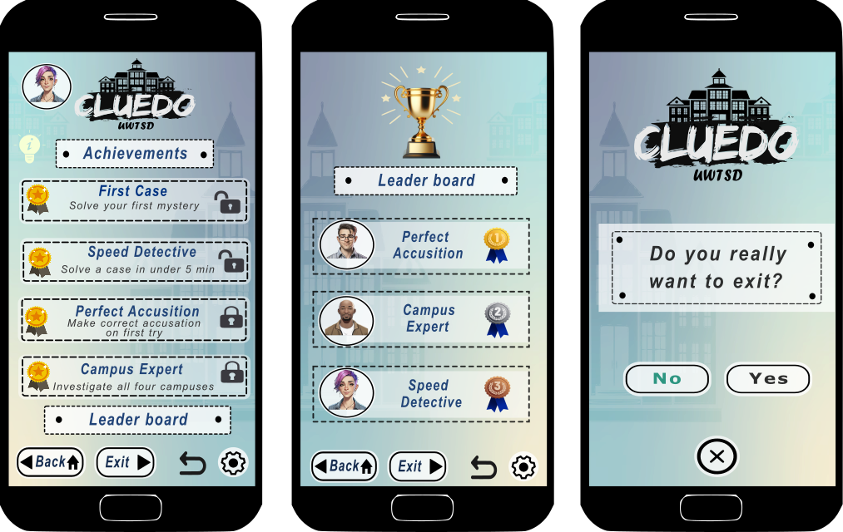
Figure 17 Achievements and Leader Board pages of the Cluedo UWTSD game.

Appendix B: User Navigation Flow Chart
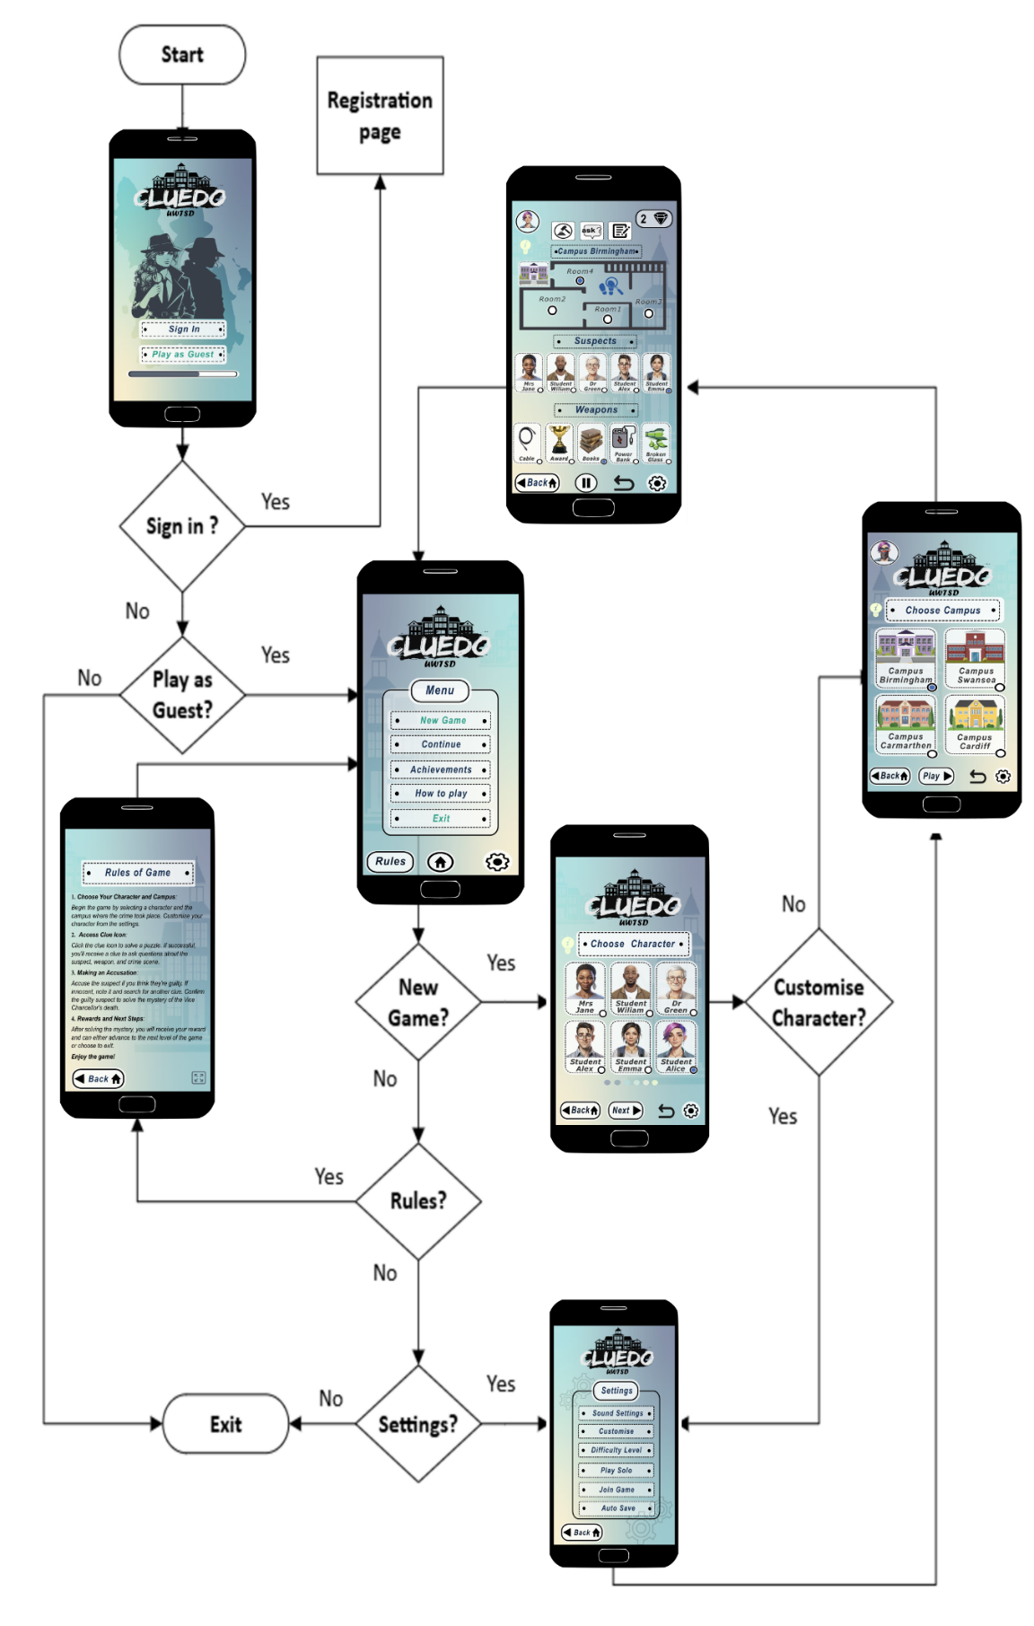
Figure 18 Flow Chart of Cluedo UWTSD navigation.
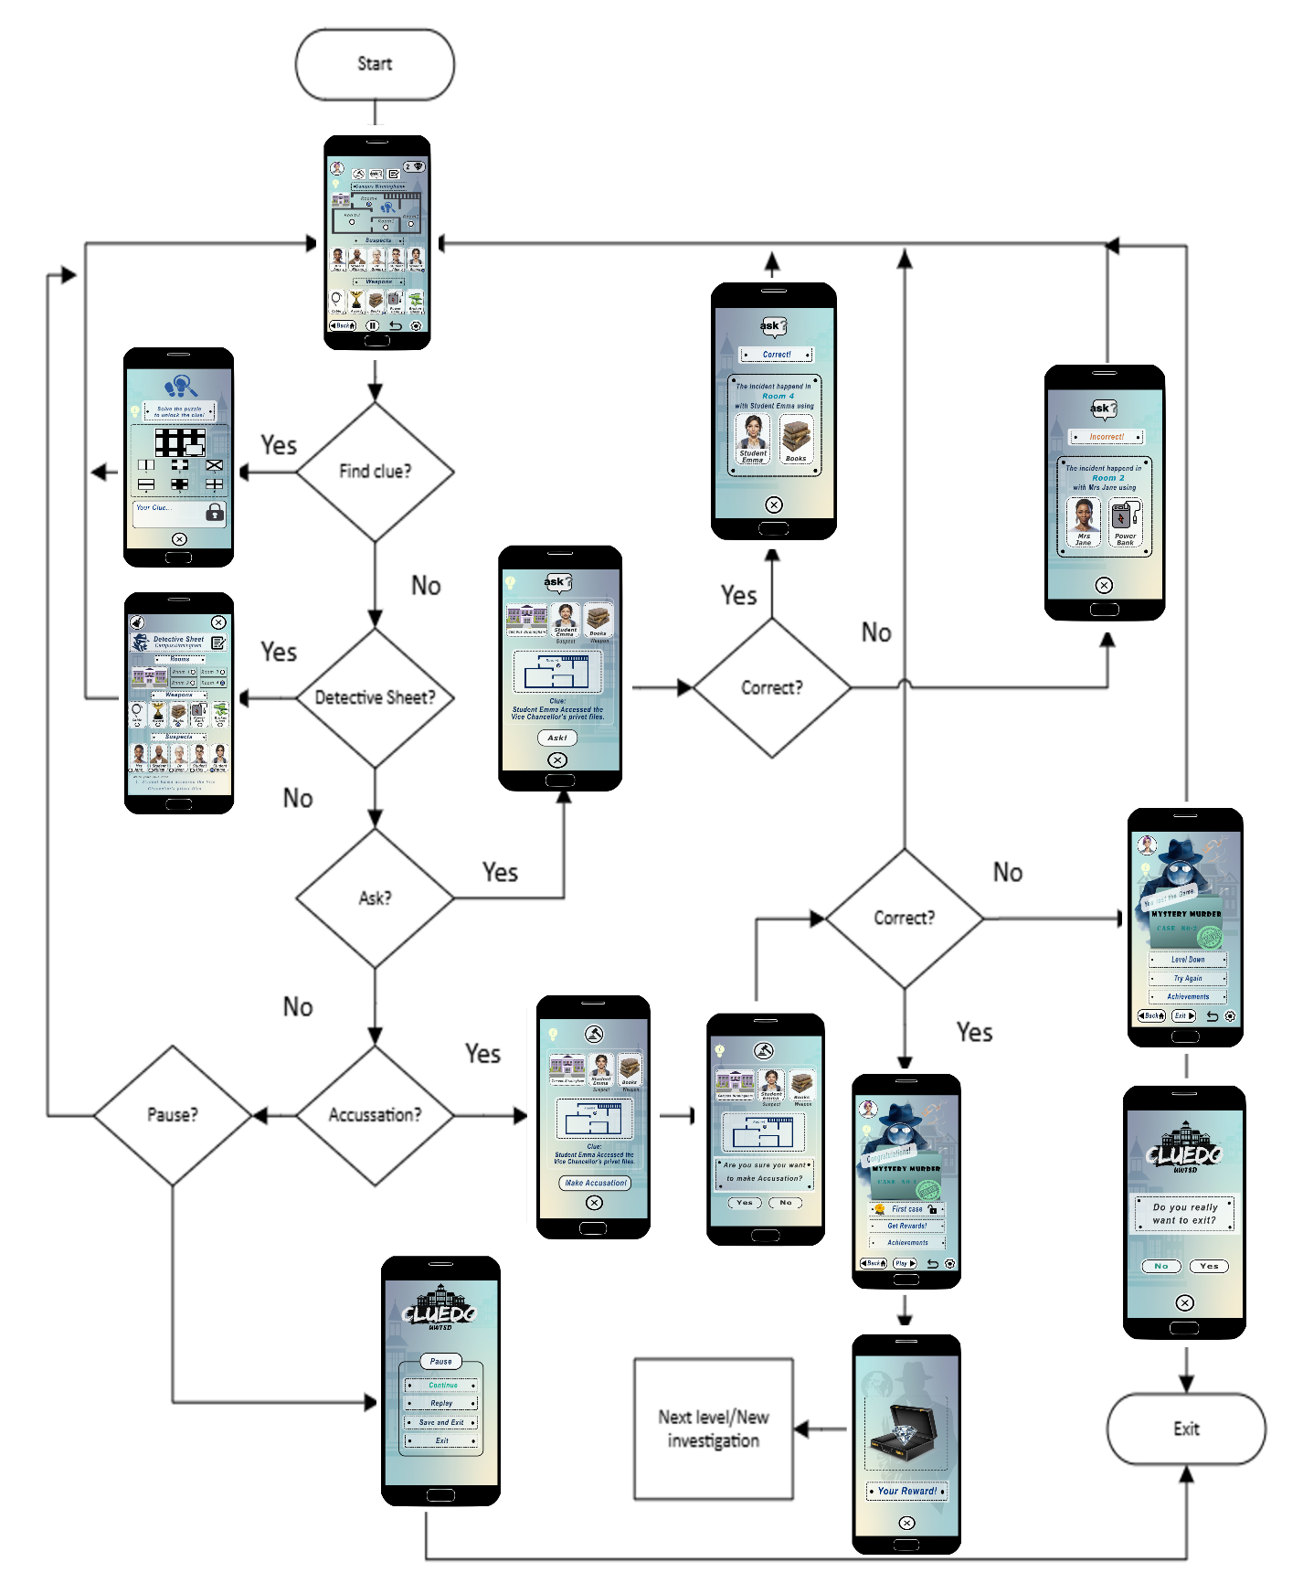
Figure 19Flow Chart of the user navigation

Appendix C: Background Customisation of the Cluedo UWTSD game

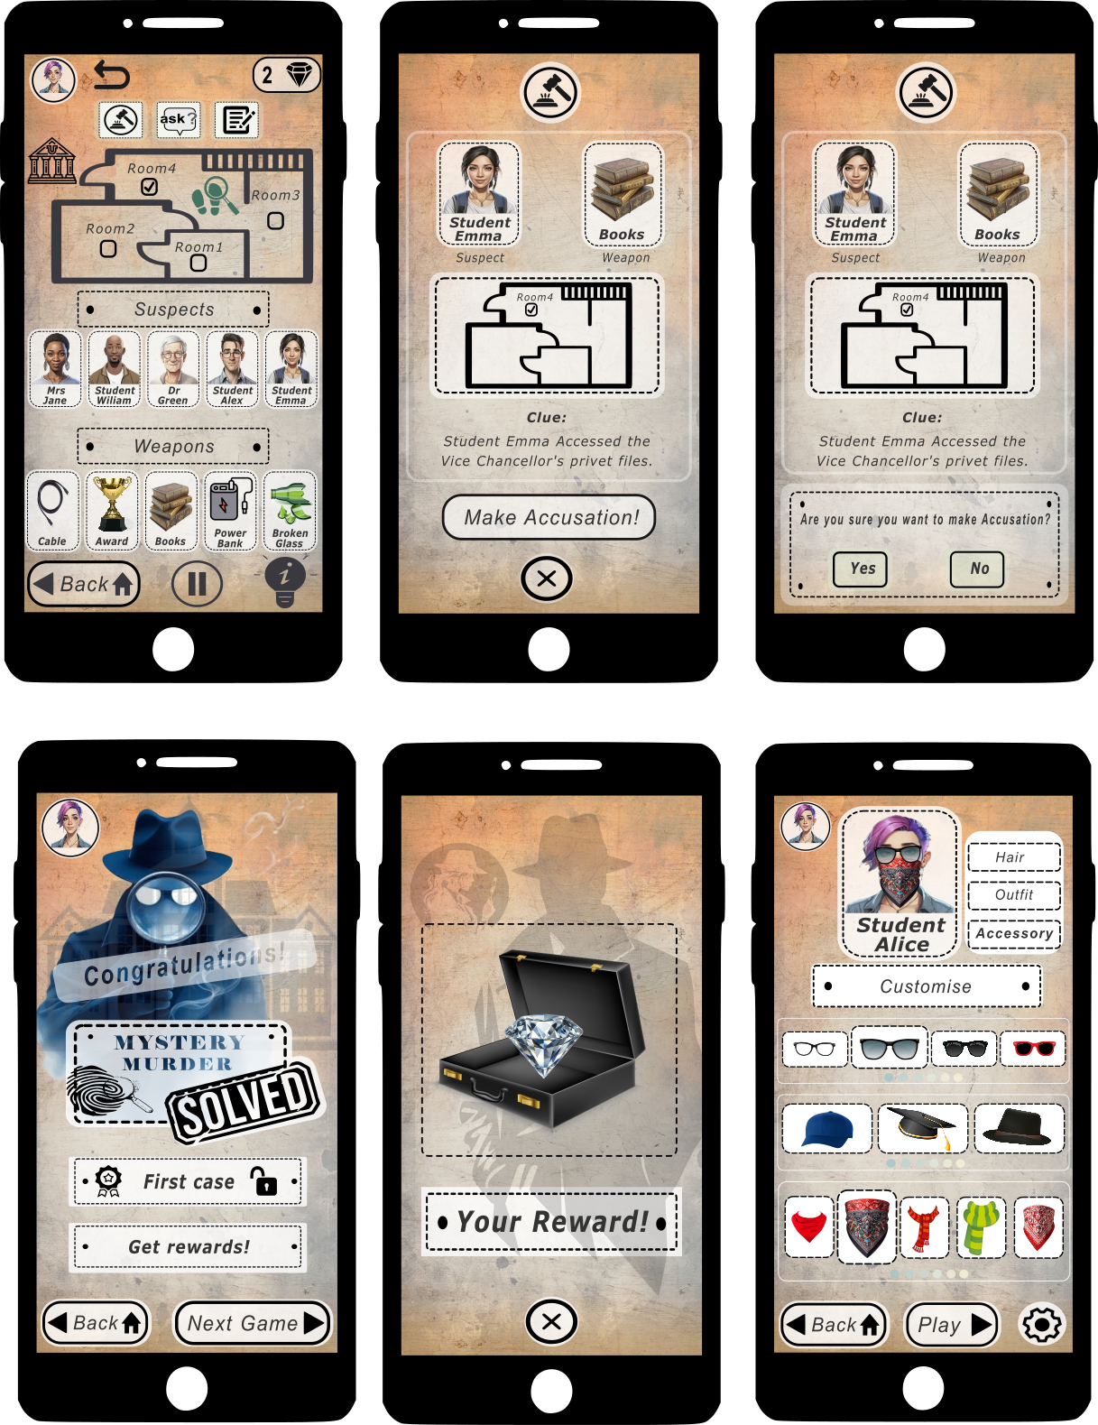
Figure 20 Background Customisation of the Cluedo UWTSD game.

Appendix D: Feedback results
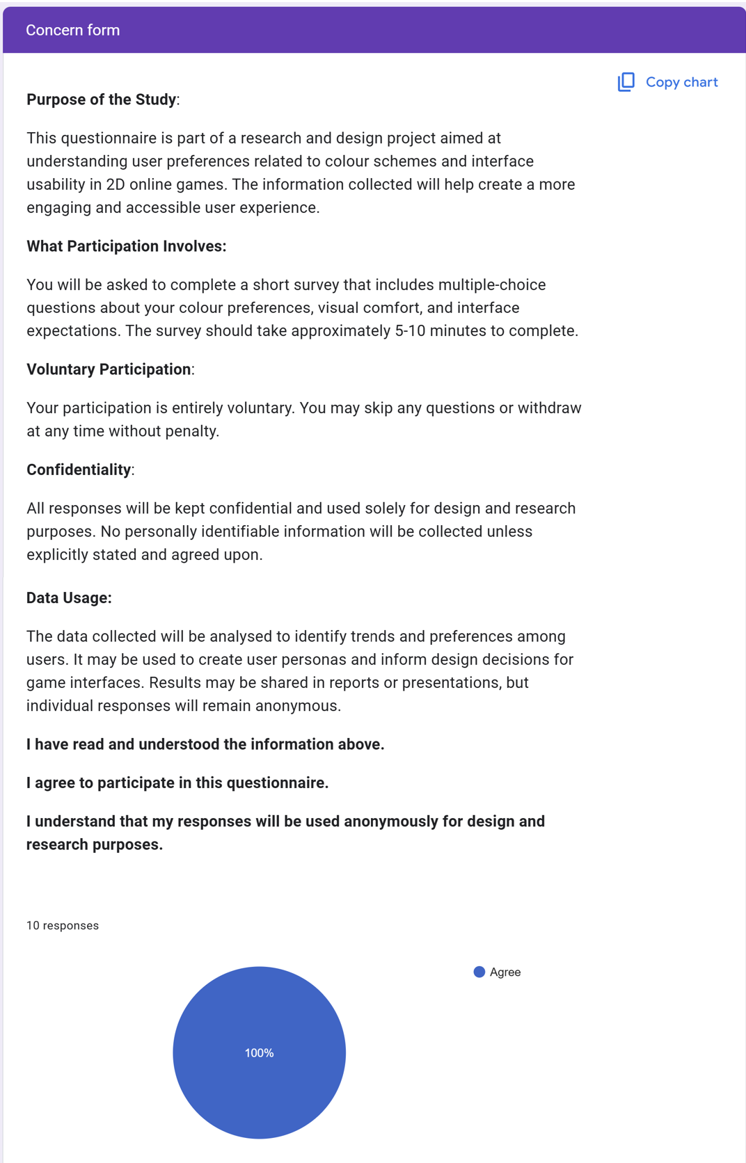
Figure 21Feedback results Concern Form
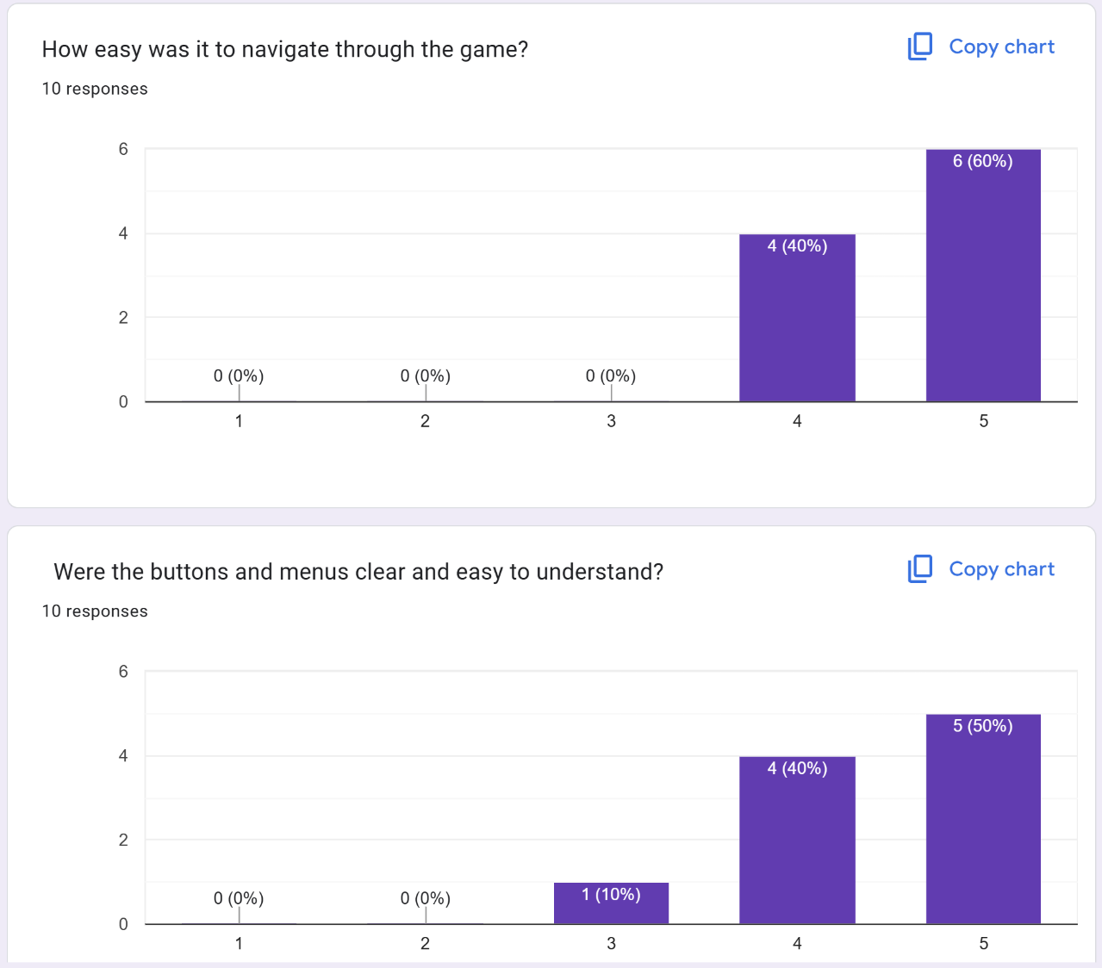
Figure 22
Figure 23
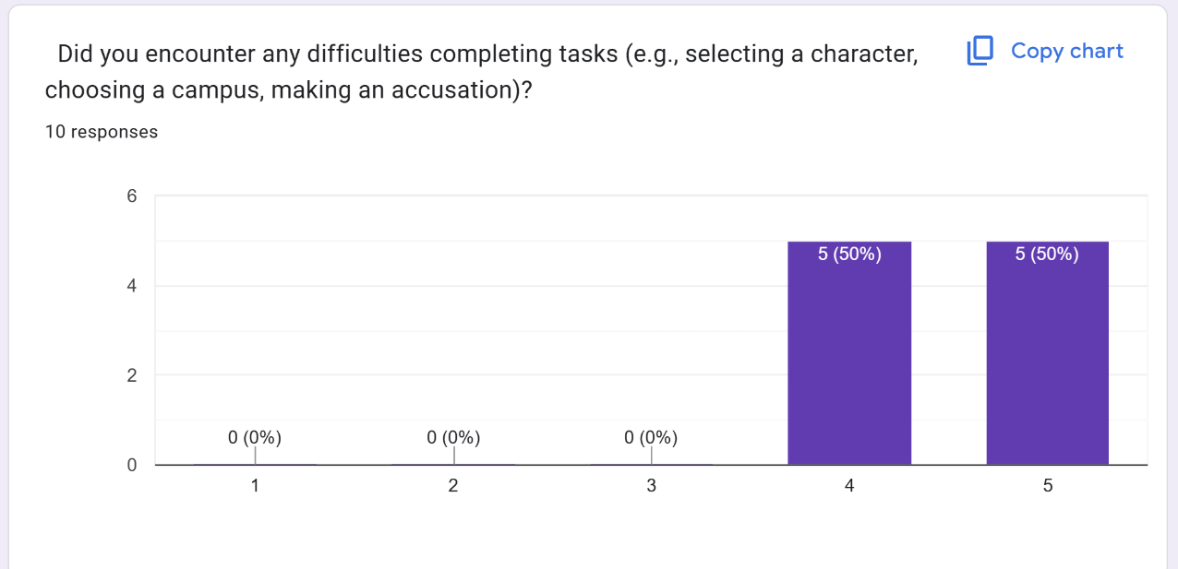
Figure 24
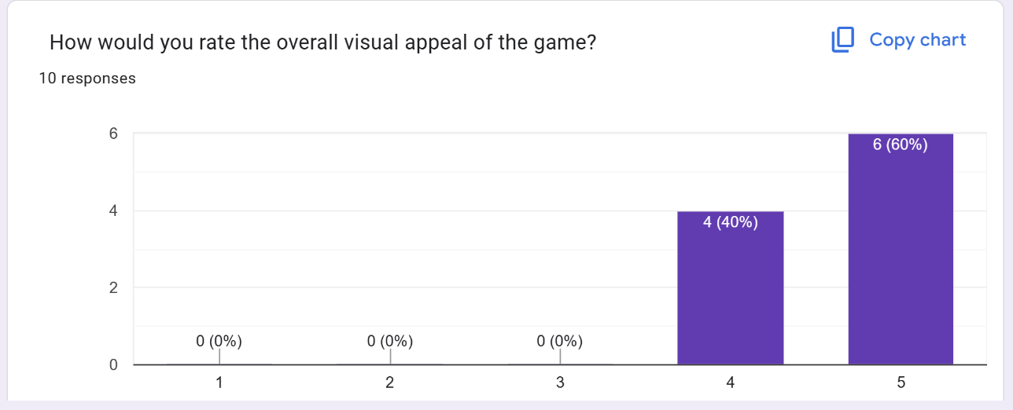
Figure 25
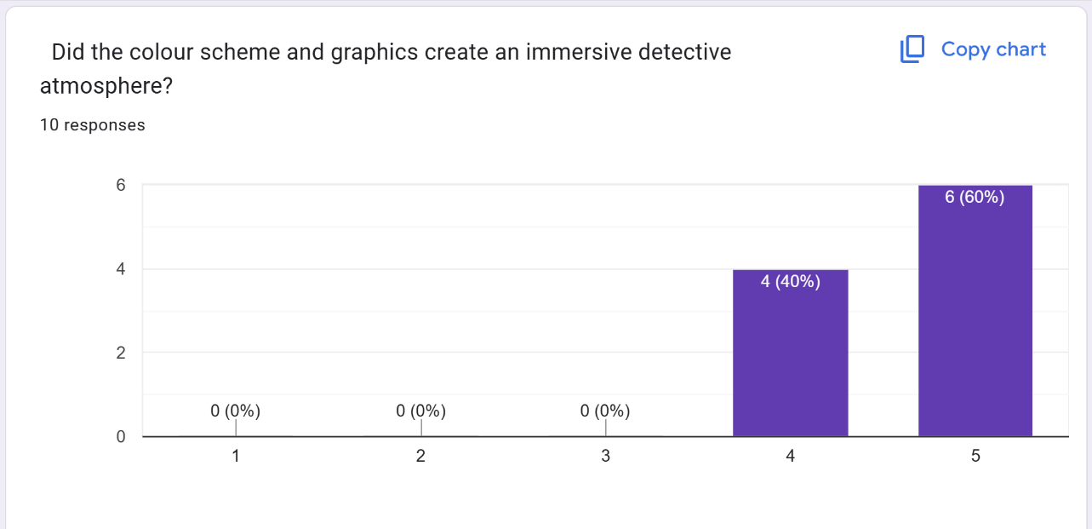
Figure 26
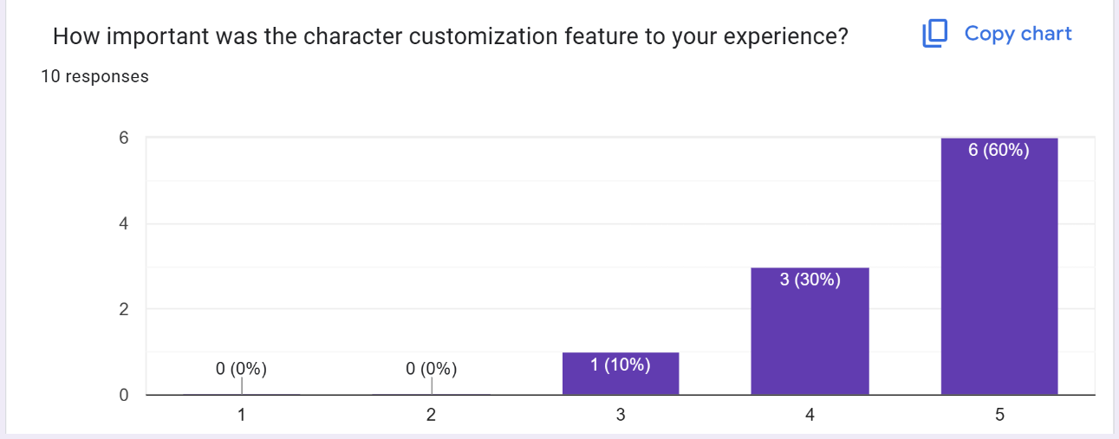
Figure 27
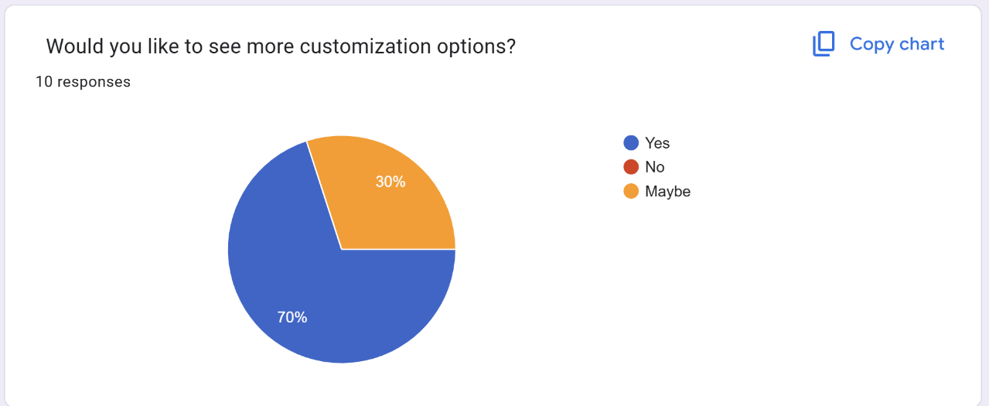
Figure 28
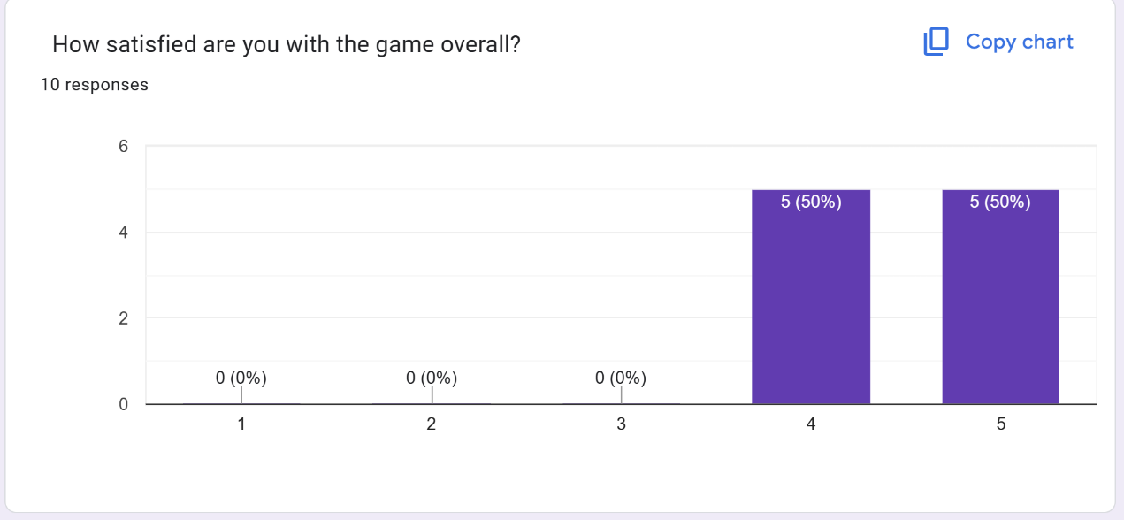
Figure 29
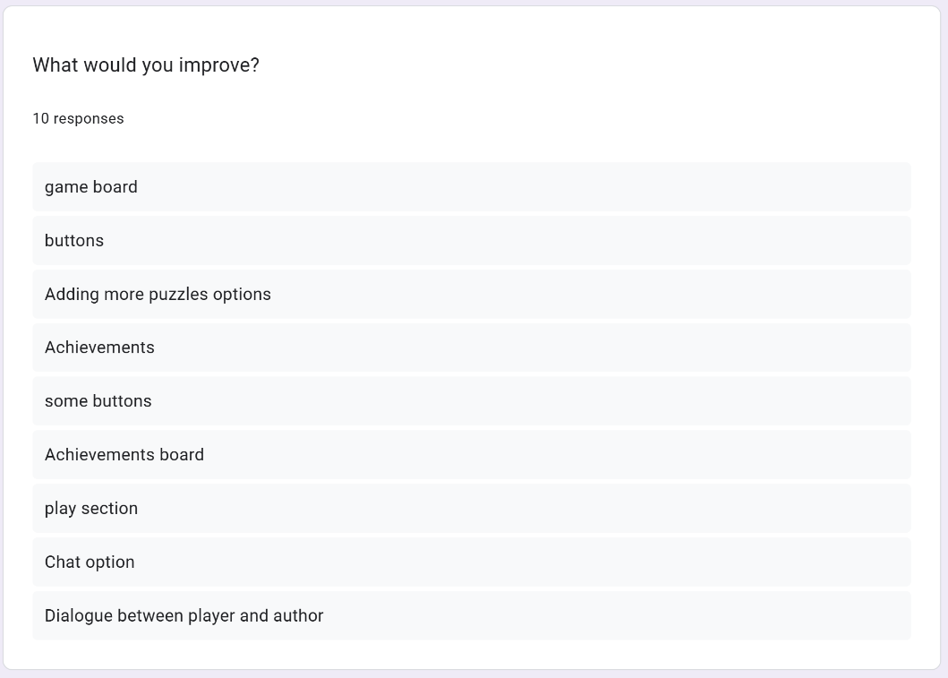
Figure 30

