By Kyle Ramcke P150658

Organisational Consultancy: M6X01422
Project Initiation: Feasibility Report

Table of Contents
EXECUTIVE SUMMARY 1
INTRODUCTION 3
Report Remit 3
What is a Feasibility Analysis? 3
The Importance of a Feasibility Study 4
Iron Lion Fitness Clothing Brand 4
MAIN BODY 4
Product Feasibility 4
Product Desirability 4
Product Demand 5
Industry/ Target Market Feasibility 5
Industry Attractiveness 5
Target Market Attractiveness 6
Organisational Feasibility 6
Management Prowess 6
Resource Sufficiency 6
Financial Feasibility 6
Total Start-Up Cash Needed 6
Financial Performance of a Similar Business 7
Overall Financial Attractiveness of the Proposed Venture 7
CONCLUSION 7
RECCOMENDATIONS 7
REFERENCES 7
LIST OF FIGURES 8

INTRODUCTION

Report Remit
The purpose of this report is to evaluate the feasibility of a new business venture involving the development of a new fitness clothing brand, (Iron Lion) and its introduction into the current market. The report aims to highlight the objectives set out to better understand the credibility of the business idea and whether there is validity in its promise. The objectives of the report are to set out a clear pathway to ascertain the information needed to make an informed culmination of how feasible the project is which is categorised into several sections forming a reliable feasibility analysis. The report will identify methods to research product desirability and demand, industry and target market attractiveness with consideration to financial feasibility analysis using both primary and secondary research with the objective to add value to the organisations developments (Wickham and Wilcock, 2012). The report will conclude with considerations and recommendations on how the organisation can progress utilising the methods of analysis detailed.

What is a Feasibility Analysis?
A feasibility analysis is the stage in which an entrepreneur would identify a business idea and consider its viability by processing a series of research methods before proceeding to the business start-up. As seen in figure 1, the initial stage is the recognition of a business venture. This is followed by the consideration of resources available to sustain progressive action relying on four quadrants of feasibility: Product/ Service, Industry/ Target Market, Organisational and Financial (Barringer, 2016). In the event one or more of these quadrants are deemed impracticable, then the entrepreneur should revisit for further examination to find a solution or to revaluate his or her options. 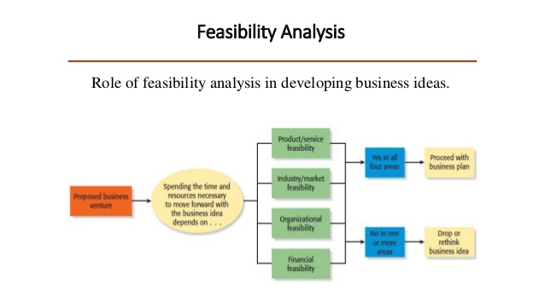
Figure 1: Feasibility Analysis: Role of Feasibility Analysis in Developing Business Ideas.

The Importance of a Feasibility Study
Many entrepreneurs overlook this process, proceeding to the business plan, focusing primarily on the planning and sale implementation which therefore, result in premature preparation. This is concurred by Mullins (2003) who stresses the risks incurred through negligence of proper consideration of the business idea can determine the successes and failures of an organisation. The feasibility analysis offers an opportunity to restructure the progression plan to reduce risk factors. The process is an opportunity to address key issues by utilizing primary research to coincide with time and financial planning and the investigation into secondary data previously researched.

Iron Lion Fitness Clothing Brand
Iron Lion is a Fitness clothing brand which offers fitness fashion products and accessories which combine physical activities and healthy wellbeing with a amalgamation of comfort, style and quality which fitness enthusiasts can wear with pride.

MAIN BODY

Product Feasibility
Product feasibility aims to inspect how the targeted demographic can find the product alluring. It is imperative for a business to first and foremost establish whether the product will sell which can be examined within two categories.

Product Desirability
Category A studies the desirability of the product in the current market place and can establish if the product can offer something unique. This research process would only be effective using primary research as the research carried out would have to be current and fresh to suit the market needs and the basis of what the product has to offer (Saunders, 2009). The initiation of test trading should equip the organisation with sample data using questionnaires with variation of listed, category and ranking, rating and quantity questions with the refrain of using open questions to keep the gathering of data simple and time efficient. (Saunders and Lewis, 2012). Both semi structured and unstructured interviews can be useful during this process for gathering more specific details. Information on the interviewee would be required before interviews are conducted. The research should aspire to answer the questions of how the customers would relate to the product being offered and if it solves any issues they currently experience or if the concept offers something unique which the customers subject to the research could express. The timing of the introduction of a new product into the marketplace will also be analysed. There will be no overall conclusions required based on the research gathered, only an impression. One other option is to formulate a new business concept statement which can then be offered both in person and online to gather a varied selection of feedback from unbiased and broader extensions of the market. This method should refrain from friends or family whom are inclined to offer positive and biased feedback at the risk of causing offence.

Product Demand
The second category for product feasibility is exploring the demand of the product the organisation is offering. This is usually conducted via face to face interactions with potential customers which will gain much more understanding about the needs and wants of customers. This method will be supported by online tools such as google analytics and ad word, websites, institutional reports and library resources (Gray, 2017). Trending patterns via social media are easily accessible and can be monitored via business accounts on social media platforms. It is important to acknowledge that it is common at this stage for entrepreneurs to be punctured by the reception their idea receives.

Industry/ Target Market Feasibility
It important for an entrepreneur to establish the difference between industry and target market as they are both elements of where the product will be exposed to. An industry is the cluster of organisations offering similar products or services which share a common interest but is separated by each of the organisations targeted market in which they wish to appeal to (Bhide et al, 1999). It is often preferential for an organisation to focus on catering for a specific portion of the market for better performance as opposed to attempting to monopolise the whole industry. The feasibility analysis will focus on two categories.

Industry Attractiveness
Industry attractiveness summaries how luring an industry is for an organisation to introduce a new product or service. The appealing characteristics of an attractive industry would include relatively new market offering which could be at its infancy where growth is at its highest. Activewear at present is still a new sub category of fashion which is not only a reflection of its unprecedented growth (Market Watch, 2018), but also the development of multiple organisational entrants which would be interpreted as a negative characteristic when industry attractiveness is concerned. Customers should need the product or service as opposed to wanting which is not often the case when fashion is concerned but due the relentless mediation of the consumer market, research could discover this may not be a definitive factor. It is important to factor in the economic climate in which the industry can be affected negatively. The manufacturing industry is increasingly subject of scrutiny factoring in the sustainability and ethical processes in which garments are produced (Op De Beeck, 2018). A SWOT analysis (Figure 3) or a PESTEL analysis (Figure 4) can be produced to account and consider these implications and possible use to differentiate Iron Lion as a brand of morals and values separate to its competition.

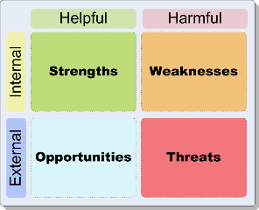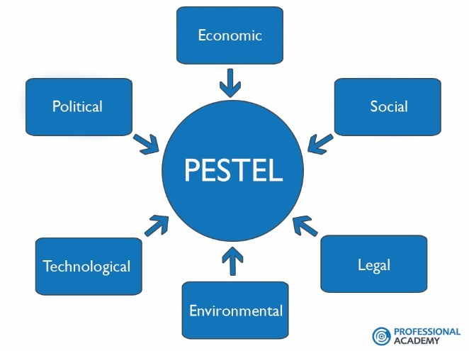
Figure 2: SWOT Analysis Figure 3: PESTEL Analysis

Target Market Attractiveness
For a new business to establish itself into a market, it would commonly be financially restricted to one market segment which will allow the organisation to expend its energy and resources in reinforcing a strong base during its infancy. This also allows an organisation to avoid competitors with more resources. Due to the complexities of identifying the attractiveness of a specific target market, there should be both primary and secondary research involved to establish strong understanding. Research should include qualitative research which involves penetrating interaction with real life settings providing more intricate findings (Miles, Huberman and Saldana, 2013).

Organisational Feasibility
Organisational Feasibility is an internal assessment on the organisations management’s ability to perform or the competency of the founder of a new business venture. This section of the report will look at the founder of Iron Lion and present the organisations intentions to recruit or outsource freelance specialists (Brierley, 2006). The second element of organisational feasibility is resource sufficiency which consists of non-financial aspects of the business’s potential resources.

Management Prowess
Assessing the ability of the sole entrepreneur and founder of Iron Lion will request an authentic evaluation of their capabilities which will offer a clear indication on where assistance and resources can be spending to improve support. For a sole trader, the management prowess analysis can evolve with recruitment (Boselie, 2014), when the organisation is able to do so.

Resource Sufficiency
Resource sufficiency primarily identifies a company’s non-financial resources (Barringer and Ireland, 2012). This could include trademarks or intellectual property attainability which could pose a potential risk in the future. Whilst all intellectual property will bare financial cost, the focus of this example is the availability of such protection. For Iron Lion, the complexities of the trademark process should be highlighted and an action for procurement should be developed. Using a trademark attorney or conducting the application unaccompanied should also be analysed. Resource sufficiency isn’t restricted to intellectual property. Further findings into prioritised resources required to progress should be examined thoroughly.

Financial Feasibility
In this section of the report, the primary focus is on the business financial requirements needed to start up, the research into similar organisations performance or historical information regarding start ups and the overall financial attractiveness to the proposed business venture which can give a good overview of the financial feasibility. As this report is analysing feasibility of the business, there is no requirement to obtain detailed financial forecasts unless the organisation has surpassed the feasibility stage.

Total Start-Up Cash Needed
This category aims to identify and clearly indicate how much cash is needed before it can make its initial sale. This can include facilities to operate, manufacturers, equipment, furniture, personnel and government aid schemes as well as other business relationships (McLaney, 2014).. During this stage, the founder of Iron Lion will refrain from unrealistic options of funding or options which have high probability of collapsing which can compromise the start up. All business requirements should determine a final amount which needs to be obtained with credit or any forms of borrowing accompanied with a structured payment plan to replenish al debts.

Financial Performance of a Similar Business
Investigating the financial performance of similar businesses can give clarity and insight with what to expect for a business start-up. Gathering this data may not be completely accurate therefore assuming and generalising may be the only option with most organisations. However unreliable that may appear to be, there are several online resources which can be used to analyse the financial performances of organisations (Mitra, 2012). This may be confined to larger businesses submitting annual reports but can at least give indication of the financial predictions within Iron Lion. Networking with geographically local businesses within the same industry but different target markets can prove a valuable method of gaining information (Wither, 2018). Other solo entrepreneurs are typically more enthusiastic to share the complexities of start ups during early stages due to their recollection of seeking out assistance themselves, though this may not refer to everyone. Consideration to their working schedule should be empathised with if they are in the early stages of their own venture.

CONCLUSION
In conclusion this report will serve as a project initiation document outlining the methods of research required to gather the relevant information to explore the feasibility of the project. The report asks questions which should be considered before resources are expended without detailed consideration. Different sections of the feasibility report require different methods of research for specific reasons. Although Iron Lion doesn’t have a management team during its early stages to consider the prowess, it can exponential for future analysis. .

REFERENCES

Barringer. B and Ireland. D (2016). Entrepreneurship: Successfully Launching New Ventures. (5th Edition). Pearson Education. Harlow
Barringer. B and Ireland. D (2012). Entrepreneurship: Successfully Launching New Ventures. (4th Edition). Pearson Education. Harlow
Bhide. A et al (1999). Harvard Business Review on Entrepreneurship. Harvard Business School Press
Boselie. P (2014). Strategic Human Resource Management: A Balanced Approach. (2nd Edition). McGraw Hill Education.
Brierley. E (2006). Talent on Tap: Getting the Best from Freelancers, Interims and Consultants. Chartered Institute of Personnel and Development. London.
Cameron. E. and Green. M (2012). Making Sense of Change Management: A Complete Guide to the Models, Tools and Techniques of Organizational Change (3rd Edition). Kogan Page. London.
Golman. D (1996). Emotional Intelligence: Why It Can Matter More Than IQ. Bloomsbury Publishing PLC. London
Gray. D (2017). Doing Research in The Business World. Sage Publications. London.
Market Watch (2018). The Global Activewear Market Size is Expected to Reach $567 Billion by 2024. (Online). August 22nd 2018. Available at https://www.marketwatch.com/press-release/the-global-activewear-market-size-is-expected-to-reach-567-billion-by-2024-rising-at-a-market-growth-of-68-cagr-during-the-forecast-period-2018-08-22. Accessed on: March 5th 2019.
McLaney. E (2014). Business Finance Theory and Practice. (10th Edition). Pearson Education. Harlow
Miles. M. B, Huberman. A.M and Saldana. J. M (2013). Qualitative Data Analysis: A Methods Sourcebook. (3rd Edition). Sage. Thousand Oaks, California.
Mitra. J (2012). Entrepreneurship, Innovation and Regional Development. Routledge New York.
Mullins. J (2003). The New Business Road Test. Prentice Hall. London
Op De Beeck. P (2018). Three Sustainability Trends Shaping the Future of the Fashion Industry. (Online). 29th March 2018. Carbon Trust. Available at: https://www.carbontrust.com/news/2018/03/sustainability-trends-future-of-fashion-industry/. Accessed on: March 5th 2019
Saunders. M and Lewis. P (2012). Doing Research in Business and Management: An Essential Guide to Planning Your Project. Pearson Education. Harlow
Saunders. M, Lewis. P and Thornhill. A (2009). Research Methods for Business Students. (5th Edition). Prentice Hall. Harlow.
Wickham. L and Wilcock. J (2012). Management Consulting: Delivering an Effective Project. (4th Edition). Pearson Education. Harlow
Wither. D (2018). 6 Ways to Improve Your Entrepreneur Network. (Online). Start Up Grind. Available at: https://www.startupgrind.com/blog/6-ways-to-improve-your-entrepreneur-network-2/. Accessed on March 6th 2019

LIST OF FIGURES

Figure 1: Feasibility Analysis: Role of Feasibility Analysis in Developing Business Ideas.
Figure 2: SWOT Analysis
Figure 3: PESTEL Analysis

