UNIVERSITY OF WALES TRINITY SAINT DAVID
MASTER OF BUSINESS ADMINISTRATION (MBA)

MODULE NAME: HUMAN CAPITAL MANAGEMENT
MODULE CODE: LCMB7023
ASSIGNMENT TITLE: INTEGRATED HUMAN CAPITAL BLUEPRINT: ALIGNING PEOPLE AND PERFORMANCE AT AETHER INNOVATIONS

ASSESSMENT COMPONENT:
COMPONENT 1 – INDIVIDUAL REPORT: HR STRATEGY

STUDENT NAME: PRAHAR SUNILBHAI SHAH
STUDENT ID: 2528026
LECTURER: GLADIUS KULOTHUNGAN
EJIKE UDEOGU

Table of Contents
1. Introduction 3
PART 1 — HR STRATEGY 3
2. Current Practices in Performance Appraisal and Job Design 3
2.1 Performance Appraisal in Tech Companies 3
2.2 Job Design in Tech Firms 4
3. Proposed Modern Performance Appraisal System 4
3.1 OKR-Based Performance System 4
3.2 360-Degree Feedback 5
3.3 Benefits for Aether Innovations 5
4. Job Analysis and Job Design Framework 5
4.1 Job Analysis Approach 5
4.2 Applying the Job Characteristics Model 6
5. Job Descriptions and Specifications for Key Roles 7
6. Integration: Creating a Performance-Driven Culture 7
PART 2 — REFLECTION 8
7. Reflective Learning Journey (Using Gibbs Reflective Cycle) 8
7.1 Learning from the Module 8
7.2 Personal Development 9
7.3 Application to Future Career 9
8. Staying Relevant in the Age of AI 10
9. Conclusion 11
References 12

1. Introduction
Aether Innovations is a fast-developing technological firm with about 300 employees that is already struggling with serious organisational issues such as loss of business growth, high turnover rate, and loss of customer satisfaction. These problems signify more underlying issues in regard to poor performance management systems and with poorly-structured job roles that inhibit employee motivation and productivity as well as innovation (Mothafar et al., 2022).
The report will establish a unified human capital plan of Aether Innovations through recommendations of a growth-based performance management system and redesigning key organisational roles based on applicable HRM theory. The report further explains the ways in which these interventions would together build performance based organisational culture which would enable innovation and long-term business success.

PART 1 — HR STRATEGY

2. Current Practices in Performance Appraisal and Job Design

2.1 Performance Appraisal in Tech Companies
Most technology organisations continue using the traditional performance appraisal system where emphasis is paid on periodic appraisal as opposed to continuous performance improvement (Gautam and Gautam, 2022). The most prevalent is the annual performance review, whereby the employees are evaluated on the basis of pre-determined targets, observation by the superiors and previous performance records (Boudreau et al., 2023). Although these methods offer an organised method of assessing the employees, they are being widely condemned because they are considered old fashioned in dynamic environments that are driven by innovation such as the technology industry (Mothafar et al., 2022).
A significant constraint of the traditional appraisal systems is that they are not a frequent occurrence (Agustian et al., 2023). The annual reviews do not reflect the actual contributions of the employees in real-time and do not make it possible to provide feedback on the improvement. The second weakness that should be noted is the lack of emphasis on innovation and collaborative performance (Boudreau et al., 2023). The conventional appraisal usually focuses on the productivity of the individual as opposed to teamwork, creativity and learning that are crucial in the knowledge based organisations.
According to the performance management theory, effective appraisal systems need to be continuous, developmental, and strategic (Wahab et al., 2025). The contemporary methods emphasize continuous feedback, participation of the employees and results that are measurable in order to enhance individual as well as organisational performance.

2.2 Job Design in Tech Firms
Rigid role structure, high workload, and lack of skill development is the typical features of job design in most technology companies. Employees often have rather specific tasks, and this prevents them using a range of skills and limits the possibility of innovation. Such rigidity of position can lead to boredom and a restriction of the involvement of the employees, particularly in the creative sector where flexibility and independence is paramount (Gautam and Gautam, 2022).
Work overload is another problem. The unrealistic expectations, excessive working hours, and high-performance demands are likely to be caused by rapid technological changes and competitive pressure. This further adds to stress, burnout and employee turnover. Moreover, an issue of underutilisation of skills is also a serious problem since workers can have the valuable competences that are not exhaustively used because of the poorly developed positions (Agustian et al., 2023).
These challenges can be explained in terms of the Job Characteristics Model created by Hackman and Oldham. This model states that occupations with a high level of skill variety, autonomy, the importance of tasks, task identity, and feedback would help to increase motivation and performance of employees (Ussher-Eke et al., 2025). But these factors are not included in many of the traditional job designs hence leading to the decline in job satisfaction and organisational dedication.

3. Proposed Modern Performance Appraisal System

3.1 OKR-Based Performance System
In order to overcome the constraints of the conventional appraisal techniques, Aether Innovations ought to adopt an Objectives and Key Results (OKR)-based system of performance management. The OKR model is based on the definition of specific measurable goals which are aligned with organisational objectives, as well as particular key results which monitor the progress (Armstrong and Taylor, 2023). This methodology promotes accountability, transparency, and constant performance control (Valecha, 2022).
The OKR system encourages frequent performance reviews, unlike the traditional annual reviews where employees and managers needed to assess the progress quarterly or monthly. This will make sure that performance problems are detected at the earliest time and remedial measures can be taken in time (Ussher-Eke et al., 2025). Moreover, OKRs also streamline the organisational strategy with individual efforts to make sure that employees know how their contribution contributes to the overall business goals.

3.2 360-Degree Feedback
The 360-degree feedback is another imperative element of the modern appraisal system. In this strategy, the performance appraisals are gathered through various channels which include supervisors, peers, subordinates and the customers. This approach will help decrease bias, as it uses a variety of different standpoints to give a more in-depth evaluation of employee performance (Ercantan and Eyupoglu, 2022).
Peer feedback encourages teamwork and collaboration, and customer feedback presents the quality of the services, and the level of customer satisfaction. Strategic alignments and accountability are taken care of through managerial evaluations. The combination of these viewpoints will give employees an in-depth knowledge of the strengths and weaknesses to be improved (Cho et al., 2023).

3.3 Benefits for Aether Innovations
A state-of-the-art performance appraisal system will offer a number of advantages to Aether Innovations. To begin with, it will promote innovation because it will motivate employees to have high targets and constantly enhance their work. Second, frequent feedback will increase the level of employee involvement and motivation because they will feel taken care of and appreciated by their contributions (Akuffo-Aduamah, 2025). Thirdly, the accountability and fairness will be enhanced in the organisation by clear performance metrics.
This system will eventually assist in building a culture of performance in which employees will be empowered to own their jobs, work as a team and lead to the organisational achievement.

4. Job Analysis and Job Design Framework

4.1 Job Analysis Approach
The recommended job analysis approach that should be used by Aether Innovations is the comprehensive job analysis. This is to be done through task analysis, competency mapping and skills-based job design. Task analysis is a process of determining the important duties, work processes and performance criteria of every position. Competency mapping aims at identifying the skills, knowledge and behaviours that performers need in order to effectively do the job (Radu, 2023).
Skills-based job design focuses on flexibility and adaptability as it permits the employee to employ a wide range of skills as opposed to having a narrow job role. This strategy helps to facilitate organisational flexibility and gives the employees an opportunity to help with innovation efforts.

4.2 Applying the Job Characteristics Model
The Job Characteristics Model can be applied to the design of Aether Innovations and can help a lot in enhancing job design. The engagement and creativity of employees is increased because increasing skill variety enables them to execute a variety of tasks (Huang et al., 2023). The increased autonomy gives more power to employees and makes them take charge of their tasks, resulting in the increase of motivation rates.
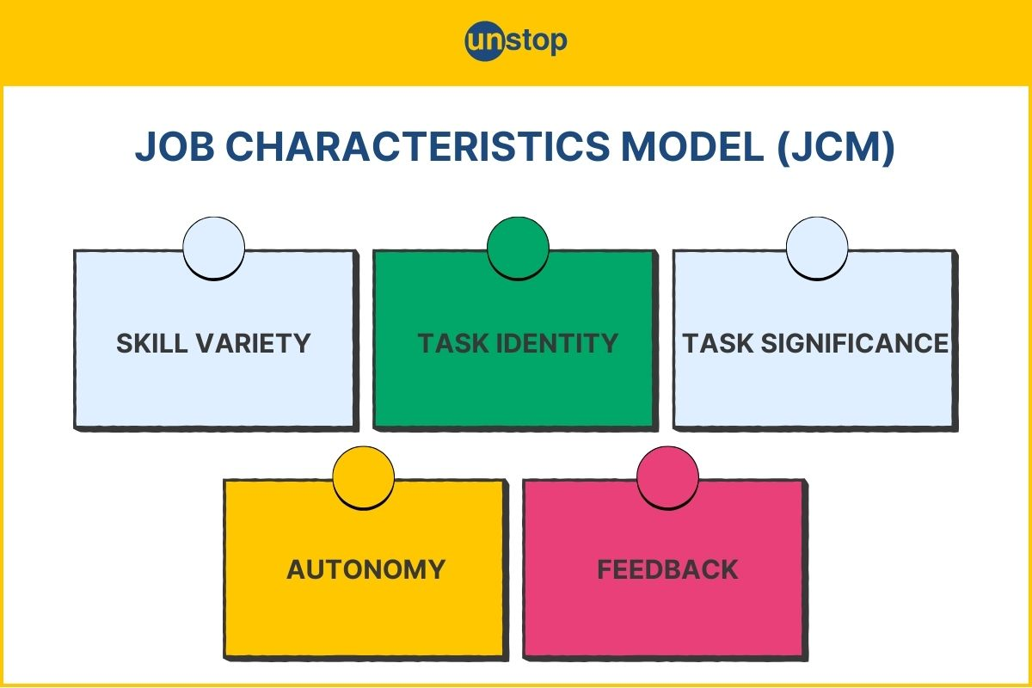
Figure: Job Characteristics model
Source: (Unstop, 2024)
Improving the meaning of tasks makes the employees feel the relevance of their work to organisational performance and customer satisfaction. An integrated feedback process would make sure that the employees get timely feedback on the level of their performance thus ensuring constant improvement (Wahab et al., 2025). All these aspects are combined to produce relevant and motivator job descriptions that promote individual and organisational performance.

5. Job Descriptions and Specifications for Key Roles
CEO: They lead the organisation, vision and business performance. Needs good decision making skills, leadership, as well as management of innovation.
CFO: Manages financial planning, risk management, and allocation of resources. Needs knowledge in financial analysis, strategic budgeting, and decision-making using data.
CTO: Head of technology strategy, product development, and digital transformation. Demands technical skills, ability to be innovative and think strategically.
CIO (Chief Innovation Officer): He is the driver of organisational innovation, research and creative problem-solving. Needs innovativeness, management of change ability and cross-functional team work.
HR Director: Leads the strategy of talent development, performance management and engagement of employees. Needs an ability to interact with people, HR background, and strategic leadership skills (Valecha, 2022).
RandD head: Manages research, product innovation and knowledge development. Needs technical knowledge, project management and innovation leadership.
Every job position must underline the anticipation of collaboration, lifelong learning, and innovation to facilitate organisational development.

6. Integration: Creating a Performance-Driven Culture
Introducing modern performance appraisal systems and enhancement of the job design will assist Aether Innovations to develop a strong performance based culture. Employee motivation and engagement will be inspired through continuous feedback systems, specific performance targets and meaningful roles.
The motivation theories including self-determination theory propose that self-determination is autonomy, competence, and relatedness which are significant objectives in employee performance. The organisation can enhance employee satisfaction and commitment by redesigning jobs to give autonomy and having transparent performance systems (Agustian et al., 2023).
Finally, the performance management-job design fit will help Aether Innovations to develop innovation and enhance productivity and ensure sustainable organisational success.

PART 2 — REFLECTION

7. Reflective Learning Journey (Using Gibbs Reflective Cycle)
The reflection is made in accordance with the Reflective Cycle by Gibbs, which involves description, feelings, evaluation, analysis, conclusion and plan of action.
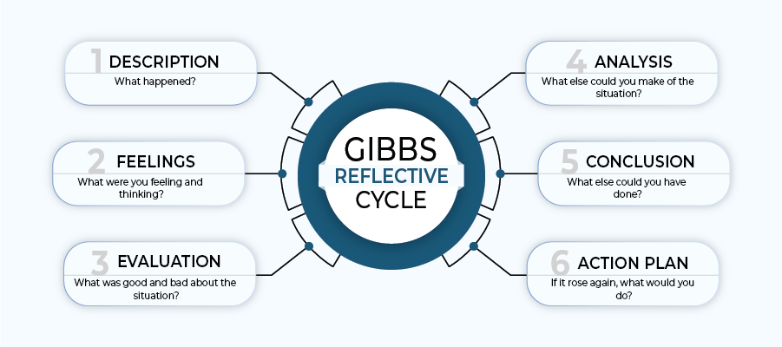
Figure: Gibbs Reflection Cycle
Source: (Athal, 2025)
Human Capital Management module has been very informative of the role of strategic HR practices in organisational performance, employee engagement, and long-term sustainability of business (Boudreau et al., 2023).

7.1 Learning from the Module
Among my most significant learning outcomes during this module has been a better understanding of HR strategy and its significance in one-on-one management practices in line with the organisational objectives. My understanding of HR before was mainly administrative and HR was viewed as an administrative department as far as recruitment and employee relations. But, by means of this module, I have come to understand that HR is a strategic part of the organisational culture formation, a force of innovation, and the business performance in general.
Specifically, I have acquired a better insight into performance management. I came to understand that the conventional appraisal systems are no longer adequate in the contemporary organisations particularly the dynamic industries like technology (Cho et al., 2023). The module emphasized the need to have ongoing feedback, ability to have clear performance indicators, and employee participation in setting goals. The notions of OKRs and the 360-degree feedback have proven how the contemporary appraisal systems could enhance the accountability, motivation, and alignment of the organisational goals (Ercantan and Eyupoglu, 2022).
The other significant aspect of learning was job design and how it affected employee engagement. The Job Characteristics Model has been a useful model to explain the impact of factors like autonomy, skill variety and feedback in the motivation and job satisfaction. I also understood that poorly constructed jobs may result in disengagement, stress and high turnover and that well-constructed jobs might result in increased creativity and output.

7.2 Personal Development
Looking back at the way that I have grown as a person over the course of this module, I can say that I have gained a number of valuable professional skills. To begin with, my analytical thinking has also improved considerably. The process of assessing HR theories and learning how to apply them to the organisational context assisted me in the creation of the skill to critically evaluate the issues and suggest the practical solutions (Ussher-Eke et al., 2025).
Secondly, my communication and problem-solving skills have been built. Composing academic reports and case study analysis demanded me to have a clear and logical structure of complex information. The skills would be crucial in making decisions and being a good leader in the workplace.
Another aspect that I have gained with regard to developing my leadership through this module is that it has assisted me in this aspect. The knowledge of how HR strategy contributes to the motivation of employees and organisational performance has made me value the roles of people-centred leadership. I have also been taught that good leaders should not only aim at meeting business goals but also at establishing conducive working conditions that will help employees to give their best.
Moreover, the learning experience has made me embrace the growth mindset. I have now understood that lifelong learning and flexibility are fundamental in the modern business world that is constantly evolving. The module has strengthened my ideas that professional success is based on the ability to build not only technical experiences but also interpersonal skills (Armstrong and Taylor, 2023).

7.3 Application to Future Career
The experience that I have acquired in this module will make a tremendous difference in my future practice as a professional. Strategic HR principles that I am seeking to apply in my career will help enhance the performance and participation of employees in organisations. By knowing how performance management systems affect motivation, I will be able to develop fair and effective evaluation systems that facilitate the development of employees.
The experiences that I will gain with regard to job design will also enable me to participate in the development of valuable and encouraging workplaces. I will be in a position to promote the satisfaction and productivity of employees by making sure that the roles offer them autonomy, use of skills as well as clear feedback (Radu, 2023).
The module has also equipped me to be able to think strategically when dealing with organisational issues. I have also learned to combine HR practices and business strategy, which will be useful in the leadership position. On the whole, this learning experience has made me more confident in the ability to apply HR theories to specific organisational problems and made me more prepared to have professional responsibilities.

8. Staying Relevant in the Age of AI
The fact that artificial intelligence is rapidly developing is changing how people work, including HR functions. Recruitment screening, performance analytics, employee monitoring, and workforce planning are all avenues through which AI technologies are becoming more and more popular in recruitment. Although the developments enhance efficiency and decision-making, they also present some concerns regarding job displacement and ethical issues (Huang et al., 2023).
In order to be relevant in the age of AI, HR professionals have to acquire the skills that cannot be so easily substituted by technology. Strategic thought is critical to comprehending organisational requirements, workforce development planning and HR practices in line with business goals. Another important skill is emotional intelligence because HR professionals should deal with relationships among employees, conflict resolution, and organisational culture promotion. Moral consideration is also critical especially in instances of working with sensitive staff information and to make a decision that is ethical and objective (Akuffo-Aduamah, 2025).
Even though AI will simplify most of the routine HR tasks; it must be regarded as assistive, not a substitute of human skills. AI has the ability to help HR practitioners to analyse data in large quantities, determine workforce patterns, and enhance the accuracy of decisions (Akuffo-Aduamah, 2025). It is also capable of supporting decision-making by giving predictive evidence about the high-risk of employee performance and retention. Moreover, the administrative tasks, including payroll management, employee records and recruitment scheduling can be automated by HR.
Thus, AI will not substitute HR professionals but will change their work by enabling them to pay more attention to strategic planning, employee development, and organisational leadership.

9. Conclusion
To summarize, Aether Innovations has a substantial number of HR-related issues, such as poor performance management practices, job descriptions, and salespeople losing their motivation. These issues can be addressed using the proposed solutions, including the use of modern appraisal tools like the OKRs and 360-degree feedback and through the better job design conducted through the Job Characteristics Model. A combination of the job design and performance management strategies is fundamental in the establishment of performance oriented organisational culture that can promote innovation and sustainable business performance in the long run (Gautam and Gautam, 2022).
Personally, this module has been useful in offering my understanding of the strategic significance of HR management and its implication on the performance of organisations. It has strengthened my analytical skills, leadership skills, and professional skills and promoted the attitude of growth and lifelong learning. Moreover, being aware of the effects of AI on HR practices has equipped me with the ability to embrace changes in the workplace and be relevant in a rapidly changing professional world.

References
Agustian, K., Pohan, A., Zen, A., Wiwin, W., and Malik, A. J. (2023). Human resource management strategies in achieving competitive advantage in business administration. Journal of Contemporary Administration and Management (ADMAN), 1(2), 108-117. https://journal.literasisainsnusantara.com/index.php/adman/article/download/53/60
Akuffo-Aduamah, C. C. N. (2025). The impact of compensation on employees performance in organizations. International Journal of Multidisciplinary Studies and Innovative Research, 13(1), 57-69. https://scholarindexing.com/uploads/files/rj0xpn7udfmec9v.pdf
Armstrong, M., and Taylor, S. (2023). Armstrong's handbook of human resource management practice: A guide to the theory and practice of people management. Kogan Page Publishers. http://repository.iuk.ac.ke:8080/xmlui/bitstream/handle/123456789/281/Armstrongs%20Handbook%20of%20Human%20Resource...%20%28Z-Library%29.pdf?sequence=1andisAllowed=y
Athal, K. (2025) Gibbs reflective cycle explained: A framework for structured self-reflection. https://drkrishnaathal.com/blog/gibbs-reflective-cycle-explained-a-framework-for-structured-self-reflection/
Boudreau, D. W., Ulrich, J. S., and Buhler, E. P. (2023). The interplay between human resource strategies and strategic alignment: A comprehensive review of conceptual and empirical literature in the United States. Journal of Strategic Management, 7(5), 1-10. https://stratfordjournalpublishers.org/journals/index.php/journal-of-strategic-management/article/download/1675/2196
Cho, W., Choi, S., and Choi, H. (2023). Human resources analytics for public personnel management: Concepts, cases, and caveats. Administrative Sciences, 13(2), 41. https://www.mdpi.com/2076-3387/13/2/41
Ercantan, O., and Eyupoglu, S. (2022). How do green human resource management practices encourage employees to engage in green behavior? Perceptions of university students as prospective employees. Sustainability, 14(3), 1718. https://www.mdpi.com/2071-1050/14/3/1718
Gautam, P. K., and Gautam, R. R. (2022). Investing in Human Capital Management for Firm Performance: Liability or Strategic Alignment?. Management Dynamics, 25(2), 39-53. https://nepjol.info/index.php/md/article/download/57426/42935
Huang, X., Yang, F., Zheng, J., Feng, C., and Zhang, L. (2023). Personalized human resource management via HR analytics and artificial intelligence: Theory and implications. Asia Pacific Management Review, 28(4), 598-610. https://www.sciencedirect.com/science/article/pii/S1029313223000295
Mothafar, N. A., Khokhar, M., Zehra, N., Khaskhelly, F. Z., Mirza, M. H., Rafique, M. A., and Raza, A. (2022). Aligning organization and human resource management practices for business strategy. Journal of Positive School Psychology, 6(12). https://www.researchgate.net/profile/Na-m/publication/368684973_Aligning_Organization_And_Human_Resource_Management_Practices_For_Business_Strategy/links/63f508690cf1030a563eb952/Aligning-Organization-And-Human-Resource-Management-Practices-For-Business-Strategy.pdf
Radu, C. (2023). Fostering a positive workplace culture: Impacts on performance and agility. In Human resource management-an update. IntechOpen. https://www.intechopen.com/chapters/1170791?ref=remote4africa
Unstop, (2024) Job characteristics model of Hackman & Oldham: Core components. https://unstop.com/blog/job-characteristics-model
Ussher-Eke, D., Emmanuel, I. O., Ijiga, O. M., and Enyejo, J. O. (2025). Improving employee engagement and safety through the use of IoT-enabled monitoring tools in human resource practices. Journal of Technology and Innovation, Zibeline International Publishing, 5(2), 48-55. https://www.researchgate.net/profile/Diana-Ussher-Eke-3/publication/395231436_Improving_Employee_Engagement_and_Safety_through_The_Use_of_Iot-Enabled_Monitoring_Tools_in_Human_Resource_Practices/links/68b814e63391fb1a7a4d070a/Improving-Employee-Engagement-and-Safety-through-The-Use-of-Iot-Enabled-Monitoring-Tools-in-Human-Resource-Practices.pdf
Valecha, N. (2022). Transforming human resource management with HR analytics: A critical Analysis of Benefits and challenges. International Journal for Global Academic and Scientific Research, 1(2), 56-66. https://pdfs.semanticscholar.org/adbc/8691855f39ad2238d4305a20cb344758df71.pdf
Wahab, Y., Asif, M., Hassan, M., and Khokhar, A. N. HUMAN RESOURCE MANAGEMENT AND FINANCE ALIGNMENT: A ROADMAP TO ORGANIZATIONAL SUCCESS. https://www.academia.edu/download/124788427/JMHV6I4202525.pdf

