Evidence of Learning (E portfolio)

Sadie-May Mason
2204171

Learning in the digital Era

Contents Page
1
Summary
2
Mind Map
3
Video Presentation
4
Reflection
7
6
5
References

Summary
This assignment will be covering factors that contribute to the successful preparation for higher education. There are many elements needed to ensure that the right preparation is made prior to beginning Higher Education.
One of these factors include studying effectively. Effective studying includes many different methods, these can vary and change according to the individual. A strict and structured learning pattern is not suited for everyone, some experts such as Barnett(2022), state that for some individuals, flexible approaches rather than sticking to a strict learning curriculum is perhaps the solution to successful study. This would incorporate different learning styles such as: Watching educational videos on the topic, Researching online, the use of articles or books.
Another component that contributes to successful preparation is the effective use of digital skills. Within the world today, the use of technology and the digital world are evolving quicker than ever. For a student within today's era, it is essential to have the correct digital tools/knowledge. Gladwell(2008) states that by obtaining a good digital knowledge, allows students to take control of their own studies, whilst also encouraging deeper and more innovative thinking, as well as promoting collaboration.

Producing authentic work is vital. This allow a student to generate their own unique ideas on a topic. For a student, most information used for assignments will be that of someone else's, otherwise the work would just be opinions with no academic evidence, therefor referencing in the correct way is essential. If referencing is not included, students maybe at risk of plagiarism. There are many variety’s of plagiarism, all being a form of academic misconduct, one of these types being; Complete plagiarism, this is the most serious form of plagiarism. Murrel(2022)expresses, It is when the entirety of someone’s work is copied and fabricated as your own.
(YMCA, 2021).
1

Mind Map
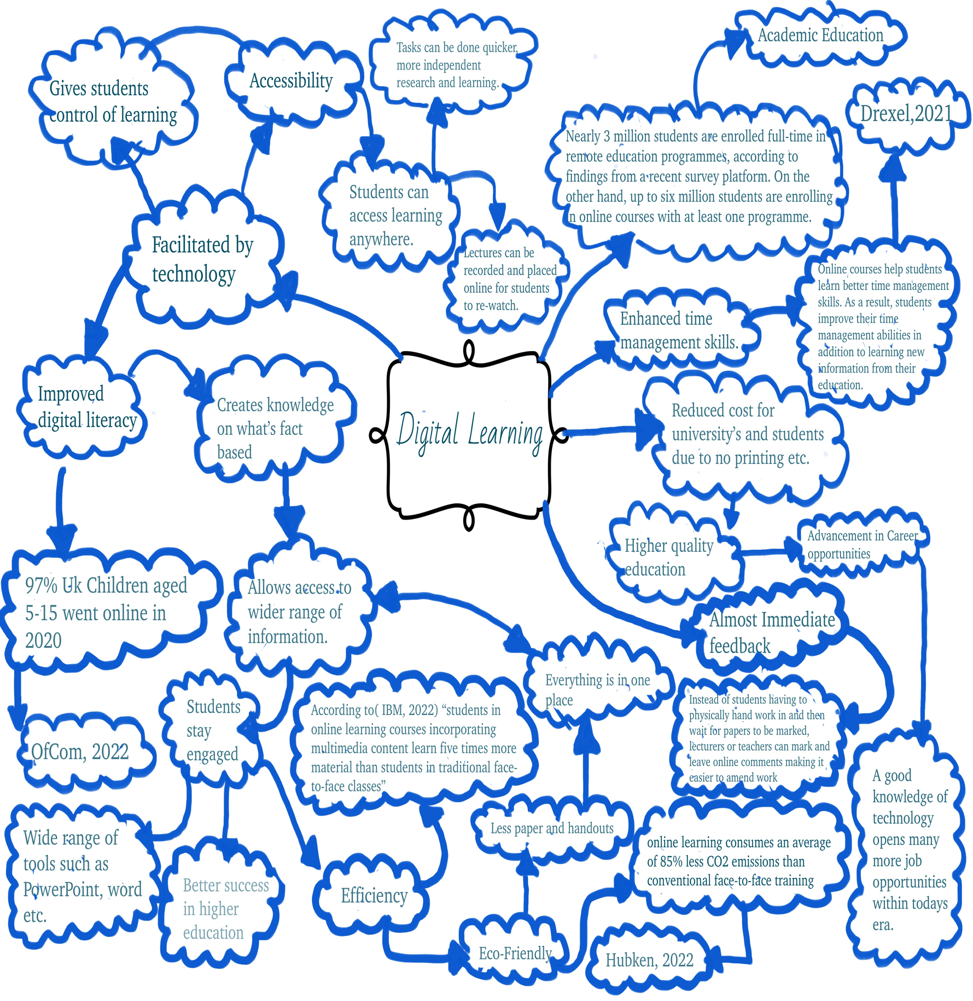
Bhattacharya,2022

2

Video

https://youtu.be/IfmI2nrAtP4

3

Reflection

Beginning University is a big advancement within any students education journey.All this change can sometimes be very overwhelming and can cause some stress and anxiety but there is a range of support and tools to ease this transition.
Students today are no stranger to the world of technology, an event that has increased this knowledge being the pandemic. With School closures beginning during 2020 many students transferred onto online learning, in fact according Li(2022) from the world economic forum over 1.2 billion children were out of the classroom
However, there are also many changes to the type of resources that are used within higher education. Some of these being, handing in online assignments using a different software or using online information sources and then having to reference using a different referencing method that some students may have been familiar with in the past. This can be very hard to grasp although attending help sessions and speaking to lectures can help simplify all the new information.
After overcoming the changes in technology and different resources, there may still be some implications within university life. Some of these may include, meeting deadlines and organising and prioritising tasks. If tasks such as the ones mentioned above are procrastinated, they become harder to deal with creating more apprehension that is unnecessary. In order to deal with these issues, it is a good idea to take many notes within lectures, focus on a structured revision/self-learning plan but also ensure time to rewind with free time.
The main point to take away from beginning university would be to enjoy, according to ONS “37% of first year students students surveyed in England during 2020 suffered with symptoms of stress and depression” (Okolicsanyi, 2021). Sodexio(2016)states,If students are not enjoying university life they are more likely to drop out of their course.
4

References
Barnett, A(2022) ‘Why online learning can be more productive’, Linked in, 19th July. Available at: https://www.linkedin.com/pulse/why-online-learning-can-more-productive-avi-bhattacharya (Accessed:5/10/22)

Berggruen,I(2018) ‘Anthony Giddens bibliography’, Digital image. Available at: https://www.berggruen.org/people/anthony-giddens/ (Accessed: 5/10/22)

Murrel(2022) ‘8 most common types of plagiarism to stay away from!’. Available at: https://www.enago.com/academy/fraud-research-many-types-plagiarism/ (Accessed: 4/10/22)

Giddens,A(2016) ‘Modernity and self identity-in 14 bullet points’ , Thompson, K, 22nd April. Available at: https://revisesociology.com/2016/04/22/giddens-modernity-self-identity-summary/ (Accessed: 5/10/22)

Gladwell,M(2008) ‘Outliers’, Little brown and company, New York.

Hubken(2022) ‘5 Reasons to go green with E-learning’,E-learning and Lms [Blog]. Available at: https://www.hubkengroup.com/resources/go-green-with-elearning (Accessed: 4/10/22)

Li,C(2022) ‘The COVID-19 Pandemic has changed education forever. This is how’, World economic forum, 29th April. Available at: https://www.weforum.org/agenda/2020/04/coronavirus-education-global-covid19-online-digital-learning/ (Accessed:6/10/22)
5

Naden,G(2018) ‘The great learning curve:how to improve your study habits’ Guardian, 22nd March. Available at: https://www.theguardian.com/education/2018/mar/22/the-great-learning-curve-how-to-improve-your-study-habits (Accessed: 4/10/22)

Ofcom(2020) ‘The COVID-19 Pandemic has changed education forever.This is how’, World economic forum, 29th April. Available at: https://www.weforum.org/agenda/2020/04/coronavirus-education-global-covid19-online-digital-learning/ (Accessed:5/10/22)

Oxford(2022) ‘Oxford learners dictionaries’. Available at: https://www.oxfordlearnersdictionaries.com/definition/english/self-identity (Accessed: 5/10/22)

Oxford(2022) ‘Oxford learners dictionaries’. Available at: https://www.oxfordlearnersdictionaries.com/definition/english/belief?q=Belief (Accessed: 6/10/22)

Okolincsany,I(2021) ‘Coronavirus and first year higher education students’, 27th October. Available at: https://www.ons.gov.uk/peoplepopulationandcommunity/healthandsocialcare/healthandwellbeing/bulletins/coronavirusandfirstyearhighereducationstudentsengland/4octoberto11october2021 (Accessed: 6/10/22)
6
Sodexio(2016) ‘Sodexo university lifestyle survey launched’ 10thMarch. Available at: https://uk.sodexo.com/home/media/news-room/newsList-area/uk-press-releases/University-Lifestyle-Survey-1.html (Accessed:6/10/22)

Williams,V(2020) ’10 benefits of digital learning’ 9thApril. Available at: https://drexel.edu/soe/resources/student-teaching/advice/benefits-of-online-and-virtual-learning/ (Accessed: 4/10/22)

YMCA(2021) ‘Unlocking potential of digital learning’ Digital image. Available at: https://www.ymca.co.uk/education/feature/unlocking-potential-digital-learning (Accessed 4/10/22)

7

