LCBB4002

Assessment 1 Community Engagement

Student ID:2132532
Student name: Radostin Angelov
Contents
Introduction 3
Programme summary 4
The values, norms, and roles of many parties involved in the Commonwealth Games 5
Social media strategies for stakeholder engagement 7
Community engagement, diversity, inclusiveness, and multi-culturalism 9
Internal and external factors that influence community development 10
Importance of adopting a forward-looking approach 12
Use of social media in community education 12
Recommendations 13
Conclusion 14
References 15

Introduction
Most towns participate in community programmes to help alleviate their economic and social problems. To be successful, sustainable, and impactful, however, most of these initiatives would need the assistance of a trained community engagement practitioner. The Birmingham Commonwealth Games were the topic of this essay, which examines how community engagement advocates helped locals get ready for and enjoy the games. The community programmes that tried to unite the Commonwealth via a fantastic athletic event will serve as the case study for this report. World Against Single Use Plastic is the project’s motto. The programme is effective because it uses a book aimed at elementary schools to raise students' consciousness on the hazards of plastic waste (Commonwealth Games – Birmingham, 2022). The paper will investigate social media techniques to foster community involvement based on stakeholder correlations. The study will discuss successful multicultural, racial and ethnic variety and community cohesion initiatives. The research will conclude that community engagement specialists must actively enlighten residents about internal and external influences that influence their communities.

Programme summary
Birmingham organised several events throughout 2022 to celebrate the Commonwealth Games and the Birmingham Culture Festival, preparing for a historic year. Because of its central location in the United Kingdom and Commonwealth, Birmingham is well suited to host the Games. Since Birmingham is the Commonwealth's true capital, its citizens look forward to displaying the city's humanity and pride in the following months and years. Birmingham City Council, the event's official sponsor, has set up a £7 million Tournament Community Fund. The whole legacy programme is geared toward making it as easy as possible for locals to participate in the event or reap the benefits of the legacy. In all, 400 competitors from 13 different countries participated in the first-ever games. World Against Single-Use Plastic was the motivation for one project. The goal of the initiative is to raise awareness of the issue of plastic pollution and to motivate individuals to take action to combat it (Cole and Barras, 2022). The book elaborates on the WASUP tenets of advocacy, education, litter picking, plastic recycling, and supply chain pressure to reduce the use of plastic in shipping and packaging.
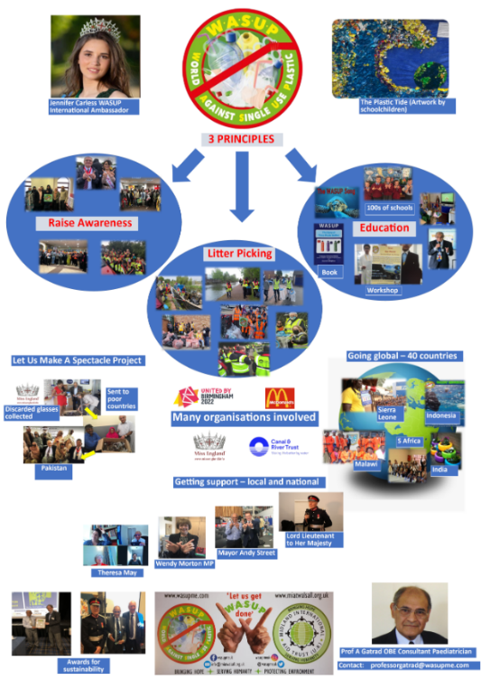
  - Figure 1: World Against Single-Use Plastic project of Commonwealth (Khorana et al., 2022)

The values, norms, and roles of many parties involved in the Commonwealth Games
A study's examination of stakeholder answers suggests the following regarding the priorities and standards that should guide community-based efforts around the recent Commonwealth Games.
Sustained engagement: Awareness of plastic waste has risen thanks to global campaigns, and in certain places, individuals have taken action; nevertheless, campaigns have also changed people towards more sustainable purchasing habits.
Participatory culture and: Consistent participation and involvement from all parties help them work together to ensure the program's continued success.
Comprehensive preparation and planning: Community programme managers make sure their projects have clear goals and objectives. Heavy metal houses and a lack of educational options have a devastating influence on the Birmingham area. The UK's government has enacted a ban on the production, import, stockpiling, transportation, sale, and use of certain single-use plastic goods with poor service and a high littering potential to reduce the pollution produced by littered and mismanaged plastic trash.
Collaboration and a common goal: Prospective CCOA members are urged to make at least one of the following pledges:
- Act to end the use and disposal of single-use plastics altogether.
- The usage of disposable plastic bags is expected to drop significantly by 2022.
- Sales and production of microbeads for use in personal care and cosmetic products that need rinsing will be prohibited as of 2022 (Lee and Hsieh, 2022).
Demographic diversity and inclusion: There is consensus among the general public that reaching out to everyone is the key to successfully launching a programme. One way to achieve this aim is to encourage participation from various individuals and perspectives. This improves the legitimacy and popular representation of decision-making processes, benefiting the people they serve. Collaboration between city authorities, youth groups, women, the disabled, and the able-bodied.
Transparency and Learning: The Birmingham neighbourhood has earned trust by providing an easy-to-follow process for executing its projects. Public members inspire one another to collaborate by sharing and expanding on ideas.

Social media strategies for stakeholder engagement
Social media may successfully affect consumer behaviour toward plastic use, provided the information offered is derived from credible research, is readily translatable to their actions, and has a direct effect on consumers' health. During the research period, the social media & e-newsletter treatments and the comparison group resulted in substantial decreases in consumers' self-reported food waste (Fissi et al., 2022). When selecting the most effective communication methods to promote their engagement, diverse stakeholders must be considered. It will need the joint effort of all relevant parties to implement binding legislation and a commitment to minimising plastic pollution. Single-use plastics and microbeads are regulated to varying degrees, depending on the country.

  - Figure 2: Social Media Strategy (Quesenberry, 2020)
WhatsApp: This virtual gathering place allows for easy access to information and communication among all participants. With WhatsApp, you may send direct messages to one or more recipients across countries and time zones, making it a potent tool for establishing broad perspectives and friendships. WhatsApp's most vital characteristics are its ease of use and capacity to conduct personal and collective video and phone communications. Literate participants in the Commonwealth Games may now easily remain in contact with one another and track the tournament’s progress thanks to WhatsApp.
Facebook platform: By facilitating a single stakeholder contact method, Facebook promotes individual and commercial involvement. Facebook is a fantastic match for disseminating information about the Commonwealth Games since users can provide feedback on postings by liking or sharing them. They want to advertise on Facebook and use live-stream videos to spread the word about their product to as many people as possible. The Zero Trash movement is a style of thought, extensively disseminated on Facebook via the hashtag #ZeroWaste, that attempts to reduce the amount of waste (Kanol and Nat, 2021). Customers who avoid overpackaged items and firms that avoid excessive packaging share such material.
LinkedIn platform: A promotion was created by recycling and reposting ideas on other pages. It's essential to update profiles with identical messages or statuses whenever someone else does so. One strategy for doing so is to announce successes along the way. It is helpful to make sure that all of the public and commercial organisations involved in putting on a significant event, like the Commonwealth Games, are healthy and able to send out material when the time comes.
YouTube: Promotion of the product on this service is accomplished by live telecasts that reach a large audience all at once. This approach has the potential to rapidly disseminate to a worldwide audience while still being cost-effective for the distribution of multimedia content (Falla et al., 2022). These avenues provide more traffic to the website, which improves openness, accessibility, and the ability to measure outcomes based on user input.

Community engagement, diversity, inclusiveness, and multi-culturalism
When we talk about "multicultural community involvement," we mean activities that bring individuals of different origins together to solve a problem or achieve a goal that affects the whole community. If we learn to work together across cultural boundaries, we may better accept one another's uniqueness and advance toward our shared objective.
Through strategic community participation and engagement, the 2022 Commonwealth Games Organizing Committee hopes to realise its goal of "Making a world of difference during the Games for everyone" (Bild and Pachana, 2022)
Training and education in youth work are encouraged, and competency requirements are set to foster professional growth. They provide technical assistance to youth policy on a local and national level and provide structures, guidelines, and tools to aid in the development of young people. In the year 2020, more individuals of various ethnicities live in Birmingham than in any other city in the Uk. Birmingham's cultural diversity inspired the city to adopt the Race at Work Code by 2021, a policy benefiting the city's many disadvantaged, young, unemployed, and handicapped residents. This will have a dual purpose: it will assist with the Games and begin educating locals to fill economic roles. Organisers of the Commonwealth Games hope that athletics will spark dialogue and lead to action against discrimination and inequality in the region. Games will promote diversity and inclusion.

Internal and external factors that influence community development
The different perspectives, preferences, beliefs, and attitudes held by project stakeholders are internal factors that affect community development. Community outreach workers, however, must educate locals with a vision for the future (Aitken, 2022). In contrast hand, factors outside the control of a project's creators might provide opportunities and threats to the endeavour.
Internal factors
Participation: The importance Birmingham plays in community development is frequently highlighted in discussions on the topic. Human nature makes participation in community development essential.
Effective strategies: Based on an analysis of existing initiatives and the existing research, they propose 14 strategies for promoting environmentally friendly plastic usage:
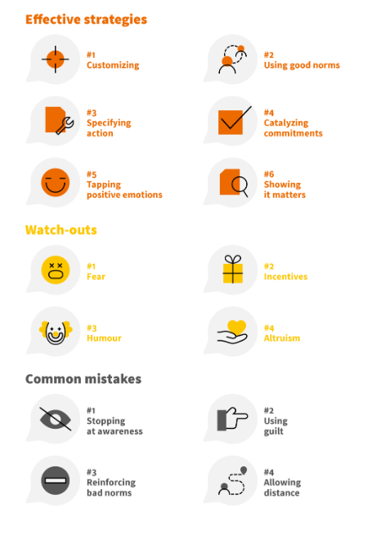
  - Figure 3: Effective strategies for protecting the environment (Vanapalli et al., 2021)
Interest: Whether or whether individuals feel invested in their neighbourhood is a critical factor in how successful a community development plan will be. If there is much enthusiasm for something, people will work together to make it happen.
Attitude: People's perspectives may not match their enthusiasm for community development, even if they are eager participants.
External factors
Culture: The culture of a community incorporates several social elements. Their morals, expectations, and perspectives are significantly different. The cultural norms of a society may influence the evolution of the social design phase.
Political: This is when even the most apolitical topics feel charged with political overtones. Politicians in Birmingham set the policy agenda, and the personal ideologies of those in power might stymie effective administration and hinder good judgement.

Importance of adopting a forward-looking approach
Lessening plastic usage helps stop pollution from the introduction of new raw materials, conserves energy, and lowers emissions of greenhouse gases that contribute to global warming. Thinking ahead involves examining the present to foretell the future of an issue. Professionals in the field of community engagement must assess the impact of several external variables on their client's business before developing effective strategies to move the project forward and realise its intended outcomes (Andersson et al., 2019). Because of this, less worry is felt. Professional groups widely consider the forward approach because it aids in understanding employees’ goals, increasing their satisfaction, inspiring them to boost business output, and keeping them around for a more extended period, all of which are crucial to the business’s success. WASUP will be a purpose-built facility offering 15 initiatives in sport, health, dance, arts, music, media, and personal development at each session for 120 different nations. It's a just resolution and good for promoting environmental awareness.

Use of social media in community education
Climate change and the destruction of ecosystems are only two of the many problems due to the plastic plague. There is presently the most significant health crisis in human history because of all these factors. Students' engagement has improved thanks to teachers' usage of social media. The use of social media in the classroom has boosted students' technical skills and fostered a greater sense of collaboration, both of which are essential for effective community service (Prestridge, 2019). In addition to continuing their education, students benefit from being immersed in a culturally rich environment with students from various backgrounds.

Recommendations
The success of the Commonwealth Games depends heavily on the results of the evaluation of community engagement. The Games boost the economies of the host city, region, and country. As a result, stakeholders may stress the importance of efficiency and kindness among their volunteers. The spread of the coronavirus has caused widespread illness and death. Facebook, LinkedIn, and YouTube may all be used effectively to spread the word about a community's needs and encourage more people to get involved and donate money to the cause of saving the place. Professor Gatrad has developed a book for elementary schools entitled The Story of Three Plastic Water bottles to raise students' understanding of reducing plastic pollution. Parents and children who have read the book are already spreading the word and organising cleanup events in their neighbourhoods and along the canal. CCOA will bring up Commonwealth member nations, corporations, and NGOs to pledge to action on plastic, exchange best practices, leverage funds, and press for global action.

Conclusion
Solving the community's socioeconomic problems requires the involvement of the whole community. Many issues have been raised about the way the Birmingham Commonwealth Games programme has dealt with them, including a lack of funds, the proliferation of Covid-19, a lack of unanimity on how to award medals, and the involvement of athletes from many different nations. The study also covered the " World Against Single Use Plastic" project based on the Onside concept. Theresa May, the ex-Prime Minister of the United Kingdom, has donated £61.4 million to a worldwide coalition of Commonwealth members to combat marine plastic waste. Therefore, the programme must ensure that it is meeting public demands and providing stakeholders with a transparent view of the outcomes they may expect. Second, it's prudent to consider a targeted approach with specific goals in mind. Finally, projects should be launched to solve urgent local problems and provide observable outcomes in a timely manner.

References
- Andersson, U.B., Löfgren, H. and Gustafson, S., 2019. Forward-looking assessments that support students’ learning: A comparative analysis of two approaches. Studies in Educational Evaluation, 60, pp.109-116.
- Aitken, A., 2022. Community perceptions of private security at a mega-event. Security Journal, 35(4), pp.987-1005.
- Bild, E. and Pachana, N.A., 2022. Social prescribing: A narrative review of how community engagement can improve wellbeing in later life. Journal of Community & Applied Social Psychology, 32(6), pp.1148-1215.
- Commonwealth Games – Birmingham. 2022. World against single-use plastic (WASUP). Available at: https://www.birmingham2022.com/news/2481236/world-against-single-use-plastic-wasup- (Accessed: November 30, 2022).
- Cole, A. and Barras, M., 2022. The commonwealth games: A history of human movement. Interaction, 50(2), pp.20-21.
- Falla, M., Prior, J. and Jacobs, B., 2022. Assessing the impact of sporting mega-events on the social and physical capital of communities in host cities: the Gold Coast 2018 Commonwealth Games experience. Commonwealth Journal of Local Governance, pp.5-27.
- Fissi, S., Gori, E. and Romolini, A., 2022. Social media government communication and stakeholder engagement in the era of Covid-19: evidence from Italy. International Journal of Public Sector Management.
- Kanol, D. and Nat, M., 2021. Group type and social media engagement strategies in the EU: The case of British interest groups on Facebook. Journal of Public and Nonprofit Affairs, 7(2), pp.205-219.
- Khorana, S., Escaith, H., Ali, S., Kumari, S. and Do, Q., 2022. The changing contours of global value chains post-COVID: Evidence from the Commonwealth. Journal of Business Research, 153, pp.75-86.
- Lee, C.T. and Hsieh, S.H., 2022. Can social media-based brand communities build brand relationships? Examining the effect of community engagement on brand love. Behaviour & Information Technology, 41(6), pp.1270-1285.
- Prestridge, S., 2019. Categorising teachers’ use of social media for their professional learning: A self-generating professional learning paradigm. Computers & education, 129, pp.143-158.
- Quesenberry, K.A., 2020. Social media strategy: Marketing, advertising, and public relations in the consumer revolution. Rowman & Littlefield Publishers.
- Vanapalli, K.R., Sharma, H.B., Ranjan, V.P., Samal, B., Bhattacharya, J., Dubey, B.K. and Goel, S., 2021. Challenges and strategies for effective plastic waste management during and post COVID-19 pandemic. Science of The Total Environment, 750, p.141514.

