
communication skills in the workplace
FOYSAL AHMED 1709523

July 13, 2018
University of Wales Trinity Saint David

Executive Summary

The purpose of this report is to analyse a case study and review all of the different issues that have been highlighted within the organisation. Some of the main problems that the researcher identified were, poor management, lack of staff and too many employees without full training and lack of communication.
Upon looking into these issues, the researcher has identified several different communication models which when implemented, can help to overcome or improve thee issues. The Argyle communication model, Tuckman and Berlo were amongst the ones discussed within the report.
The conclusion that that the researcher came up with is that more methods of communication needs to be implemented to help the employees keep updated with policies and procedures, and most forms of communication were all one way which meant that employees were not always able to contact the managers for advice or feedback.

Table of Contents
Executive Summary 1
Terms of Reference 3
Procedure 4
Introduction 5
Findings 6
Communication issues and the impacts on the organisation……………………………….………………6-10
Conclusion 11
Recommendations 12
Bibliography 13
Appendices 15
Acknowledgements 16

Terms of Reference

This report has been put together by Foysal Ahmed.
The report has been asked for submission for the 13th July 2018 by Mel Squire. The purpose of the research was to find all the different issues within the given case study and discuss the impacts these issues have in the organisation. Different communication models were also mentioned to see how these issues could be resolved. The main issues found were problems with management and communication.

Procedure

In order to gather all the information for the report, the researcher obtained all the relevant information from the internet.

Introduction

The researcher has been presented with case study which needed to be thoroughly analysed to try and find the issues and problems that the organisation is facing. Upon highlighting these, possible impacts that these issues had on team work within the organisation. As explained by RK BLOG (2013), communication within an organisation helps to ensure managers are able to keep updated regarding progress and performance. It assists with decision making and building a strong relationship with the team. Methods of communication where also researched to see how these issues could be resolved if the right level of guidance and support was provided. The researcher has then finalised a few recommendations which may help the organisation.

Findings

Communication issues and the impacts they have on the organisation
After going through the case study provided, the researcher has identified the following issues and the impacts these have on the organisation.
Some of the staff were located in different buildings which resulted in the staff not being updated on any new plans and policies regarding procedures. The staff were left stunned when these new ideas were being presented to them. The impact these issues showed on the team working aspect of the organisation is that many staff were left feeling unhappy and in a lot of work related stress. One of the communication methods that could be used to help resolve the issue or improve the situation would be the Argyle communication cycle. According to CollectifBDP (2018), the purpose of this communication cycle is to be able to read and understand the message being relayed, and then obtain feedback regarding the message from the receiver of the message. This cycle consists of six stages. As stated by Study.com (2018), these are ‘sender’ which refers to the person sending the message, ‘message’ which is what the sender wants the receiver to know, ‘encoding’ which is the method the sender has chosen to relay the information, ‘channel’ which is the way the message will be sent. This can be done in many ways to broaden the ways of communication. The ‘receiver’ is the person who the message is intended for, ‘decoding’ refers to what the receiver understands from the message, and lastly, ‘feedback’ which is what the receiver provides to the sender regarding the original message that was received.

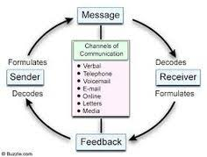

Taking this cycle into consideration regarding the case study, if the manager was to relay all updates, procedures and policies to all the staff through the same medium and all at the same time, it gives the opportunity for all the staff to be informed and be kept ‘in the loop’ always. The cycle also provides opportunities for all the staff to provide feedback should they need to. It would encourage the staff and managers to liaise more often.
Poor management is also another evident issue within the case study. Performance was very low amongst all the staff and this was caused mainly due to a lot of absences from work which were left un managed by staff and the staff turnover was also very high. The impact that this had on the organisation was that they were having to employ new, un-trained staff to complete unfinished work. Another issue linked with this impact is that some team members never had a consistent manager. This had a negative impact on all the staff members because they were always given new information with different managers, so the employees were always applying different techniques all the time. This showed an inconsistency within the working standards. Whilst some members decided about a specific case, other members would disagree with the decision and override it. This opened windows for conflict. The reasons behind this type of behaviour between staff members was down to a lack of communication. According to the case study, the head of social services was not very open with discussions and preferred to express changes or updates through email. This was not always convenient as, according to Bizfluent (2017), written communication can feel very impersonal. Certain information may be better informed face to face as opposed to through the internet. Miscommunication may also occur as sarcasm or humour may not be understood by some. Also, written communication does not provide the instant feedback a person would receive if conversations took place directly. As per the case study, any meetings the manager held face to face were only one way, so employees were not able to express their opinions. Any employee who emailed the manager back in response to receiving emails, never received any form of gratitude as the manager hardly checked emails for feedback. If the employees felt that they had an idea or opinion about a case, the organisation, or in general, they were never given the opportunity to express these as there was no means of doing so. All of these issues have impacted the team working within the organisation is that conflict was potentially being created due to clashing of decision making between the different teams and managers. This kind of behaviour and the structure that the organisation works in is an example of the Shannen and Weaver communication model. It is like a one-way communication process where the manager is relaying their information to the rest of the group but does not take in any feedback that could prove to be beneficial. According to Communication Theory (2018), the idea behind this model is to help improve communication between the person sending the message and the other person receiving it. The model is made up of five components, which are ‘sender’ that refers to the person who wants to send the message, so in this case the manager, the ‘encoder’ which is what transmits the message and converts the message and converts it into signals. The ‘decoder’ is what reverses the process and changes it back into the message. Lastly, the ‘noise’ considers any factors that may have changed the message or caused a disruption. Regarding the case study, emailing employees is not always effective, as some may not receive the message if there is a technical fault, whilst others may interpret the message incorrectly.



In regards to some of the issues mentioned, the Tuckman model may be a positive way to help overcome some of the issues being expressed. As Mind Tools (2018) states, it helps a group of people form together to work more effectively. The model consists of four main stages. These are ‘forming’ which is the start of the process where everyone has just met and are mostly working on their own. The second stage is ‘storming’ which is where everyone starts to open up and express their own opinions. If these are not expressed correctly, or collide with another person’s choices, this is where conflict starts to show. The ‘norming’ stage is where differences start to be overcome and trust starts to build, as they ask each other for help and advice. In the ‘performing’ stage, everyone starts to work together to achieve their goal.
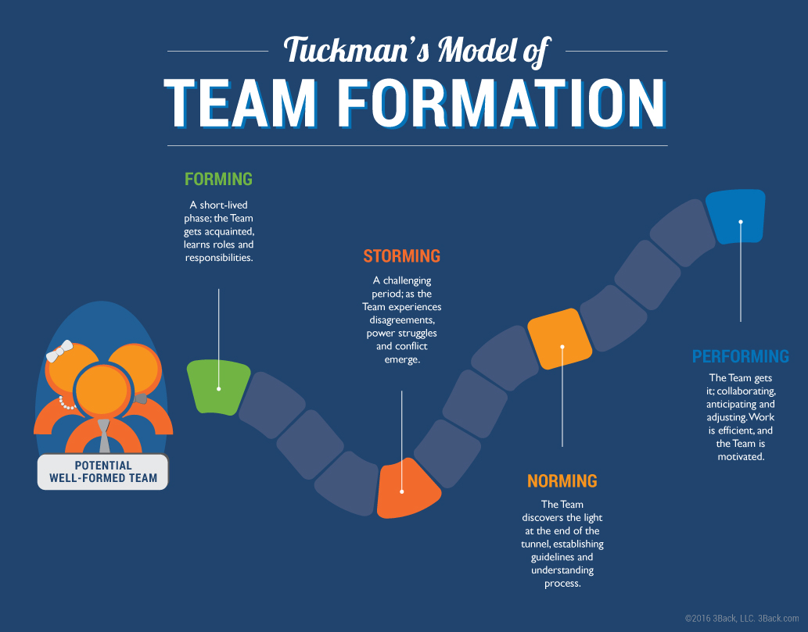
Linking this model to the issues within the case study will help in the sense that the group of employees are currently stuck within the storming process and have not actually managed to move on to the norming stage. Using this model as a guide to work on each other’s views and opinions will help to find ways to work around them and then help to move on through the stages to reach the final stage. It is up to the manager to open up to all the employees and offer them the chance to speak up. Effective team work is very important in any organisation. As The happy manager (2018) mentions, good team work helps create a synergy effect and allows any barriers to be removed and work together. It promotes motivation within the group and helps increase morale.
Another issue the researcher identified is the lack of performance from the employees. Due to high levels of stress, a lot of the staff were either absent a lot or leaving the job, resulting in a high turnover. As the management was poor, none of these absences or leaves were monitored or looked into, so there was no way of finding out what the cause of these issues were. The organisation was continuously hiring new staff and due to insufficient staff, the new employees were put onto the work floor and asked to take over cases without any full training or a formal induction. Due to new faces in the office all the time, staff very rarely communicated with each other and just preferred to do their own work and leave. This demonstrated very little trust within the group and they all preferred to work alone. The impact that these issues had on the organisation’s teams is that the staff were working more like a group rather than a team. They showed no signs of self-regulation, identity, no purpose or a common goal. According to Hogan (2012), a team is defined as a group of people who work together towards a common goal. They share responsibilities and leadership, and all take joint responsibility for all the outcomes. They work as one rather than by themselves which is what a ‘group’ is defined as. Individuals within a group prefer to work individually and for themselves and their on purposes.
To help on these issues, the Berlo communication model can be used. According to Proxis (2015), the purpose of this model is to gain a proper understanding o the messages being played and positions can be reversed to see how the messages turn out as it does not provide feedback. The model has four main stages. The first is the ‘source’ which again is the initial stage where the messages are being created. The message being sent out can be affected by communication skills, knowledge and social backgrounds. The second stage is the message, which needs to have the correct content of information. The structure and the elements used can affect what is actually being composed. The ‘channel’ is the way in which the message is being read. Factors affecting this can be any of a person’s five senses. Lastly, the ‘receiver’ is the person reading the message. Again, all the same factors that affect the source are applicable to the receiver too.
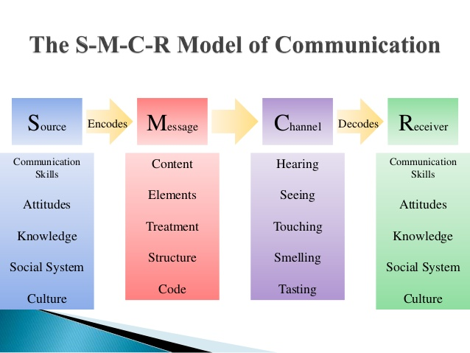
Although this model does not provide feedback, it can help the managers to relay all the correct information and guidance to the employees ensuring all sections of work are covered. This model also gives the opportunity to look into certain factors that would hinder the messages being sent out.
The last issue that the researcher identified was that some members of staff had their achievements ignored or not acknowledged. This was an issue that needed to be addressed as the impact that it had was that it was lowering the self-esteem of everyone working, and there was no sense of motivation or appraisal. This results in less productivity or interest in their job, which eventually leads to employees leaving the job. Every individual is different and recognising their potential is a great way to boost confidence within the team. As explained by Belbin (2018), the Belbin team roles is a way for everyone to learn and understand their own strengths and weaknesses, which when put together within a team, helps make communication more effective. There are nine different characteristics and in many cases, individuals possess more than one characteristic which is very useful within a group.
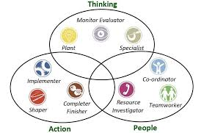As Heathfield (2018), explains, examples of recognitions are praises, saying thank you, offering rewards, providing treats and opening up opportunities for them, all of which will help to make the organisation more productive.

Conclusion

After carrying out thorough research on the case study, it has been identified that some of the main issues within the organisation is new employees with little training or knowledge on the role of their job, which results in low performances. Communications within the group were mostly one-way, which created a barrier for employees to provide feedback and advice or to express any concerns. According to Study.com (2018), the Argyle communication cycle can help to gain essential feedback and also widen the ways of communicating. As Mind Tools (2018) stated, the Tuckman’s model will be an effective way to overcome any conflicts and look at the causes of them too.
Concluding all the information found, it shows that with the correct level of support taken from all of the different communication methods, improvements to the system ca be made. Any skills and/or knowledge displayed should be utilised effectively to achieve the best possible result for the progression of the organisation.

Recommendations

- Communication needs to be enhanced in order to widen the probability of successful message transfers and receivals. Using the Argyle communication cycle as a guide, it shows how more than one method can be used to send messages across the organisation. As mentioned by Cliffsnotes (2016), although most forms of communication are oral, some methods can be non-verbal. This would include body language, facial expressions and physical appearance, all of which ply a role in how a message is conveyed.

- Rewarding and showing appreciation towards staff will help to boost confidence as well as motivate them. As Business Dictionary (2018) stated, honouring a person’s positive behaviour or recognising one’s ability to work well helps to ensure the individual will continue their hard work and repeat their actions to continue doing well.

- managers need to get into the habit of setting goals and objectives for their group members. According to Chron (2018), setting goals helps to provide a path to work through and keeps everyone in the right direction.

Bibliography

Belbin (2018), ‘What is Belbin all about?’, [Online] Available: www.belbin.com, [Accessed: 2018,7,1].

BizFluent (2017), ‘The Disadvantages of Written Communication’, [Online] Available: http://bizfluent.com/info-8130487-disadvantages-written-communication.html/, [Accessed: 2018,7,2].

Business Dictionary (2018), ‘Employee Recognition’, [Online] Available: www.businessdictionary.com/definition/employee-recognition.html, [Accessed: 2018,7,2].

Chron (2018), ‘Why Is Goal Setting Important In Organizations?’, [Online] Available: smallbusinesses.chron.com/goal-setting-important-organizations-2509.html, [accessed: 2018,7,2].

Cliffsnotes(2016), ‘Methods of Communication’, [Online] Available: http://www/cliffsnotes.com/study-guides/principles-of-management/communication-and-interpersonal-skills/methods-of-communication, [Accessed: 2018,7,2].

Collect if BDP (2018), ‘Argyle’s and Tuckman’s theories of communication’, [Online] Available: http://collectifbdp.com/argyles-and-tuckamns-theories-of-communication/, [Accessed: 2018,7,2].

Communication Theory (2018), ‘Shannen and weaver Model of Communication’, [Online] Available: http://www.communicationtheory.org/shannen-and-weaver-model-of-communication/, [Accessed: 2018,7,2].

EK BLOG (2013), ‘Importance of Effective Communication in an Organization’, [Online] Available: www.edukart.com/blog/importance-of-effective-communication-in-an-organization/, [Accessed: 2018,7,9].
Heathfield, S.M (2018), ‘Top 10 Ways of Showing Appreciation’, [Online] Available: http://www.thebalancecareers.com/top-ways-to-show-appreciation-to-employees/1916807, [Accessed: 2018,7,9].

Hogan(2012), ‘Important Differences Between Groups and Teams’, [Online] Available: http://www.hoganassessments.com/important-differences-between-groups-and-teams/, [Accessed:2018,7,2].
Mind Tools (2018), ‘Forming, Storming, Norming and Performing’, [Online] Available: http://www.mindools.com/pages/article/newLDR_86.htm, [Accessed: 2018,7,2].

Praxis (2015), ‘Berlo’, [Online] Available: http://www.proxisframework.org/en/library/berlo, [Accessed: 2018,7,2].

Study.com (2018), ‘Communication Cycle: Definition & Stages’, [Online] Available: http://study.com/academy/lesson/communication-cycle-definiton-stages.html/, [Accessed: 2018,,2].

The Happy Manager (2018), ‘Why Is Teamwork Important?’, [Online] Available: http://the-happy-manager.com/articles/why-is-teamwork-important/, [Accessed: 2018,7,2].

Appendices

Acknowledgements

the researcher acknowledges the lecturer Mel Squire for all the help and information provided, the help received from the researcher’s wife, and the information obtained from the internet.

