
University of Wales Trinity Saint David
School of Computing
04/20/2023
Research on Traffic Flow Prediction Algorithm Based on Deep Learning
Research Methods and Professional Development/ACFA7004

Table of Contents
Table of Contents
Table of Contents 2
Abstract 3
1. Introduction 3
2. Background 3
2.1. Aims and Objectives 4
2.1.1. Aim 5
2.1.2. Objectives 5
3. Literature Review 5
3.1. Convolutional neural networks 5
3.2. Long short memory & Gated recurrent neural network 6
3.3. Embedding 7
4. Methodology 9
4.1. Spatial feature extraction of trajectory data 9
4.2. Temporal feature extraction of trajectory data 10
5. Results 11
6. Evaluation 11
7. Conclusion 12
References 12

Abstract
Timely and accurate traffic forecasting is the key to urban traffic control and guidance. Due to the highly nonlinear and complex nature of traffic flow, traditional methods cannot meet the requirements of medium- and long-term forecasting tasks and often ignore spatial and temporal correlations. In this paper, a new deep learning framework, spatio-temporal convolutional network, is proposed to solve the time series prediction problem in the traffic domain. A vehicle density prediction algorithm is constructed with a convolutional neural network and gated recurrent units, where the convolutional neural network and gated recurrent units are used to extract spatial features and time-dependent correlation features of trajectory data, respectively, and add information such as the time cycle pattern of trajectory data to the model in the form of embedding vectors by analyzing the time cycle of urban trajectory data, which can be used with fewer parameters to The training speed is improved. Experiments show that our model effectively captures integrated spatio-temporal correlations by modeling multi-scale traffic networks and consistently outperforms the state-of-the-art baseline on real traffic datasets.

Introduction
An concept for a master's dissertation project is the main focus of this assignment. This will elaborate on the main pillars of the research program. The thesis will provide a general background on traffic flow prediction within the discipline of computer science and technology. The substantial research that has been conducted in the area will then be extensively reviewed to show why this research is crucial to the field of study. The project's technique will next be given and thoroughly examined in order to comprehend the anticipated results of the project idea.

Background
Trajectory prediction is one of the key problems in traffic control and guidance systems. Trajectory prediction can be described as predicting the path that a vehicle will take when its trajectory route and the surrounding traffic environment are known for the past period of time. The solution to this problem can be applied to vehicle travel safety analysis, road safety assessment and infrastructure safety systems to provide collision warning in time . Solving this problem is also crucial for autonomous vehicles and Advanced Driver Assistance Systems (ADAS).
Trajectory data are similar to speech data and natural language data in that they are both time-series related. In recent years In recent years, many studies have applied various neural network models to trajectory data mining, e.g., Deo et al proposed a model based on Long Short-Term Memory (LSTM), which was designed to study the dependencies of neighboring vehicles in motion and has good robustness. Singh et al describe the trajectory of a vehicle as a sequence of states in a certain time interval, each state represents the vehicle's current Each state represents the current coordinates of the vehicle, thus transforming the vehicle trajectory prediction problem into a multi-scale Graph Neural Networks (GNN) with a temporal feature architecture, and experiments show that the model effectively captures the spatio-temporal correlation of track data. The experiments show that the model effectively captures the spatio-temporal correlation of the track data.
In addition to the above methods, recently proposed trajectory prediction models tend to combine different neural network models, and the trajectory prediction algorithm used in this paper belongs to this category. For example, Xie et al proposed an interactive multi-model trajectory prediction scheme that adjusts the weights of the models according to the prediction variance of each model. In the maneuver-based approach, a random element of uncertainty from a dynamic Bayesian network is brought into the trajectory of each vehicle. In the physics-based prediction model, the method uses a Kalman filter to improve the accuracy of the prediction. Experimental results show that the method is able to obtain more accurate predicted trajectories for relatively long prediction periods, but due to the long convergence time of its algorithm, its prediction results cannot be used to guide routing protocols that need to achieve efficient forwarding.Mo et al proposed a heterogeneous edge-enhanced graph attention network (HEAT) for simultaneous trajectory prediction for multiple different traffic participants, HEAT uses a specific type of encoder to extract the dynamics of a target from its historical state, and HEAT can also process and extract interaction features between targets. In addition, map features are shared among all targets by introducing an optional gate mechanism. Finally, the trajectories of multiple targets are predicted simultaneously.Simon et al proposed an almost fully automated neural network approach that predicts the destination of a cab based on the starting point of the cab trajectory and the associated metadata, and uses the Multilayer Perceptron Model (MLP) and the LSTM to prefix the trajectory and metadata, respectively data are labeled and output. The experiments show that the best model is a bidirectional neural network using recurrent.
Kim et al proposed a vehicle trajectory prediction framework based on the combination of Recurrent Neural Network (RNN) and LSTM. The method uses RNN models to learn the complex motion behavior of vehicles from a large amount of trajectory data. This method uses RNN models to learn the complex motion behavior of vehicles from a large amount of trajectory data, and then uses LSTM to analyze the motion behavior of surrounding vehicles and predict the future coordinates. The scheme takes The solution inputs the vehicle coordinate sequences measured by sensors into the LSTM, and generates probabilistic information about the future locations of vehicles on a grid-divided map. Jazayeri et al proposed a new solution for trajectory prediction by combining elements of the prediction and control formulations. The whole solution is divided into two steps: the first step represents the vehicle trajectories as B-sample curves and trains a neural network model to predict the coefficients of these B-sample curves. The autoencoder is then used to generate candidate trajectories from these predicted coefficients. The second step uses inverse reinforcement learning (IRL) to rank the candidate trajectories and selects the trajectory with the highest reward value as the predicted outcome. In summary, in the existing studies of neural network-based prediction models, the model construction mostly relies on the time series features of the vehicle trajectories, while the spatial features of the trajectory data are ignored. Therefore, if we want to further improve the accuracy of the prediction results, the spatial features of the trajectory data should also be fully explored.

Aims and Objectives
For the project to be achievable, there will need to be concise requirements in the form of aims and objectives. The overall aim will be achievable through the objectives that are set to form the completion. The background study completed in the previous study enables the research objectives to be formed.

Aim
In order to increase prediction speed and accuracy, the aim of this study is to examine and comprehend the history of traffic flow prediction and to construct a more creative network structure based on cutting-edge deep learning theories and algorithms.

Objectives
1. To survey current methods used for traffic flow forecasting and their evaluation metrics to build an understanding of the need for j traffic flow forecasting efforts
1.1. This will include a comprehensive and clear literature review within these areas to understand why this research is still relevant
2. Build a traffic flow prediction network architecture based on the current more popular deep learning networks for faster and more accurate predictions
2.1. This will take up most of the time of the paper as this is the focus of the application
3. Collect real traffic datasets for validating the soundness of the proposed network architecture to improve the application
3.1. This will take the form of information gathered from several papers to create the overall areas for development.
4. Examine and critically assess the test data gathered to identify methods to enhance accessibility and usability.
4.1. This will be discussed critically in the final report to identify the project's strengths and areas for improvement.

Literature Review

Convolutional neural networks
Convolutional Neural Network (CNN) is a deep learning network structure that is mainly used in areas such as image recognition and natural language processing.CNN mainly consists of convolutional layer, pooling layer and global. The convolutional layer is the most important part of CNN for extraction. It does this by uninterruptedly convolving filters (i.e., convolutional kernels, convolutional rock formations) and input data to the avatar of a specific sign. The bureau features of the image are used to obtain higher dimensional features. The pooling layer is mainly the next step of acquisition based on the results of the convolutional layer, i.e., it reduces a small amount of data and computation and maintains the main information in the image, while being better for image and plane panning non-negativity. The fully-connected layer is the last layer in CNN, which connects all the feature maps together to get the final classification result. Meanwhile, the fully connected layer can incorporate some regular reform methods, such as Droo ensemble. CNN can extract the advanced features of the image also step by step through the combination of multiple convolutional and pooling layers for the purpose of image classification and object knowledge. In tasks such as natural language processing NN, edge reasoning C classification, document generation, etc.
Convolutional neural networks use the original image as input, which can effectively learn the corresponding features from a large number of samples and avoid the complicated feature extraction process. Since CNN can directly process two-dimensional images, it has been widely used in image processing, and has achieved many research results. The network extracts more abstract features from the original image by a simple nonlinear model and requires only a small amount of human involvement in the whole process.
The CNN has two features: local perception and parameter sharing. Local perception means that each neuron does not need to perceive all pixels in the image, but only local pixels of the image, and then merges these local information at higher levels to obtain the full representation information of the image. The neural units in different layers are connected locally, i.e., the neural units in each layer are connected to only some of the neural units in the previous layer. Each neural unit responds only to the regions within the receptive field and does not care at all about the regions outside the receptive field. Such a local connectivity pattern ensures that the learned convolutional kernel has the strongest response to the spatially localized patterns of the input. The weight sharing network structure makes it more similar to a biological neural network, reducing the complexity of the network model and reducing the number of weights. This network structure is highly invariant to translation, scaling, tilting, or co-otherwise forms of deformation. Moreover, the convolutional neural network uses the original image as input, which can effectively learn the corresponding features from a large number of samples and avoid the complicated feature extraction process.

Long short memory & Gated recurrent neural network
LSTM is a variant of RNN, whose core concept lies in the cell states and the "gate" structure. The cell states are equivalent to the paths of information transmission, allowing information to be passed on in a sequence. You can think of it as the "memory" of the network. Theoretically, the cell state is able to pass on the relevant information during sequence processing. Thus, even information from earlier time steps can be carried to cells at later time steps, which overcomes the effects of short-term memory. Information is added and removed through "gate" structures that are trained to learn which information to keep or forget.
Forgetting gate: determines which information should be discarded or kept. The information from the previous hidden state is passed to the sigmoid function along with the current input, and the output value is between 0 and 1, with closer to 0 meaning it should be discarded and closer to 1 meaning it should be kept.
Input gate: The input gate is used to update the cell state. First, the information from the previous layer of hidden states and the current input is passed to the sigmoid function. The value is adjusted between 0 and 1 to determine which information to update. 0 means not important and 1 means important. Next, the information from the previous layer of hidden states and the current input is passed to the tanh function to create a new vector of candidate values. Finally, the output of the sigmoid is multiplied by the output of tanh. The output of the sigmoid determines which information in the output of tanh is important and needs to be preserved.
Cell state: The cell state of the previous layer is multiplied point by point with the forgetting vector. If it is multiplied by a value close to 0, it means that the information is to be discarded in the new cell state. This value is then added point by point with the output value of the input gate to update the new information found by the neural network into the cell state. At this point, the updated cell state is obtained.
Output gate: The output gate is used to determine the value of the next hidden state, which contains the information from the previous input. First, we pass the previous hidden state and the current input into the sigmoid function, and then pass the newly obtained cell state to the tanh function. Finally, the output of tanh is multiplied with the output of sigmoid to determine the information that the hidden state should carry. The hidden state is then used as the output of the current cell, and the new cell state and the new hidden state are passed to the next time step.
GRU is a neural network model proposed by Chung et al in 2014 and is a simplified version of LSTM.The advantage of GRU is that less training time is required, which improves the network performance.GRU and LSTM work similarly, but the neurons of GRU use a hidden state and combine the forgetting and input gates from LSTM into one update gate. In addition, GRU combines hidden states and neuron states into one state. Therefore, the total number of gates in GRU is half of the total number of gates in LSTM. two gates of GRU are update gate and reset gate. The update gate is responsible for calculating the amount of information to be yielded from the previous hidden state to the new hidden state. The reset gate is responsible for handling the flow of information and determining the amount of information that is forgotten when the hidden state is updated.
Advantages of LSTM over GRU: the structure is not simplified, the number of parameters is larger, and the fitting effect may be slightly better. Disadvantages of LSTM over GRU: LSTM has one more gate than GRU, the number of parameters is larger, the training cost is higher, and the risk of overfitting is greater. In fact, there is no definite result between the two, which is related to the actual data. However, the advantages and disadvantages of the number of parameters and training time are very obvious, which is the original purpose of GRU. In addition to new structures, improvements made on LSTM and GRU are also emerging. For example, the Oral paper Mogrifier LSTM of ICLR 2020 is a slight modification of the normal LSTM, so that the input and state first undergo multiple rounds of interaction before being fed into the LSTM to participate in the operation. The model modification looks simple, but the gain is significant, and the result exceeds the previous SOTA model. The motivation is that context-independent input representation may be a bottleneck in LM, and allowing this input to fully interact with the previous state before feeding it into the LSTM may improve the results. In addition to new structures, improvements on LSTMs and GRUs are coming out of the woodwork. For example, the Oral paper Mogrifier LSTM from ICLR 2020 is a slight modification of the normal LSTM, so that the input and state first undergo multiple rounds of interaction before being fed into the LSTM to participate in the operation. The model modification looks simple, but the gain is very significant, and the result exceeds the previous SOTA model.

Embedding
Embedding is the operation of mapping discrete objects or objects (e.g., words, phrases, pictures) in the objective world to a feature space. embedding vectors are continuous and dense high-dimensional vectors in the mapped feature space. In machine learning scenarios, we often use embedding vectors to describe objects in the objective world. embedding vectors are not the result of simple numbering of objects, but the product of abstracting and encoding features of objects while maintaining similarity invariance as much as possible. Through continuous training, we can map objects in the objective world into a high-dimensional feature space without distortion, and use these embedding vectors to perform classification, regression, and prediction operations.
Embedding is the method of "representing" an object with a numerical vector. An "entity object" can be an image, word, etc., and the "numerical representation" is a coded vector. For example, a three-element vector like (R, G, B) is used to encode a solid object like "color". embedding can also be understood as the projection of a discrete object onto a point in a continuous space. The numerical embedding vector itself is meaningless, it is the relative relationship between the different vectors that has practical meaning. For example, the most basic word embedding in NLP is to give each word an N-dimensional encoding vector (or to project each word into N-dimensional space), and we expect this encoding to satisfy the property that the smaller the "distance" between two vectors, the closer the meaning of the two words. For example, using the Word2vec model to map words into a high-dimensional space, the vector from king to queen and the vector from man to woman are exceptionally close in both direction and scale.
Embedding is a good tool to handle sparse features. Because there are so many category and ID-based features in the recommendation scenario, the extensive use of One-hot coding will lead to extremely sparse sample feature vectors, and the structural features of deep learning are not conducive to the processing of sparse feature vectors, so almost all deep learning recommendation models will have the Embedding layer responsible for converting sparse high-dimensional feature vectors into dense low-dimensional feature vectors.
Embedding can fuse a large amount of valuable information and is an extremely important feature vector in itself. Embedding is more expressive than the feature vector obtained by direct processing of the original information, especially after the Graph Embedding technique is proposed, Embedding can introduce almost any information for encoding, so that it contains a lot of valuable information itself, so the Embedding vector obtained by pre-training is a very important The Embedding vector obtained through pre-training is itself an extremely important feature vector.
The end-to-end approach is to use the Embedding layer as part of the neural network and update the Embedding at the same time as BP updates the parameters of each layer. The advantage of this approach is to make the training of Embedding a supervised way that can be well associated with the final target, so that the Embedding is in the same meaning space as the final target . However, the disadvantage of this approach is also obvious: the addition of the Embedding layer slows down the convergence of the entire neural network due to the large dimensionality of the input vector. Most of the training time and computational overhead is taken up by the Embedding layer. Because of this reason, "for those scenarios with more demanding time requirements, Embedding is best done in a non-end-to-end, i.e., pre-training, manner."
In traditional machine learning model building, we often use one hot encoding to encode discrete features, especially id-like features, but since the dimensionality of one hot encoding is equal to the total number of objects, for example, the dimensionality of one hot encoding for Ali's products is at least 10 million. Such encoding is extremely sparse for commodities, and even the encoding of user browsing history with multi hot encoding will be a very sparse vector. And the characteristics of deep learning and engineering reasons make it unfavorable for sparse feature vectors. Therefore it would naturally be an efficient basic operation if objects could be encoded as a low-dimensional dense vector and then fed to the DNN.

Methodology
The importance and necessity of traffic density forecasting is very high. First, traffic density prediction can improve the probability of traffic guidance, patrol and command of command hitches and events by predicting vehicle flow and congestion. Secondly, it can improve the accuracy and efficiency of layer transportation, provide the basis for urban planning and resource allocation, and provide better traffic travel experience and service. Finally, it can also provide data to support the construction and development of intelligent market of smart city. The prediction of each vehicle's travel path in an urban environment will lead to excessive time complexity and the training difficulty of the model will rise. Therefore, this paper focuses on the prediction of vehicle density in the region, which not only can effectively reduce the training time, but also can reduce the impact of the high mobility of vehicles on the overall prediction results. Inspired by the fact that the vehicle distribution in urban areas shows a certain change pattern over time, we divide the time into time periods and combine CNN and GRU to obtain the vehicle distribution in each area at each time period. After the prediction of vehicle density is completed, the prediction results are sent to people, so that advance planning can be done to reduce traffic congestion and traffic pressure. In this process, the accuracy of the vehicle density prediction algorithm is crucial, because more accurate prediction results can greatly improve the accuracy of inter-regional traffic conditions and thus improve travel efficiency.
The proposed vehicle density prediction model is divided into two main parts: spatial feature extraction module and temporal feature extraction module, as shown in Figure 4-1.
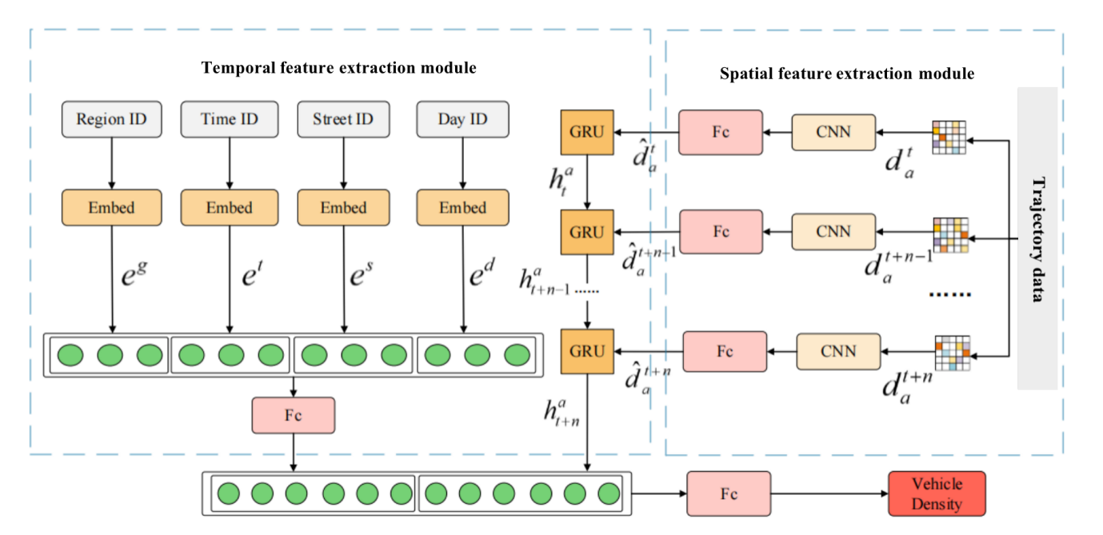
Figure 4-1 Framework of vehicle density prediction algorithm based on traffic cycle law

Spatial feature extraction of trajectory data
In this paper, we find that the vehicle density in a single region has a high probability of being similar to the vehicle density in the nearby region through the analysis of the trajectory data, which is consistent with the first law of geography [53] that "things in close proximity are more closely related" and can be regarded as the spatial characteristics of the vehicle density. Therefore, the vehicle densities of nearby areas can be used as a complement to the vehicle density of the current area, thus forming a two-dimensional matrix to represent the characteristics of the vehicle density of the current area, and the feature vector of the current area is obtained by feature extraction of this matrix. If the whole city map is regarded as a black and white image, and the density of vehicles in each area is regarded as the gray value of the image, then the spatial feature extraction of trajectory data can be analogized to the extraction of image features by two-dimensional neural networks, which is the basic idea of spatial feature extraction in this paper.
In this paper, the spatial feature extraction of trajectory data can be performed in three steps. The first step is to pre-process the city map to avoid errors. The second step is to deconstruct the city map into multiple components, each component represents a specific city map feature and reduces the dimensionality of the data. The last step is mainly responsible for collecting information related to the city map and classifying the city map into available output labels,where the fully connected layer helps the model to classify the city map, the activation function is responsible for nonlinearizing the output of the convolutional layer, the pooling layer reduces the spatial dimensionality by downsampling, and the convolutional layer is responsible for collecting specific targets in the feature space of the city map.

Temporal feature extraction of trajectory data
In this section, firstly, the real life trajectory of vehicles in the city is analyzed based on GPS data to determine the historical vehicle trajectory data with a strong temporal sequence. Figure 4-2 shows the statistical results of the number of GPS points in a week in the commercial area next to the railway station in Xi'an. From the figure, it can be seen that the pattern of vehicle density changes with time is basically consistent with the work and rest of the city residents, and the change pattern is mainly divided into two aspects: different days in a week and different time periods in a day. These two points should be considered when using GRU to complete the time-dependent feature extraction of the trajectory data.
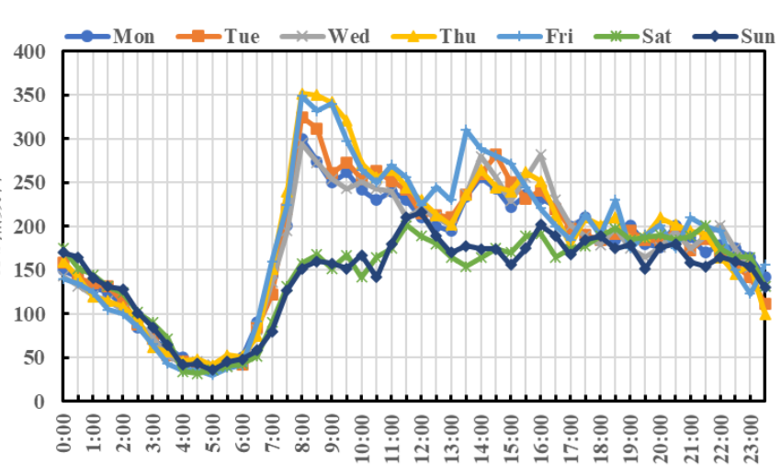
Figure 4-1 Trend of the number of GPS points over time
GRU autonomously extracts features from a prepared vehicle trajectory dataset and generalizes and captures them to determine a deeper and more abstract feature matrix to mine the time-dependent features of the trajectory data.The efficiency of GRU depends on the weights of the update and reset gates, and the optimization of the hyperparameters [23]. In addition, GRU can capture and generalize deeper features in the trajectory data by embedding sparse vectors in low dimensions. From the above analysis, the basic pattern of vehicle density in urban areas over time can be transformed into a sparse vector, and GRU can extract the time-dependent features of the trajectory data at a deeper level by embedding and encapsulating this feature vector.
Based on the above analysis, the proposed vehicle density prediction algorithm transforms additional information representing urban traffic cycle patterns into embedding vectors, which helps GRU to extract trajectory data features more fully. The additional information includes Day ID, Time ID, Region ID and Street ID, which represent the different days of the week and the time period of the current time respectively, and help the prediction model to extract the time-related features of the trajectory data, while the Region ID and Street ID represent the vehicle distribution patterns of the city over time. ID and Street ID represent the area where the vehicle density data is located and the number of the street where it is located, respectively, and these two additional information are complementary to the geographically relevant information.

Results
In this paper, experiments are conducted using the vehicle trajectory dataset from the Xi'an Second Ring Road area for November 2016 from the Drip Express platform, which is derived from the Drip Gaia dataset. 70% of the experimental dataset is used as training data and 30% as test data, and the performance of the vehicle density prediction algorithm will be measured using MAPE and RMSE. Before comparing this vehicle density prediction algorithm with other algorithms, two important values need to be determined: the time step of GRU and the number of adjacent regions selected for extracting spatial features. This section first discusses the impact of these two important parameters on the proposed prediction algorithm before comparing this vehicle density prediction algorithm with other algorithms. The predicted results of vehicle density are shown in Table 5-1.
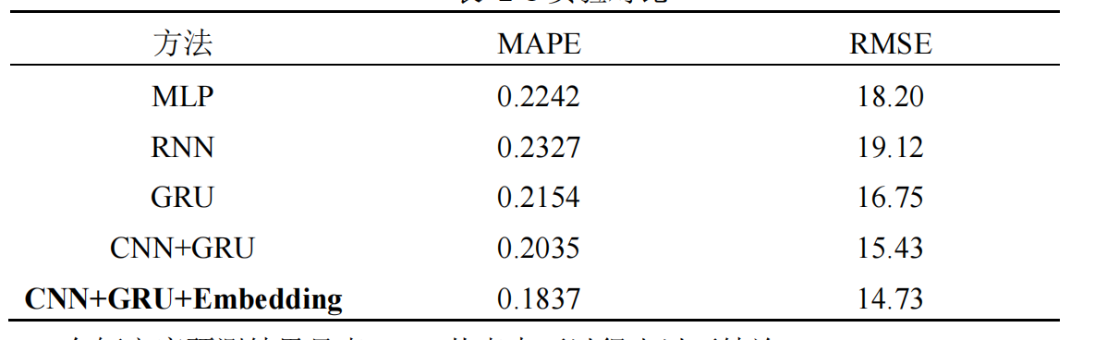

Table 5-1 Experimental comparison

Evaluation
(1) The MLP neural network is used to predict vehicle density in the experiment, and comparing its prediction results with the GRU alone, we can find that the GRU outperforms the MLP for data with time-series characteristics because the GRU can preserve and utilize time-series information.
(2) RNN alone cannot handle the long-term dependence problem, so it has the lowest prediction accuracy in processing trajectory data. The experimental results of GRU alone are significantly better than RNN, which indicates that mining the traffic cycle pattern of vehicle density data can be effectively applied to vehicle density prediction.
(3) Compared with GRU alone, the combination of CNN and GRU to mine the spatial and temporal features of data can train better models and achieve better experimental results. This indicates that mining the spatial features of the data is effective for improving the prediction accuracy of vehicle density.
(4) The best experimental results are obtained by combining CNN, GRU and Embedding, where the Embedding layer represents the embedding vector transformed into urban traffic patterns. The experimental results show that the vehicle density prediction algorithm proposed in this paper has better prediction results than other existing methods and has good effect on the improvement of prediction accuracy.

Conclusion
This chapter uses CNN and GRU to build the vehicle density prediction algorithm, where CNN and GRU are used to extract spatial features and temporal features, respectively. The algorithm analyzes the correlation of vehicle density between adjacent regions based on the first law of geography, combines it with the law of vehicle distribution in the city, fully exploits and utilizes the spatial correlation of vehicle density data, and then adds the temporal cycle law of vehicle density data into the algorithm in the form of embedding vectors to enhance the extraction of temporal and spatial features of trajectory data.
The temporal step of GRU is 6 and the number of adjacent regions selected for extracting spatial features is 2. Then the proposed method is compared and analyzed with other existing methods, and the experimental results show that the best experimental results are obtained after combining CNN, GRU and Embedding, which indicates that the vehicle density prediction algorithm proposed in this paper has better prediction results than other models and has a good effect on This shows that the proposed algorithm has better prediction results than other models and has good effect on the improvement of prediction accuracy.

References
- Xiao, Yuelei, and Yang Yin. 2019. “Hybrid LSTM Neural Network for Short-Term Traffic Flow Prediction.” Information 10 (3): 105. doi:10.3390/info10030105.
- Lv, Y., Duan, Y., Kang, W., Li, Z., & Wang, F.-Y. (2014). Traffic Flow Prediction With Big Data: A Deep Learning Approach. IEEE Transactions on Intelligent Transportation Systems, 1–9.
- Li, N., Martinez-Ortega, J.-F., Diaz, V. H., & Fernandez, J. A. S. (2018). Probability Prediction-Based Reliable and Efficient Opportunistic Routing Algorithm for VANETs. IEEE/ACM Transactions on Networking, 26(4), 1933–1947.
- Zhao, L., Liu, Y., Al-Dubai, A. Y., Zomaya, A. Y., Min, G., & Hawbani, A. (2020). A Novel Generation-Adversarial-Network-Based Vehicle Trajectory Prediction Method for Intelligent Vehicular Networks. IEEE Internet of Things Journal, 8(3), 2066–2077.
- Deo, Nachiket, and MohanM. Trivedi. “Convolutional Social Pooling for Vehicle Trajectory Prediction.” arXiv: Computer Vision and Pattern Recognition, May 2018.
- Singh, Divya, and Rajeev Srivastava. "Graph Neural Network with RNNs based trajectory prediction of dynamic agents for autonomous vehicle." Applied Intelligence 52.11 (2022): 12801-12816.
- Xie G, Gao H, Qian L, et al. Vehicle trajectory prediction by integrating physics-and maneuver-based approaches using interactive multiple models[J]. IEEE Transactions on Industrial Electronics, 2017, 65(7): 5999-6008.
- Mo, Xiaoyu, et al. "Multi-agent trajectory prediction with heterogeneous edge-enhanced graph attention network." IEEE Transactions on Intelligent Transportation Systems 23.7 (2022): 9554-9567.
- Kim, B., Kang, C. M., Kim, J., Lee, S. H., Chung, C. C., & Choi, J. W. (2017, October). Probabilistic vehicle trajectory prediction over occupancy grid map via recurrent neural network. In 2017 IEEE 20th International Conference on Intelligent Transportation Systems (ITSC) (pp. 399-404). IEEE.
- Jazayeri, M. S., & Jahangiri, A. (2022). Utilizing B-Spline Curves and Neural Networks for Vehicle Trajectory Prediction in an Inverse Reinforcement Learning Framework. Journal of Sensor and Actuator Networks, 11(1), 14.
- Wang, X., Ma, Y., Wang, Y., Jin, W., Wang, X., Tang, J., … Yu, J. (2020). Traffic Flow Prediction via Spatial Temporal Graph Neural Network. Proceedings of The Web Conference 2020. Presented at the WWW ’20: The Web Conference 2020, Taipei Taiwan.
- Chen, Cen, et al. “Citywide Traffic Flow Prediction Based on Multiple Gated Spatio-Temporal Convolutional Neural Networks.” ACM Transactions on Knowledge Discovery From Data, May 2020.
- Zheng, Haifeng, et al. “A Hybrid Deep Learning Model With Attention-Based Conv-LSTM Networks for Short-Term Traffic Flow Prediction.” IEEE Transactions on Intelligent Transportation Systems, vol. 22, no. 11, June 2020, pp. 6910–20.
- Krizhevsky, A., Sutskever, I., & Hinton, GeoffreyE. (2012). ImageNet Classification with Deep Convolutional Neural Networks.
- Howard, A., Zhu, M., Chen, B., Kalenichenko, D., Wang, W., Weyand, T., … Adam, H. (2017). MobileNets: Efficient Convolutional Neural Networks for Mobile Vision Applications.
- Gatys, Leon A., Alexander S. Ecker, and Matthias Bethge. 2016. “Image Style Transfer Using Convolutional Neural Networks.” In 2016 IEEE Conference on Computer Vision and Pattern Recognition (CVPR). doi:10.1109/cvpr.2016.265.
- Lai, S., Xu, L., Liu, K., & Zhao, J. (2022). Recurrent Convolutional Neural Networks for Text Classification. Proceedings of the AAAI Conference on Artificial Intelligence.
- Zagoruyko, S., & Komodakis, N. (2016). Paying more attention to attention: improving the performance of convolutional neural networks via attention transfer.
- He, Y., Kang, G., Dong, X., Fu, Y., & Yang, Y. (2018). Soft Filter Pruning for Accelerating Deep Convolutional Neural Networks. Proceedings of the Twenty-Seventh International Joint Conference on Artificial Intelligence. Presented at the Twenty-Seventh International Joint Conference on Artificial Intelligence {IJCAI-18}, Stockholm, Sweden.
- Hochreiter, S., & Schmidhuber, J. (2006). Long short-term memory. Neural Computation, 1735–1780.
- Yan, R., Liao, J., Yang, J., Sun, W., Nong, M., & Li, F. (2020). Multi-hour and multi-site air quality index forecasting in Beijing using CNN, LSTM, CNN-LSTM, and spatiotemporal clustering. Expert Systems with Applications, 169, 114513.
- Alahi, A., Goel, K., Ramanathan, V., Robicquet, A., Fei-Fei, L., & Savarese, S. (2016). Social LSTM: Human Trajectory Prediction in Crowded Spaces. 2016 IEEE Conference on Computer Vision and Pattern Recognition (CVPR). Presented at the 2016 IEEE Conference on Computer Vision and Pattern Recognition (CVPR), Las Vegas, NV, USA.
- Kong, W., Dong, Z. Y., Jia, Y., Hill, D. J., Xu, Y., & Zhang, Y. (2017). Short-Term Residential Load Forecasting Based on LSTM Recurrent Neural Network. IEEE Transactions on Smart Grid, 841–851.
- Shi, X., Chen, Z., Wang, H., Yeung, D.-Y., Wong, W., & Woo, W. (2015). Convolutional LSTM Network: A Machine Learning Approach for Precipitation Nowcasting.
- Cho, K., van Merrienboer, B., Gulcehre, C., Bahdanau, D., Bougares, F., Schwenk, H., & Bengio, Y. (2015). Learning Phrase Representations using RNN Encoder–Decoder for Statistical Machine Translation. Proceedings of the 2014 Conference on Empirical Methods in Natural Language Processing (EMNLP). Presented at the Proceedings of the 2014 Conference on Empirical Methods in Natural Language Processing (EMNLP), Doha, Qatar.
- Chung, J., Gulcehre, C., Cho, K., & Bengio, Y. (2014). Empirical evaluation of gated recurrentChe, Z., Purushotham, S., Cho, K., Sontag, D., & Liu, Y. (2018). Recurrent Neural Networks for Multivariate Time Series with Missing Values. Scientific Reports. https://doi.org/10.1038/s41598-018-24271-9 neural networks on sequence modeling.
- Tang, D., Qin, B., & Liu, T. (2015). Document Modeling with Gated Recurrent Neural Network for Sentiment Classification. Proceedings of the 2015 Conference on Empirical Methods in Natural Language Processing. Presented at the Proceedings of the 2015 Conference on Empirical Methods in Natural Language Processing, Lisbon, Portugal.
- Spurr, A. R. (2004). A low-viscosity epoxy resin embedding medium for electron microscopy. Journal of Ultrastructure Research, 26(1–2), 31–43.
- Luft, J. H. (2004). Improvements in epoxy resin embedding methods. The Journal of Biophysical and Biochemical Cytology, 9(2), 409–414.
- Schroff, F., Kalenichenko, D., & Philbin, J. (2015). FaceNet: A unified embedding for face recognition and clustering. 2015 IEEE Conference on Computer Vision and Pattern Recognition (CVPR). Presented at the 2015 IEEE Conference on Computer Vision and Pattern Recognition (CVPR), Boston, MA, USA.
- Daw, M. S., & Baskes, M. I. (2002). Embedded-atom method: Derivation and application to impurities, surfaces, and other defects in metals. Physical Review B, 29(12), 6443–6453.
- Richardson, K. C., Jarett, L., & Finke, E. H. (2007). Embedding in epoxy resins for ultrathin sectioning in electron microscopy. Stain Technology, 35(6), 313–323.
- Hekkert, M. P., Suurs, R. A. A., Negro, S. O., Kuhlmann, S., & Smits, R. E. H. M. (2006). Functions of innovation systems: A new approach for analysing technological change. Technological Forecasting and Social Change, 74(4), 413–432.

