SustainablePackaging Implementation Project (Marks & Spencer)

LCBB6006_LON PROJECT MAMAGEMENT

@2337237BOGDAN-FLORIN VASILE

Table of Contents

INTRODUCTION 3
PROJECT BACKGROUND 3
AIM, OBJECTIVES & SCOPE 4
PROJECT DELIVERABLES 4
WORK BREAKDOWN STRUCTURE (WBS) 5
ACTIVITIES & SUB-ACTIVITIES 6
MILESTONES & TIMELINE 6
RESOURCES 8
RISK ASSESSMENT 8
METHODOLOGY 9
CONCLUSION 10
REFERENCES 11

List of Figures
Figure 1: Work Breakdown Structure 7
Figure 2: Schedule Table 8
Figure 3: Gantt Chart 8
Figure 4: Critical Path 8

List of Tables
Table 1: Risk Assessment 9

INTRODUCTION
According to Ngo and Hwang (2022), project management is the systematic application of knowledge, skills, resources and techniques to the activities of a project to meet defined objectives within a defined time, cost and quality. It provides a systematic framework to the initiation, planning, execution, monitoring and closing of a project successfully. This exercise will enable you to develop a detailed project plan within a real-life scenario and demonstrate the application of project management principles within a real world business scenario.
The project chosen is to overcome sustainable packaging solutions in a large retailer (Marks & Spencer) in UK, where there are increasing environmental and regulatory pressures. The retail sector is a major sector that is also making significant strides towards sustainability, as consumers are increasingly pushing for more sustainable products and practices, environmental issues are on the agenda, and regulations are becoming stricter. Sustainability is making its way onto the retail industry's agenda as consumers, environment and plastic reduction and waste management regulations are all demanding it.
Sustainable packaging is key to minimizing the environmental footprint and ensuring that operations continue to be efficient and cost effective. This essay will describe and explain the project aim, objectives, scope, deliverables, work breakdown structure, milestones, resources, risks and methodology, which would be used for the successful delivery of the project.

PROJECT BACKGROUND
Marks & Spencer is a well-known and reputable UK-based multinational food, clothing and home products retailer. The organisation's Plan A sustainability strategy involves it reducing its environmental footprint in three ways: in its operations, supply chain and packaging. But, the organisation still grapples with various issues of excess plastic packaging, mainly in its food and retail packaging systems that increase environmental waste and inefficiency. External factors also drive a need for change such as government regulations regarding the reduction of plastic, growing environmental awareness and greater customer awareness and expectations for sustainable practices (Odeyemi et al., 2023). Current packaging solutions are perceived as inefficient as a consequence of excessive materials, poor recyclability and low level of sustainability between suppliers. It is therefore necessary to carry out this project during this period to create operational efficiency, reduce environmental impact and to follow up with strategic sustainability objectives. The use of a structured project management approach will provide a more effective plan, monitor and control of packaging transformation, minimise risk of packaging transformation cost escalation, supplier resistance and implementation timeliness and ensure long term packaging transformation and organisational sustainability performance and compliance with evolving environmental standards in the UK retail sector. This enhances the overall project success and stakeholder confidence in project delivery and implementation outcomes in general.

AIM, OBJECTIVES & SCOPE
This project will design and create a sustainable packaging system, delivering certain Marks & Spencer product packs to minimize environmental impact and improve the sustainability in the supply chain. It is in line with the sustainability commitments of the organisation and the ever growing consumer expectations on sustainable and eco friendly retail practices.
The project activities revolve around reducing the use of plastic (30% cut) with the aim of finding more sustainable packaging materials, engaging suppliers, continuously reducing packaging costs and testing sustainable packaging solutions for a number of stores before implementing this on a broader scale.
Project scope has been clearly defined, is achievable and controllable. It comprises various categories of products (e.g. food or clothes packaging), working with some of the best suppliers, redesign processes and pilot testing in controlled environment. It does not cover the full(er) rollout of the organisation / global rollout, factory/ manufacturing facility redesign or engagement with non-Marks & Spencer supply chains. Having a definite boundary is essential to the project to keep it focused, manageable and achievable within a limited time and resource boundary, and to deliver measurable sustainability and operational improvements.

PROJECT DELIVERABLES
The key deliverables of this project are set out to make sure that all of the outputs are measurable, aligned to objectives and will lead to the successful implementation of sustainable packaging at Marks & Spencer.
The first deliverable will be sustainable packaging prototypes that will be used to prove the viability of the use of recyclable and biodegradable materials in specific product lines. Secondly, a supplier sustainability compliance framework will be generated to ensure compliance of all the relevant suppliers with the required environmental and ethical standards. A pilot implementation report will also be produced that will include performance, challenges and outcomes of the deployment of trial stores.
Furthermore, a thorough cost-benefit analysis will be conducted to assess the cost-effectiveness and long-term savings of adopting sustainable packaging solutions. The report of communication, feedback and collaboration with internal and external stakeholders will be created to capture this communication throughout the project life cycle (Possoli, 2025). Moreover, a final implementation approach will be developed and will be applied to a potential scaling to broader operations. Lastly, a project closure report will recap performance as a whole, lessons learned, and recommendations for future improvement.

WORK BREAKDOWN STRUCTURE (WBS)
The Work Breakdown Structure (WBS) is a hierarchical breakdown of the project on sustainable packaging into more manageable phases, activities and tasks. It offers the structures for organizing a project so that it is better planned, responsibility is clearly assigned, and the project's progress is monitored at all stages. Level 1 is the overall project, Level 2 defines the key project phases and Level 3 further details the project tasks and activities. This means that better control, schedules and project objectives are achieved. It also helps in identifying deliverables, dependencies and requirements for resources throughout the project lifecycle (Hassanain, Zourob and Ibrahim, 2023). The WBS is used in this project to help define Marks and Spencer's sustainable packaging project, covering the initiation, research and analysis, design and development, supplier engagement, testing and pilot, implementation and closure, where each of the activities is clearly defined, measurable and contribute to the sustainability and operational efficiency goals. This improves governance and accountability and successful achievement of project outcomes within scope.
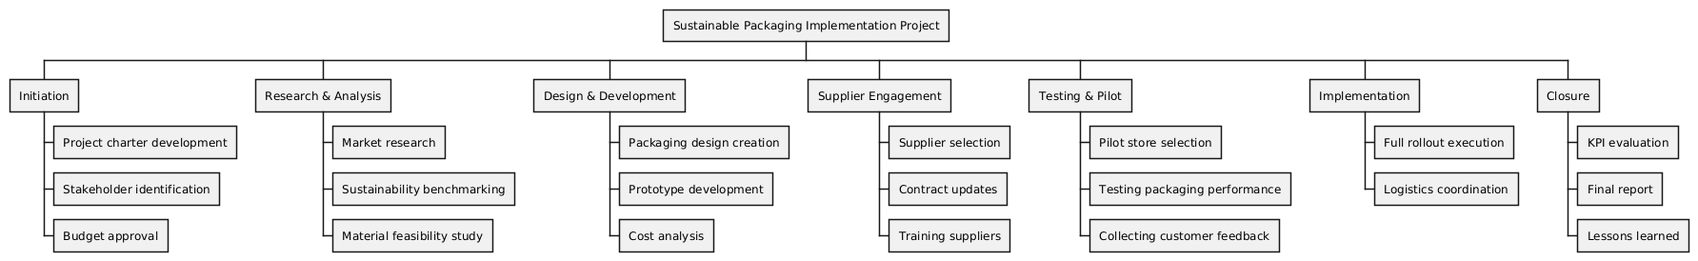
Figure 1: Work Breakdown Structure

ACTIVITIES & SUB-ACTIVITIES
The project activities are organized in line with the systematic and controlled execution of the implementation of sustainable packaging at Marks & Spencer. Specific sub-activities are further broken down for each activity to improve clarity, accountability and efficiency of project life-cycle.
Packaging Design Development activity refers to the research process of finding environmentally friendly materials suitable for packaging for retail products, development of initial design prototypes, assessment of the package durability and functionality as well as cost, and finally seeking stakeholder approval to ensure that the package is designed in a way that meets both sustainability and business objectives (Anokye, 2025).
The Supplier Integration activity is on finding suppliers that can supply quality materials that can be used sustainably, negotiating new contracts that incorporate environmental requirements and messaging that training is needed for the suppliers to meet new packaging requirements and sustainability expectations.
The Pilot Testing activity comprises the selection of suitable store test sites, tracking the performance of the packaging during its field trial, gathering customer and operational data and making design changes upon testing results (Fettes, 2025). This will be done in a progressive manner—making sure that the packaging solution is viable, environmentally friendly and commercially viable before implementing it.

MILESTONES & TIMELINE
The project milestones have been established to enable the sustainable packaging project to be effectively monitored, controlled and implemented in Marks & Spenser. Milestones are used to mark meaningful moments in the project's timeline that can be utilized to monitor project performance and identify risks and make decisions during the project lifecycle.

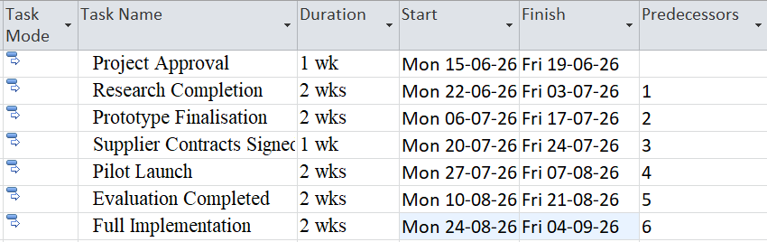
Figure 2: Schedule Table
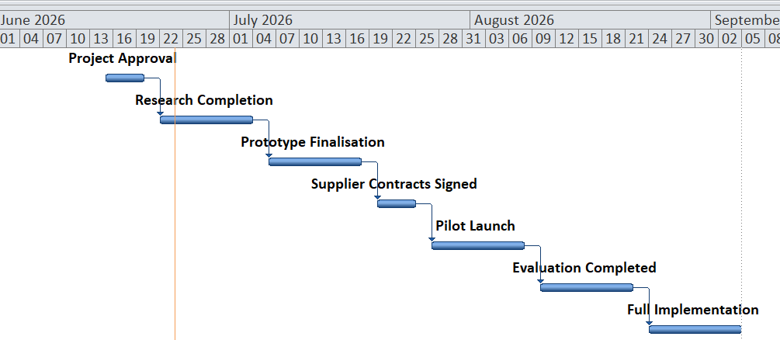
Figure 3: Gantt Chart
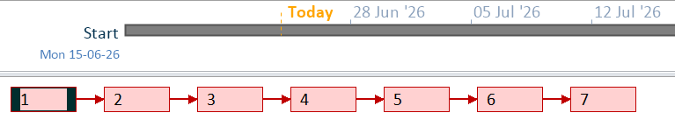
Figure 4: Critical Path
Successful timeline control is achieved by managing every stage of the timeline within specific boundaries of time, money, and quality; preventing delays and wasting resources (Jupally et al., 2024). Tracking milestones is crucial in maintaining project governance, forensics and understanding potential project risks and project alignment to sustainability goals and stakeholder expectations. Milestones can be monitored continuously to improve accountability and boost the likelihood of the project being delivered on time and on budget.

RESOURCES
To implement sustainable packaging successfully, and meet the requirements of the project at Marks & Spencer, it is essential that the human, material and financial resources are carefully allocated to ensure efficiency, quality and risk management throughout the project.
Human resources consist of a Project Manager for overall coordination and governance, a Sustainability Analyst for assessing environmental impact, a Procurement Team for supplier engagement and sourcing, Designers for packaging prototype development and Supply Chain Specialists to ensure operational alignment and logistics efficiency.
Material resources involve materials that can be reused and recycled, biodegradable materials, design software for packaging prototype and modelling and testing laboratories to test the durability, safety, and performance of packaging materials (Chinnappan et al., 2025).
Financial resources encompass the Research and Development budget for the activities aimed at innovations, the costs of changing suppliers for sustainable materials, and the funding for the pilot rollout of sustainable material to facilitate the implementation of trials in selected stores.
Good allocation is a key factor – a bad allocation can introduce risk on the project, reduce efficiency, have an effect on cost control and timelines.

RISK ASSESSMENT
The risk management process plays a crucial role in providing stability, continuity and successful delivery of the sustainable packaging implementation project at Marks & Spencer. Being able to identify potential risks early allows proactive steps to be taken to mitigate the risks, and the risk of project disruption is decreased.
Table 1: Risk Assessment
Risk | Impact | Likelihood | Mitigation Strategy
Supplier resistance to change | High | Medium | Early stakeholder engagement and clear communication of sustainability benefits
Increase in packaging costs | Medium | Medium | Bulk sourcing agreements and cost-benefit optimisation analysis
Material performance failure | High | Low | Rigorous testing during prototype and pilot phases
Delay in project rollout | High | Medium | Agile monitoring approach with continuous progress tracking and corrective actions

Good risk management will make sure that the risk factors are managed and the project goals are attainable within the constraints. However, it is important to continuously monitor the project through its lifecycle to detect any "new" risks and take timely corrective action (Bhatia, 2025). This will help create project resilience, better decisions and operation/sustainability.

METHODOLOGY
The project for implementing sustainable packaging in Marks & Spencer is a hybrid of the project management models – a mix of Waterfall and Agile, given the need to have a structure governance, as well those of Agile – a flexible and iterative one. This blend is particularly suited in projects that have sustainability objectives with an adaptive need and a need to plan.
The Waterfall approach is implemented at the early and structured stage of the project, in planning and approval of the project, and in procurement (Gamido and Mariano, 2025). Each of these stages has specific requirements, formal authorisation and a distinct sequence of action that needs to be followed to ensure the proper controls of the financial process, compliance with the regulatory process and supplier alignment. The linear structure of waterfall and well documented records allow for the advantages of accountability and risk reduction which is beneficial in these areas.
Agile methodology, however, is used when designing and developing the product, such as the packaging design iterations, prototype testing and feedback. This enables ongoing optimization and further development based on the feedback of stakeholders and customers, ensuring that packaging solutions are constantly optimized and developed in line with their real-life performance and sustainability needs.
Most important, Waterfall ensures stability but may not be flexible in the event of changes, whereas Agile is flexible and may lead to uncertainty in timelines and scope control (Ampatzidis and Symeonidis, 2024). Hence, a hybrid approach is most suitable balancing governance and innovation. This will keep the project controlled and responsive and enhance the likelihood of successful and sustainable project delivery.

CONCLUSION
Marks & Spenser's implementation of sustainable packaging is a strategic project that is designed to have a positive impact on the environment and increase efficiency in the retail packaging system. The project directly enhances the organisation's sustainability objectives to reduce plastic use, increase the recyclability of plastic, and ensure better environmental compliance for suppliers.
The key value of this project is the opportunity to provide a number of business benefits such as cost reduction over the long term due to efficient use of materials, better environmental outcomes due to less waste being generated and better compliance with changing UK environmental legislation. It's also an excellent approach for developing your brand image and identity as it resonates to the increasing demand of your customers for eco-friendly retail practices.
The use of WBS, risk assessment system, and milestone tracking system in the project management ensures that the project is controlled, measurable and it is consistent with the project objectives. These tools promote better planning accuracy, accountability and minimize implementation risks.
Overall, the project has good potential to be delivered well, if a structured governance framework and monitoring is maintained throughout life.

REFERENCES
Ampatzidis, D. and Symeonidis, I. (2024). Hybrid Project Management: Combining Waterfall and Agile What Do Organizations Do in Practice? [online] DIVA. Available at: https://www.diva-portal.org/smash/record.jsf?pid=diva2:1955671.
Anokye, K. (2025). Reviewing the Efficacy of Eco-design Strategies for Sustainable Packaging in Ghana: Challenges, Opportunities, and the Way Forward. Materials Circular Economy, 7(1). doi:https://doi.org/10.1007/s42824-025-00185-6.
Bhatia, U. (2025). Risk Monitoring and Response Strategies in Construction Projects. Handbook of Construction Project Management, pp.727–748. doi:https://doi.org/10.1007/978-981-96-7631-6_23.
Chinnappan, B., Kumar, G.B.S., Ramesh, S., Devaraj, A.R. and Sureshkumar, M. (2025). Biodegradable and Eco-Friendly Materials for Sustainable Construction and Biomedical Packaging Applications Developed Using AI-Driven Life Cycle Assessments. Advanced Materials for Biomedical Devices, pp.236–249. doi:https://doi.org/10.1201/9781003651772-22.
Fettes, K. (2025). Testing products where they matter most : Investigating the method of home testing in the product development process. [online] DIVA. Available at: https://www.diva-portal.org/smash/record.jsf?pid=diva2:1981870.
Gamido, M.V. and Mariano, V.Y. (2025). Hybrid Agile-Waterfall Methodology for Philippine Public Sector Procurement Planning System. Proceedings of the 9th International Conference on Algorithms, Computing and Systems, pp.164–174. doi:https://doi.org/10.1145/3789418.3789438.
Hassanain, M.A., Zourob, M.A. and Ibrahim, A.M. (2023). Analysis of FM involvement during project Lifecycle phases. Journal of Facilities Management. doi:https://doi.org/10.1108/jfm-12-2022-0127.
Jupally, S.P., Yalamati, S., Jupally, A. and Pub, I. (2024). DRIVING EFFICIENCY AND SUCCESS: THE ROLE OF RELEASE MANAGEMENT IN PROJECT TIMELINES, COST BUDGETING, AND RISK ASSESSMENT. INTERNATIONAL JOURNAL OF COMPUTER ENGINEERING & TECHNOLOGY, [online] 15(4), pp.1–11. doi:https://doi.org/10.17605/OSF.IO/QK37A.
Ngo, J. and Hwang, B.-G. (2022). Critical Project Management Knowledge and Skills for Managing Projects with Smart Technologies. Journal of Management in Engineering, 38(6).
Odeyemi, O., Favour, Mhlongo, N.Z., Elufioye, O.A. and Ike (2023). Sustainable entrepreneurship: A review of green business practices and environmental impact. World Journal Of Advanced Research and Reviews, 21(2), pp.346–358. doi:https://doi.org/10.30574/wjarr.2024.21.2.0461.
Possoli, K. (2025). Improving stakeholder communication in project management. Utfpr.edu.br. [online] doi:http://repositorio.utfpr.edu.br/jspui/handle/1/38716.

