Skills for the Workplace
Module Assignment Submission

Student Name: | James Lewis
Student Number: | 2019456
Module No: | BMSK4008
Module Title: | Academic and Research Skills

Statement of Confirmation of Authenticity
By the act of making this submission, the student declares that this is the work of the student named above. The work has not, in whole or in part, been knowingly presented elsewhere for assessment, or where assessment has been built on a previous assessment, this has been identified. Where materials have been used from other sources it has been properly acknowledged. If this statement is untrue, the student acknowledges that an assessment offence has been committed.
Attention is drawn to the plagiarism and unfair practice policies of both the University and of ILM.
Permission for ILM to use this script
ILM uses learners’ submissions – on an anonymous basis – for assessment standardisation. By submitting, both the centre and the learner agree that ILM may use this script on condition that identifying information is removed. However, if you are unwilling to allow ILM use this script, please refuse by ticking the box: □

Table of Contents
Managing Remotely: Is it the Way Forward?
Part 1
1.1 Introduction
1.2 Findings
1.3 Conclusion
Part 2
Personal Reflection on Managing Remotely
2.1 Description
2.2 Feelings
2.3 Evaluation
2.4 Analysis
2.5 Conclusion
References
Bibliography

Managing Remotely: Is it the Way Forward?

Part 1

1.1 Introduction

The following report will look in detail at remote working and if this approach to working in the future. The report will consist of findings and statistics of how Businesses, Managers and Employees manage remotely. The report writer will look in detail at what positive and negative effects working remotely has on their businesses, how managers manage their employees and how employees actually manage themselves while working remotely. The report writer will conduct academic arguments based on the finding so that the report writer can come to a conclusion that answers the question is remote working the way forward.

1.2 Findings

Businesses

The report writer will look at the positive and negative effects remote working has had on businesses and if it is something that more businesses will implement in the future.
Remote working has been long established for businesses that can offer this to their employees, Over the past 10 years, the number of people working primarily from home has grown 115%, and remote work has grown faster than any other commute method. In fact, according to a recent report from Global Workplace Analytics, remote work has grown by 173% since 2005 (Lucidchart, 2020). Most businesses have had to adapt their office based teams to become fully remote to keep in line with government guidelines. Businesses that have taken a fully remote approach to running their business have benefited from not paying the cost associated with renting or owning an office, according to the PGi 2019 report “ organizations save on average $10,000 per year for real estate savings per one full-time employee. The company saves money on the office upkeep, electricity, and everything you need to keep an office running smoothly.” (Miro, 2020)
The report writer also found that businesses who utilise remote workers also benefit from their employees increased productivity, a study documented in a 2020 survey by airtaskers found that “while remote employees spent more time taking breaks throughout the workday, they also devoted more time on work tasks. Additionally, among employees who had their mouse movement and/or screen time tracked by their employers, only 39% of remote workers sought out work distractions, compared to 56% of in-office worker” (Airtasker, 2020)
A similar study also found that the stigma of their employees actually underperforming was not the case and there was an increase in productivity the study found that “employees at a Chinese call center who were given the opportunity to work from home saw a 13 percent increase in performance; 9 percent worked more minutes per shift, and 4 percent handled more calls per minute.” (Hulett, 2020).
This was not the case in every country and a report by aternity found that productivity levels in europe were considerably less than in other countries around the world Aternity (2020), (see table below) 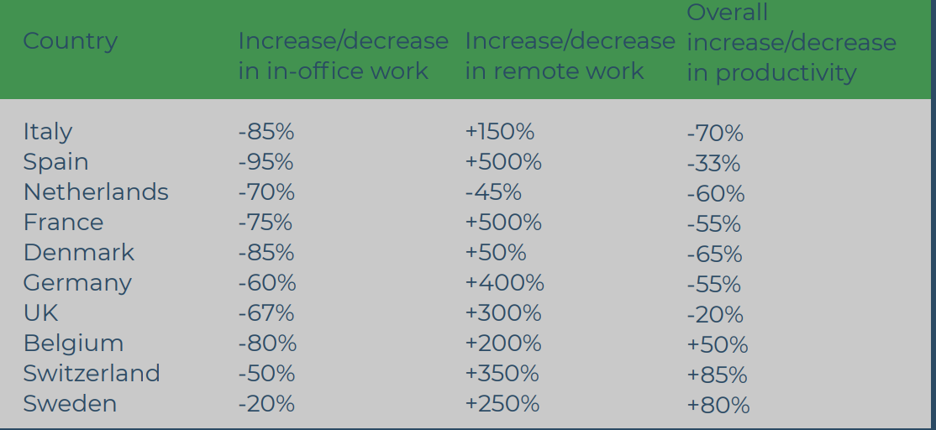
A more concerning issue for businesses managing a remote business is the fact that cyber crime is on the rise and a very worrying concern for businesses and valuable data they cannot afford to lose . The report writer found a recent study that suggests “according to CISO’s Benchmark Report 2020, organisations are struggling to manage remote workers’ use of phones and other mobile devices. It found that 52% of respondents said that mobile devices are now challenging to protect from cyber threats” (Irwin, 2021)
Business emails being one of the main targets for cyber attackers by sending phishing emails to their employees “A recent report found that there has been a 600% increase in reported phishing emails since the end of February, with many of them cashing in on the uncertainty surrounding the pandemic (Muncaster, 2020)”.

Managers
The report writer will look at how managers manage their employees remotely, the report writer will look in detail at the advantages and disadvantages they face and if this is the future of how employees should be managed.
Managers find it difficult to monitor their employees while working remotely, some businesses have implemented time tracking software which is essential to make sure you are getting the most out of their employees. This helps managers get a better overview of how tasks are completed, to make sure who is working on what, and the times they are working to see how productive they are away from the office (Nevogt, 2020). This Helps managers track their employees' productivity to make sure they are working when they should be but managers struggle to give their employees the information they need to excel in their role, so that their employees can be cooperative so they can work to the best of their abilities. They need to know exactly who they need to contact if they need support, to share their thoughts and get the feedback needed to complete their daily tasks (Regan, 2020).
In a study by Buffer, 21% of remote workers said that their biggest struggle was collaborating/communicating so that should act as a huge wakeup call when it comes to managing remote employees. (Regan, 2020).
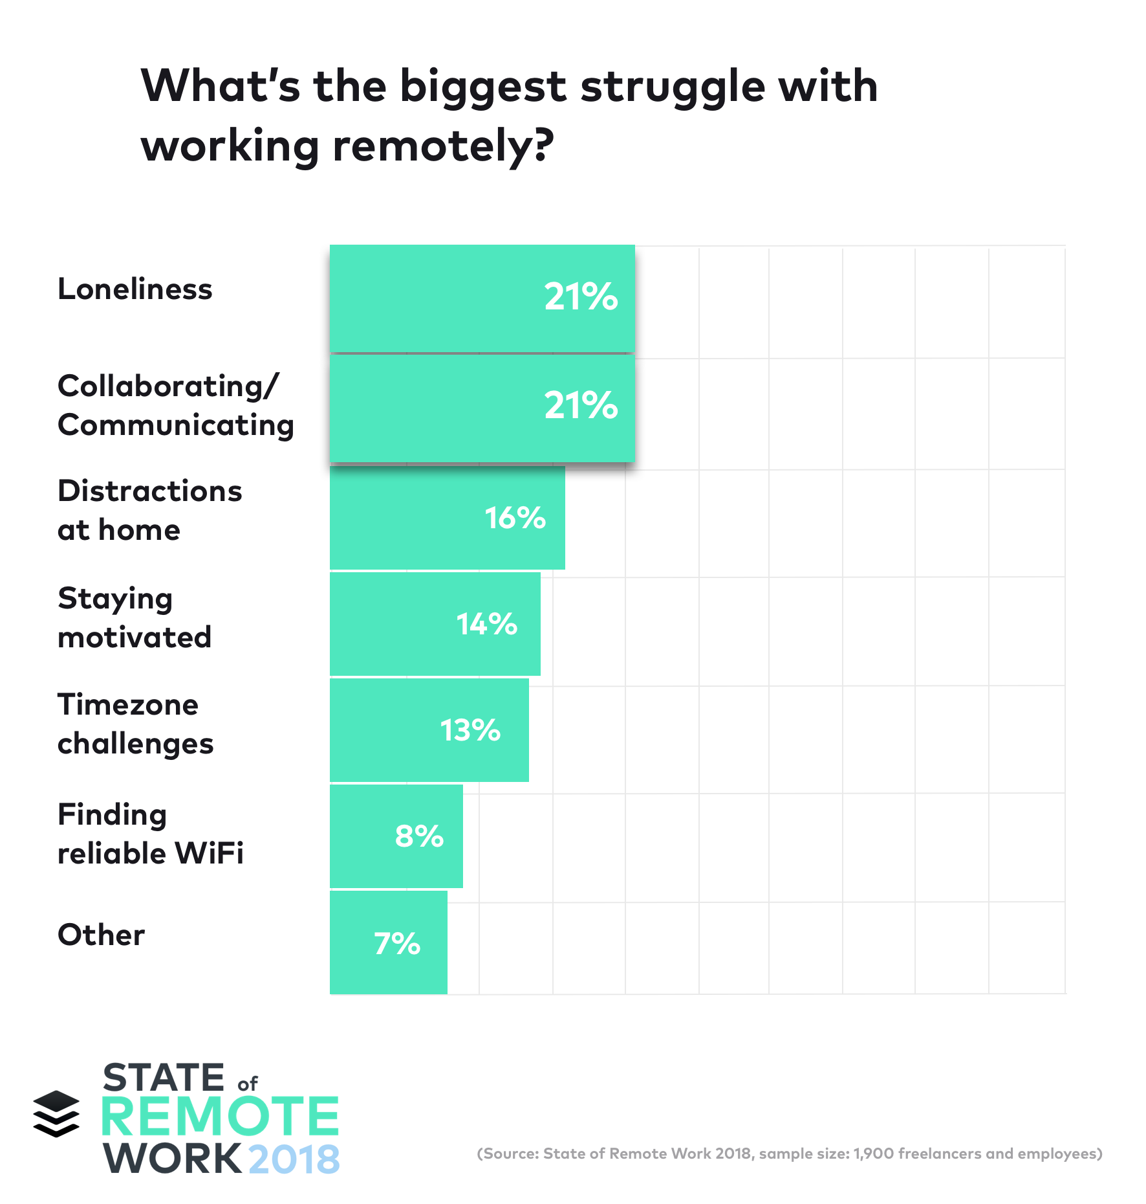
(see table above).
More concerns managers face when managing their remote teams are (see infographic below).
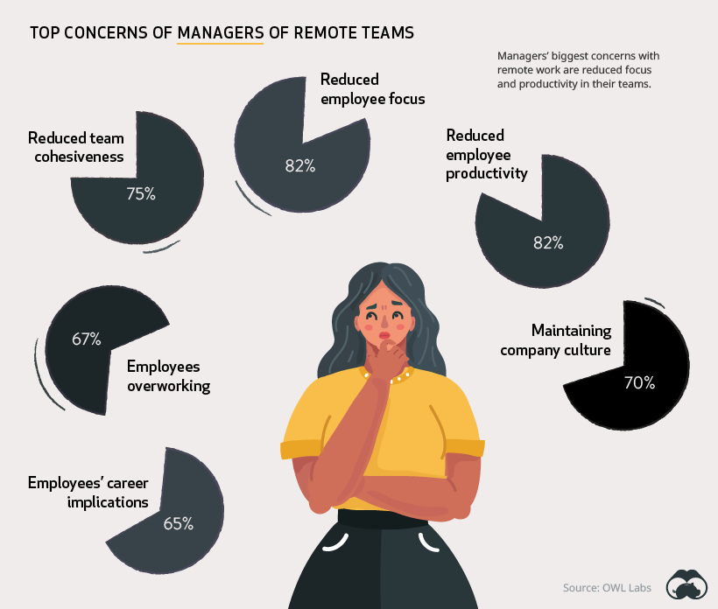
(Routley, 2020)
These statistics are alarming when a manager is the person in charge of how their employees actually deliver as if they do not work to or exceed their expectations while working remotely this could have a negative impact on the business. This could also have a negative impact on a managers mental health which would result in them not giving their employees the best possible management they need while working as a remote worker.

Employees
The report writer will look at how employees work remotely and the advantages and disadvantages they face on a day-to-day basis.
Working remotely has many benefits especially for people who have families or commitments outside of work as their work life balance is significantly increased due to cutting out the time it takes to commute to an office and employees are not fixed to a time schedule and they way they work and hours they work are flexible. A Gallup survey found that “53% of employees say a role that allows them to have greater work-life balance is very important to them”. (Wrike, 2020)
People are usually more productive when they work remotely due to not having the feeling of being micro managed and monitored, a “2-year Stanford study found that employees working from home saw a dramatic productivity boost. So great, in fact, that it amounted to an extra full day’s worth of work each week! Study participants found it was much easier to concentrate and far less distracting to work from home.” (inc, 2018).
The report writer found that tho employees were more productive there was a significant increase in employee burnout due to working remotely, According to a July 2020 survey of 1,500 respondents by FlexJobs and Mental Health America (MHA), “75 percent of people have experienced burnout at work, with 40 percent saying they’ve experienced burnout during the pandemic specifically”. (Robinson, 2020). Another growing concern for employees is that working from home has a significant impact on their mental health and well-being. In the UK, businesses lose £100m every year due to workplace stress, depression and anxiety (Price, 2018), and in a 2017 report by the United Nations It found that “41% of remote workers reported high stress levels, compared to just 25% of office workers” (United Nations, 2017).

1.4 Conclusion

After the report writer researching all aspects of remote working and if it is the way forward, the conclusion of the report is as follows;
The report shows a number of positive statistics in favour for businesses and also their employees to implement remote working as the way they run their businesses, but the fact that businesses struggle to support their employees when they need it most and this is having a detrimental effect on their employees mental health. This is an issue which needs to be addressed more thoroughly before remote working could be considered as the way forward and the future to which businesses work.
The report's finding shows that a balance of remote working and also office based working may be more beneficial as businesses would benefit from reduced overheads and also higher employee productivity and better work life balance.

Part 2

Personal Reflection on Managing Remotely

Gibbs (1988)

2.1 Description

I have extensive experience working remotely due to the industry I work in, I have always been offered part time remote working as an employee benefit but due to the pandemic I have been forced to work remotely full time.
During this time while working fully remote it was at the height of the pandemic and as a father of two children I had to work eight hours a day from home and still look after two children the majority of my working week due to my partner being a key worker.
This was particularly difficult as my daughter was a constant distraction who needed help with online learning herself and also the fact she could not comprehend the situation we were in and also was under the impression that because I was home and not in the office like I usually was I was just off work and not working.
I was not given the adequate equipment to work remotely as the company I worked for were not in favour of remote working so did not have any type of remote working strategy in place. This meant I had issues with the lack of equipment I was provided, due to the quick nature of how the pandemic struck the nation I was without a suitable place to sit for 8 hours and work like I would do if I was in my office and this really affected the way I conducted my daily work schedule. I had to work and also have meetings from different rooms in my house and the majority of my working day was working from my living room due to not having a suitable desk and chair to work from. I know that my employer at the time did not follow strict guidelines set by the government to cater for the needs of their fully remote employee.
As I was usually in a busy office environment the majority of my working week before transitioning to working remote the feeling of loneliness and also poor management were factors during this time, myself and the rest of my department had to adapt to learning new software and also learn to manage our own time without the same planning we would have during weekly meetings.
The lack of human interaction other than with my own family I felt was a factor on my mental health, our department would have daily meetings over online video conferencing applications which allowed us meet with each other at the same time, this was difficult to manage with some members of the team having inadequate internet connection and also lacked the equipment needed to best conduct an online meeting.

2.2 Feelings

My personal feeling to working remote full time are that the feeling of loneliness is a common issue, this was not something I was supported with during my time as a remote worker, this was due to the company not having the experience to manage remote workers and not having the resources or training they needed to give people the support with their mental health.
Another issue, which affected the way I worked remotely, was being micromanaged by people who had very basic knowledge of managing employees remotely. The feeling of constantly being monitored due to the lack of trust within the company, the issue of having to manage my own workload and having considerably less support with tasks.
Though there were a significant number of negatives that came with working remotely, there were some benefits which did make remote working a positive experience. The fact that I could manage my own time due while working from home was beneficial as I was nott stuck to my typical nine to five routine, I was able too work hours which suited me any my family commitments. My work life balance improved considerably as I was not commuting to work over one hour per day meant that the time I wasted getting to work I was able to spend with my family.
Not having an adequate place to work affected me physically as I would get a bad back due to bad posture from leaning over looking at my laptop and also eye strain due to staring at my screen all day not being able to sit somewhere with adequate lighting.

2.3 Evaluation

During my time working remotely i encountered a number of advantages and disadvantages which were;
Advantages
I found working remotely that my work life balance improved significantly due to the fact I was always at home with my family and also I did not have to commute to work which gave me more time after work to spend with my family during the evenings. I also saved a considerable amount of money, I would usually have to pay to travel to and from Cardiff on a daily basis. I was also able to pick my daughter up from school which meant that I did not have to pay for after school childcare. I benefited greatly from the fact that I was able to be at home all day because during the pandemic certain facilities which were available before the pandemic were actually so I did not have to find additional childcare provisions as especially when my children were not able to attend school as these were closed during this time.
Another benefit of working remotely was the fact I could manage my own time, I could work hours that suited me and as long as it was inline with the company's core working hours I could schedule my work day to suit me. This helped when working around my childrens at home learning and being able to start earlier meant that I could finish work earlier and give my children all my attention.
Disadvantages
There were a number of disadvantages while working remotely, constant distractions from my children really affected the way I worked, my children being off school due to the pandemic meant that they had to complete home based learning which they were not able to do themselves so this would take me from my work a number of times throughout the day. This resulted in me having to take more breaks and time out of my work day to make sure they were properly looked after, I felt I wasn’t able to manage my time correctly and some days I felt I would work less than I was supposed to and other times more. I was not given the adequate equipment needed to work remotely, my employer did not provide me with a suitable workstation which resulted in me having to work on my sofa or in my bed due to not having a suitable place to put or charge my laptop. This did affect my posture and did result in me having lower back pain during the day which meant I constantly moved to find a suitable place to work.
Due to the company not having a remote strategy in place as the company I was employed by was an office based company, myself and my team were introduced to new software which we were not giving the adequate training to use, this would affect the way we would communicate with each other and also record daily tasks. This then resulted in days if not weeks of trying to learn and implement these new applications ourselves as we did not have a dedicated support team to help us with any issues we would face. The most concerning disadvantage was the effect remote working had on my mental health, the fact I would spend almost all day in my house as we were not allowed to leave our houses during the time really took its toll. Not having any means of human interaction apart from the people I lived with took a lot of getting used to and it was a very lonely experience.

2.4 Analysis

During my time working fully remote I learnt to adapt quickly to the sudden change in circumstance the majority of people had to face. I felt that I gained extensive knowledge of managing my own time, working to strict deadlines while not being micro managed and also keeping productive even though there were so many distractions during my working day.
If I was in this situation again the things I would implement my own remote working strategy, I would make sure I asked for more support from my line manager and make sure they were aware I was struggling at times with my work and also my mental health, I would make sure we used similar software we as a team were used to and if we were asked to use something we were not familiar with I would ask to arrange dedicated training sessions so I did not was time trying to learn things by myself as this would cost the company money in the long run. I would arrange more one to one meetings and also more group meetings to feel like you were still working in a team and not alone, I think more regular meetings is something that I believe would have benefited me while working remotely.
I would also arrange that the correct equipment was allocated to me so I could work to the best of my ability. I wouldn't hesitate to ask for the equipment I needed as I was not as productive as I could have been due to the simple fact I was constantly repositioning where I would work during my work day.

2.5 Conclusion

The conclusion I came to about remote working being the way forward is that I believe that remote working is not the way forward, it should be offered as an option or a benefit to employees and should only be a set number of days per week.
I feel this split would work a lot better for myself as it would still give me the work life balance which is important for me and my family. Being able to go to an office where you can attend important meetings and also get support when it is needed works a lot better in person face to face with the people you need to raise your concerns to. The feeling of being part of a team and being able to communicate with people in person is something which is missed when working remotely everyday of week and makes it hard to build a bond with your co-workers which I feel is so important when you spend so much time in work.

References

Gibbs, G. (1988) Learning by doing; A guide to teaching and learning methods. London: FEU

Lucidhart (2020) Benefits and challenges of remote workers
https://www.lucidchart.com/blog/benefits-and-challenges-of-remote-workers
(Accessed at 10th March 2021)

Routley , N. (2020) How people and companies feel about working remotely
https://www.visualcapitalist.com/how-people-and-companies-feel-about-working-remotely/
(Accessed at 10th March 2021)

Inc (2018) A 2-Year Stanford Study Shows the Astonishing Productivity Boost of Working From Home, Available at: https://www.inc.com/scott-mautz/a-2-year-stanford-study-shows-astonishing-productivity-boost-of-working-from-home.html. (Accessed at 10th March 2021)

Wrike (2020) How to manage remote works & virtual teams, Available at
https://www.wrike.com/remote-work-guide/managing-remote-workers-and-virtual-teams/
(Accessed at 10th March 2021)

Miro(2020) The ultimate guide to remote work, Available at:
https://miro.com/guides/remote-work/?fbclid=IwAR0eezDf-BPdx-1Mnxfe2XKs_SHoCDWnSEsvcod20UyffAY7vTBcQOTQius). (Accessed at 9th March 2021)

Airtasker (2020) The Benefits of working from home, Available at:
https://www.airtasker.com/blog/the-benefits-of-working-from-home/
(Accessed at 9th March 2021)

Irwin, L. (2021) The cyber security risks of working from home, Available at:

https://www.itgovernance.co.uk/blog/the-cyber-security-risks-of-working-from-home (Accessed at 9th March 2021)

Hulett, J. (2020) Does productivity increase when working remotely?, Available at:
https://www.wework.com/ideas/worklife/does-productivity-increase-when-working-remotely

(Accessed at 9th March 2021)
Aternity (2020) The Global Remote Work Productivity Tracker, Available at:
https://www.aternity.com/wp-content/uploads/2020/04/Global-Remote-Work-Productivity-Tracker-Vol-1.pdf

(Accessed at 9th March 2021)
Mucunsteer, P. (2020) Covid 19 Drives Phishing Emails Up 667% In Under A Month, Available at:
https://www.infosecurity-magazine.com/news/covid19-drive-phishing-emails-667

(Accessed at 9th March 2021)

Regan, R. (2020) Top Challenges & Solutions When Managing Remote Employees. Available at:
https://connecteam.com/managing-remote-employees/
(Accessed at 9th March 2021)

Griffis, (2018) State of Remote Work 2018 Report: What It’s Like to be a Remote Worker in 2018. Available at:

https://open.buffer.com/state-remote-work-2018/

Nevgot, D. (2020), How to Implement Remote Worker Monitoring At Your Company. Available at:
https://blog.hubstaff.com/remote-worker-monitoring/
(Accessed at 9th March 2021)

Price, D. (2018), Can remote working affect your employee’s mental health?
Available at:
https://www.hrreview.co.uk/analysis/analysis-wellbeing/can-remote-working-affect-your-employees-mental-health/111800
(Accessed at 9th March 2021)

United Nations (2017), Working anytime, anywhere: The effects on the world of work
Available at:
http://www.ilo.org/wcmsp5/groups/public/---dgreports/---dcomm/---publ/documents/publication/wcms_544138.pdf

Bibliography

- https://miro.com/guides/remote-work/statistics
- https://www.smallbizgenius.net/by-the-numbers/remote-work-statistics/#gref
- https://www.wrike.com/remote-work-guide/remote-work-statistics/
- https://www.proofhub.com/articles/managing-remote-teams
- https://www.merchantsavvy.co.uk/remote-working-statistics/
- https://www.smallbizgenius.net/by-the-numbers/remote-work-statistics/
- https://www.bbc.co.uk/news/technology-52628119
- https://www.nuffieldhealth.com/article/working-from-home-taking-its-toll-on-the-mental-health-relationships-of-the-nation
- https://www.forbes.com/sites/carolinecastrillon/2021/12/27/this-is-the-future-of-remote-work-in-2021/?sh=78bcea901e1d
- https://www.globalgovernmentforum.com/remote-working-caring-for-the-health-of-public-sector-employees/
- https://www.openaccessgovernment.org/public-sector-remote-working-revolution/79063/
- https://scholarworks.waldenu.edu/cgi/viewcontent.cgi?article=6848&context=dissertations
- https://hbr.org/2020/03/a-guide-to-managing-your-newly-remote-workers
- https://www.telegraph.co.uk/business/future-technologies/evolution-of-remote-working/
- https://www.forbes.com/working-remote/?sh=73b532ac413f
- https://www.forbes.com/sites/kevinkruse/2020/12/08/the-3-most-common-mistakes-managers-make-when-leading-remote-teams/?sh=2b717c82803c
- https://www.forbes.com/sites/deloitte/2021/02/08/the-key-to-organizational-resilience-is-planning-ahead-heres-why-some-organizations-fared-better-than-others-during-the-pandemic/?sh=35b8ca1f9a82
- https://www.mckinsey.com/featured-insights/future-of-work/whats-next-for-remote-work-an-analysis-of-2000-tasks-800-jobs-and-nine-countries#
- https://www.remotepathways.com/uploads/3/7/3/7/37374841/march_2020_remote_working_whitepaper_jennifer_britton_final.pdf
- https://www.ibm.com/downloads/cas/O90WYGXZ
- https://1r4z5a9gfu1acm33245gbc10-wpengine.netdna-ssl.com/modern-workplace/wp-content/uploads/sites/10/2020/03/Whitepaper-Remote-Working.pdf
- https://www.remotepathways.com/uploads/3/7/3/7/37374841/march_2020_remote_working_whitepaper_jennifer_britton_final.pdf
- https://www.amazon.co.uk/ReWork-Change-Way-Work-Forever/dp/0091929784/ref=pd_sbs_1?pd_rd_w=xh40Z&pf_rd_p=92878142-c05c-4f4d-82b6-21f96d3338d3&pf_rd_r=G9YZ8GKX6G4CZECN2FWJ&pd_rd_r=67bb7360-0784-4b56-938a-eeeb5090997d&pd_rd_wg=E3YWE&pd_rd_i=0091929784&psc=1
- https://www.amazon.co.uk/Remote-Required-David-Heinemeier-Hansson/dp/0091954673/ref=tmm_pap_swatch_0?_encoding=UTF8&qid=1613574700&sr=1-1
- https://www.bbc.co.uk/news/technology-54063648
- https://www.bbc.co.uk/news/business-55824139
- https://www.bbc.co.uk/news/uk-54937713
- https://metro.co.uk/2021/01/07/the-impact-working-from-home-has-on-your-body-and-how-to-reverse-it-13864123/
- https://blog.hubstaff.com/disadvantages-of-working-from-home/
- https://blog.derby.ac.uk/2020/08/psychology-work-home-covid19/
- https://www.coworkingresources.org/blog/the-negative-effects-of-working-from-home-on-company-culture
- https://www.nibusinessinfo.co.uk/content/advantages-and-disadvantages-employees-working-home
- https://www.bbc.com/worklife/article/20200710-the-remote-work-experiment-that-made-staff-more-productive
- https://management30.com/blog/8-remote-team-leadership-dos-and-donts/
- https://remote.co/10-stats-about-remote-work/
- https://management30.com/blog/manage-remote-employees/
- https://management30.com/blog/8-remote-team-leadership-dos-and-donts/
- https://management30.com/blog/managing-remote-workers-how-can-we-maximize-productivity/
- https://www.cipd.co.uk/knowledge/fundamentals/relations/flexible-working/remote-working-top-tips
- https://www.ringcentral.co.uk/gb/en/blog/managing-remote-teams/
- https://blog.trello.com/how-to-manage-a-remote-team
- https://hbr.org/2015/02/how-to-manage-remote-direct-reports

