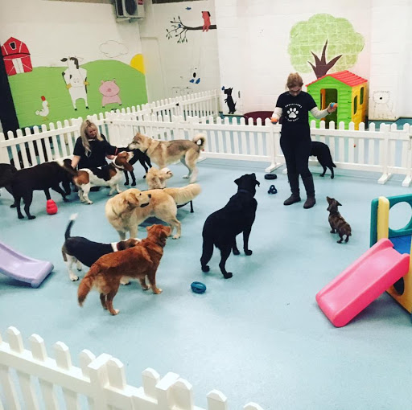

RESEARCH PROPSAL

An Analysis On the Growth and Development of the Doggy Day-Care Industry Over the Past Thirty Years

Researcher: Alicia Graham-Evans (1800532)
BA (Hons) Business Management
University of Wales Trinity Saint David
November 2020

TABLE OF CONTENTS

- Introduction………………………………………………………………………………………………………………….3
  - Rationale…………………………………………………………………………………………………………..3
  - Literature Review………………………………………………………………………………………………4
  - Industry Background…………………………………………………………………………………………4
  - Aims and Objectives………………………………………………………………………………………….5
- Research Designs……………………………………………………………………………………………………………5
  - Methodology…………………………………………………………………………………………………….5
- Resources and Planning…………………………………………………………………………………………………5
  - Resources…………………………………………………………………………………………………………5
  - Timescale…………………………………………………………………………………………………………6
  - Gantt Chart………………………………………………………………………………………………………6
- Bibliography…………………………………………………………………………………………………………………..7

Table of Figures
Figure 1 – Researcher’s Gantt Chart………………………………………………….………………………………6

INTRODUCTION
This dissertation aims to analyse the growth and development of the ‘Doggy Day Care’ business industry over the past thirty years. It will explore how people’s attitudes have changed towards their pets, specifically dogs, within this time frame and explore how this change in behavior has led to the invention of new businesses. This dissertation will look in to the effect ‘Doggy Day Care’ businesses have had on the economy and peoples social lives as well as evaluating whether this business is truly relevant in modern day, and if so, why that is.

Rationale
Academic research on the topic of ‘Doggy Day Care’ businesses is limited due to the fact that it is a new field. However, numerous amounts of academic research and data has been collected regarding the human-canine bond. This research assists the topic of Doggy Day Care and may even help to explain why this field was introduced altogether. Human-dog interaction has become popular as a line of research documenting health benefits for humans. For example, data from the National Health and Nutrition Examination Survey of a representative sample of people living alone in the United States showed that dog owners had better physical health than nonowners or owners of other types of companion animals (González-Ramírez, 2019). This data has sparked interest amongst scientists to understand exactly why dogs appear to make better companions than other pets such as cats and rabbits. This may also help to explain why ‘Doggy Day Care’ businesses are in place, rather than cat day care centers. This could imply that dog owners more actively seek to ensure that their pets are looked after and do not experience feelings of loneliness or abandonment anxiety, however, this may simply be down to the fact that dogs are purely more sociable animals and therefore need more attention and company. Each year, people become more and more willing to purchase upscale services to care for their pets. Dog owners spend £55 million each year to care for their animal friends and this growth is projected to continue. Families are working longer hours and struggle to find a balance between family needs and work requirements. These struggles have boosted the demand for service-orientated businesses such as Doggy Day Care (Bennett, 2014).

Literature Review
The analysis of the growth of the Doggy Day Care industry is a relatively new research interest. The first modern dog day care in New York City, Yuppie Puppy Pet Care was opened in 1987, by Joseph S. Sporn (Fern, 2020). Although this was only three decades ago, a significant amount of data has been gathered surrounding the topic and investigates how consumer-behavior contributed to the success of this industry. Marc Bekoff, PhD, a University of Colorado ethologist who has studied dogs for more than four decades, gives the concept of dog daycare a thumbs-up: “I love the idea. I think they provide a great function”. E’Lise Christensen, DVM, and board-certified veterinary behaviorist in New York City, agrees “For healthy, active, social dogs, daycare can be a great outlet for getting exercise and social enrichment.” (Hecht, 2015). The text clarifies the position of doggy daycare businesses and highlights the importance of the industry for both dogs and their owners. I believe research into this topic is interesting as it provides an outlook toward the changing behaviors of pet owners. For example, just over thirty years ago, doggy daycare businesses did not even exist. Now, they are popular amongst many pet owners. This in itself provides an intriguing research proposal. Furthermore, there hasn’t been too many similar studies published unlike other popular topics such as Women’s Rights and the Death Penalty. Although this research will be more challenging, it is a distinctive topic that has the ability to evaluate many points, such as the change in human behavior over the last three decades.

industry background
Doggy day care is a short-term boarding service for dogs. Usually, dogs will stay for the day, being dropped off in the morning and collected at night, although care of just a few hours at a time may also be offered (Rodgers, 2017). This allows dog-owners to go to work or participate in other activities without having to worry about their dog being left alone, ensuring that their pet is getting enough attention and company. This is particularly helpful for dogs who suffer with separation-anxiety. There are several benefits of doggy day care for both dogs and their owners. It allows dogs to socialise and receive physical and mental stimulation, as well as offering dog-owners peace of mind. The popularity of doggy day care establishments has grown greatly since the early 1990’s. Prior to World War II, dogs more commonly lived outside, but as urbanization spread, dogs started to live indoors more frequently. Other factors, including an increase in the population of adults without children, have gradually led to more attention and money being spent on pets. During the 2020 Covid-19 Pandemic, doggy day-care became increasingly visible and important as an essential service for people that work in the healthcare industry (Strasburg, 2020).

Aims and Objectives
This study aims to analyse the growth and development of the Doggy Day Care industry over the past thirty years in order to gain understanding of the relatively new industry and explain how peoples’ behavior has changed regarding their dogs.
- To critically analyse existing academic research and data to understand how and why the Doggy Day Care industry has grown to such an extent of the past three decades.
- To conduct primary research through online questionnaires to better understand the relationship between people and their dogs and compare this data to previous years, exploring how peoples attitudes have changed towards their pets.
- To understand the benefits of doggy day care on people, animals, the economy and the environment and evaluate whether doggy day care is truly a necessary industry in the modern world.

2.0. RESEARCH DESIGN

2.1 Methodology
Research is a process of systematic inquiry that entails collection of data; documentation of critical information; and analysis and interpretation of that data/information, in accordance with suitable methodologies set by specific professional fields and academic disciplines (Hampshire College, 2020). This dissertation will follow the research philosophy and approach of interpretivism. The term interpretivism refers to epistemologies, or theories about how we can gain knowledge of the world, which loosely rely on interpreting or understanding the meanings that humans attach to their actions (Payne, 2004). This differs to positivism, which uses methods of the natural sciences – it can either be proved or it can’t. Interpretivism is a more suitable research approach to this topic as it understands behaviors and relationships rather than simply focusing on numbers.

3.0. Resources and Planning

3.1. RESOURCES
Primary data is data that is collected by a researcher from first-hand sources, using methods like surveys, interviews, or experiments. It is collected with the research project in mind, directly from primary sources (Glen, 2020). Within this dissertation, primary data will be collected using a combination of online resources and also a personal questionnaire. This allows the research to have a better level of control over how information is gathered, provides up-to-date information and also resolves specific research issues. An array of secondary data will also be collected. Secondary data is the data that has already been collected through primary sources and made readily available for researchers to use for their own research (Longe, 2013). This data will be collected from an array of sources such as books, academic journals and newspaper articles.

3.2 Timescale
The researcher will implement the use of a Gantt chart. A Gantt chart is a visual view of tasks scheduled over time. Gantt charts are used for planning projects of all sizes and they are a useful way of showing what work is scheduled to be done on a specific day. They also help you view the start and end dates of a project in one simple view (Westland, 2018). The complete dissertation will be submitted in May 2021. (See 4.3 Gannt Chart).

3.3. GANTT CHART
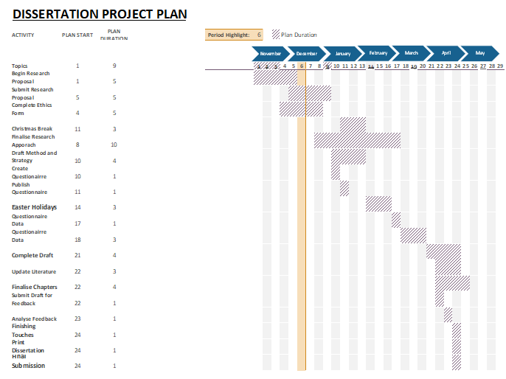
Figure 1 – Researchers Gantt Chart

4.0. BIBLIOGRAPHY
Bennett, R., 2014. All About Dog Daycare ... A Blueprint For Success. 7th ed. Falcon: RB CONSULTING, p.14.

Fern, R., 2020. The Truth About Dog Daycare - Ferndog Training. [online] FernDog Training. Available at: <https://ferndogtraining.com/the-truth-about-dog-daycare/> [Accessed 29 November 2020].

Glen, S., 2020. Primary Data & Secondary Data: Definition & Example - Statistics How To. [online] Statistics How To. Available at: <https://www.statisticshowto.com/primary-data-secondary/#:~:text=Primary%20data%20is%20data%20that,mind%2C%20directly%20from%20primary%20sources.> [Accessed 30 November 2020].

González-Ramírez, M., 2019. Compatibility between Humans and Their Dogs: Benefits for Both. Animals, 9(9), p.674.

Hacht, J., 2015. Dog Daycare. [online] The Bark. Available at: <https://thebark.com/content/dog-daycare> [Accessed 29 November 2020].

Hampshire College, 2020. What Is Research?. [online] www.hampshire.edu. Available at: <https://www.hampshire.edu/dof/what-is-research> [Accessed 29 November 2020].

Longe, O., 2013. What Is Secondary Data? + [Examples, Sources, & Analysis]. [online] Formpl.us. Available at: <https://www.formpl.us/blog/secondary-data> [Accessed 30 November 2020].

Payne, G., 2004. Key Concepts In Social Research. London: SAGE Publications.

Rodgers, N., 2017. Doggy Daycare - What Is It And Is It A Good Idea For Your Own Dog? | Pets4homes. [online] Pets4Homes. Available at: <https://www.pets4homes.co.uk/pet-advice/doggy-daycare-what-is-it-and-is-it-a-good-idea-for-your-own-dog.html> [Accessed 29 November 2020].

Strasburg, J., 2020. Busy Owners Lap Up Doggy Daycare. [online] The Globe and Mail. Available at: <https://www.theglobeandmail.com/news/world/busy-owners-lap-up-doggy-daycare/article1043131/> [Accessed 29 November 2020].

Westland, J., 2018. Gantt Chart: The Ultimate Guide (With Examples) - Projectmanager.Com. [online] ProjectManager.com. Available at: <https://www.projectmanager.com/gantt-chart> [Accessed 30 November 2020].

