(Hughes, 2016)

University of Wales Trinity Saint David
School of Engineering

Motion Analysis and FEA

of a

Road Bicycle Crank Arm

Carl P. Engelbrecht
P150898

Advanced Computational Methods
M6X00408
Motorsport Engineering

26 January 2020

Contents
Introduction 3
Model 3
1.1 Components and Materials 3
1.1.1 Modelling 3
1.1.2 Materials 7
1.2 Final Assembly 8
Motion Analysis 9
1.3 Rigid Bodies 9
1.4 Forces Calculation 9
1.4.1 Forces Input 11
1.4.2 Load Bearing Faces 11
1.4.3 Import Motion Loads 12
FEA Study 13
1.5 Mesh Parameters 13
1.6 Original Component 13
1.7 Optimization 15
1.7.1 Design Improvement 15
1.7.2 Analysis 16
Conclusion 17
References 18
Appendix 19

Figure 1 - A 1972 Raleigh Super Course. 3
Figure 2 - Method of importing two-dimensional picture in order to sketch intricate shapes. In this case a chainring is drawn. 4
Figure 3 - 48 tooth chainring. 4
Figure 4 - 38 tooth chainring. 4
Figure 5 - Bottom bracket assembly with all constituent parts. 5
Figure 6 - Bicycle Frame. 5
Figure 7 - Non-drive crank arm. 5
Figure 8 - Sketch of the drive crank circular section where the chain rings attach. 6
Figure 9 - Cavity feature being used on drive crank arm to achieve perfect interface with the bottom bracket. 6
Figure 10 - Drive crank arm. 7
Figure 11 - Assembly mates used. 8
Figure 12 - Render of final crank arm study assembly. 9
Figure 13 - Rigid group usage within motion analysis. 9
Figure 14 - Forces and measurements involved in propelling the bicycle forward through pedal force. 10
Figure 15 - Applied pedal force within the motion analysis. 11
Figure 16 - Applied chain force, on one of the chainring teeth. 11
Figure 17 - Load bearing faces defined on the model. Specifically, the chainring interface with the crank arm. 12
Figure 18 – Von Mises stress result comparison between a lock mate and a concentric mate for the pedal axle. 12
Figure 19 - Von Mises principles stress eclipse. Inside the green eclipse is within yield. (eFunda, Inc., 2020) 13
Figure 20 - Fine mesh used on part for FEA study. 13
Figure 21 - Von mises stresses on original part. 14
Figure 22 - Iso clipping of von mises stress within crank arm. 14
Figure 23 - Displacement within drive crank arm. 15
Figure 24 - Optimized design. The addition of seven chamfered 8mm holes are present. 15
Figure 25 - Configurations tree used. 16
Figure 26 - Optimised component Von Mises stress plot. 16
Figure 27 - Iso clipping of the optimised part load study. 16
Figure 28 - Mass comparison between original drive crank arm design and final optimisation. 17
Figure 29 - Back side of the drive crank arm. 19
Figure 30 - Import motion loads window. 19
Figure 31 - Failure of cavity feature resulting in a two-body component not capable of importing motion loads. 19
Figure 32 - Comparison between the original component and optimised iteration concerning factor of safety (FOS). 20
Figure 33 - Equation Usage. 20

Table 1 - Materials and masses of components. 7
Table 2 - Force calculation data table. 10

Equation 1 - Reaction force calculation. 10
Equation 2 - Chain force from the reaction force acting on the wheel. 10
Equation 3 - Torque acting through the chainring. 10
Equation 4 Von Mises stress definition. 13

Introduction
Possible through modern computational capabilities Motion Analysis and Finite Element Analysis is a cornerstone featured in most design projects. Used to either model and evaluate an existing design or featured within the design process in producing an initial design. Solidworks is a parametric modelling software package that allows such parts, assemblies and drawings to be made. (Onwubolu, 2013) Driven off of dimensions it provides a flexible design environment where dimensional alterations can be made and updated automatically altering the part. Advanced analysis under simulated motion and loading is also possible through this medium.
This project aims to look at the drive side bicycle crank arm from a 1972 Raleigh Super Course bicycle used in daily commuting. A bicycle once prized for its performance driven design for touring is now only but practical. However, through in-depth analysis of the forces transferred through the component, possible through the aforementioned analysis, improvements on the part can be made. Three areas are investigated, principle stress, displacement and the safety factor, all important factors to consider in terms of the vehicles’ use, pedestrian transport. Therefore, maintaining a similar safety factor and stiffness the aim is to make the component lighter, reducing rotational mass, and therefore the force exertion required from the rider.

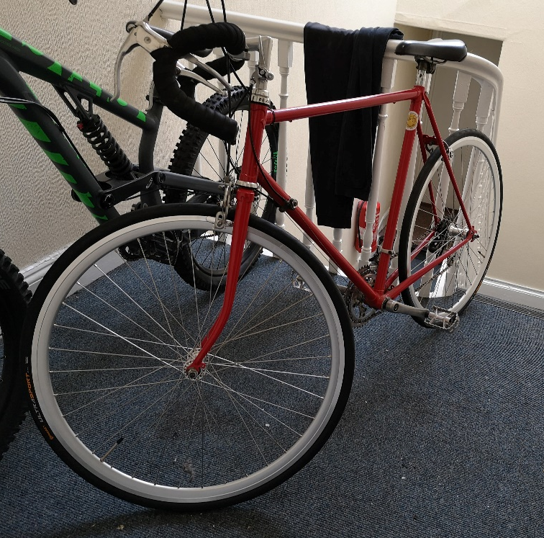
Figure 1 - A 1972 Raleigh Super Course.

Model

Components and Materials
The main area focused upon for modelling is the lower half of the frame cutting a circular 250mm radius around the centre of the Bottom Bracket. All the components interacting with the crank arm is modelled.

Modelling
Each of the following components make up the assembly. The process of modelling each component begins with taking accurate measurements with the available instrumentation, Vernier calliper etc. Accurate sketch modelling is also achieved by the use of two-dimensional scanning when applicable. One particular case where it was used is in the modelling of both the chainrings which featured intricate cut shapes, difficult to accurately measure without specialist equipment. Therefore, the item was 2 dimensionally scanned as seen in Figure 1, and then imported into a Solidworks sketch. Reference dimensions is used to size the image accurately, in this case the bolt hole pattern diameter from centre was used. As there is no visual warping involved on a printer scanner the scan can be considered dimensionally true.
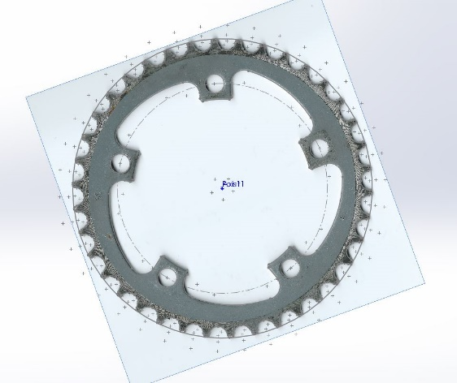
Figure 2 - Method of importing two-dimensional picture in order to sketch intricate shapes. In this case a chainring is drawn.
The following is all the components modelled for study of stresses within the crank arm.
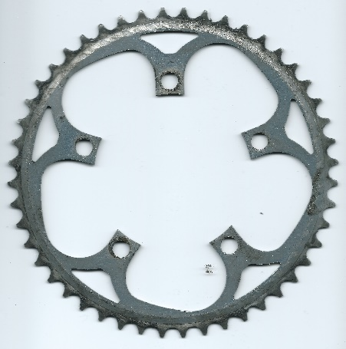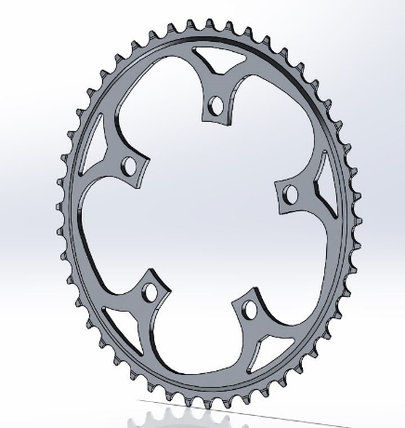
Figure 3 - 48 tooth chainring.
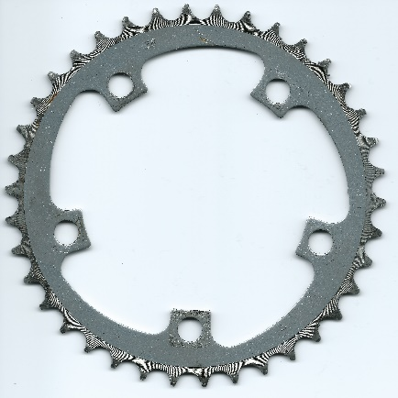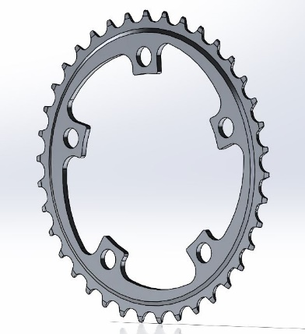
Figure 4 - 38 tooth chainring.
The bottom bracket modelled is an assembly made up of three components, more complex in real life, however due to it not being an analysed component it is simplified. This is done in two cases, first the shell (outer casing) splits in order to fasten into the frame. It is however only made into one piece as it can be mated into position without splitting. Clamping forces from the fasting moment, which acts on the frame, is irrelevant in this case. Secondly, the bearings are modelled as a cylinder. This is consciously done in order to simplify the motion analysis and solid body contacts.
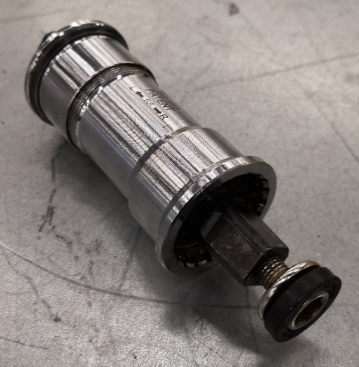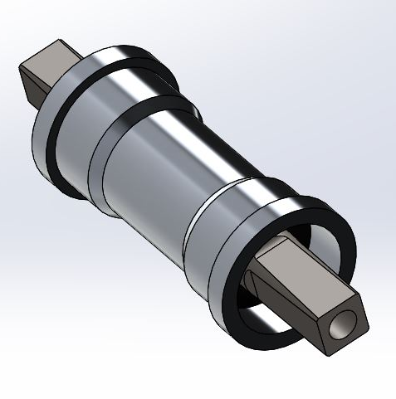
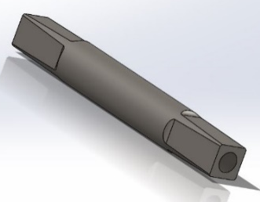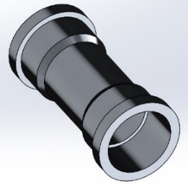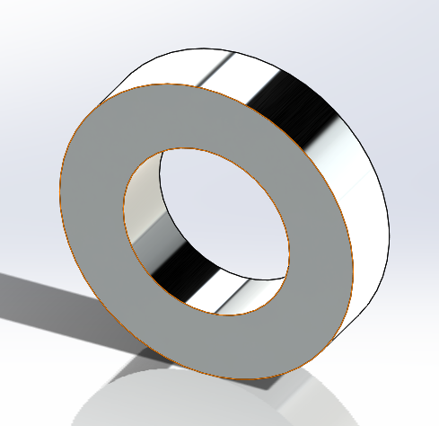
Figure 5 - Bottom bracket assembly with all constituent parts.

The frame is constrained and fixed, therefore there is no need to model the entire frame as it is not being stressed.

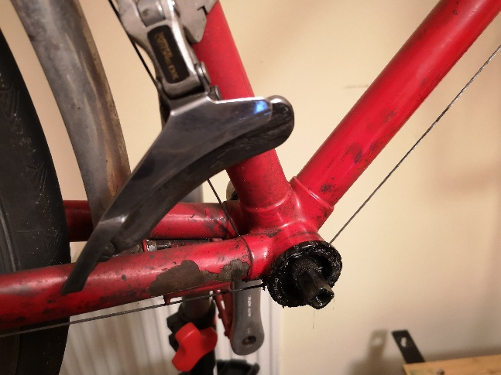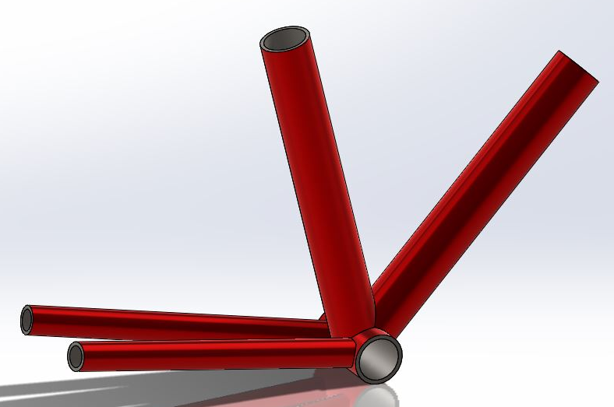
Figure 6 - Bicycle Frame.
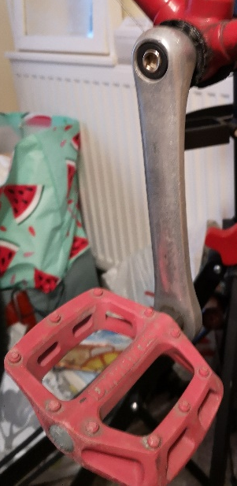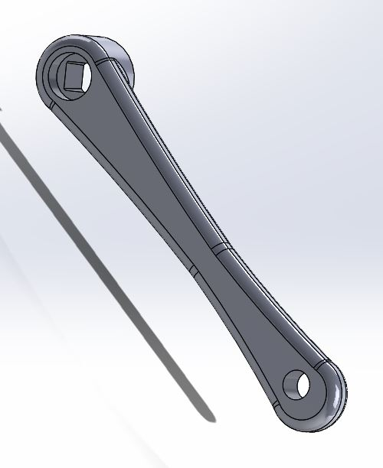
Figure 7 - Non-drive crank arm.
One of the most challenging items to model is the drive side crank arm, where accuracy is essential. Where the chainrings attach there is a revolved structure which features an organic casting structure. Breaking the part into two elements the circular structure was sketched and formed first, see Figure 8, and then the crank arm extrusion followed as an extrusion.
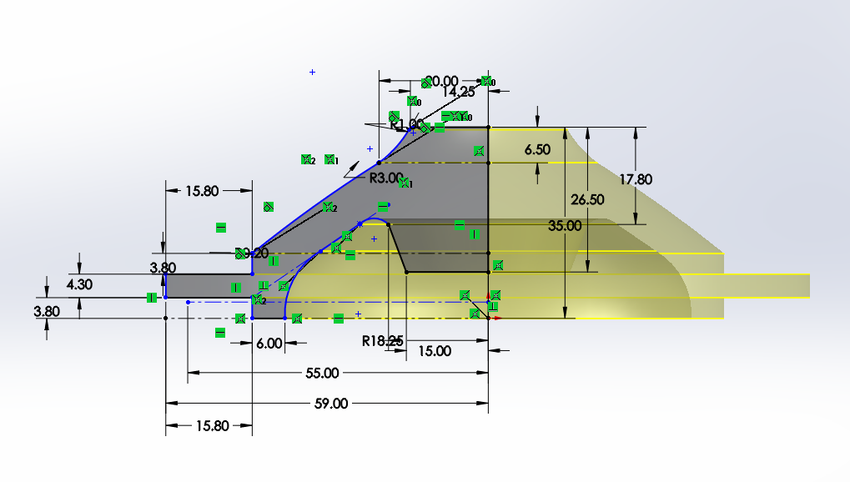
Figure 8 - Sketch of the drive crank circular section where the chain rings attach.
Another element process unique to the drive and non-drive crank arm was the creation of a cavity from assembly into the initial modelling in order to create a coherent interface with the bottom bracket (BB) axle, as seen in the real assembly. This was initially done during assembly, mating the BB axle to the crank arm in the correct orientation and angle using the Cavity feature. However, this prevented both crank models to appear in the ‘import motion loads’ window. What was found is when the cut feature in the BB axle was unsuppressed it caused a second body to be formed in the part file, as seen in appendix Figure 25. It was therefore discovered that loads cannot be imported for a multi-body part. A subtraction was done instead using a similar process.
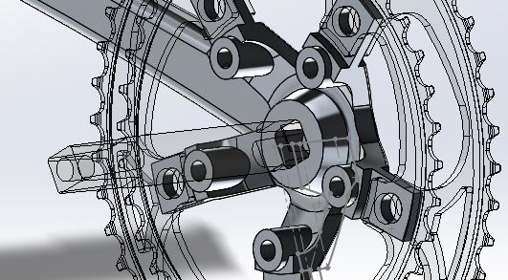
Figure 9 - Cavity feature being used on drive crank arm to achieve perfect interface with the bottom bracket.
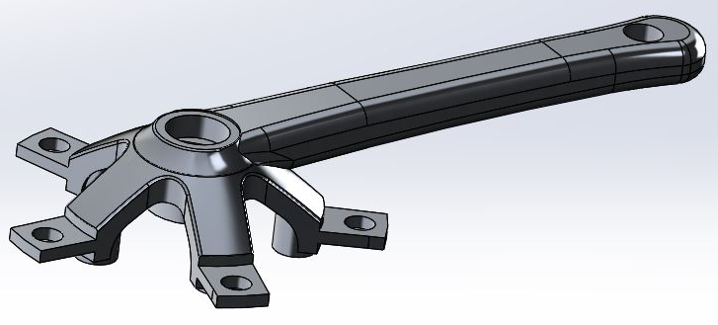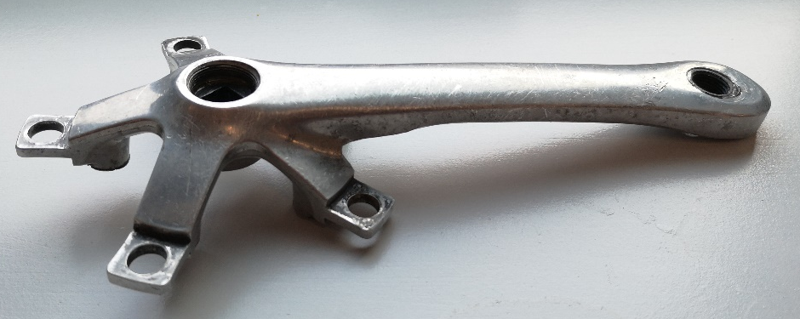
Figure 10 - Drive crank arm.

Materials
The component materials need to be assigned in order to run the study. The material of each component is estimated if not stated through visual analysis and usage conditions. Further reading of a publishing by (Cantrell, 2003) shows the most likely materials used in bicycle manufacture, aiding assumptions. The crank arm material is identified as aluminium alloy 6061-T6 through the use of an acid test identifying a high magnesium content. The bearings within the bottom bracket identifies as an ISO 6903RS standard roller bearing which is made of SUJ2 high carbon steel, there is not a similar material available in Solidworks therefore it is assumed to be AISI 316L stainless steel (Wiggle Ltd., 2020) (Ju Feng Special Steel Co., Ltd., 2019). The outer hub will be assumed to be made of 6061-T6 aluminium alloy, while the axle is assumed to be made of the steel alloy 4130 due to the high loading conditions. The frame is known to be made of Reynolds 531 (Brown, 2020) which is the most similar to 4130 available in Solidworks.
A mass study is done to compare the model component to the real component in order to validate material choice. As featured in Table 1, the mass percentage difference apparent in each case do not exceed 14% at worst case and this can be caused by modelling in-accuracies on non-essential study components such as the bottom bracket. On the other hand, the studied drive crank arm only exhibits a mass difference of 4.19% (heavier) which is acceptable.

Table 1 - Materials and masses of components.
Components | Assigned Material | Real Mass (kg) | Solidworks Mass (kg) | Mass Difference (%)
Bottom Bracket | - | 0.329 | 0.288 | 13.29
Axle | AISI 4130 Annealed at 850°C | N/A | 0.192 | -
Bearing | AISI 316L Stainless Steel | N/A | 0.027 | -
Outer Shell | 6061 – T6 | N/A | 0.042 | -
48t Chainring | 6061 – T6 | 0.073 | 0.066 | 10.07
38t Chainring | 6061 – T6 | 0.043 | 0.043 | 0
Non-drive Crank Arm | 6061 – T6 |  | 0.220
Drive Crank Arm | 6061 – T6 | 0.304 | 0.317 | 4.19
Chainring Bolts |  | 0.005 | - | -
Frame | AISI 4130 Annealed at 850°C | - | 2.284 | -
Whole Bicycle | - | 12.771 | - | -

Final Assembly
The final assembly is created using standard mates in order to position all the components. Mechanical mates are also used in some instances; however, it is not necessary to streamline mates to lower redundancies as rigid body groups will be used later to improve simulation speeds. The folder system of mates can be seen in Figure 11. The mates are organised into two folders, rigid bodies and active mates. One mate outside of the folder system is a positioning mate for the crank arm starting point within the motion analysis.

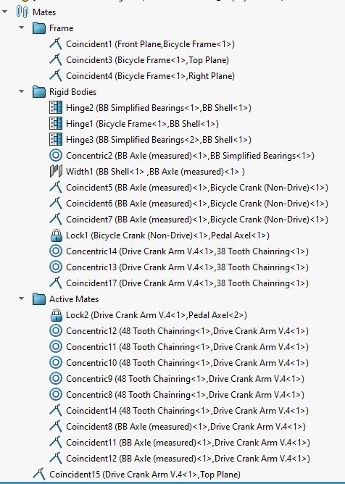
Figure 11 - Assembly mates used.

A final render is made of the assembly is made using the render tools, Figure 11.
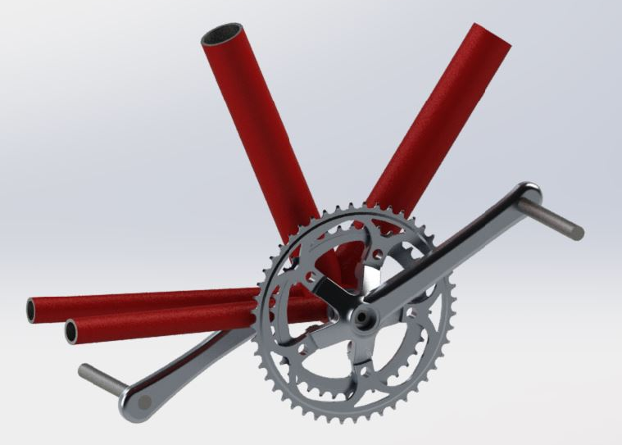
Figure 12 - Render of final crank arm study assembly.

Motion Analysis

Rigid Bodies
Rigid body groups within Solidworks is used to lower the redundancies within a motion analysis. Parts that do not move in relation to each other such as the bottom bracket components, chainring group and non-drive crank arm can all be added as a rigid body group. This will greatly lower the redundancies and allow for faster simulation.

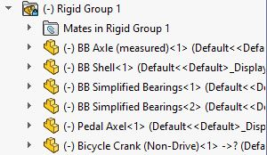
Figure 13 - Rigid group usage within motion analysis.

Forces Calculation
The forces to be inputted into the motion simulation is first calculated. The two forces that act on the crank are the force down on the pedal $(F_{PEDAL})$ and the force through the chain ${(F}_{CHAIN})$. The total mass of the bicycle is assumed to be acting on the rear wheel for a maximum loading condition. It is also known that the maximum reaction force on the wheel is experienced on a level surface. The coefficient of friction is taken as 1. A diagram of forces and measurements are illustrated in Figure 13. The values used in this model for each variable is found in Table 2.
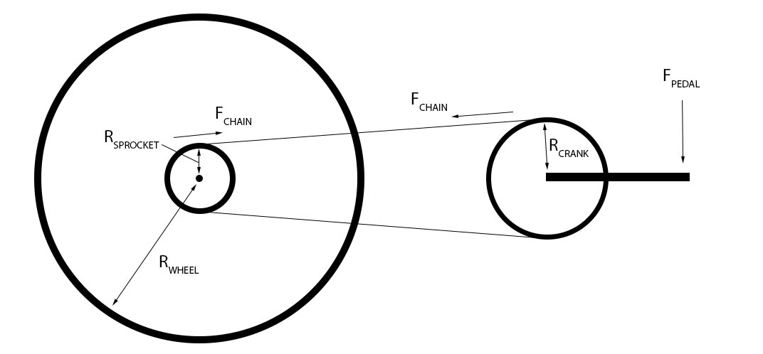
Figure 14 - Forces and measurements involved in propelling the bicycle forward through pedal force.

Variables | Value
M_{RIDER} | 110 kg
M_{TOTAL} | 122.71 kg
Gravity | 9.81
R_{WHEEL} | 0.340 m
R_{SPROCKET} | 0.050 m
R_{CHAINRING} | 0.0987 m
F_{PEDAL} | 1079.1 N
F_{CHAIN} | 282.04 N
T_{CHAINRING} | 817.43 Nm
F_{PEDAL} | 1079.1 N
µ | 1
g | 9.81
Table 2 - Force calculation data table.

The chain force will be added into the motion analysis as a force. Firstly, the opposing force acting on the chainring is calculated through Equation 2, using the products from the maximum force equation ($F_{MAX})$. Following this the torque can be found through the use of Equation 3. An Excel spreadsheet has been created to calculate the forces, allowing quick alterations in both weight and gear ratios. ( Stack Exchange Inc, 2015)

$$F_{MAX}=µ*R N$$
$$R=M_{TOTAL}*g N$$
Equation 1 - Reaction force calculation.

$$F_{CHAIN}=({(M}_{TOTAL}*9.81)*R_{w})/R_{S} N$$
Equation 2 - Chain force from the reaction force acting on the wheel.

$$T_{CHAINRING }= F_{CHAIN}*R_{CHAINRING} Nm$$
Equation 3 - Torque acting through the chainring.

Forces Input
Once the pedal force and chainring force are calculated for a worse case loading scenario it is applied to the model within the motion analysis. Firstly, the pedal force is applied as a force to the pedal axle acting downwards aligned with the top plane, Figure 14, which represents the ground. Therefore, the force is always acting perpendicular to the ground. Secondly, the chainring force was originally applied as a torque however within the motion study the affect did not realistically translate. Therefore, it is applied as a force on one of the chainring teeth at 90° to the drive crank arm, mated perpendicularly to the right plane, seen in Figure 16.

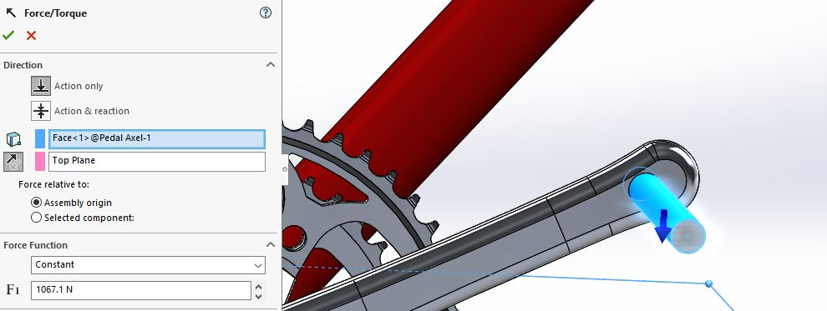
Figure 15 - Applied pedal force within the motion analysis.

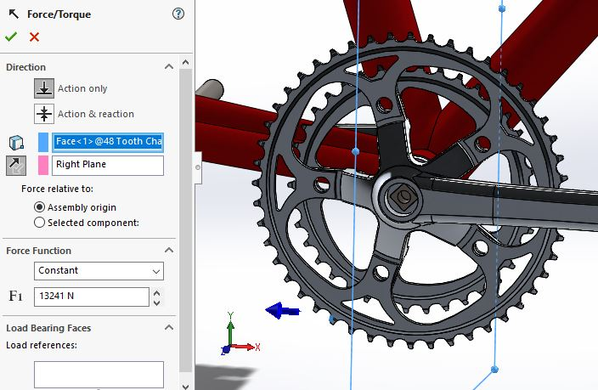
Figure 16 - Applied chain force, on one of the chainring teeth.

Load Bearing Faces
Load bearing faces define the points of load transfer between two parts, defined in the mate window. This is done for each concentric mate between the 48t chainring and the crank arm spider. The process is showcased in Figure 17. The pedal axle was initially mated using a lock mate for simplicity however a test has been done using a concentric mate with the load bearing faces specified. The result was that the stress concentration spread from the concentric mate was more conducive to that which would be seen within real loading conditions. The difference in Von Mises stress results for each mate is shown in Figure 18.
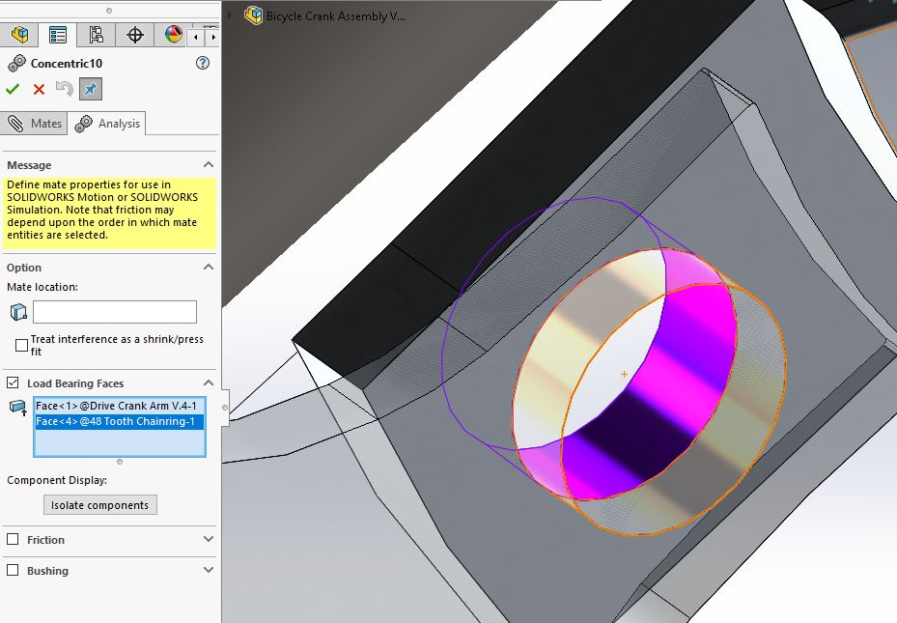
Figure 17 - Load bearing faces defined on the model. Specifically, the chainring interface with the crank arm.
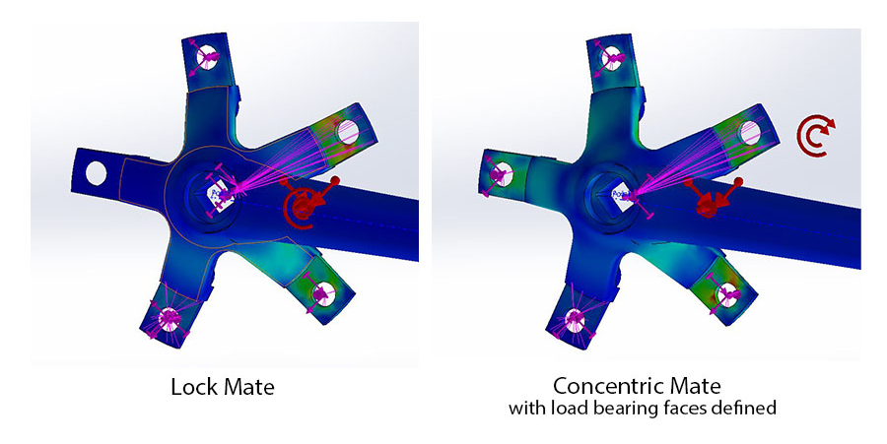
Figure 18 – Von Mises stress result comparison between a lock mate and a concentric mate for the pedal axle.

Import Motion Loads
Once the study is run the loads can be ‘exported’ to the part being analysed through the ‘import motion loads’ feature, Appendix Figure 24. The drive crank arm is selected and a single frame study is chosen. It is known that the maximum force is experienced when the forces are 90° to each other, which is at the absolute start of the motion analysis. Hence, in order to lower the computational time one frame study is selected.

FEA Study
The finite element method (FEM) will be used after the loads have been imported into the part file. FEM is the process of breaking a complex geometrical shape into small connected subregions referred to as finite elements (Rao, 1999).
The main area of focus will be on reducing the mass of the component while maintaining the level of stiffness and displacement properties (reducing loss in power delivery), and further to this maintain a consistent safety factor due to the nature of use of the component.
Von Mises stresses will mainly be focused upon in this study as the loading is not completely in a linear plane, a level of torsional loading is present. Von Mises stress, defined by Equation 4, describes a more complicated ideal than principle stress by functioning on more micro-mechanical principles. (Anon., 2012) Von Mises defines the limit of yield and beyond.
$$σ_{v }= \sqrt{σ_{1}^{2}+σ_{2}^{2}-{(σ}_{1}*σ_{2})}$$
Equation 4 Von Mises stress definition.
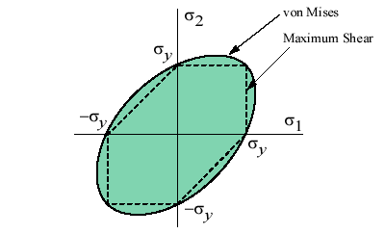
Figure 19 - Von Mises principles stress eclipse. Inside the green eclipse is within yield. (eFunda, Inc., 2020)

Mesh Parameters
The FEA method uses a system of complex nodes known as a mesh. The mesh in this instance is of a tetrahedral shape and contain the data of the material and how it reacts under loading. The benefit of running a single frame study is the lower computational time being run on cases, therefore the mesh size can be greatly decreased, in this case to 1mm on each side of the tetrahedral.
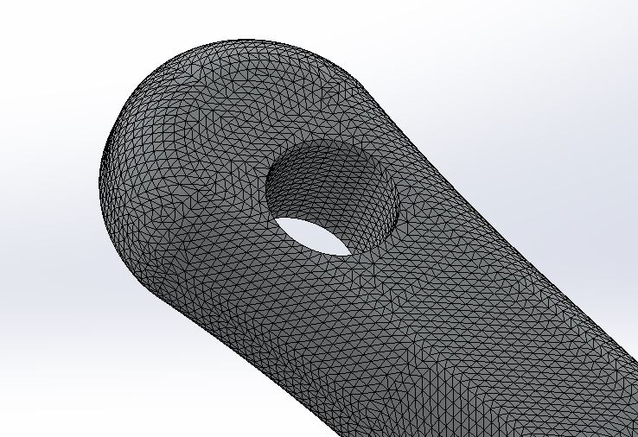
Figure 20 - Fine mesh used on part for FEA study.

Original Component
Examining the results from the FEA study it can be seen in the graphed Von M ises stress plot on the part, Figure 21, that a large percentage of the part in above yield of the material. An odd occurrence as the real component does not reach yield with the current forces applied. The force calculation is verified therefore a computational error must be apparent in the solving. The trends however are assumed to be correct and thus further optimisations will be undertaken from the results seen.
Highest stress concentrations are seen in the spiders attached to the chain ring. The lowest stress concentrations are featured at the end of the crank arm. This is a section where a taper to a smaller radius can be beneficially used to reduce the mass without increasing stress concentrations. The extrusion section is largely under the yield limit and does not appear in the iso clipping. The stress concentrations do not act symmetrically along component.
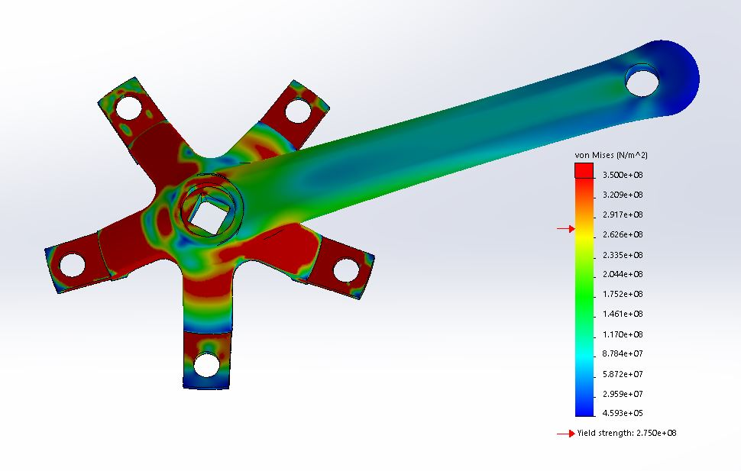
Figure 21 - Von mises stresses on original part.
Further analysis of an iso clipping of the part exposes another area for possible improvement in the area where the crank arm extrusion joins the spider frame. High levels over yield are exemplified on the clipping however it also highlights areas which fall well bellow yield internally. Internal cavities can be machined to take advantage of this low stressed area.
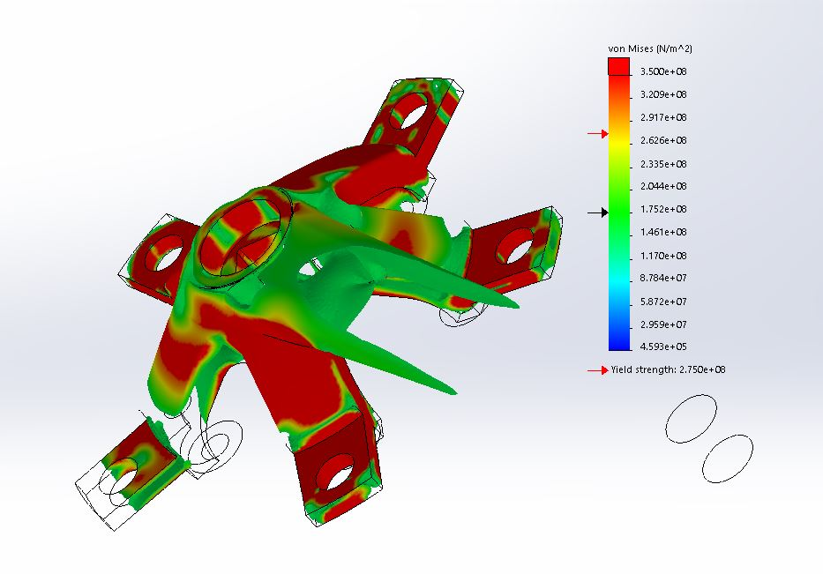
Figure 22 - Iso clipping of von mises stress within crank arm.
The displacement result of the component under load can be seen in Figure 21. The largest displacement is apparent at the end of upper spider where it attaches to the chainring at 7.3mm and averages to approximately 4mm around the remaining spider sections. Another area of mild displacement is the bottom side of the crank arm end where the pedal axle is acting down upon.

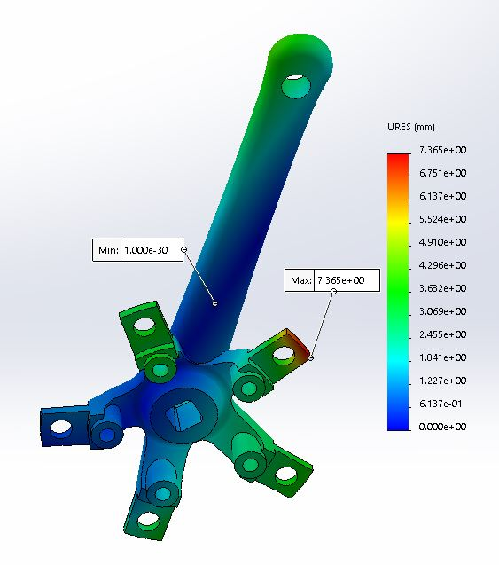
Figure 23 - Displacement within drive crank arm.

Optimization

Design Improvement
From the analysed study of the part design improvements can be recommended and implemented. In this case the addition of seven 8mm holes through the main extrusion are added and chamfered, see Figure 24, taking advantage of section under yield. Further areas can be recommended such as a recess cut into the connecting area between the spider and extrusion, as well as reduction in end section radius. However only the first of the three is implemented for ease of practical execution.
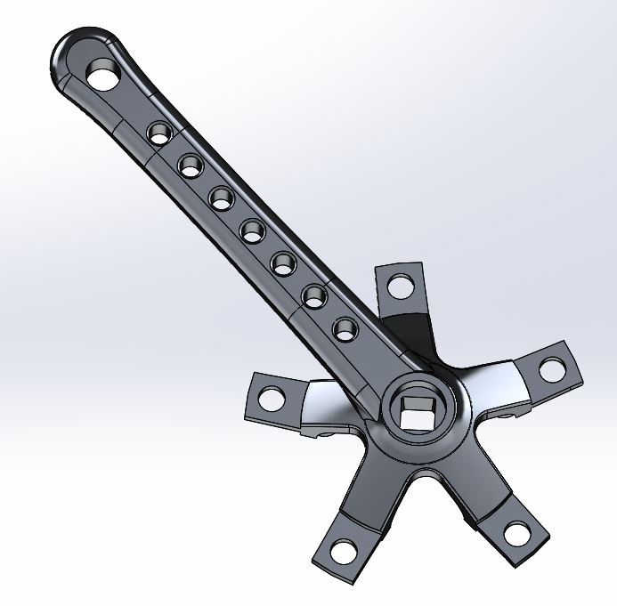
Figure 24 - Optimized design. The addition of seven chamfered 8mm holes are present.
Configurations tree is used to interchange between the optimisation features and the original component.

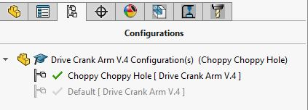
Figure 25 - Configurations tree used.

Analysis
The optimised component is run under the same load conditions as the original component configured with the same material. Reviewing the von mises stress plot, seen in Figure 26, it is apparent that the material surrounding the drilled holes lean closer to yield than the original part. However, from the iso clipping it is clear that the addition of the new feature has not caused the material in that section to go above yield. Proving it is a viable optimisation. It has although caused a higher level of stress on the outer edges of the extrusion.
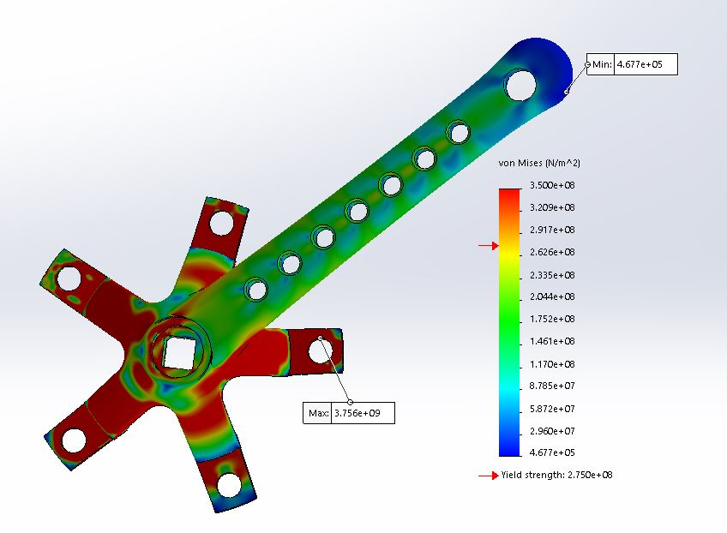
Figure 26 - Optimised component Von Mises stress plot.
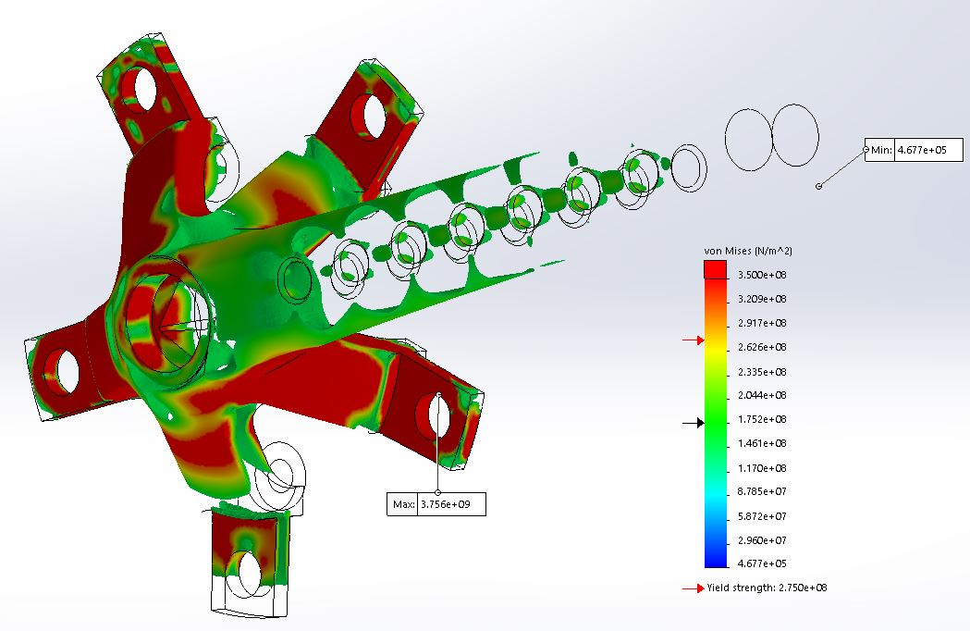
Figure 27 - Iso clipping of the optimised part load study.

Evaluating the displacement after the optimisation, illustrated below, it can be pointed out there is an increase at the end of extrusion where the pedal is mated. The displacement is also more uniform in this area.
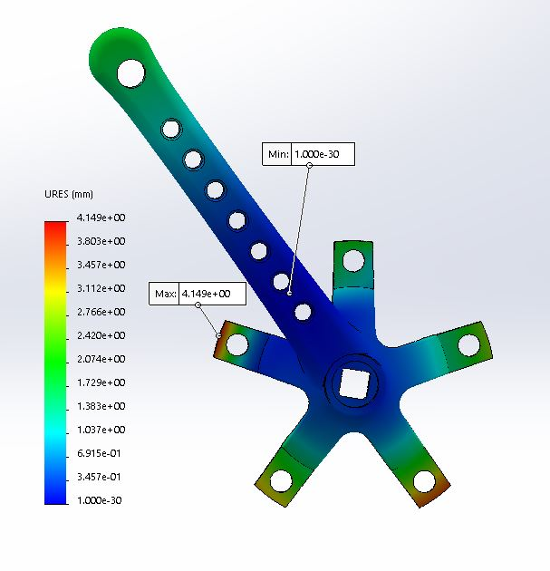
Compared to the original component a mass reduction of 5.31% (16.41g) was achieved over the original design, with scope for further improvement.

Factor | Version | Value | Difference %
Mass (g) | Original | 317.00 | 5.31 (Reduction)
Mass (g) | Optimised | 300.59 | 5.31 (Reduction)
Displacement (mm) | Original | 4.093 | 73.19 (Reduction)
Displacement (mm) | Optimised | 1.9 | 73.19 (Reduction)
Figure 28 - Mass comparison between original drive crank arm design and final optimisation.

Conclusion
Finite element analysis through motion simulation within Solidworks software package has proven very beneficial in the evaluation and optimisation of a drive side bicycle crank arm. From initial accuracy within modelling using image techniques it was found to directly improve sketching accuracy while reducing modelling time. The use of equations aided in alterations. In reference to the motion analysis it was found that a multibody part will not be processed through the import motion load feature, a stumbling block which consumed many hours. Further to this a study in mate types showed that in the case of the pedal axle a concentric mate with defined loading faces emulated a loading stress result similar to that experience in real usage, more so than a locked mate. The single frame usage allowed finer mesh sizing while lower computational time.
The final FEA study result yielded interesting results despite the issues experienced with the large percentage of the component experiencing stresses well above yield. Further refinement of the model can be conducted in future to identify the underlying issue. Despite this the Von Mises stress plot highlighted areas along the crank arm extrusion which allowed for areas of development as well as various other points identified through an iso clipping. The component was optimised with the addition of holes in the crank extrusion and resulted in a weight reduction of 5.31%. The addition of the holes increase stress along the extrusion however it was still below yield and would not critically affect the stiffness of the component. A Major change was experienced with displacement between the two iterations, the optimised version showed a 73.19% reduction in displacement distance at the end of the crank arm extrusion. Lastly the safety factor experienced a minor change, lowering around the holes, however still acceptable. Overall the optimisation yielded positive results reinstating the 1972 Raleigh Super Course as a machine of performance orientation.

Link to Solidworks file: https://uowtsd-my.sharepoint.com/:u:/g/personal/cengelbrecht_150898_student_uwtsd_ac_uk/EfpCmVEi5m5Do3-GwzheljsBH1XqRdyfaYNmeCTGISPugg?e=3bNWN0

References
Stack Exchange Inc, 2015. How bicycle gear works?. [Online]
Available at: https://physics.stackexchange.com/questions/220992/how-bicycle-gear-works
[Accessed 25 January 2020].
Anon., 2012. Von Mises 1 - Brian Waves.avi. [Online]
Available at: https://www.youtube.com/watch?v=mdcB9wUg7Xo
[Accessed 24 January 2020].
Brown, S., 2020. The Raleigh Super Course Series. [Online]
Available at: https://www.sheldonbrown.com/retroraleighs/super-course.html
[Accessed 22 January 2020].
Cantrell, A., 2003. Bicycle Materials Case Study. [Online]
Available at: https://depts.washington.edu/matseed/mse_resources/Webpage/Bicycle/Bicycle%20Materials%20Case%20Study.htm#_Possible_Materials
[Accessed 22 January 2020].
eFunda, Inc., 2020. Maximum Shear Stress Criterion. [Online]
Available at: https://www.efunda.com/formulae/solid_mechanics/failure_criteria/failure_criteria_ductile.cfm
[Accessed 26 January 2020].
Ju Feng Special Steel Co., Ltd., 2019. SUJ2. [Online]
Available at: https://www.jfs-steel.com/en/product/SUJ2.html
[Accessed 22 January 2020].
Onwubolu, G., 2013. Computer-Aided Engineering Design with Solidworks. London: Imperial College Press.
Rao, S. S., 1999. The Finite Element Method in Engineering. Woburn: Butterworth-Heinemann.
Wiggle Ltd., 2020. Brand-X Sealed Bearing - 6903 SRS Bearing. [Online]
Available at: https://www.wiggle.co.uk/brand-x-sealed-bearing-6903-srs-bearing/?lang=en&curr=GBP&dest=1&sku=100259064&kpid=100259064&utm_source=google&utm_term=&utm_campaign=Shopping+-+All+Products&utm_medium=base&utm_content=mckv|siBzPhmMj_dc|mcrid|295270531587|mkw||m
[Accessed 22 January 2020].

Appendix
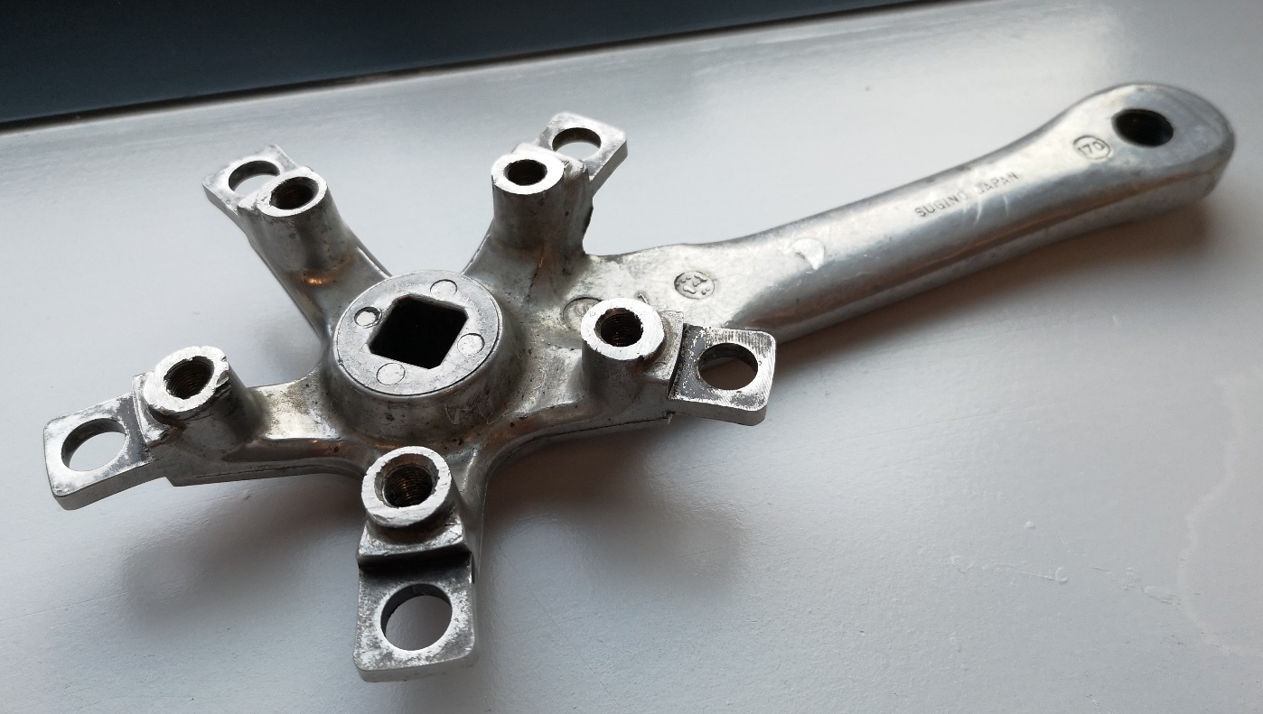
Figure 29 - Back side of the drive crank arm.
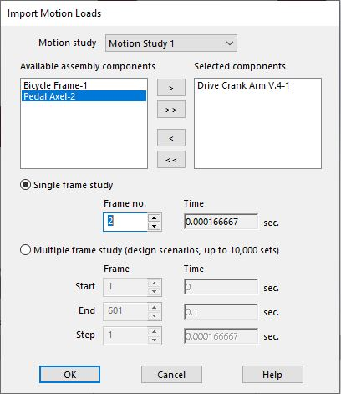
Figure 30 - Import motion loads window.
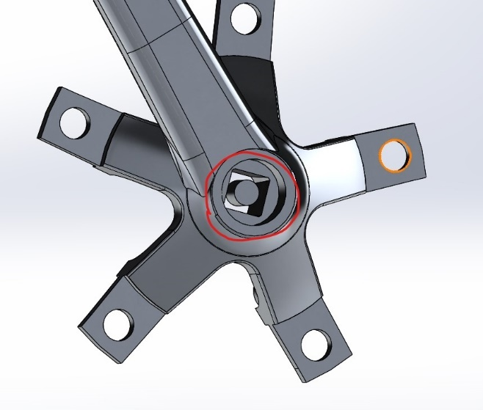
Figure 31 - Failure of cavity feature resulting in a two-body component not capable of importing motion loads.
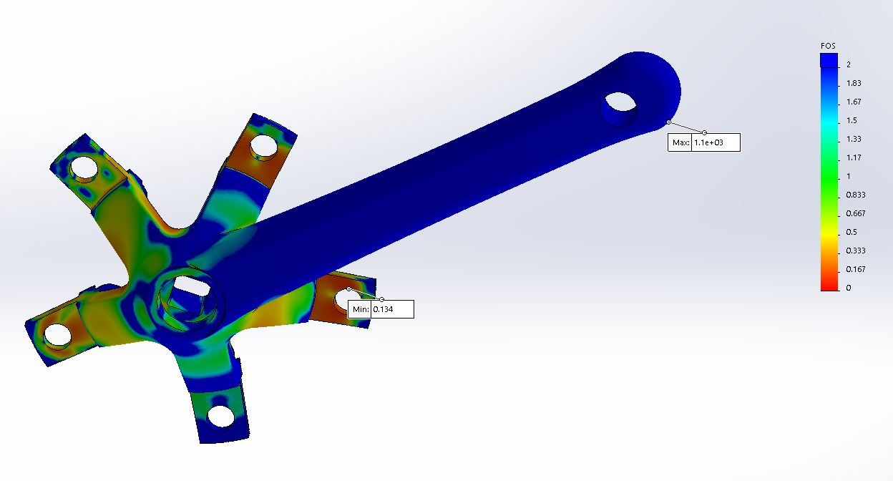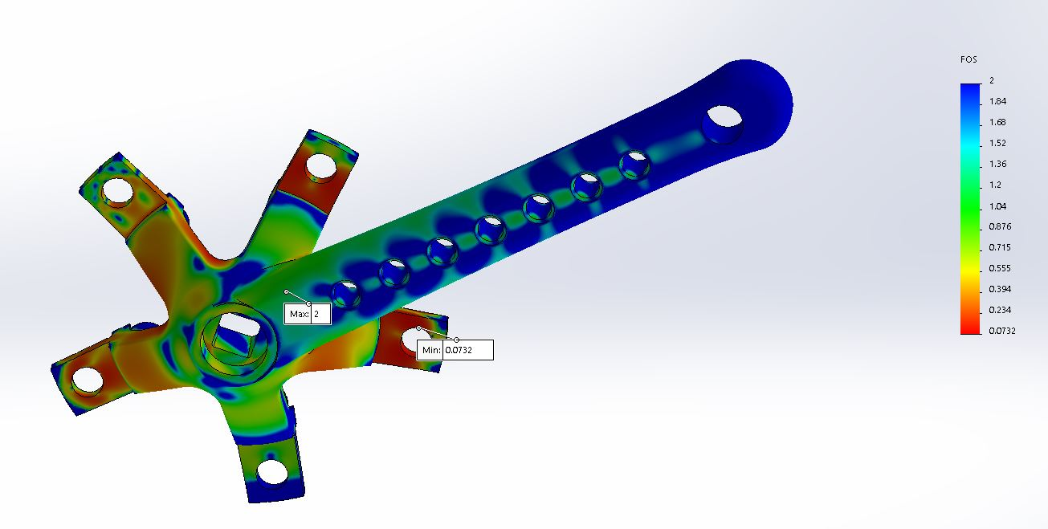
Figure 32 - Comparison between the original component and optimised iteration concerning factor of safety (FOS).

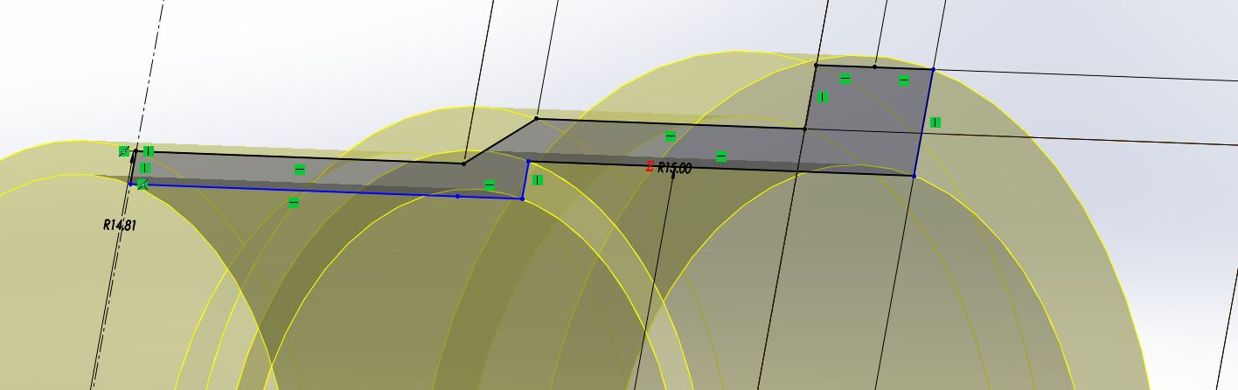
Figure 33 - Equation Usage.

