

ECPS6001: Psychology Empirical Project
Research Proposal

Assessment Component 1: Research proposal (1,000 words) worth 10% of the overall module mark for the Psychology Empirical Project. The proposal form will be marked in line with the Level Six Grading Rubric. The boxes below will expand as you type.
Student Name and University ID number: | Stacey Joy- 1905942
Proposed Supervisor’s name: | Unknown

Suggested Research Title/Area: (between 10-15 words and must reflect the essence of your proposed research question, study design and study population and should be more specific than a broad topic area).

-Is artificial memory replacing human memory, recall test explores the benefits of artificial memory.
-analysis of variance explored in memory recall predicts poorer recall when answers are saved, due to over reliance on artificial memory.
- The affect Deception has on Memory recall and the role of images, text, gender and educational status.

Please state the aim and rationale of your study:
To understand if people rely more on technology than their own memory.
By testing deceived participants who believe answers are being saved and will not be asked to recall the information submitted, are able to recall answers as well as those who are not being deceived, inspired by the google effect study (Sparrow et al, 2011).
This study also aims to understand if education status, gender and word vs image have any effect on memory recall.
Please state the main research question(s):

- Does deception of the memory recall task have a worse recall rate than those who are not deceived?
- If deception has a negative affect on recall, can it be linked to education status or gender?
- If deception does not have a negative affect to memory recall, does education status or gender?
- Are images recalled at a higher rate than words?

Please state the hypothesis/hypotheses (if appropriate):

- Deception of participants will result in poorer memory recall.
- Participants in education will have scored higher on memory recall.
- Image Memory recall scores will be higher in both deceived and non-deceived participants than word recall scores.

What theory and empirical research evidence supports your research question? (Please provide a brief review of relevant psychological literature and theory and a minimum of eight references).

Atkinson & Shiffrin, (1968) MSM, Baddley,(1992) WM.
Sparrow et al, (2011) explored the affect wider access to internet had upon memory recall and found that due to the wider more frequent use of search engines such as google people were retaining less information. The term came to be called “the google effect” (Sparrow et al,2011). Wegner & Ward, (2013) also explore the effect the phenomena plays to human cognition and the role changes that have been seen to occur in memory recall. Thomson, (2018) explores the possibility that technology has tweaked human capacity for recall believing that brains will adapt further in future, while Haron et al, (2014) discuss and explore the possibilities of technology use and reliance in positively supporting recall of elderly generations, particularly those with recall issues.
Loprinzi & Frith, (2018) explore gender differences in memory recall and found that females had higher recall than males in both image and word recall however noted with age that female recall did decrease in comparison of males. Lowe et al, (2003) studied gender differences in recall of children and found females to have higher scores in verbal recall while males scored higher in visual recall. This literature reflects the possibility of positive and negative factors to the reliance of technology, the factors that age within educational status and gender could specifically have upon memory recall abilities.

Methodological Details

Please describe the intended participant group – including anticipated numbers, target population, and any specific inclusion/exclusion criteria:

Between 100 and 200 Participants will include students of school age, higher education students and non-students all within the UK.
2 questionnaires will be created, these will be-
1. Deception with words and images.
2. Non-deception with words and images.
Participants will complete only 1 questionnaire and groups will aim to be equally split demographically.
The results of this study will be analysed using two 2x2x3 ANOVA‘s, the study is expected to gain around 100-200 participants aiming to be split into 2 equal subgroups to participate in one of the questionnaires. Each group will aim to contain equal numbers of males/females and evenly matched in terms of educational status.

Please describe the anticipated design (e.g., Qualitative/quantitative, between/within-subjects, mixed design, regression, focus groups, interviews, experimental, questionnaire, etc.):

This study will be using two 2x2x3 ANOVA’s to assess the data of the questionnaires to note the differences between the subgroups, to better understand if one group has higher recall.

If relevant, include details of the…

- IV(S) and number of levels:
The first independent variable will be the participant group with 2 levels, Gender, this being a between subject variable
The second independent variable will be the questionnaire assigned to participant with 2 levels, Deceived, non-deceived, this also being a between subject variable.
The third independent variable will be the educational status of the participant and this will have 3 levels, School age student, higher education student and non-student.

- DV(s):

The dependent variable in the first ANOVA will be the accuracy of memory recall of words

The dependent variable in the second ANOVA will be the accuracy of memory recall of images

What materials/measures are you planning to use for data collection? (E.g., questionnaires, tests/tasks, interview schedules, auditory/visual stimuli, computer programme, etc. Be as detailed as possible here - what specific topics/measures/scales/instruments will you be using and what will you do with this data?)
Questionnaire, containing words and images to be tested in memory recall task
see Appendices 1. Answers will be analysed and marked against demographics, applied to SPSS for further in-depth analysis, all being carried out on a password protected computer.
Words are used from cluster groups while images are at random containing some of the listed words.
Questionnaires to be carried out on personal I.T equipment or school computer facilities.

Please describe the study procedure (what will your participant have to do from start to finish? It should be clear from this how you are actually planning to carry out your study, and what will happen to participants):

Students from primary school will have consent from parents, teacher as well as self-consented to take part in this study, participants over the age of 18 will also have given consent, See Appendices 2 for consent forms, Appendices 3 for information sheets and Appendices 4 for debrief.
Participants in primary school will be using a school computer to take part in one of the two questionnaires which will be accessed through a weblink that will have been provided for use. Participants from outside the school setting will be sent a link to complete for one of the two questionnaires.
Depending on which questionnaire they receive they may or may not be deceived. They will be asked to make a selection and be advised they will/will not be saved and then will go onto complete the remainder of the task See Appendices 1 for the questionnaire task.

Please describe the data you will obtain and how it will be analysed (e.g., test or questionnaire scores calculated as a mean and analysed quantitatively, recorded verbal reports analysed qualitatively, etc.):

The quantitative data collected will be the scores from the questionnaire.
The results will be calculated and analysed in SPSS
Results will also be calculated to find scores of genders, image vs word recall and education status to discover if there is significant difference.

If relevant, what statistical test will you use and how will your data be analysed through this test (e.g., two-way ANOVA, Multiple Regression, Chi Square, etc.):
To analyse the data two 2x2x3 Anova’s will be completed, the first will look at the rate of word recall while the second will look at the recall of images, both will be looking to see if gender or educational status have a significant affect.

If relevant, what qualitative analysis will be used (e.g., IPA, Thematic analysis, etc.):

Reference list.

Atkinson, R. C., & Shiffrin, R. M. (1968). Human memory: A proposed system and its control processes. In Psychology of learning and motivation (Vol. 2, pp. 89-195). Academic Press.

Baddeley, A. (1992). Working memory. Science, 255(5044), 556-559.

Haron, H., Sabri, S. M., & Jamil, N. (2014). Exploring technology use in reminiscence for elderly knowledge recall. Aust. J. Basic & Appl. Sci, 8(5), 469-477.

Loprinzi, P. D., & Frith, E. (2018). The role of sex in memory function: considerations and recommendations in the context of exercise. Journal of clinical medicine, 7(6), 132.

Lowe, P. A., Mayfield, J. W., & Reynolds, C. R. (2003). Gender differences in memory test performance among children and adolescents. Archives of Clinical Neuropsychology, 18(8), 865-878.
Sparrow, B., Liu, J., & Wegner, D. M. (2011). Google effects on memory: Cognitive consequences of having information at our fingertips. science, 333(6043), 776-778.

Thomson, H. (2018). Is technology making my memory worse?. New Scientist, 240(3201), 38-39.
Wegner, D. M., & Ward, A. F. (2013). How Google is changing your brain. Scientific American, 309(6), 58-61.

Appendix (not included as part of the 1,000 words but must still be completed)
APPENDICEIES 1.
- The deception task will be as follows:
This task will ask you to select ONE of the following answers for each question. There is no need for you to try and remember the selections as all answers WILL be saved and WONT need to be recalled. These answers will be calculated at the end of the questionnaire to see if any links between the images and words can be made.
The non-deception task as follows:
This task will ask you to select ONE of the following answers for each question. The answers are NOT being saved and you WILL be asked to recall your answers.
1. Horse
Cat
Dog
Fish
Bird
2. Orange
Yellow
Blue
Green
Black
3. Table
Chair
Desk
Bookcase
Bed
4. Teacher
School
Student
Homework
Class
5. Apple
Banana
Kiwi
Grape
Margo
(all of the following images are from google images- would I need to reference each individual picture in a reference list or are they able to be used freely in this format?)
6.
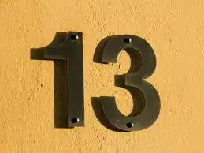 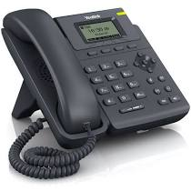 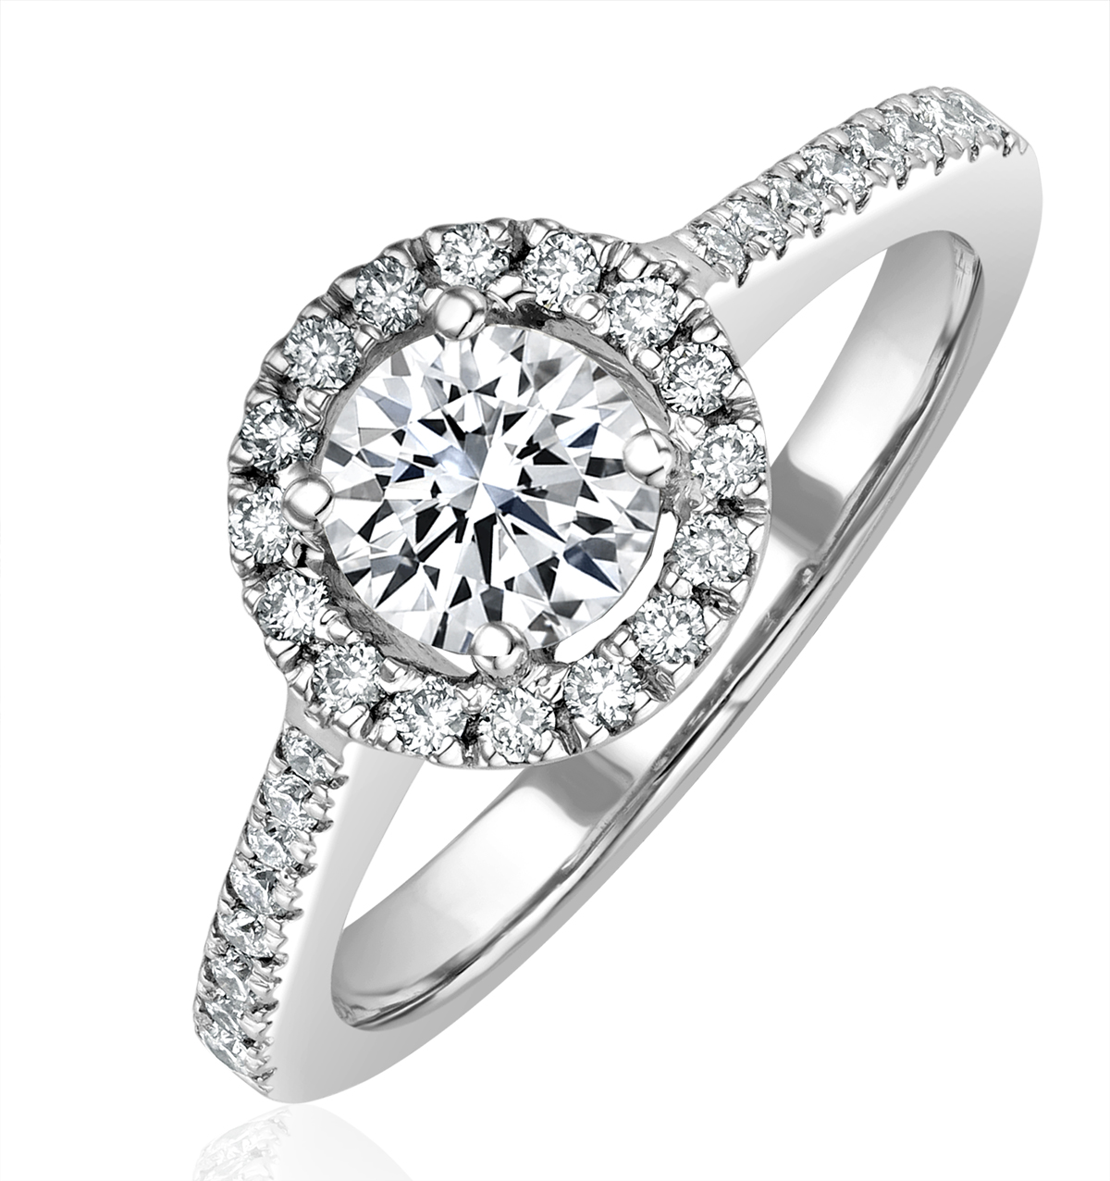 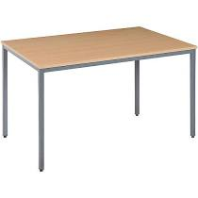 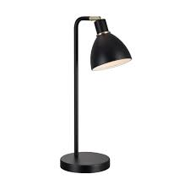
7.
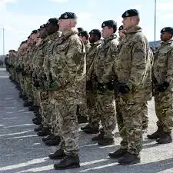  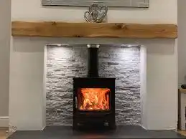 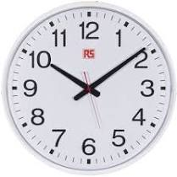 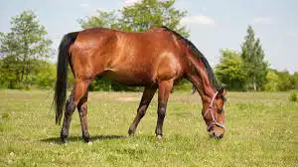
8.
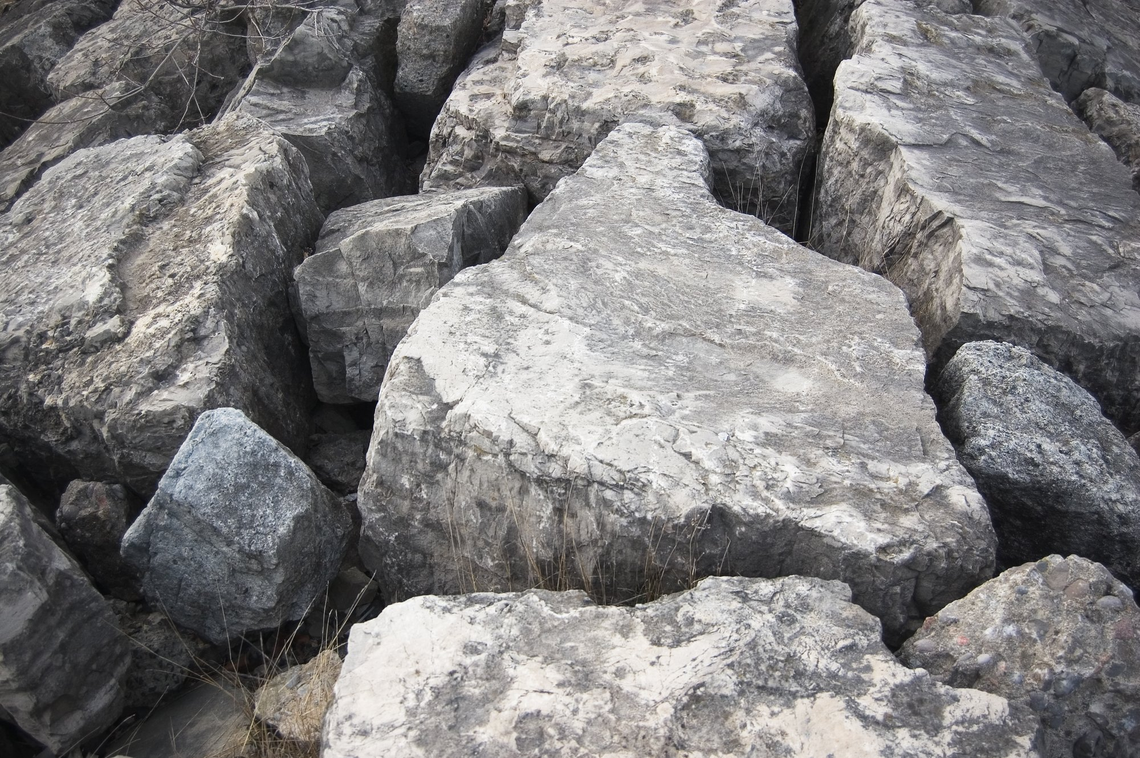 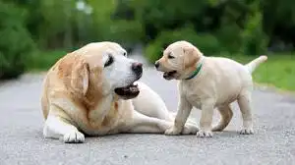  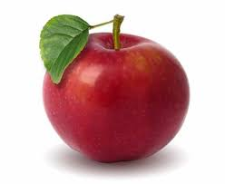 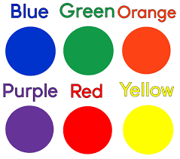
9.
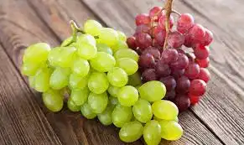  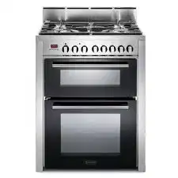 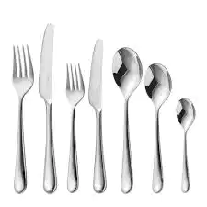 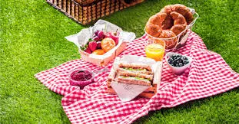
10.
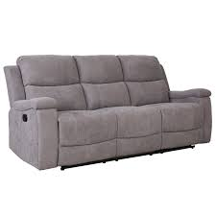 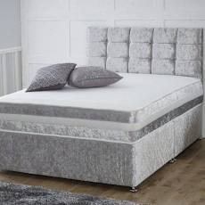 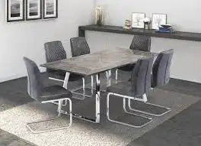 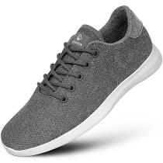 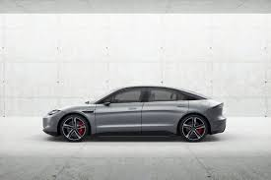
Thank you for completing this part of the questionaire.
You will now be asked to recall all of the answers you selected.
(answers will be in shuffled positions but following the same format E.g Q1 will have the same answers just shuffled in order).
Decieved participants:
Thank you for taking part and completing this questionnaire, you WERE misled at the start of this questionnaire. You were told answers would be saved and that you would not have to recall the selected answers, the reason you were misled is the nature of this study was to understand if reliance on technology alters our own memory recall. Results will be calculated against those who were not misled in the hopes of gaining better understanding of this. Your participation has been valued and appreciated.
APPENDIECIES 2.
Adult consent form.
Consent form for parents of children.
APPENDICIES 3.
APPENDICIES 4.

- Ethics: Describe the main ethical issues of your study and explain how you will address them here (Refer to the BPS ethical guidelines and address all issues not just informed consent. Please note all students will need to complete a full ethics form, which must be approved prior to any data collection commencing).

Internet-mediated research (IMR) guidlines will be considered to ensure the safety of any online information provided.
All names will be anonymous, and a pseudonym will be created by the participant.
Consent forms and information sheets will be completed prior to any participation, and any child under the age of 18 will have parent or guardian approval and consent.
Debrief sheets will be given out at the end of the task and any support the participant needs will be offered.
BPS ethical guidelines will be adhered to.
There is a possibility that due to deception in one of the questionnaires it could cause harm to participants, however this is likely to be of minimal risk.
Due to the nature of the task being memory recall this could also cause upset or psychological harm to the participant. To avoid and keep any harm and upset of participants to a minimum, a full debrief will be caried out at the end of the task, will contact details for support available.
UWTSD Research Ethics & Integrity Code of Practice
UWTSD Research Data Management Policy

