Course: Foundation Degree in Inclusive Education.
Module: Celebrating Language and Culture-Belonging to Wales
Module code: SJIE5004



(Rheilffordd Dyffryn Conwy, 2018).
(Wales Online, 2018).
^{Contents.}
^{Rationale-} ³
^{Overview of activities-} ⁴ ⁻ ⁶
^{Evaluation-} ⁷
^{Appendices-} ⁸ ⁻ ¹⁴
^{References.} ¹⁵ ⁻ ¹⁶

The aim of this portfolio is to discuss activities in the educational setting that promotes the Welsh language and culture. The author will link in Welsh policies as well as discussing theory. Learning about Welsh culture and exploring the language has a bigger emphasis in Wales today. Throughout History the amount of people speaking Welsh as well as Welsh in education has changed dramatically. It is very important that we keep the history of Wales and the language alive through future generations. The Welsh heritage school initiative, through its yearly competition aims to “enable [children and young people] to value their heritage and help in its preservation” WHSI (2019). Learning about our country and its history gives us a sense of belonging. As stated in Nation Cymru (2017) Welsh identity is strongest in its linguistic heartland. That is no coincidence, it shows that Welsh language is an integral part of Welsh identity. The way in which Welsh has been taught in schools has to say the least changed hugely over time. The Welsh language was nearly brought to extinction with the treachery of the blue books and the introduction of the welsh not back in 1987. The Welsh Not prevented children from speaking Welsh in schools and if caught they were punished. In order to get through education during that time children were forced to learn and use English, some children who had only ever spoken welsh. This had a massive impact on the amount of Welsh spoken in Wales, along with the industrial revolution, during the 19th century brought a higher rate of immigration to Wales most of them being from England and only speaking English. Changes in Welsh education have been ongoing for centuries; however, the biggest change has come more recently with the introduction of a more adaptable and inclusive curriculum which has welsh language and culture at the heart of it. An action plan set out by the Welsh government (2017) talks about the vision to enable all learners to develop their Welsh language skills and to use these skills confidently in everyday life. In order to achieve the vision, the aim is to build sustainable provision for the future generations. Something that the implementation of the new curriculum for Wales will ensure. Welsh education has most recently been on a reform journey. According to OECD (2017) The disappointing PISA results in 2009 showed Wales was far from providing an inclusive education for all welsh citizens. This resulted in a realisation that there was a need for change. In 2011 wales launched a school improvement reform, introducing several policies to improve the quality of the school system. Schools are central to sustaining not only the language of wales but its history and culture. “The disappointing performance of Wales in successive PISA surveys has been and remains the significant driver for change” (Successful Futures, 2015). Most learning is done at school and for a lot of young people school is their first experience of the welsh language and culture if it is not spoken at home. Setting A is a school for children with additional learning needs, aged 3 to 19 years of age. Each year the school takes part in several activities to celebrate being ‘welsh’. From yearly Eisteddfod’s to celebrations on St David’s day. The author will discuss setting A’s involvement in the Welsh Heritage school’s initiative competition.

According to the Welsh Heritage Schools Initiative (2020) The initiative was launched in 1990. An annual competition is held for schools in Wales to show their projects, which are then judged. In one’s setting they take part in the welsh heritage project every year. The whole school have an input into the project and each class produces many pieces of work appropriate to their ability to put forward for judging. It gives the school a real Welsh feel over the time in which the evidence is being produced and a chance for everyone involved to learn more about wales and its culture. Each year the initiative provides a theme in which all schools need to work from, for example, welsh myths and legends. “Its aim is to encourage young people in schools in Wales to take a greater interest in their heritage and the contribution made to it by their families and communities” (WHSI, 2020). The theme encouraged pupils to find out about historic myths and legends of wales. The project is inclusive for all ages and abilities and allows learners to become immersed in the Welsh culture which enables them to learn more about the history and culture of wales. As set out in the review of the curriculum by Donaldson (2015) the principles of the curriculum design should be based on Welsh values and culture. These would have been used to evaluate practice and guide proposals for the future. This leads onto the development of the new curriculum for Wales 2022. The curriculum aims to “instil learners with passion and pride in themselves, their communities and their country” (Education Wales, 2020). The work undertaken within the competition address’ many of the requirements in most areas of learning in the new curriculum for Wales, as shown in the school’s curriculum cymraeg policy (see appendix 1). According to Education Wales (2020) there is a huge importance for the curriculum to be inclusive. It will draw on the cultural heritage, experiences and perspectives of Wales. This will allow learners to appreciate the contribution that everyone can make to within their community. Enabling them to explore and develop their knowledge about local, national and global matters. According to Aubrey and Riley (2019) There are several educational theories which have been disputed, modified and sometimes disregarded. However, there are theories which have an influence on where education is today and the way in which children learn within the classroom. The theory of learning through working together. Lev Vygotsky developed a theory called the zone of proximal development (ZPD). According to pound (2008) The theory is based on working with a more skilled or experienced partner, may that be a peer or an adult, in order to learn from them. The heritage project encourages working together as well as independently. There were a wide range of abilities within the class and during this term their targets were linked to attention and concentration. A lot of teaching was done through attention autism, this is how the author taught the class about this legend as the sessions are enjoyable and engaging. Hitting individual targets as the topic was being taught. “The attention autism approach provides the child with an experience worth communication about” (Drum Beat ASD, no date). Attention Autism believes that individuals work best when sessions are motivating and creative because what we remember are shared experiences. Each session is broken up into stages, stage one is the bucket where everyone attends to the same thing, the teacher pulls out exciting things, often linked to the topic. When the pupils see the bucket, they gather around excited to find out what is in the bucket (see appendix 2). Stage 2 is where pupils sustain attention for longer periods of time. During the activity the author simply tells the story of Y Draig Cymru. whilst keeping attention with flour shaking on black paper the image of a dragon. (see appendix 3). Stage 3 is where the pupils must take turns. This stage includes vegetable printing, using ingredients from the famous welsh soup cawl. the pupils practiced saying colours and counting in welsh (see appendix 4). Stage 4 is where the pupils complete independent work modelled by an adult and visual instructions are provided (see appendix 5). After the demonstration they complete their work independently (see appendix 6). Stage one and two are all about attention, stage 3 is all about turn talking although each child has to wait their turn they all help and encourage each other, for example, when printing the vegetables the children had to count in welsh if possible. for those who found this difficult their peers and adults counted whilst they counted along with them. Working together allowed the more able pupils to encourage and help the less able pupils to count in welsh. According to Aubrey and Riley (2019) The zone of proximal development discuss’ the difference between what a child can do alone and what they can do through collaboration with a more capable peer or adult. Vygotsky believed that “education should match the cultural and historic needs of learners” (Aubrey and Riley, 2019). This view was also embraced by Paulo Freire. According to Aubrey and Riley (2019) Freire recommended that teachers prepare a pedagogy which embraced the learners social, historical and cultural background. The critique of Vygotsky’s theory on the ZPD is that the child will become dependent on the adult or more able peer and therefore may not have the confidence to complete tasks alone. During stage 4, the pupils are strategically sat by a peer they can learn from. The more able pupils helped the less able pupils but not by doing their task for them, but by modelling and completing their work following the instructions. It is evident that when the less able pupils were unsure of what was next, they were able to look at their partners work for clarification. Learning through experience is discussed in a theory by David Kolb. According to Aubrey and Riley (2019) Kolb built on theories by Dewey and Piaget. He looked at ways in which learning could be enhanced and identified that experiences can be transformed into knowledge. “Kolb saw learning at the process whereby knowledge is created through the transformation of experience” (Aubrey and Riley, 2019). Sitting and talking about something in a classroom does not have the same impact on young people as attending a motivational and exciting session in which all children are engaged and ready to learn. According to the Welsh Heritage Initiative (2020) the project requires learners to research, collect materials, analyse and evaluate. All skills which link into the New curriculum for Wales and its four key purposes. According to HWB (2020) Children and young people should be able to experience an insight into the culture, people and history of wales. When their understanding of these is increased, learners can develop an ability to relate to and demonstrate several different skills. When we think about teaching and learning welsh sometimes the culture is not always the first topic we think about, it is usually speaking the language. In setting A the use of incidental welsh is used throughout the day. There is a range of abilities within the school, the amount of welsh used depends on the needs and abilities of pupils within each class. With this group of pupil’s welsh is used during each lesson. The welsh language is taught through a designated welsh lesson, but the vocabulary learnt is then reinforced through the week in all other areas of learning. As stated in setting A’s welsh policy (see appendix 7) Setting A “encourages all pupils to achieve by helping pupils acquire and develop skills, knowledge and understanding and then applying these to lead confident, healthy, independent lives” (School policy, 2019). When learning a language, you need to be hearing and speaking it daily in order to develop to your full potential, to build confidence and eventually for it to become the ‘norm’ for people to use it. Sabbatical courses have been launched to increase the quality of teaching the language, places are offered to both teachers and teaching assistants. When staff have returned from the courses, one person is not enough to build the confidence of everyone in school no matter how much they try. A lot of adults in school are reluctant to give it a go because of fear of getting it wrong or being corrected by others, for welsh to grow we need to support and encourage each other no matter what the person’s ability may be. It takes a combined effort of everyone in order to successfully drive something like the welsh language in a school setting.
The Welsh Heritage Schools Initiative caters for all ages and abilities. When judged the categories are primary, secondary and special education. This means that work is judged against those who work at a similar level to the others in the category. Therefore it is a fair process. The Heritage Project is a whole school effort and is really celebrated due to the effort everyone has put into it. The pupils take pride in showing what they have made. As mentioned, setting A is a school for children with additional learning needs. A lot of our pupils have communication difficulties and therefore find it hard to communicate using their first language let alone introducing another. The amount of welsh in this setting differs depending on the needs of the class and unfortunately welsh does not always take preference in their learning. Despite this fact the welsh language in setting A where appropriate is really pushed and used hugely with the pupils. As a school we celebrate being welsh through all areas of the curriculum at a level that suits the individual’s abilities and needs. The heritage project encourages cross curricular learning, which means it is inclusive to the aim of the new curriculum for wales. According to Aubrey and Riley (2019) John Dewey developed a theory on education in which he believed that teaching should not be based on fixed restrictions. Much like the old curriculum where teaching, especially in secondary schools, is done through a subject-specific curriculum. Dewey believed in a learner centered approach that encouraged curiosity. He believed that learning in schools was disconnected from the real world and school should prepare pupils for real life. Dewey has been referred to as “the philosopher who has had the greatest influence on education in the last century” (Aubrey and Riley, 2019). Dewey, among others have influenced a need for change in education over the years. The new curriculum encompasses welsh language and culture within it and recognises “that Wales, like any other society, is not a uniform entity, but encompasses a range of values, perspectives, cultures and histories: that includes everybody who lives in Wales" (Education Wales, 2020). The welsh spoken in setting A has increased hugely over the years. The heritage project gives the whole school a focus and increases the welsh feel. Automatically more welsh is generally spoken around the school as everyone is embracing the Welshness. Setting A has encouraged and incorporated Makaton across the whole school and it is now used in every class no matter what the abilities of the children. Although welsh has increased over the years in this setting, it would take this type of approach to really embed the language used in school. It would require a whole school effort and for some reason it has never been adopted by enough staff to really make the difference for everyone. According to BBC News (1999) the revival of the language has been strengthened by the fact that welsh has been made compulsory in English-medium schools and the increasing number of English-speaking families who are choosing to send their children to welsh medium schools. The language is on the rise all over wales and even though none of the pupils in setting A come from welsh speaking families the focus and push on welsh has increased and will continue to increase as we strive for a bilingual wales.

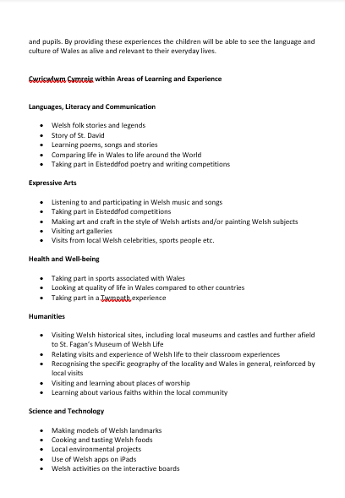
^{Appendix 1.} ^{The Curriculum Cymraeg policy.}

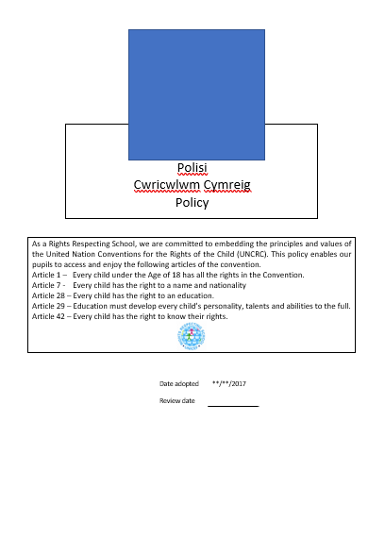
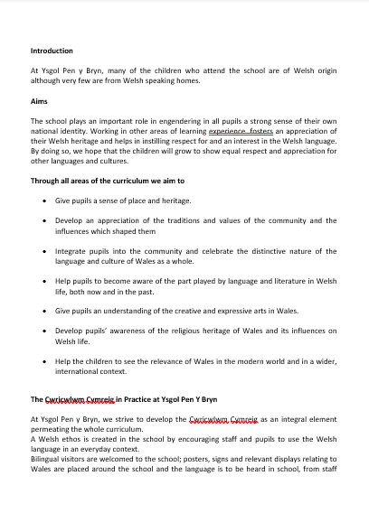
(School policy, 2017).

^{Appendix 2.} ^{Stage 1- The Bucket.}

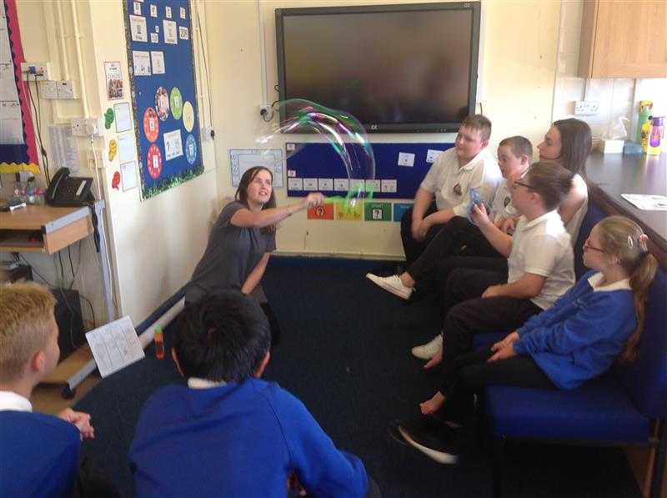

(Author’s image).
^{Appendix 3.} ^{Stage 2- Dragon Flour Shaking}

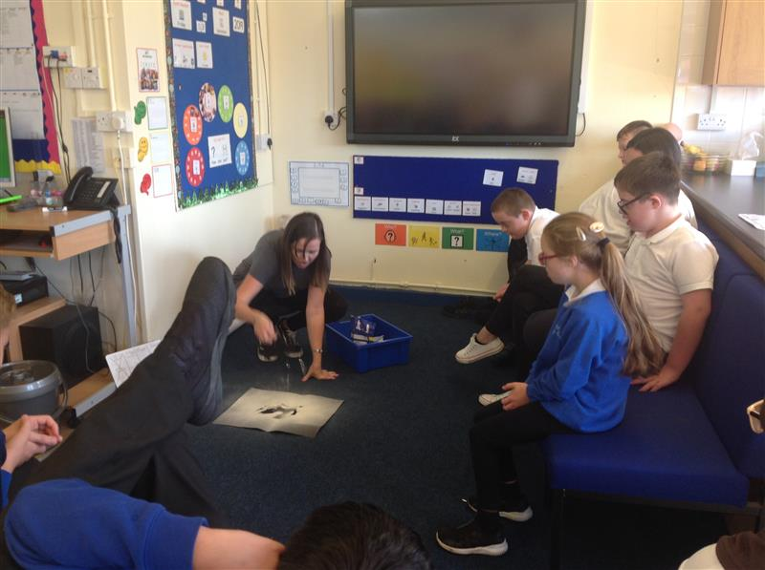
(Author’s image).
^{Appendix 4.} ^{Stage 3- Vegetable Printing.}

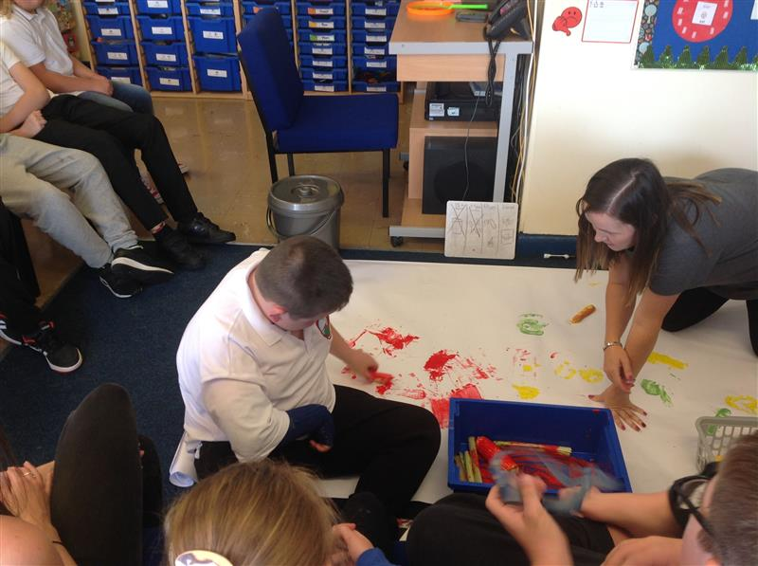
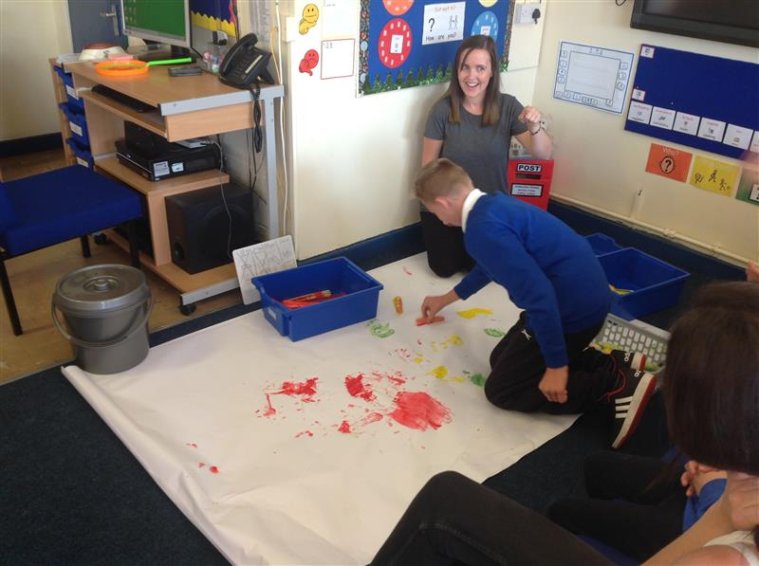
(Author’s image).
(Author’s image).
^{Appendix 5.} Stage 4- Activity Instructions.
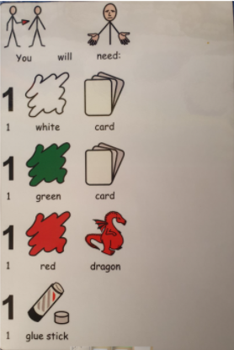
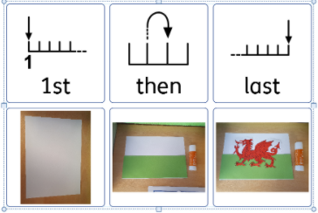
(Author’s image).
(Author’s image).
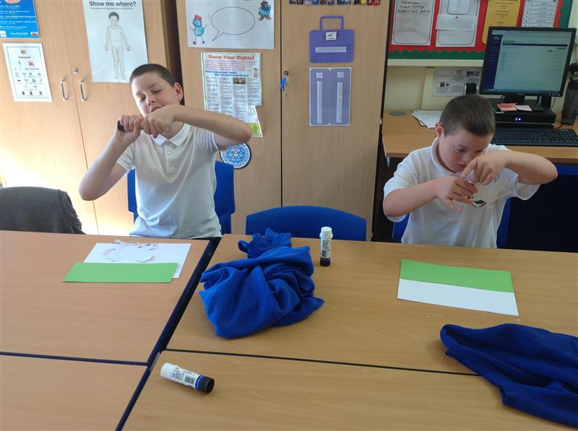
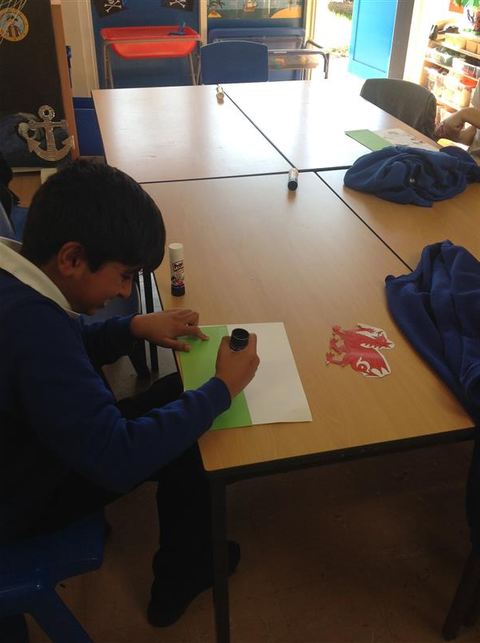
^{Appendix 6.} ^{Stage 4- Welsh flag Activity.}
(Author’s image).
(Author’s image).
^{Appendix 7.} ^{Welsh Policy.}
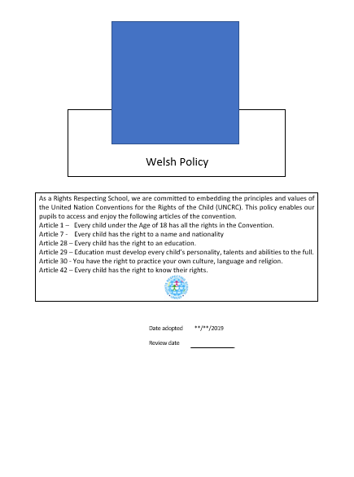
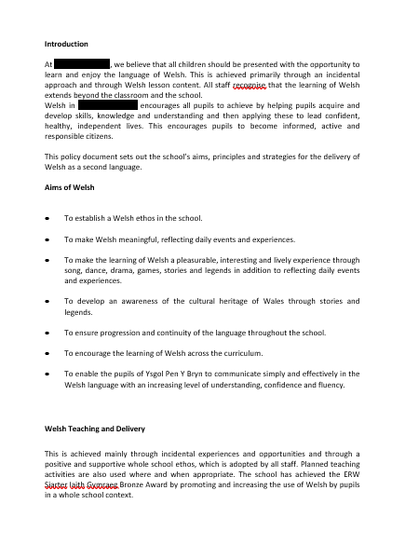
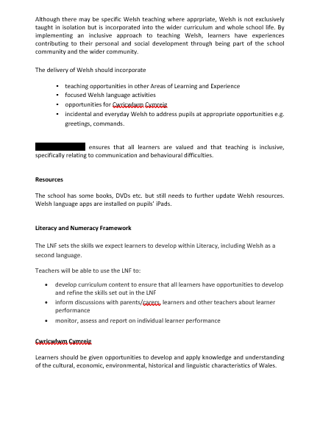
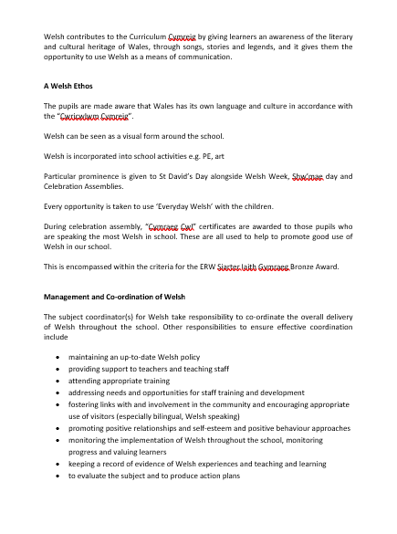
(School policy, 2019).

^{References}
Aubrey, K. and Riley, A. (2019) Understanding and Using Educational Theories. London: SAGE.
BBC News. (1999) Welsh Becomes a must for school children. Available at: http://news.bbc.co.uk/1/hi/wales/434738.stm (Accessed: 25th October 2020).
Donaldson, G (2015) Successful Futures. Available at: https://gov.wales/successful-futures-review-curriculum-and-assessment-arrangements (Accessed: 27th October 2020).
Drum beat asd. (No Date) Attention Autism. Available at: http://www.drumbeatasd.org/attachments/download.asp?file=102&type=pdf (Accessed: 7th October 2020).
Education Authority. (2017) EA Educational Visits Interim Guidance for Schools. Available at: https://www.eani.org.uk/sites/default/files/2018-10/EA%20Educational%20Visits%20Interim%20Guidance.pdf (Accessed: 24th October 2020).
Education Wales. (2020) Curriculum for Wales guidance. Available at: https://hwb.gov.wales/curriculum-for-wales/?_ga=2.55795880.2009456370.1603535253-338950664.1592252583 (Accessed: 24th October 2020).
HWB. (2020) Guidance to help schools and settings develop their own curriculum, enabling learners to develop towards the four purposes. Available at: https://hwb.gov.wales/curriculum-for-wales/languages-literacy-and-communication/statements-of-what-matters (Accessed: 4th November 2020).
Nation Cymru. (2017) Four Reasons why you should support the Welsh language. Available at: https://nation.cymru/opinion/four-reasons-why-you-should-support-the-welsh-language/ (Accessed: 24th October 2020).
OECD. (2017) Welsh Education Reform Journey. Available at: http://www.oecd.org/education/The-Welsh-Education-Reform-Journey.pdf (Accessed: 25th October 2020).
Pound, L. (2008) How Children Learn. London: Step forward publishing limited.
Rheillffordd Dyffryn Conwy. (2018) 5 Traddodiaid Cymraeg. Available at: https://www.conwyvalleyrailway.co.uk/cy/2018/03/01/5-welsh-traditions/ (Accessed: 4th November 2020).
Wales Online. (2018) The Reason Wales has a big red Dragon on its flag. Available at: https://www.walesonline.co.uk/news/wales-news/reason-wales-great-big-red-15433821 (Accessed: 4th October 2020).
Welsh Government. (2017) Welsh in Education: Action plan 2017- 2021. Available at: https://gov.wales/welsh-education-action-plan-2017-2021 (Accessed: 25th October 2020).
WHSI. (2020) Welsh heritage Schools Initiative. Available at: https://www.whsi.org.uk/ (Accessed:8th October 2020).

