

Student Name: Shaan Aboobacker
Student ID:2503771
Programme:Master Of Business Administration

Module Name: International Marketing Principles And Practices
Module Code: LCMB7026

Lecturer’s Name: Tushara Balendran

Term 1

Table of Contents
Section 1 4
1. Introduction 4
2. Company Overview & Strategic Context 5
3. Comparative Market Analysis (PESTEL) 6
4. Cultural Analysis 10
4.1 Hofstede Overview 10
4.2 Cultural Comparison 10
4.3 Implications for Mercedes 10
4.4 Critical Evaluation 10
5. STP Analysis 12
5.1 Segmentation 12
5.2 Targeting 13
5.3 Positioning 14
5.5 STP Comparison Table 16
6. Marketing Mix (7Ps) 17
6.1 Product 17
6.2 Price 17
6.3 Place 18
6.4 Promotion 18
6.5 People 19
6.6 Process 19
6.7 Physical Evidence 19
6.8 7Ps Comparison Table 20
7. Directional Development Strategy (USA Focus) 21
8. Ethical Issues 22
8.1 Environmental Ethics 22
8.2 Status Marketing 22
8.3 Cultural Ethics 22
8.4 Legal vs Ethical 22
9. Recommendations 23
10. Conclusion 24
Section 2: Reflective Account 25
1. Introduction 25
2. Description 25
3. Feelings 25
4. Evaluation 26
5. Analysis 26
6. Conclusion 27
7. Action Plan 27
References 28

Section 1

1. Introduction
In this report, the operations of the international marketing strategy of Mercedes-Benz are critically analysed by comparing its operations in Germany and the United States. Marketing strategies of organisations should be adjusted to suit different economic, cultural and regulatory environments in markets in a highly globalised business world (Hasan, et al., 2024). Mercedes-Benz is one of the most prominent luxury automotive brands, which makes it an interesting case to investigate the standardisation or adaptation of international marketing strategies in different countries.
The domestic market in Germany would be an ideal country for the company, as it is a high-engineering country, the demand is mature, whereas the United States is a major international market with a great purchasing power and diverse consumer demands (Rodller , 2024). A comparison of these two markets helps to better understand the way environmental and cultural aspects can determine marketing decisions.
To support this analysis, some of the most important frameworks, such as PESTEL, cultural dimensions by Hofstede, STP (Segmentation, Targeting, Positioning), and the 7Ps marketing mix, are to be used. The report will assess the efficacy of the strategies of Mercedes-Benz and will also point out the areas where the strategies of the company can be improved in an international environment.

2. Company Overview & Strategic Context

Figure 1: Mercedes Logo
Mercedes-Benz is a technology-based and engineering-based luxury motor vehicle company of global origin with high quality and technology (Mercedes-Benz Group, 2026). Even though this positioning is a great source of competitive advantage, it operates in various markets differently depending on the expectations of consumers and the maturity of the market.
Germany is a stable and saturated domestic market, in which brand loyalty and engineering heritage strengthen the positioning of Mercedes-Benz (Li, 2022). The nature of the market is mature, limiting the potential for major growth and hence not as favourable to expansion. On the other hand, the United States is a very attractive market with high purchasing power, demand for luxury cars and SUVs, and technologically advanced products (Market, 2024). This makes the USA more strategically important in terms of revenue creation and long-term growth.
These two markets raise a very important strategic issue in which Germany encourages brand recognition and homogeneity, while the United States needs greater product and marketing strategy flexibility. Therefore, Mercedes-Benz must strike a balance between global standardisation and local responsiveness in its effort to compete in both markets.

3. Comparative Market Analysis (PESTEL)
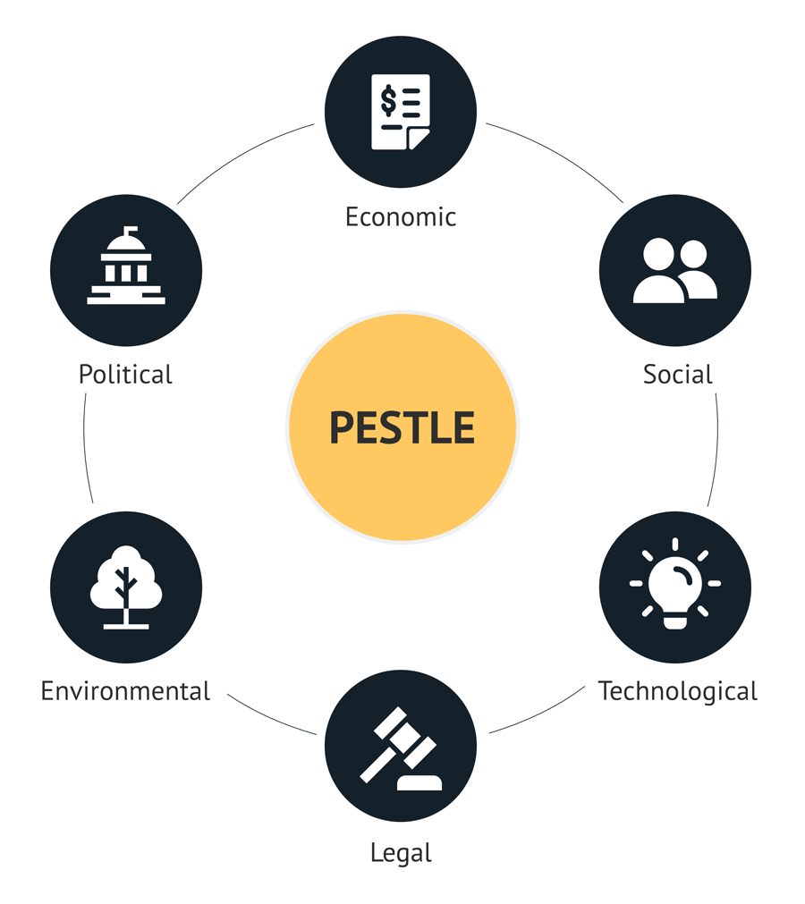
Figure 2: PESTLE ANALYSIS
Factor | Germany (Home Market) | USA (Host Market) | Comparative Evaluation (Critical Insight)
Political | Germany is a very stable political environment with a stable EU-oriented policy, which is conducive to long-term planning (Edelman Global Advisory, 2026). However, there exists a high cost of compliance and a low degree of flexibility due to strict government regulation, especially on emission and sustainability rules. This puts pressure on companies such as Mercedes-Benz to invest in innovation on a continuous basis. | Policy support of innovation in the USA, especially through EV incentives and infrastructure investment (Cain, et al., 2024). However, the frequent change of policies between administrations is uncertain, and trade wars and tariffs may impact foreign operations. | Germany is predictable yet restricting, making it favourable to consistency but limits strategic flexibility. The USA is less predictable but opportunity-oriented, which makes it more favourable to expand, even with a greater risk.
Economic | Germany has a stable and strong economy with high-income buyers (Trade, 2025). The automotive market is mature and saturated which restricts growth opportunities. The competition with local brands further limits market expansion. | The USA is a massive and lucrative luxury car market with suitable disposable income and a desire for premium cars, especially SUVs (Imarcgroup, 2024). The increased level of consumption contributes to the increase in sales volume and revenue potential. | Germany is economically stable but has slow growth, whereas the USA is very favourable for revenue and market expansion. This implies that Mercedes-Benz relies more on the US market for long-term growth.
Social + Cultural | The German consumers are rational, risk-averse, and quality-conscious towards engineering precision, reliability, and sustainability. Purchasing decisions are mainly functional, there is minimal focus on emotional appeal and status. | US consumers are individualistic and status-oriented with a lot of emphasis on lifestyle, brand image and identity. Luxury cars are regarded as a sign of success, and it boosts the demand for high-quality brands. | Germany supports functional positioning on engineering excellence, whereas the USA leans towards emotional and aspirational positioning. The USA is thus more conducive to luxury marketing and communication marketing must change.
Technological | Germany is known to have a global network in automotive engineering and manufacturing experience which forms a good foundation to innovate in the aspects of performance and safety (Zhou, 2024). However, there is a slower pace of digital technologies and AI-based experiences adoption. | The USA is the most innovative country in digital technology, artificial intelligence, and connectivity, and these are becoming more significant in new vehicles (The Hindu, 2024). High-tech features such as connectivity and self-driving functions are expected to be provided to consumers. | Germany is profound in traditional innovation, and the USA is favourable to digital progress. It means that Mercedes-Benz must exploit the US technological ecosystems to be competitive in future mobility trends.
Legal | Germany has strict legal regulations on emissions, safety and labour regulations. Although these add to quality and sustainability, they add to operational costs and diminish flexibility. | The legal system in the USA is disjointed with different regulations in different states, which makes compliance difficult. This makes legal uncertainty and operational risk more prominent, even though it is less restrictive in certain aspects. | Germany is legally restrictive and expensive, whereas the USA is moderately unfavourable because of the complexity of regulations. Both demand high compliance measures although Germany places more cost pressures.
Environmental | Germany has severe environmental laws, which are pushing the adoption of electric vehicles (‌Van, et al., 2023). This poses short-term cost problems but promotes long-term sustainability and innovation. | The USA supports the use of EVs by offering incentives and increasing consumer demand, but the policies depend on the state (Akinsooto, et al., 2025). Sustainable mobility is growing rapidly in the market. | Germany is challenging in the short-term, but favourable long-term, whereas the USA is extremely favourable to the development of the EV markets. Both settings seek to drive Mercedes-Benz towards sustainability, but the USA has quicker commercial prospects.

The PESTEL analysis shows that Germany offers a very stable and controlled environment and this strengthens the brand credibility of Mercedes-Benz and their engineering image. However, its market maturity and rigid regulatory environment restrict growth opportunities and strategy flexibility, which would make it less favourable in the case of expansion. Conversely, the United States is a more vibrant and opportunity-oriented environment, marked by high economic demand, preference for luxury cars by consumers and fast technological development. These considerations make the USA much more favorable to revenue generation and growth in the long run. However, this benefit comes with the added advantages of greater political uncertainty and legal complexity, adding to the operational risk. Overall, the USA is a more strategically appealing market whereas Germany needs to preserve brand identity and innovations. This comparison shows that Mercedes-Benz needs to take a moderate international approach that blends global standardisation with market-based adaptation to ensure maximum competitiveness.

4. Cultural Analysis

4.1 Hofstede Overview
Hofstede's Cultural Dimensions Theory explains how consumer behaviour and choice are influenced by national culture. It features six dimensions, namely: Power Distance, Individualism, Masculinity, Uncertainty Avoidance, Long-Term Orientation, and Indulgence, as the most used dimensions in international marketing to adjust to countries and learn differences in consumer expectations and preferences (Yu, et al., 2025).

4.2 Cultural Comparison
There are notable cultural differences between Germany and the USA. Both countries have low Power Distance, which encourages consumer empowerment, benefiting Mercedes-Benz. The USA scores higher in Individualism (91 vs 67), supporting personalised and lifestyle-focused marketing, while Germany scores higher in functional value (Varma, et al., 2025). Both countries have high scores in Masculinity, aligning with performance-oriented branding. Germany's high Uncertainty Avoidance index favour’s reliability and engineering precision, whereas the USA's lower score suggests a greater openness to innovation, making EV expansion more suitable there (EBSCO, 2025). Germany's emphasis on sustainability is helped by its high Long-Term Orientation, while in the USA, a high Indulgence score supports emotional and luxury branding.

4.3 Implications for Mercedes
Such cultural variations dictate that Mercedes-Benz must use a differentiated strategy. Marketing in Germany is based on engineering excellence, durability and efficiency, which are the same as risk-averse and long-term oriented consumers. Conversely, the USA needs emotionally touching campaigns that emphasise status, innovation and driving experience. Strategies of the products are also not the same, with Germany requiring efficient sedans and the USA preferring SUVs and luxury. The customer experience expectations are different because German consumers are more interested in technical knowledge, whereas U.S. consumers give preference to personal attention. Thus, brand relevance, customer satisfaction and competitive positioning are boosted in the two markets through cultural adaptation.

4.4 Critical Evaluation
The Hofstede model is very easy to use, and it offers a systematic way of comparing cultures in global marketing. It has, however, been criticised for being old-fashioned and overly generalised because it presupposes cultural homogenisation in countries and not dynamic cultural changes, which limits its suitability in contemporary international markets.

5. STP Analysis

5.1 Segmentation
Mercedes-Benz uses a multi-dimensional strategy of segmentation to cater to different consumer demands in Germany and the USA.
Demographic segmentation targets high-income people and is generally aged between 35 and 65, which includes professionals, executives and businesspeople who have a good income (Cacija, et al., 2023). The brand is aimed at upper-middle and wealthy groups in both countries, but in the USA, younger wealthy consumers can also be added since credit access and leasing options are more abundant.
Psychographic segmentation is vital in the luxury automotive industry (Barakati, et al., 2024). Concerns of rational and value-focused behaviour in German consumers are primarily engineering quality, efficiency and sustainability. On the contrary, the American consumers are focused on lifestyle, status, and personal identity, and emotional appeal and brand image have a greater role. With the help of the VALS (Values and Lifestyles) model, Mercedes-Benz is directed mostly at the Achievers (status-conscious, success-driven consumers) and Innovators (high-resource individuals who prefer high-quality, technologically advanced products). The USA is also more concentrated around the Innovators, whereas Germany is more inclined towards Achievers, whose functional expectations are strong.
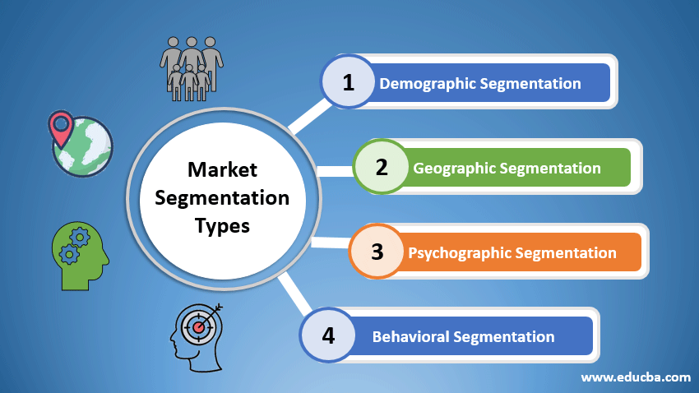
Figure 1: Segmentation Types
(Source: Petkar, 2020)
Geographic segmentation differentiates demand. In Germany, luxury car consumption occurs in rich areas like Bavaria and Baden-Württemberg since the industrial areas are performing well. In the USA, the market is centralised in the state of metropolitan areas such as California, Texas and New York that have higher disposable income and urban lifestyles, which makes them own luxury cars in greater numbers (Gao and Zhu, 2022).
Behavioural segmentation is concerned with usage behaviours, brand attachment and perks aspired (Sakhawalkar and Pawar, 2024). German customers are also highly brand loyal and have a longer ownership period, which appreciates reliability and long durability. On the contrary, the consumers of the U.S. tend to change brands and upgrade more often in search of innovation, improved technology, and improved driving experiences.

5.2 Targeting
Mercedes-Benz has high differentiated targeting strategy, where different products and different marketing strategies are being targeted to different segments in the country. The company is focusing on a rather safe and developed market in Germany, which is comprised of professionals, executives and family buyers who are concerned with reliability, precision in engineering and sustainability (Mercedes-Benz, 2022). It has a targeting strategy that is quality-oriented and cautious in purchasing behaviour, and high expectations about product life and performance.
In its turn, the USA market is larger and more varied, which means that Mercedes-Benz has a chance to appeal to several segments at once. These are the prosperous lifestyle customers, performance customers and technology buyers (Li and Wang, 2021). The target market has a very high number of younger high-income drivers and SUV buyers, with a solid demand for luxury SUV models like the GLE and GLS models (Dataintelo and Patel, 2019). The USA is more flexible and has more room to grow as compared to stability-centred targeting by Germany, where Mercedes-Benz can diversify its product portfolio and focus on marketing strategies more actively.

5.3 Positioning
Mercedes-Benz uses a differentiated positioning approach and has a global image of premium products. In Germany, the brand is placed as an emblem of engineering quality, reliability and technological excellence, which has a strong national heritage in the automotive industry (Mercedes-Benz, 2024). Marketing communication is focused on accuracy, effectiveness and long-term value, which is in line with the expectations in the consumer perspective on functional quality and sustainability.
Conversely, Mercedes-Benz is established as a luxury lifestyle and status in the USA, which is based on comfort, innovation, and aspirational living. Emotional appeal, driving experience and prestige are the factors that are highlighted in the advertising campaigns, affecting consumers who associate luxury cars with individual success and image (Ferris, 2021). The two-divided strategy will help Mercedes-Benz balance its global brands and the local culture so that it can compete better in both markets by addressing the unique consumer motivation factors.

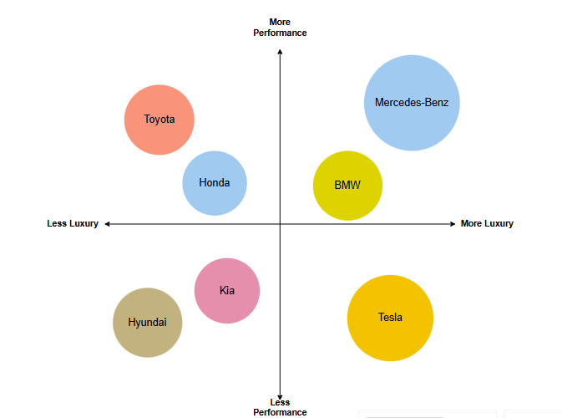
Figure 2: Perceptual Map
The perceptual map positions Mercedes-Benz in the high-luxury and high-performance segment alongside BMW and Audi. However, Mercedes tends more toward comfort and reputation in the USA, while in Germany it emphasises engineering precision. Tesla occupies a performance-innovation space, while mass-market brands remain in lower luxury segments.
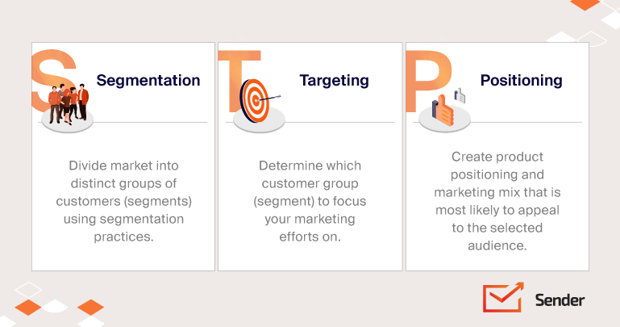
Figure 3: STP Analysis
(Source: Venckus, 2022)

5.5 STP Comparison Table
Element | Germany | USA | Key Difference
Segmentation | Rational, quality-focused, sustainability | Lifestyle, status, innovation-driven | Functional vs emotional
Targeting | Conservative, professional buyers | Diverse, comfortable, younger segments | Narrow vs broad
Positioning | Engineering excellence | Luxury lifestyle & status | Rational vs aspirational

6. Marketing Mix (7Ps)

6.1 Product
The product strategy used by Mercedes-Benz is partially standardised, but it has local modifications. The width of the product mix comprises sedans, SUVs, electric vehicles (EQ series), and performance cars, and the depth is shown in the number of variants, which include C-Class, E-Class, S-Class, and G-Class (Mercedes-Benz, 2023). Germany is more inclined towards the fuel-efficient sedans and hybrids that are in demand. In comparison, the USA is more interested in SUVs such as the GLE and GLS with a focus on comfort and size. The branding approach is also different as Germany emphasises the engineering quality and reliability, whereas the USA emphasises the luxury, lifestyle, and prestige.

6.2 Price
In both markets, Mercedes-Benz applies a premium pricing strategy, although the pricing strategies are different. In Germany, the consumers are comparatively sensitive to the price through high taxes, fuel prices and insurance with competitive prices and greater emphasis on ownership. Conversely, the USA market is more adaptable and leasing as well as financing occupy a large part of the sales, thus luxury cars are more affordable. The American consumers are less price-sensitive and relatively willing to pay for features, comfort and brand image. Consequently, the USA is more profitable, and in Germany, price positioning must be done carefully in line with the value perception (Czeczotko, et al., 2022).
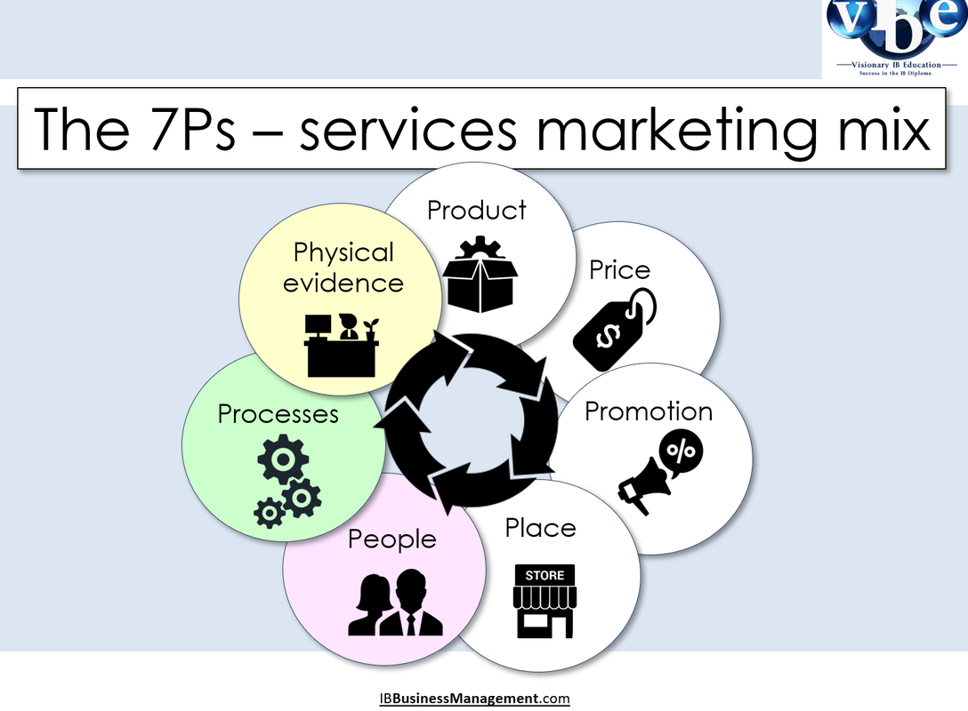
Figure 4: 7P's
(Source: IB, 2026)

6.3 Place
Mercedes-Benz has an established channel of distribution in both countries, although structurally different. In Germany, the company is dependent on direct dealerships and manufacturer-controlled channels, which make it consistent and have high control over the brand (McKinsey China, 2019). The market is less concentrated and immature. The USA, on the other hand, has a larger and more decentralised dealer network with massive operations, such as the Alabama plant. The USA distribution approach is focused on accessing and covering geographically scattered markets. Also, online platforms and digital showrooms are more developed in the USA, and this is indicative of more digital adoption in the USA as compared to Germany.

6.4 Promotion
The strategies of promotion vary greatly because of cultural preferences. Mercedes-Benz in Germany is applying rational and informational advertisement, which emphasises engineering quality, safety and efficiency. Technical and product-oriented campaigns are more in line with the expectations of the consumer, where functionality is concerned (Rezzano, et al., 2021). Otherwise, the USA has an emotional and aspirational approach, which emphasises lifestyle, luxury, and status. The adverts tend to focus on driving, comfort and personal achievement. The USA features more digital marketing, influencer campaigns, and experiential campaigns.

6.5 People
The element of the people indicates the difference in the service expectations. In Germany, the customers are professional, efficient, and technically knowledgeable in their requirements, and are highly valued for their expertise and reliability (Schilling, et al., 2023). Communications are more corporate and businesslike. On the contrary, U.S. customers appreciate relationship-based, personalised service, with customer experience and emotional involvement as the priorities. The USA salespeople are taught to develop understanding and provide a higher quality of experience in line with luxury branding. Such distinctions necessitate the need for Mercedes-Benz to adjust its employee training and communication style, as well as its service approach, to ensure that the culture of the two markets is satisfied and customer satisfaction is retained in the two markets.

6.6 Process
Germany has high uncertainty avoidance processes structured with high efficiency and consistency and high uncertainty avoidance, which is reflected in processes. The buying procedure is more conventional, and the desire is to have interactions in the dealership and a comprehensive analysis of the product. Conversely, the USA market exhibits a more mature digitalised process, such as online configuration, virtual showrooms, and online financing. In the purchasing process, customers want convenient, fast and flexible purchasing (Deshmukh, 2025). So, this is the hybrid strategy of Mercedes-Benz, which has more structured processes in Germany and more digitalised and customer-oriented experiences in the USA.

6.7 Physical Evidence
The physical evidence is important in supporting brand positioning. In Germany, Mercedes-Benz dealerships are characterised by minimalist design, technical accuracy, and functionality, which is in line with the brand identity of engineering (Peng, et al., 2026). Unlike this, U.S. showrooms are planned to provide the customer with a luxury and immersive experience, including high-quality interior design, customer lounges, and experiences. In the USA, branding is a more visual way of expressing the lifestyle and prestige (Bae and Jeon, 2022).

6.8 7Ps Comparison Table
Element | Germany | USA | Key Difference
Product | Sedans, efficiency-focused | SUVs, luxury & comfort | Functional vs lifestyle
Price | More price-sensitive, ownership | Leasing & financing dominant | Value vs flexibility
Place | Controlled dealerships | Wide dealer network | Centralised vs expansive
Promotion | Rational, technical | Emotional, aspirational | Informational vs experiential
People | Professional, formal | Personalised, relationship-based | Efficiency vs experience
Process | Traditional, structured | Digital, flexible | Stability vs convenience
Physical Evidence | Minimalist, technical | Luxurious, immersive | Subtle vs expressive

7. Directional Development Strategy (USA Focus)
The US is the most strategically significant market in which Mercedes-Benz can continue to expand, which requires a particular and adaptable directional growth approach. Since the consumer has a high tendency towards buying larger and more powerful cars, the company should concentrate on the production of its SUVs. The G-Class and GLS models already fit the US consumer needs, and further diversification, particularly in the hybrid and electric SUVs, would improve the competitiveness and increase market share (Mercedes Benz, 2021). This is a strategically justified move since in the US, the SUV is the luxury car that is overwhelming the market, as opposed to the more balanced preferences in Germany.
One of the most significant areas of development is to accelerate the adoption of electric vehicles (EVs). Despite the increasing demand for EVs, Tesla, which has dominated the US market of EVs, competes with Mercedes-Benz. Therefore, the company must diversify the product line of EQ but also make the battery more efficient, cooperate with the charging infrastructure, and raise the price competitiveness.
A big role also belongs to the digital transformation, as the US consumers give high value to connectivity, automation and personalised experience. The allocation of investment into AI-based functionalities, autonomous driving technology, or digital ecosystems may help to enhance customer satisfaction levels and make Mercedes-Benz shine in the market.
However, these methods are economically risky measures, especially where the economy and the competition change. Hence, Mercedes-Benz should have a balanced growth strategy that will not only focus on innovation but will also be profitable. In general, a long-term competitive position in the US market is achieved by the strategic orientation on SUVs, EV mobility and digitalisation.

8. Ethical Issues

8.1 Environmental Ethics
The issues of the environment are key to Mercedes-Benz, especially in matters of carbon emission and sustainability. Sustainability is a serious ethical expectation in Germany, as the country has strict environmental laws and the public is highly informed, which is in line with the ethical absolutism, where universal environmental standards are given prominence (Bergmann and Posch, 2018). In the USA, despite the presence of EV incentives, the priorities of consumers are not as sustainability-oriented, which results in a conflict between profitability and environmental responsibility.

8.2 Status Marketing
The status-based marketing is an ethical issue that is associated with Mercedes-Benz as a luxury brand. As it has been said, according to the theory of marketing ethics, exaggerated consumption and social comparison may be promoted by the promotion of products as a symbol of success. This is further manifested in the USA, where aspirational advertising helps to strengthen prestige and identity, which may add to the feelings of materialism and inequality.

8.3 Cultural Ethics
The cultural differences affect the ethical perceptions by cultural relativism, where the marketing practises are modified to the local norms. As an example, the emotional advertising in the USA can be tolerable, whereas German customers favour the rational message. Nevertheless, over-adaptation will lead to the sacrifice of uniform ethical practises across markets.

8.4 Legal vs Ethical
Ethical behaviour is not necessarily present because the law is observed. Although Mercedes-Benz follows the strict EU laws in Germany, the decentralised system of the U.S. law may permit such practises that may be legal, but unethical (News, 2018). This raises the issue of international uniformity in ethical standards outside the law.

9. Recommendations
Mercedes-Benz needs to focus on electric vehicle (EV) development, especially in the USA, where the governmental incentives and readiness of consumers to innovations allow for the growth (Achillas and Iosifidou, 2024). By investing more in the EQ series and enacting more charging alliances, it will increase the level of competitiveness in the changing mobility market. The digital marketing strategy in the USA and in the country overall also needs to be intensified by the company, through the ability to take advantage of data-based advertising, engagement in social media, and customised online experiences (Sharabati, et al., 2024).
Improving virtual showrooms and digital configurators will help to increase the level of customer interaction and conversion rates. It is necessary to pay more attention to cultural adaptation. German marketing needs to insist on the qualities of engineering, efficiency, and sustainability, whereas in the USA, the marketing campaigns need to lay emphasis on lifestyle, status and feelings (Theocharis and Tsekouropoulos, 2025). Customisation of communication will enhance relevance in markets and brand relationships.
Finally, Mercedes-Benz needs to supplement its sustainability policy with the help of carbon-neutral manufacturing and clear environmental efforts in both markets. Constant communication of sustainability initiatives can build brand loyalty and meet the rising global demands of ethics.

10. Conclusion
In this report, it has been shown that Mercedes-Benz uses a differentiated international marketing strategy in Germany and the USA due to the influence of cultural, economic, and environmental differences. Although it keeps its strong premium brand image, the company is flexible in STP and marketing mix to match the conditions of the local market. To be competitive in the long run, strategic focus on innovation, cultural alignment and sustainability is necessary. A proper balance between globalisation and localisation will help Mercedes-Benz to maintain its leadership in the global luxury automotive market.

Section 2: Reflective Account

1. Introduction
This reflects my learning experience as I worked on the international marketing analysis of Mercedes-Benz in Germany and the United States. This reflection is aimed at critically evaluating my knowledge of the most prominent marketing frameworks, such as PESTEL, cultural dimensions of Hofstede, STP, and the marketing mix of 7Ps, and the ways they were utilised in a real-life situation. This section discusses my experiences, challenges, and development during the assignment using Gibbs Reflective Cycle. It also determines the essential skills obtained, including critical thinking, analytical skills, and academic writing, and maps the areas of improvement and further learning plans.

2. Description
During this assignment, I have analysed the international marketing strategy of Mercedes-Benz by comparing its operations both in Germany and the United States. The task involved the theoretical knowledge applied to business situations, such as macro-environmental analysis with PESTEL, cultural differences analysed with the Hofstede framework, and segmentation, targeting, positioning and marketing mix.
At first, I was more descriptive and concentrated more on explaining concepts instead of analysing them critically. However, as I continued, I started to include comparative analysis and evaluation, especially in analysing differences between the two markets. I also gained a better insight into how global firms change their strategies depending on environmental and cultural components. It was done with a lot of research and the arrangement of information in logical order.

3. Feelings
At the start of the assignment, I was confused about how to use theoretical models critically and analytically. I knew the concepts, but I struggled to go beyond the basic explanation and formulate a more profound analysis. This made the task appear complicated and challenging.
But as I went on with the report, I got more confident. I also started to learn how to effectively compare markets and apply frameworks to argue about them instead of describing them. This change of strategy rendered the assignment more interesting and thought-provoking.
At the end of the process, I became confident that I could analyse international marketing strategies and provide organised academic arguments. However, I have also understood that I still must work on my skills to maintain a critical tone all the time in my work.

4. Evaluation
The effective application of various marketing frameworks to understand the strategy of Mercedes-Benz was one of my strengths in the work. Combining PESTEL, Hofstede, STP, and the 7Ps made it possible to have a thorough insight into how external forces can affect marketing decisions. Further, the comparison provided between Germany and the United States was well-organised, thus enabling the need to identify differences in consumer behaviour, market conditions, and their strategic approaches.
My approach also had several limitations. To begin with, my analysis was not deep enough since I concentrated more on describing factors instead of assessing their influence. The discussion could have been more critical in certain areas, such as the marketing mix, by directly relating each of the elements to strategic outcomes. Besides, I was rather generic in my recommendations as they could have been more specific and linked to the analysis.
Overall, the report showed a good command of the concepts of international marketing but could also be improved in terms of critical thinking and strategic implementation.

5. Analysis
This report has made me realise that it is necessary to go beyond descriptive knowledge and apply it critically in international marketing. The application of models such as the PEST and Hofstede proved that external environmental and cultural forces have a great impact on business strategy. This analysis revealed that the United States is a better market to develop in because of economic and social factors, whereas Germany favours brand credibility and engineering excellence.
In a theoretical sense, this portrays the element of standardisation versus adaptation in international marketing. Mercedes-Benz does not need to stick to one global strategy but to adjust its approach to the local market conditions. This was also consolidated by the STP analysis, where segmentation and targeting may vary greatly in the two countries because there was a difference in consumer behaviour and preference.
The report also highlighted the importance of cultural knowledge in marketing performance. The model offered by Hofstede was quite informative, yet its limitations were revealed as well, especially in its simplified perception of culture. It means that the theoretical models can be helpful but should be utilised in an analytical manner and combined with practical experience.
Overall, the assignment enabled me to better relate theory to practice, which proved that effective international marketing needs analytical thinking and flexibility in strategies.

6. Conclusion
To sum up, this assignment is highly informative regarding the marketing strategies in international markets and the significance of adjusting to various market settings. My analytical and critical thinking abilities were enhanced, especially in the application of the theoretical framework to practical situations. Although the level of my evaluation and comparison of markets was developed, I see that I should enhance my skills in critical writing and strategic thinking. This has made me realise the importance of connecting theory with practical implications and being able to adopt a consistent level of analytics throughout the academic process.

7. Action Plan
To enhance my academic performance in the future, I will work on enhancing my critical thinking and analytical writing skills. This also involves practising the application of evaluative language, which includes determining benefits, constraints, and strategy in each part of my work. I will also become more active in terms of utilising academic sources to back up arguments and enhance the quality of analysis.
I will also work on integrating theoretical frameworks into practical cases, and this will assist me in enhancing my capacity to connect theory to practice. Another area to improve is time management, since the time allocated to go through my work and polish it will increase the overall quality. I will become more active in getting feedback and utilising it to keep progressing in my academic writing and the process of thinking. These will ensure that I perform better in my future projects.

References
Achillas, C. and Iosifidou, P. (2024) Shifting towards Electric Vehicles: A Case Study of Mercedes-Benz from the Perspective of Cross-Functional Teams and Workforce Transformation. World Electric Vehicle Journal, 15(7), pp. 325.
Akinsooto, O., Ezeanochie, C.C. and Ogunnowo, E.O. (2025) Economic Incentives for EV Adoption: A Comparative Study between the United States and Nigeria. International Journal of Multidisciplinary Research and Growth Evaluation, 6(2), pp.1056-1064.
‌Bae, J.-H. and Jeon, H.-M. (2022) Exploring the Relationships among Brand Experience, Perceived Product Quality, Hedonic Value, Utilitarian Value, and Brand Loyalty in Unmanned Coffee Shops during the COVID-19 Pandemic. Sustainability, 14(18), pp. 11713.
‌Barakati, P., Bertini, F., Corsi, E., Gabbrielli, M. and Montesi, D. (2024) Luxury Car Data Analysis: A Literature Review. Data, 9(4), pp. 48.
‌Bergmann, A. and Posch, P. (2018) Mandatory Sustainability Reporting in Germany: Does Size Matter? Sustainability, 10(11), pp. 3904. ‌
‌Cacija, L.N., Lovrincevic, M. and Bilic, I. (2023) The Role of Demographic Factors and Prior Entrepreneurial Exposure in Shaping the Entrepreneurial Intentions of Young Adults: The Case of Croatia. Sustainability, 15(6), pp. 5151.
Cain, B.E., Gerber, E.R., Lee, N. and Miller, S. (2024) Investing in the future of mobility: The role of US local governments in building EV infrastructure. Energy Policy, 195, p.114372.
‌Czeczotko, M., Górska-Warsewicz, H. and Zaremba, R. (2022) Health and Non-Health Determinants of Consumer Behavior toward Private Label Products—A Systematic Literature Review. International Journal of Environmental Research and Public Health, 19(3), pp. 1768.
‌Dataintelo and Patel, D. (2019) Luxury SUV Market Report | Global Forecast From 2025 To 2033. [Online] Dataintelo.com. Available at: https://dataintelo.com/report/luxury-suv-market [Accessed on: 26th March, 2026].
‌Deshmukh, M. (2025) US Fintech Market By Service Proposition (Digital Payments, Digital Investments, Alternative Lending, Alternative Financing), By Technology (Artificial Intelligence, Cloud Computing, Big Data and Analytics), By End-User (Consumers, Businesses, Financial Institutions), And Region for 2025-2032. [Online] Verified Market Research. Available at: https://www.verifiedmarketresearch.com/product/us-fintech-market/#:~:text=The%20fintech%20market%20in%20the%20United%20States,capital%20investment%2C%20and%20a%20favorable%20regulatory%20environment. [Accessed on: 26th March, 2026].
‌EBSCO. (2025) Uncertainty avoidance | Sociology | Research Starters | EBSCO Research. [Online] Available at: https://www.ebsco.com/research-starters/sociology/uncertainty-avoidance [Accessed on: 26th March, 2026].
Edelman Global Advisory. (2026). Germany: Political Outlook 2026. [Online] Available at: https://www.edelmanglobaladvisory.com/insights/germany-political-outlook-2026 [Accessed on: 26 Mar. 2026].
‌Ferris, R. (2021) How Mercedes-Benz became so prestigious, and why it is challenged by a new era. [Online] CNBC. Available at: https://www.cnbc.com/2021/04/07/how-mercedes-benz-became-so-prestigious-and-why-it-is-challenged.html#:~:text=Follow%20your%20favorite%20stocksCREATE,adapt%20to%20the%20electrification%20challenge. [Accessed on: 26th March, 2026].
‌Gao, Y. and Zhu, J. (2022) Characteristics, Impacts and Trends of Urban Transportation. Encyclopedia, 2(2), pp. 1168–1182.
‌Hasan, M.M., Rayhan, Z., Mukta, R.T. and Faruq, O. (2024) Research on adapting marketing techniques to different culture economics and regulatory environment to entering new international markets. Информатика. Экономика. Управление/Informatics. Economics. Management, 3(4), pp.0257-0277.
IB., Business Management. (2026) IB Business Management: The 7 Ps - Services Marketing. [Online] Available at: https://www.ibbusinessmanagement.com/ib-business-management-the-7-ps-services-marketing.html [Accessed on: 26th March, 2026].
Imarcgroup (2024). U.S. Luxury Car Market Size, Share, Forecast 2033. [Online] Available at: https://www.imarcgroup.com/united-states-luxury-car-market [Accessed on: 26 Mar. 2026].
Li, X. (2022). An Analysis of Mercedes-Benz Marketing Strategy. Frontiers in Business, Economics and Management, 6(1), pp.87–89.
‌Li, Y. and Wang, Y. (2021) What Marketing Strategies Did Mercedes-Benz Use to Succeed in the US Market? [Online] www.atlantis-press.com. [Accessed on: 26th March, 2026].
Market.us. (2024). Luxury Car Market. [Online] Available at: https://market.us/report/luxury-car-market/. [Accessed on: 26 Mar. 2026].
‌McKinsey China. (2019) Available at: https://www.mckinsey.com/~/media/mckinsey/industries/automotive%20and%20assembly/our%20insights/winning%20the%20race%20chinas%20auto%20market%20shifts%20gears/winning-the-race-chinas-auto-market-shifts-gears.pdf. [Accessed on: 26th March, 2026].
Mercedes Benz (2021). Mercedes-Benz Group. [Online] Available at: https://group.mercedes-benz.com/documents/investors/reports/annual-report/mercedes-benz/mercedes-benz-ir-annual-report-2021-incl-combined-management-report-mbg-ag.pdf.
‌Mercedes-Benz Group (2023) Annual Report 2023. [online] Available at: https://group.mercedes-benz.com/documents/investors/reports/annual-report/mercedes-benz/mercedes-benz-annual-report-2023-incl-combined-management-report-mbg-ag.pdf. [Accessed on: 26th March, 2026].
Mercedes-Benz Group. (2026). Mercedes-Benz Group. [Online] Available at: https://group.mercedes-benz.com/en/ [Accessed on: 26 Mar. 2026].
Mercedes-Benz. (2022) Mercedes-Benz Group. [Online] Mercedes-Benz Group. Available at: https://group.mercedes-benz.com/careers/about-us/insights/marketing-sales/ilhee-han.html#:~:text=One%20recent%20example%20is%20the%20Mercedes%2DBenz%20EQ,groups%20of%20people%20and%20then%2C%20with%20consent%2C [Accessed on: 26th March, 2026].
‌Mercedes-Benz. (2024) Mercedes-Benz Group. [Online] Available at: https://group.mercedes-benz.com/documents/investors/reports/annual-report/mercedes-benz/mercedes-benz-annual-report-2024-incl-combined-management-report-mbg-ag.pdf. [Accessed on: 26th March, 2026].
News, I. (2018) Mercedes-Benz ordered to recall models due to defeat devices. [Online] Autocar. Available at: https://www.autocarindia.com/car-news/mercedes-benz-ordered-to-recall-models-due-to-defeat-devices-408671 [Accessed on: 26th March, 2026].
‌Peng, S., Ye, D. and Tan, H. (2026) Modeling User Requirement for Value-Oriented Design: A Multi-Dimensional Perception Evidence from the Automobile Market. Systems, 14(3), pp. 251.
‌Petkar, P. (2020) Market Segmentation Types. [Online] EDUCBA. Available at: https://www.educba.com/market-segmentation-types/ [Accessed on: 26th March, 2026].
‌Rezzano, S., Filippo Fallini and Brun, A. (2021) DEFINING LUXURY CARS: A COMPREHENSIVE STUDY OF CRITICAL SUCCESS FACTORS AND MANAGERIAL STRATEGIES. ResearchGate.
Rodller (2024). German Market: Features, Opportunities, and Challenges. [Online] Rodller. Available at: https://www.rodller.com/the-specific-features-of-the-german-market-opportunities-and-challenges/. [Accessed on: 26 Mar. 2026].
‌Sakhawalkar, A. and Pawar, S. (2024) IMPACT OF BEHAVIORAL SEGMENTATION ON CUSTOMER SATISFACTION - A CONCEPTUAL REVIEW. [Online] ResearchGate. Available at: https://www.researchgate.net/publication/381096525_IMPACT_OF_BEHAVIORAL_SEGMENTATION_ON_CUSTOMER_SATISFACTION_-_A_CONCEPTUAL_REVIEW. [Accessed on: 26th March, 2026].
‌Schilling, R., Pavlova, M. and Karaman, A. (2023) Consumer Preferences for Health Services Offered by Health Insurance Companies in Germany. Risks, 11(12), pp. 216.
‌Sharabati, A.-A.A., Ali, A.A.A., Allahham, M.I., Hussein, A.A., Alheet, A.F. and Mohammad, A.S. (2024) The Impact of Digital Marketing on the Performance of SMEs: An Analytical Study considering Modern Digital Transformations. Sustainability, 16(19), pp. 8667.
The Hindu (2024) U.S. ahead in AI innovation, easily surpassing China in Stanford’s new ranking. [Online] The Hindu. Available at: https://www.thehindu.com/sci-tech/technology/us-ahead-in-ai-innovation-easily-surpassing-china-in-stanfords-new-ranking/article68896770.ece [Accessed on: 26 Mar. 2026].
‌Theocharis, D. and Tsekouropoulos, G. (2025) Sustainable Consumption and Branding for Gen Z: How Brand Dimensions Influence Consumer Behavior and Adoption of Newly Launched Technological Products. Sustainability, 17(9), pp. 4124.
Trade (2025). Germany - Market Overview. [online] International Trade Administration | Trade.gov. Available at: https://www.trade.gov/country-commercial-guides/germany-market-overview [Accessed on: 26 Mar. 2026].
‌Van, T.L.C., Barthelmes, L., Gnann, T., Speth, D. and Kagerbauer, M. (2023) Enhancing electric vehicle market diffusion modeling: A German case study on environmental policy integration. Energy Strategy Reviews, 50, p.101244.
‌Varma, R., Sabharwal, M., Schaeffer, A. and Zaidi, S. (2025) Spanning Cultural Boundaries: U.S. Return Migrants in the Indian Technology Sector. World, 6(3), pp. 126.
‌Venckus, S. (2022) STP Marketing Analysis: Segmentation, Targeting, Positioning. [Online] Sender. Available at: https://www.sender.net/blog/stp-marketing/ [Accessed on: 26th March, 2026].
‌Yu, T., Yang, W., Wu, R., Xu, J. and Yang, J. (2025) A Multidimensional Exploration Based on Hofstede’s Cultural Theory: An Empirical Study on Chinese Audience Acceptance of American Animated Films. Behavioral Sciences, 15(2), pp. 164.
Zhou, X. (2024) Germany’s Economic Integration: Automotive Industry and FDI Analysis. Frontiers in Business, Economics and Management, 15(1), pp.220–229.
‌

