DISSERTATION
LCBB6000

An Exploration into the Impact of Leadership Style on Employees’ Productivity and Motivation – A Case of ASDA Supermarket

Lecturer Supervisor: Dr. Taye Timothy Osadiya

Student: Anna Silistraru (1917422)

OCTOBER 2022
Abstract

The leaders are the major area within the organisation and ASDA is following the leadership strategy to make staff morale. There is the major importance of transformational leadership that is helpful for ASDA in the development of motivation among the staff. This is leading to the proper performance of the organisation. Different types of leadership strategies are there that can be focused on by ASDA to make performance development. The research study is focused on the primary data analysis that helps in affecting the performance development of the organisation. Considering the contingency theory of leadership, it can be said that the organisation needs to be focused on the development of mutual trust within the organisation.
The study is also focused on the different types of issues within leadership. This can make the major areas of concern in ASDA's management development. The leaders in the UK are forced to make changes to the organisation that make difficulties in managing the performance. This should be focused on the development of the different areas of productivity within the organisation. There is less availability of the limited number of staff in the market and the leaders of ASDA are facing these areas of concern to make the proper areas of organisational performance. There is a major problem of ASDA regarding the management of the operation in the organisation that leads to leadership issues. There is concern related to the payroll that leads to the major areas of concern in developing the leadership. So, ASDA needs to be focused on the proper areas of employee motivation. On this, there should be consistency in transformational leadership.
The study is developing the proper knowledge related to the researchers as well as the readers. On this note, it is essential to focus on the different areas of the specific research that can make the proper organisational management.
Keywords: Leadership, employee motivation, employee productivity, leadership strategy.

Table of Contents
Chapter 1: Introduction 5
1.1 Introduction 5
1.2 Background related to the Research Study 5
1.3 Problem Statement 5
1.4 Aim, objectives, questions, hypothesis, and prepositions of the research study 6
1.5 Research Rationale 7
1.6 Methodology 7
1.7 Scope of the Research 7
1.8 Structure of Dissertation 7
1.9 Summary 8
Chapter 2: Literature Review 8
2.1 Introduction 8
2.2 Base theory of the sub-discipline/different background aspects of the concept 9
2.3 Theoretical frameworks/models related to the research 12
2.4: Previous studies and lessons learnt 15
2.5: Gaps identified from the research 16
2.6: Summary of Chapter 2 17
Chapter 3 – Methodology 17
3.1 Introduction 17
3.2 Research Philosophy with Justification 17
3.3 Research paradigm with justification 18
3.4 Research Approach 18
3.5 Research Methodology with justification 18
3.6: Research strategy and design 19
3.7: Research Sample and Population 19
3.8: Data Collection and Data Analysis Tools/Techniques 20
3.9: Ethical Consideration of the Research 20
3.10: Summary of Chapter 3 20
Chapter 4: Data Analysis and Discussions 21
4.1: Introduction 21
4.2 Analysis and Discussions of findings/data 21
4.2.1 Survey analysis 21
4.2.2 Interview analysis 23
4.3: Summary of Chapter 4 24
Chapter 5: Conclusions, Limitations & Recommendations 24
5.1 Conclusion 24
5.2 Research Limitation 25
5.3 Recommendations 25
5.4 Reflections 25
References 27
Appendix 31

Chapter 1: Introduction

1.1 Introduction
The research study is going to explain the impact of the development of leadership on organisational performance as well as productivity. This is research that is developed following the leadership style of ASDA. The leadership can make the proper relationship with the employees and through these proper areas of motivation can be developed within the organisation. In ASDA, a good, as well as fair management style of leadership, is helpful for developing the proper areas of performance within the organisation.

1.2 Background related to the Research Study
Leaders within the organisation are making the proper contribution in managing different areas of the organisational activities. Through this, the development of performance can be managed within the organisation. There are various types of styles of leadership and those are effective through different types of purposes. Transformational leadership is followed by the UK retail organisations that help the companies in developing the different areas of the organisational operations. In this sense, the goals of the team members in the organisation can be achieved in a strategic way (Circlebizz, 2020).
There is the major importance of transformational leadership that is helpful for ASDA in the development of motivation among the staff. This is leading to the proper performance of the organisation. Through the development of transformational leadership, companies can make the proper areas of motivation within the organisation (Moynihan, 2021).
There is also the consideration of democratic leadership that helps the organisation to make the proper employee motivation within the organisation. It has been seen that the leaders of the company are making awards to 688856 of the staff as the employees are making an extra effort for the organisation (Silvera, 2015).

1.3 Problem Statement
As per the analysis of the leadership problem within UK retail, it can be said that there is a concern related to poor trading and this is leading to major issues in the development of the performance of the organisation (Hayward, 2015). The leaders in the UK are forced to make changes to the organisation that make difficulties in managing the performance. There is a concern about the leadership in managing the proper areas of the staff within the organisation. Through this, the proper concern related to the recruiting of the latent can be the major concern of the retail industry. There is less availability of the limited number of staff in the market and the leaders of ASDA are facing these areas of concern to make the proper areas of organisational performance. There is a major problem of ASDA regarding the management of the operation in the organisation that leads to leadership issues. There is concern related to the payroll that leads to the major areas of concern in developing the leadership (JMK Group UK, 2022).

1.4 Aim, objectives, questions, hypothesis, and prepositions of the research study
Aim
The research study aims to make a critical presentation of the leadership on productivity and employee motivation in ASDA UK.

Objectives
- To identify the negative and positive impacts of the leadership on the staff morale of ASDA.
- To analyse the positive and negative impact of the leadership on the development of the productivity of ASDA.
- To explain the leadership strategies that help in motivating the staff for increasing the productivity of ASDA.

Questions
- What are the negative and positive impacts of the leadership that influences the staff morale of ASDA?
- What are the positive and negative impacts of leadership in influencing the productivity of ASDA?
- What are the strategies that help motivate the staff that can increase the productivity of ASDA?

1.5 Research Rationale
Through the development of leadership, the organisation can develop a clear vision that can make the different areas of the development of the goals within the organisation. Through this research study, organisations from the retail industry can develop their strategical approaches related to the motivation that is making proper development of productivity within the organisation (Archer and Willcox, 2018). The development of the leadership can make the staff and this is the research that is developing different areas of the strategies that can make the ultimate development of the organisation.

1.6 Methodology
The research study is conducted with the primary data analysis method. Through this, the research study is focused on data analysis using the survey method that helps in collecting the logical data related to the research. Following the random sampling method, there will be 24 respondents selected for the development of the research study. The participants in the research will analyse the quantitative data and the participants through the research are included the employees, managers and leaders from ASDA UK. There is the consideration of the post-positivism philosophy of the research that is included with the deductive approach related to the research.

1.7 Scope of the Research
This is the research study that is very important for developing the proper understanding of the proper style of leadership. In this sense, this is the research that can make the proper areas of the knowledge related to leadership that helps future researchers in developing the research study based on the same type of research topic. This can also make a proper contribution to the strategic development of the organisation.

1.8 Structure of Dissertation
The research study is included five chapters that are presenting the proper analysis of the data related to the effectiveness of leadership in organisational performance with product development. Different types of specific processes of research are mentioned in Chapter 3.
The last chapter of the study is developed based on the findings of the research topic.

Chapter 1: Introduction

Chapter 2: Literature Review

Chapter 3: Research Methods and Methodologies

Chapter 4: Data Analysis and Discussions

Chapter 5 - Conclusion, Limitations and Recommendations
Figure 1: Dissertation Structure
Source: (self-created)

1.9 Summary
There is of major importance in effective leadership within retail organisations. This is the area that helps in the development of the different areas of decision-making within the organisation. The development of the leadership within ASDA helps maintain the proper areas of the operations of the organisation. The development of staff motivation is a major part of leadership that can make the proper areas of organisational profitability.

Chapter 2: Literature Review

2.1 Introduction
The chapter analyses the general concepts related to the impact of leadership style on the motivation of employees. The chapter explores different types of the leadership styles that are related to the development of organisational productivity. Through the analysis of the different areas of the research data, the concept of the effectiveness of leadership is analysed that can motivate employees. The chapter also focuses on leadership theories with a wide range that is important for the proper analysis of the research topic. So, the focus of chapter one is important to carry out the entire research area. So, the literature review chapter focuses on leadership styles and their effectiveness using ASDA supermarkets in the UK as a case study.

2.2 Base theory of the sub-discipline/different background aspects of the concept
2.2.1 Leadership styles
Autocratic leadership style is the management style of the organisation in which one particular person controls all of the important things, tasks, and decisions and that person takes very little input from the team members. This type of leadership style has its strengths and weaknesses (Premratan, 2018). This leadership style has created the strength of any company in such a way that this leadership style creates a decision-making process very quickly because this kind of leader does not follow any one decision (Premratan, 2018). If an organisation follows this type of leadership style, it would have negative impacts on the organisation. The performance of the company would be stagnant because this leadership style does not follow any new visions. This leader reduces employee morale in various ways. This leader is taking credit for the project's success and achieving various goals. Employees do not receive any job satisfaction and rarely have an effective leadership style (Premratan, 2018).

Transformational leadership style is one of the management styles that helps to innovate new ideas from the employees and this leader enhances the path of the company. Employees get huge job satisfaction from this leader and can think in a versatile way. Employees can take on various responsibilities and get proper appreciation from the other employees as well as the leader. The leader gives a wider range to perform so that employees are inspired to participate in various teamwork (michiganstateuniversityonline, 2022). The negative part of this leadership style is the risk of performing down. Transformational leaders love to take various risks and ignore various protocols of the organisation. Sometimes it creates a danger to the company’s growth (michiganstateuniversityonline, 2022).

In furtherance to the leadership discourse, Ionescu and Bolcaş (2019), there is the major importance of strategic leadership within the organisation can make the proper relationship between the employees and the senior team. Leaders are developing strategic leadership style that helps in developing the working conditions within the organisation. In the organisation, transactional leadership also has the effect that helps the employees to stay motivated within the organisation. Alrowwad and Abualoush (2020) express that bonus of the employees can be achieved within the organisation. One of the criticisms of the leadership is that the leadership does not encourage the productivity of the organisation and there is the concern related to the development of poor leadership. The leadership cannot include the long-term vision related to the organisation (Status Guides, 2022). There is also the effectiveness of Laissez-faire leadership that can make the empowerment of the employees and this made the proper area of the decision within the organisation. This is leading to the development of positive feedback towards the organisation that can make the proper areas of development within the organisation (Status Guides, 2022. On this note, Cherry (2022) asserts that this leadership style is not effective for the newcomer as there is a lack of clarity regarding the development of the role within the organisation. This can also be included in the poor involvement of the leaders that cannot make effective performance within the organisation which has been considered with the explanation by Cherry (2022). So, different types of leadership styles within the organisation are playing an important role in the various types of purposes of the organisation.
2.2.2 Motivation of the employees
The motivation of the employees can be explained through the development of the energy level of the organisation. There are also major areas of consideration related to creativity, the persistence as well as commitment towards the development of the jobs within an organisation. In the organisation, it is important to focus on extrinsic as well as intrinsic motivation. These are the areas that are important for the development of a pleasant environment in the workplace. There are different ways employees can be motivated to enhance the development of the organisation. On this note, Daniel (2019) asserts that the incentives of the organisation are related to the motivation of the employees within the organisation. The development of motivation among the employees is related to the positive feedback from the employees towards the organisation.
2.2.3 Employee productivity
Employee productivity is referred to the assessment that can make the efficiency of workers in an organisation. Organisational productivity is helpful for developing the morale of the employees. In the organisation employee productivity is related to the organisational outcomes. This is the area that is developed within the organisation through the development of the proper areas of leadership Studies have shown that there is a link between effective leadership style and employees’ productivity and engagement (Romi et al., 2018). This is also related to employee engagement which is also related to the development of the organisational reputation. It is therefore important for organisations that are aspiring to grow and enhance employees’ productivity to consider having a strategic plan on how best to motivate staff.
2.2.4 Leadership style on employee motivation
Altheeb (2020) asserts that the style of authoritarian leadership can create motivate employees. In this sense, Altheeb (2020) explained that transformational leadership can also motivate as it has the tendency to enhance flexibility within the organisation. There is major contribution of dynamic leadership that helps in motivation. Effective development of leadership within the organisation is related to the management of the objectives and goals of the organisation. On this note, there is the major importance of developing innovation that can manage employee attention and this is related to the development of the proper culture of the organisation (Graves and Sarkis, 2018). Leaders within the organisation have the major responsibility to execute the proper goals of the organisation and through this, the employees can also make the growth of the overall performance of the organisation. However, Al Rahbi et al. (2017) explained that transformational leadership is the major style of leadership that can make organisational success that is included with the proper success of the team within the organisation.
2.2.5 Employee motivation in developing the productivity
According to Basit et al., (2018), there is the major importance of internal motivation in developing a work environment that reflects the performance of the organisation. Employee motivation refers to the factor that can drive the employees to put their best efforts towards the development of the work of the organisation. Motivated people within the organisation can be creative and this is helpful for proper employee engagement within the organisation. Through the proper areas of employee development, it can be said that the turnover of employees can be reduced as explained by the research of Prasetio et al., (2019). So, productivity is affected by this. The technique related to employee motivation is allowing the organisation to achieve a high level of satisfaction within the organisation. It can be said that this is considered as the straightforward way within the organisation that can make the proper performance of the organisation. It has been seen that the motivation of the employees in the organisation can bring enthusiasm and commitment within the workplace which can create an energetic atmosphere within the organisation. There is a major importance in investing in the development of the employees with the development of the education and training that can motivate the employees within the organisation (Aydın and Tiryaki, 2018). Through this productivity level of the organisation can be increased.

2.3 Theoretical frameworks/models related to the research
2.3.1 Goal-setting Theory
According to Steinmann et al., (2018), this is the theory that can be developed for the development of organisational motivation. Through this theory, it can be said how unfavourable and favourable strivers of the goal can perceive the external conditions with the development of the goals of the organisation. There are five principles that are included in Locke's theory of Goal setting. The five principles are challenge, clarity, feedback, commitment as well as the complexity of the task. (MindTools, 2022). Through the development of this theory, the specific objective of the organisation can be achieved that is leading to the development of the performance of the staff within the organisation. In this sense, it can be said that there is the consideration of motivation among the employees within the organisation.
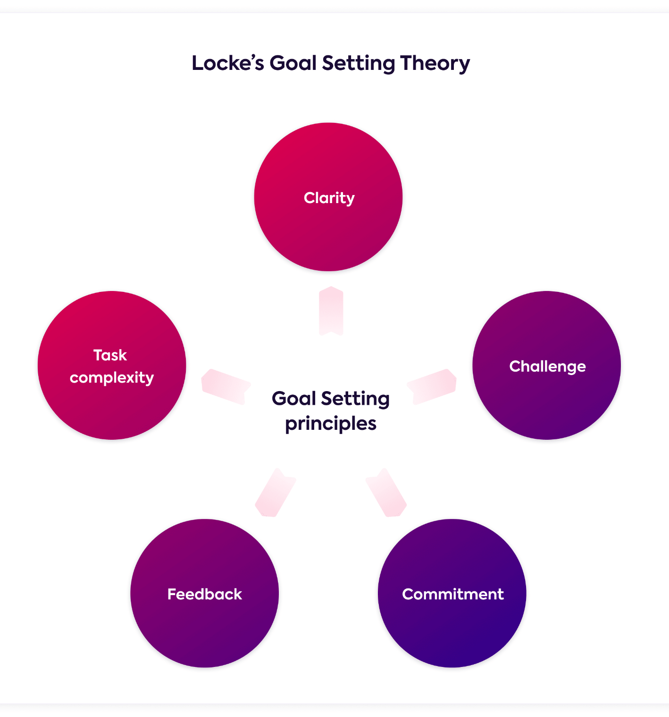
Figure 2: Principles of the Goal setting theory
Source: (MindTools, 2022)
There are also some drawbacks related to the theory. It can be said that goals that are too high from the competencies and skills of the employees can make the major concern through the performance of the employees within the organisation. Complexities of the goal can also lead to risky behaviour through this theory (Indeed, 2022).
2.3.2 Maslow’s Hierarchy of needs
As per the statement of Hopper (2020), this is the framework that refers to the theory of motivation within the organisation that can meet the five types of needs related to the human that is related to the different types of behaviour within the individual. This is the theory that can meet the inherent desire of the individual within the organisation. Fallatah and Syed (2018) made a critical presentation of the five tiers of needs are included the physiological needs that are placed at the bottom line of the needs of this theory that is referred to the needs of the employees regarding shelter and food, second need can be the safety needs of the individual, the third step is referred to the love and belonging needs, the fourth level refers to the esteem needs and the last and the top level of the needs within the framework is referred to the self-actualization of the individual.
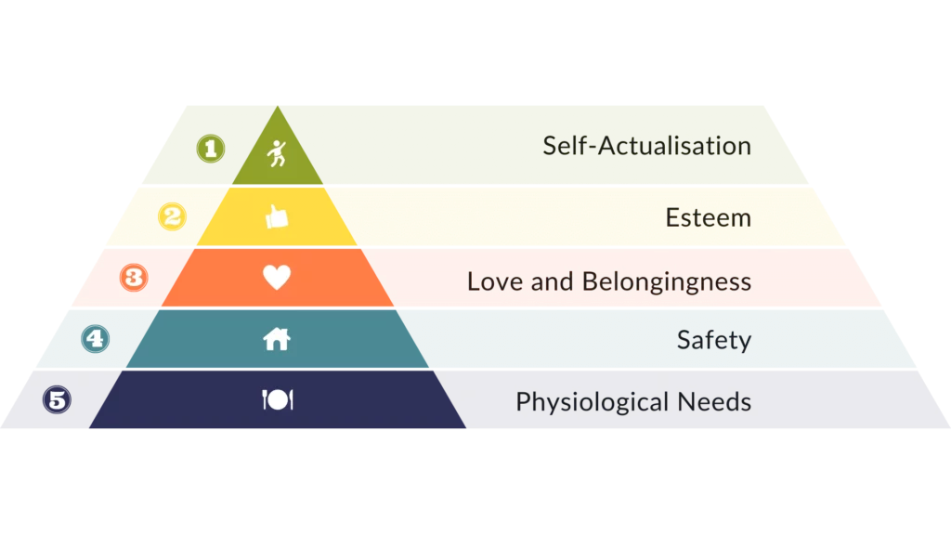
Figure 3: Maslow’s Hierarchy of Needs
Source: (Channell, 2022)
There is also criticism related to this theory that is evaluated by managementstudyguide (2022). It can be said that this theory is not supported empirically. This theory cannot be applicable when the needs of the individual cannot be satisfied properly within the organisation. There is concern about the theory related to the unscientific approach and there is the consideration of using unreliable samples that can make the issues of the effectiveness within the organisation (managementstudyguide, 2022).
2.3.3 Contingency Model of Fielder
This is the model that explains that there is no best style of leadership within the organisation. The effectiveness of the leader is developed in the abscess of the situation. As per the development of the theory, it can be said that the leadership in the organisation needs to be developed as per the situation of the organisation (MindTools, 2022). According to De Souza (2020), this is the model that can prejudice the performance of the group within the organisation and this is included four major variables. This can be considered the major framework within the leadership of the organisation. It can be said that there should be mutual respect, confidence as well as trust between the subordinates and the leaders within the organisation.
There is also the concern regarding this model that the assumption that is explained by Lindberg (2022). Lindberg (2022) analysed that the behaviour of the leadership within the model of Fielder is static and this is the area that can make the limitation for the leaders within the organisation who are trying to change different types of the ways the organisation.

2.4: Previous studies and lessons learnt
Leadership refers to the ability that can influence the team or the individuals within the organisation. Through the development of the leadership, the management of the organisation can make the proper direction and this is reflected in the overall performance of the organisation. The development of leadership is related to the development of ongoing motivation and this is related to the development of staff engagement within the organisation. According to Paais and Pattiruhu (2020), leadership is the area of the organisation that can develop the proper culture and make the employee satisfied. Through this, there is the effectiveness of the decision-making within the organisation. There is a major importance in leadership to tackle different types of critical situations within the organisation and through this, the manager of the retail industry can make the proper evaluation of the employees. There is major importance of transformational leadership within the retail sectors of the UK that helps in running the proper areas of the business (Modern Retail, 2022). In the retail sector, leadership is important to make sustainable performance and this is helpful for meeting the consumer needs of the organisation as mentioned in the explanation by Kokemuller (2016). This is also related to the development of the visionary roadmap of the organisation. As per the analysis of the study of Mekraz and Gundala (2016), it has been seen that there is a major impact of leadership on the development of the performance of the store manager. Mekraz and Gundala (2016) explained that there is a major challenge related to the retail change to deal with the inconsistency and uncertainty that can make performance issues in the store. Here the implementation of effective leadership within the organisation can make a competitive advantage for the organisation. It can be said that the development of management skills in the organisation is important to manage the proper environment within the retail business and this makes the sustainable development of the retail organisations.
There are different types of literature that have explained the concept related to the different types of leadership styles within the organisation. The previous studies on the following topic clarified that there are major areas of the effectiveness of the organisation in building the proper team the organisation. In this sense, it can be said that both the styles and types of leadership can be reviewed through the development of productivity within the organisation (Al-Malki and Juan, 2018). The studies related to this topic explained that there is a major relationship between leadership with employee performance within the organisation.
Through the analysis of the different research studies on leadership, the effectiveness of the different leadership styles within the organisation is explored. It has been seen that leadership is important in the development of decision-making in the organisation. Leadership can create better organisational productivity and this is also related to the different areas of work within the organisation. Analysing different types of studies it can be said that leadership is the area that is related to the different areas of motivation among employees and this is closely related to the productivity development of the organisation. The studies related to leadership have explained different types of styles like transformational leadership, autocratic leadership as well as democratic leadership that should be developed to reach the proper goal of the organisation. Through the analysis of the studies, it can be said that the organisation should focus on the development of transformational leadership has major importance in the retail industry that can make proper employee motivation within the organisation. It is also researched that there are different types of drawbacks related to the different types of leadership styles that need to be followed by the organisation before implementing the leadership styles within the organisation.

2.5: Gaps identified from the research
There are various types of literature that are included with the lack of information. It has been seen that there is also a lack of real-life examples that can make the proper areas of effectiveness related to the research data. The research paper should be included authentic information that can make the proper areas of effectiveness related to the research area. There should be a proper focus on the development of specific leadership styles and their effect on the organisation. The information development related to this type of area can make the proper areas of the research effective. The identification of the literature also made me concerned that there is a lack of performance data that can make sure that the development of a specific leadership style can make the effective performance of the organisation.

2.6: Summary of Chapter 2
Through the analysis of the different research studies, it can be said that there is a major importance of leadership in the development of productivity. This is also related to the proper areas of the performance of the organisation. Motivation is an area that is closely connected with leadership. In this sense, it can be said that the researchers have mentioned the different types of theories that should be implemented to make the proper areas of organisational effectiveness. Transformational leadership is important that is followed by the retail sectors to make the proper areas of employee motivation that are related to the development of productivity within the organisation. Motivation and productivity are closely related to the development of the performance of the organisation.

Chapter 3 – Methodology

3.1 Introduction
This section provides the different types of specific processes that are helpful for the development of the research area. The chapter focuses on the development of the research approach, and design that is used to collect the data for the analysis of the data related to the impact of the leadership on the development of the productivity and performance of ASDA UK. The researchers are committed to collecting the primary data related to the research areas. On this note, the researcher is focused on the analysis of both the qualitative as well as quantitative data related to the research.

3.2 Research Philosophy with Justification
Research philosophy deals with nature, sources as well as the development of knowledge. This is the belief in which the research data can be collected. Through this, the thought of the researcher can be reflected upon (Žukauskas et al., 2018). The research paper is following the post-positivism philosophy of the research.
Post-positivism philosophy emphasizes the interdependence between the researched person and the researcher (Bisel and Adame, 2017). This type of philosophy is helpful as it offers a fresh perspective on the research topic. Considering this philosophy, core areas of the analysis related to the research topic can be built and may lead to the development of the results related to the research areas. Considering this philosophy, the researchers can collect relevant data with the analysis of the theoretical concepts (Bisel and Adame, 2017). Therefore, this is leading to the collection of data regarding the impact of leadership on the development of the motivation and productivity of the employees of ASDA UK.

3.3 Research paradigm with justification
The research paper is developed with a focus on the positivism paradigm. This type of paradigm is included objectivity as well as deductive logic. This is helpful for the researchers in collecting specific data related to the positive and negative impacts of leadership on the development of the staff of ASDA UK (Park et al., 2020). It is therefore assumed that the chosen paradigm will present the researcher with the opportunity to uncover a wide range of situations within a very short period that reflects on the effectiveness of the research data.

3.4 Research Approach
The research approach is the major area of the research that can be selected by the researcher for the interpretation of the data. The research uses the deductive and inductive approach through the development of the research data and this is considered through the mixed methods of the research. Following this research data, quantitative and qualitative data is collected on the topic of enquiry. There is a focus on the analysis of the top-down approach. Through this, the researchers can make the proper areas of the decision related to the research topic. This is also related to the development of specific actions related to data analysis on the effectiveness of the leadership that helps in productivity development in the ASDA UK.

3.5 Research Methodology with justification
The research method is the specific technique that is useful for identifying, selecting as well as analysing the data related to the topic of the research. The methodology section of the research is allowing the researcher for the critical evaluation of the research topic. There is the use of open-ended and closed-ended surveys are used for the data analysis of the effectiveness of the leadership on the performance development of the ASDA UK. Through this, there is a focus on the analysis of staff morale as well as productivity. The data through the survey is collected with the proper observation of the data and this is also included with the behavioural observation. On this note, the development of the open-ended survey and close-ended survey is helpful for the researcher in analysing the information in a detailed way that helps in making the proper decision related to the development of the data related to the research area (Gillespie et al., 2021).
So, it can be said that both qualitative and quantitative data analysis means that the researcher is using a mixed method. Through the development of this research method, a proper understanding of the problem and opportunity of the research area can be established.

3.6: Research strategy and design
Research strategy in the research refers to the detailed plan that can give a proper direction related to the thought process of the researchers. It is enabling the researchers to conduct the research systematically. On this note, research design refers to the overall strategy that is integrating the vicarious types of components related to the study that can be developed logically.
The researcher used both qualitative and quantitative strategies of the research for collecting the data. Following the Quantitative and Qualitative research data related to the research data helps develop the major knowledge regarding the development of the research topic. Through this, there is the proper development of the situations towards the motivation and this helps analyse the information related to the leadership productivity of ASDA UK.

3.7: Research Sample and Population
The research sample is defining the people's group that can provide the proper information related to the research topic. There can be a proper strategy that is useful for the collection of the data for ASDA UK. The research paper is developed following random probability sampling for collecting the data related to the research topic. This type of sampling is used by the researcher because this helps reduce the biases that can make better results related to the research topic. This is also a cost-effective approach that is helpful for the development of the different areas of the research. Through this, the risks of the data analysis are also minimized related to the following research areas (Sowah et al., 2021).
The sample size included 20 employees and 4 managers of ASDA UK. Twenty employees are included in the close-ended survey and 4 managers are included in the Interview analysis.

3.8: Data Collection and Data Analysis Tools/Techniques
The method of data collection refers to the information analysis related to the different types of sources that are related to the research topic. In the data collection method, the researcher is using qualitative as well as quantitative data that is developed through primary data. This is the area that can provide authentic information related to the research data. Authentic information is collected from the respondents involved in the interview as well as the survey. The respondents included the employees and leaders of ASDA UK. The tools for the data collection are included survey questionnaires, an internet connection, pen, paper, an ethical consideration form and other important tools for data collection.

3.9: Ethical Consideration of the Research
The researcher has developed the research data related to the ASDA UK following ethical manners. The researcher makes sure that the collected information for the research will be kept secure and will not be shared with any third party. After the completion of the research, all of the recorded data will be deleted. It is also to make sure that the data related to the research is protected properly. On this note, data security and confidentiality are maintained properly within the data analysis of the research. All of the participants signed for approval for the ethical form. On this note, it can be said that the researcher will not force any of the participants to give information related to the research topic and all of the participants in the research will get the proper respect.

3.10: Summary of Chapter 3
The chapter has developed the different types of strategic approaches that are used for the data collection of the effectiveness of the leadership on the development of the productivity performances of ASDA UK. Through this primary data analysis is conducted that is included both closed-ended and open-ended surveys. The close-ended survey is conducted with the employees of the organisation and the open-ended survey will be conducted among the leaders of the organisation. However, the research paper is included quantitative as well as qualitative data analysis. The people involved with the survey and interview are selected based on the probability sampling method. The researcher is focused on the development of the proper ethics that is related to the development of the effectiveness of the research. However, the methodology is an important part of the research that is helpful for the development of the decision related to the development of the research areas.

Chapter 4: Data Analysis and Discussions

4.1: Introduction
The chapter is focused on the presentation of the data analysis that is collected through the survey as well as the interview with the participants. The analysis of the chapter is included with both the presentation of the qualitative as well as quantitative data. The survey is conducted with six questions and the interview is analysed based on the three questions.

4.2 Analysis and Discussions of findings/data

4.2.1 Survey analysis

Q.1
Most of the participants are involved in the age group of 18-24. This means that ASDA is focused on the management of young employees within their organisation.
Q.2
It has been seen that there are high percentages of male respondents. On this note, it can also be said that the company is focused on female empowerment because there are also female employees in the interview.
Q.3.
Among the total 20 respondents, 18 employees wanted to respond to this question. It has been seen that 10 employees are working for one year within the organisation. This is a higher response than the other options of the questions. So, it can be said that the view of the employees in the organisation is strong towards the development of the leadership within the organisation.
Q.4.
19 participants gave responses to this question and one participant did not want to give a response on this area as the participant was not sure about the style of the leadership. The participants mentioned that there is the importance of transformational leadership which is the major area to make the proper areas of motivation of the employees within the organisation. On the other hand, there was also the response of the autocratic as well as the democratic leadership. But, the other 5 respondents mentioned that ASDA is following the other type of leadership within the organisation.
Al Rahbi et al., (2017) refers that the Transformational leadership style is one of the management styles that helps to innovate new ideas from the employees and this leader enhances the path of the company. Employees get huge job satisfaction from this leader and can think in a versatile way. So, this can make the productivity development of ASDA.
Q.5
17 respondents gave the response among a total of 20 respondents. Most of the employees made the response that they are not sure about the effectiveness of the leadership strategy on ASDA in the productivity as well as the motivation of ASDA. But, 7 responses also agreed with this statement.
This means that there should be a clear leadership strategy for ASDA that can make the proper areas of the performance of the organisation from the perspective of developing employee morale. On this note, there is the importance of focusing on a specific model of management like the Contingency Model. According to De Souza (2020), this is the model that can prejudice the performance of the group within the organisation. This can be considered the major framework within the leadership of the organisation. On this note, ASDA should be focused on developing mutual respect, confidence as well as trust between the subordinates and the leaders within the organisation.
Q.6
There are different types of strategies that can be followed by ASDA to make the different areas of leadership in the organisation. The participants made responses on the different types of strategies that can make the effectiveness of the leadership of ASDA. Five respondents pointed out that ASDA needs to focus on the skills and the other 5 respondents mentioned that the decision-making should be strong. Leadership style has created the strength of ASDA (Premratan, 2018).
So, there should be variations of the decision-making that can make the proper areas of leadership development within the organisation. On this note, leaders need to be effective in analysing the various areas of the skills of the employees that are related to the development of the organisation.

4.2.2 Interview analysis
Q.1.
Two managers responded that the leadership of their organisation is very effective and this made the other two managers make the response that they need to focus on the staff morale because they have seen some loss of work productivity.
Prasetio et al., (2019) explained that through the proper areas of employee development, it can be said that the turnover of employees can be reduced. So, ASDA needs to be focused on the proper strategy for employee management that is leading to the performance development of the organisation.
Q.2.
The first manager made the response that they are focusing on clear communication with the staff that helps in understanding the proper areas of the organisational development. The second and third managers made the responses that they are trying to encourage the employees to take risks within the workplace that help in getting knowledge. The fourth manager did not specify any type of special strategy that helps in motivating their staff.
Altheeb (2020) explained that leadership can motivate employees to enhance flexibility within the organisation. As per the response of the respondents in the interview, clear communication is essential for the development of organisational performance that is also essential for employee engagement. There is a major contribution of dynamic leadership that helps in motivation. Effective development of leadership within the organisation is related to the management of the objectives and goals of the organisation.
Q.3.
Three managers made the responses that they have focused on developing the payroll system of the employees where they can apply the strategies for the reward presentation to the employees. Other managers mentioned that they will identify the skills gaps among the staff and through this, they will focus on recruiting the proper talent for the organisation. Basit et al. (2018) opined that there is the major importance of internal motivation in developing a work environment that reflects the performance of the organisation. So, the managers need to focus on the proper motivation. Employee motivation refers to the factor that can drive the employees to put their best efforts towards the development of the work of the organisation. Motivated people within the organisation can be creative and this is helpful for proper employee engagement within the organisation. On this note, the engagement of the employees is essential as there are issues with ASDA in managing the proper number of staff in the organisation.

4.3: Summary of Chapter 4
The chapter has analysed the importance of communication in developing the different areas of organisational performance. On this note, there is a plan from the manager to develop the leadership for ASDA in the future. However, the development of reward management is essential to make the proper areas of the responses within the organisation.

Chapter 5: Conclusions, Limitations & Recommendations

5.1 Conclusion
The research analysed the leadership effectiveness on productivity and motivation among employees. It has been seen that the development of the proper leadership strategy is important to the staff morale whereas the negative side of the leadership development made the poor performance from the employees. These analyses met objective 1 of the research. Leadership development is making the proper employee engagement. It has been seen that ASDA has faced issues in engaging with the proper staff. This affects the overall performance of the organisation. So, the analysis of these areas has met the establishment of objective two. The organisation can focus on the proper management of the reward as well as the incentives. These are the areas that can reduce turnover. Considering the analysis of Maslow's Hierarchy of Needs, the organisation needs to focus on the proper performance development of the workplace. This affects the proper production of the organisation. The areas of the discussion on the strategies development met the last objective of the research area. However, ASDA is focused on the proper style of management but there are issues of motivation that need to be developed within the organisation. There should be a focus on the contingency theory of leadership. This is the theory that can develop mutual trust among the staff and this is reflected in the proper performance of the organisation. The studies related to leadership have explained different types of styles like transformational leadership, autocratic leadership as well as democratic leadership that should be developed to reach the proper goal of the organisation. On this note, the effectiveness of every type of leadership style should be understood so can manage the proper performance of the organisation.

5.2 Research Limitation
A concern involved with the research related to the analysis of the authentic data from the survey because there was the possibility of unbiased information through the survey analysis. On this note, there is also the concern related to the authentic data from the interview. The research did not properly mention the evidence and the statistical areas that can make the proper areas of the research development. It has been seen that there were different types of data related to the leadership and they made different types of conflict in developing the research data. The researcher also found limitations related to the design of the research.

5.3 Recommendations
ASDA is facing different types of issues related to motivation in the organisation. So, some suggestions can be mentioned that help in managing the issues of the organisation -
- ASDA should develop a system of payroll. It is essential to make modifications to the reward system that can be help engage the employees with the organisation. There can be an effective system for incentives and bonuses that can be helpful for the employees to do more work for the organisation. This will also inspire the staff of the organisation in the workplace.
- The company should follow transformational leadership constantly and a proper structure should be followed in the organisation. The development of the structure will allow the organisation to manage the different types of activities in an organised manner.
- The leaders of the organisation should be focused on the analysis of the skills gap. This will be helpful for the organisation to focus on effective employees within the organisation. On this note, proper employees should be recruited by the managers as the organisation is going through a lack of staff development within the organisation.

5.4 Reflections
This is the research paper that made the different areas of knowledge related to the development of leadership in the organisation. I recognised different types of leadership styles that have different types of effectiveness within the organisation. This will help me in the professional areas of my development. I have seen that I have a weakness in using keywords in my writing. This is also reflected in my writing on the research paper. I need to use different types of phrasing as well as keywords that can be help make the writing related to the research paper. I have realised that there is also a lack of evidence which means there is a concern about the research skills. So, I will practice more and more and through this, I need to use the effectiveness of the search engine tool. This will help in finding the different types of resources related to the topic. But, I think I have the strength in critical thinking skill that helps in taking decisions through the research paper. So, discussion on leadership is essential to manage the various organisational activities.

References
Al Rahbi, D., Khalid, K. and Khan, M., (2017). The effects of leadership styles on team motivation. Academy of Strategic Management Journal, 16(2), pp.1-14.
Al-Malki, M. and Juan, W., (2018). Leadership styles and job performance: A literature review. Journal of International Business Research and Marketing, 3(3), pp.40-49.
Alrowwad, A.A. and Abualoush, S.H., (2020). Innovation and intellectual capital as intermediary variables among transformational leadership, transactional leadership, and organisational performance. Journal of Management Development.
Altheeb, S.A., (2020). Leadership Style and Employee Motivation: A Study of Saudi Arabian Work Environment. Journal of Educational Psychology-Propositos y Representaciones, 8.
Archer, D. and Willcox, P., (2018). The faces at play in performance appraisals: With a focus upon a UK retail organisation. Journal of Politeness Research, 14(2), pp.167-192.
Aydın, A. and Tiryaki, S., (2018). Impact of performance appraisal on employee motivation and productivity in Turkish forest products industry: A structural equation modeling analysis. Drvna industrija, 69(2), pp.101-111.
Basit, A.A., Hermina, T. and Al Kautsar, M., (2018). The Influence of Internal Motivation and Work Environment on Employee Productivity. KnE Social Sciences.
Bisel, R.S. and Adame, E.A., (2017). Post‐positivist/functionalist approaches. The international encyclopedia of organisational communication, pp.1-22.
Channell, M., 2022. Maslow's hierarchy of needs: An in-depth guide for leaders and managers, TSW Training. [online] Available at: https://www.tsw.co.uk/blog/leadership-and-management/maslows-hierarchy-of-needs/ [Accessed 29 November 2022].
Cherry, K., 2022. What is laissez-faire leadership? [online] Verywell Mind. Available at: https://www.verywellmind.com/what-is-laissez-faire-leadership-2795316 [Accessed 30 November 2022].
Daniel, C.O., (2019). Effects of incentives on employees productivity. International Journal of Business Marketting and Management, 4(1).
De Souza, S., (2020). An Experimental Test of Fiedler's Contingency Model of Leadership Effectiveness: The Effect of Gender (Doctoral dissertation, Loyola University Chicago).
Fallatah, R.H.M. and Syed, J., (2018). A critical review of Maslow’s hierarchy of needs. Employee Motivation in Saudi Arabia, pp.19-59.
Gillespie, B.J., Mulder, C.H. and Eggleston, C.M., (2021). Measuring migration motives with open‐ended survey data: Methodological and conceptual issues. Population, space and place, 27(6), p.e2448.
Graves, L.M. and Sarkis, J., (2018). The role of employees' leadership perceptions, values, and motivation in employees' provenvironmental behaviors. Journal of cleaner production, 196, pp.576-587.
Hayward, S., (2015). The challenges of retail leadership. [online] HR Magazine. Available at: https://www.hrmagazine.co.uk/content/features/the-challenges-of-retail-leadership/ [Accessed 3 December 2022].
MindTools., (2022). Fiedler's Contingency Model [online] mindtools.com Available at: https://www.mindtools.com/ayfk2dg/fiedlers-contingency-model [Accessed 3 December 2022].
MindTools., (2022). Locke's Goal-Setting Theory [online] mindtools.com. Available at: https://www.mindtools.com/azazlu3/lockes-goal-setting-theory [Accessed 3 December 2022].
Hopper, E., (2020). Maslow’s hierarchy of needs explained. [online] ThoughtCo. Available at: https://www.thoughtco.com/maslows-hierarchy-of-needs-4582571 [Accessed 5 December 2022].

Ionescu, V.C. and Bolcaş, C., (2019). Leadership and organisational development. Revista de Management Comparat International, 20(5), pp.557-564.
Kokemuller, N., (2016). The impact of a leadership style on a retail store. [online] Chron.com. Available at: https://smallbusiness.chron.com/impact-leadership-style-retail-store-71921.html [Accessed 5 December 2022].
Lindberg, C., (2022). Fiedler's contingency model of leadership – what is it? pros/cons? examples? [online] Leadershipahoy.com Available at: https://www.leadershipahoy.com/fiedlers-contingency-model-of-leadership-what-is-it-pros-cons-examples/ [Accessed 5 December 2022].
Managementstudyguide., (2022). Maslows Hierarchy of Needs Theory. [online] managementstudyguide.com Available at: https://www.managementstudyguide.com/maslows-hierarchy-needs-theory.htm [Accessed 7 December 2022].
Mekraz, A. and Gundala, R.R., (2016). Leadership style and retail store performance-A case study of discount retail chain. Journal of Business and Retail Management Research, 10(2), pp.1-10.
Michiganstateuniversityonline., (2022). What Are the Characteristics of a Transformational Leader? [online] Michiganstateuniversityonline.com. Available at: https://www.michiganstateuniversityonline.com/resources/leadership/characteristics-of-transformational-leadership/ [Accessed 7 December 2022].
Moynihan, C., (2021). A Study On The Impact Of Transformational Leadership On Employee Retention. Does This Leadership Style Increase Job Satisfaction And Reduce Turnover Intention In The Irish Retail Sector? (Doctoral dissertation, Dublin, National College of Ireland).
JMK Group UK., (2022). Next and Asda Workers Left Struggling Due to Payroll Errors. [online] Jmkgroupuk.com. Available at: https://jmkgroupuk.com/next-and-asda-workers-left-struggling-due-to-payroll-errors-2/ [Accessed 7 December 022].
Paais, M. and Pattiruhu, J.R., (2020). Effect of motivation, leadership, and organisational culture on satisfaction and employee performance. The Journal of Asian Finance, Economics and Business, 7(8), pp.577-588.
Park, Y.S., Konge, L. and Artino, A.R., (2020). The positivism paradigm of research. Academic Medicine, 95(5), pp.690-694.
Prasetio, A.P., Azis, E. and Anggadwita, G., (2019). Exploring compensation satisfaction to enhance motivation and reduce turnover intention among employee of private bottled water company in Indonesia. Jurnal Bisnis dan Manajemen, 20(1), pp.32-48.
Premratan., (2018). Different types of leadership and their advantages and disadvantages. [online] PloPdo.com. Available at: https://plopdo.com/2018/12/19/different-types-of-leadership-and-their-advantages-and-disadvantages/ [Accessed 9 December 2022].
Romi, A., Cook, K.A. and Dixon-Fowler, H.R., (2018). The influence of social responsibility on employee productivity and sales growth: Evidence from certified B corps. Sustainability Accounting, Management and Policy Journal.
Silvera, I., (2015). ASDA rewards staff for Customer Service. [online] EmployeeBenefits.co.uk Available at: https://employeebenefits.co.uk/issues/june-2013/asda-rewards-staff-for-customer-service/ [Accessed 9 December 2022].
Sowah, R.A., Kuditchar, B., Mills, G.A., Acakpovi, A., Twum, R.A., Buah, G. and Agboyi, R., (2021). HCBST: An Efficient Hybrid Sampling Technique for Class Imbalance Problems. ACM Transactions on Knowledge Discovery from Data (TKDD), 16(3), pp.1-37.
Steinmann, B., Klug, H.J. and Maier, G.W., (2018). The path is the goal: How transformational leaders enhance followers’ job attitudes and proactive behavior. Frontiers in Psychology, 9, p.2338.
Indeed., (2022). What is Goal-Setting Theory: Principles, Pros and Cons. [online] Indeed.com. Available at: https://www.indeed.com/career-advice/career-development/goal-setting-theory [Accessed 14 December 2022].
StatusGuides., (2022). What is transactional leadership? (pros, cons, how-to's) [online] Status.net. Available at: https://status.net/articles/transactional-leadership/ [Accessed 14 December 2022].
Modern Retail., (2022). Why transformation leaders are needed in retail. [online] Modernretail.co.uk. Available at: https://modernretail.co.uk/why-transformation-leaders-are-needed-in-retail/ [Accessed 17 December 2022].
Žukauskas, P., Vveinhardt, J. and Andriukaitienė, R., (2018). Philosophy and paradigm of scientific research. Management culture and corporate social responsibility, 121.

Appendix
Survey Questionnaires
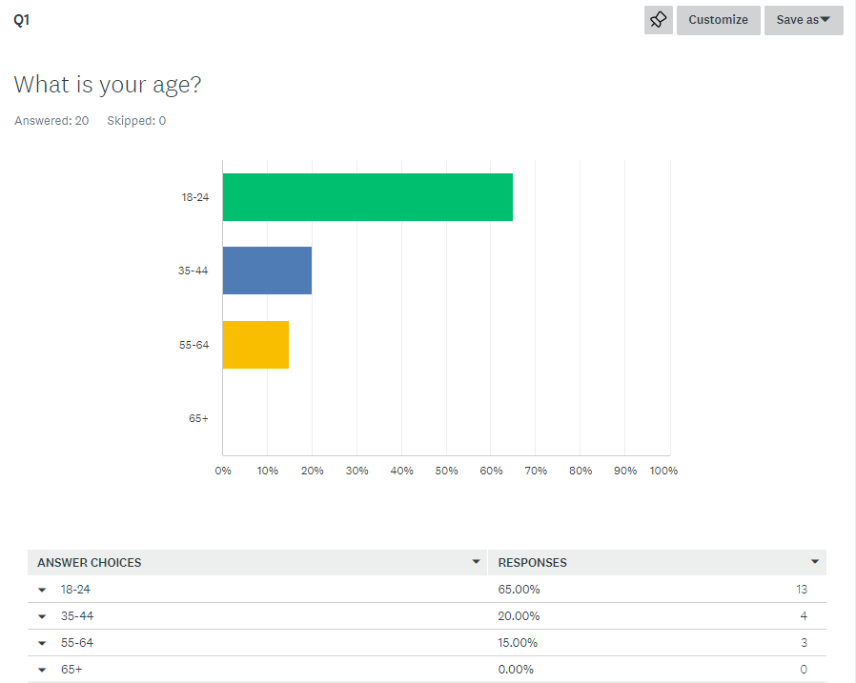
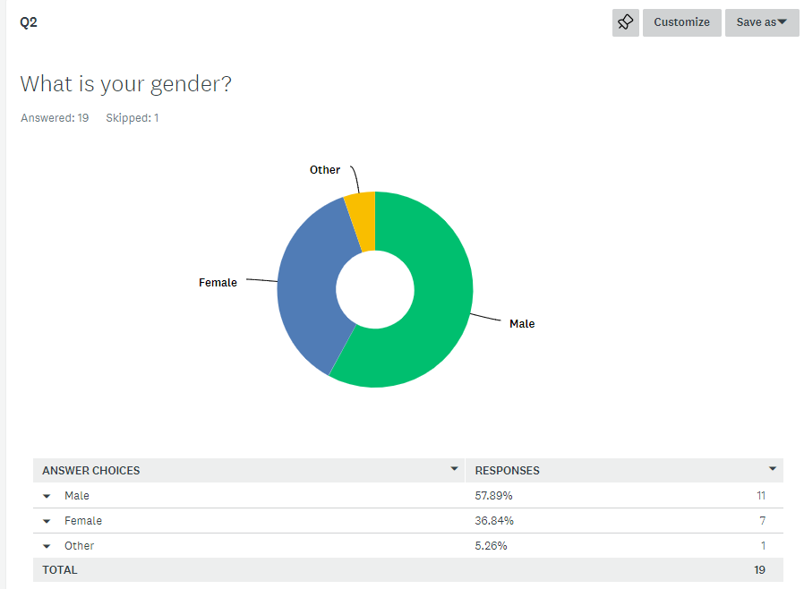
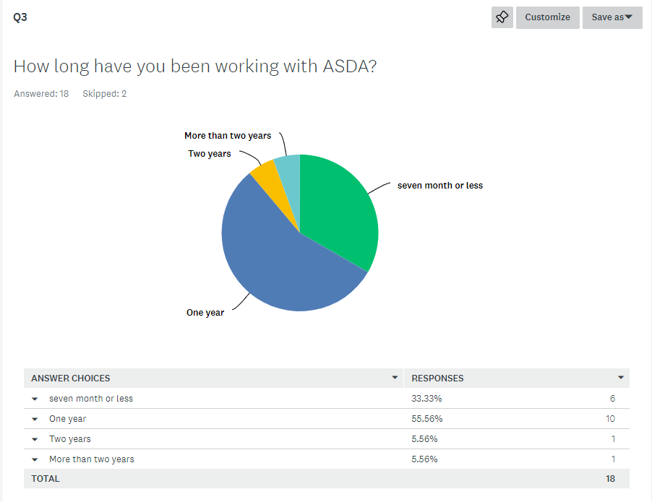
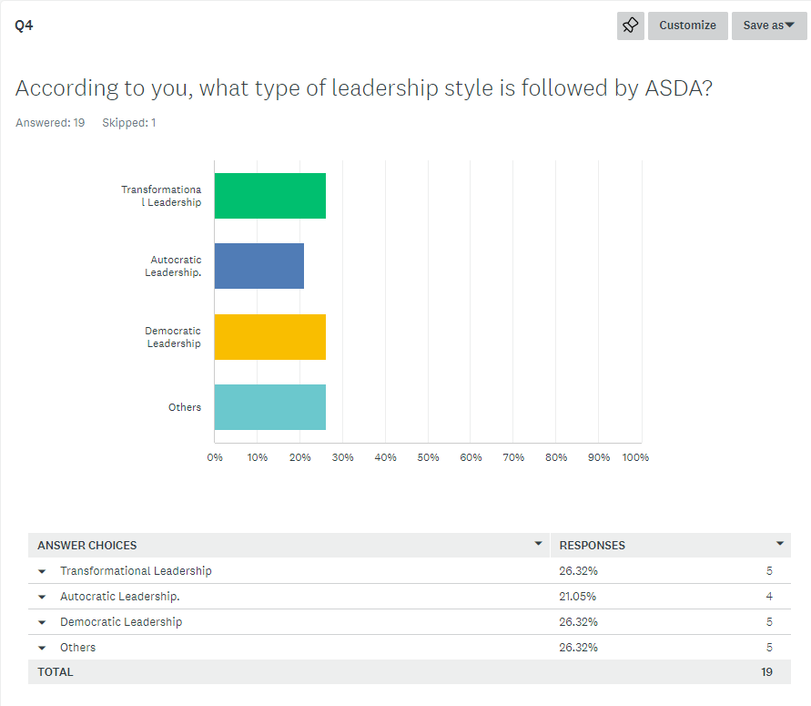
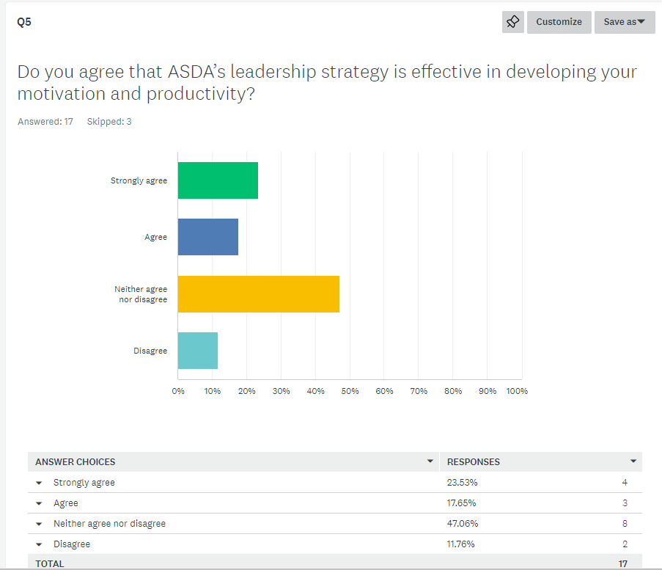
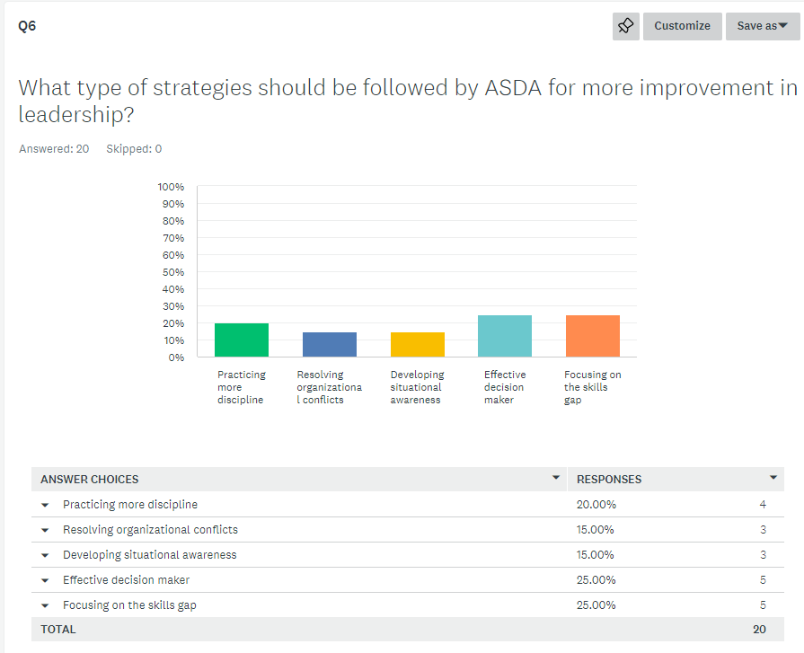

Interview Transcript

Q.1. How is leadership effective for your organisation in terms of employee productivity?

First Manager - Our leadership is very effective and helps in motivating the staff of the organisation.
Second Manager - Our effective leadership is essential in managing the productivity performance in the organisation.
Third Manager - We need to focus on the motivation of the employees more as the staff have made complaints regarding their workplace structure.
Fourth Manager - I think we need to focus on employee morale to make the development of employee performance within the organisation.

Q.2. How is your leadership motivating the employees of your organisation?

First Manager - We will focus on the development of the communication channel in the workplace.
Second Manager - We are trying to use unique words that are helpful for managing the attention of the employees.
Third Manager - I am trying to encourage different employees within the organisation.

Q.3. What is your plan to develop leadership in the future?

First Manager - I think we need to pay attention to the reward strategies and there will also be a focus on the flexibility of the employees.
Second Manager - We will focus on the reward management system for the employees.
Third Manager - ASDA is focused on the payroll system and there is the system of incentives.
Fourth Manager - We are focused on the different types of skills gaps that can manage the issues of the organisation.

