Ioan Davies
2115169
control & automation
Development and application of manufacturing automation

Table of Contents
2 Introduction 2
3 Fixed automation 2
4 Programmable automation 4
5 Flexible automation 7
5.1 Employing Flexible Automation in Flat-packed Furniture Manufacturing 9
6 Bibliography 11

Introduction
Manufacturing automation is the use of equipment to automate systems or processes, to increase production capacity and reduce cost (Finch, 2022). There are three main types of manufacturing automation: fixed, programmable, and flexible automation. Through this report I will investigate these types of manufacturing automation with particular interest in their history and the industries where these types of automation emerged. I will also discuss the advantages and disadvantages of each type of manufacturing automation.

Fixed automation
One type of automation manufacturing is fixed automation. This systems sequence of processing or assembly operations are fixed by a specific equipment configuration. Although the operations in the sequence of manufacturing may be simple, many operations in one piece of equipment can make the system complex (Anil Kumar & Suresh, 2008). Fixed automation manufacturing is used for production systems with specifically allocated equipment that carries out repetitive, fixed processes for high volume production needs. One example of fixed automation are automated production lines that consist of workstations connected by a transfer system that moves the parts between each station. Each station is designed to perform a specific operation and therefore, the part is produced in steps as it works its way along the line (Groover, 2023).

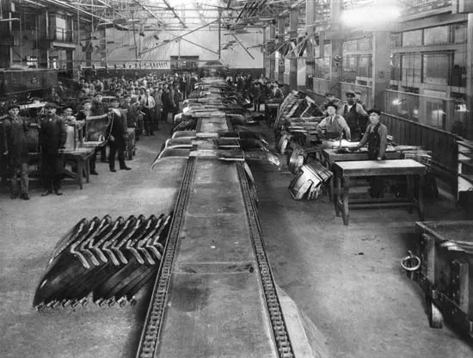

Figure 1: Ford Motor Company plant, River Rouge, Detroit during the 1930s. With the automatic transfer conveyor on the assembly line (Encyclopedia Britannica, Inc., 2022).

The earliest example of automated transfer lines (fixed automation) was described by (Bright, 1958) In which the Ford Motor Company introduced an automatic transfer machine for their engine blocks in the 1930’s. The automatic transfer machine linked machine tool operations and different workstations such as drilling, tapping holes and boring. This was all controlled by a series of cams, timers and limit switches and shuttle bars that slid or lifted the engine block to transfer it to the next workstation. Following the outbreak of World War 2 manufacturers were forced to significantly increase their production speed and capacity to meet demand, especially aircraft manufacturers and ship builders. One of these aircraft manufacturers, Vultee Aircraft Corporation produced over 13,000 aircraft of various type for the Unites States Air Force during, as they developed the first powered assembly line incorporating fixed automation (Parker, 2013).

During the post war period, fixed automation was dominated by the Japanese automotive industry. By 1951 Japanese automotive manufacturer Toyota, converted its manufacturing equipment to basic automatic machinery by installing cam-feed mechanisms and micro-switches, which provided automatic feed and shutdown (Toyota, 2012). This system made it possible for one worker to operate multiple machines at one time, rapidly increasing work efficiency. Further improvements were made by Toyota with the implementation of the first domestically produced transfer machine in 1956. Which was used to transport a work piece between workstations for different machining operations (Toyota, 2012).

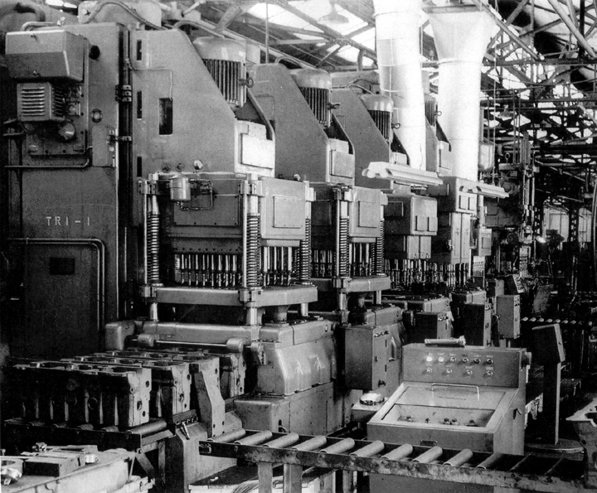

Figure 2: Image of the Toyota “TR1 transfer machine” from 1956 (Toyota, 2012).

The automobile industry continued to show interest in improving the automation of production lines with the first industrial robot Unimate introduced onto the General Motors assembly line in 1961 (Menzel & D'Aluisio, 2000). Unimate was an electronically controlled hydraulic arm that was used in automated die casting moulds that dropped hot components into pools for cooling. Robots have continued to advance fixed automation until the present day, especially in the automobile industry. The modern robots are now much more intelligent and are controlled by microprocessors and powered with multiple motors and joints. With some robots such as the Motoman XRC having the ability to control 27 axis (Globaltranz, 2014). Modern day automobile assembly lines use a series of robots connected by a moving transfer line. As work piece moves down the line each robot carries out the next step of the process. Operations may include spot welding, drilling riveting, placement or measurement and inspection.

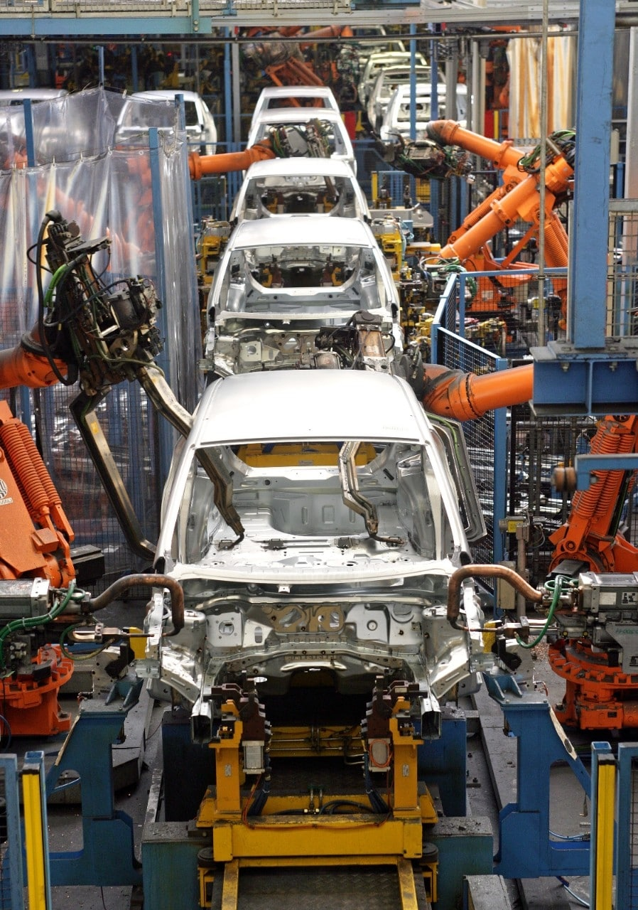

Figure 3: Ford Fiesta assembly line at Cologne-Niehl in 2008, demonstrating modern day robotic use during assembly (Ford, 2013).

One of the main advantages of fixed automation systems is that they are robust and can easily handle high load capacities required in mass production. Systems are simple only carrying out one operation meaning maintenance is also easier, with fewer components to fail and no tooling changes required (Bemer & Tynczuk, 2017). Therefore, fixed automation provides high levels of production at a low cost per unit with consistent quality, which is supported by minimal maintenance requirements. However, the main disadvantage of fixed automation is that it cannot be used for other operations than it was designed for (CSD & Integration, 2021). Therefore, if the production line requires a variety of different products to be manufactured then fixed automation would not be suitable.

Programmable automation
Another commonly recognised type of automation is programmable automation. In this system the production equipment is designed with the capability to change the sequence or type of operations required (Anil Kumar & Suresh, 2008). The sequence of operations is controlled by a program to accommodate different product configurations. The systems operations and sequence depend on the program, improving flexibility. Programmable automation is used for producing products in batch quantities, which may range from a few dozen to thousands (Britannica, 2023). The production equipment must be reprogrammed, and tooling changed to run a new batch.

Programmable automation was not introduced until 1968, by General Motors who operate in the automotive industry. General Motors adopted PLC control or programmable logic controllers on some of their production lines, with the aim to replace hardwired relays and timers with the first PLC known as the Modicon model 084 (c3Controls, 2023). At General Motors, Hydra-Matic Division at Ypsilanti transmission systems were produced on long complex automatic transfer lines made up of 58 workstations, that converted castings into finished machined transmission housings (Ball, 2015). Each machine was controlled by a cabinet full of relays, timers, and motor starters etc. The PLCs were used to replace the relay panels and control the transfer machines on the assembly lines, programmed by relay ladder logic.

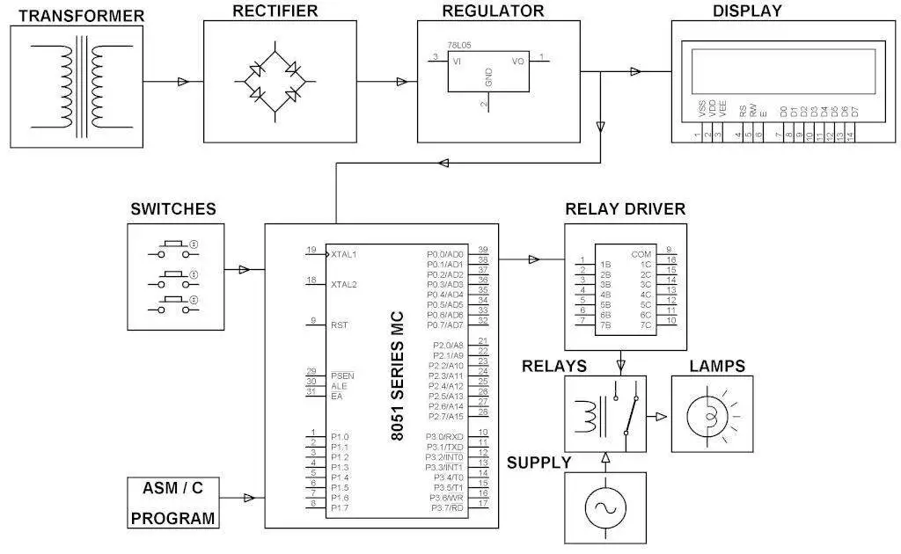

Figure 4: Block diagram for a basic programmable Switch control used that may be used in industrial automation (Kumar, 2013).

The programmable logic controller in figure 4 can be programmed to set the time and sequence in which the lamps are turned on and off. The system provides manual switches to turn each lamp on or off, a digital display for time and sequence, as well as programmable switches for a fully automated sequence.

With the introduction of inexpensive microprocessors during the late 1970s, PLC manufacturers began to develop graphical programming devices (Process Solutions, Inc, 2020). These devices could be used to digitally programme PLCs with graphical representation however, these early programming devices were very expensive and large. Additionally, they were only compatible with one manufacturers controller, reducing their flexibility and uses in manufacturing.

By the early 1980s PLCs could now be programmed using programming software running on a personal computer. With Automation Direct developed by Host Engineering being the first window-based PLC programming software package in 1985 (AutomationDirect, 2023). This allowed a PC to communicate with the PLC meaning testing and troubleshooting could be carried out much easier on automatic manufacturing equipment. This technology was also transferred to CNC machines (Computerised Numerical Control) in which pre-programmed software controls the movement of tooling and production components to machine parts (Goodwin University, 2018). In 1989, software-controlled CNC machines were the industrial standard. CAD (Computer-aided design) and CAM (Computer-aided manufacturing) software could now be used by manufacturers to design and develop new parts and then export programs that the CNC machine would run to physically machine it (Rapid Direct, 2021).

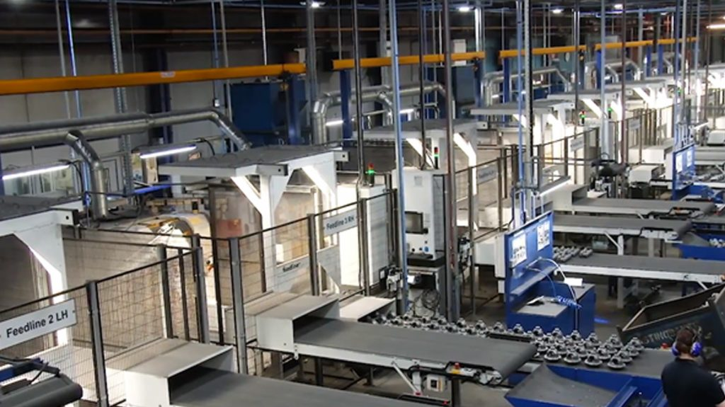

Figure 5: Production line of CNC Speedwell part of UK based Castings Group. With over 100 programmable automated CNC machines (automotive manufacturing solutions, 2008).

PLCs continued to advance and by the late 1990s become smaller, faster, and more powerful with significantly more memory than earlier examples. Most modern automotive manufacturers employ many CNC machines that are programmed to produce batches of machines parts. One of the main examples of modern CNC machining is found with engine block machining, as this requires high levels of accuracy and complexity CNC machines are ideal. For example, CNC speedwell in the UK machines approximately eight million chassis, engine, and castings every year for companies such as Volvo, BMW, Land Rover, and Toyota, using CNC machines that are pre-programmed then manually loaded and unloaded with parts (automotive manufacturing solutions, 2008).

One of the main advantages of programmable automation is the flexibility to deal with changes in production configurations and is therefore, more suitable for batch production (Anil Kumar & Suresh, 2008). This means for a CNC machine to change the type of product it is producing an operator would have to select a different program and run it. However, a disadvantage would be that the tooling and physical set up of the machine would also have to be altered to produce a different batch of products. Therefore, there is a period of downtime between changeover of products, reducing the production rate when compared to fixed automation (Britannica, 2023).

Flexible automation
The third type of automation to discuss is flexible automation. Flexible automation is an extension of programmable automation as many different products can be manufactured using the same system with almost no change over time (Britannica, 2023). Producing different parts is accomplished by preparing the programs off-line on a computer system and then transmitting the new program to the production system using cable or secured networks (Anil Kumar & Suresh, 2008). A common example of where flexible automation is used can be found in the automotive industry. As customers now like to fully customise their cars such as choosing paint colour etc, flexible automation enables manufacturers to quickly re-program assembly equipment to perform different actions depending on the requirements of each individual vehicle.

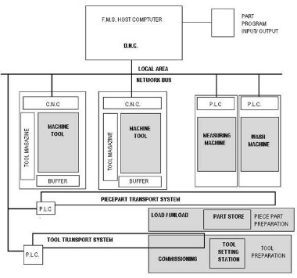

Figure 6: Block diagram of a basic flexible automation system used in manufacturing (Parrish, 1993).

The host computer in figure 6 controls the entire system including the CNC machine tools with PLCs programmed for the control of the transport systems. Everything is then connected and communicated with using a local network bus of cable. Any changes to the programs will make instant subsequent changes to the production system.

One of the earliest examples of flexible automation was developed by the Sundstrand Corporation in 1965, who manufactured aerospace products (now known as Collins aerospace a subsidiary of Raytheon Technologies) (Wikipedia, 2023). The flexible automation system at Sundstrand involved eight NC (numerical control) machines with a computer automated roller conveyor (Stecke & Parker, 1998). Part programs for different parts could be loaded onto microprocessors local to each NC machine with very little set-up required between changes.

With the introduction of more advanced computer technology such as the microprocessor in 1973 GE Aerospace developed the MC 8500 series, the first computer numerical control (CNC) machine and featured its own minicomputer (American Machinist, 2001). This enabled the machine to be programmed by a main frame computer which cut programming and set-up times between product changes even further. These CNC routers were used to cut complex patterns out of sheets of aluminium to be used in the assembly of aircraft.

During the early 1980s the introduction of personal computers enabled computers to be set-up anywhere and run a machine control (Goodwin University, 2018). According to (Steinhilper, 1985) there were 230 flexible automation systems in use worldwide, with Japan leading the way with 100 systems. The basic concept of these systems involves multiple CNC machines supplied with an automatic material handling unit, usually a robot. The information such as programs and feedback are fed to the system by an integrated central control system (Edquist & Jacobsson, 1988). The central control system was usually a computer with a sole purpose for controlling the automation system.

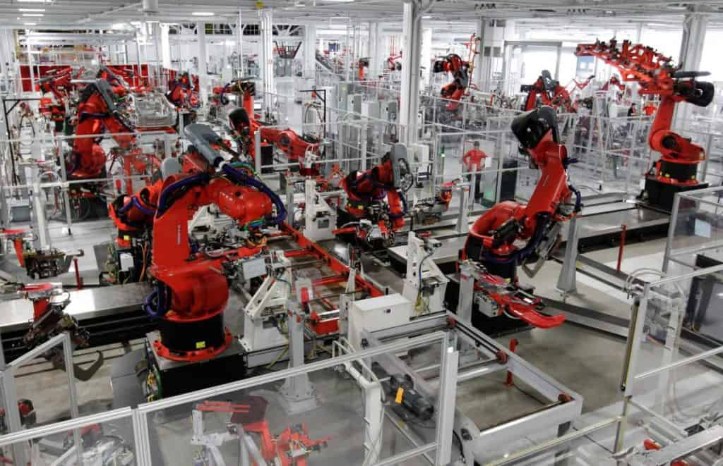

Figure 7: Tesla Motors Factory in Freemont, California, showing the flexible automation production line with KUKA robots (cross, 2023).

Both the CNC machines, robots and microprocessors used in the computers continued to advance through the 1990s, becoming faster and much more capable. A good example of modern-day flexible automation can be seen at the Tesla Motors Factory in Freemont, California shown in Figure 7. As mentioned by (Anderson, 2013) Tesla has implemented hundreds of general-purpose KUKA robot arms that can do many tasks required such as metal-bending to assembly. Machining of parts is done using CNC machines that are fed and tool changed using the robots.

The main advantage of flexible automation is the ability to change part programs and the physical setup of manufacturing equipment to produce new parts without loss in production time (Anil Kumar & Suresh, 2008). They are also much more efficient than other types of manufacturing automation, as they can easily adapt to any required changes and keep production flowing with minimal downtime (CPV Manufacturing, 2023). This allows parts to be produced at a faster rate increasing customer satisfaction. However, the one disadvantage that makes some manufacturers wary of implementing this system is the high initial cost and investment required (Anil Kumar & Suresh, 2008). The cost of the robots, CNC machines, computers and programming software can be very expensive to initially purchase and may take several years to gain a return on investment within the short term (Robots Done Right, 2023).

Employing Flexible Automation in Flat-packed Furniture Manufacturing
Flexible automation could also be appropriately employed to produce flat-packed furniture. In the furniture industry there is a requirement to handle high levels of customisation to the product and keeping production efficient. (Johansson, Blomqvist, Nilson, & Landscheidt, 2016) suggest that flexible automation is a production solution that allows a system to be rapidly reconfigured for different products and if implemented in the furniture industry will allow high levels of customisation to be achieved.

One method in which flexible automation could be employed is during the machining process of the flat-packed furniture. For example, part blanks could be automatically fed and removed from CNC router tool machines using a robotic arm. The CNC machines, robotic arm and transfer system would be programmed offline using a central computer system. (Culbreth, et al., 1996) describe how a prototype flexible furniture manufacturing cell would operate to satisfy these requirements, as shown in figure 8. A six-axis, jointed, pedestal base, robotic arm would use a vision system for identifying and locating parts on the input conveyor, scrap bin and output conveyor. The robot would load parts blanks form the input conveyor into the CNC machine for processing, once complete the robot would remove the finished piece into the output conveyor.
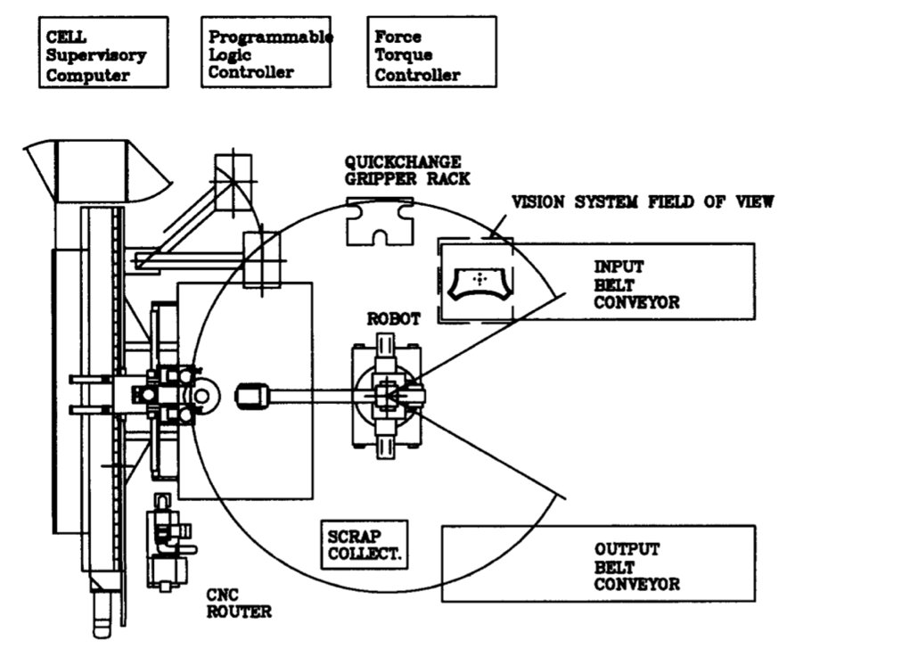

Figure 8: Flexible automation manufacturing cell for flat-packed furniture (Culbreth, et al., 1996)

Another method for implementing flexible automation would be in the packaging process. Again, a modular production cell could be implemented with robotic technology which utilises a pick and place robotic arm to pack the finished parts into boxes ready for shipping. Automated machine manufacturer MicroStep together with partners Photoneo and ABB produced a modular flat-packed furniture packing production cell, with robot technology for IKEA Industry, Malacky. A robotic arm picks parts from a predefined address and the places them in a predefined address (cardboard box) within a tolerance of ± 2mm and perform 10 cycles per minute (MicroStep, 2020). As explained by (Photoneo, 2020) a flexible automation solution was the most appropriate due to the variety of products required to be packed by this system. Different products vary in size, thickness and especially surface finish such as shiny, diffused, black to white. To combat this issue a robot was employed with a visual scanner to identify the part that was to be moved and placed with a secondary scanner for localisation positioning.

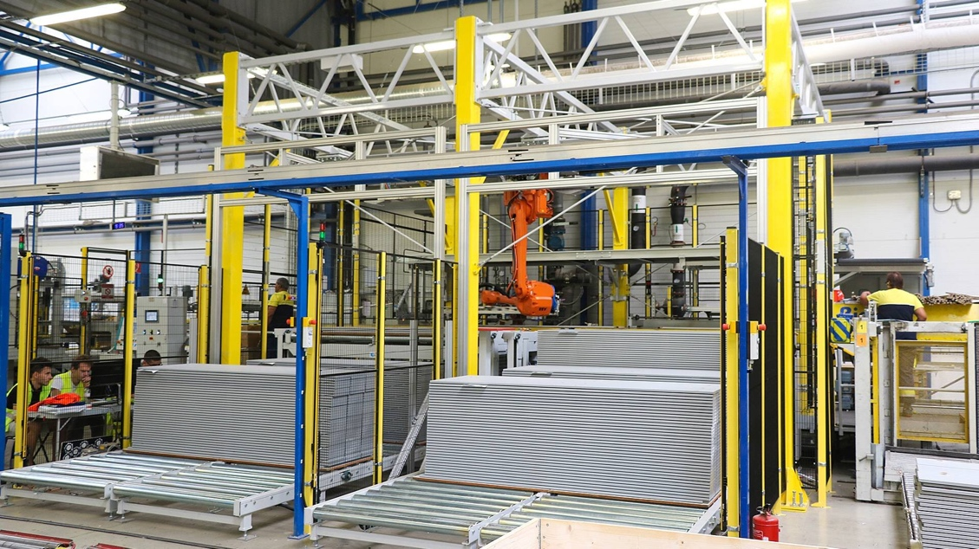

Figure 9: modular flat-packed furniture packing production cell, with robot technology for IKEA Industry, Malacky (MicroStep, 2020).

In summary, flexible automation is the most appropriate type of automation for this industry as it requires the ability to adapt quickly to a variety of different products in small or large batches. Therefore, it is essential for the automation system to have the flexibility to carry out these changes without downtime between change overs. This is supported by (Culbreth, et al., 1996) who describes furniture products as inherently complex with raw material often supplied with surface imperfections and not homogenous. With a flexible approach to automation being the most efficient way to manufacture furniture parts.

Bibliography
Abernathy, W. J., Clark, K. B. & Kantrow, A. M., 1983. Industrial Renaissance: Producing A Competitive Future For America. New York: Basic Books.
American Machinist, 2001. 1970s. [Online]
Available at: https://www.americanmachinist.com/archive/features/article/21897390/1970s

Anderson, C., 2013. Makers: The New Industrial Revolution. s.l.:Random House Business.

Anil Kumar, S. & Suresh, N., 2008. Production and Operations Management. New Delhi: New Age International P Limited.

AutomationDirect, 2023. History of the PLC. [Online]
Available at: https://library.automationdirect.com/history-of-the-plc/

automotive manufacturing solutions, 2008. Grinding down the expenses. [Online]
Available at: https://www.automotivemanufacturingsolutions.com/grinding-down-the-expenses/6590.article

Ball, K., 2015. The Dawn of the Programmable Logic Controller. [Online]
Available at: https://www.automation.com/en-us/articles/2015-2/the-dawn-of-the-programmable-logic-controller-plc

Bemer, T. & Tynczuk, R., 2017. Fixed vs Flexible Automation Systems. [Online]
Available at: https://www.assemblymag.com/articles/93979-fixed-vs-flexible-automation-systems

Bright, J. R., 1958. Automation and Management. Boston: Harvard University.

Britannica, 2023. Manufacturing applications of automation and robotics. [Online]
Available at: https://www.britannica.com/technology/automation/Manufacturing-applications-of-automation-and-robotics

c3Controls, 2023. PLC Programming Then & Now: The History of PLCS's. [Online]
Available at: https://www.c3controls.com/white-paper/history-of-programmable-logic-controllers/

Charig, N., 2022. Basic Knowledge - Integrated Circuits. [Online]
Available at: https://www.power-and-beyond.com/what-are-integrated-circuits-definition-types-and-more-a-66046a289105d037a11ba94461ef9c5e/

CPV Manufacturing, 2023. Advantages & Disadvantages of Flexible Manufacturing System. [Online]
Available at: https://www.cpvmfg.com/news/advantages-disadvantages-flexible-manufacturing-system/
cross, 2023. Technical Guide: Improve Efficiency with Flexible Automation. [Online]
Available at: https://www.crossco.com/resources/technical/fixed-versus-flexible-automation/

CSD & Integration, 2021. The Difference Between Fixed & Flexible Automation. [Online]
Available at: https://controlsystemsdesign.com/blog/the-difference-between-fixed-flexible-automation/

Culbreth, C. T., Miller, M. & O'Grady, P., 1996. A CONCURRENT ENGINEERING SYSTEM TO SUPPORT FLEXIBLE AUTOMATION IN FURNITURE PRODUCTION. Robotics & Computer-Integrated Manufacturing, pp. 81-99.

Edquist, C. & Jacobsson, S., 1988. Flexible Automation. Oxford: Basil Blackwell.

Encyclopedia Britannica, Inc., 2022. [Online]
Available at: https://kids.britannica.com/students/assembly/view/88738#

Finch, C., 2022. Manufacturing Automation: What Does It Mean for Manufacturers?. [Online]
Available at: https://www.qad.com/blog/2022/01/manufacturing-automation-what-does-it-mean-for-manufacturers

Ford, 2013. Celebrating the Moving Assembly Line in Pictures. [Online]
Available at: https://media.ford.com/content/fordmedia/fna/us/en/features/celebrating-the-moving-assembly-line-in-pictures.html

Globaltranz, 2014. The History of Robotics in Manufacturing. [Online]
Available at: https://www.globaltranz.com/resource-hub/robotics-in-manufacturing/

Goodwin University, 2018. What is CNC Machining & What Role Does It Play in Modern Manufacturing?. [Online]
Available at: https://www.goodwin.edu/enews/what-is-cnc/

Groover, M. P., 2023. Automation. [Online]
Available at: https://www.britannica.com/technology/automation

intel, 2023. Intels First Microprocessor. [Online]
Available at: https://www.intel.co.uk/content/www/uk/en/history/museum-story-of-intel-4004.html

Johansson, J., Blomqvist, L., Nilson, H. & Landscheidt, S., 2016. Influencing Factors To Enable Automation of Wood Furniture Production, Vaxjo: Linnaeus University.

Kumar, R., 2013. Programmable Switching Control for Industrial Automation. [Online]
Available at: https://www.eeweb.com/programmable-switching-control-for-industrial-automation/
Menzel, P. & D'Aluisio, F., 2000. ROBO SAPIENS: EVOLUTION OF A NEW SPECIES. Napa: MIT Press.

MicroStep, 2020. Exceptional automation solution for the IKEA furniture group. [Online]
Available at: https://microstep.com/en/Media/News/ikea-automatisierung-furniture-manufacture
[Accessed April 2023].

Parker, D. T., 2013. Builidng Victory: Aircraft Manufatcuring in the Los Angeles Area in World War II. s.l.:s.n.

Parrish, D. J., 1993. Flexible Manufacturing. s.l.:Butterworth-Heinemann Ltd.

Photoneo, 2020. Packaging solution at IKEA Industry, s.l.: YouTube.

Process Solutions, Inc, 2020. A Brief History of Programmable Logic Controllers. [Online]
Available at: https://processsolutions.com/a-brief-history-of-programmable-logic-controllers-plcs/

Rapid Direct, 2021. CNC History: The Origination and Evolution of CNC Machining. [Online]
Available at: https://www.rapiddirect.com/blog/cnc-history/

Robots Done Right, 2023. Flexible Automation vs Fixed Automation. [Online]
Available at: https://robotsdoneright.com/Articles/flexible-automation-vs-fixed-automation.html

Stecke, K. E. & Parker, R. P., 1998. Flexible Automation, s.l.: University of Michigan Business School.

Steinhilper, R., 1985. Communication by letter. s.l.:Fraunhover Institute.

Toyota, 2012. A 75-Year History through text. [Online]
Available at: https://www.toyota-global.com/company/history_of_toyota/75years/text/taking_on_the_automotive_business/chapter2/section7/item3_a.html

Wikipedia, 2023. Collins Aerospace. [Online]
Available at: https://en.wikipedia.org/wiki/Collins_Aerospace

