Practical Task: Classifying Iris Flower Species using KNN
Context
The Iris dataset contains measurements of iris flowers from three species: Setosa, Versicolor, and Virginica. Each flower is described by four numerical features: sepal length, sepal width, petal length, and petal width.
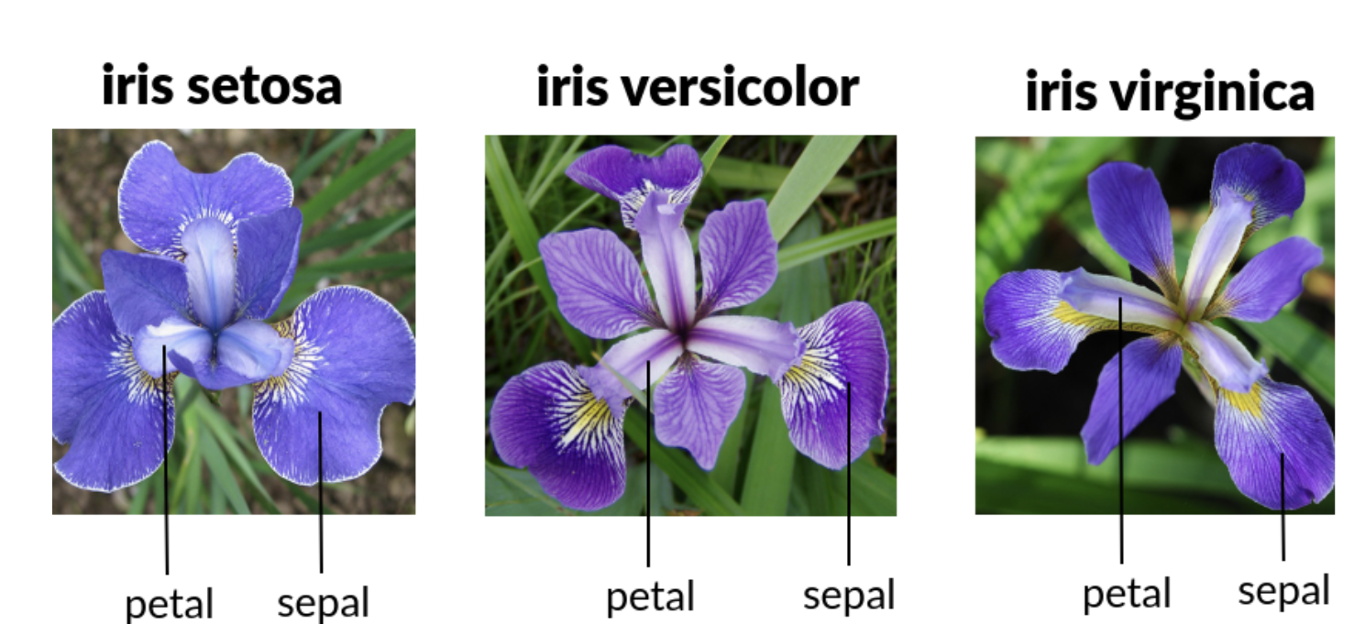

In this practical, you will use the K-Nearest Neighbors (KNN) algorithm to classify the species of iris flowers. You will explore the data, visualize it, train a model, and evaluate its performance.
Activity Instructions

- Load the Iris dataset and inspect its first few rows.
- Visualize the data using a scatter plot (or pairplot). Use species names in the legend instead of numeric labels.
- Split the dataset into training and test sets (80% training, 20% testing).
- Scale the features to improve KNN performance.
- Train a KNN classifier (choose k=3).
- Predict the species of flowers in the test set.
- Evaluate your model using Accuracy score
- Confusion matrix (show species names)
- Optional: classification report

Tasks to Complete
Answer the following based on your results:
- Which species are easily classified? Which are sometimes confused? Why do you think this happens?
- What is the accuracy of your KNN model on the test set?
- Interpret the confusion matrix. How many flowers were misclassified, and which species were confused?
- Try changing the value of k (number of neighbours). How does this affect the accuracy?
- Optional: Visualize the decision boundaries of your KNN model (advanced).

