

Project Initiation Document
Wednesdays Wheelers and Walkers
Marketing Strategy
Prepared by:
Mrs Sarah Hillam
P137987
Submitted to:
Jacqui Jones
05/04/2020

Contents
- Project Justification 3
  - Graphs 4
    - Measurements of Success 4
    - Depreciation 5
    - Appreciation 6
- Project Approach 7
- Project Management and Team Structure 8
- Communication Management Strategy 9
  - Stakeholders 9
- Gannt Chart 10
- Market Research 11
- Competitors 12
- References 13
- Appendix 14

1.0 Project Justification
Wednesday’s Wheelers and Walkers was formally known as first steps forward from 2009 to 2017 when the management team decided to re brand the day centre to its current name of Wednesday’s wheelers and walkers and this is when the main issue with declining members really started to happen as the re brand was not a huge success and the day centre has depreciated year by year to the point where the day centre only has 15 members now and even then some of them don’t attend each week so funds are declining as well, this decline was due to poor management strategies and attitude towards current and prospective clients.

The purpose of this proposal is to improve Wednesdays Walkers and Wheelers day centre, the day centre is a community group and has no local authority funding and is run by its members and their families.

The aim of this consultancy project is to help promote awareness of Wednesdays Wheelers and Walkers day centre.

- Promote awareness of the group
- Advertise
- Re-brand
- Gain additional members for the group

The Scope and Exclusions for this project are as follows:
Included in the project are the following:
- Marketing plan/ strategy
- Promote awareness of the day centre and to gain new members.
- Set up social media, Email and Website for the day centre
- Organise small events to gain members
- Advertisements through Yell.com, Google Ads, Facebook, Swansea Free Ads.
Exclusions include the following:
- Not organising Holidays or events outside of what is stated above
- No other duties such as administration

1.1 Graphs
1.1.1 Table 1 – Measurement of Success
Change in Client Numbers | GROWTH | YR1 | YR2 | YR3
Clients -3 | -20% | £4200 | £3500 | £2450
Clients +5 | 33% | £7000 | £8750 | £10500
Clients +10 | 67% | £8750 | £24500 | £31500
Clients +15 | 100% | £21000 | £31500 | £63000
Clients +20 | 133% | £24500 | £57750 | £78750

For the first row on the graph above it shows that if no intervention was taking the business would severely decline and loose members to the point where the day centre would have to cease trading on the third year due to lack of funding and members.
From line 2 onwards it focuses more on gaining new members, there is 2 measurements of success which both contribute to the business been successful, the first is to gain members and the second Is to improve the opening days and times and activities. From the table you can see I managed to gain 15 members then it shows the day centre would be in a position to host annual holidays, day trips and in house activities, by increasing to an extra 30 members this could potentially allow the day centre to open for a third day and improve on its activities etc.

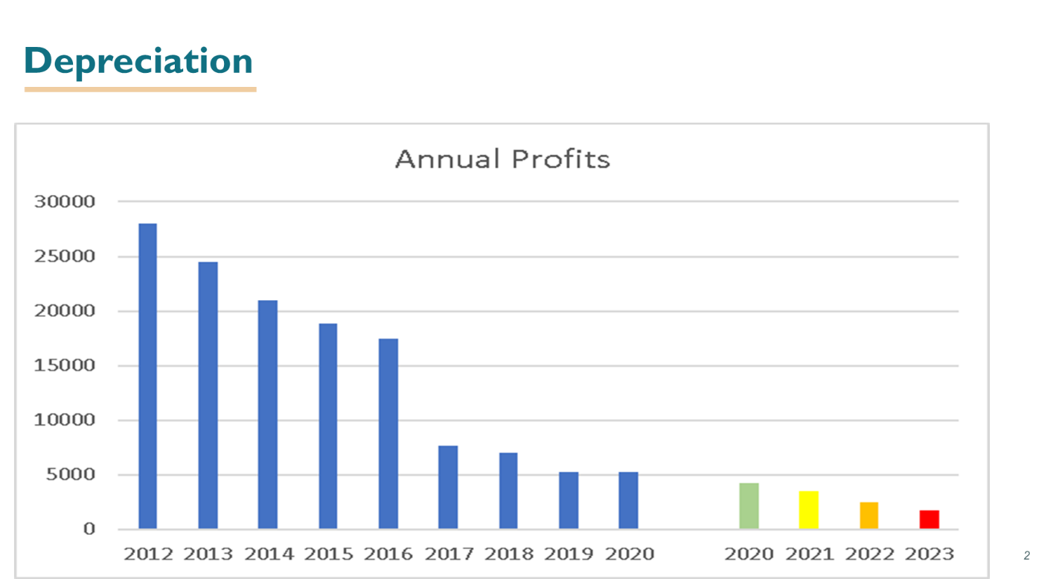
1.1.2 Graph 1 - Depreciation
From the graph above you can see that since 2012 the business has rapidly declined in members due to changes in management, in 2017 the client numbers seemed to stay steady then in 2019 it declined again this was due to members leaving and some passing away but now the day centre only has 13-15 members who only attend one day per week on a regular basis. I have continued the graph until 2023 which shows if the depreciation continues the day centre will have to shut its doors.

From the graph below you can see that the graph depicts the appreciation for the number of clients, ultimately any profit above the 20k region allows the business to become financially stable and open on multiple days, so as shown by the graph 10 new members per month is heading in the right direction but it could take approximately 2 years to reach its safety net, however this is still a suitable rate of success for the business.
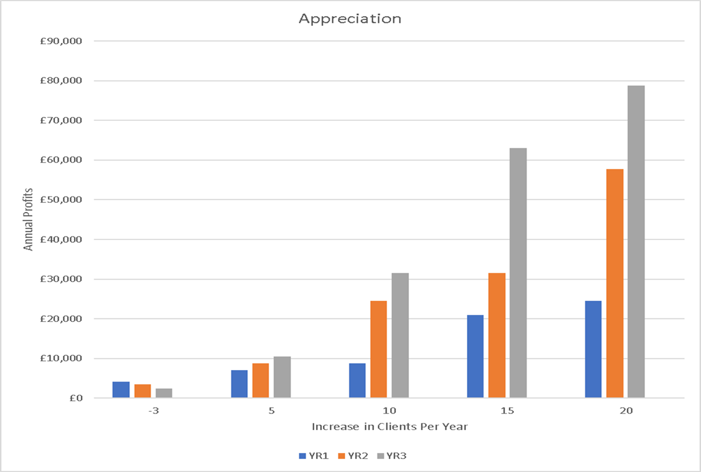
1.1.3 Graph 2 - Appreciation
2.0 Project Approach
To determine what kind of support the day centre is needing and what the marketing strategy should provide for them, communications will be established with professional organisations to determine what support they could possibly offer the day centre to help promote it wider around the Swansea area.
One of the objectives is to run multiple events to help boost awareness of the day centre Wednesday’s wheelers and walkers, by running various events over a period of time, it makes it possible for me to gather the information on how many prospective clients could potentially attend the day centre by the number of people interested at my event. Ultimately running these events will provide myself with a lot of experience and confidence to run events in the future.

- Project Management & Team Structure
The users will be all the members of the day centre and the Chairlady Carol Sayce Wilkins and other Interested parties would include the members family members.
Project Manager – Sarah Hillam
My role in this marketing plan will be to promote Wednesday’s wheelers and walkers through various strategies and to relay any proposals to the committee members through the chairlady.
Chairlady – Carol Sayce Wilkins
Carols role in this will be to work directly with me on this marketing plan and relay any information between myself and the other members and give feedback regarding my proposals to promote, advertise, website etc.

- Communication Management Strategy
Due to the outbreak of the coronavirus my communication strategies have changed on how I am going to contact Carol with regards to this marketing plan and any proposals I have for them in regards to advertising, email address set up and creating their brand-new website. I will now be contacting carol via email and telephone only.
I have spoken with each member from the day centre via phone or Facebook regarding what the day centre needs and what members want to see the day centre achieve( please see appendix for details on questionnaire), below is some of the common answers from the questionnaire I asked them.
The common answers consist of: they enjoy the day centre and like to come here to socialise with each other; they attend each week to give them a sense of independence and some social time; they all said they would love for the day centre to run holidays again as it relieves stress and pressure on family members who care for them on a regular basis; they would like better facilities in the building they rent for the day centre as its lacking cleanliness and some of the facilities are out of date such as the heating; they also said that they would like to see regular entertainment such as singers (Wilkins, 2020).
All of the members agree that a website and social media page is needed to gain new members and boost profits for the day centre, so it can return how it used to be, they also agreed with the proposal of re-branding the day centre back to first steps forward (Wilkins, 2020).

4.1 Stakeholders
The stakeholders for Wednesdays wheelers and walkers are the following:
Carol Sayce Wilkins – Chairlady
Beryl Thomas – Deputy Chairlady
Norma Sharpe – Head Banker
Julie Williams Tancock – Assistant Banker
Plus, all members of the day centre and their families.

- Gantt Chart
Table 2 – Gantt Chart

6.0 Market Research
By conducting further research into how many people would be interested it would provide a more thorough understanding of the lack of knowledge of the day centre that people in the local communities have regarding the services that are offered by the day centre and conducting research prior to any event Is a fundamental part of this marketing strategy.

By conducting questionnaires and speaking with the relevant local authorities it makes it possible to understand what people want and need and what support these organizations can provide to aid in the success of the day centre in the future.

Further market research shows that Swansea Social Services has a team which includes specialist social workers and care managers who support people with mobility impairment. They, along with our Occupational Therapists can provide a range of information and practical support. Social Services can also offer short-term rehabilitation support to people with a physical impairment. The aim is to enable people to find new ways of doing things that they are finding difficult, and to look for practical solutions to encourage greater independence (Swansea.gov.uk, 2019).

Further research shows that there may be funding available to non-government organisations from the national lottery and other sources such as the Esmée Fairbairn Foundation who is one of the largest independent grant-making foundations in the UK, which aims to improve the quality of life throughout the UK and the Foyle Foundation
An independent grant making trust that distributes grants to UK charities with an annual turnover of less than £100,000 (Company, 2019).

7.0 Competitors
There are some local competitors that would be competition for the day centre but most of these are government funded.
The Squirrel club which is based in Town hill Swansea is a non-profit organisation day centre like what Wednesdays walkers and wheelers offer and offer similar activities plus day trips to cinema, bowling etc and holidays for their members, they also offer a bus service for pick up and drop off and annual holidays.
There is also a day centre called rose cross house which is based In penlan Swansea this day centre is government funded and run by Swansea local authority, it offers its members a pick up and drop off service for service users and a wide range of activities on site, they also prepare meals for each member which is normally a hot meal with pudding.
There is also friends of the young disabled group which are based in Cwmbrula Swansea and offer a social gathering for members twice per week, they have a workshop for men to do outdoor activities and gardening and also sewing club and arts and crafts for other members.

8.0 References

Ads, G., 2020. Local Disabled day centres. [Online]
Available at: https://www.google.co.uk/search?sxsrf=ALeKk01heleMGldLHFo7uLg_yEZaJxpdkg%3A1586100816552&source=hp&ei=UPqJXorIH4zjgwfRn7v4Cw&q=disabled+day+centres+near+me&oq=disabled+day+cen&gs_lcp=CgZwc3ktYWIQARgBMgIIADICCAAyCAgAEBYQChAeMgYIABAWEB4yBQgAEM0COgcIIxDqAhAn
[Accessed 5th April 2020].
Company, T. S., 2019. Disabled grants for non profit organisations. [Online]
Available at: https://www.thestablecompany.com/sources-of-funding/charities-voluntary-organisations
[Accessed 5th April 2020].
Swansea.gov.uk, 2019. Disabled Day Centres. [Online]
Available at: https://www.swansea.gov.uk/article/5458/Information-resources-for-disabled-people
[Accessed 5th April 2020].
Wilkins, C. S., 2020. Wednesdays Walkers and Wheelers [Interview] (5th April 2020).
Yell.com, 2020. Disability Services. [Online]
Available at: www.yell.com/disabilityservicesswansea
[Accessed 5th April 2020].

Works Cited
Ads, G., 2020. Local Disabled day centres. [Online]
Available at: https://www.google.co.uk/search?sxsrf=ALeKk01heleMGldLHFo7uLg_yEZaJxpdkg%3A1586100816552&source=hp&ei=UPqJXorIH4zjgwfRn7v4Cw&q=disabled+day+centres+near+me&oq=disabled+day+cen&gs_lcp=CgZwc3ktYWIQARgBMgIIADICCAAyCAgAEBYQChAeMgYIABAWEB4yBQgAEM0COgcIIxDqAhAn
[Accessed 5th April 2020].
Company, T. S., 2019. Disabled grants for non profit organisations. [Online]
Available at: https://www.thestablecompany.com/sources-of-funding/charities-voluntary-organisations
[Accessed 5th April 2020].
Swansea.gov.uk, 2019. Disabled Day Centres. [Online]
Available at: https://www.swansea.gov.uk/article/5458/Information-resources-for-disabled-people
[Accessed 5th April 2020].
Wilkins, C. S., 2020. Wednesdays Walkers and Wheelers [Interview] (5th April 2020).
Yell.com, 2020. Disability Services. [Online]
Available at: www.yell.com/disabilityservicesswansea
[Accessed 5th April 2020].

9.0 Appendices

 |  |  | E3 FORM
APPLICATION FOR ETHICAL APPROVAL – BA level

CAIS AM GYMERADWYAETH MOESEGOL – Lefel BA

Mae'r ffurflen hon i'w chwblhau gan bob BA myfyrwyr. Rhaid i bob ffurflen gael ei ystyried gan diwtor y modiwl.  Dylai un copi o'r ffurflen yn cael ei roi ar y ffeiliau Gyfadran ac un copi cadw ar y ffeil myfyrwyr. |  | This form is to be completed by all BA students conducting research, projects or productions. This form should be completed by the student. All forms must be considered by the Module tutor. A copy of the form must be kept centrally and on the student file.
ADRAN 1 – MANYLION MYFYRIWR |  | SECTION 1 - STUDENT DETAILS
Enw Llawn  Full Name | Mrs Sarah Louise Hillam
Ysgol/Cyfadran/  School/Faculty | Business School Swansea |  |  | Rhif Myfyriwr Student Number | P137987
Cydlynydd prosiect / Tiwtor  Module Tutor/ Programme Co-ordinator | Jacqui Jones |  |  | Enw'r Gradd  Name of Degree | BA Events & Festivals Management
Teitl dangosol yr Traethawd Hir: |  |  |  | Indicative Title of Dissertation:

ADRAN 2 – MANYLION CYFRANOGWYR / CYNULLEIDFA |  |  | SECTION 2 - PARTICIPANT / AUDIENCE DETAILS
Pwy yw’r cyfranogwyr arfaethedig? |  | Who are the intended participants? |  |  | Ydw / Yes | Na / No
Myfyrwyr / staff Y Drindod Dewi Sant |  | Students / staff of Trinity Saint David |  |  |  | X
Oedolion (dros oed 16 ac yn gymwys i gydsynio) |  | Adults (over the age of 16 and competent to give consent) |  |  | X
Plant a phobl ifanc dan oed |  | Children / legal minors |  |  |  | X
Cleifion neu gleientiaid gweithwyr proffesiynol |  | Patients or clients of professionals |  |  |  | X
Rhywun sy’n cael ei gadw yn y ddalfa neu y mae’r llys wedi cymryd cyfrifoldeb amdano |  | Anyone in custodial care or for whom the court has assumed responsibility |  |  |  | X
Aelod o unrhyw sefydliad lle mae’n bosibl bod angen i unigolyn arall hefyd gydsynio. |  | A member of any organisation where another individual may also need to give consent. |  |  |  | X
Eraill: Nodwch: / Others: please identify:

Nifer, Oed a Ffynhonnell y Cyfranogwyr  Rhowch fanylion yr demograffeg y cyfranogwyr / gynulleidfa. |  |  |  | Participant / Audience Number and Age  Provide details of the demographics of the participants / audience.
Nifer o Gyfranogwyr / yn y Gynulleidfa | Participant/ Audience number |  |  | 15 +
Grŵp oedran y Cyfranogwyr/y Gynulleidfa | Participant/ Audience age group |  |  | 30-80

ADRAN 3 – GWEITHGAREDD YMCHWIL |  |  | SECTION 3 – RESEARCH ACTIVITY
1. | Ydy’r prosiect yn cynnwys: | Does the project include: |  | Ydy / Yes | Nac ydy/No
Defnyddio holiadur neu offeryn ymchwil tebyg |  | Use of questionnaire or similar research instrument |  | X
Defnyddio prawf ysgrifenedig neu gyfrifiadurol |  | Use of written or computerised test |  |  | x
Cyfweliad (cysylltwch gwestiynau posibl) |  | Interview (attach provisional questions) |  |  | x
Dyddiaduron |  | Diaries |  |  | x
Arsylwi ar gyfranogwyr a hwythau'n ymwybodol o hynny |  | Participant observation with their knowledge |  |  | X
Arsylwi ar gyfranogwyr a hwythau ddim yn ymwybodol o hynny |  | Participant observation without their knowledge |  |  | X
Recordio fideo neu sain |  | Video or audio-taping |  |  | x
Mynediad i wybodaeth bersonol neu gyfrinachol heb gydsyniad penodol y cyfranogwyr |  | Access to personal or confidential information without the participants specific consent |  |  | x
Defnyddio unrhyw gwestiynau, ysgogiadau prawf, cyflwyniad y gallai rhai cyfranogwyr eu profi fel rhywbeth sy'n achosi niwed / tramgwydd corfforol, meddyliol neu emosiynol |  | Administration of any questions, test stimuli, presentation that may be experienced as physically, mentally or emotionally harmful / offensive |  |  | X
Cyflawni unrhyw weithredoedd allai achosi embaras neu effeithio ar hunan-barch |  | Performance of any acts which may cause embarrassment or affect self-esteem |  |  | x
Ymchwilio i gyfranogwyr sy’n ymwneud â gweithgareddau anghyfreithlon |  | Investigation of participants involved in illegal activities |  |  | x
Gweithdrefnau lle defnyddir twyll |  | Procedures that involve deception |  |  | x
Gweini unrhyw sylwedd, cyfrwng neu blasebo |  | Administration of any substance, agent or placebo |  |  | x
Dull arall o gasglu data neu fformat cyflwyno (esboniwch) |  | Other method of data collection or presentation format (please explain) |  |  | x

2. | Restru eich dull o gasglu data | List your method of data collection:
Online, Email, Phone,

3. | Risg Posibl:  (corfforol, seicolegol, cyfreithiol, cymdeithasol neu economaidd) | Potential Risk:  (physical, psychological, legal, social or economic)
A oes unrhyw risg bosibl i: |  | Is there any potential risk to: | Ydw / Yes | Na / No
A | Cyfranogwyr? | Participants? |  | x
B | Ymchwilydd? | Researcher? |  | x
C | BrifYsgol/Cyfadran? | University? |  | x

4. | Rheoli Risg:  Os oes, beth yw'r risg a sut y bydd yn cael ei reoli? | Management of Risk:  If yes, what is the risk and how will it be managed?

5. | Os ydych yn delio â phlant a / neu oedolion agored i niwed, rhaid i chi gyflwyno eich tystysgrif DBS i'ch tiwtor goruchwylio i'w cymeradwyo cyn i unrhyw gysylltiad â cyfranogwyr hyn. | If you are dealing with children and/ or vulnerable adults you must present your DBS certificate to your supervising tutor for approval before any contact with these participants.
 |  |  |  | Ydw / Yes | Na / No
A | Ydych chi wedi gwneud cais am dystysgrif DBS? |  | Have you applied for a DBS certificate? | x
B | A yw eich tiwtor weld a'i gadarnhau eich tystysgrif DBS? |  | Has your tutor seen and approved your DBS certificate? |  | x

6. | A fyddwch yn cael cydsyniad gwybodus ysgrifenedig gan eich cyfranogwyr? |  | Will you obtain written informed consent from your participants?
 |  |  |  |  |  | Ydw / Yes | Na / No
A | Os na fyddwch, pam hynny? |  |  | If no, why not? |  | x
B | Os byddwch, sut byddwch yn sicrhau cydsyniad gwybodus? |  |  | If yes, how will you secure informed consent?
Rhowch eglurhad / Please explain:
Via email and verbal

Cynhwyswch gopi o’r ffurflen gydsynio os ydych yn defnyddio un. |  |  |  | Please include a copy of the consent form if you are using one.

ADRAN 4 |  | SECTION 4
CEFNOGWYD /APPROVED |  | NIS CEFNOGWYD/  NOT SUPPORTED
Datganiad  Mae'r wybodaeth a gynhwysir yma yn gywir, hyd eithaf fy ngwybodaeth a’m cred. Rwyf wedi ceisio dynodi unrhyw risgiau a phroblemau sy’n gysylltiedig â’r prosiect / ymchwil neu gynhyrchiad ac rwyf yn cydnabod f’ymrwymiadau innau a hawliau’r cyfranogwyr. |  |  | Declaration  The information contained herein is, to the best of my knowledge and belief, accurate. I have attempted to identify any risks and issues related to the project/research or production and acknowledge my obligations and the rights of the participants.
Llofnodau  Dylai'r ffurflen hon gael ei chwblhau a'i llofnodi gan y myfyriwr a'r Cydlynydd y prosiect /Twitor |  |  | Signatures  This form should be completed and signed by the student and the Module tutor/Programme Co-ordinator.
Myfyriwr / Student |  |  |  |  | Dyddiad: / Date:
Mrs Sarah Hillam |  |  |  |  | 2nd april 2020
Cydlynydd y prosiect /Twitor  Project co-ordinator / Tutor |  |  |  |  | Dyddiad: / Date:


Cyfranogwr Rhif Adnabod:
Participant Identification Number:
CWESTIYNAU CYFWELIAD SAMPL | SAMPLE INTERVIEW QUESTIONS
TEITL Y PROSIECT: / PROJECT TITLE:

1 | What do you enjoy about the day centre
2 | What don’t you enjoy about the day centre
3 | What makes you attend the day centre on a weekly basis
4 | What activities would you like to see at the day centre
5 | Would you be interested in annual holidays returning – if applicable what did you enjoy about the holidays?
6 | Previously the day centre used to get entertainment in- would you like to see this return and if applicable what did you enjoy about the entertainers?
7 | Would you like to see an arts and crafts teacher return to the day centre?
8 | What improvements to the facilities would you like to see?
9 | Do you know of anyone who may be interested in joining the day centre?
10 | Would you be happy to pay more for subs for the centre if it goes towards improving the day centre? If applicable how much would you consider a suitable amount per day?

ENW A CHYFEIRIAD YR YMCHWILYDD | NAME & ADDRESS OF RESEARCHER

 | Cyfranogwr Rhif Adnabod:  Participant Identification Number: | P137987
FFURFLEN GANIATÂD CYFRANOGIAD | PARTICIPATION CONSENT FORM
TEITL Y PROSIECT: / PROJECT TITLE: Wednesdays Wheelers & Walkers
MARKETING PLAN

Name of Researcher:
Please initial box

1. I confirm that I have read and understand the information sheet dated April 2020 for the above study. I have had the opportunity to consider the information, ask questions and have had these answered satisfactorily.

2. I understand that my participation is voluntary and that I am free to withdraw at any time, without giving any reason.

3. I understand that any information given by me may be used in future reports, articles or presentations by the research team.

4. I understand that my name will not appear in any reports, articles or presentations.

5. I agree to take part in the above study.

________________________ ________________ _____________________________
Name of Participant Date Signature

_________________________ ________________ _____________________________
Researcher Date Signature

You may decline to participate in this study. You may end your participation in this study at any time. If you decide to remain anonymous, maintaining your anonymity will be a priority and every practical precaution will be taken to disguise your identity. If you prefer anonymity, there will not be any identifying information on audiotapes or transcripts of this or any interview. No-one will hear any audiotapes or see any transcripts without your prior consent. All materials generated from this or any interview will remain confidential.

When completed, please return in the envelope provided (if applicable). One copy will be given to the participant and the original to be kept in the file of the research team at: PLACE:

ENW A CHYFEIRIAD YR YMCHWILYDD | NAME & ADDRESS OF RESEARCHER

 | Cyfranogwr Rhif Adnabod:  Participant Identification Number: | P137987
FFURFLEN GANIATÂD CYFRANOGIAD | SAMPLE PARTICIPANT INFORMATION SHEET
TEITL Y PROSIECT: / PROJECT TITLE: Wednesdays Wheelers & Walkers
MARKETING PLAN
Dear Participant:

My name is Sarah Hillam and I am studying in the School of Tourism and Hospitality.

I would like to invite you to participate in my research project. This project will focus on the revival of the day centre and aims to bring more members back to the day centre and increase and improve the current activities.

*Attached to this letter is a short questionnaire developed by sarah hillam which will assess the current needs of clients at the day centre, I believe your opinions will be extremely helpful to me.

Through your participation in the questionnaire and/or interviews, I hope to ascertain what you enjoy at the centre and what you don’t enjoy and what can be done to further improve your experience.

All questionnaires will be kept strictly confidential to the researchers involved and at NO time will individual questionnaires be released to the general public. This gives you a chance to express your views on your programme a confidential and anonymous forum and still be able to make a difference. Your participation in this study is completely voluntary so you can withdraw from the questionnaire at any stage.

Our questionnaire should take about 10 minutes to complete, but there is no time constraint. There are also no right or wrong answers. Attached to this letter along with the questionnaire a consent form for me to use your answers in my report (e.g. an instruction sheet / a consent form /a feedback sheet). As this is a new project, your feedback is also important to us and we would be much obliged if you could also complete the feedback sheet along with the questionnaire. We understand that your time is at a premium, but your opinions are very valuable to us.

After careful and precise analysis of the data obtained from this questionnaire, I will be happy to provide you with a copy of the findings at your request. The results of this questionnaire will hopefully enhance my understanding of the day centre and its need for new members and improved activities and will be stored on my one drive for university. The results of the research will be fed back to Carol Sayce Wilkins.

We thank you in advance for your time and participation. If any questions do arise, feel free to contact me at your convenience.

ENW A CHYFEIRIAD YR YMCHWILYDD | NAME & ADDRESS OF RESEARCHER  Mrs Sarah Hillam  17 Brenig Road  Penlan  Swansea  SA5 7BW

