University of Wales Trinity Saint David
Wales Institute of Science & Art



Kinetic Energy Recovery
Alternative Propulsion Systems (ACHA5010)

Ross Vince
1902545
January 2022
Contents
1 Introduction 2
2 Literature Review 3
2.1 Vehicle Choice 3
2.2 Vehicle Specifications 3
2.2.1 Test Mass 3
2.2.2 Frontal Area 3
2.2.3 Coefficient of Aerodynamic Drag 3
2.2.4 Rolling Resistance Coefficient 3
2.3 WLPT Class 3
3 Methodology 5
4 Discussion 7
4.1 KERS Systems 7
4.1.1 Electronic KERS 7
4.1.2 Electro-mechanical 7
4.1.3 Mechanical 7
4.2 KERS System for The Vauxhall 8
4.2.1 Building Up Kinetic Energy 9
4.3 Driveability 9
5 Conclusion 11
6 References 12

Figure 1-Excel Spreadsheet 5
Figure 2- First 100 second force graph 5
Figure 3- Cumulative traction and braking 6
Figure 4- Energy Recovered 8

Introduction

This report investigates the effects that an ICE stop-start strategy in combination with a kinetic energy recovery system (KERS) on reducing fuel consumption of a vehicle. The report will look at stages of the WLTP cycle where it is possible to recover energy and suggest a suitable KERS system to help make use of this wasted energy. The report will then detail how efficient the system is, and any differences the driver may experience with the car performance once the system is put into place.
The report will investigate how much energy can be recovered by KERS, and when the best time to harvest or deploy energy. The different variations of KERS systems will be analysed, and the most appropriate will be suggested for the chosen vehicle.
Finally, the report will discuss the effects of the KERS system will have on the vehicle dynamics, and how relevant the effects are on road use.

Literature Review

Vehicle Choice

The vehicle that this report will investigate is a 2002 1.2 litre Vauxhall Corsa SXI 16 valve. This vehicle is a good baseline, as it is a very common car that many people use daily across multiple operating conditions, such as town centre driving, a roads and motorway driving. This will result in a good general idea of how much fuel efficiency could be improved on average across a high portion of the population, as this is the type of vehicle that a high percentile of the population commute in.

Vehicle Specifications

Test Mass

In the EU, vehicles do not just run through the WLTP cycle with just curb mass, they run the cycle with “mass in running order”. These equals curb mass with an additional 75kg (Emissions Test Cycles, n.d). The curb weight for the Vauxhall Corsa is 935kg (ultimateSPECS, n.d). This results in a mass in running order of 1010kg.

Frontal Area

The frontal area of the Vauxhall Corsa is 2.01$M^{2}$ (2000 Opel Corsa 1.2 16v specifications, n.d).

Coefficient of Aerodynamic Drag

The coefficient of aerodynamic drag for the Vauxhall Corsa is 0.32 (VAUXHALL Corsa 3 Doors 2001 - 2006, 2021).

Rolling Resistance Coefficient

The rolling resistance coefficient for a car on concrete or asphalt is between 0.01 and 0.015 (Engineering ToolBox, 2008). Therefore, the figure that will be used for the calculations is 0.0125.

WLPT Class

The WLPT class is decided by dividing the power produced by the drivetrain in watts by the mass in running order (Emissions Test Cycles, n.d). The Vauxhall Corsa produces 80 horsepower (VAUXHALL Corsa 3 Doors 2001 - 2006, 2021). This converts into 59655.9898 watts. This means the Vauxhall Corsa has a PMR of 59.07. This puts the Vauxhall Corsa in WLPT class 3.

Methodology

Figure 1-Excel Spreadsheet
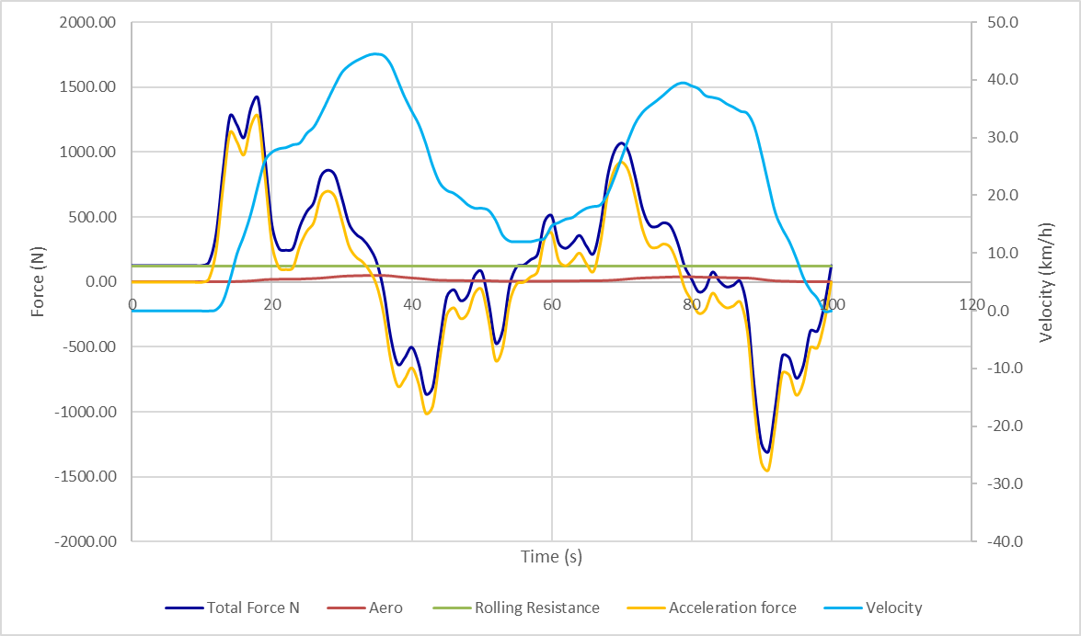
By using Microsoft Excel and its mathematic functions, it was possible to calculate the traction forces and breaking forces in order to create graphs at each section of the WLPT test and detect where kinetic energy could be saved during the cycle. Acceleration force is calculated by multiplying acceleration and mass in running order. The rolling resistance is calculated by multiplying the rolling resistance coefficient and the weight of the car. The aerodynamic resistance is calculated by using the formula: $AR=0.5×Car frontal area×air density×coeficcient of aero drag(\frac{velocity}{3.6})^{2}$.
Figure 2- First 100 second force graph
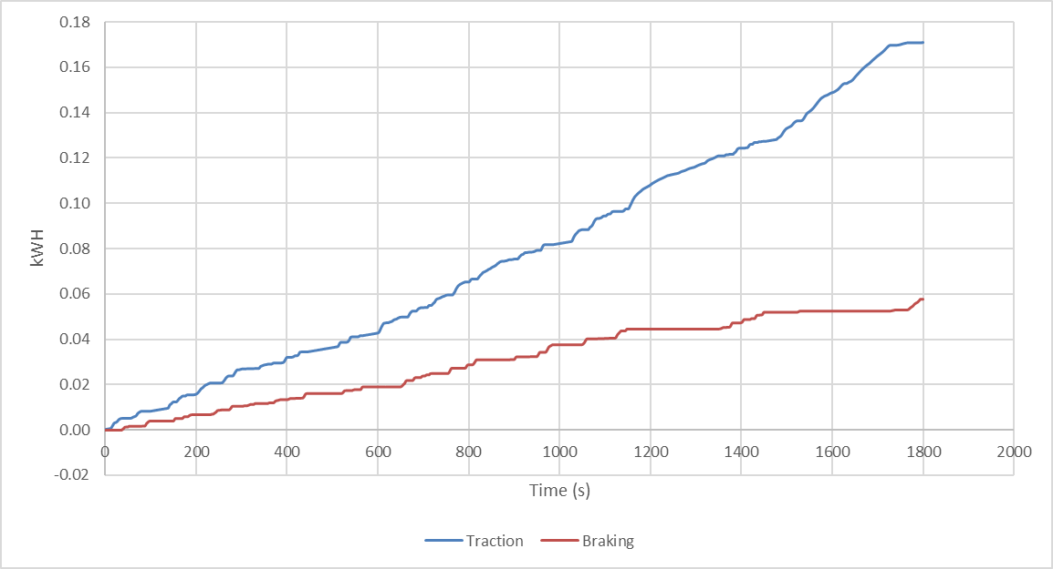
Figure 2 shows a graph comparing the forces acting on the car during the first 100 seconds of the WLTC while in the low phase. Kinetic energy is recoverable when the total force (tractive force) is below 0. This is when the car is decelerating. These are the areas in the WLTC test that need to be targeted with the KERS system.
Figure 3- Cumulative traction and braking
Figure 3 shows the energy used during traction (accelerating) and braking (decelerating) across the whole WLTC test. The braking data has been flipped from negative figures to positive so that it is easy to compare the energy used in traction and braking. The area between the traction and braking lines is as a result of aerodynamic and friction forces that aid the car in slowing down. However, no kinetic energy can be stored to the KERS system from these forces, so the only energy that can be saved is energy from the brakes.

Discussion

KERS Systems

There are three different types of KERS systems: electronic, electro-mechanical and mechanical. All the systems store energy while the car is braking that would usually be lost through heat energy. This process also assists during braking. Two elements are needed in all three variations of the system, first a place to store the energy so it can be returned to the powertrain, as well as a place to store it once it has been returned to the powertrain in preparation to deploy and assist in acceleration phases (Batalha, n.d).

Electronic KERS

Electronic KERS captures the rotational force in a generator unit (MGU) located on the engine’s crankshaft. The MGU then converts the kinetic energy into electrical energy and stores it in batteries. The electrical energy is then deployed by the MGU while a boost button is pressed, or a certain mode is engaged that deploys the power. In most cases, electrical systems use lithium batteries. However, some of the energy is lost through heat as the battery stores the electrical energy. The battery requires good cooling, so cooling vents are required directly to the batteries. This means it would be difficult to implement into the current chassis. Super-capacitors can also be used instead of batteries as they run at cooler temperatures, however this does increase the cost (Batalha, n.d).

Electro-mechanical

Electro-mechanical KERS systems store energy kinetically in a flywheel. The system effectively works as an electro-mechanical battery. The system is smaller and lighter than the electrical systems, which suits the Vauxhall Corsa as the car is small and lightweight with an engine that only produces 80 HP, so if the system was too heavy, it would have a negative effect on performance and will cause the car to struggle in the high-speed section at end of the WLTP cycle. The flywheel must spin at a very fast speed, between 50000 and 160000 RPM, in order to achieve an appropriate energy density. The flywheel is stored in a vacuum environment in order to reduce aerodynamic and friction losses. The flywheel is paired with an MGU attached to the gearbox which feeds electrical energy to the flywheel, which it will then return to the gearbox to be used during acceleration phases (Batalha, n.d).

Mechanical

Mechanical KERS systems also utilise flywheels, however they do not use MGU’s. Instead, they use a transmission system to control the transfer of energy between storage and the driveline. The flywheel stores kinetic energy by utilising shafts and gears. This means there is no need to transfer the energy from one form to another. This makes mechanical systems more efficient than electrical systems, as every time electrical systems convert energy from one form to another, energy is lost through things like heat and friction. A continuously variable transmission is used in mechanical systems in order to cope with the constant change in speed between the flywheel and road wheels. The CVT is controlled by an electro-hydraulic control system (Batalha, n.d). Mechanical systems have an efficiency of over 70%, whereas electrical systems only produce an efficiency of around 30%. Mechanical systems can store up to 400KJ of energy and can produce a maximum power boost of around 60 kW for just shy of 7 seconds. This would effectively double the power output of the Corsa during this time period (Batalha, n.d).

KERS System for The Vauxhall

The most suitable KERS system for the Vauxhall Corsa is a mechanical system. This is as a result of its high efficiency. During the WLTP, there aren’t enough heavy braking and acceleration periods to make us of the electrical system with it only having 30% efficiency. The most effective way of using the stored kinetic energy is by building up the energy during the initial stages of the WLTP while the car is at low to medium velocity. This energy will then be deployed during wide open throttle in the final high velocity stages of the WLTP, as this is when the KERS system can aid the most in improving fuel consumption.

Building Up Kinetic Energy
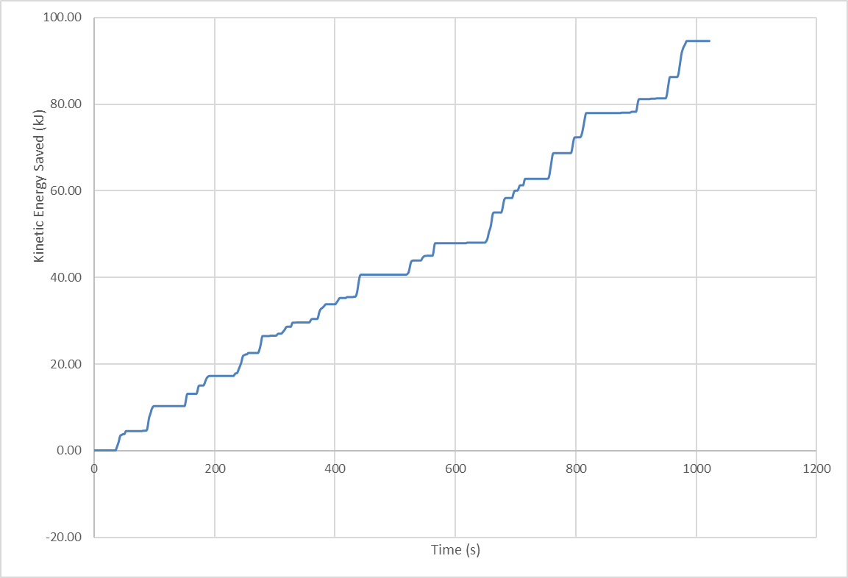
Figure 4- Energy Recovered
Figure 4 presents the amount of kinetic energy that can be recovered for the first 1022 seconds of the WLPT cycle. This is the part of the cycle where the vehicle would not benefit much from deploying the stored energy, as there aren’t too many heavy acceleration periods. During this time period, the mechanical KERS system can store 94.64 kJ’s of energy out of the 135.2 kJ’s of braking force produced during the time period. In comparison, the electrical system would only have been able to save 40.46 kJ’s. This energy can then be deployed under high load situations in order to have the most positive effect on fuel efficiency.

Driveability

The KERS system will influence the balance of the car. As the Corsa’s engine is at the front of the car, the load over the front axle will increase by up to 30 kg. This in turn causes a higher level of weight transfer over the front axle, causing the front tyres to be under increasing load. This means the car will understeer more. However, as the car is only used for road use, the driver should not be on the limit of grip, meaning this shouldn’t be a big issue. If the car was being used for motorsport, this would be more problematic. An issue that will affect road use however is increased tire wear and a result of the increased load. This makes the car more expensive to run in the longer term. This would also be more problematic in a motorsport setting, as it makes strategy more difficult with a higher race time as a result. This means that in motorsport its important to get a good balance between performance gained through the recovered energy against the performance lost through higher tire wear and potentially a less optimal balance through the corners.

When the extra energy is deployed, the driven wheels will have an increased level of torque. For rear-wheel drive cars, it can make a driver more prone to spinning as a result of loading the tires up past their maximum inertia. If the car is front-wheel drive, this increases the chances of wheelspin and understeer on-throttle. This again has a negative effect on tire wear. This has a great effect on how teams deploy the energy in motorsport. In modern F1 cars, the systems can deploy the energy the same place on every lap once the traction critical phase has passed, and torque becomes the most important element of performance to gain lap time.

Conclusion

This report has investigated how much energy is recoverable from a road car, and how KERS can be used to extract and store this energy so that the vehicle is able to reuse it. The report achieved this by looking at some initial research on the chosen vehicle, a 2002 1.2 Vauxhall Corsa SXI, finding test mass, frontal area, rolling resistance coefficient and coefficient of aerodynamic drag.
Having found the initial values, the report was able to determine that the car fell into class 3 of the WLTC. From this information, the report found the acceleration force, rolling resistance, aero resistance and total force using Microsoft Excel. This resulted in the potential kinetic energy that could be saved by a KERS system being presented in graphical form, so that it was clear to see the advantages a KERS system would have on the vehicle.
The report then detailed the different types of KERS system: electrical, electro-mechanical and mechanical. From this, the report reasoned that the most suitable KERS system for the vehicle would be the mechanical system, as a result of its high efficiency. It was then concluded that the best time to save the energy was at the low and medium velocity stages of the WLTC and the best time to deploy the energy is at the high and very high velocity stages at the end of the WLTC cycle, as the extra energy would help improve fuel efficiency the most in high load situations.
Finally, the report investigated the effect the KERS system would have on the balance of the car. It detailed that although the extra weight would influence the balance of the car, this is less important in the automotive industry than it is in the motorsport industry.

References
2000 Opel Corsa 1.2 16v specifications, n.d. 2000 Opel Corsa 1.2 16v specifications. [Online]
Available at: https://www.carfolio.com/opel-corsa-1.2-16v-99715
[Accessed 5th Jan 2022].
Batalha, J., n.d. Kinetic Energy Recovery Systems. [Online]
Available at: https://cecas.clemson.edu/cvel/auto/AuE835_Projects_2009/batalha_project.html
[Accessed 7th Jan 2022].
Emissions Test Cycles, n.d. Worldwide Harmonized Light Vehicles Test Cycle (WLTC). [Online]
Available at: https://dieselnet.com/standards/cycles/wltp.php
[Accessed 3rd Jan 2022].
Engineering ToolBox, 2008. Rolling Resistance. [Online]
Available at: https://www.engineeringtoolbox.com/rolling-friction-resistance-d_1303.html
[Accessed 5th Jan 2022].
ultimateSPECS, n.d. Vauxhall Corsa C 1.2 16v Specs. [Online]
Available at: https://www.ultimatespecs.com/car-specs/Vauxhall/71280/2002-Vauxhall-Corsa-C-12-16v.html
[Accessed 4th Jan 2022].
VAUXHALL Corsa 3 Doors 2001 - 2006, 2021. VAUXHALL Corsa 3 Doors 2001 - 2006. [Online]
Available at: https://www.autoevolution.com/cars/vauxhall-corsa-3-doors-2001.html#aeng_vauxhall-corsa-3-doors-2001-12i
[Accessed 5th Jan 2022].

