Stephen Ace - L6 - Critical Review (ADFM6001)
Showreel: https://www.youtube.com/watch?v=NfA6iyWfi3w
Business Card: Front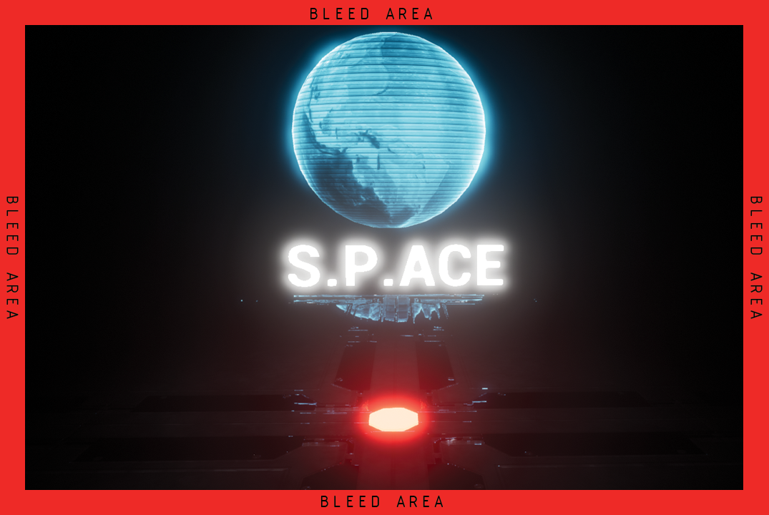
Back
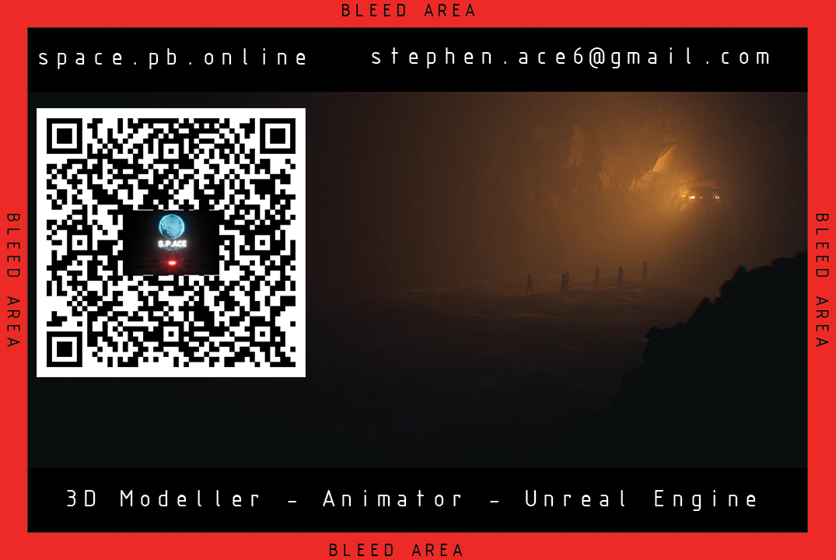
Bibliography
[1] Freesound - Freesound", Freesound.org, 2022. [Online]. Available: https://freesound.org. [Accessed: 01- May- 2022].
[2] M. DB, "SynthMadnessV1.mp3 by Michael-DB", Freesound, 2017. [Online]. Available: https://freesound.org/people/Michael-DB/sounds/393839/. [Accessed: 01- May- 2022].
[3] “Game Art Showreel 2016", Youtube.com, 2016. [Online]. Available: https://www.youtube.com/watch?v=sliDsEiVVus. [Accessed: 01- May- 2022].
[4] "Escape Studios Game Art Showreel", Youtube.com, 2019. [Online]. Available: https://www.youtube.com/watch?v=l89F_wvMrLA. [Accessed: 01- May- 2022].
[5] “6 Ways to Make Your Showreel or Demo Reel Stand Out", Premium Beat, 2022. [Online]. Available: https://www.premiumbeat.com/blog/demo-reel-showreel-tips/. [Accessed: 01- May- 2022].
[6] "How to create the perfect 3D, VFX or games art showreel", Digital Arts Online, 2022. [Online]. Available: https://www.digitalartsonline.co.uk/features/creative-software/how-create-perfect-3d-vfx-or-games-art-showreel/. [Accessed: 01- May- 2022].

